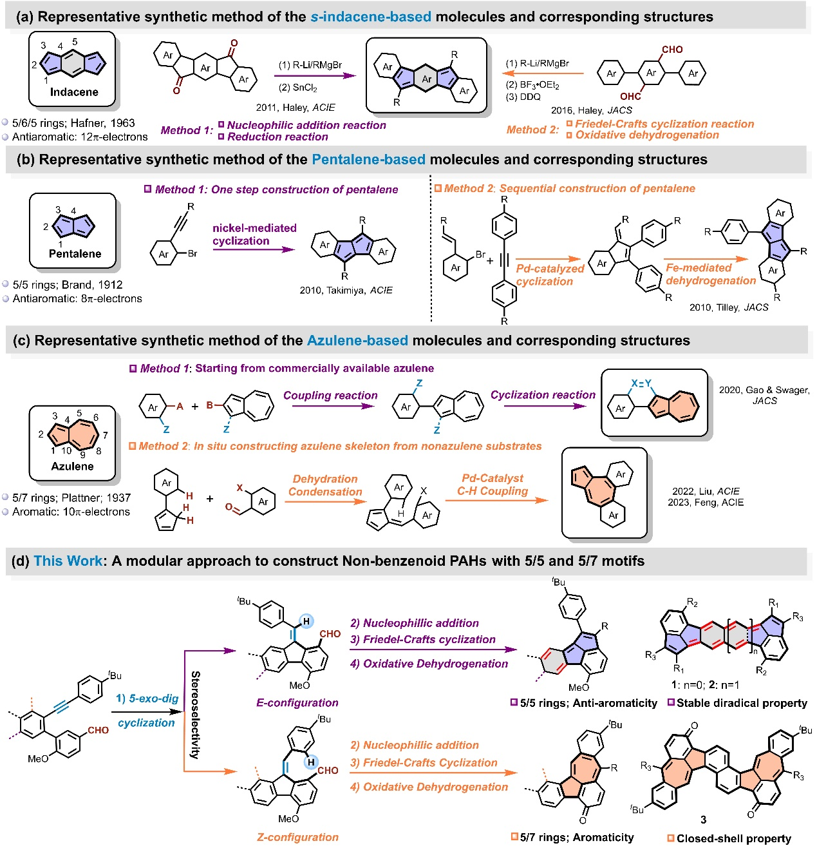
Scheme 1. The representative synthetic strategies for (a) indacene, (b) pentalene and (c) azulene motifs-based non-benzenoid PAHs. (d) The modular synthetic approach to construct 5/5 and 5/7 motifs of this work.
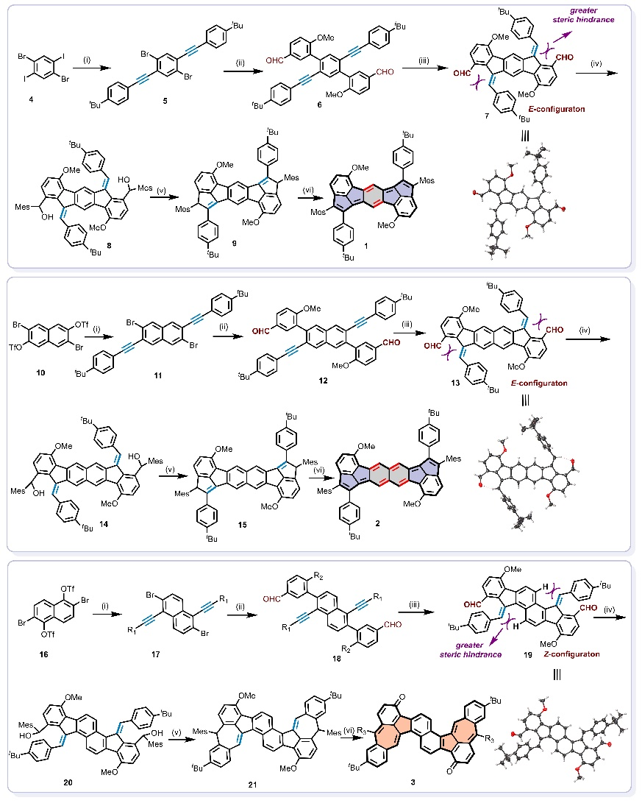
Scheme 2 The synthetic routes of (a) 1, (b) 2 and (c) 3. (i) 4-Tert-butylphenylacetylene, Pd(PPh₃)₂Cl₂, CuI, diisopropylamine, DMF; (ii) 2-Methoxy-5-formylphenylboronic acid, Pd(PPh₃)₄, K₂CO₃, Tolunen/EtOH/H₂O; (iii) Pd(OAc)₂, Sphos, tri-n-butylphosphine, Toluene; (iv) MesMgBr, THF; (v) BF₃·OEt₂, DCM; (vi) DDQ, Toluene.

