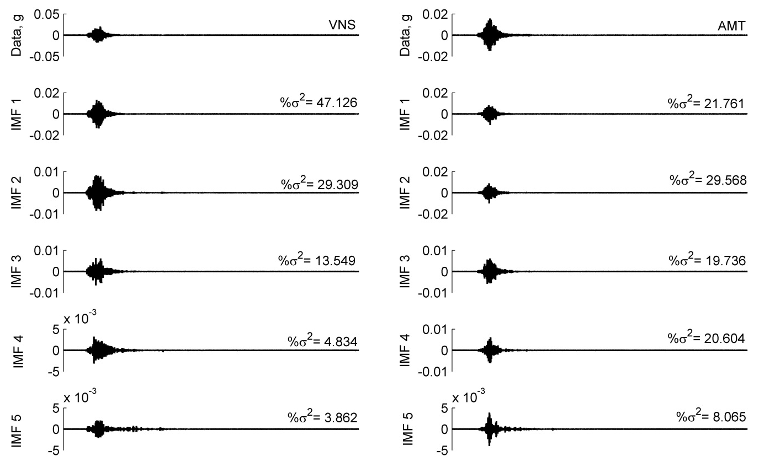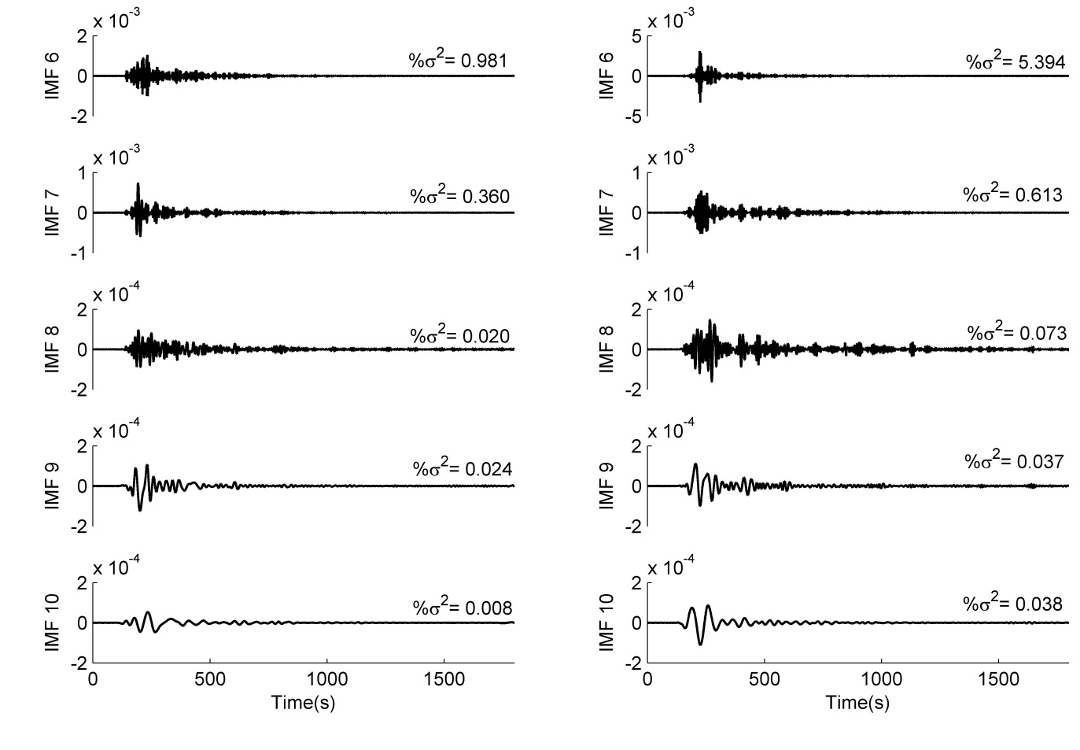
Figure A1. Intrinsic mode functions (IMFs) for acceleration time histories (NS component) of the Mw 7.9 Nepal earthquake, recorded at stations: VNS, AMT, BSR and TDR in the IG basin and KTP, TVU, PTN and THM in the Kathmandu basin.
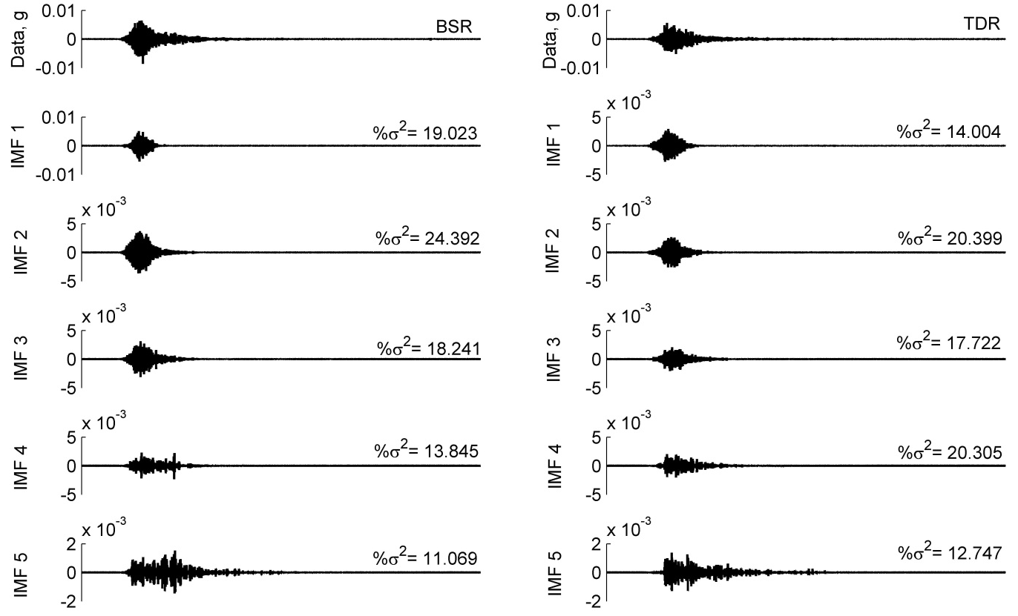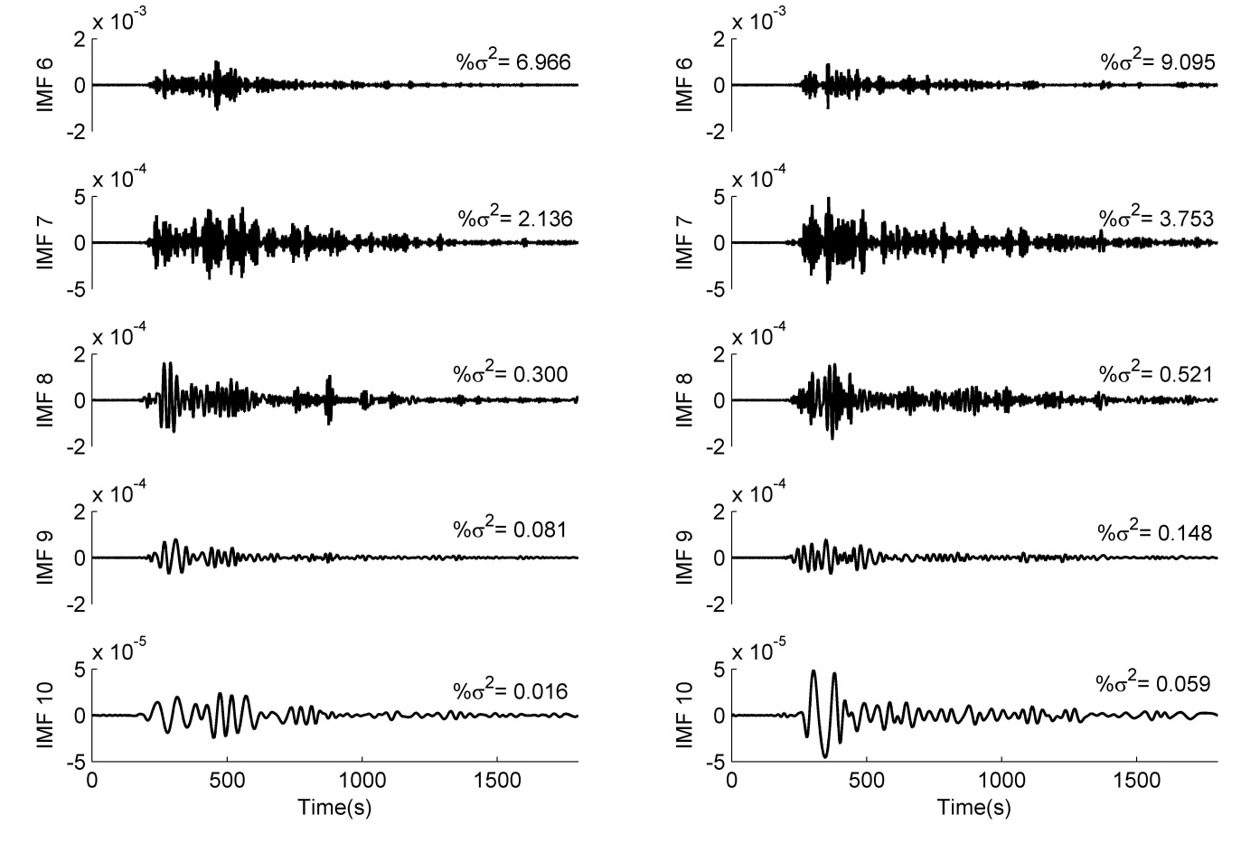
Figure A1. [Continued] Intrinsic mode functions (IMFs) for acceleration time histories (NS component) of the Mw 7.9 Nepal earthquake, recorded at stations: VNS, AMT, BSR and TDR in the IG basin and KTP, TVU, PTN and THM in the Kathmandu basin.

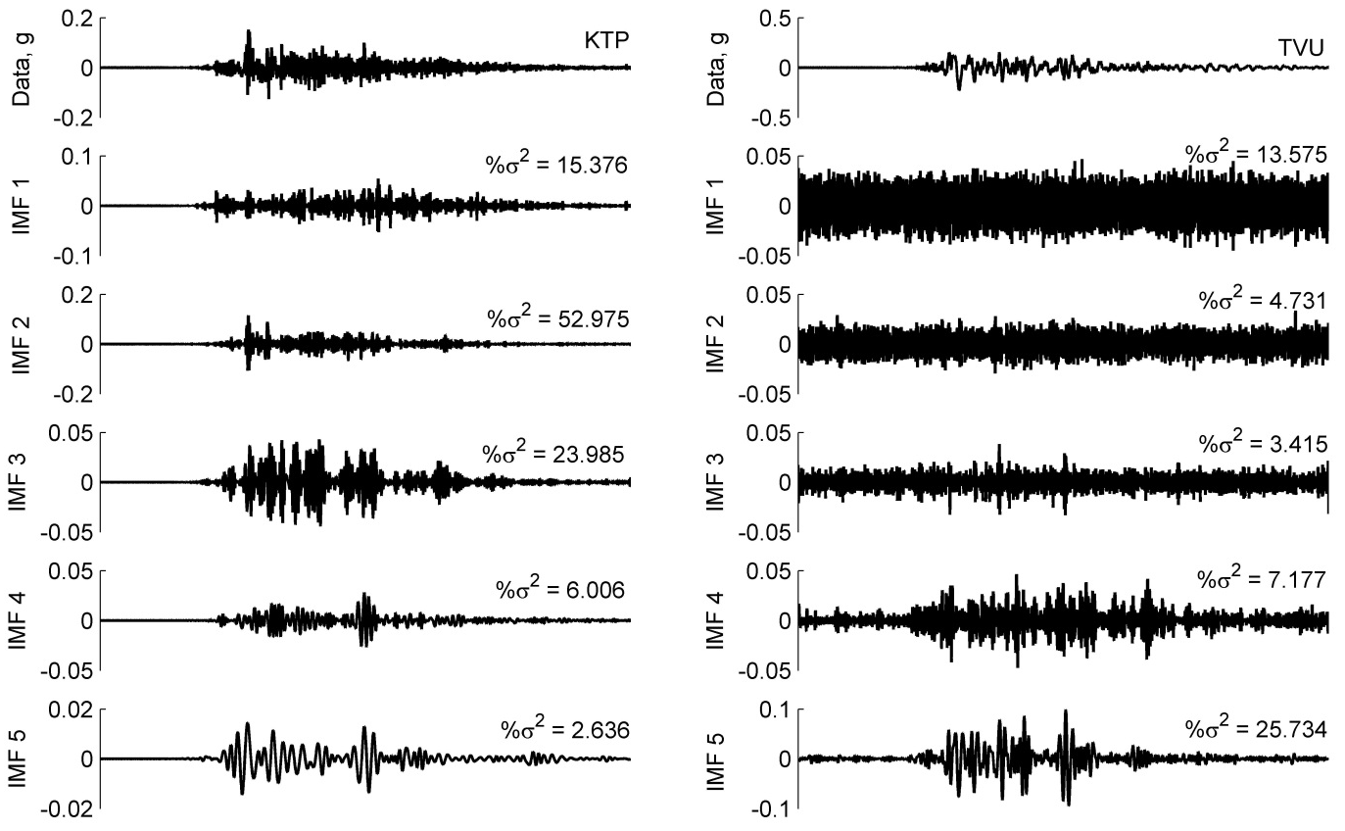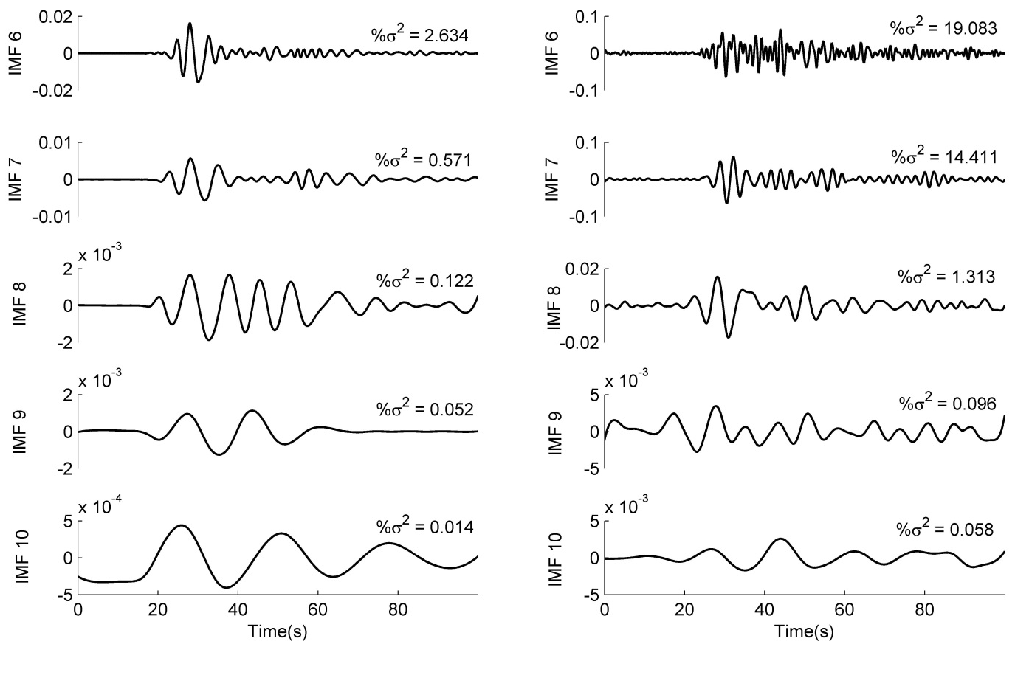
Figure A1. [Continued] Intrinsic mode functions (IMFs) for acceleration time histories (NS component) of the Mw 7.9 Nepal earthquake, recorded at stations: VNS, AMT, BSR and TDR in the IG basin and KTP, TVU, PTN and THM in the Kathmandu basin.

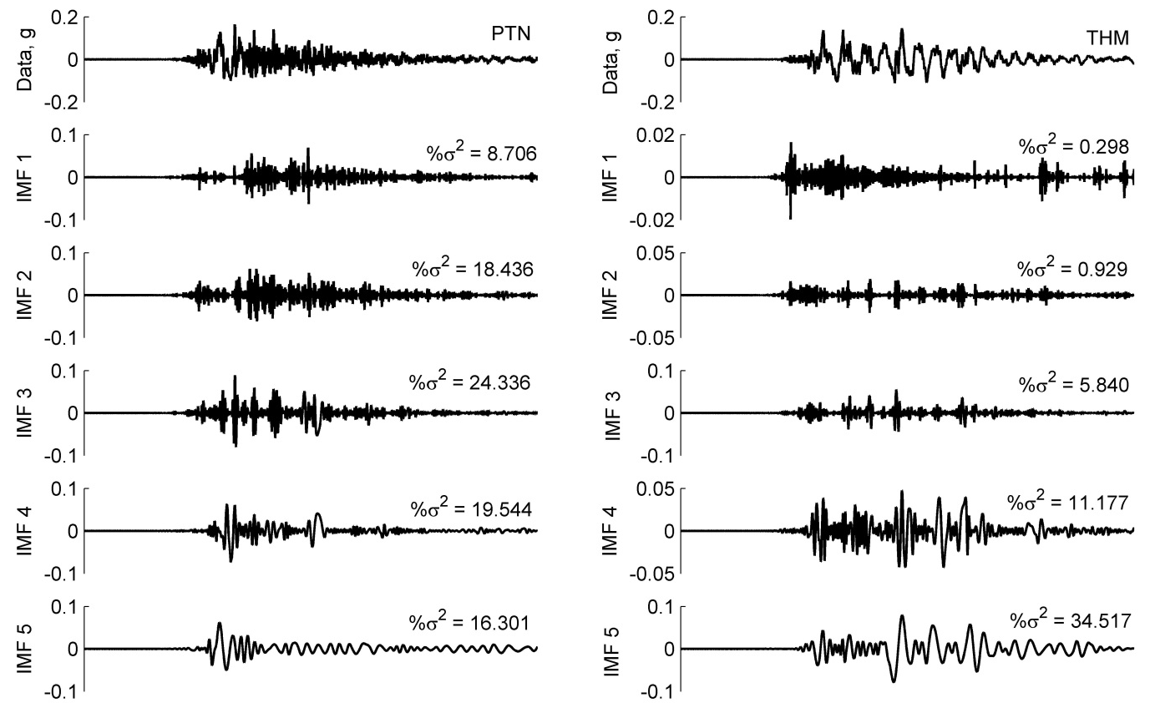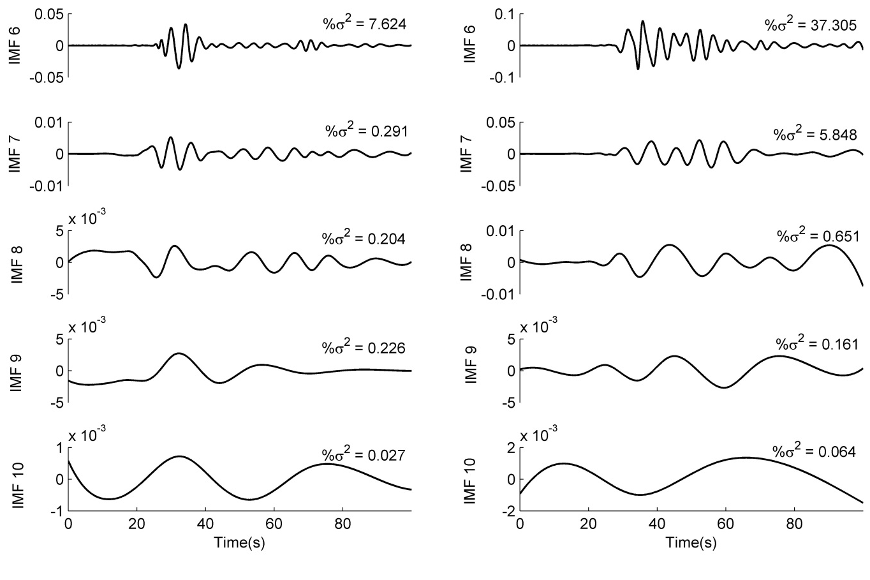
Figure A1. [Continued] Intrinsic mode functions (IMFs) for acceleration time histories (NS component) of the Mw 7.9 Nepal earthquake, recorded at stations: VNS, AMT, BSR and TDR in the IG basin and KTP, TVU, PTN and THM in the Kathmandu basin.
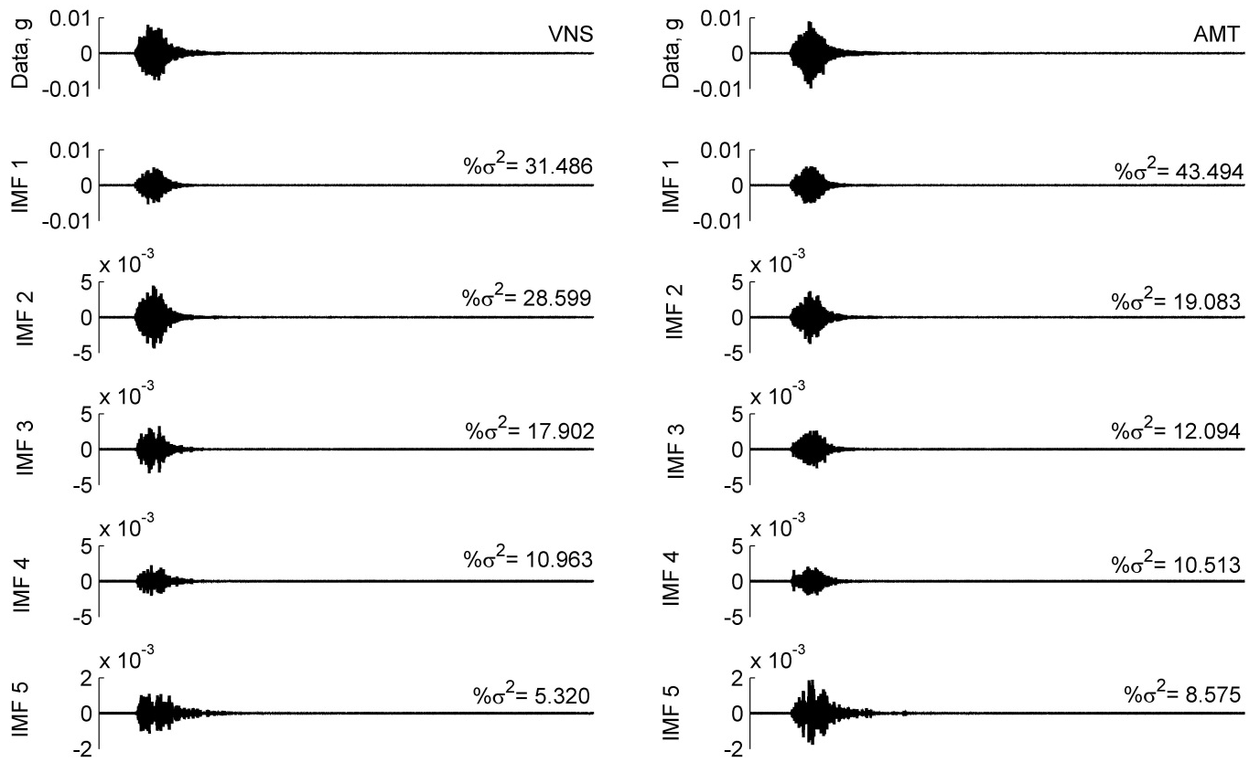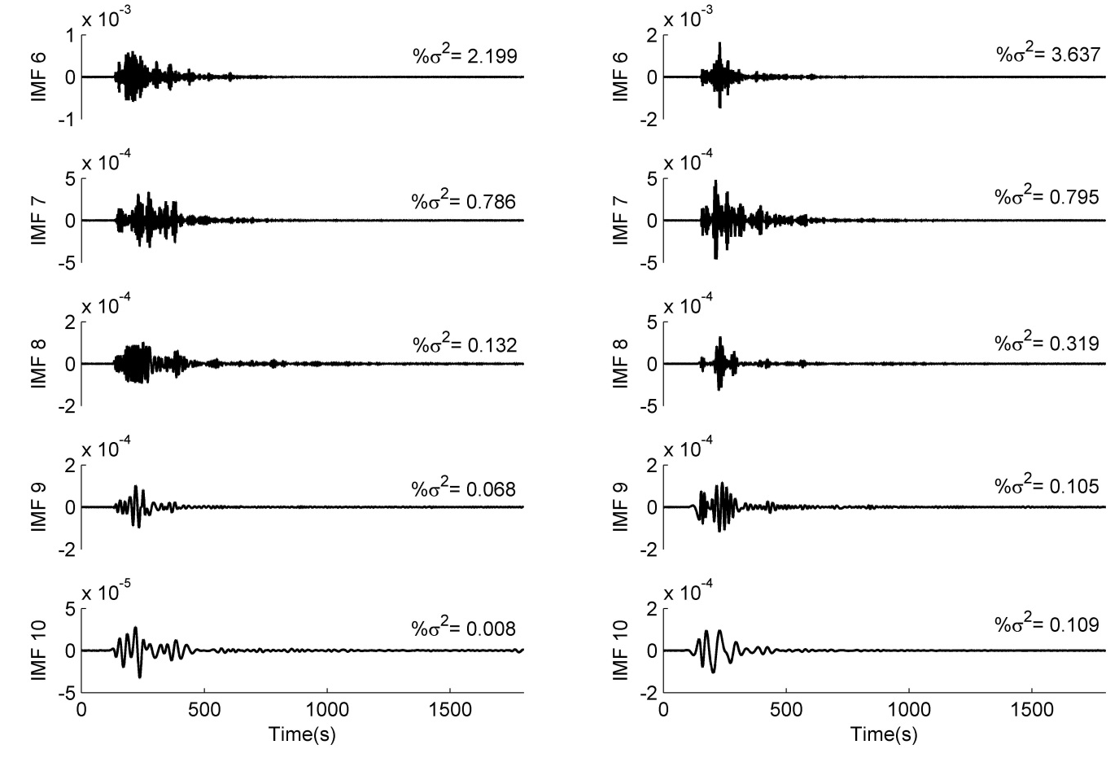
Figure A2. Intrinsic mode functions (IMFs) for acceleration time histories (Vertical component) of the Mw 7.9 Nepal earthquake, recorded at stations: VNS, AMT, BSR and TDR in the IG basin and KTP, TVU, PTN and THM in the Kathmandu basin.

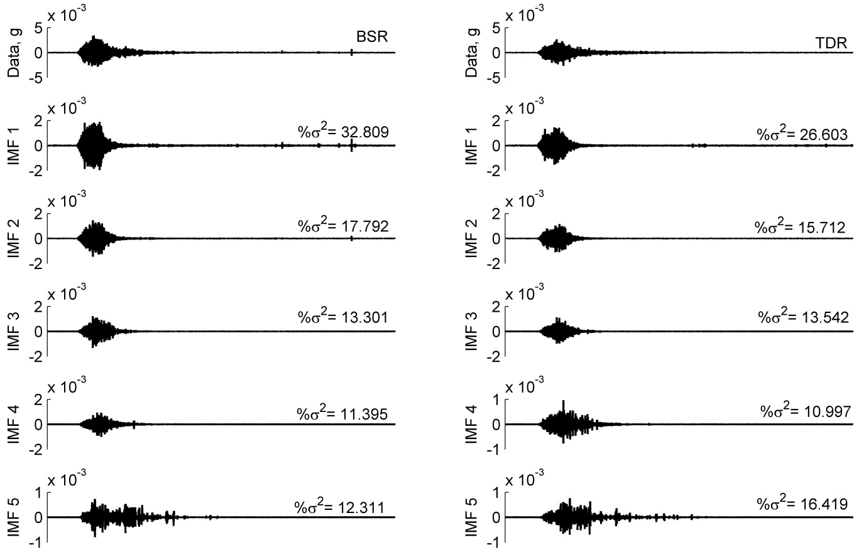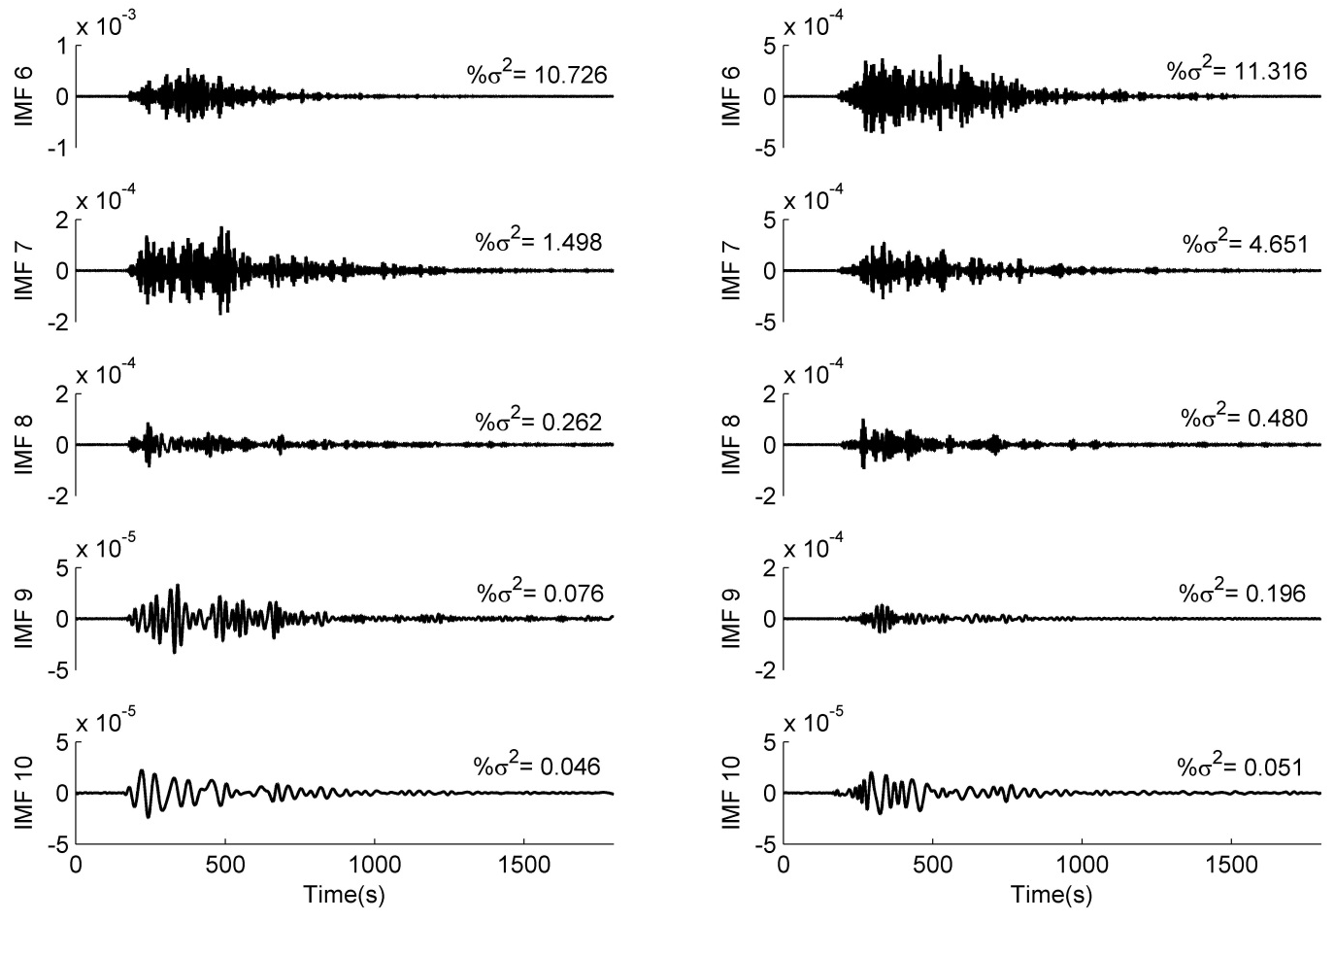
Figure A2. [Continued] Intrinsic mode functions (IMFs) for acceleration time histories (Vertical component) of the Mw 7.9 Nepal earthquake, recorded at stations: VNS, AMT, BSR and TDR in the IG basin and KTP, TVU, PTN and THM in the Kathmandu basin.

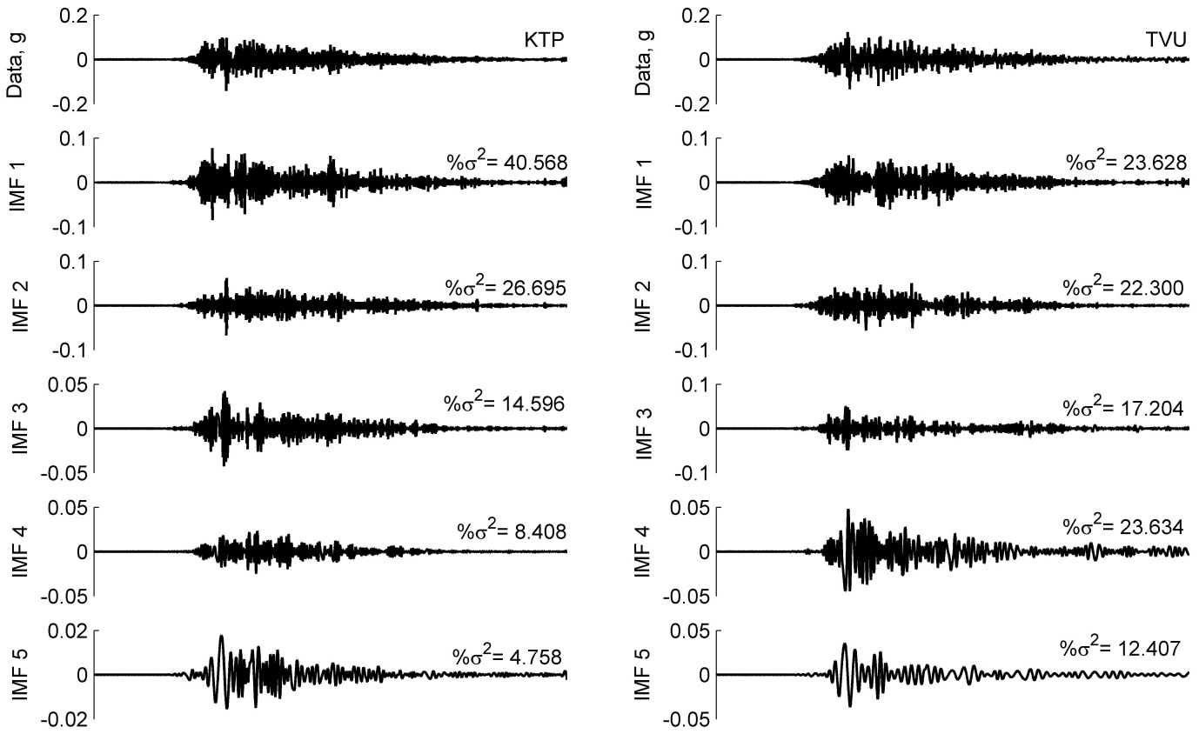
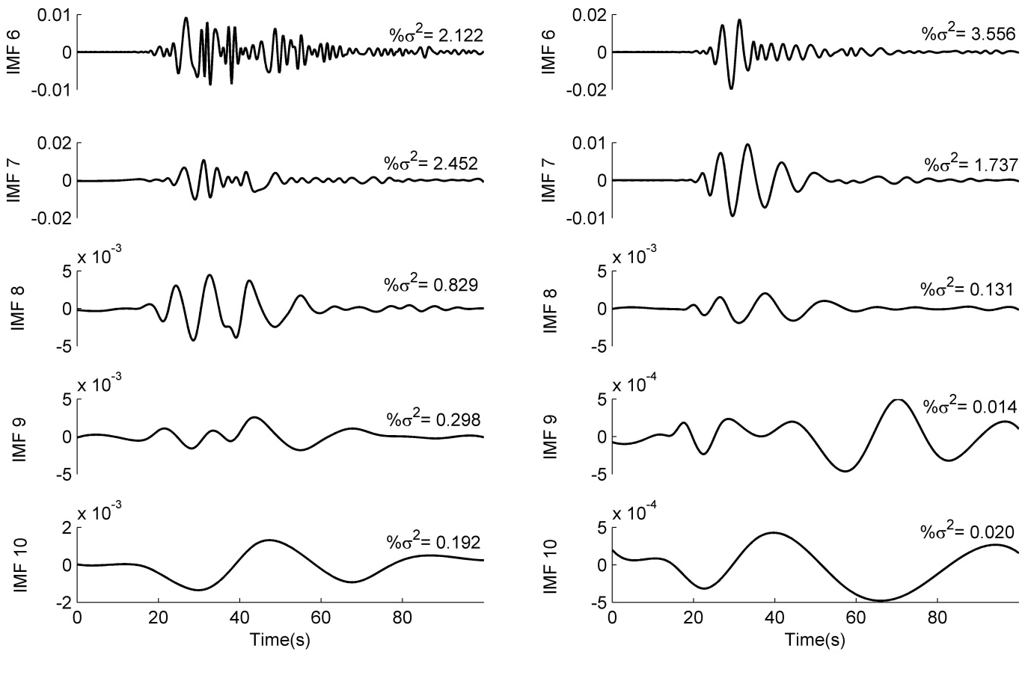
Figure A2. [Continued] Intrinsic mode functions (IMFs) for acceleration time histories (Vertical component) of the Mw 7.9 Nepal earthquake, recorded at stations: VNS, AMT, BSR and TDR in the IG basin and KTP, TVU, PTN and THM in the Kathmandu basin.

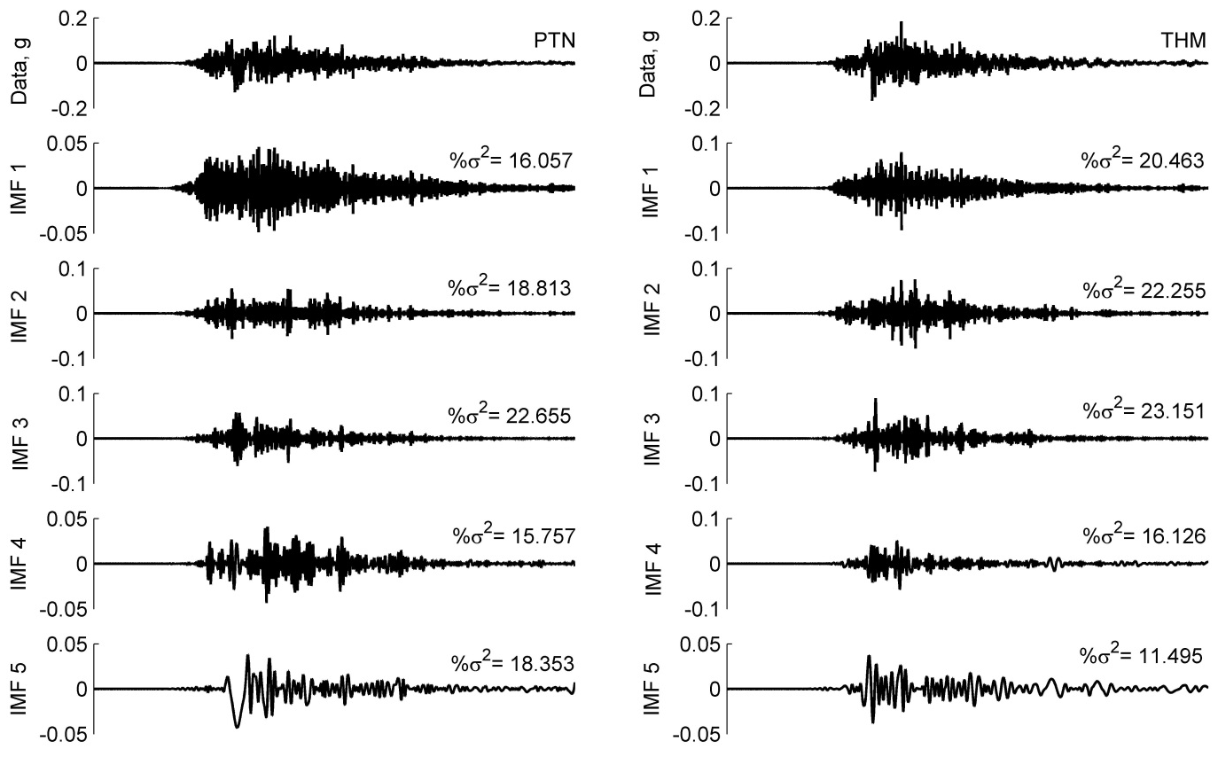
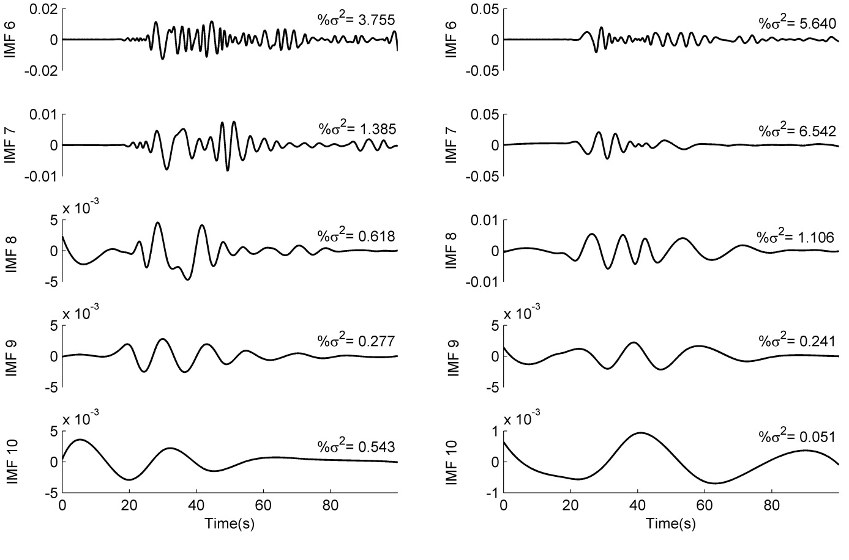
Figure A2. [Continued] Intrinsic mode functions (IMFs) for acceleration time histories (Vertical component) of the Mw 7.9 Nepal earthquake, recorded at stations: VNS, AMT, BSR and TDR in the IG basin and KTP, TVU, PTN and THM in the Kathmandu basin.

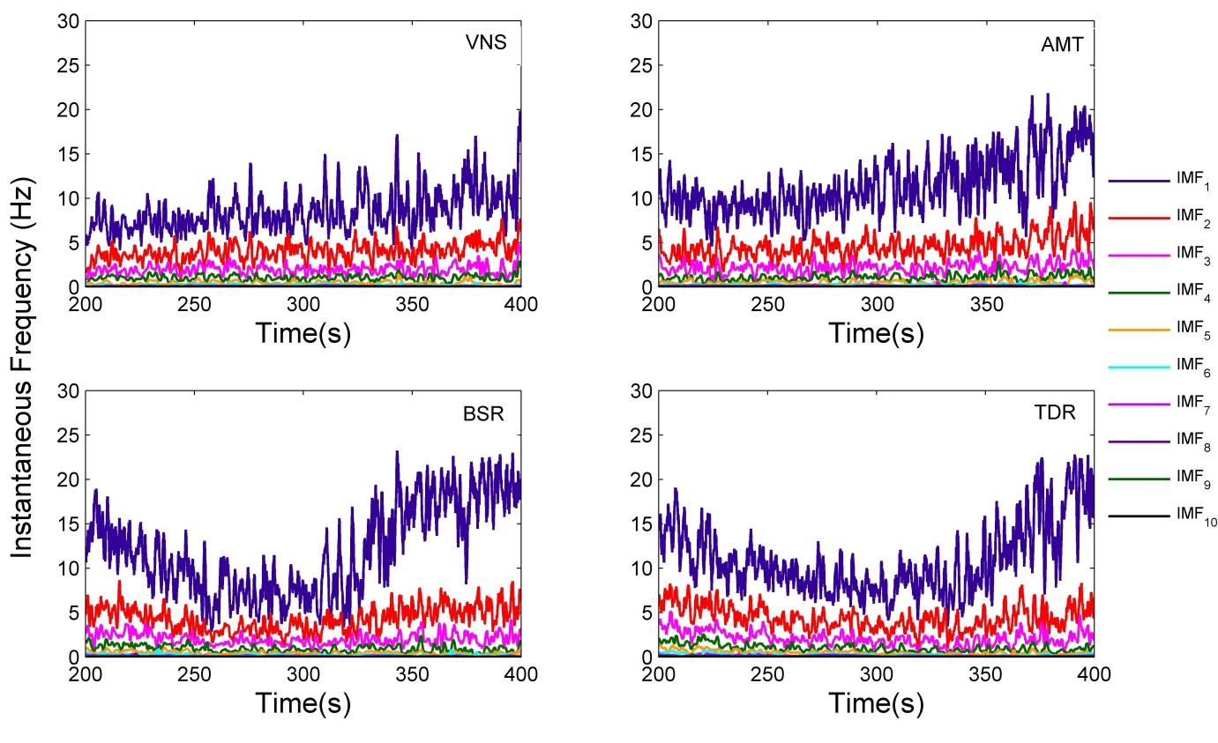
(a)
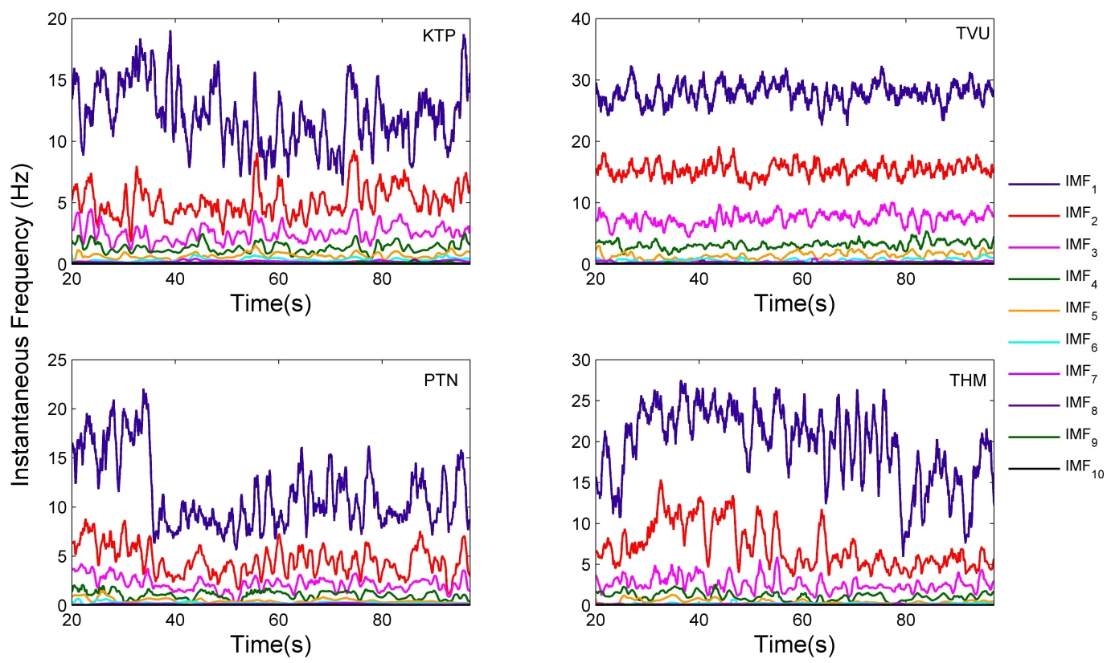
(b)
Figure A3. Instantaneous frequencies of acceleration time histories (NS component) for stations (a) VNS, AMT, BSR and TDR in the IG basin and (b) KTP, TVU, PTN and THM in the Kathmandu basin.
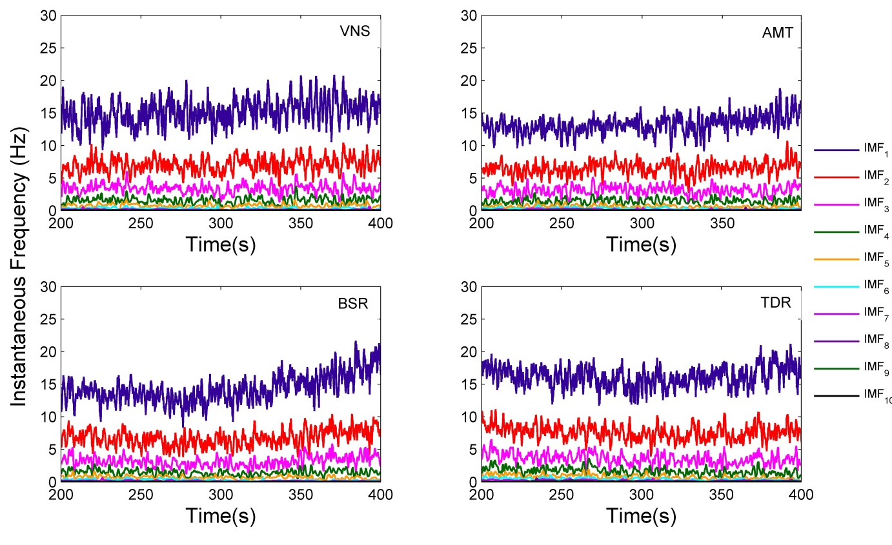
(a)
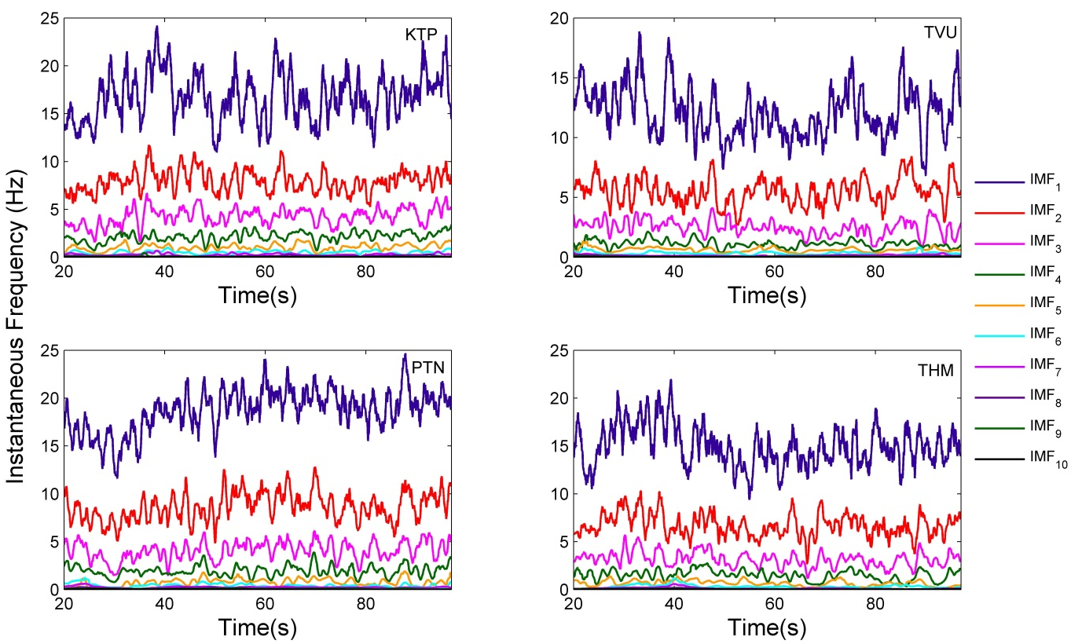
(b)
Figure A4. Instantaneous frequencies of acceleration time histories (Vertical component) for stations (a) VNS, AMT, BSR and TDR in the IG basin and (b) KTP, TVU, PTN and THM in the Kathmandu basin.

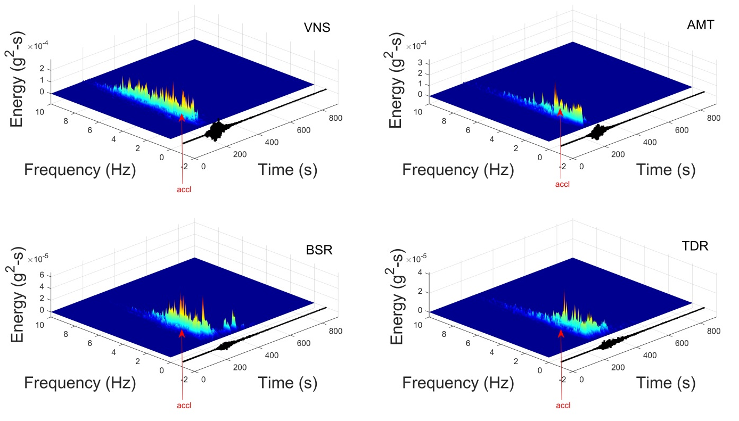
(a)
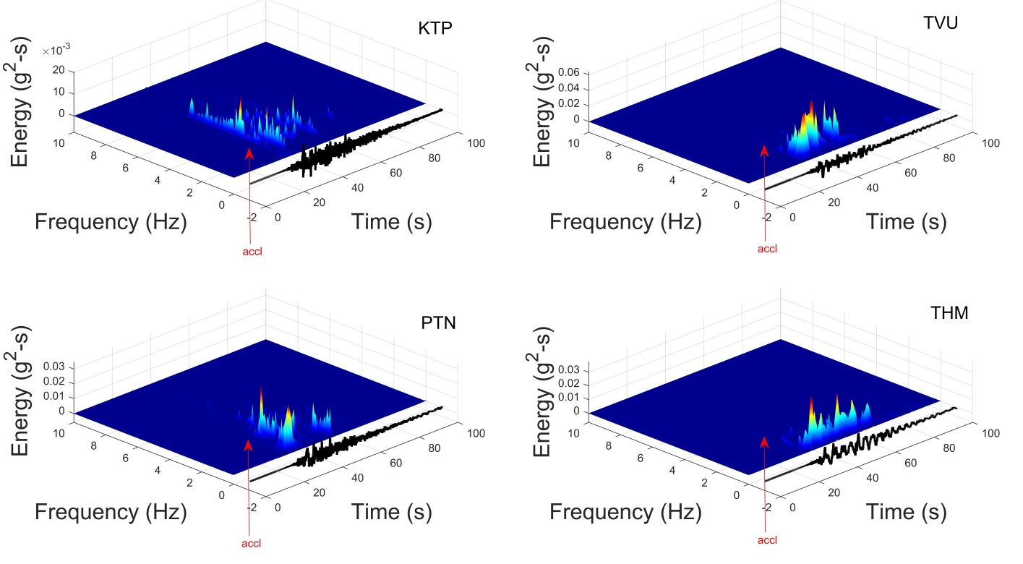
(b)
Figure A5. Hilbert Energy Spectrum for acceleration time histories (NS component)of the Mw 7.9 Nepal earthquake, recorded at stations (a) VNS, AMT, BSR and TDR in the IG basin and (b) KTP, TVU, PTN and THM in the Kathmandu basin

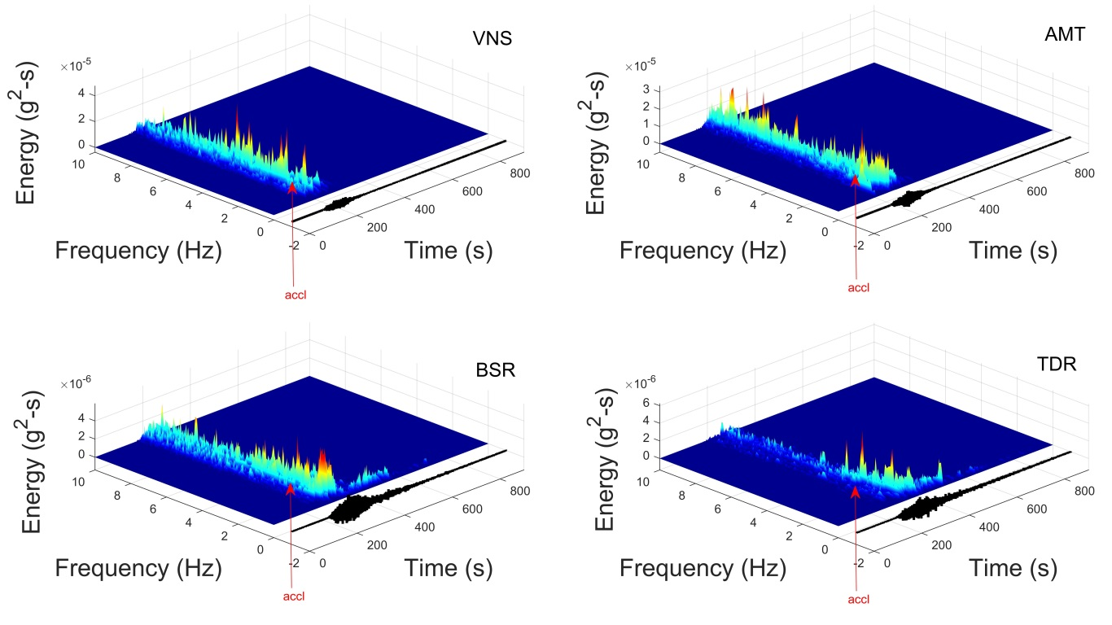
(a)
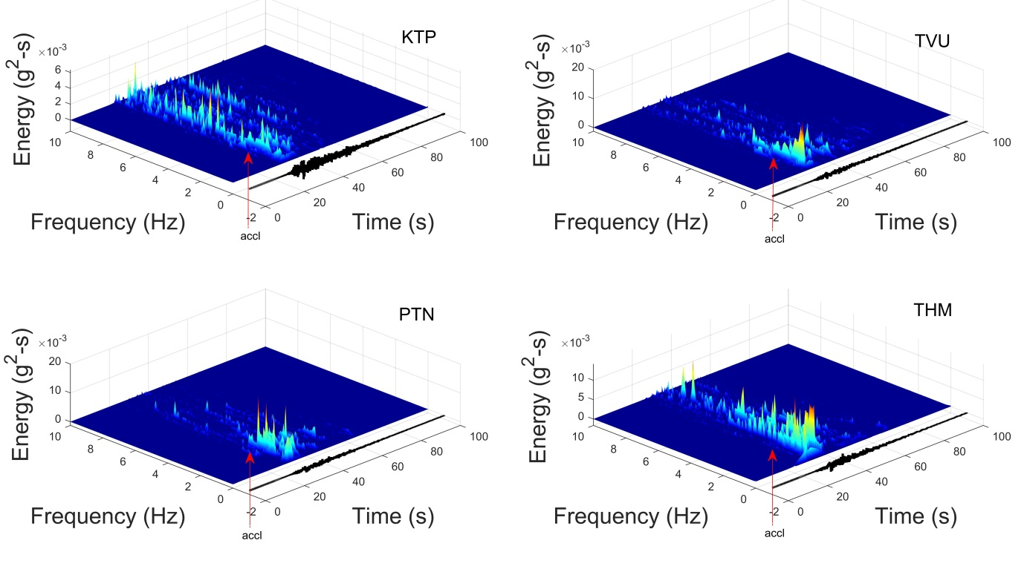
(b)
Figure A6. Hilbert Energy Spectrum for acceleration time histories (Vertical Component) of the Mw 7.9 Nepal earthquake, recorded at stations (a) VNS, AMT, BSR and TDR in the IG basin and (b) KTP, TVU, PTN and THM in the Kathmandu basin

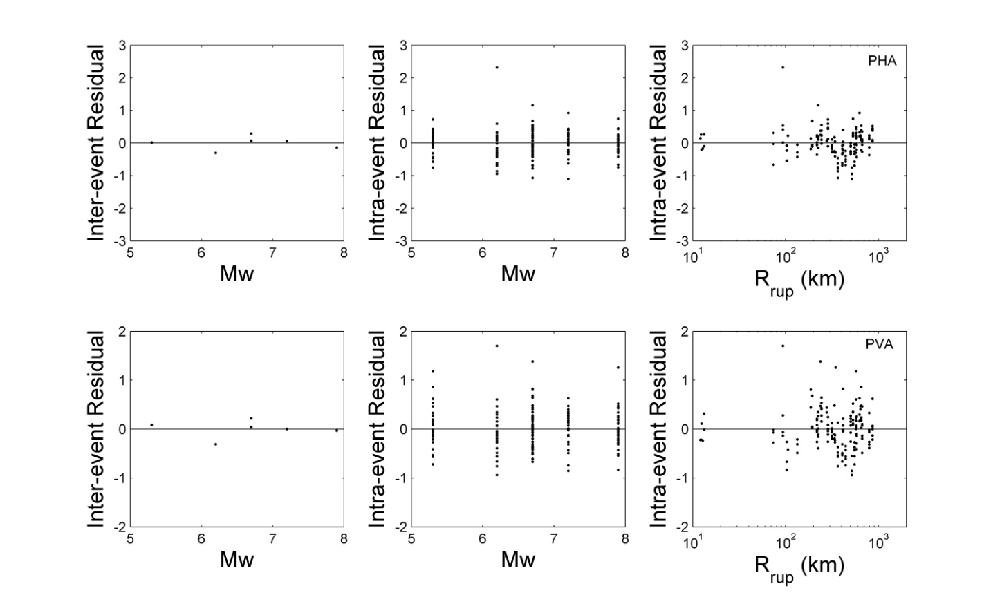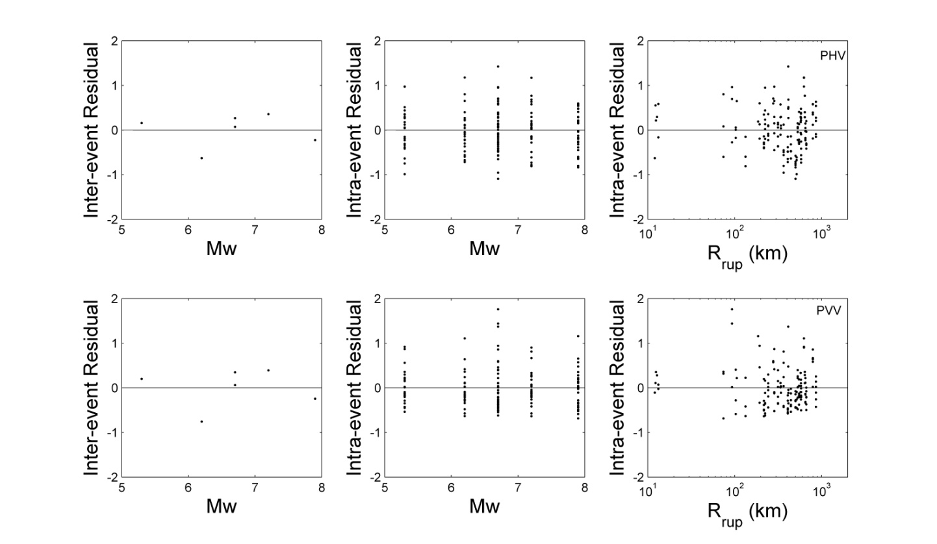Figure A7. Interevent and intraevent residuals with respect to predictor variables: M_{w} and R_{rup}, for all GMPs.

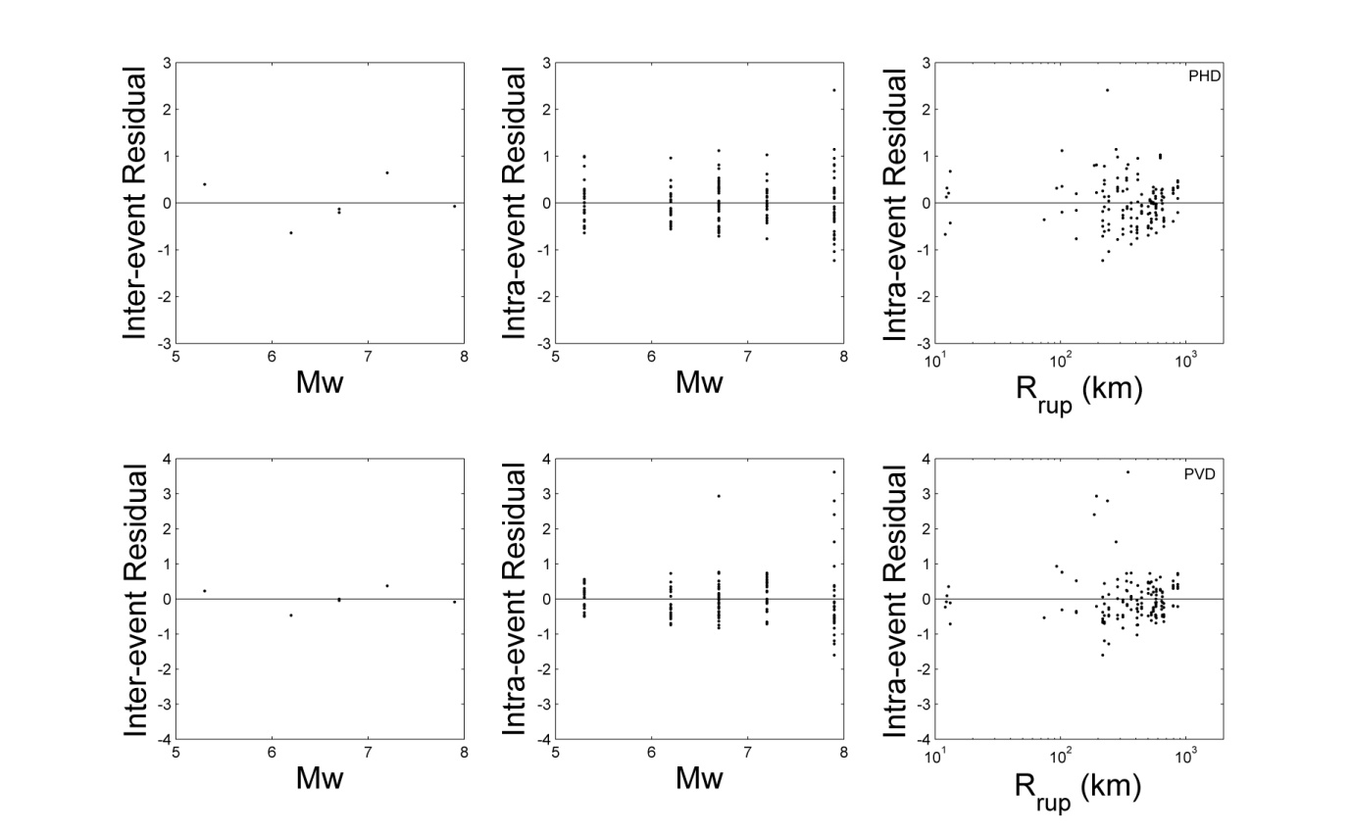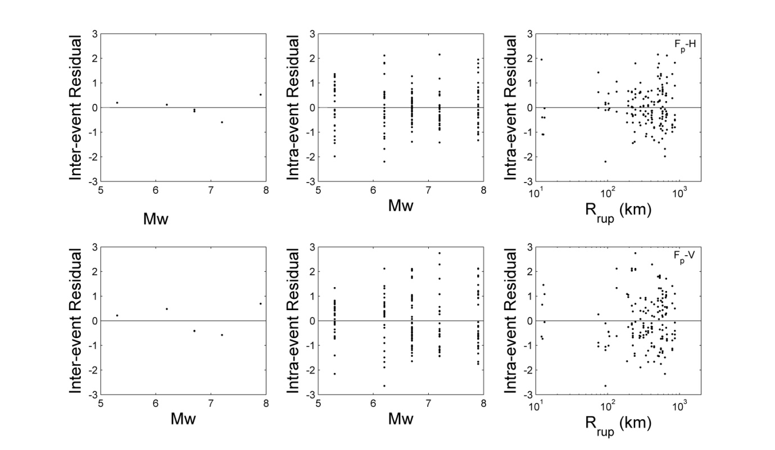Figure A7. [Continued] Interevent and intraevent residuals with respect to predictor variables: M_{w} and R_{rup}, for all GMPs.
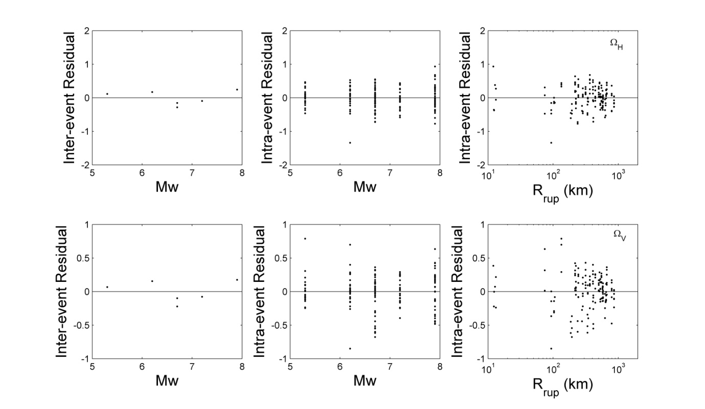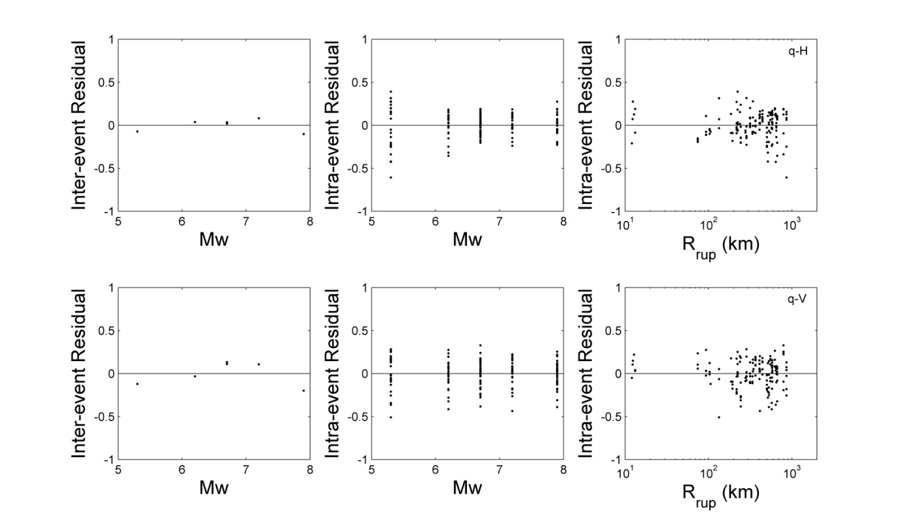Figure A7. [Continued] Interevent and intraevent residuals with respect to predictor variables: M_{w} and R_{rup}, for all GMPs.
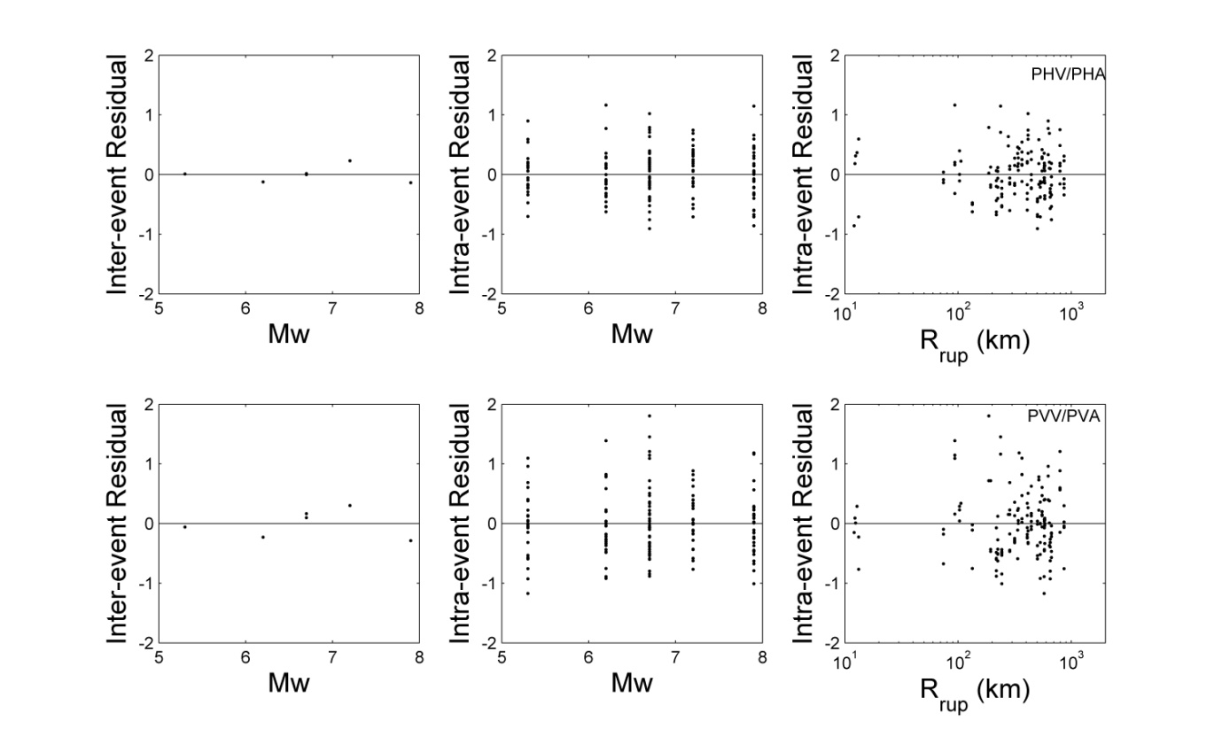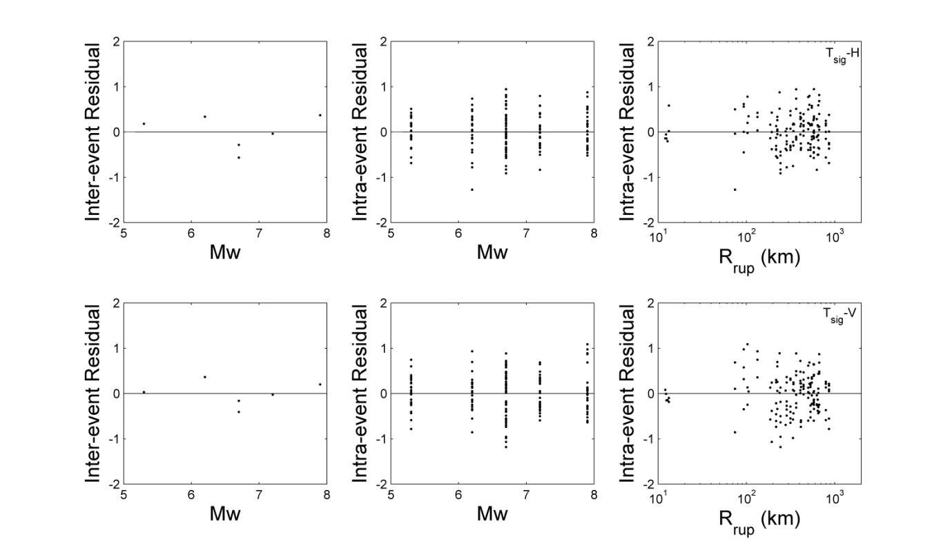Figure A7. [Continued] Interevent and intraevent residuals with respect to predictor variables: M_{w} and R_{rup}, for all GMPs.
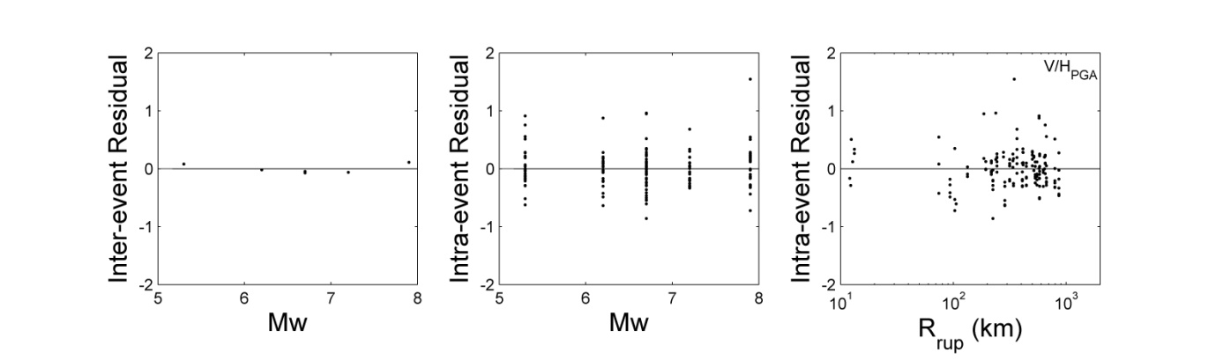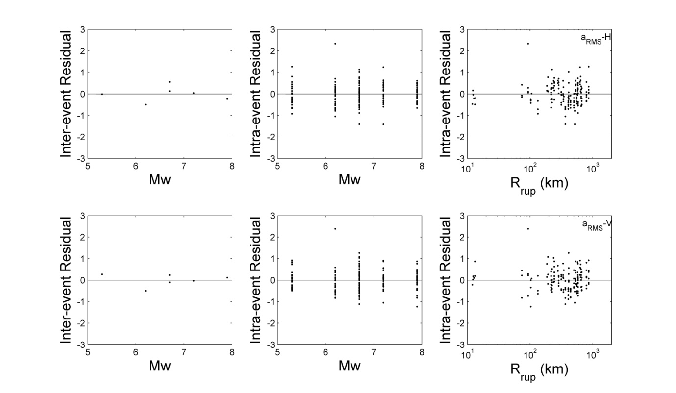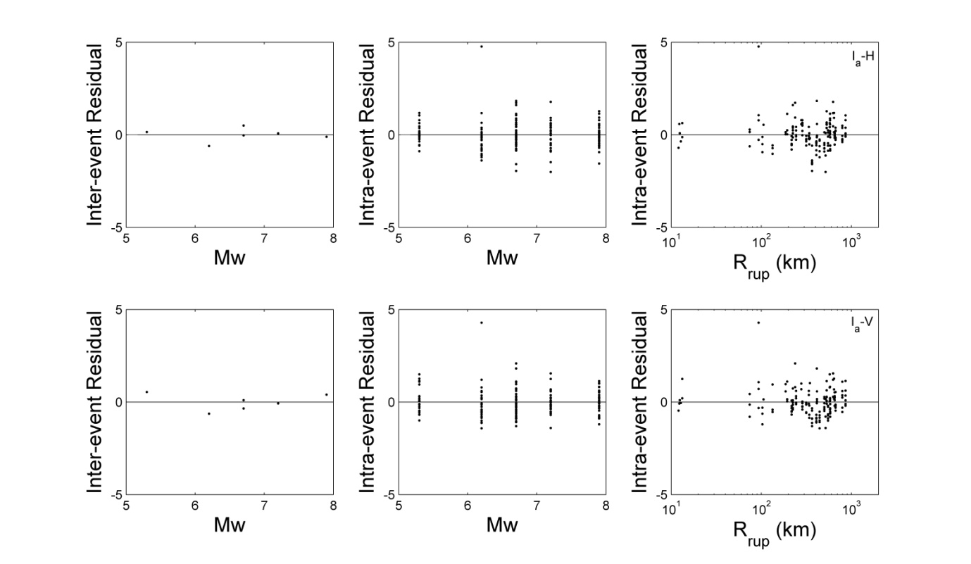
Figure A7. [Continued] Interevent and intraevent residuals with respect to predictor variables: M_{w} and R_{rup}, for all GMPs.
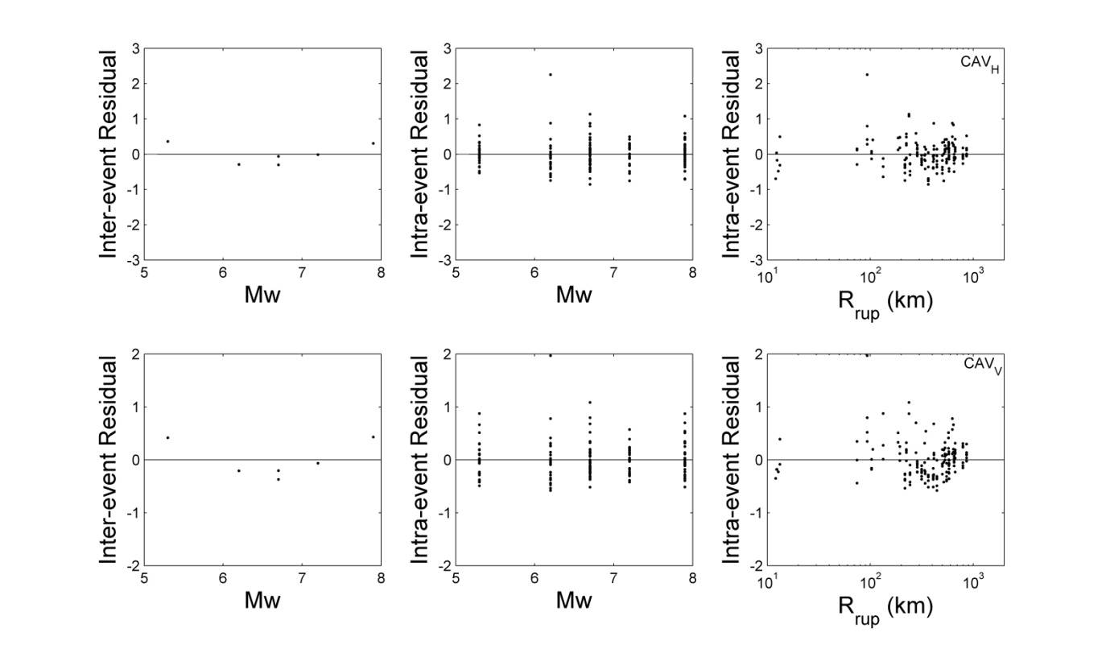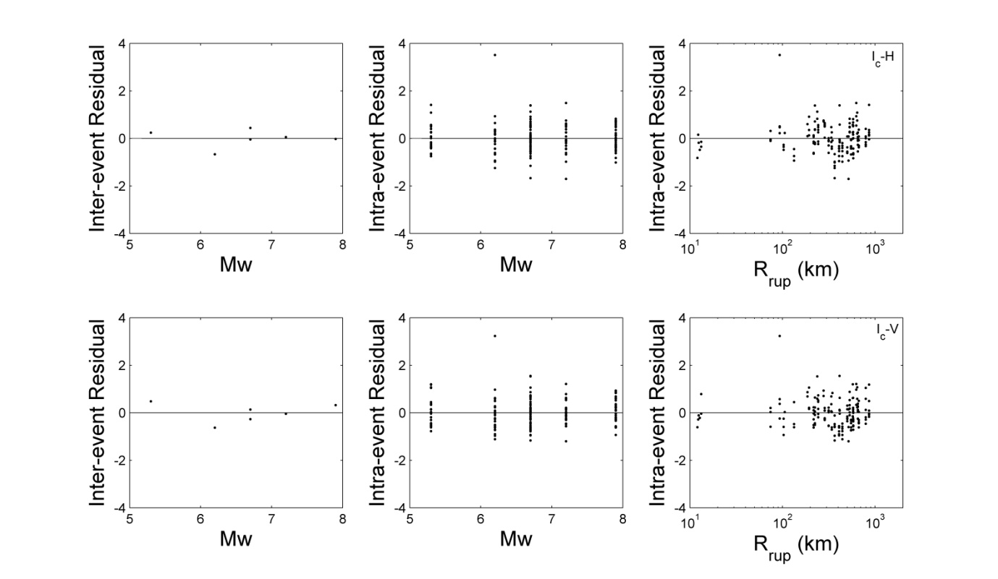Figure A7. [Continued] Interevent and intraevent residuals with respect to predictor variables: M_{w} and R_{rup}, for all GMPs. 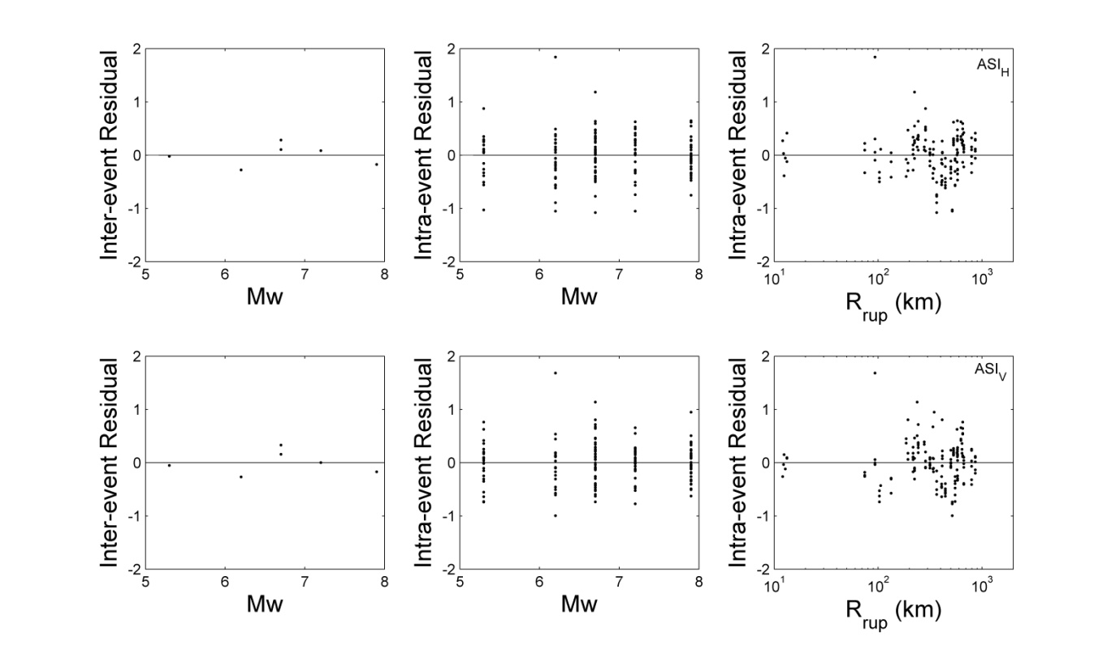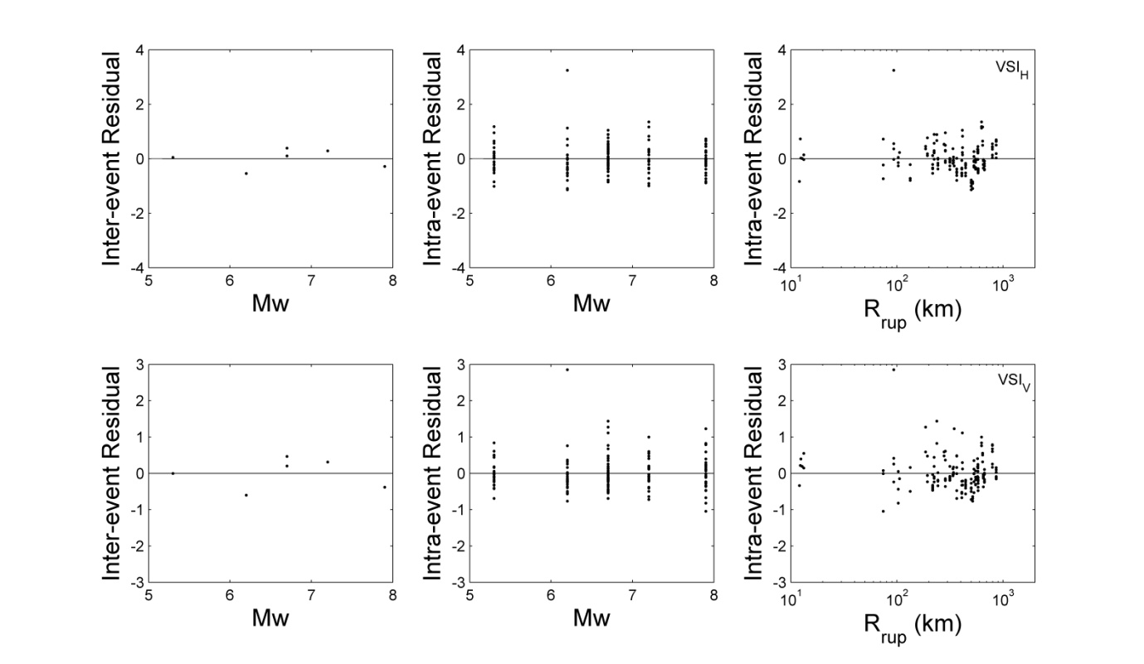

Figure A7. [Continued] Interevent and intraevent residuals with respect to predictor variables: M_{w} and R_{rup}, for all GMPs.
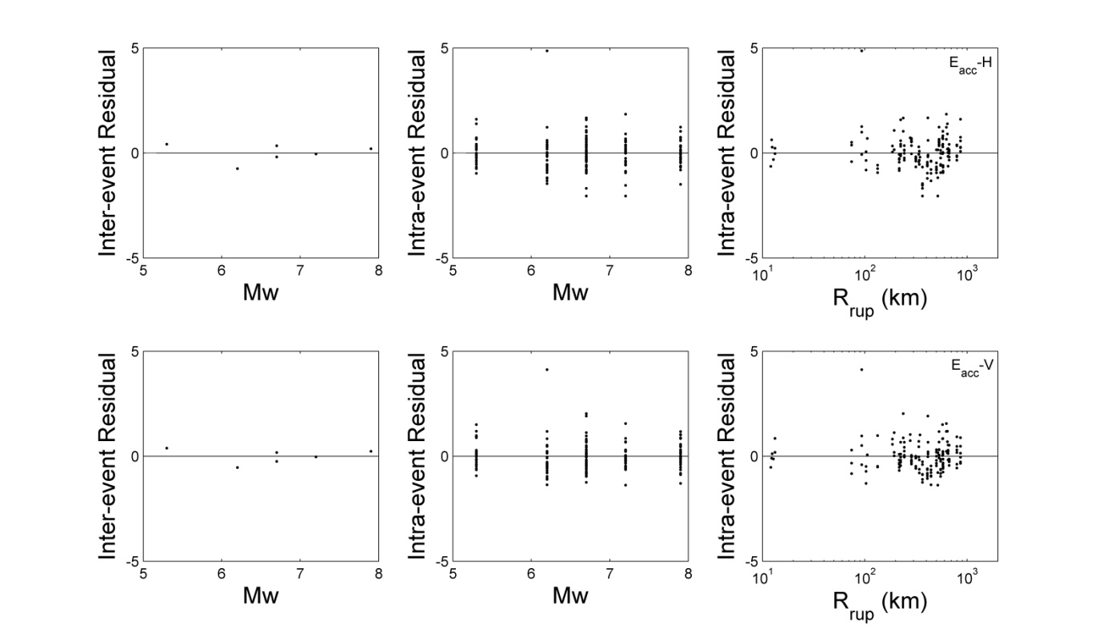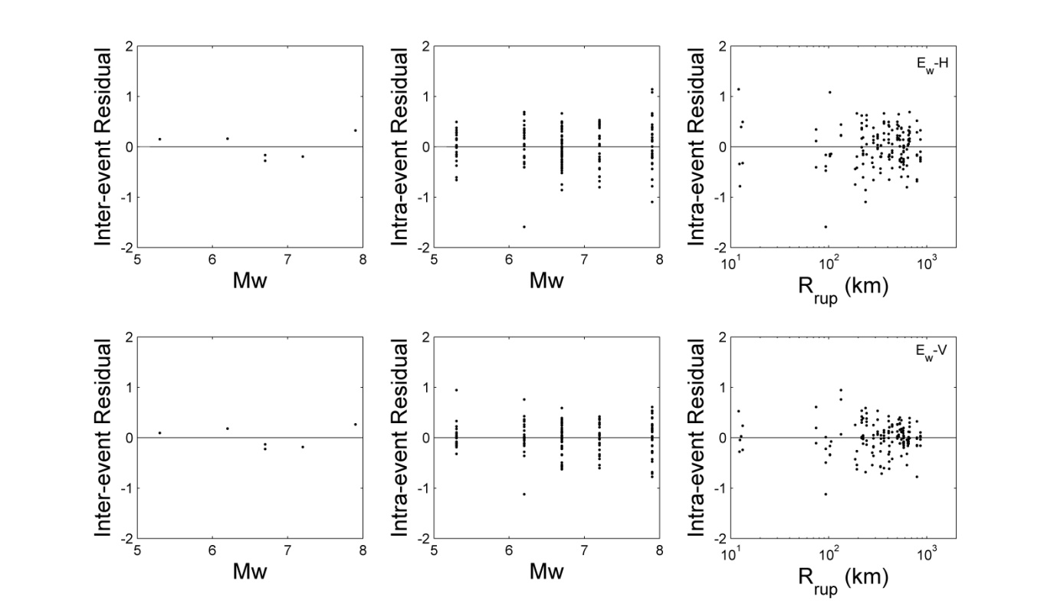Figure A7. [Continued] Interevent and intraevent residuals with respect to predictor variables: M_{w} and R_{rup}, for all GMPs.
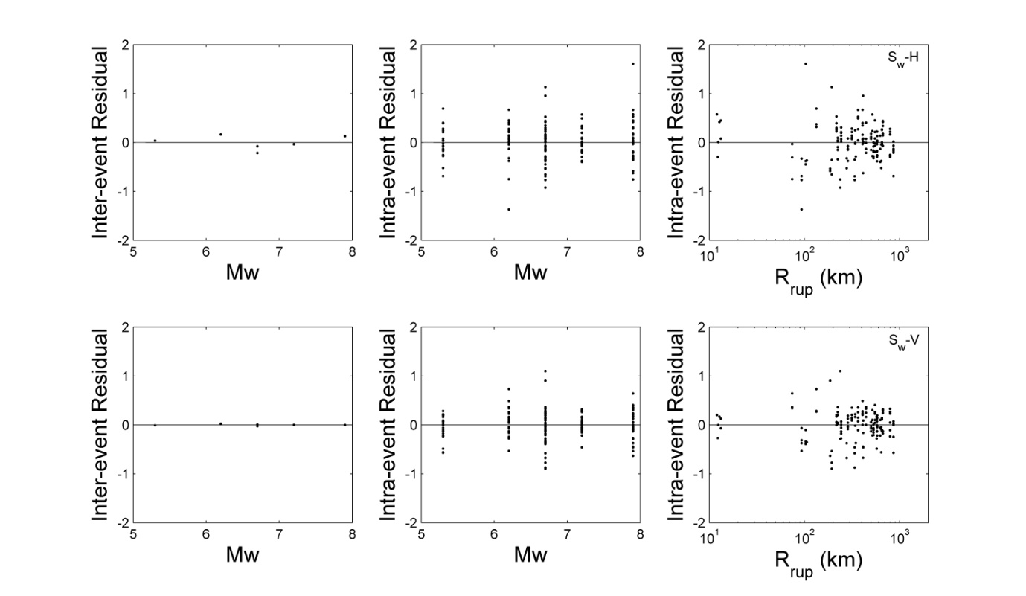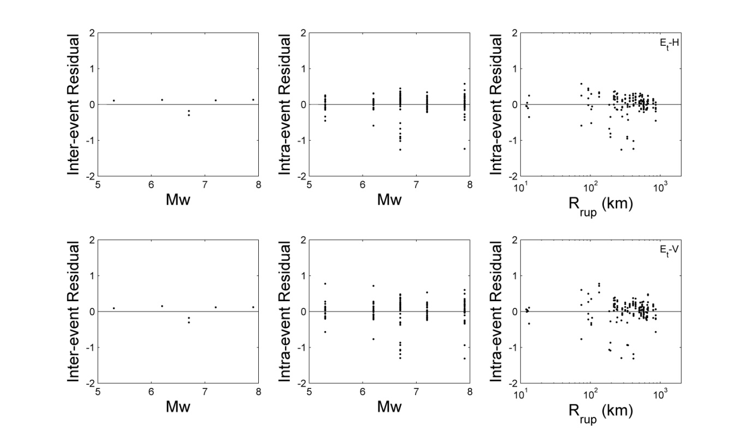Figure A7. [Continued] Interevent and intraevent residuals with respect to predictor variables: M_{w} and R_{rup}, for all GMPs.
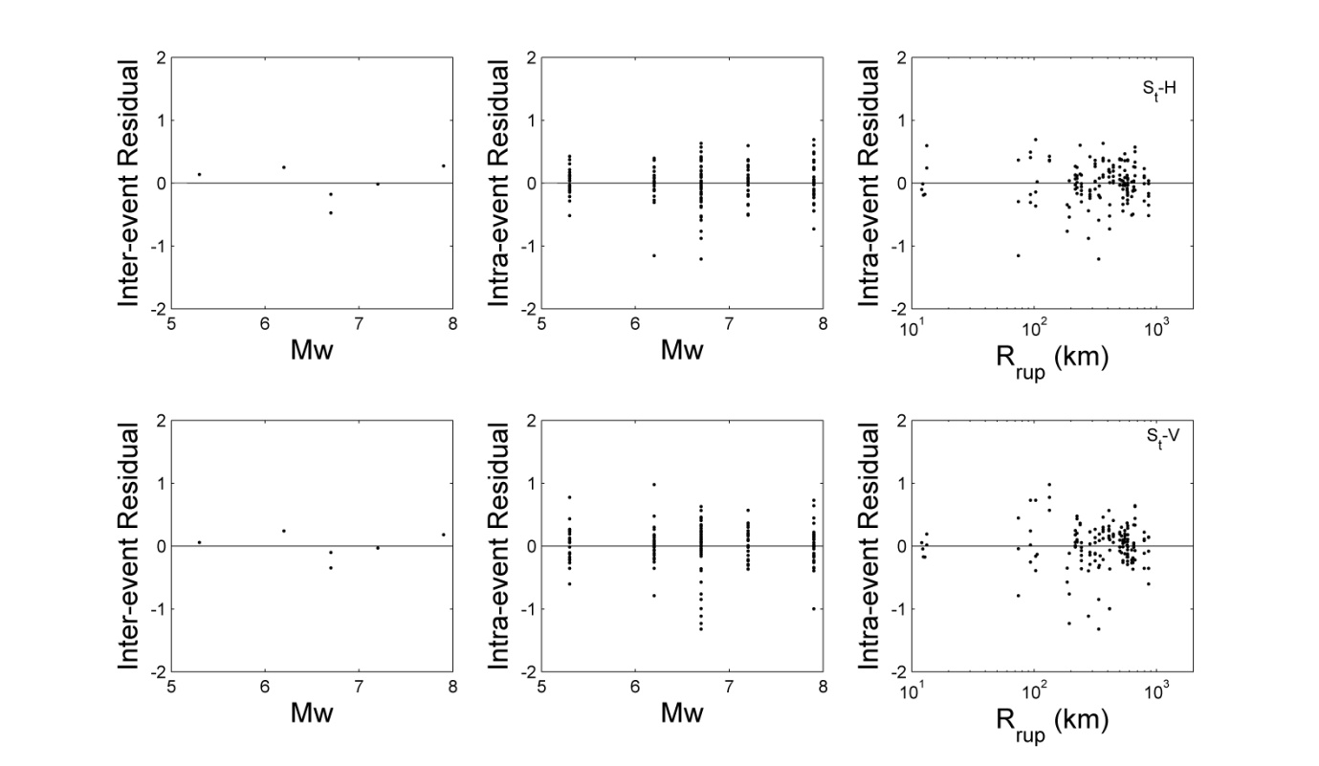
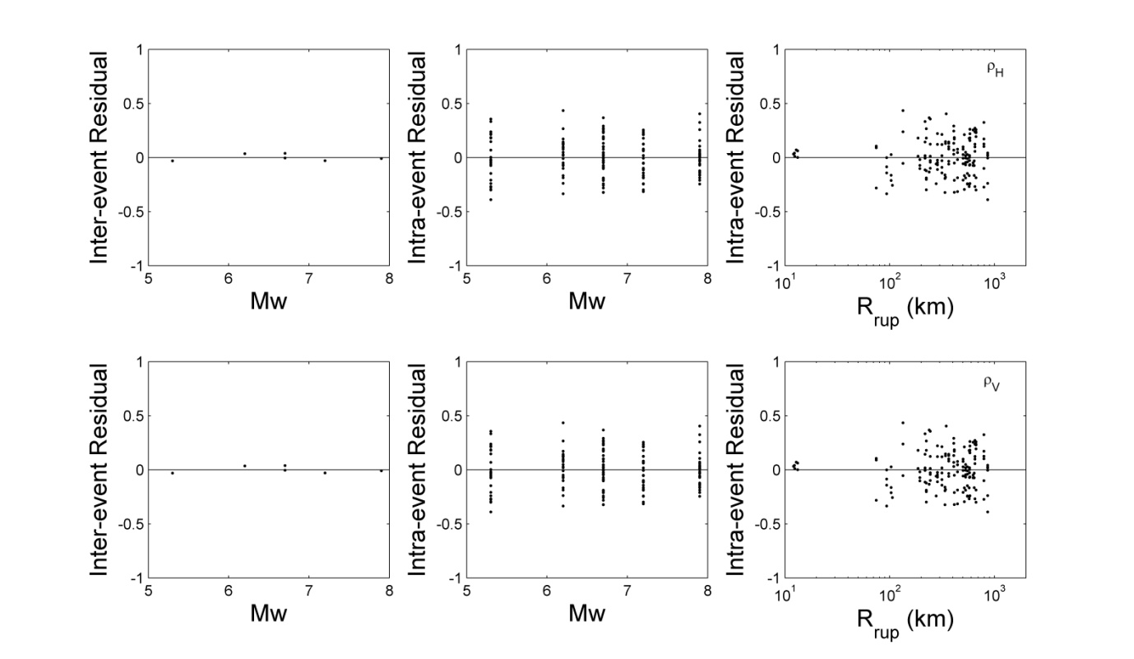
Figure A7. [Continued] Interevent and intraevent residuals with respect to predictor variables: M_{w} and R_{rup}, for all GMPs.

