CRISPR/Cas9 Mediated-Disruption of ZNF543 Gene: An Approach Towards Discovering Its Relation to TRIM28 Gene in Parkinson's Disease
Mohammad Hashemabadi¹ ², Hosseinali Sasan²*, Mojdeh Amandadi³, Keyvan Esmaeilzadeh-Salestani⁴ Saeed Esmaeili-Mahani², Hadi Ravan²
¹ Department of Biology, Faculty of Science, Shahid Bahonar University of Kerman, Kerman, Iran
² Department of Genetic, Faculty of Biological Science, Tarbiat modares University, Tehran, Iran
³ Department of Biochemistry, Faculty of Biological Science, Tarbiat Modares University, Tehran, Iran
⁴ Chair of Crop Science and Plant Biology, Institute of Agricultural and Environmental Sciences, Estonian University of Life Sciences, Fr. R.Kreutzwaldi 1, EE51014 Tartu, Estonia
* Corresponding Author
E-mail: Hsasa@uk.ac.ir

Name | Primers | Sequence (5’-3’) | Length (bp) | Target site | PAM
sgRNA1 | sgRNA-sence1 | CACCGAGGGCCGCCGCTTTACTAT | 24 | AGGGCCGCCGCTTTACTAT | GGG
sgRNA1 | sgRNA-antisence1 | AAACATAGTAAAGCGGCGGCCCTC | 24 | AGGGCCGCCGCTTTACTAT | GGG
sgRNA2 | sgRNA-sence2 | CACCGTAGGGCCGCCGCTTTACTA | 24 | TAGGGCCGCCGCTTTACTA | TGG
sgRNA2 | sgRNA-antisence2 | AAACTAGTAAAGCGGCGGCCCTAC | 24 | TAGGGCCGCCGCTTTACTA | TGG
sgRNA3 | sgRNA-sence3 | CACCGCACAAAGCGGGCGCAGCGT | 24 | CACAAAGCGGGCGCAGCGT | CGG
sgRNA3 | sgRNA-antisence3 | AAACACGCTGCGCCCGCTTTGTGC | 24 | CACAAAGCGGGCGCAGCGT | CGG
sgRNA4 | sgRNA-sence4 | CACCGCAAAGCGGGCGCAGCGTCG | 24 | CAAAGCGGGCGCAGCGTCG | GGG
sgRNA4 | sgRNA-antisence4 | AAACCGACGCTGCGCCCGCTTTGC | 24 | CAAAGCGGGCGCAGCGTCG | GGG
Table S1. Sequences of sgRNAs used in this study

Table S2. Sequences of primers used in this study
Primer name | Sequence (5’-3’) | Purpose | Product size (bp)
ZNF543-DF | AAAGGACCTTTCGACCCTCC | Used for T7-assay and detection of ZNF543 regulatory region delete mutation | 828
ZNF543-DR | TGTCGGAGGCCAACACTATT |  | 828
ZNF543-RTF | CTGAACGTGATGGTTTGGGG | Used for RT-PCR and real time PCR to evaluate mRNA expression of ZNF543 | 128
ZNF543-RTR | TTCGCGAATCAAGGCATCTG |  | 128
TRIM28-RTF | AGGATGCGAACCAGTGCT | Used for real time PCR to evaluate mRNA expression of TRIM28 | 150
TRIM28-RTR | AACCAGTAGAGCGCACAGTA | Used for real time PCR to evaluate mRNA expression of TRIM28 | 150
GAPDH-RTF | CCCTAGTCCCCAGAAACAGG | Used for real time PCR to evaluate mRNA expression of GAPDH as internal control | 79
GAPDH-RTR | TTCATTTCCTTCCCGGTTGC |  | 79
Vec-F | GAGGGCCTATTTCCCATGAT | Used for colony PCR which confirms exist of the target plasmid (pSpCas9 (BB)-2A-puro) | 400
Vec-R | CGCTAAAAACGGACTAGCCT |  | 400
Vec-F | GAGGGCCTATTTCCCATGAT | Used for colony PCR which confirms integration of antisense strands in target plasmid | 273
sgRNA-antisence1(R) | AAACATAGTAAAGCGGCGGCCCTC |  | 273
sgRNA-antisence2(R) | AAACTAGTAAAGCGGCGGCCCTAC |  | 273
sgRNA-antisence3(R) | AAACACGCTGCGCCCGCTTTGTGC |  | 273
sgRNA-antisence4(R) | AAACCGACGCTGCGCCCGCTTTGC |  | 273
sgRNA-sence1(F) | CACCGAGGGCCGCCGCTTTACTAT | Used for colony PCR which confirms integration of sense strands in target plasmid | 155
sgRNA-sence2(F) | CACCGTAGGGCCGCCGCTTTACTA |  | 155
sgRNA-sence3(F) | CACCGCACAAAGCGGGCGCAGCGT |  | 155
sgRNA-sence4(F) | CACCGCAAAGCGGGCGCAGCGTCG |  | 155
Vec-R | CGCTAAAAACGGACTAGCCT |  | 155

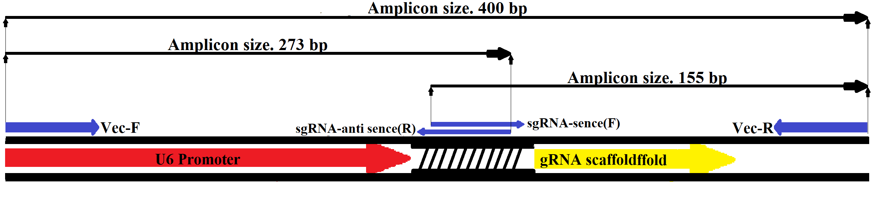
Figure S1. Schematic map of primers used in colony PCRs

