Allobacillus salarius sp. nov., and Allobacillus saliphilus sp. nov., isolated from shrimp paste (ka-pi) in Thailand

Supalurk Yiamsombut¹, Pawina Kanchanasin², Wongsakorn Phongsopitanun², Nattakorn Kuncharoen², Ancharida Savarajara¹, Wenyu Shi³, Linhuan Wu³, Juncai Ma³ and Somboon Tanasupawat²

¹Biotechnology Program and Department of Microbiology, Faculty of Sciences, Chulalongkorn University, Bangkok 10330, Thailand

²Department of Biochemistry and Microbiology, Faculty of Pharmaceutical Sciences, Chulalongkorn University, Bangkok 10330, Thailand

³World Data Center for Microorganisms (WDCM), Institute of Microbiology, Chinese Academy of Sciences, Beijing 100101, P.R. China

Author for correspondence: Somboon Tanasupawat. Tel +66-2-218-8376. Fax +66-2-254-5195, E-mail: Somboon.T@chula.ac.th

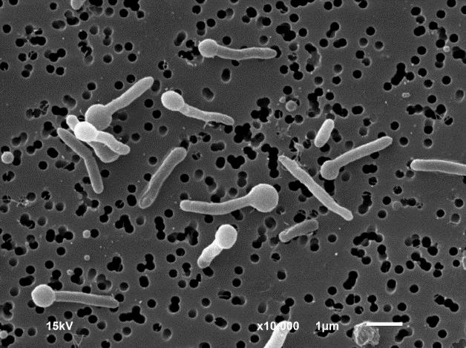
A
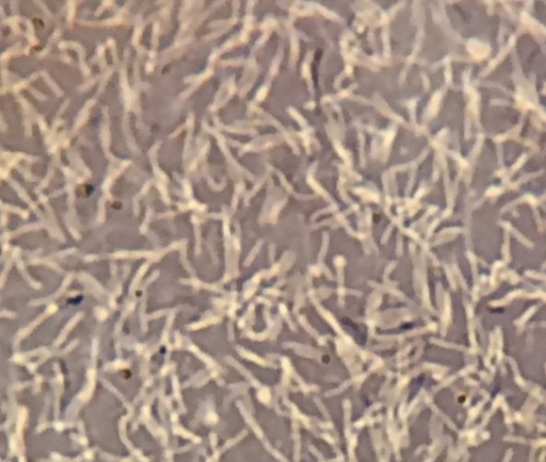
B
Supplementary Fig. S1 Scanning electron micrograph of terminal endospores of strain SKP4-8^{T} grown on modified JCM no.377agar plates incubated at 37°C for 2 days (A). Photomicrograph of terminal endospores of strain SKP8-2^{T} (nigrosin stain) grown on modified JCM no.377 agar plates incubated at 37°C for 3 days (B).

Supplementary Fig. S2 Polar lipid profiles of strain SKP4-8^{T} based on a two-dimensional thin-layer chromatograms that were detected with anisaldehyde, ninhydrin, Ditter & Lester, Drangendorff and phosphomolybdic acid as spraying reagent.
Abbreviations: PG, phosphotidylglycerol; DPG, diphosphatidylglycerol; PL1, PL2 and PL3 unknown phospholipids; GL, glycolipid.
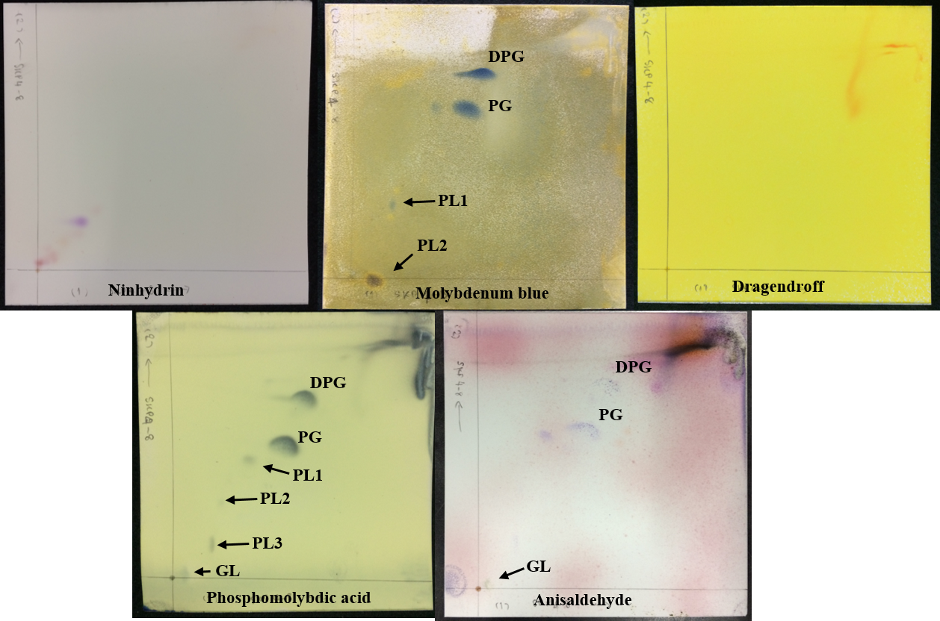

Supplementary Fig. S3 Polar lipid profiles of strain SKP8-2^{T} based on a two-dimensional thin-layer chromatograms that were detected with anisaldehyde, ninhydrin, Ditter & Lester, Drangendorff and phosphomolybdic acid as spraying reagent.
Abbreviations: PG, phosphotidylglycerol; DPG, diphosphatidylglycerol; PL1 and PL2 unknown phospholipids; GL, glycolipid.
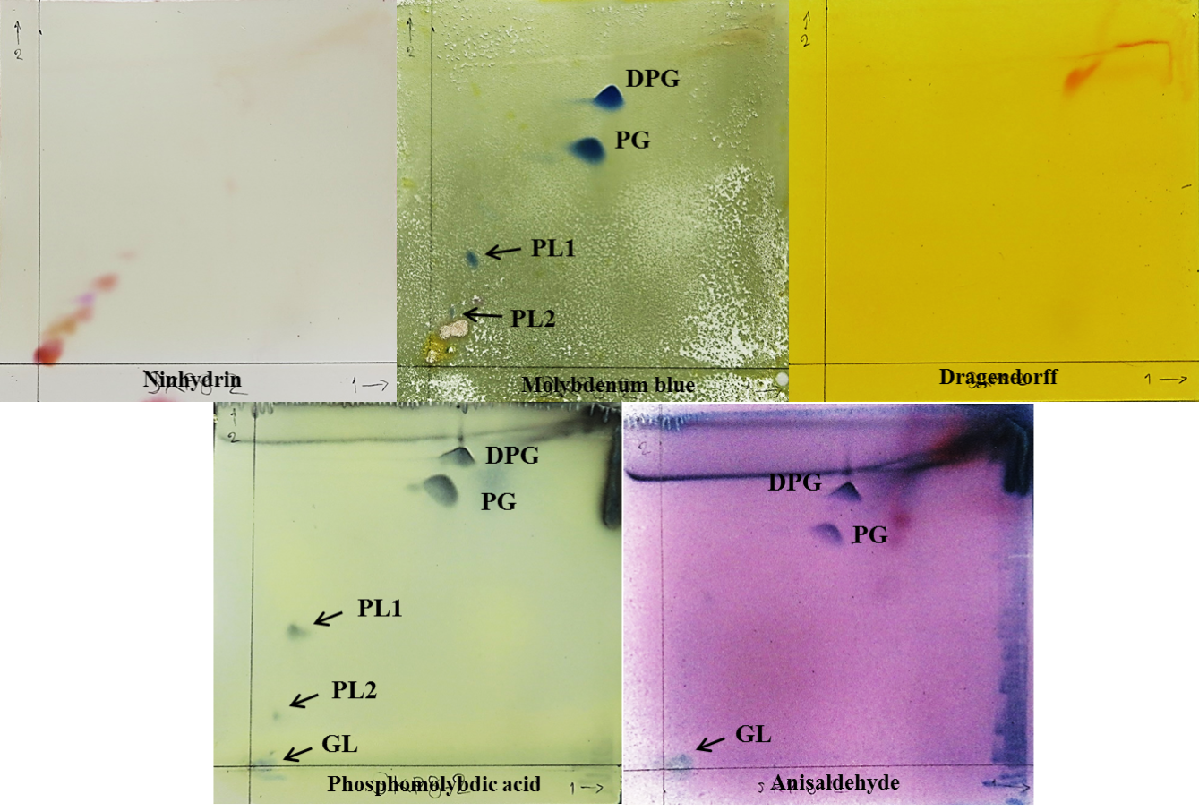

Supplementary Fig. S4 Maximum-likelihood tree based on 16S rRNA gene sequences showing the relationships between SKP4-8^{T}, SKP8-2^{T} and Alkalibacillus halotolerans LMG 24826^{T}. Bootstrap values (>50 %) based on 1000 replications are given at branch nodes. Bacillus taeanensis BH030017^{T} was used as an outgroup. Bar, 0.005 substitutions per nucleotide position.

Tenuibacillus multivorans NBRC 100370^{T} (AB681155)
Aquisalibacillus elongatus SH4s^{T} (AM911047)
Alkalibacillus filiformis 4AG^{T} (AJ493661)
Alkalibacillus silvisoli BM2^{T} (AB264528)
Halalkalibacillus halophilus BH2^{T} (AB264529)
Allobacillus halotolerans B3A^{T} (FJ347755)
Allobacillus salarius SKP4-8^{T} (LC215448)
Allobacillus saliphilus SKP8-2^{T} (LC215449)
Bacillus oryzaecorticis R1^{T} (KF548480)
Bacillus taeanensis BH030017^{T} (AY603978)
Ornithinibacillus contaminans CCUG 53201^{T} (FN597064)
Aquibacillus koreensis BH30097^{T} (AY616012)
99
99
100
81
92
83
89
0.0050

Supplementary Fig. S5 Maximum-parsimony tree based on 16S rRNA gene sequences showing the relationships between SKP4-8^{T}, SKP8-2^{T} and Alkalibacillus halotolerans LMG 24826^{T}. Bootstrap values (>50 %) based on 1000 replications are given at branch nodes. Bacillus taeanensis BH030017^{T} was used as an outgroup.

Ornithinibacillus contaminans CCUG 53201^{T} (FN597064)
Aquibacillus koreensis BH30097^{T} (AY616012)
Bacillus oryzaecorticis R1^{T} (KF548480)
Bacillus taeanensis BH030017^{T} (AY603978)
Allobacillus saliphilus SKP8-2^{T} (LC215449)
Allobacillus salarius SKP4-8^{T} (LC215448)
Allobacillus halotolerans B3A^{T} (FJ347755)
Halalkalibacillus halophilus BH2^{T} (AB264529)
Tenuibacillus multivorans NBRC 100370^{T} (AB681155)
Aquisalibacillus elongatus SH4s^{T} (AM911047)
Alkalibacillus filiformis 4AG^{T} (AJ493661)
Alkalibacillus silvisoli BM2^{T} (AB264528)
98
88
85
100
95
87
99

