Supplementary material
- Supplementary Figures

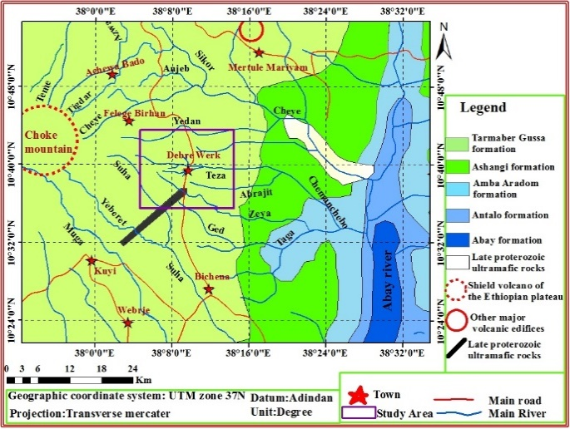
Figure SM1. General geology of the area (1:200,000) (modified after Mengesha et al.,1996)

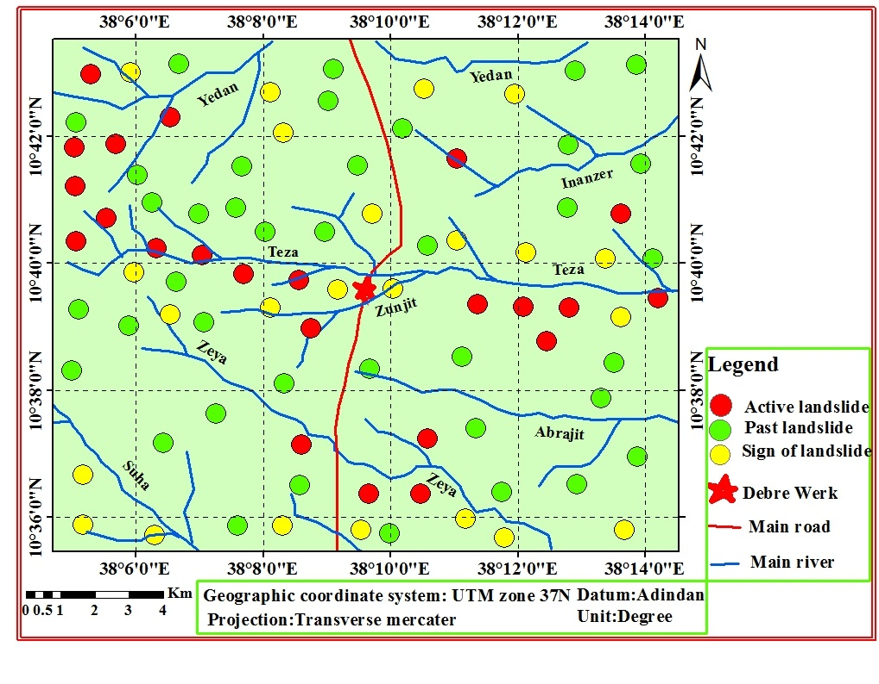
Figure SM2. Landslide inventory map of the study area

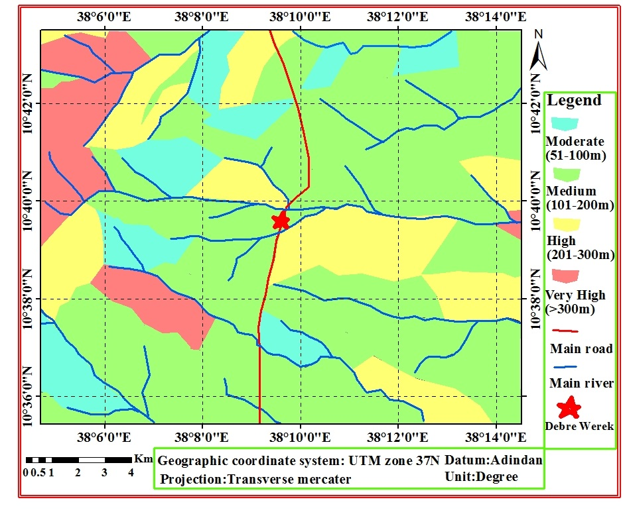
Figure SM3. Relative relief map

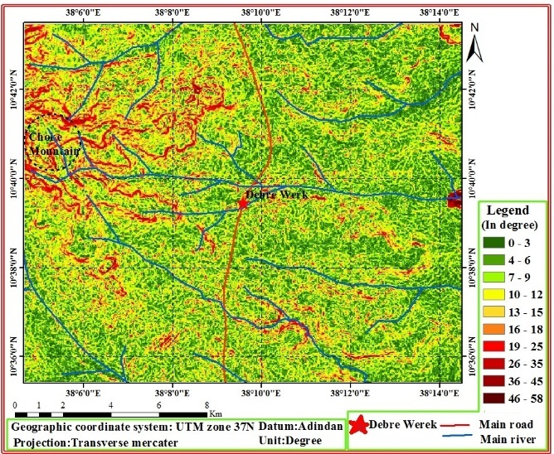
Figure SM4. Elevation map

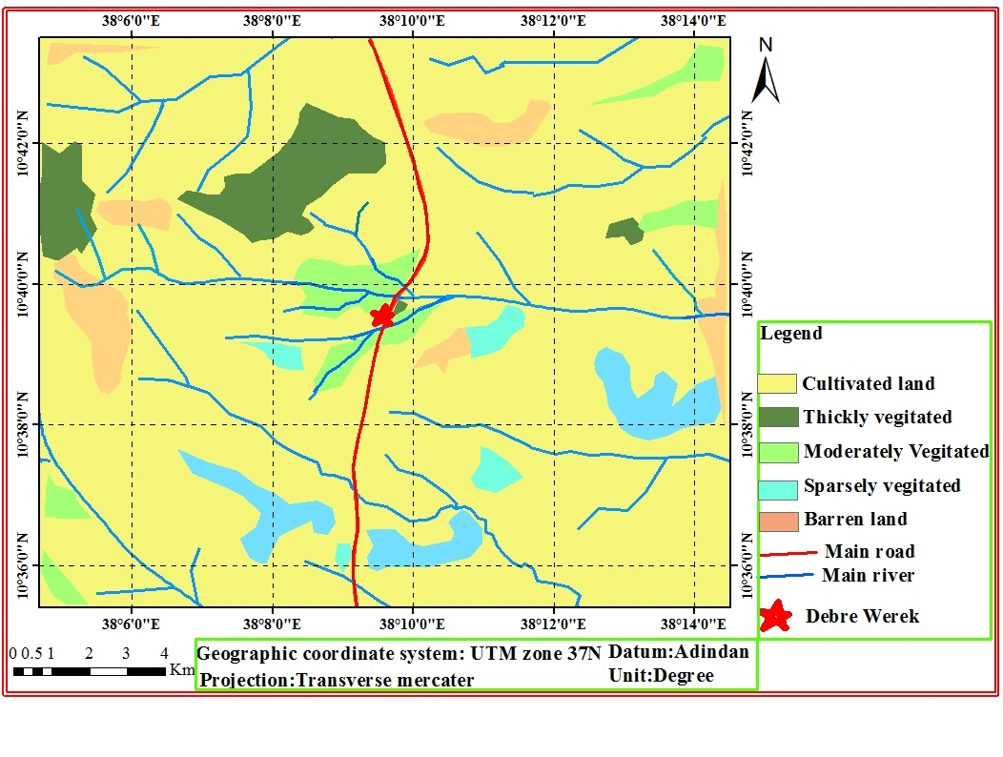
Figure SM5. Land use land cover map
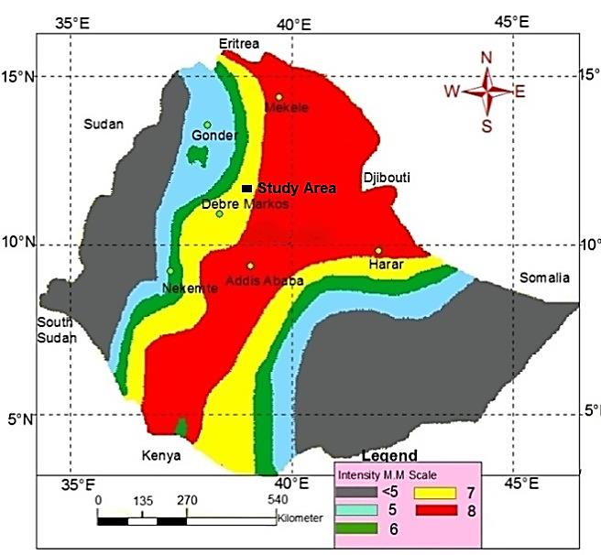 Figure SM6. Seismic risk map of Ethiopia 100-year return period, 0.99 probability (Modified after Laike Mariam Asfaw, 1986) | 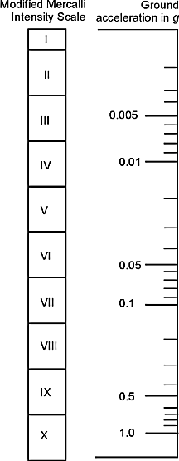  Figure SM7. Relationship between the intensity of earthquake and ground acceleration (Hays, 1980)
- Supplementary Tables

Table SM1. Distribution of maximum SSEP ratings assigned to various intrinsic and external causative parameters (Raghuvanshi et al., 2014).

Distribution of maximum SSEP ratings assigned to various intrinsic and external parameters
Slope Stability Susceptibility Evaluation Parameter |  | Maximum Rating
Intrinsic Parameters
Slope Geometry | Relative Relief | 1
Slope Geometry | Slope Morphometry | 2
Slope Material (rock and soil type) |  | 1
Structural Discontinuities |  | 2.5
Land use and landcover |  | 1.5
Groundwater |  | 2
External Triggering Parameters
Seismicity |  | 2
Rainfall |  | 1.5
Manmade Activities |  | 1.5
Total |  | 15

Table SM2. Slope stability vulnerability evaluation parameter rating for Relative relief (Raghuvanshi et al. 2014).
Relative Relief
Class | Value Range | Ratings
Very High | >300m | 1
High | 201-300m | 0.8
Medium | 101-200m | 0.6
Moderate | 51-100m | 0.2
Low | <50m | 0.1

Table SM3. Estimation of slope angle (Anbalagan, 1992)
a) Estimation of Slope Angle
Number of contour lines over one cm length (1: 50,000) | Slope Angle
>25 | >45⁰
19-25 | 36⁰-45⁰
13-18 | 26⁰-35⁰
8-12 | 16⁰-25⁰
<7 | <15⁰
Slope stability susceptibility evaluation parameter rating for slope morphometry.
b) Slope Morphometry
Class | Value Range | Rating
Escarpment/cliff | >45⁰ | 2
Steep slope | 36⁰-45⁰ | 1.7
Moderately steep slope | 26⁰-35⁰ | 1
Gentle slope | 16⁰-25⁰ | 0.6
Very gentle slope | <15⁰ | 0.3

Table SM4. Slope materials – Rock classes and corresponding ratings (Hoek and Brown, 1997)
Slope material
i. Rock type
 | class |  |  | Description | Rating
Grade I | Very weak rock |  |  | Strength: 1–5 MPa  Field estimate of strength: Crumbles under firm blows with the point of a geological hammer, can be peeled by a pocket knife. Examples: Highly weathered or altered rock | 1.0
Grade I | Weak rock |  |  | Strength: 5–25 MPa  Field estimate of strength: Can be peeled with a pocket knife with difficulty, shallow indentation made by a firm blow with the point of a geological hammer. Examples: Chalk, rock salt, potash | 0.8
Grade II | Medium-strong  rock |  |  | Strength: 25–50 MPa  Field estimate of strength: Cannot be scraped or peeled with a pocket knife, the specimen can be fractured with a single blow from a geological hammer. Examples: Claystone, coal, concrete, schist | 0.5
Grade II | Strong rock |  |  | Strength: 50–100 MPa  Field estimate of strength: Specimen needs more than one geological hammer blow to break. Examples: Limestone, marble, phyllite, sandstone, schist, shale | 0.4
Grade III | Very strong rock |  |  | Strength: 100–250 MPa  Field estimate of strength: Specimen requires several blows of a geological hammer to fracture it. Examples: Amphibolite, sandstone, basalt, gabbro, gneiss, granodiorite, limestone, marble, rhyolite, tuff | 0.3
Grade III | Extremely  strong |  |  | Strength: >250 MPa  Field estimate of strength: Specimen can only be chipped with a geological hammer. Examples: Fresh basalt, chert, diabase, gneiss, granite, quartzite | 0.1
The adjustment factor for weathering grade for rock mass
Weathering grade |  |  | Description |  | Rating
Fresh |  |  | No visible sign of weathering of rock material; probably minor slight discoloration on large discontinuity surfaces |  | 1.0
Slightly  weathered |  |  | Discoloration shows weathering of the rock material and discontinuity surfaces |  | 1.2
Moderately  weathered |  |  | Less than 35% of the rock material is decomposed and/or disintegrated into the soil. Fresh or discolored rock is present either as a continuous framework as a core stone |  | 1.5
Highly  weathered |  |  | More than 35% of the rock material is decomposed and/or disintegrated into the soil. Fresh or discolored rock is present either as a continuous framework as a core stone |  | 1.65
Extremely  weathered |  |  | All the rock material is decomposed and/or disintegrated into the soil. The original mass structure is still largely intact |  | 1.8
Residual soil |  |  | All the rock material is converted to soils, the mass structure and material fabrics are destroyed |  | 2.0
ii, Soil type
class |  | Description |  |  | Rating
Collapsible soil |  | The loose mix of granular material containing primarily sand and silt. Mainly non-cohesive material that can be suffused |  |  | 1.0
Alluvial deposits |  | Well graded material containing a mix of cobble/pebbles, sand, and silt in a matrix of clay |  |  | 0.8
Residual expansive soils |  | Mainly containing clay. Exhibits swelling when saturated and typical shrinkage cracks when dry |  |  | 0.6
Poorly graded colluvial  material |  | Poorly graded rounded to sub-rounded rock fragments/ cobble/ pebbles mixed in a matrix of fine-grained sand or silt |  |  | 0.5
Fluvio-glacial deposits |  | Well graded angular rock fragments mixed in a matrix of clayey material. The partial interlocking of angular rock fragments |  |  | 0.4
Well graded colluvial  material |  | Well graded angular to sub-angular rock fragments mixed in a matrix of clayey material. The partial or well interlocking of angular rock fragments |  |  | 0.3
Residual soils |  | Well compacted residual deposits of soil mainly comprising silt and clay |  |  | 0.2

Table SM5. Slope Stability Susceptibility Evaluation Parameter (SSEP) rating system for structural discontinuity (Raghuvanshi et al., 2014).

(i) The parallelism between discontinuities dip direction and slopes |  |  |  |  |  |  | ii) Relationship between dip of discontinuity and inclination of the slope
aj - as) or  (ai - as) | Rating | Planer Mode of Failure  (aj - as)  Wedge Mode of Failure  (ai - as) |  |  |  |  | βj - βs) or  (βi - βs) |  | Rating | Planer Mode of Failure  (βj - βs)  Wedge Mode of Failure  (βi - βs)
0⁰ | 0.5 | aj - Discontinuity dip direction |  |  |  |  | < (-10⁰) |  | 0.5 | βj - Dip of Discontinuity plane
1⁰-5⁰ | 0.4 | ai - Direction of line of intersection of two wedge forming discontinuities |  |  |  |  | 0⁰ - (- 10⁰) |  | 0.4
6⁰-10⁰ | 0.3 |  |  |  |  |  | 0⁰ |  | 0.2 | βi - Plunge of the line of intersection of two wedge forming discontinuities
11⁰-15⁰ | 0.25 |  |  |  |  |  | 10⁰ - 0⁰ |  | 0.15
16⁰-20⁰ | 0.2 | as - Direction of Slope inclination |  |  |  |  | >10⁰ |  | 0.1 | βs - Direction of Slope inclination
>20⁰ | 0.1 |  |  |  |  |  | (iii) The dip of discontinuity or plunge of the line of the intersection of wedge forming planes
(iv) Soil cover depth |  |  |  |  |  |  | (βi) or (βs) |  |  |  |  |  | Rating
Depth |  |  |  | Rating |  |  | 45⁰ |  |  |  |  |  | 0.5
>20m |  |  |  | 2.5 |  |  | 45⁰-35⁰ |  |  |  |  |  | 0.4
20-15m |  |  |  | 1.8 |  |  | 34⁰-30⁰ |  |  |  |  |  | 0.25
14-10m |  |  |  | 1.4 |  |  | 29⁰-20⁰ |  |  |  |  |  | 0.15
9-5m |  |  |  | 1 |  |  | <20⁰ |  |  |  |  |  | 0.1
<5m |  |  |  | 0.5
(v) Structural discontinuities and rock mass condition***
Condition |  |  |  |  |  |  |  |  |  |  |  | Rating
Disintegrated – poorly interlocked heavily broken rock mass with a mixture of angular and rounded rock pieces. |  |  |  |  |  |  |  |  |  |  |  | 0.25
Blocky/ Disturbed – folded and/or faulted with angular blocks formed by many intersecting discontinuity sets. |  |  |  |  |  |  |  |  |  |  |  | 0.2
Very Blocky – interlocked, partially disturbed rock mass with multifaceted angular blocks formed by four or more discontinuity sets. |  |  |  |  |  |  |  |  |  |  |  | 0.1
Blocky – very well interlocked undisturbed rock mass consisting of cubical blocks formed by three orthogonal discontinuity sets. |  |  |  |  |  |  |  |  |  |  |  | 0.05
(vi) Characteristics of structural discontinuity
Continuity |  |  | Rating |  | Separation | Rating |  | Roughness |  | Rating | Infilling |  |  | Rating
<1m |  |  | 0.02 |  | None | 0.02 |  | Very rough |  | 0.02 | None |  |  | 0.02
1-2m |  |  | 0.04 |  | < 0.1mm | 0.05 |  | Rough |  | 0.03 | Hard filling < 5mm |  |  | 0.04
3-9m |  |  | 0.07 |  | 0.1 - 0.9mm | 0.07 |  | Slightly rough |  | 0.07 | Hard filling > 5mm |  |  | 0.07
10-20m |  |  | 0.1 |  | 1 - 5mm | 0.12 |  | Smooth |  | 0.1 | Soft filling < 5mm |  |  | 0.12
>20m |  |  | 0.15 |  | > 5mm | 0.15 |  | Slickensided |  | 0.15 | Soft filling > 5mm |  |  | 0.15
Weathering |  |  | Rating |  | (Hoek and Bray 1997)
Unweathered |  |  | 0.02
Slightly weathered |  |  | 0.05
Moderately weathered |  |  | 0.07
Highly weathered |  |  | 0.1
Decomposed |  |  | 0.15

Table SM6. Slope Stability Susceptibility Evaluation Parameter (SSEP) rating system for land use and land cover (Raghuvanshi et al., 2014).

(e) Land-use and Land-cover
Class / Description | Rating
Barren land - No vegetation, land not used for any activity | 1.5
Sparsely vegetated - Very thin scattered vegetation in the form of wild grass, bushes, scrub, and random | 1.2
Moderately vegetated area - Moderately covered vegetation land in the form of wild grass, scrub, and trees | 0.75
Thickly vegetated forest area - Dense forest area with thick vegetation cover. | 0.4
Cultivated land with a populated area | 0.4

Table SM7. Slope Stability Susceptibility Evaluation Parameter (SSEP) rating system for groundwater (Raghuvanshi et al., 2014).

(f) Ground Water
Surface traces of groundwater | Ratings
Flowing – the presence of spring on the slope face | 2
Dripping – dripping of water through structural discontinuities. | 1.5
Wet – watermarks on the rock surface, some droplets along structural discontinuities, algal growth in shadow areas. | 1
Damp – Moist conditions on rock face surface, moss, and algal growth in shadow areas. | 0.6
Dry – rock face surface is dry, no water traces along structural discontinuity surfaces | 0

Table SM8. Slope Stability Susceptibility Evaluation Parameter (SSEP) rating system for eternal Parameters (Raghuvanshi et al., 2014).

(a) Rain Fall |  |  |  | (b) Seismicity
(i) Mean annual rainfall (mm) |  |  |  | Ground acceleration |  | Rating
Class | Mean annual rainfall (mm) |  | Rating | 1 - 0.5g |  | 2.0
Very High | > 1500 |  | 0.75 | 0.5 - 0.1g |  | 1.5
High | 1101 - 1500 |  | 0.60 | 0.1 - 0.05g |  | 1.0
Moderate | 701 -1100 |  | 0.30 | 0.05 - 0.01g |  | 0.8
Low | 300 - 700 |  | 0.20 | 0.01 - 0.005g |  | 0.4
Very low | < 300 |  | 0.10 | < 0.005g |  | 0.4
(ii) Rainfall induced manifestations on the slope
Surface Traces |  |  |  |  |  | Rating
Slope Toe erosion – The toe of the slope is eroded by streamflow, Surface material overhangs, and prone to failure. |  |  |  |  |  | 0.25
Streambank erosion – Stream water has undercut the banks and made the sides of the slope hang. |  |  |  |  |  | 0.15
Gully erosion over the slope face |  |  |  |  |  | 0.10
No Rain induced manifestation on the slope |  |  |  |  |  | 0.00
(iii) Slope Material
Description |  |  |  |  |  | Rating
Soil mass – Rainfall will saturate soil mass and pore water pressures will develop. |  |  |  |  |  | 0.25
Disintegrated – heavily broken rock mass. Much of the rainwater will seep into the rock mass and will recharge groundwater considerably. |  |  |  |  |  | 0.2
Blocky/ Disturbed – folded and/or faulted with angular blocks formed by many intersecting discontinuity sets. |  |  |  |  |  | 0.15
Very Blocky – Partially disturbed rock mass having four or more discontinuity sets. |  |  |  |  |  | 0.1
Blocky – Undisturbed rock mass consisting of cubical blocks formed by three orthogonal discontinuity sets. |  |  |  |  |  | 0.05
(iv) Discontinuity Orientation with respect to slope
Soil Mass |  |  |  |  |  | 0.25
More than one discontinuity dipping into the hill or the bedding joint/discontinuity dipping into the hill. |  |  |  |  |  | 0.25
At least one discontinuity dipping into the hill. Which may or may not be a bedding joint. |  |  |  |  |  | 0.12
None of the discontinuities dips into the hill. |  |  |  |  |  | 0.00
The rainfall adjustment factor for slope morphometry #
Class |  | Value Range |  |  | Adjustment factor
Escarpment/cliff |  | > 45⁰ |  |  | 0.1
Steep slope |  | 35⁰ - 45⁰ |  |  | 0.3
Moderately steep slope |  | 25⁰ - 35⁰ |  |  | 0.5
Gentle slope |  | 15⁰ - 25⁰ |  |  | 0.8
Very gentle slope |  | < 15⁰ |  |  | 1.0
# Rainfall adjustment factor for slope morphometry has to be multiplied with the Rainfall rating after summing up (i, ii, iii, and iv).

Table SM9. Manmade activities and related ratings (Raghuvanshi et al., 2014).

Description | Rating
(a) Developmental activities
Steep soil mass cut (slope > 45_). Slope overhangs | 1.25
Moderate steep soil mass cut (slope 35–45_) | 1.0
Soil mass cut into the gentle slope (slope < 35_) | 0.75
Steep rock mass cut (slope > 45_). Slope overhangs | 1.0
Moderate steep rock mass cut (slope 35–45_) | 0.75
Rock mass cut into the gentle slope (slope < 35_) | 0.5
Description | Adjustment Factor a
The adjustment factor for developmental activities a
Slope toe supported by retaining structure | 0.15
Proper drainage system provided | 0.1
Slope face dressing into terrace design | 0.1
Excavated material not dumped over the downslope | 0.1
Description | Rating
(b) Cultivation activities
Sparsely cultivated land with a small populated area | 0.1
Moderately cultivated land with a medium populated area | 0.15
Densely cultivated land with a largely populated area | 0.25
Irrigation practice | rating
The adjustment factor for irrigation b
Rainfed irrigation | 0.75
Unplanned irrigation | 0.5
Channelized planned | 1.0
a. The adjustment factor for developmental activities has to be subtracted from the rating of development activity.
b. Multiply adjustment factor for irrigation with ratings of cultivated land.

Table SM10. Seismicity and corresponding ratings (Raghuvanshi et al., 2014).

Ground acceleration a | Rating
1.0–0.5g | 2.0
0.5–0.1g | 1.5
0.1–0.05g | 1.0
0.05–0.01g | 0.8
0.01–0.005g | 0.4
<0.005g | 0.2
- For ground acceleration estimation refer to Hays's (1980) relation and seismic intensity map of the area.

