Sporolactobacillus fermentans sp. nov, an obligately anaerobic and lactic acid bacterium isolated from pit mud

1.1 Author names
Guangbin Ye ^{1,2*}, Xun Liu^{1,3}, Caiyu Zeng^{1,3} and Xiang Zeng^{1,3,4*}
- Guangbin Ye https://orcid.org/0000-0001-8690-1579
- Xun Liu https://orcid.org/0009-0007-9928-9527
- Caiyu Zeng https://orcid.org/0000-0001-7033-5138
- Xiang Zeng https://orcid.org/0000-0001-6662-4551

1.2Affiliation
¹School of Food and Liquor engineering, Sichuan University of Science & Engineering, No.1, Baita Road, Sanjiang New Area, Yibin 644000, Sichuan, PR China
²Liquor Science and Technology Key Laboratory of Sichuan Province, Sichuan University of Science & Engineering, No.1, Baita Road, Sanjiang New Area,Yibin 644000, SiChuan, PR China
³Key Laboratory of Marine Genetic Resources, Third Institute of Oceanography, Ministry of Natural Resources, No. 184, Daxue Road, Siming District, Xiamen 361005, Fujian, PR China
⁴Faculty of Marine Biology, Xiamen Ocean Vocational College, Xiamen 361100, Fujian, PR China

1.3 Corresponding author and email address
*Ye Guangbin, guangbin1980@suse.edu.cn
*Zeng Xiang, zengxiang@tio.org.cn

Fig S1. Gram-stained cells of strain CQH2019^{T} under light microscopy (a) and under transmission electron microscopy (b).
(a)Microscopy images showing Gram-positive stained cells and spores of strain CQH2019^{T}(100-fold)
(b)Microscopy images showing cells of strain CQH2019^{T}, transmission electron microscopy images using 6000-fold magnification.

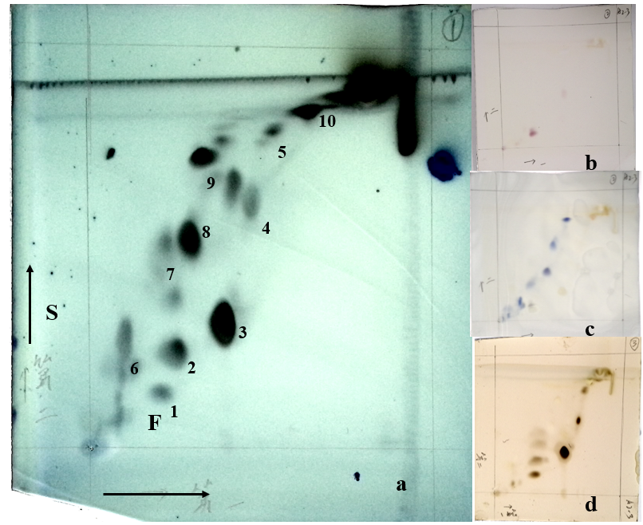

Fig S2. The major polar lipids profile of CQH2019^{T}.
(a)10% phosphomolybdic acid staining; (b) ninhydrin staining; (c) ninhydrin-molybdenum blue staining; (d) Staining with α-naphthol reagent.

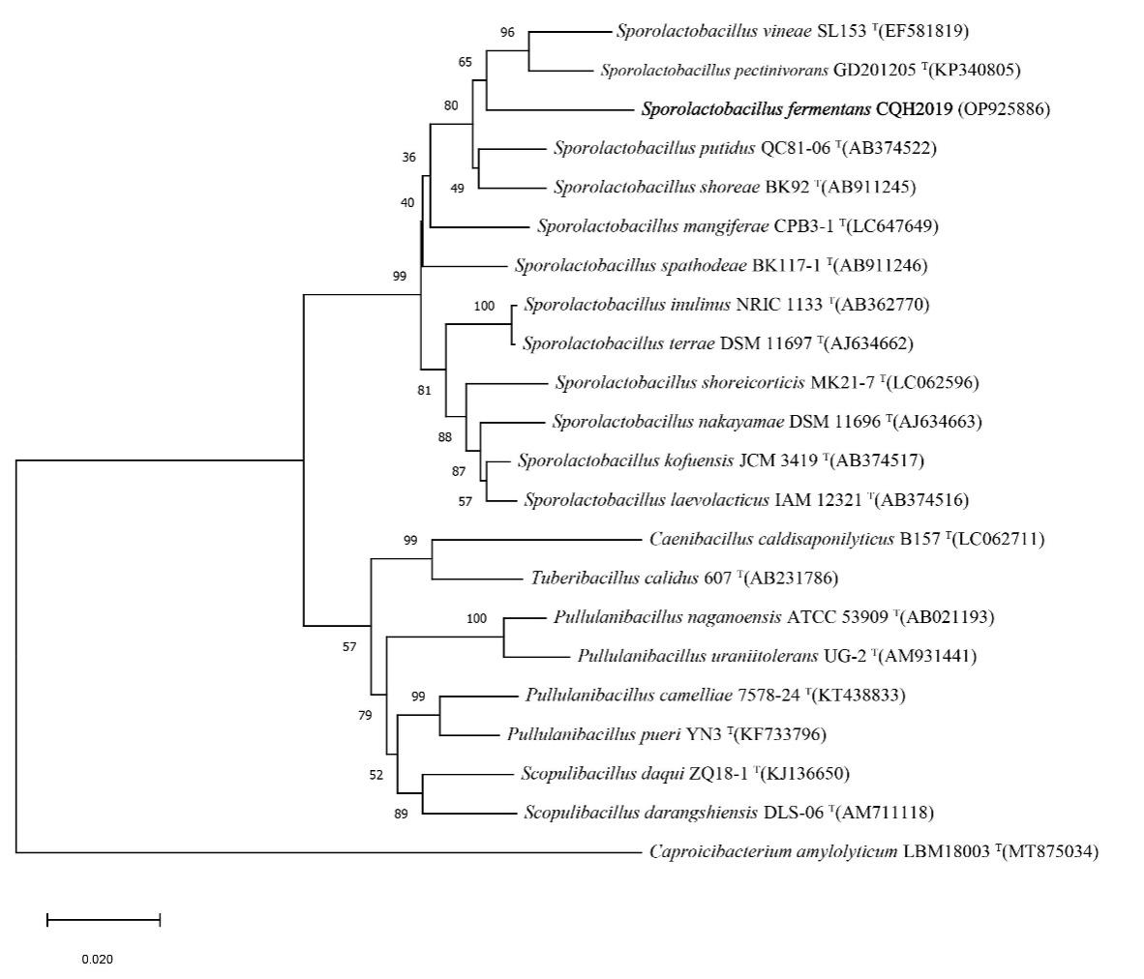

Fig S3. Phylogenetic tree (constructed using the minimum-evolution) showing the position of strain CQH2019^{T} in the Sporolactobacillus cluster based on 16S rRNA gene sequences (OP925886). Caproicibacterium amylolyticum LBM18003^{T} (MT875034) served as an outgroup. The numbers indicate the percentage of 1000 replicated bootstrap samplings. Bar, 0.02 substitutions per nucleotide position

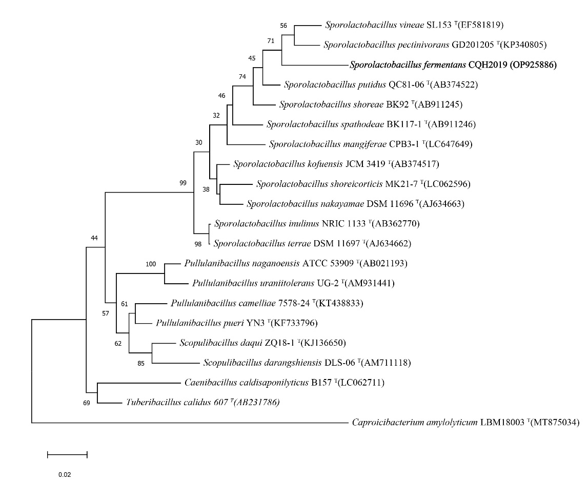
Fig S4. Phylogenetic tree (constructed using the maximum-likelihood) showing the position of strain CQH2019^{T} in the Sporolactobacillus cluster based on 16S rRNA gene sequences (OP925886). Caproicibacterium amylolyticum LBM18003^{T} (MT875034) served as an outgroup. The numbers indicate the percentage of 1000 replicated bootstrap samplings. Bar, 0.02 substitutions per nucleotide position

Table S1. Cellular fatty acid contents (percentages) of strain CQH2019^{T} and type strains of related species.
Strain：1, CQH2019^{T}; 2, S. putidus QC81-06 ^{T}; 3,S. pectinivorans GD201205^{T}; 4, S. vineae SL153^{T}; 5, S. shoreae BK92^{T}
-, not detected. *, data come from(Lan, Chen, Lin, Ye, Yan, Huang, Liu, Yang, 2016);
*;** data come from (Chang, Jung, Park, Oh, 2008); *** data come from(Thamacharoensuk, Kitahara, Ohkuma, Thongchul, Tanasupawat, 2015)
Fatty Acid | 1 | 2* | 3* | 4** | 5***
C_{16:0} | 17.47 | 4.4 | 5.66 | 6.7 | 5.8
C_{18:0} | 0.67 | - | 0.89 | 2.1 | -
C_{16:0}ALDE | - | - | - | - | -
Iso-C_{15:0} | 5.72 | 4.2 | 12.62 | 5.2 | 4.5
Iso-C_{16:0} | 2.76 | 5.1 | 4.90 | 3.1 | 5.0
Iso-C_{17:0} | 2.51 | 5.1 | 4.32 | 5.8 | 3.4
Antiso-C_{15:0} | 14.42 | 12.7 | 22.02 | 12.1 | 11.6
Antiso-C_{17:0} | 29.95 | 65.8 | 42.23 | 61.0 | 61.5
C_{16:1}ω9c | 5.22 | - | - | - | -

Table S2. Compare the 16S rRNA gene sequence similarity, genome size, DNA G+C content, average nucleotide identity (ANI), average amino acid identity (AAI), and the digital DNA-DNA hybridization (dDDH) values measured between strain CQH2019^{T} and its closely related type strains.
Strain | 16S similarity(%) | Genome  size(bp) | DNA G+C  content  (mol%) | ANI(%) | AAIb(%) | dDDH(%)
CQH2019^{T} | - | 4513405 | 47.58 | - | - | -
S. putidus QC81-06^{T} | 95.74 | 3474957 | 47.5 | 82.58 | 82.78 | 26.8
S. vineae SL153^{T} | 95.74 | 3909905 | 48.7 | 71.55 | 68.42 | 19.9
S.pectinivorans GD201205^{T} | 95.38 | 2973984 | 50.6 | 72.41 | 70.29 | 19.9
S. shoreae BK92^{T} | 95.19 | 3654538 | 46.6 | 72.12 | 69.75 | 19.3

Table S3. The gene of catalase, superoxide dismutase (SOD) and peroxidase possessed by CQH2019^{T} and its four similar species, corresponding enzyme numbers are listed in the table above. −, not detected.

Characteristic | Catalase | Superoxide dismutase (SOD) | Peroxidase
CQH2019^{T} | (EC 1.11.1.6) | (EC 1.15.1.2)  (EC 1.15.1.1) | (EC 1.11.1.10)  (EC 1.11.1.15)
S. putidus  QC81-06^{T} | - | (EC 1.15.1.1) | (EC 1.11.1.15)
S. pectinivorans GD201205^{T} | (EC 1.11.1.6) | (EC 1.15.1.1) | (EC 1.11.1.10)  (EC 1.11.1.15)
S. vineae  SL153^{T} | (EC 1.11.1.6) | (EC 1.15.1.1) | (EC 1.11.1.15)
S. shoreae  BK92^{T} | (EC 1.11.1.6) | (EC 1.15.1.1) | (EC 1.11.1.10)  (EC 1.11.1.15)

