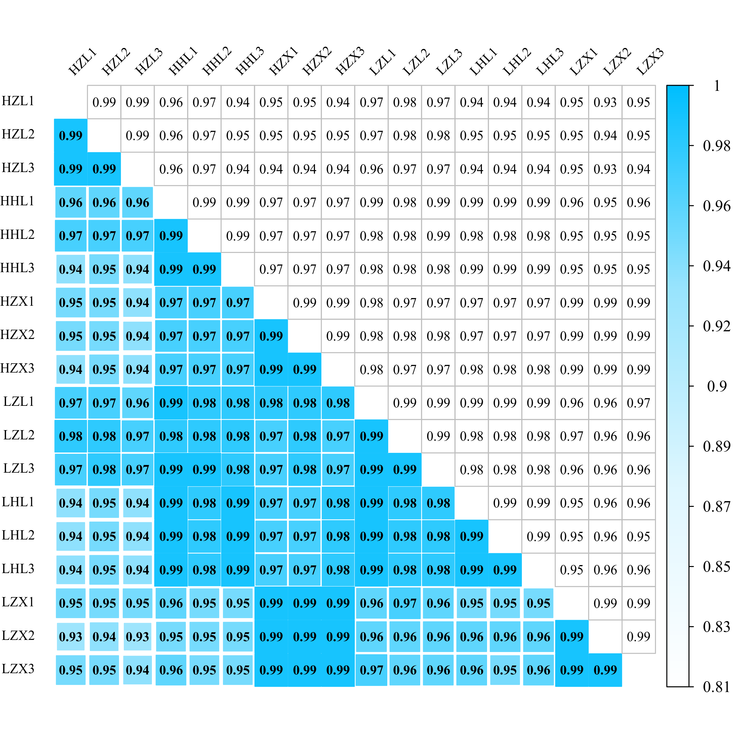
FIGURE S1 Correlation heatmap of FPKM of 18 samples.

