SUPPLEMENTARY
Performance and Mechanism of Sulfathiazole Adsorption by Magnetic Biochar: Promoting Effect of Co-existing Polystyrene and Simultaneous Removal
Xilong Zhang ª, Zihan Tang ª, Fei Liu ª, Xiuping Hong ª, Yingying Zhang ª, Ting Fang ^{b,*}, Rongjian Fan ^{c}, Xin Wang ^{a,}*

ª College of Life Sciences, Huaibei Normal University, Huaibei 235000, China
^{b} Fisheries Research Institute, Anhui Academy of Agricultural Sciences, Hefei 230000, China
^{c} Chongqing Xianjia Environmental Protection Technology Co., Ltd., Chongqing 400000, China
*Corresponding authors. E-mail addresses: wangxinhello@126.com (X. Wang), fangting_candy@163.com (T. Fang).

Figure S1 The EDS spectra image analysis of PS.
Figure S2 Surface electrostatic potential of the STZ molecule.
Figure S3 Surface electrostatic potential of the PS molecule.
Table S1 The fitting results of pseudo-first-order model, pseudo-second-order model, Elovich model and particle internal diffusion model.
Table S2 The fitting results of Langmuir model, Freundlich model, Sips.
Table S3 PS, STZ HOMO, LUMO energy and △E.
Table S4 Fukui index distribution for electrophilic attack (f⁻),nucleophilic (f⁺), and radical attack( f⁰) for STZ.
Table S5 Fukui index distribution for electrophilic attack (f⁻),nucleophilic (f⁺), and radical attack( f⁰) for PS.

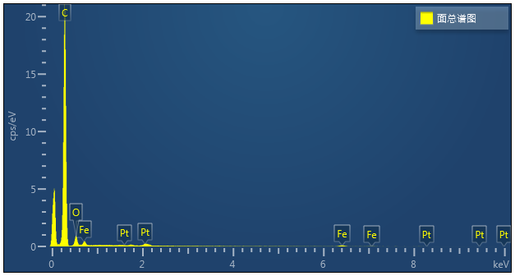

Figure S1 The EDS spectra image analysis of PS.

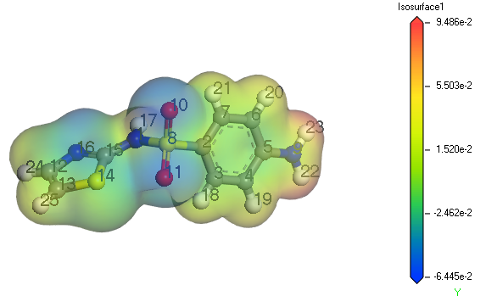
Figure S2 Surface electrostatic potential of the STZ molecule.

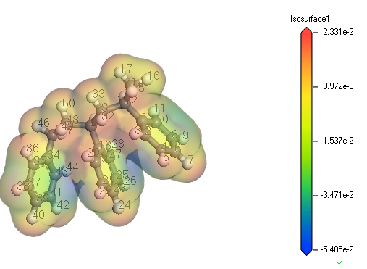

Figure S3 Surface electrostatic potential of the PS molecule.

Table S1 The fitting results of pseudo-first-order model, pseudo-second-order model, Elovich model and particle internal diffusion model.
Sample | Pseudo-first-order model |  |  | Pseudo-second-order model |  |  | Elovich model |  |  | Intra-particle diffusion model
Sample | Q_{e} | k_{f} | R² | Q_{e} | k_{s} | R² | α | 1/β | R² | k₁ | k₂ | k₃
Sample | mg·g⁻¹ | min⁻¹ | R² | mg·g⁻¹ | g·(mg·min)⁻¹ | R² | mg·(g min)⁻¹ | g·mg⁻¹ | R² | mg·(g·t^{0.5})⁻¹ | mg·(g·t^{0.5})⁻¹ | mg·(g·t^{0.5})⁻¹
PS-S | 951.09 | 1.49E-02 | 0.9868 | 1175.61 | 1.32E-05 | 0.9779 | 29.059 | 0.00323 | 0.95942 | 81.00143 | 76.30584 | 0.46976
PS-C | 957.11 | 5.42E-02 | 0.9787 | 1041.24 | 7.90E-05 | 0.9859 | 313.969 | 0.00606 | 0.9876 | 118.5186 | 49.93691 | 0.7992
STZ-S | 40.00 | 2.25E-01 | 0.9993 | 40.62 | 1.89E-02 | 0.9998 | 2.45E+12 | 0.82966 | 0.997 | 7.42218 | 0.15819 | 0.04355
STZ-C | 42.23 | 2.82E-01 | 0.9990 | 42.68 | 3.08E-02 | 0.9998 | 2.46E+19 | 1.17372 | 0.99954 | 7.86063 | 0.18746 | -0.02284

Table S2 The fitting results of Langmuir model, Freundlich model, Sips.
Sample | Langmuir model |  |  | Freundlich model |  |  | Sips
Sample | Qmax | K_{L} | R² | K_{F} | 1/n | R² | Qmax | K_{S} | n | R²
Sample | mg·g⁻¹ | L·mg⁻¹ | R² | (mg/g)/(mg/L)n | 1/n | R² | mg·g⁻¹ | L·mg⁻¹ | n | R²
PS-S | 2068.80 | 0.03432 | 0.9702 | 225.96951 | 0.42247 | 0.9563 | 2625.23 | 0.74941 | 0.74941 | 0.9732
PS-C | 1856.17 | 0.015621 | 0.9731 | 450.89875 | 0.31413 | 0.8965 | 1928.39 | 0.9083 | 0.9083 | 0.9613
STZ-S | 170.98 | 0.1964 | 0.9578 | 38.9968 | 0.40239 | 0.8813 | 159.63 | 0.23072 | 1.16994 | 0.9479
STZ-C | 157.79 | 1.30569 | 0.9749 | 66.39959 | 0.2832 | 0.8237 | 148.11 | 1.90636 | 1.8544 | 0.9938

molecule | Energy (Ha) |  | △E
 | HOMO | LUMO | Ha | eV
PS | -0.182217 | -0.021075 | 0.161142 | 4.38
STZ | -0.18215 | -0.107694 | 0.074456 | 2.03

Table S3 PS, STZ HOMO, LUMO energy and △E.

STZ |  | f⁻ | f⁺ | f⁰
Number | atom | Hirshfeld | Hirshfeld | Hirshfeld
1 | N | 0.054 | 0.057 | 0.055
2 | C | 0.026 | -0.004 | 0.011
3 | C | 0.035 | 0.012 | 0.023
4 | C | 0.038 | 0.022 | 0.03
5 | C | 0.048 | 0.022 | 0.035
6 | C | 0.037 | 0.022 | 0.029
7 | C | 0.04 | 0.008 | 0.024
8 | S | 0.07 | 0.014 | 0.042
9 | N | 0.049 | 0.033 | 0.041
10 | O | 0.097 | 0.073 | 0.085
11 | O | 0.101 | 0.036 | 0.069
12 | C | 0.037 | 0.1 | 0.068
13 | C | 0.041 | 0.124 | 0.082
14 | S | 0.031 | 0.119 | 0.075
15 | C | -0.001 | 0.074 | 0.037
16 | N | 0.039 | 0.08 | 0.059
17 | H | 0.05 | 0.03 | 0.04
18 | H | 0.022 | 0.008 | 0.015
19 | H | 0.028 | 0.016 | 0.022
20 | H | 0.028 | 0.016 | 0.022
21 | H | 0.023 | 0.005 | 0.014
22 | H | 0.027 | 0.017 | 0.022
23 | H | 0.028 | 0.017 | 0.022
24 | H | 0.027 | 0.048 | 0.037
25 | H | 0.026 | 0.053 | 0.039

Table S4 Fukui index distribution for electrophilic attack (f⁻),nucleophilic (f⁺), and radical attack( f⁰) for STZ.

Table S5 Fukui index distribution for electrophilic attack (f⁻), nucleophilic (f⁺), and radical attack (f⁰) for PS.
PS |  | f⁻ | f⁺ | f⁰
Number | atom | Hirshfeld | Hirshfeld | Hirshfeld
1 | C | 0.022 | 0.029 | 0.025
2 | C | 0.016 | 0.047 | 0.032
3 | H | 0.011 | 0.024 | 0.017
4 | H | 0.016 | 0.025 | 0.021
5 | C | 0.015 | 0.021 | 0.018
6 | H | 0.04 | 0.044 | 0.042
7 | H | 0.021 | 0.028 | 0.024
8 | C | 0.026 | 0.055 | 0.041
9 | C | 0.019 | 0.031 | 0.025
10 | C | 0.018 | 0.022 | 0.02
11 | H | 0.015 | 0.02 | 0.017
12 | C | 0.004 | 0.003 | 0.004
13 | H | 0.009 | 0.01 | 0.01
14 | C | 0.012 | 0.009 | 0.011
15 | H | 0.009 | 0.008 | 0.008
16 | H | 0.013 | 0.011 | 0.012
17 | H | 0.015 | 0.017 | 0.016
18 | C | 0.043 | 0.03 | 0.036
19 | C | 0.031 | 0.052 | 0.042
20 | H | 0.019 | 0.027 | 0.023
21 | H | 0.026 | 0.029 | 0.027
22 | C | 0.022 | 0.023 | 0.023
23 | H | 0.058 | 0.045 | 0.051
24 | C | 0.028 | 0.028 | 0.028
25 | C | 0.032 | 0.057 | 0.044
26 | C | 0.024 | 0.031 | 0.027
27 | H | 0.028 | 0.02 | 0.024
28 | C | 0.02 | 0.018 | 0.019
29 | H | 0.007 | 0.003 | 0.005
30 | C | 0.012 | 0.009 | 0.01
31 | H | 0.01 | 0.006 | 0.008
32 | H | 0.007 | 0.005 | 0.006
33 | H | 0.016 | 0.017 | 0.017
34 | H | 0.028 | 0.004 | 0.016
35 | C | 0.026 | 0.02 | 0.023
36 | C | 0.018 | 0.013 | 0.015
37 | H | 0.029 | 0.019 | 0.024
38 | H | 0.022 | 0.015 | 0.018
39 | C | 0.049 | 0.02 | 0.034
40 | H | 0.025 | 0.016 | 0.02
41 | C | 0.02 | 0.018 | 0.019
42 | C | 0.017 | 0.012 | 0.014
43 | C | 0.016 | 0 | 0.008
44 | H | 0.01 | 0.003 | 0.007
45 | C | 0.008 | 0.004 | 0.006
46 | H | 0.023 | 0.017 | 0.02
47 | C | 0.01 | 0.006 | 0.008
48 | H | 0.012 | 0.006 | 0.009
49 | H | 0.008 | 0.006 | 0.007
50 | H | 0.019 | 0.016 | 0.017

