Supporting information for
Differential responses of community nonstructural carbohydrate to drought manipulation along a natural aridity gradient
Lin Song^{1,2}, Wentao Luo^{1*}, Robert J. Griffin-Nolan³, Wang Ma^{1,2}, Jiangping Cai¹, Xiaoan Zuo⁴, Qiang Yu⁵, Henrik Hartmann⁶, Mai-He Li^{7,1}, Melinda D. Smith⁸, Scott L. Collins⁹, Alan K. Knapp⁸, Zhengwen Wang¹, Xingguo Han^{1,2}
¹Erguna Forest-Steppe Ecotone Research Station, Institute of Applied Ecology, Chinese Academy of Sciences, Shenyang 110016, China
²College of Resources and Environment, University of Chinese Academy of Sciences, Beijing 100049, China
³Department of Biology, Syracuse University, Syracuse, New York, 13244, USA
⁴Urat Desert-Grassland Research Station, Northwest Institute of Eco-Environment and Resources, Chinese Academy of Science, Lanzhou 730000, China
⁵National Hulunber Grassland Ecosystem Observation and Research Station, Institute of Agricultural Resources and Regional Planning, Chinese Academy of Agricultural Sciences, Beijing 100081, China
⁶Max-Planck Institute for Biogeochemistry, Hans Knoll Str. 10, 07745 Jena, Germany
⁷Forest Dynamics, Swiss Federal Institute for Forest, Snow and Landscape Research WSL, Birmensdorf CH-8903, Switzerland
⁸Department of Biology and Graduate Degree Program in Ecology, Colorado State University, Fort Collins, CO 80523, USA
⁹Department of Biology, University of New Mexico, Albuquerque, New Mexico 87131 USA
*Correspondence: Wentao Luo (wentaoluo@iae.ac.cn)

Table S1 Climate, plant and soil community properties of six grasslands sites in northern China.
Site | SMR | EFS | IMG | XTR | DGS | UDR
Ecosystem type | Meadow steppe | Meadow steppe | Typical steppe | Typical steppe | Desert steppe | Desert steppe
Aridity index | 0.17 | 0.25 | 0.40 | 0.42 | 0.49 | 0.51
Location | N49°21′ E120°0.6′ | N50°10′ E119°22′ | N43°33′ E116°40′ | N43°32′ E116°33′ | N41°47′ E111°53′ | N41°25′ E106°58′
Dominant Species | Stipa baicalensis, Leymus chinensis | S. baicalensis, L. chinensis | L. chinensis, S. grandis | S. grandis, L. chinensis | L. chinensis, S. krylovii | S. klemenzii
ANPP (g m⁻²) | 183.49 | 135.27 | 114.63 | 111.08 | 56.36 | 14.38
Soil type | Chernozems | Chernozems | Dark chestnut soil | Dark chestnut soil | Castanozems | Brown pedocals + Gray brown desert soil
SOC (g kg⁻¹) | 43.20 | 28.12 | 24.26 | 21.35 | 16.45 | 8.68
TN (g kg⁻¹) | 4.10 | 3.11 | 3.15 | 2.94 | 2.83 | 2.16
AP (g kg⁻¹) | 5.99 | 1.13 | 2.42 | 2.56 | 2.23 | 1.61
pH | 6.98 | 7.89 | 7.28 | 8.06 | 7.68 | 9.05
Notes: SMR, SherTara Meadow-Grassland Research Station; EFS, Erguna Forest-Steppe Ecotone Research Station; IMG, Inner Mongolia Grassland Ecosystem Research Station; XTR, Xilinhot Typical-Grassland Research Station; DGS, Damaoqi Grassland Station; UDR, Urat Desert-Grassland Research Station; ANPP, aboveground net primary production; SOC, soil organic carbon; TN, soil total nitrogen; AP, soil available phosphorus.

Figure S1 (A) Large rainout shelters were established at six grassland sites in northern China, as part of the Extreme Drought in Grasslands Experiment (EDGE, http://edge.biology.colostate.edu/EDGEchina. html). 66% of incoming precipitation passively reduced by these shelters. Drought treatment reduced aboveground net primary production across six sites, including meadow steppe (B), typical steppe (C) and desert steppe (D).

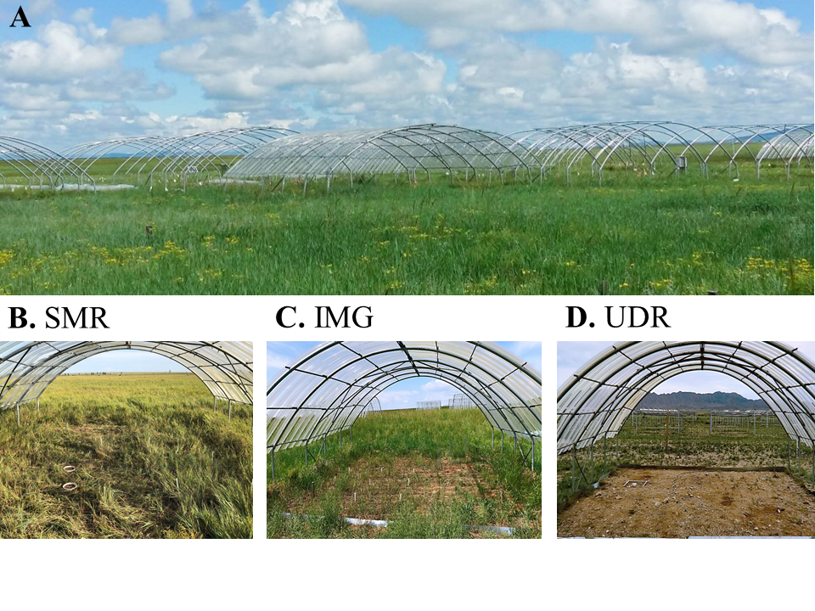

Figure S2 Community-weighted mean of plant height and leaf chlorophyll concentrations in six grassland along a natural aridity gradient. Community-weighted mean were shown as mean ± SE (n = 6).

Figure S3 Relationships between plant soluble sugar and total nonstructural carbohydrate (NSC) concentrations and plant maximum height and chlorophyll concentration at the community-scale in grasslands in northern China. Filled and open symbols indicate control and drought plots, and different symbols indicate different sites. Values of R² and P are shown for significant (P<0.05) and marginal significant (P<0.01) relationships. 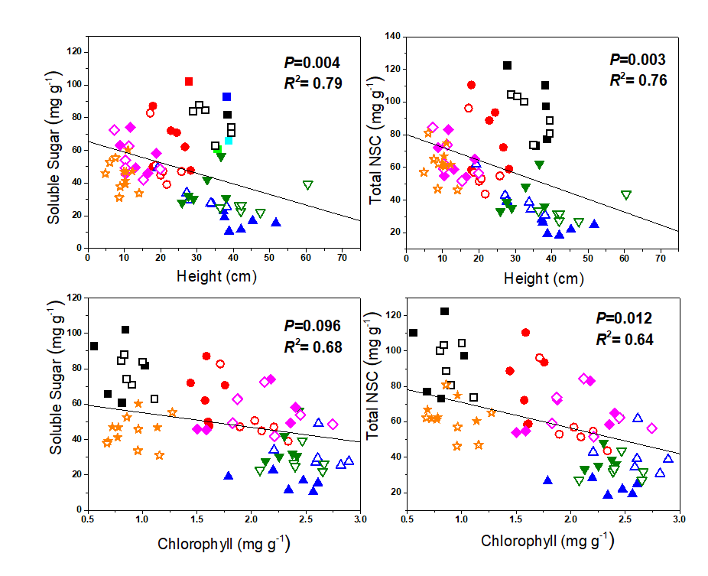

Figure S4 Responses of plant community-weighted mean of soluble sugar and total nonstructural carbohydrate (NSC) concentrations to experimental drought in grasslands of northern China. Drought treatment (drought vs. control) were used as fixed factors, and block and site as random factors. Community-weighted mean of soluble sugar and total NSC concentrations were shown as mean ± SE (n = 6).

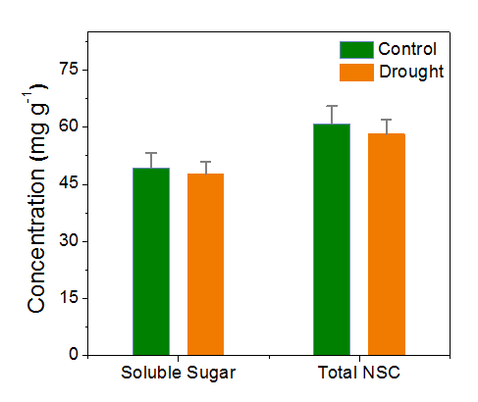

Figure S5 Plant community-weighted mean of starch concentration in plots exposed to experimental drought and control plots across six grassland sites along a natural aridity gradient in northern China. Community-weighted mean of starch concentration are shown as mean ± SE (n = 6).
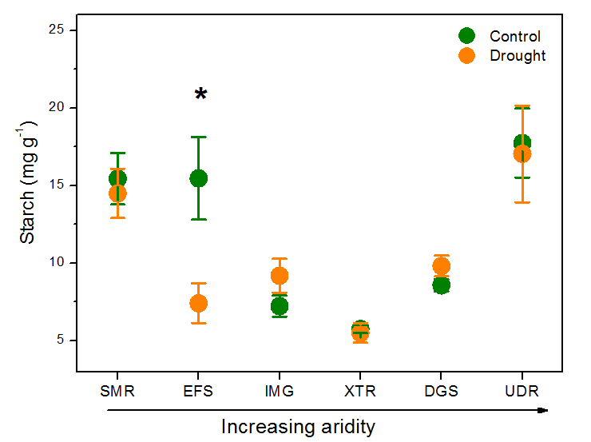

Figure S6 Responses of soluble sugar, total nonstructural carbohydrates (NSC), and relative biomass to drought at the plant species level across six grassland sites along an aridity gradient in northern China. Notes: Abbreviations of species name are as follows: Ac, Agropyron cristatum; Ad, Artemisia dracunculus; Af, Artemisia frigida; Ap, Allium polyrhizum; Ase, Allium senescens; At, Allium tenuissimum; Ata, Artemisia tanacetifolia; Bs, Bupleurum scorzonerifolium; Ca, Calamagrostis angustifolia; Cd, Carex duriuscula; Cda, Cymbaria dahurica; Cp, Carex pediformis; Cs, Cleistogenes squarrosa; Gd, Gentiana dahurica; Gv, Galium verum; Ha, Heteropappus altaicus; Id, Iris dichotoma; Il, Iris lacteal; Pb, Potentilla bifurca; Lc, Leymus chinensis; Ph, Peganum harmala; Pt, Pulsatilla turczaninovii; Pta, Potentilla tanacetifolia; Sa, Scorzonera albicaulis; Sc, Stellera chamaejasme; As, Achnatherum sibiricum; Sg, Stipa grandis; Tf, Thalictrum foetidum; Tl, Thermopsis lanceolate; Va, Vicia amoena.

