Supplementary 1: RNA 6000 Pico Chip Analysis Report
Sample | RNA Area | RNA Concentration (pg/μl) | rRNA Contamination (%) | Graphical representation
DWWS1 | 1,926.50 | 10,341 | 0 | 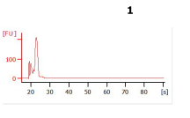
DWWS2 | 738.7 | 3,965 | 0 | 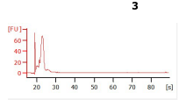
DWWS3 | 2,916.90 | 15,657 | 0 | 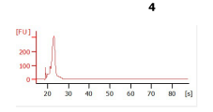
DWWS4 | 510.1 | 2,738 | 0 | 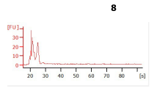
DWoWS1 | 281.2 | 1,620 | 0 | 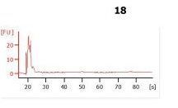
DWoWS2 | 87.8 | 506 | 0 | 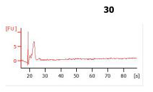
DWoWS3 | 71.7 | 413 | 0 | 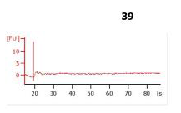
DWoWS4 | 53.1 | 306 | 0 | 