SUPPLEMENTARY MATERIALS

Characterizing Eating Behavioral Phenotypes in Mood Disorders:
A Cross-Sectional Survey Investigation

Correlations Between Maladaptive Eating Behaviors

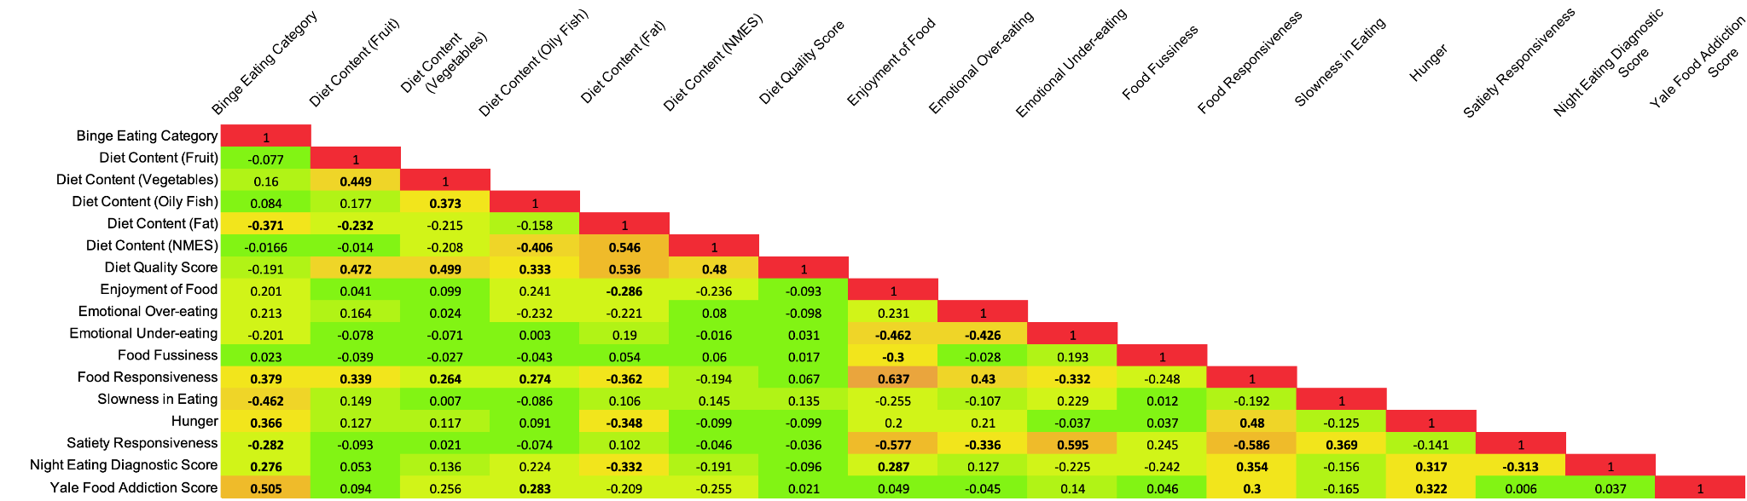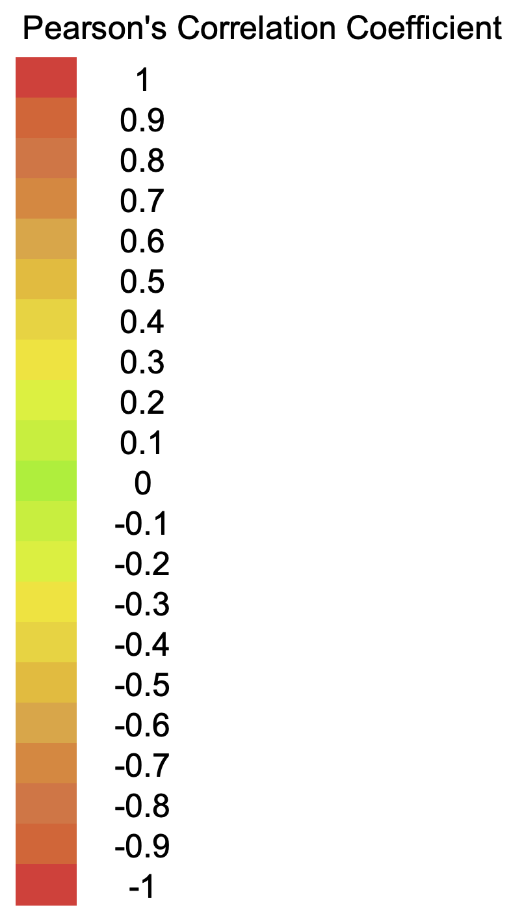

Figure A. Correlational analysis of maladaptive eating behaviors in individuals with a mood disorder. The heatmap shows Pearson’s correlation coefficients with significant correlation values (p<0.01) indicated in boldface.

Differences in the Prevalence of Maladaptive Eating Behaviors Between Diagnostic Groups

Table A. Diet Content and Quality
 |  | Sum of Squares | df | Mean Square | F | Sig.
Diet Content (Fruit) | Between Groups | .356 | 2 | .178 | .572 | .566
Diet Content (Fruit) | Within Groups | 30.204 | 97 | .311
Diet Content (Fruit) | Total | 30.560 | 99
Diet Content (Vegetables) | Between Groups | .077 | 2 | .038 | .079 | .924
Diet Content (Vegetables) | Within Groups | 47.363 | 97 | .488
Diet Content (Vegetables) | Total | 47.440 | 99
Diet Content (Oily Fish) | Between Groups | 1.690 | 2 | .845 | 1.970 | .145
Diet Content (Oily Fish) | Within Groups | 41.620 | 97 | .429
Diet Content (Oily Fish) | Total | 43.310 | 99
Diet Content (Fat) | Between Groups | 3.209 | 2 | 1.605 | 2.257 | .110
Diet Content (Fat) | Within Groups | 68.981 | 97 | .711
Diet Content (Fat) | Total | 72.190 | 99
Diet Content (NMES) | Between Groups | 5.389 | 2 | 2.695 | 5.089 | .008
Diet Content (NMES) | Within Groups | 51.361 | 97 | .529
Diet Content (NMES) | Total | 56.750 | 99
Diet Quality Score | Between Groups | 12.271 | 2 | 6.136 | 2.320 | .104
Diet Quality Score | Within Groups | 256.479 | 97 | 2.644
Diet Quality Score | Total | 268.750 | 99

Table B. Binge Eating Category
 | Sum of Squares | df | Mean Square | F | Sig.
Between Groups | .665 | 2 | .333 | .510 | .602
Within Groups | 63.335 | 97 | .653
Total | 64.000 | 99

Table C. Adult Eating Behavior Questionnaire
 |  | Sum of Squares | df | Mean Square | F | Sig.
Enjoyment of Food | Between Groups | .697 | 2 | .348 | .473 | .625
Enjoyment of Food | Within Groups | 71.432 | 97 | .736
Enjoyment of Food | Total | 72.129 | 99
Emotional Overeating | Between Groups | 10.147 | 2 | 5.074 | 4.620 | .012
Emotional Overeating | Within Groups | 106.533 | 97 | 1.098
Emotional Overeating | Total | 116.680 | 99
Emotional Under-eating | Between Groups | 8.318 | 2 | 4.159 | 4.400 | .015
Emotional Under-eating | Within Groups | 90.749 | 96 | .945
Emotional Under-eating | Total | 99.067 | 98
Food Fussiness | Between Groups | .093 | 2 | .047 | .045 | .956
Food Fussiness | Within Groups | 100.711 | 97 | 1.038
Food Fussiness | Total | 100.804 | 99
Food Responsiveness | Between Groups | 1.869 | 2 | .935 | 1.359 | .262
Food Responsiveness | Within Groups | 66.706 | 97 | .688
Food Responsiveness | Total | 68.575 | 99
Slowness in Eating | Between Groups | .451 | 2 | .225 | .222 | .801
Slowness in Eating | Within Groups | 98.261 | 97 | 1.013
Slowness in Eating | Total | 98.712 | 99
Hunger | Between Groups | 3.276 | 2 | 1.638 | 2.654 | .075
Hunger | Within Groups | 59.862 | 97 | .617
Hunger | Total | 63.138 | 99
Satiety Responsiveness | Between Groups | 11.152 | 2 | 5.576 | 5.339 | .006
Satiety Responsiveness | Within Groups | 101.300 | 97 | 1.044
Satiety Responsiveness | Total | 112.452 | 99

Table D. Night Eating Diagnostic Score
 | Sum of Squares | df | Mean Square | F | Sig.
Between Groups | .687 | 2 | .343 | .275 | .760
Within Groups | 121.273 | 97 | 1.250
Total | 121.960 | 99

Table E. Yale Food Addiction Category
 | Sum of Squares | df | Mean Square | F | Sig.
Between Groups | 4.118 | 2 | 2.059 | 3.551 | .032
Within Groups | 56.242 | 97 | .580
Total | 60.360 | 99

Principal Component Analysis
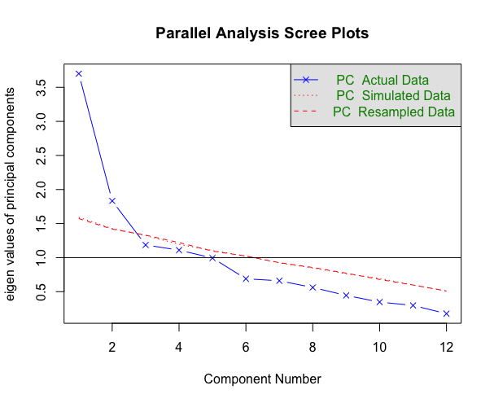
Figure B. Principal component analysis Scree plot.

