Supplementary Figure Legends
Figure S1 – Overview of responses to survey Q1.1-1.9
(A-I) Summary of Likert responses to survey Q1.1-1.9. The stacked bar charts show the % of responses for each Lickert category [Strongly Agree (Blue); Agree (purple); Neither agree or disagree (pink); disagree (orange); strongly disagree (yellow)] grouped according to whether participants completed their previous degree in the UK (PDUK) or elsewhere (PDUK). The number of participants in each of these groupings is stated in brackets and the values beneath the bars represent the % of respondents for each Likert category.

Figure S2 - Overview of responses to survey Q3.1-3.6
(A-F) Summary of Likert responses to survey Q3.1-3.6. The stacked bar charts show the % of responses for each Lickert category [Strongly Agree (Blue); Agree (purple); Neither agree or disagree (pink); disagree (orange); strongly disagree (yellow)] grouped according to PDUK and PDE categories. The number of participants in each of these groupings is stated in brackets and the values beneath the bars represent the % of respondents for each Likert category.

Figure S3 - Overview of responses to survey Q4.1-4.10
(A-J) Summary of Likert responses to survey Q4.1-4.10. The stacked bar charts show the % of responses for each Lickert category [Strongly Agree (Blue); Agree (purple); Neither agree or disagree (purple); disagree (orange); strongly disagree (yellow)] grouped according to PDUK and PDE categories. The number of participants in each of these groupings is stated in brackets and the values beneath the bars represent the % of respondents for each Likert category.

Figure S4 – Overview of responses to survey Q5.1-5.4
(A-D) Summary of Likert responses to survey Q5.1-5.4. The stacked bar charts show the % of responses for each Lickert category [Strongly Agree (Blue); Agree (purple); Neither agree or disagree (pink); disagree (orange); strongly disagree (yellow)] grouped according to PDUK and PDE categories. The number of participants in each of these groupings is stated in brackets and the values beneath the bars represent the % of respondents for each Likert category.

Figure S5 – Overview of responses to survey Q6.1-6.10
(A-D) Summary of Likert responses to survey Q6.1-6.10. The stacked bar charts show the % of responses for each Lickert category [Strongly Agree (Blue); Agree (purple); Neither agree or disagree (pink); disagree (orange); strongly disagree (yellow)] grouped according to PDUK and PDE categories. The number of participants in each of these groupings is stated in brackets and the values beneath the bars represent the % of respondents for each Likert category.

Figure S1
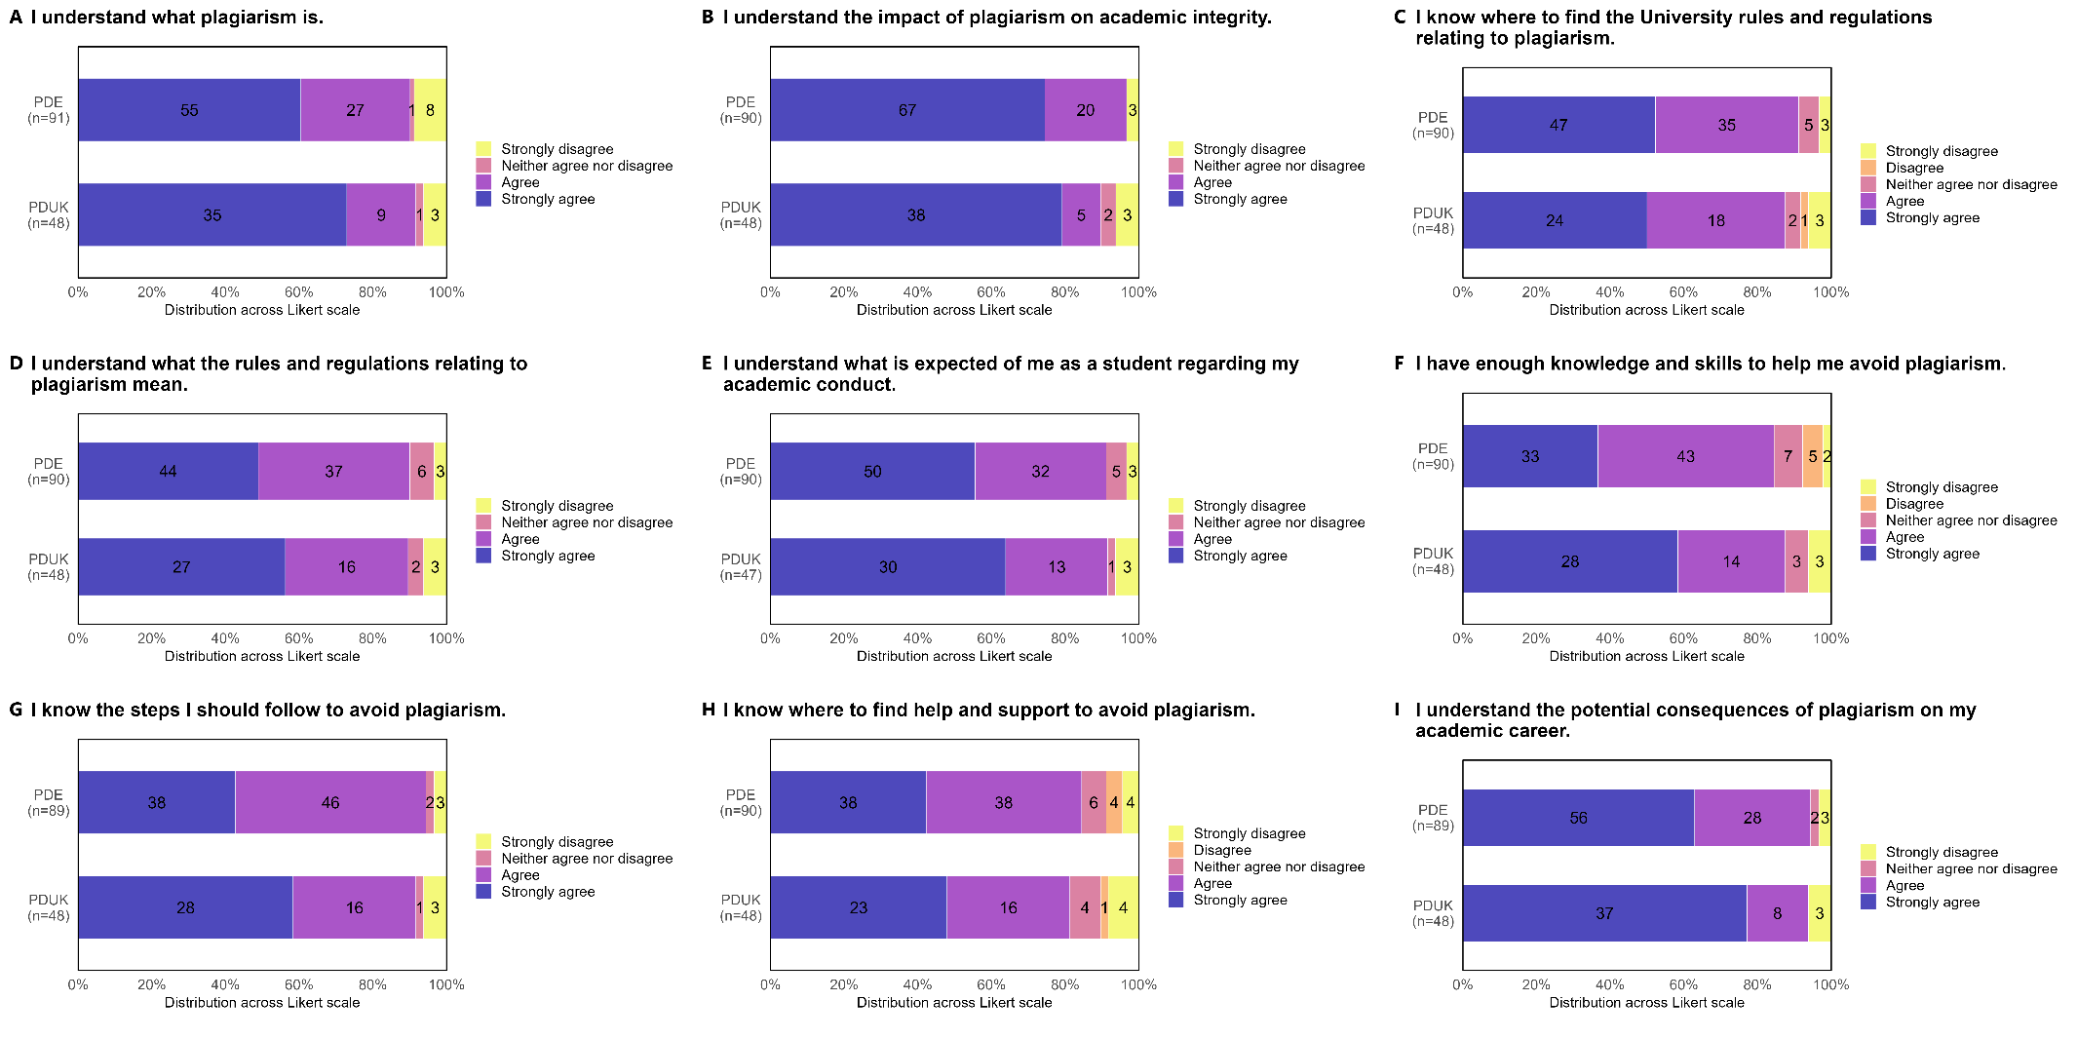
Figure S2
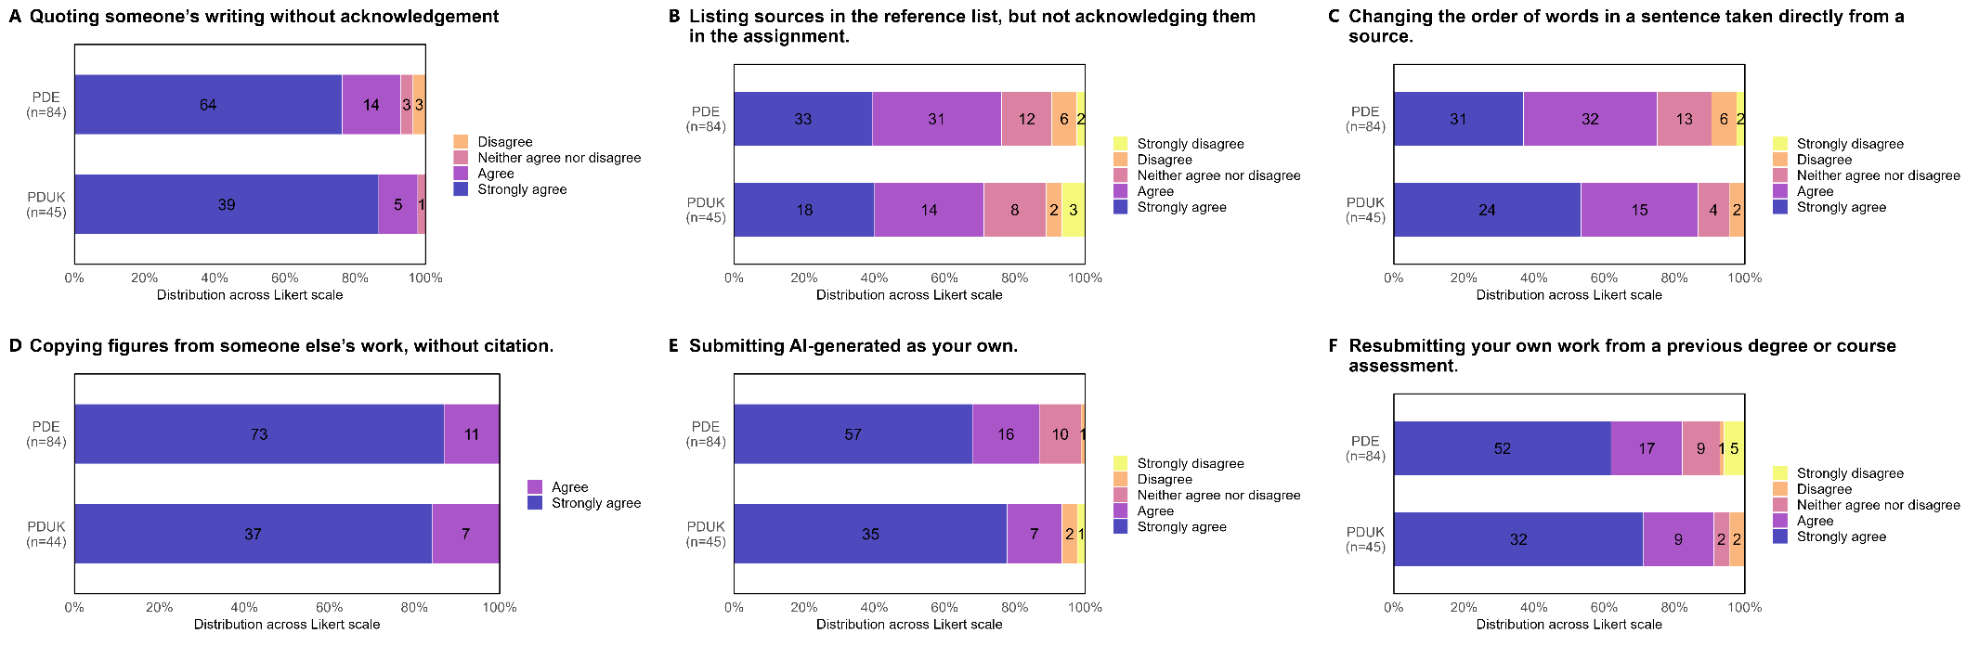
Figure S3
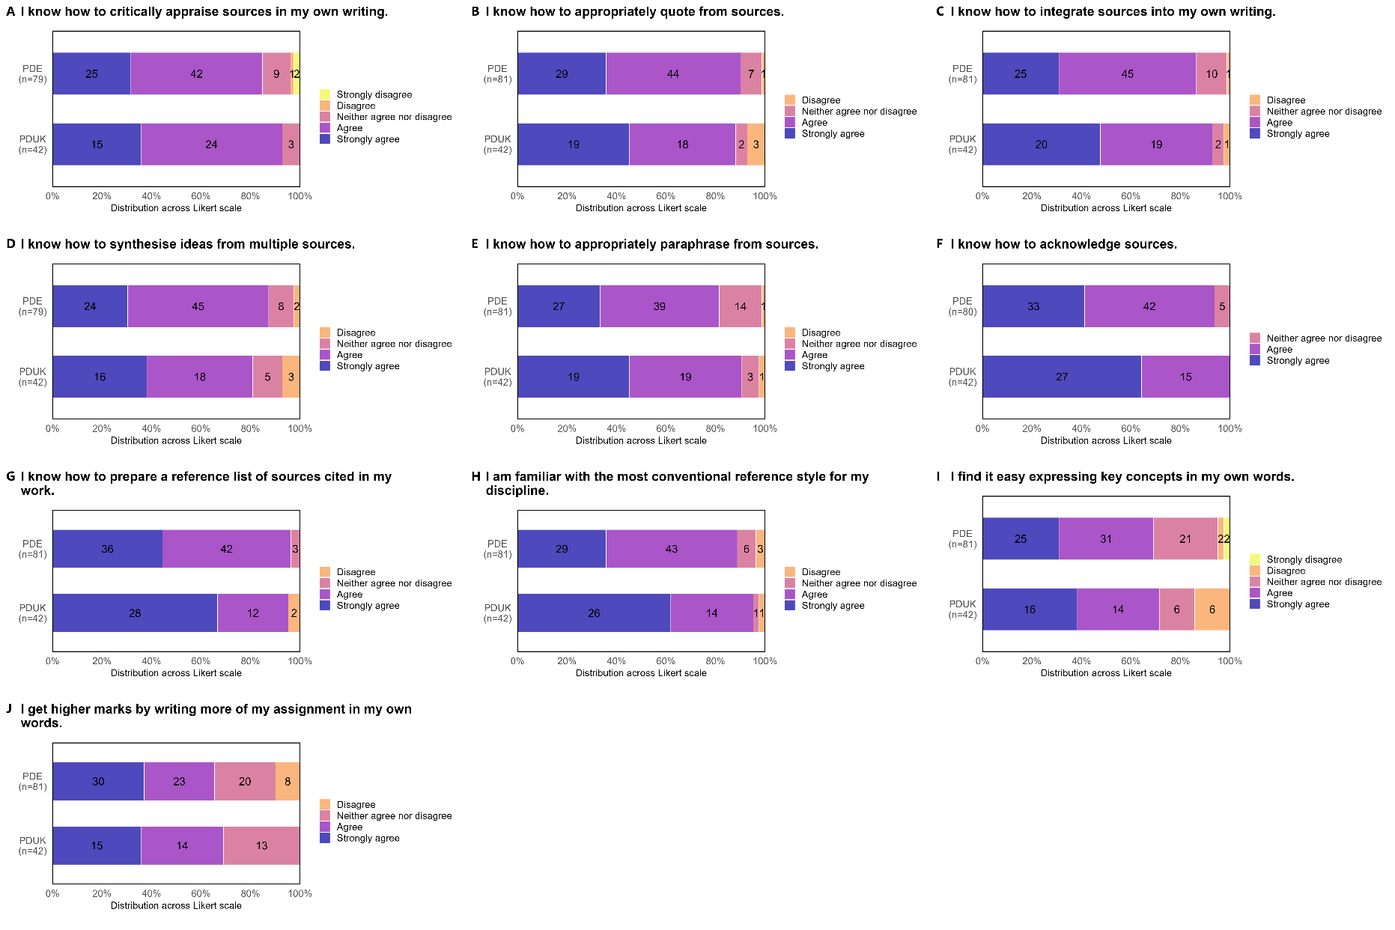
Figure S4
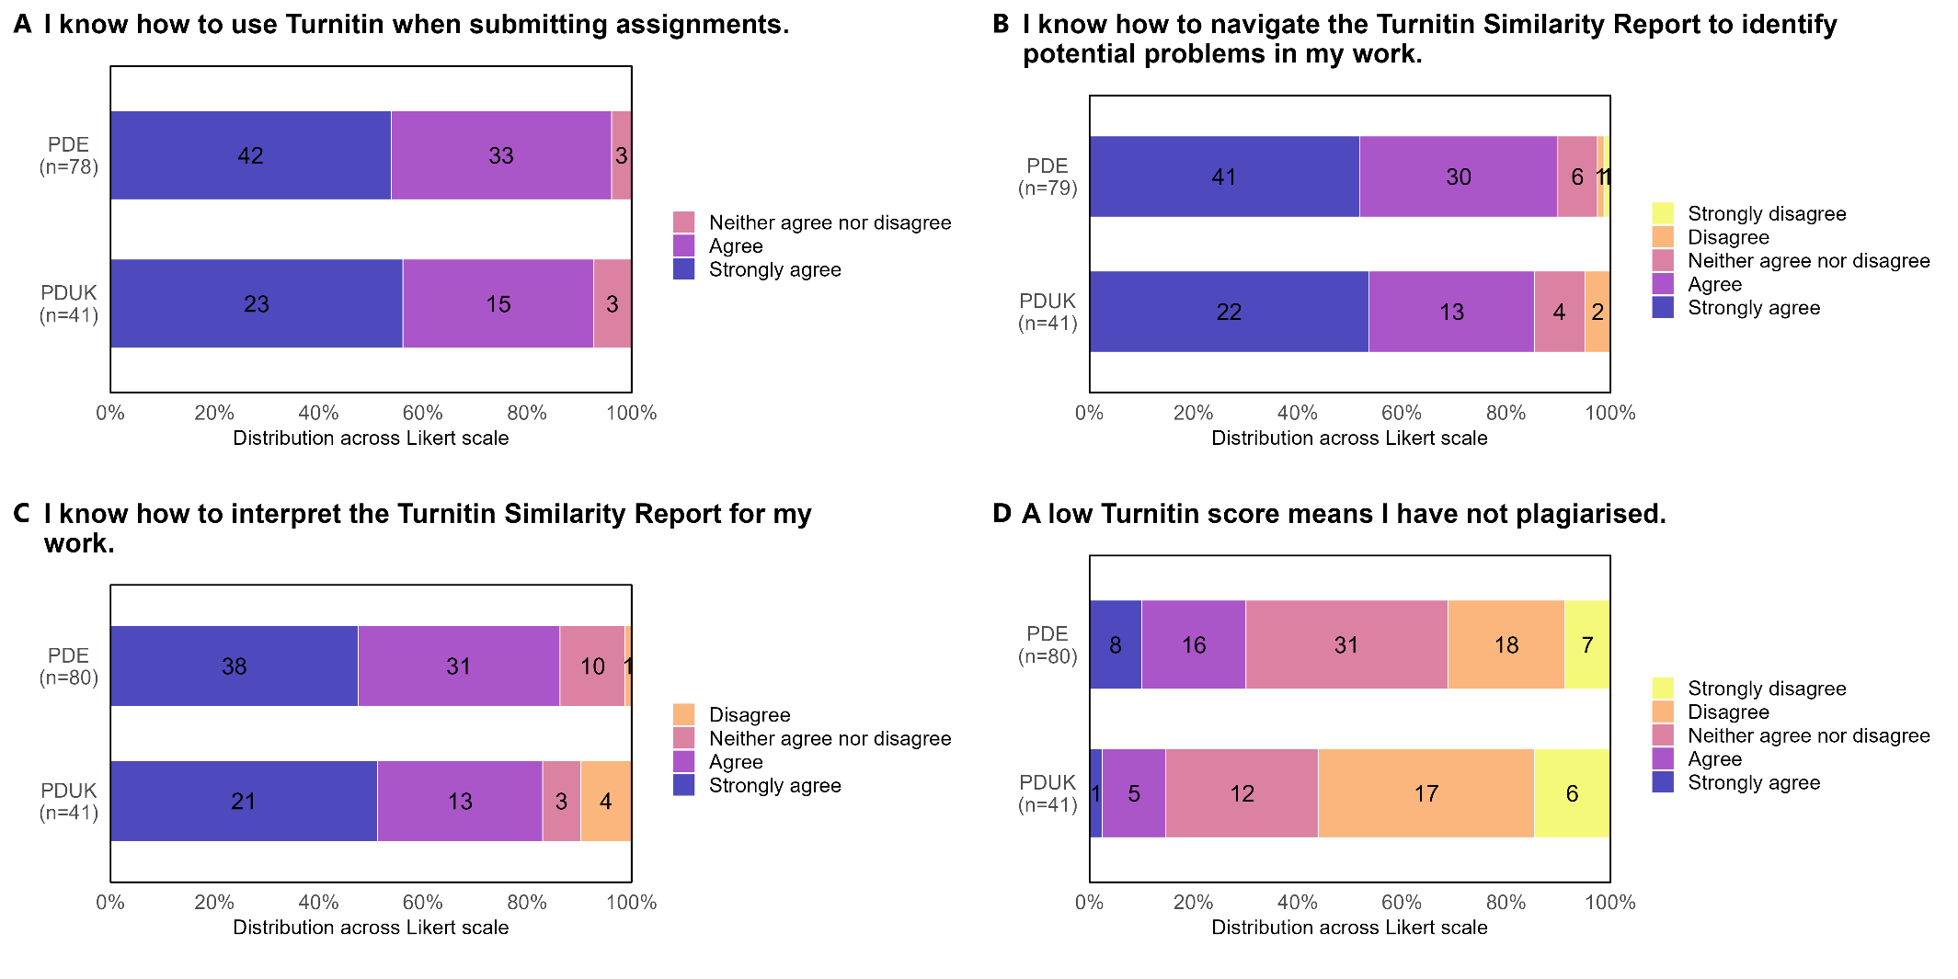
Figure S5
