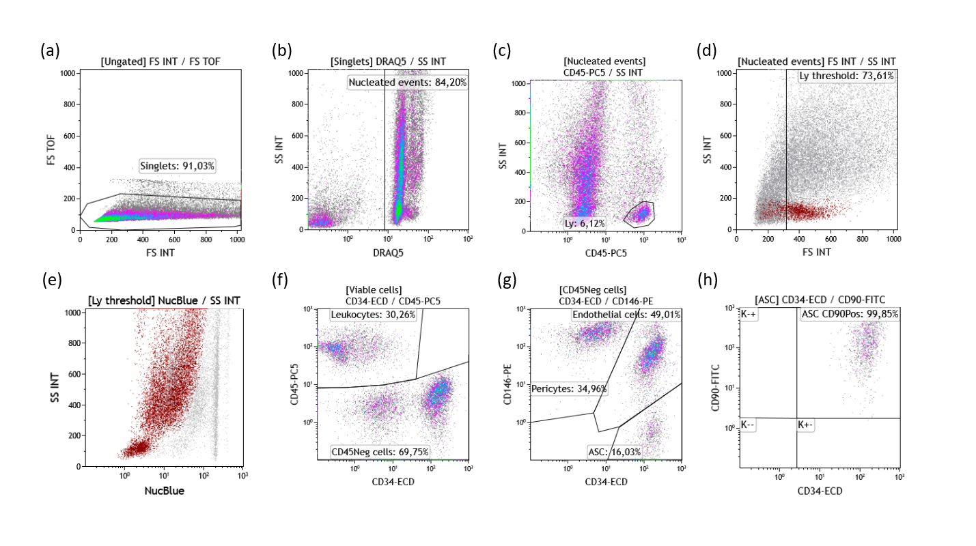
Supplemental data
Supplemental Figure 1 – Gating strategy for subsets analysis of SVF. Representative dot plots illustrate sequential gates applied to exclude aggregates (a), DRAQ5 negative debris (b), small size nucleated events (c-d), followed by selection of “NucBlue negative” live cells (e) and distribution of the main cellular subpopulations within the SVF, including leukocytes (f), endothelial cells (g), and adipose stromal/stem cells (ASC) (h).
 | Tulip Nanofat Kit | Adinizer | Hy-Tissue Nanofat | Microlyzer | LipoCube Nano | Puregraft Boost V1 | Puregraft Boost V2 | Emulsfat
n | 5 | 5 | 5 | 5 | 5 | 4 | 4 | 5
Total EVs | 41,533 [46,740] | 72,734 [61,972] | 79,417 [57,236] | 67,240 [49,794] | 57,236 [43,009] | 64,760 [55,329] | 60,496 [40,538] | 43,214 [48,421]
LEVs | 123 [103] | 164 [226] | 82 [103] | 123 [123] | 82 [82] | 103 [103] | 103 [164] | 123 [123]
PEVs | 2,009 [1,353] | 1,722 [1,435] | 1,927 [1,436] | 1,968 [1,394] | 2,419 [1,518] | 1,497 [1,179] | 2,009 [882] | 1,107 [1,640]
ErEVs | 328 [349] | 369 [410] | 451 [349] | 451 [246] | 287 [144] | 287 [267] | 328 [441] | 287 [185]
EEVs | 451 [677] | 656 [1,804] | 861 [1,456] | 902 [1,313] | 410 [903] | 389,5 [656] | 635,5 [892] | 697 [1,128]
AEVs | 2,870 [2,521] | 2,829 [2,891] | 1,599 [1,948] | 2,624 [615] | 2,214 [1,415] | 2,378 [2,625] | 2,153 [2,194] | 2,952 [1,599]
ASC-Evs | 1,517 [984] | 1,271 [2,112] | 1,476 [1,025] | 2,460 [1,743] | 1,722 [1,210] | 1,415 [1,425] | 1,517 [2,173] | 1,394 [1,230]
Supplemental Table 1. Quantification of extracellular vesicle (EV) subpopulations across eight fat processing methods. Total EV concentration (EV/µL) was measured by flow cytometry and categorized into leukocyte-derived EVs (LEVs), platelet-derived EVs (PEVs), erythrocyte-derived EVs (ErEVs), endothelial-derived EVs (EEVs), adipocyte-derived EVs (AEVs), and mesenchymal stem cell-derived EVs (MSC-EVs). Data represent as median [interquartile range].

 | Tulip Nanofat Kit | Adinizer | Hy-Tissue Nanofat | Microlyzer | LipoCube Nano | Puregraft Boost V1 | Puregraft Boost V2 | Emulsfat
n | 5 | 5 | 5 | 5 | 5 | 4 | 4 | 5
LEVs | 0.10 [0.20] | 0.23 [0.19] | 0.10 [0.15] | 0.18 [0.08] | 0.18 [0.09] | 0.14 [0.09] | 0.20 [0.14] | 0.24 [0.2]
PEVs | 2.65 [4.63] | 3.08 [2.41] | 2.68 [3.89] | 2.94 [2.90] | 2.43 [4.53] | 2.98 [4.41] | 2.69 [3.68] | 2.57 [1.65]
ErEVs | 0.65 [0.20] | 0.53 [0.45] | 0.56 [1.10] | 0.71 [0.32] | 0.45 [0.41] | 0.52 [0.59] | 0.69 [0.44] | 0.75 [1.03]
EEVs | 1.08 [0.38] | 1.01 [1.65] | 0.93 [1.28] | 1.18 [1.09] | 0.85 [0.83] | 0.97 [0.79] | 1.09 [0.70] | 1.42 [1.11]
AEVs | 6.32 [4.84] | 4.97 [4.52] | 4.48 [5.34] | 6.02 [6.25] | 5.79 [5.72] | 5.61 [4.05] | 5.32 [4.49] | 8.98 [6.80]
ASC-Evs | 2.70 [1.80] | 2.0 [1,49] | 1.64 [0.63] | 2.43 [2,58] | 2.69 [1.03] | 2.22 [0.96] | 2.43 [1.87] | 2.71 [1.86]

Supplemental Table 2 : Distribution of EV Subtypes Within the Annexin V⁺ Population Across Nanofat Processing Methods. The table presents the relative proportions (%, median [IQR]) of EV subtypes within the Annexin V⁺ EV gateSubtypes include leukocyte-derived EVs (LEVs), platelet-derived EVs (PEVs), erythrocyte-derived EVs (ErEVs), endothelial EVs (EEVs), adipocyte-derived EVs (AEVs), and mesenchymal stem/stromal cell-derived EVs (MSC-EVs). Data are expressed as median [interquartile range].

