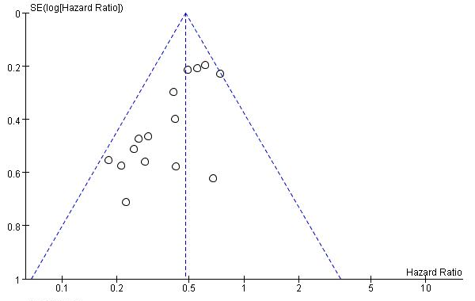
a
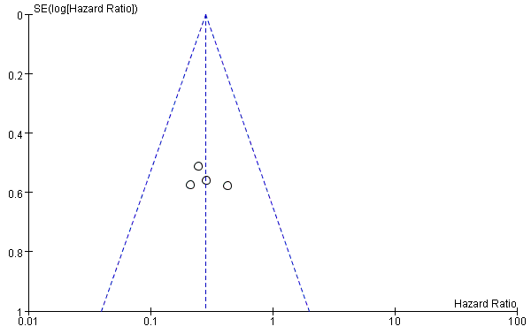
b
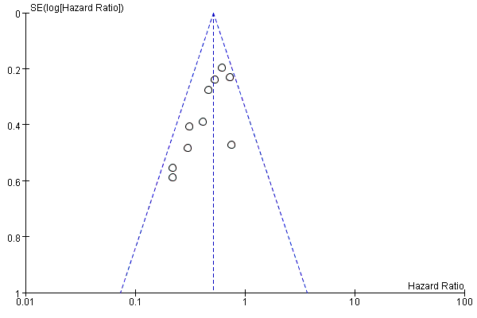
c
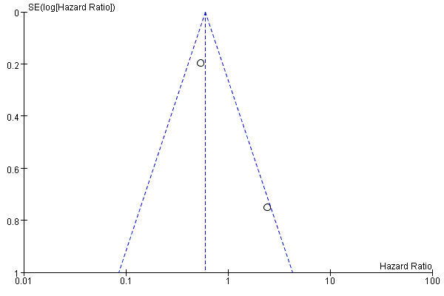
d
Figure 1 Funnel plot analysis of potential publication bias. a. High tertiary lymphoid structures (TLSs) vs. low TLSs for overall survival (OS). b. High TLSs vs. low TLSs for OS in subgroup analyses with immune checkpoint inhibitors (ICIs). c. High TLSs vs. low TLSs for disease-free survival (DFS). d. High TLSs vs. low TLSs for disease-specific survival (DSS).
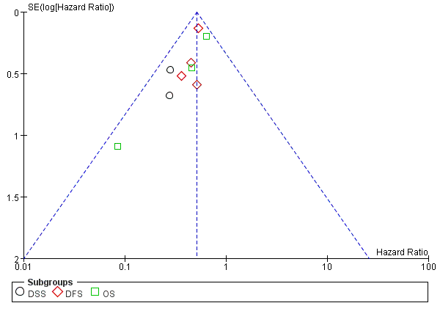
a
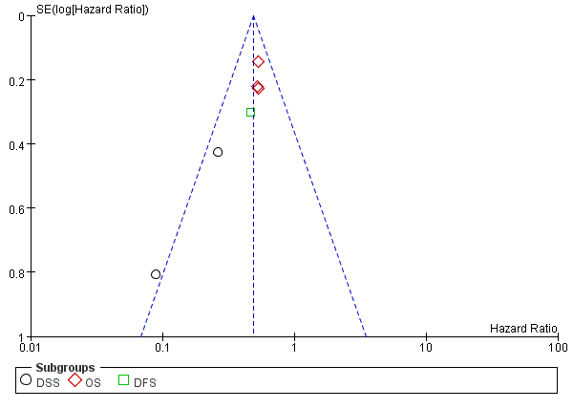
b
Figure 2 Funnel plot analysis of potential publication bias. a. High B cells in TLSs vs. low B cells in TLSs for outcomes. b. High DCs in TLSs vs. low DCs in TLSs for outcomes.

