Scheme 1. Claisen–Schmidt Condensation Reaction using Mn-MOF as a heterogeneous catalyst.

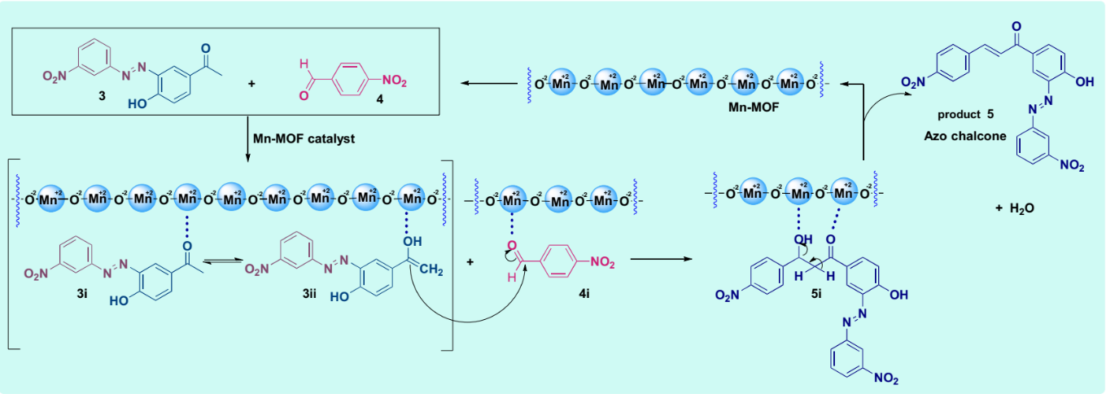
Scheme 2. Claisen–Schmidt Condensation Reaction using Mn-MOF as a heterogeneous catalyst.

