Sustainable Microwave-Assisted Synthesis of Azo Chalcone Dyestuff Using an Mn-Based Metal Organic Framework as a Catalyst: A Combined Experimental and DFT Study and Biomedical Applications.
Myasar Kh. Ibrahim¹  . Sameera Sh. Mohammed Amin² .Shireen R. Mohammed² . Khalid Omer³
- Department of Basic Science, College of Agricultural Engineering Sciences, University of Duhok, Kurdistan Region, Iraq.
- Department of Chemistry, College of Science, University of Zakho, Zakho 42002, Kurdistan Region, Iraq.
- Department of Chemistry, College of Science, University of Sulaimani, Qliasan St. 46002, Sulaymaniyah, Kurdistan region, Iraq.
E-mail: Myasar Kh. Ibrahim
Myasar.ibrahim@uod.ac
Supplementary
Fig. S1. FTIR spectrum for azo chalcone 5 with more detailed assignment.

Fig. S2. FT-Raman spectrum for azo chalcone 5 with more detailed assignment.
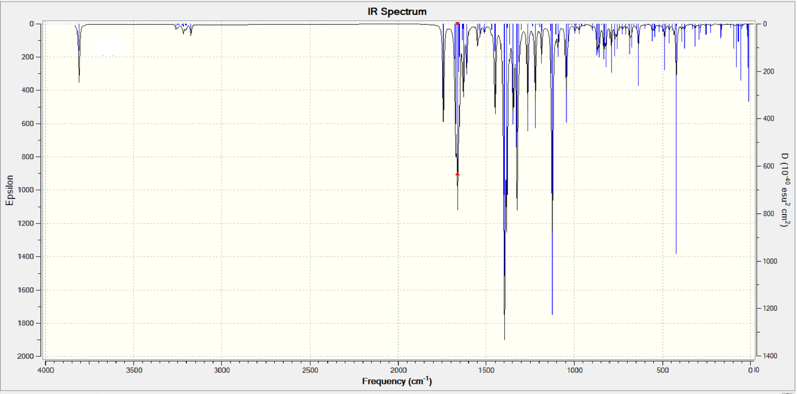
Fig. S3. Theoretical FTIR spectrum of azo-chalcone 5 calculated using B3LYP / 6-31G(d,p).
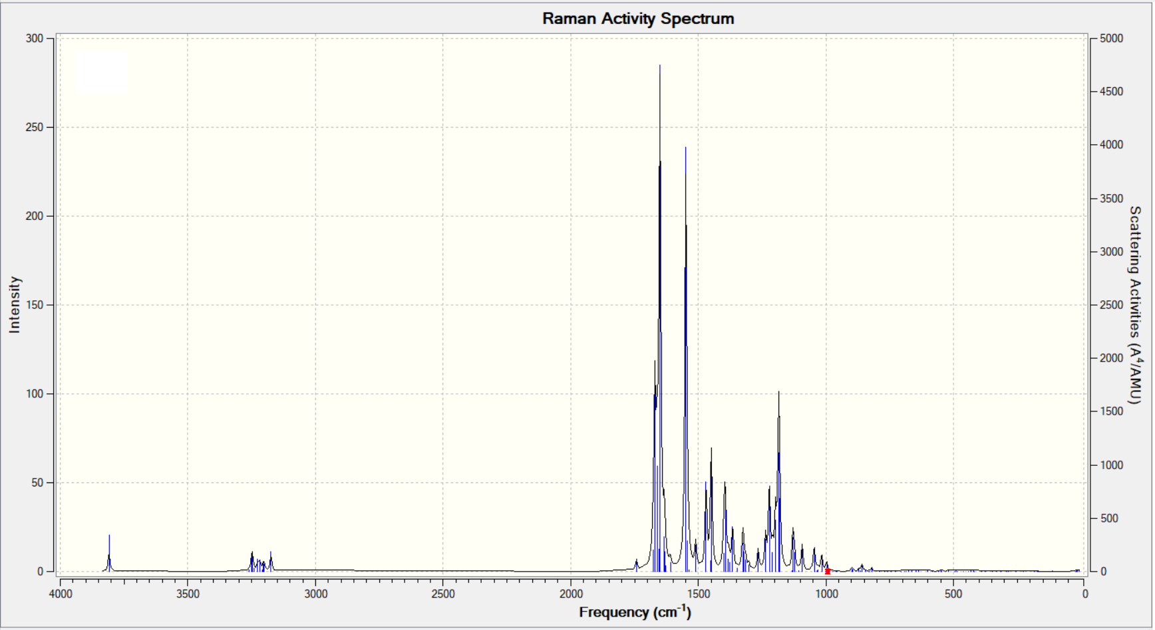
Fig. S4. Theoretical Raman spectrum of azo-chalcone 5 calculated using B3LYP / 6-31G(d,p).
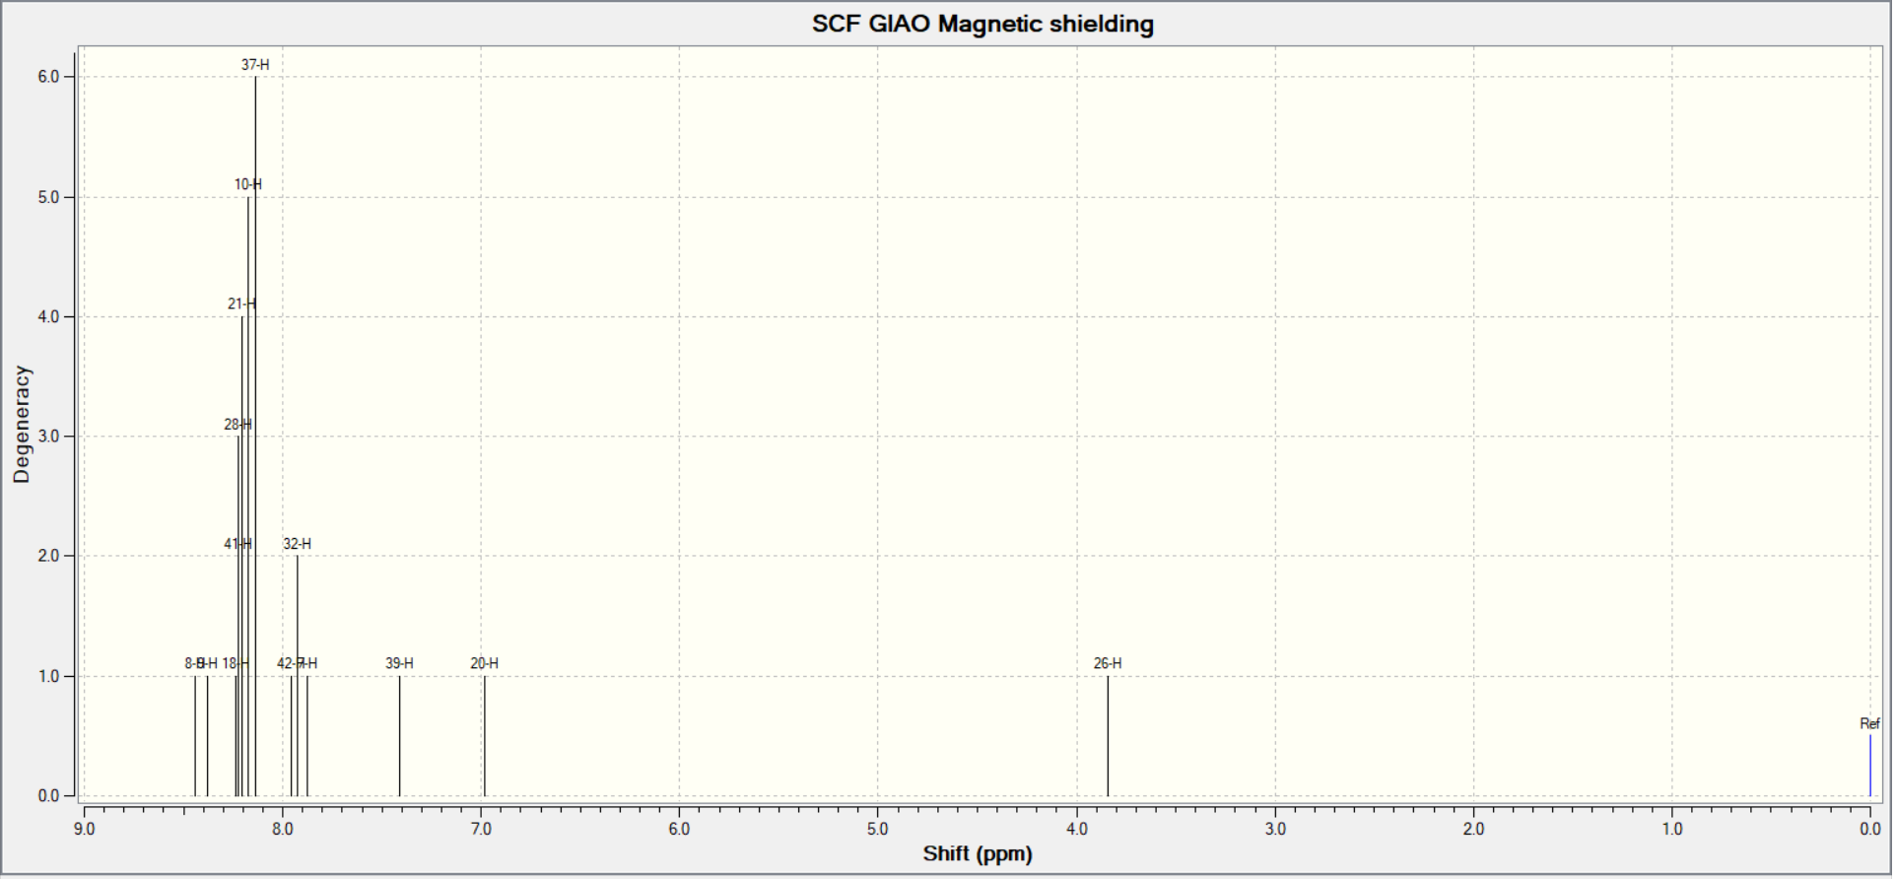
Fig. S5. Theoretical ¹H NMR spectrum of synthesis azo-chalcone 5 using B3LYP/6-31G level in CHCl_{3.}
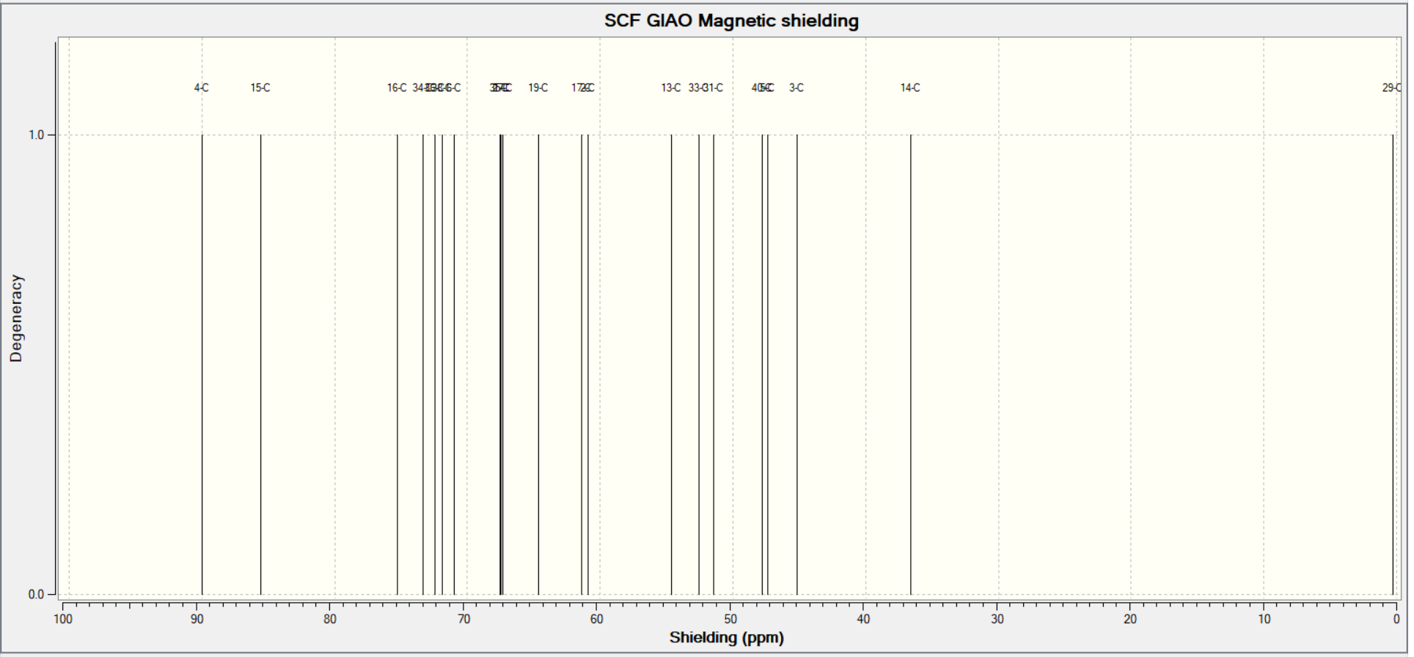
Fig. S6. Theoretical ¹³CNMR spectrum of synthesis azo-chalcone 5 using B3LYP/6-31G level in CHCl_{3.}

