Supplementary data
A stepwise-targeting strategy for the treatment of cerebral ischemic stroke
Jingbo Hu¹*,#, Xueying Tan^{2#}, Dongwei Wang¹, Hongze Liang¹, Jiejun Peng³*, Fengyan Li², Quan Zhou⁴, Peiwu Geng⁴, Shuanghu Wang⁴, Yue Yu⁵, Jin Liu⁴*

¹ Faculty of Materials Science and Chemical Engineering, Ningbo University, Ningbo 315211, China.
² College of pharmacy, Zhejiang Pharmaceutical College, Ningbo 315100, China.
³ State Key Laboratory for Managing Biotic and Chemical Threats to the Quality and Safety of Agroproducts, Institute of Plant Virology, Ningbo University, Ningbo 315211, Zhejiang, China.
⁴ Department of Neurosurgery, The People’s Hospital of Lishui, The Sixth Affiliated Hospital of Wenzhou Medical University, Lishui 323000, China.
⁵ Department of pharmacy, Ningbo women and children’s hospital, Ningbo 315012, China.

# These authors contributed equally to this paper

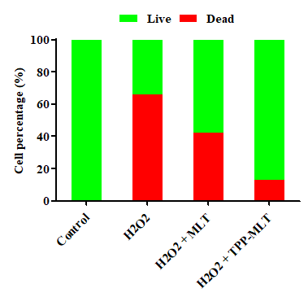
Fig. S1 Semi-quantitative fluorescent analysis of live and dead cells.
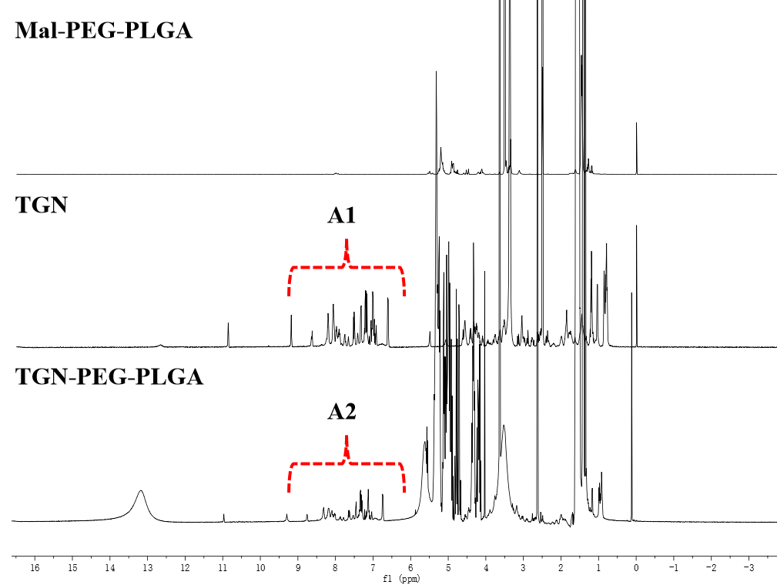
Fig. S2 ¹H NMR spectrum of TGN-PEG-PLGA (500 MHz, DMSO-d6).
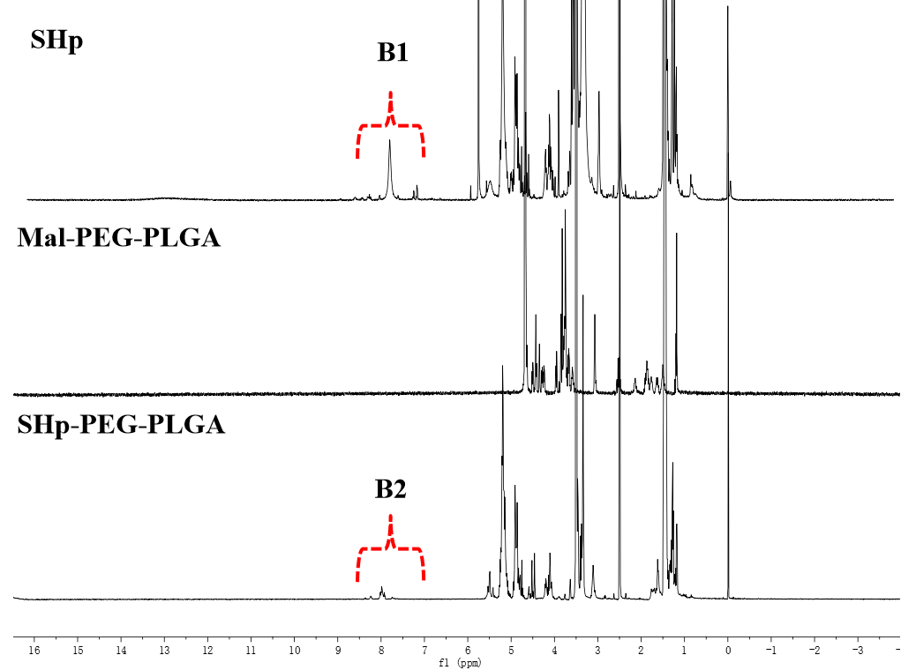
Fig. S3 ¹H NMR spectrum of SHp-PEG-PLGA (500 MHz, DMSO-d6).
Fig. S4 Intracellular fluorescence intensity, measured by flow cytometry, of bEnd.3 cells ncubated with TGN/SHp/cy3 micelles for for 0.5 and 2.0 h, TGN/cy3 micelles, SHp/cy3 micelles, cy3 micelles and free cy3 as control (n = 6, P>0.05).
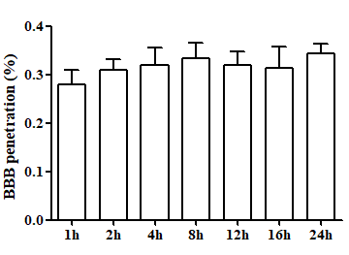
Fig. S5 The transport ratios (%) of HRP across BBB model during 24 h (n = 6).
Fig. S6 Intracellular fluorescence intensity, measured by flow cytometry, of PC-12 cells ncubated with TGN/SHp/cy3 micelles for for 0.5 and 2.0 h, TGN/cy3 micelles, SHp/cy3 micelles, cy3 micelles and free cy3 as control (n = 6, P>0.05).

Table S1 Characterization of TGN/SHp/TPP-MLT micelles (n = 6)
Feeding ratio (%) | Particle size (nm) | PDI | Zeta potential (mV) | TPP-MLT
 |  |  |  | EE (%) | DL (%)
0  5  10  20  30  40 | 88.6 ± 5.3  84.2 ± 4.8  97.5 ± 4.9  100.4 ± 4.3  102.2 ± 5.1  105.9 ± 5.4 | 0.13 ± 0.09  0.19 ± 0.05  0.18 ± 0.06  0.16 ± 0.04  0.19 ± 0.05  0.17 ± 0.04 | -8.1 ± 0.9  -8.5 ± 0.7  -8.3 ± 0.9  -8.6 ± 0.5  -8.3 ± 0.8  -8.3 ± 1.4 | 90.52 ± 1.23  88.24 ± 1.34  80.45 ± 1.04  74.82 ± 1.22  70.88 ± 1.13 | 4.29 ± 0.55  8.94 ± 0.89  9.11 ± 0.95  9.62 ± 0.84  10.06 ± 0.96
PDI, polydispersity index; EE, encapsulation efficiency; DL, drug loading

