Supplementary Figures
Mapping the sequence logic of DNA repair enzyme binding reveals mechanistic principles and evolutionary links

Noga Levy¹, Vered Levin Salomon¹, Sharon N. Greenwood², Naama Kessler¹, Omer Erez¹, Brian P. Weiser², Ariel Afek¹*

¹Department of Chemical and Structural Biology, Weizmann Institute of Science, Rehovot 7610001, Israel
²Department of Cell & Molecular Biology, Rowan-Virtua School of Osteopathic Medicine and Rowan-Virtua School of Translational Biomedical Engineering and Sciences, Rowan University, Stratford, New Jersey, 08084, United States of America

Contact information:
*Corresponding Author: ariel.afek@weizmann.ac.il

This file includes:
Supplementary Figures 1-11

Supplementary Fig. 1: Aldehyde Reactive Probe (ARP) labeling of excised products workflow.

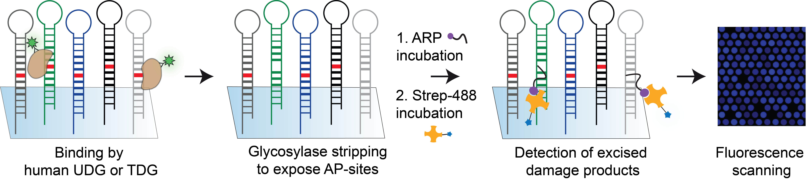
Supplementary Fig. 1 | Workflow for Aldehyde Reactive Probe (ARP) labeling of excised damage products. After glycosylase binding to lesion-containing DNA probes on the microarray, proteins are stripped to expose abasic (AP) sites formed by enzymatic base excision. These AP sites are then labeled using the Aldehyde Reactive Probe (ARP; purple), which covalently reacts with aldehyde groups at the lesion site. Following ARP tagging, a fluorescent streptavidin conjugate (Strep-488; yellow) is applied to enable detection. Fluorescent scanning of the array reveals sites of enzymatic activity, corresponding to excised damage products. Protein stripping prior to ARP labeling ensures specificity and minimizes background signal (see Methods).

Supplementary Fig. 2: BER-Map replicates and experiment reproducibility.
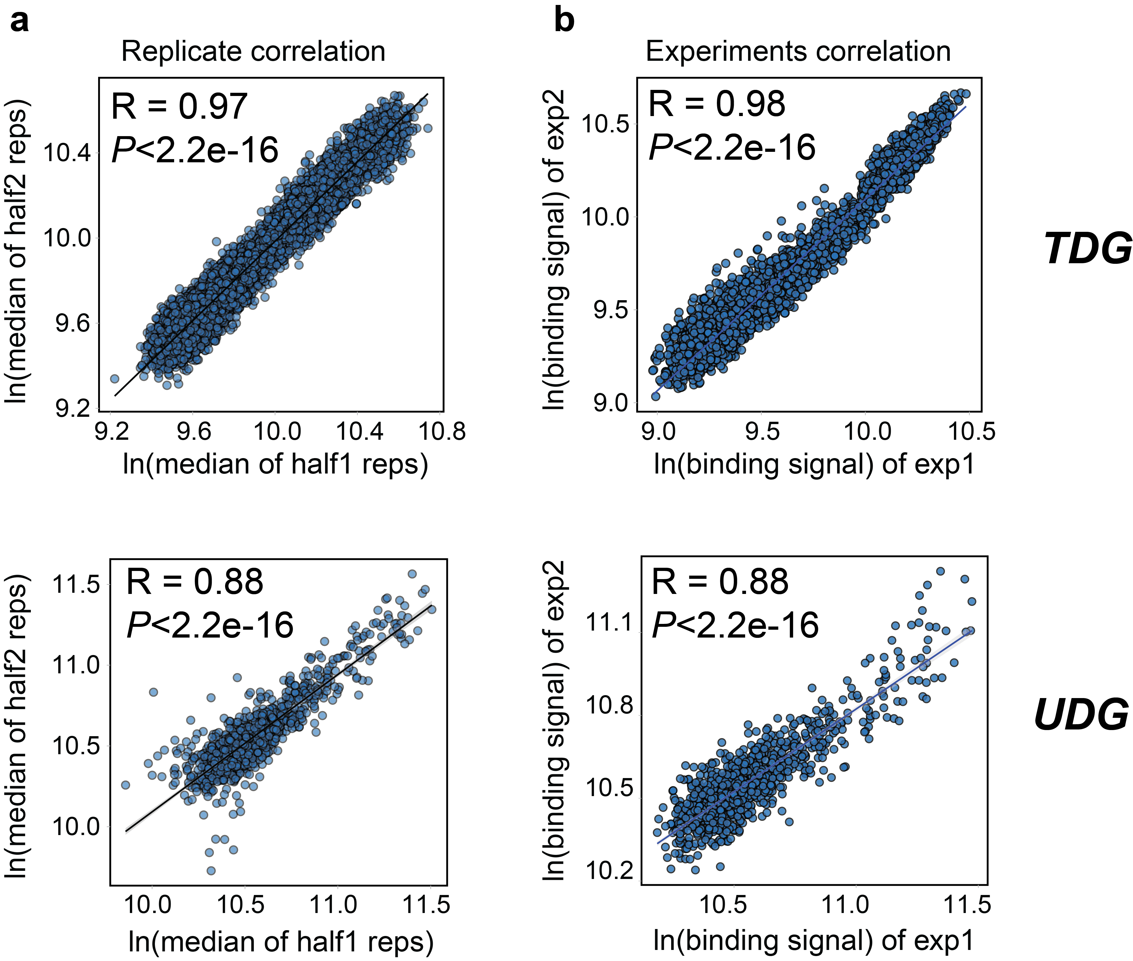
Supplementary Fig. 2 | High Reproducibility of damage recognition measurements across replicates and independent experiments. a, Correlation between log-transformed median binding signals from two independent replicate sets within the same microarray experiment for TDG (top, n = 5 each) and UDG (bottom, n = 4 each). b, Correlation between binding signals for identical sequence contexts measured in two independent microarray experiments for TDG (top) and UDG (bottom). Each point represents a unique DNA context (flank) present in both designs, and Pearson's correlation coefficient (R) and significance are shown on each plot.

Supplementary Fig. 3: Damage recognition measurements validations with orthogonal methods.
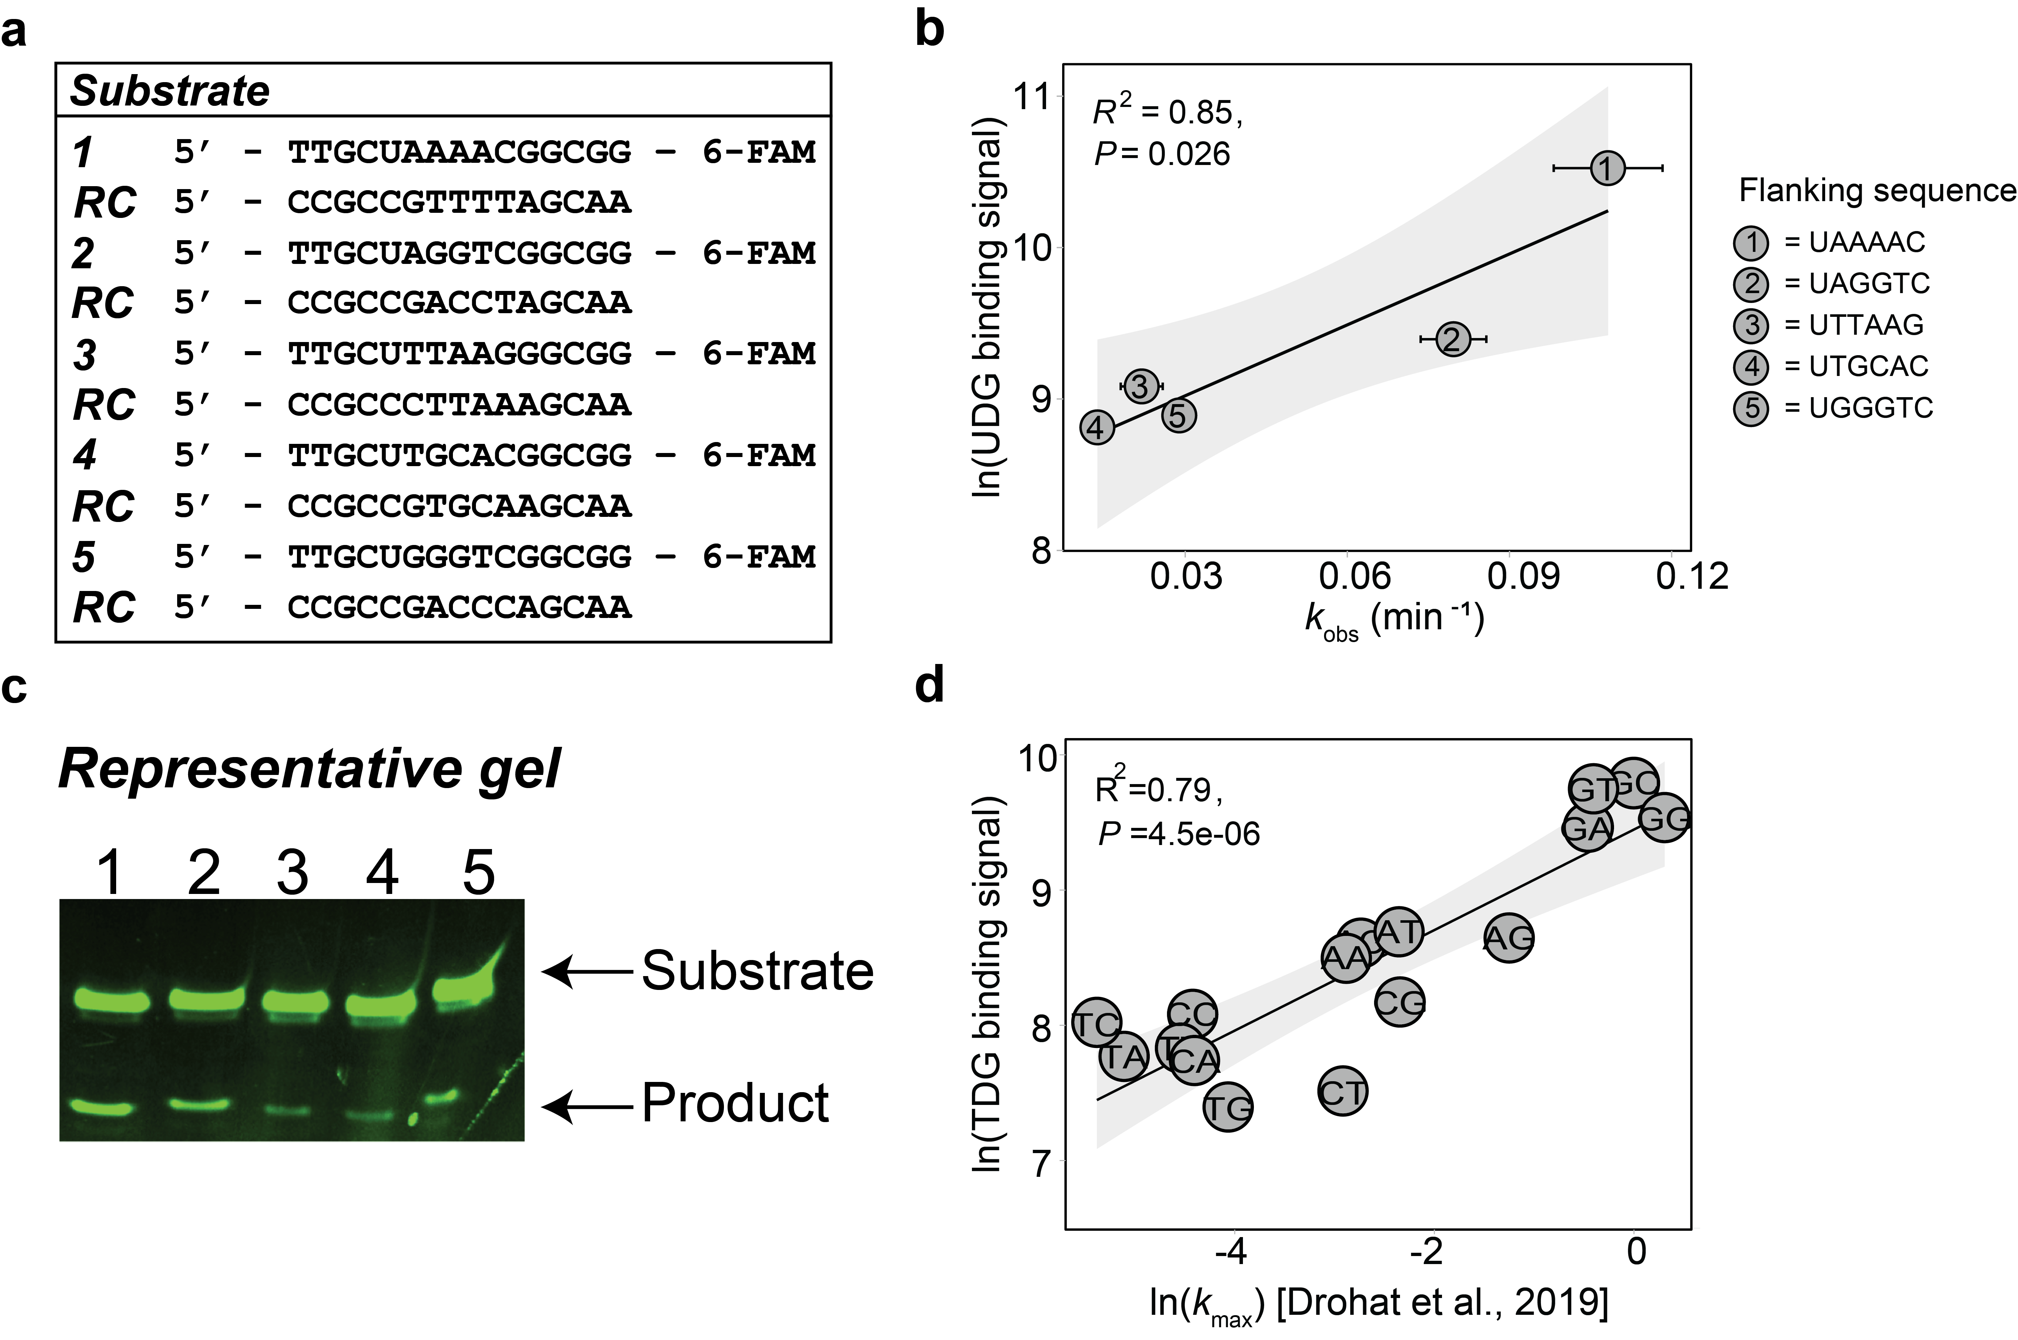
Supplementary Fig. 3 | Binding measurements correlate with independent biochemical assays. a, Synthetic DNA oligonucleotides used for UDG gel-based activity assay shown in the following panels (b,c). RC stands for reverse complement. b, Scatter plot showing the relationship between the median observed excision rate constants (k_{obs}, x-axis) and UDG binding signal (normalized median of replicates, y-axis) across five uracil-containing sequences with distinct 3′ flanks. Each point represents a different duplex context (numbered inside the point), with horizontal error bars indicating the standard error of the mean (SEM) for k_{obs} measurements. A linear regression line with 95% confidence interval (gray shading) is shown. c, Representative gel image from 3–4 independent replicates corresponding to the quantification shown in (b). Lane numbering corresponds to the substrate IDs indicated in (a) and to the data points in (b). d, Similarly, TDG binding intensities correlated well with single-turnover rate constants (k_{max}) from prior biochemical studies¹. For the correlation, we considered sequences with matching distal flanks to those tested by Drohat et al. ¹ and plotted their normalized TDG binding signals (y-axis). Reported k_{max} values were log-transformed (natural log).

Supplementary Fig. 4: ARP assay results for the detection of enzymatic products.
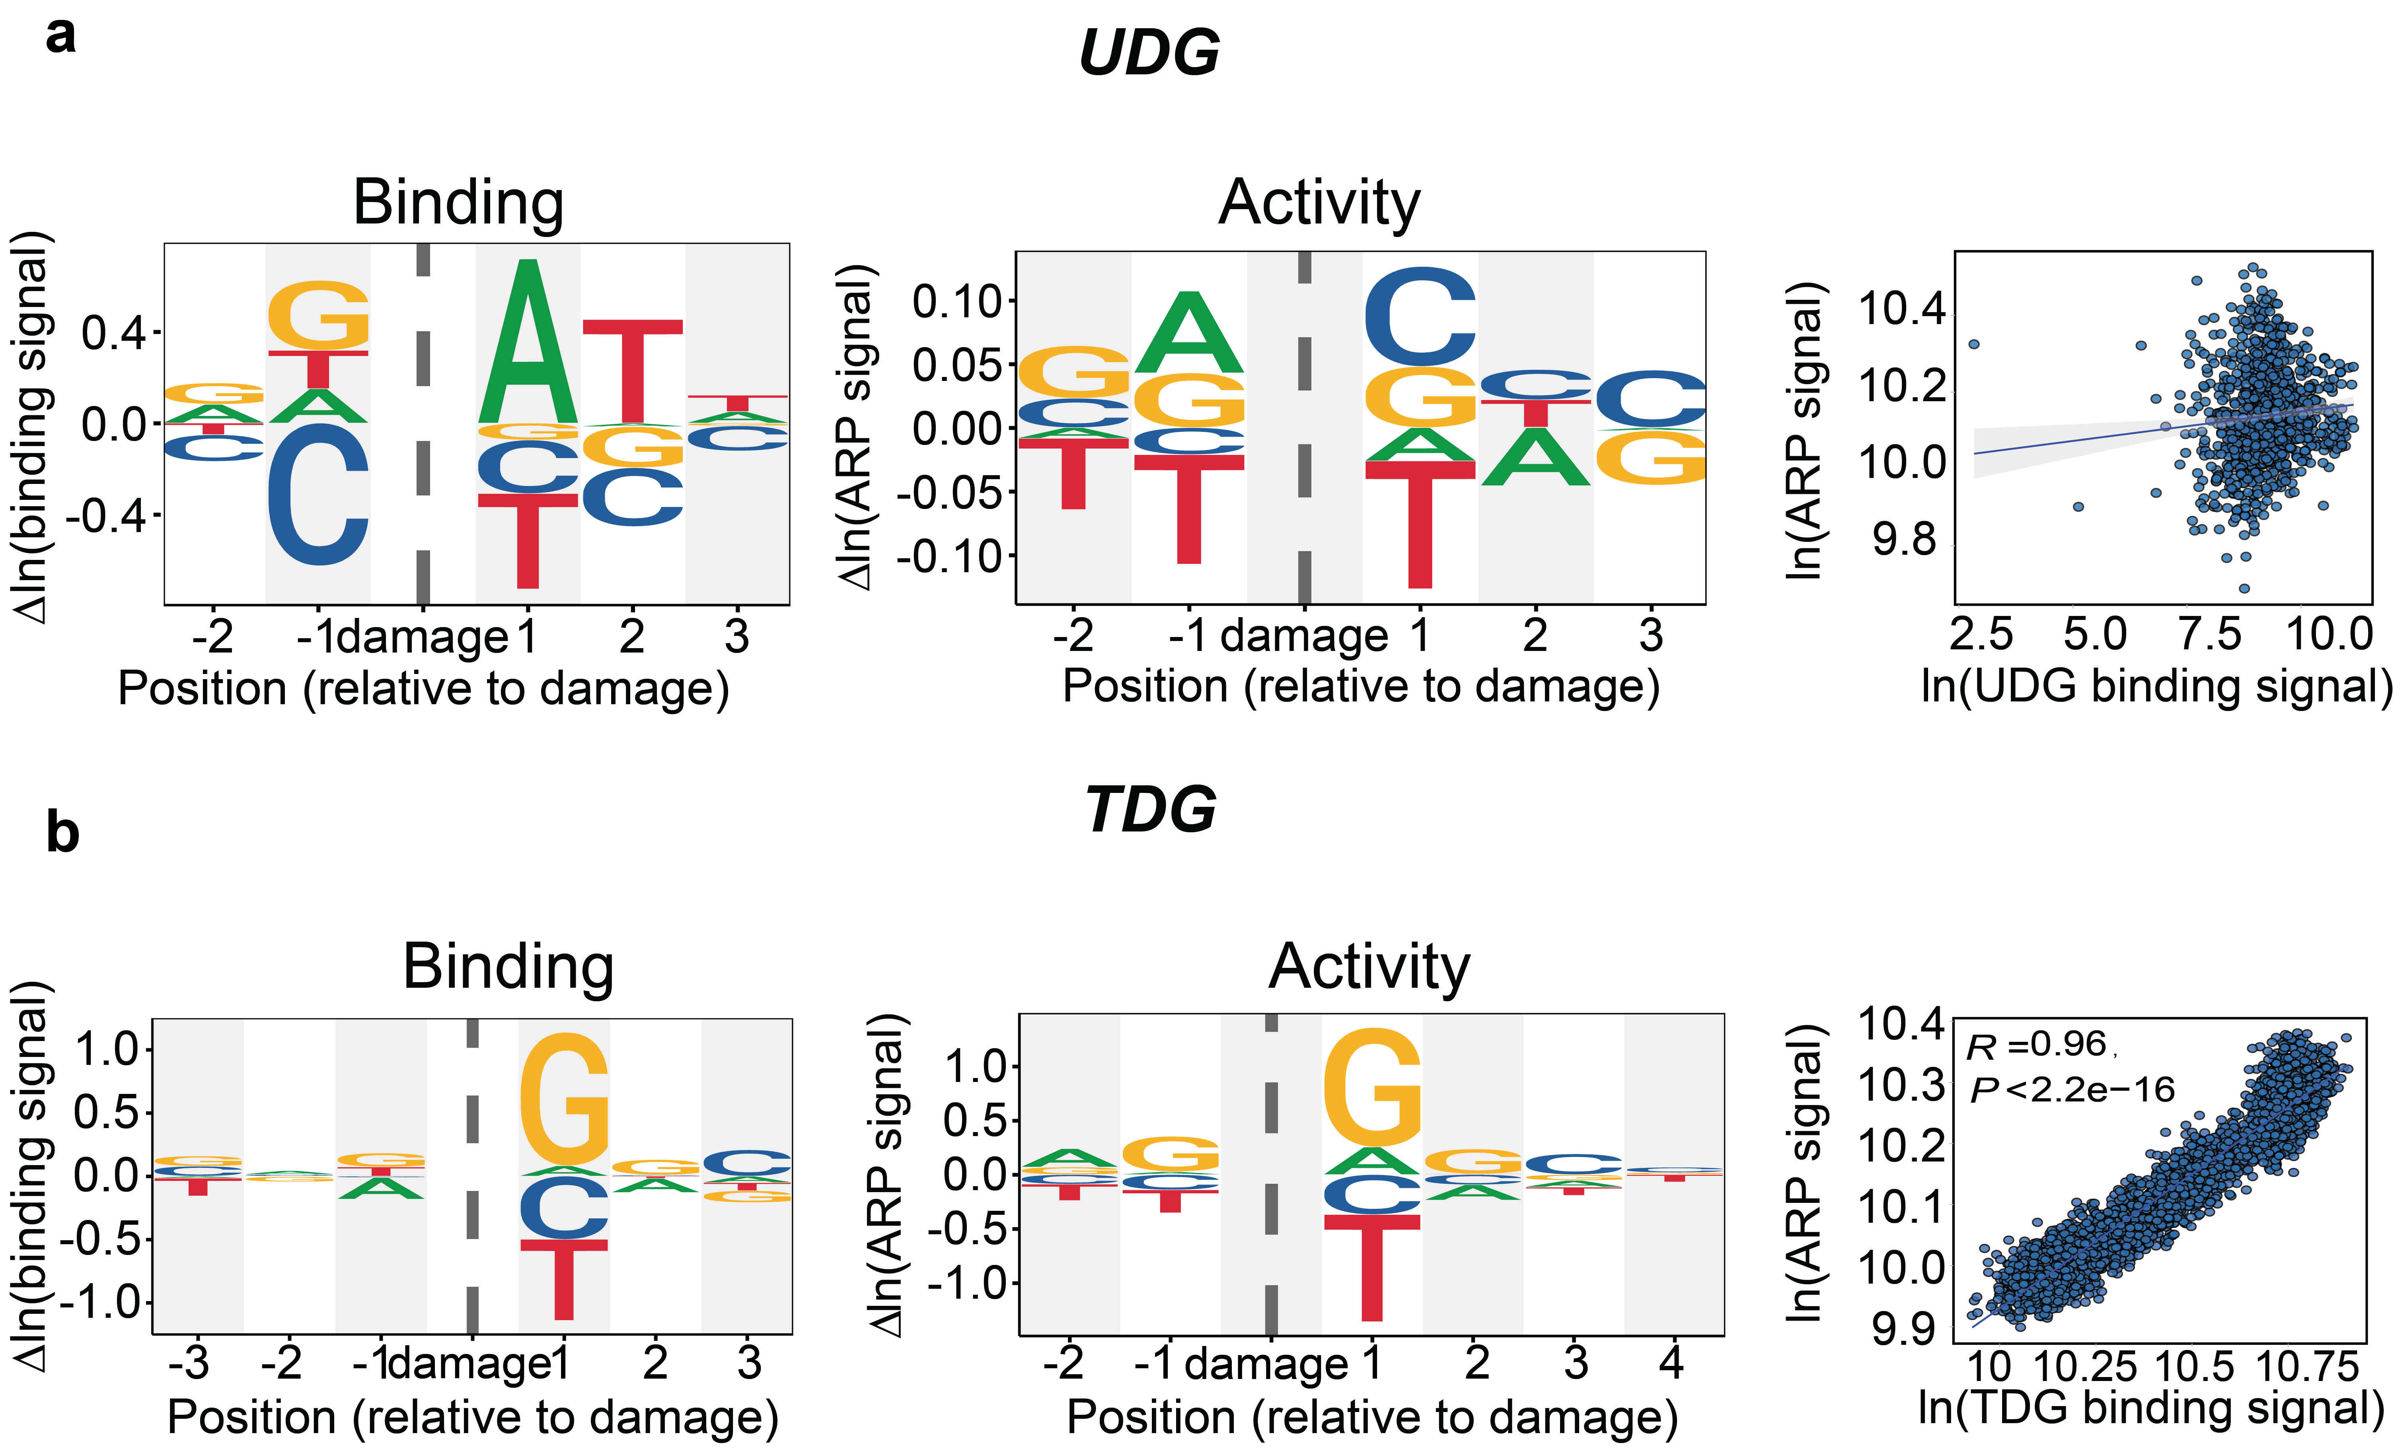

Supplementary Fig. 4 | Binding correlates with product formation for TDG but not for UDG. a, PWM logos showing UDG binding (left) and ARP-measured product formation preferences (middle) around the damaged site. Scatter plots (right) comparing ln(binding signal) to ln(ARP signal). A regression line with 95% confidence interval is shown; Pearson correlation coefficients are indicated if significant. b, The same as in (a) was done for TDG.

Supplementary Fig. 5: 4th and 5th base influence on damage recognition.
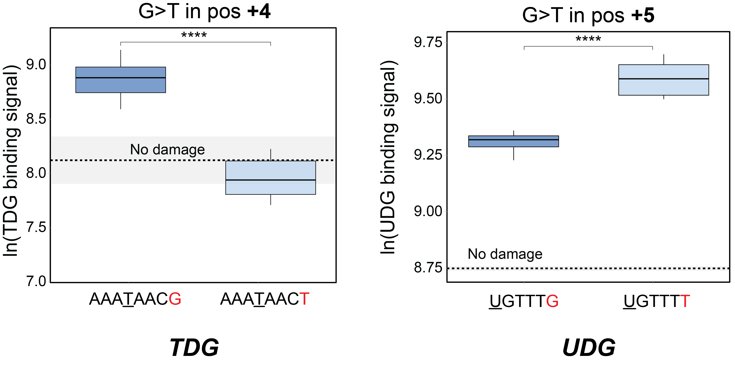
Supplementary Fig. 5 | Further flanks influence damage recognition. To evaluate how the identity of more distal 3' bases influences damage binding within the same core sequence, each context was split into a shared core and a variable 3' base (in either the 4th or 5th base for TDG and UDG, respectively, due to different library designs). For each unique core, pairwise t-tests were performed to compare binding signals across different final bases. Multiple testing was corrected using the Benjamini-Hochberg False Discovery Rate (FDR) method, and only comparisons with adjusted P-values < 0.05 were considered statistically significant. The sequences in the figures are representative examples out of 13.5% significant comparisons for TDG (3323 out of 24,576 comparisons) and 19.1% significant comparisons for UDG (294 out of 1,536 comparisons).

Supplementary Fig. 6: Circular recognition map for UDG.
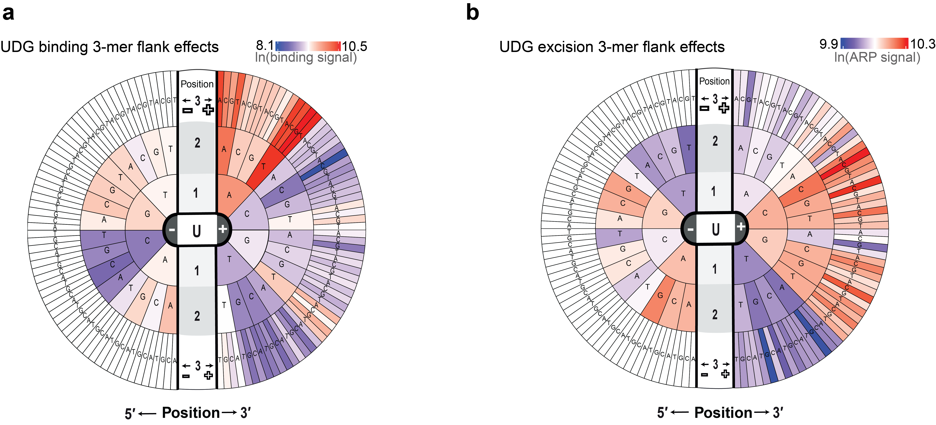
Supplementary Fig. 6 | 3-mer flanks influence on UDG damage recognition. Global view of UDG binding preferences (a) and product formation as measured by ARP (b) displayed as a circular recognition map. The right half summarizes mean signals for all 3-mer contexts on the 3′ side of the lesion (+1 to +3), and the left half summarizes the 5′ side (−1 to −3). Colors indicate average binding intensity. Position -3 (left side, outer circle) is blank due to library design (5'-NNUNNN-3').

Supplementary Fig. 7: Multiple linear regression models for UDG and TDG binding prediction.
Supplementary Fig. 7 | Multiple linear regression models for UDG and TDG binding prediction. Linear regression models without regularization were trained to predict the normalized log-transformed fluorescence intensities of DNA probes bound by TDG (a,c) and UDG (b,d), using k-mer sequence features (see Methods). Model performance was evaluated on a held-out test set, and is reported as R-squared (R²), root mean squared error (RMSE), number of test samples (n), and a shaded 95% confidence interval in each scatterplot (left). For the additive models, the flanking bases at defined positions around the central lesion (0 damage position, excluded from encoding) were one-hot encoded into binary feature vectors: 24 features (6 positions × 4 bases) for TDG and 20 features (5 positions × 4 bases) for UDG. The resulting fitted model coefficients are shown in a matrix (c,d), where each cell represents the learned weight for a specific base at a given position. e, Interaction models were additionally fit using second-order interaction terms between positions (coefficients are reported in Supplementary Table 1) to assess whether binding predictions improve when considering positional dependencies. These models achieved improved test performance relative to additive models, as shown by higher R² and lower RMSE values.

Supplementary Fig. 8: Expanded view of TDG base–base interaction effects (from Fig. 3b in the main text).
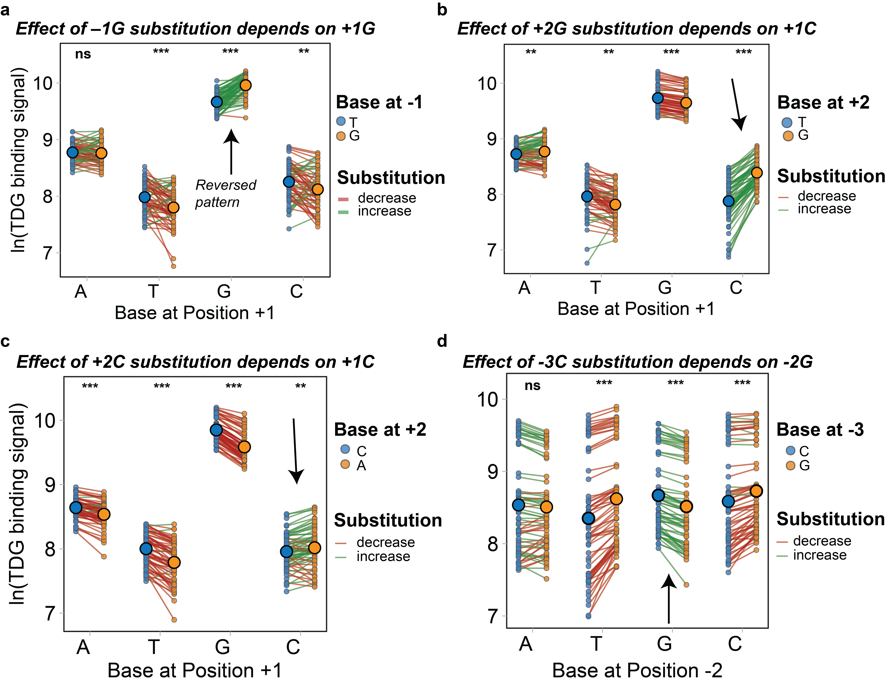
Supplementary Fig. 8 | Direct examination of base–base interactions revealed by TDG’s model-derived arc diagram. Interactions shown in the arc diagram (Fig. 3b in the main text) were individually inspected as shown here, using the same format as in Fig. 3c. For each selected interaction (indicated by the panel header and corresponding to a specific arc in the main text figure), one base out of the 6 positions (5'-NNNTNNN-3'; T stands for the damage) was fixed systematically to reduce sequence diversity and allow clearer visualization of positional effects on TDG binding. Points represent individual sequence contexts, and colored lines connect matched pairs, indicating whether the substitution increased (green) or decreased (red) binding. Bold points and letters denote group means. Statistical comparisons were performed using paired t‑tests within each group, with significance shown above (***P < 0.001; **P < 0.01; *P < 0.05; ns, not significant). This analysis shows that substitutions can either reverse binding preferences (panel a, arrow indicates the reversal pattern) or amplify the influence of neighboring bases, highlighting interactions between positions. a, Sequences were grouped by the base at position +1 (x-axis) and compared between matched pairs carrying either T or G at position -1. b, Sequences were grouped by the base at position +1 (x-axis) and compared between matched pairs carrying either T or G at position +2. c, Sequences were grouped by the base at position +1 (x-axis) and compared between matched pairs carrying either C or A at position +2. d, Sequences were grouped by the base at position -2 (x-axis) and compared between matched pairs carrying either C or G at position -3.
Supplementary Fig. 9: Expanded view of UDG base–base interaction effects (from Fig. 3b in the main text).
Supplementary Fig. 9 | Direct examination of base–base interactions revealed by UDG’s model-derived arc diagram. Interactions shown in the arc diagram (Fig. 3b in the main text) were individually examined and visualized here, using the same format as in Fig. 3c and in Supplementary Fig. 8. Points represent individual sequence contexts, and colored lines connect matched pairs, indicating whether the substitution increased (green) or decreased (red) UDG binding. Bold points and letters denote group means. Statistical comparisons were performed using paired t-tests within each group, with significance indicated above (***P < 0.001; **P < 0.01; *P < 0.05; ns, not significant). This analysis shows that substitutions can either reverse binding preferences (panel a, arrow indicates the reversal pattern) or amplify the influence of neighboring bases (panel b, arrow indicates the stronger effect relative to other comparisons), highlighting interactions between positions. See specific examples in Supplementary Fig. 8.

Supplementary Fig. 10: Structural analysis of UDG–DNA complex crystal structures.

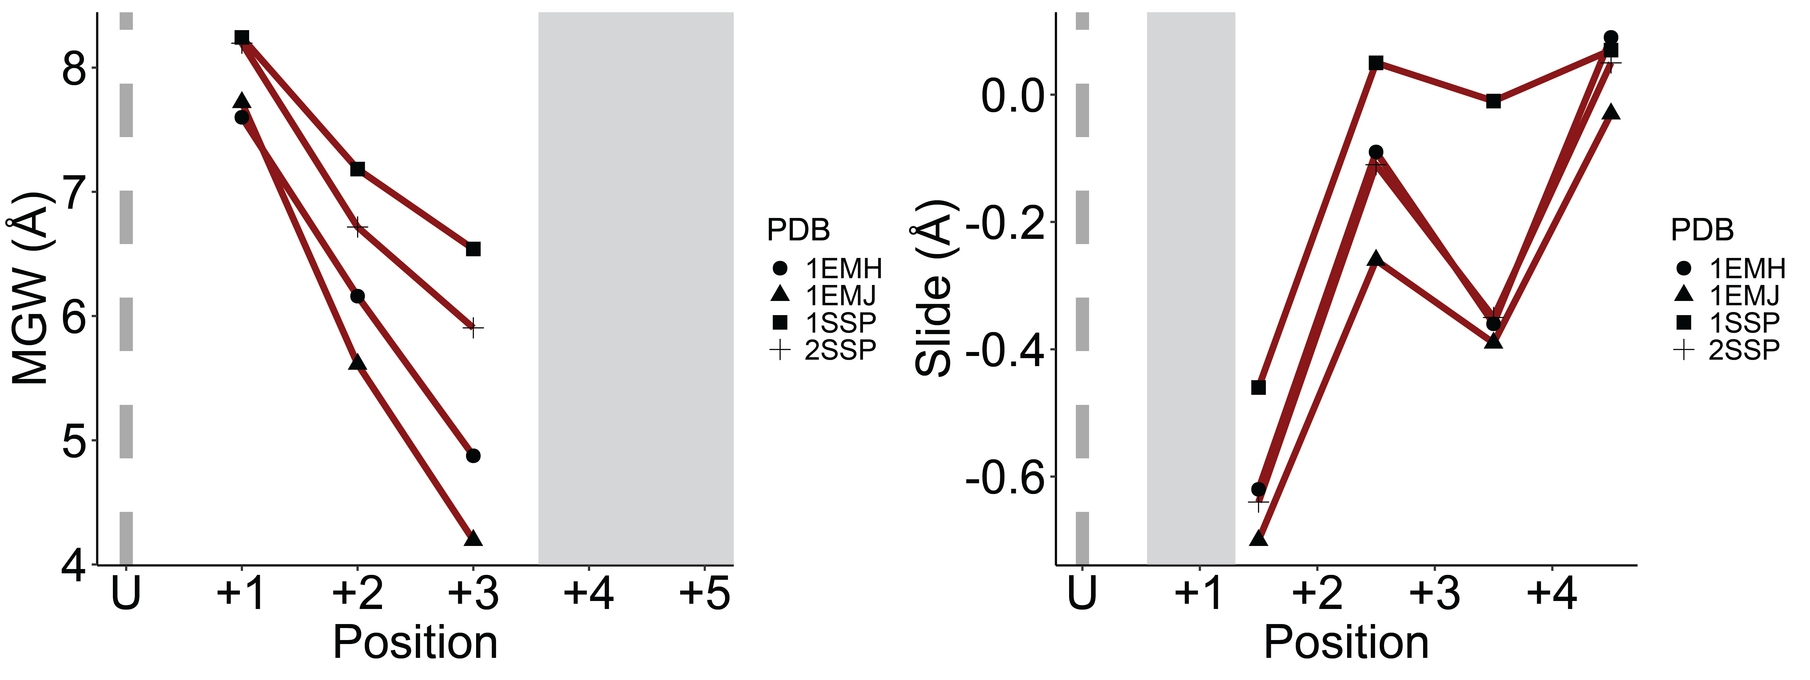
Supplementary Fig. 10 | Narrow MGW accompanied by local Slide maxima at positions 2–3. Structural analysis of four damage-bound UDG crystal structures (PDB: 1EMH, 1EMJ², 1SSP, 2SSP³) reveals consistent trends: MGW narrows toward position +3 (left), and Slide reaches a local maximum at base-step +2 to +3 (right). Note that for 1EMH and 1EMJ, MGW values reach below B-DNA MGW values as defined in Remo et. al⁴. Due to the limited length of the DNA oligonucleotides used in these crystal structures and damage presence, structural values are only available for the positions shown. Positions +4 and +5 were included for consistency in axis labeling, but no data are plotted beyond the last available base in each structure. Gray-shaded regions indicate positions where no structural data are reported. See Methods section for the extraction and analysis of the data.

Supplementary Fig. 11: C/T ratio correlation to UDG binding preferences and ARP product formation measurements.
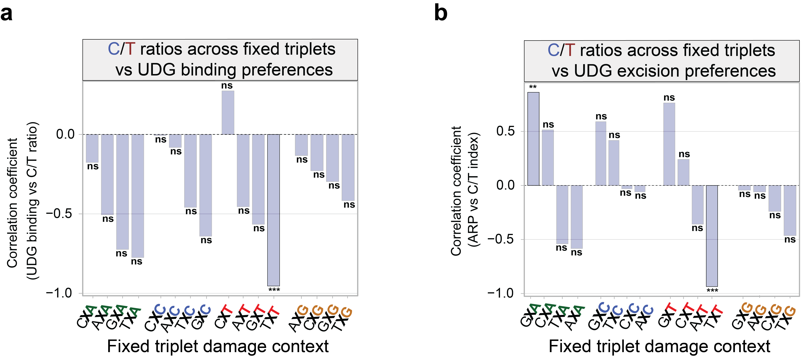
Supplementary Fig. 11 | C/T ratio correlation for UDG binding and product formation is generally low. Bar plots summarize Pearson correlation coefficients between C/T ratios across fixed triplet contexts and UDG preferences based on (a) binding intensity and (b) excision activity (measured by ARP signal). This figure corresponds to Fig. 5d in the main text. The X-axis denotes NXN triplets, where X marks the uracil damage position. Correlation P-values are shown above each bar after Benjamini–Hochberg correction for multiple comparisons. Note that the number of sequences per bin is lower for UDG due to the relevant library design (see Methods).

References:
- Dow, B. J., Malik, S. S. & Drohat, A. C. Defining the Role of Nucleotide Flipping in Enzyme Specificity Using 19F NMR. J Am Chem Soc 141, 4952–4962 (2019).
- Parikh, S. S. et al. Uracil-DNA glycosylase–DNA substrate and product structures: Conformational strain promotes catalytic efficiency by coupled stereoelectronic effects. Proceedings of the National Academy of Sciences 97, 5083–5088 (2000).
- Parikh, S. S. et al. Base excision repair initiation revealed by crystal structures and binding kinetics of human uracil‐DNA glycosylase with DNA. EMBO J 17, 5214–5226 (1998).
- Rohs, R. et al. The role of DNA shape in protein-DNA recognition. Nature 461, 1248–1253 (2009).

