Supplementary Information
µSQUID-EPR Reveals Topologically Quenched Tunnelling in a Lanthanide Molecule
Sagar Paul^{a*‡}, Eufemio Moreno-Pineda^{a,b,c*‡}, Concepción Molina-Jirón^{c,d,e}, Appu Sunilª, Mario Ruben ^{d,g,f}, Anupam Garg^{h} and Wolfgang Wernsdorfer ^{a,d*}
ª Physikalisches Institut, Karlsruhe Institute of Technology, D-76131 Karlsruhe, Germany.
^{b} Universidad de Panamá, Facultad de Ciencias Naturales, Exactas y Tecnología, Depto. de Química-Física, 0824 Panamá, Panamá.
^{c} Universidad de Panamá, Facultad de Ciencias Naturales, Exactas y Tecnología, Grupo de Investigación de Materiales, 0824 Panamá, Panamá.
^{d} Institute of Quantum Materials and Technologies (IQMT), Karlsruhe Institute of Technology (KIT), Hermann-von-Helmholtz-Platz 1, D-76344, Eggenstein-Leopoldshafen, Germany.
^{e} Depto. de Bioquímica, Escuela de Química, Facultad de Ciencias Naturales, Exactas y Tecnología, Universidad de Panamá, Panamá, Panamá.
^{f} Institute of Nanotechnology (INT), Karlsruhe Institute of Technology (KIT), Hermann-von-Helmholtz-Platz 1, D-76344, Eggenstein-Leopoldshafen, Germany.
^{g} Centre Européen de Sciences Quantiques (CESQ), Institutde Science et d’Ingénierie Supramoléculaires (ISIS), 8 allée Gaspard Monge, BP 70028, 67083, Strasbourg Cedex, France.
^{h} Department of Physics and Astronomy, Northwestern University, Evanston, Illinois 60208, United States of America
‡ These authors contributed equally to this work.
*Correspondence to: sagar.paul@kit.edu; eufemio.moreno@up.ac.pa; wolfgang.wernsdorfer@kit.edu
- CASSCF
The CASSCF-SO electronic structure calculation of Et₄N[¹⁶⁰GdPc₂] was determined using OpenMolcas¹⁻³. The CASSCF-SO calculation was performed only on the Gd³⁺ site employing the crystallographic coordinates obtained from the single crystal X-ray structure with no further optimisation. Basis sets from ANO-RCC library were employed with VTZP quality for the gadolinium ion, while VDZP were employed for all remaining atoms. The molecular orbitals (MOs) were optimised in state-averaged CASSCF calculations. For this, the active space was defined by the seven 4f electrons in the seven 4f orbitals of Gd³⁺. Four calculations were performed independently for each possible spin state, where 1 root was included for S = 7/2, 48 roots were included for S = 5/2, 392 roots were for S = 3/2 and 600 roots for S = ½ (RASSCF routine). The wavefunctions obtained from these CASSCF calculations were posteriorly mixed by spin orbit coupling, where the state for S = 7/2 states, 48 of the S = 5/2 states, 129 of the S = 3/2 and 113 of the S = 1/2 states were included (RASSI routine). The resulting spin orbit wavefunctions were decomposed into their CF wavefunctions in the ⁸S_{7/2} basis, employing the SINGLE_ANISO routine.
Table S1. Computed energy levels (the ground state is set at zero), composition of the g-tensor (g_{x}, g_{y}, g_{z}) and the main components (>10%) of the wavefunction for each m_{J} state of the ground-state multiplet ⁸S_{7/2} for the ¹⁶⁰Gd³⁺ in [¹⁶⁰GdPc₂]⁻, at the CASSCF level.
Energy (cm⁻¹) | g_{x} | g_{y} | g_{z} | Wavefunction
0 | 0.0000 | 0.0000 | 13.9734 | 100% $\left.\left|±7/2\right.\right\rangle$
0.497 | 0.0493 | 0.0494 | 9.9808 | 99.5% $\left.\left|±5/2\right.\right\rangle$
0.817 | 0.0484 | 0.0503 | 5.9884 | 91% $\left.\left|±3/2\right.\right\rangle$
0.973 | 7.9858 | 7.9839 | 1.9962 | 100% $\left.\left|±1/2\right.\right\rangle$

Table S2: Crystal field Hamiltonian is given as ${\hat{H}}_{CF}=\sum_{k,q}{B_{k}^{q}O_{k}^{q}}$ and the extended Stevens operator coefficients $B_{k}^{q}$ are extracted from CASSCF calculations.
 |  | $B_{k}^{q}$ (MHz)
k | q | Gd³⁺
2 | -2 | -7.48E-04
2 | -1 | 4.42E-03
2 | 0 | -8.11E+02
2 | 1 | 2.67E-05
2 | 2 | 3.73E-02
4 | -4 | 2.85E-01
4 | -3 | -4.38E-04
4 | -2 | 6.82E-05
4 | -1 | -3.14E-05
4 | 0 | -2.39E-01
4 | 1 | 3.43E-05
4 | 2 | 6.13E-05
4 | 3 | 1.51E-04
4 | 4 | 1.60E-01
6 | -6 | 1.21E-06
6 | -5 | -6.00E-06
6 | -4 | -3.23E-04
6 | -3 | -1.83E-06
6 | -2 | 9.86E-07
6 | -1 | 4.85E-07
6 | 0 | 1.55E-04
6 | 1 | 1.15E-07
6 | 2 | 8.07E-07
6 | 3 | 2.24E-07
6 | 4 | -2.42E-04
6 | 5 | 2.25E-06
6 | 6 | -1.44E-07

Two differently oriented molecules of Et₄N[¹⁶⁰GdPc₂] reside within the unit cell, with the second molecule being related to the first one by a +x, -y, -z symmetry. Considering this, it is clear that the “hard” and “medium” axes are nearly 90º apart from each molecule (See Figure S1).
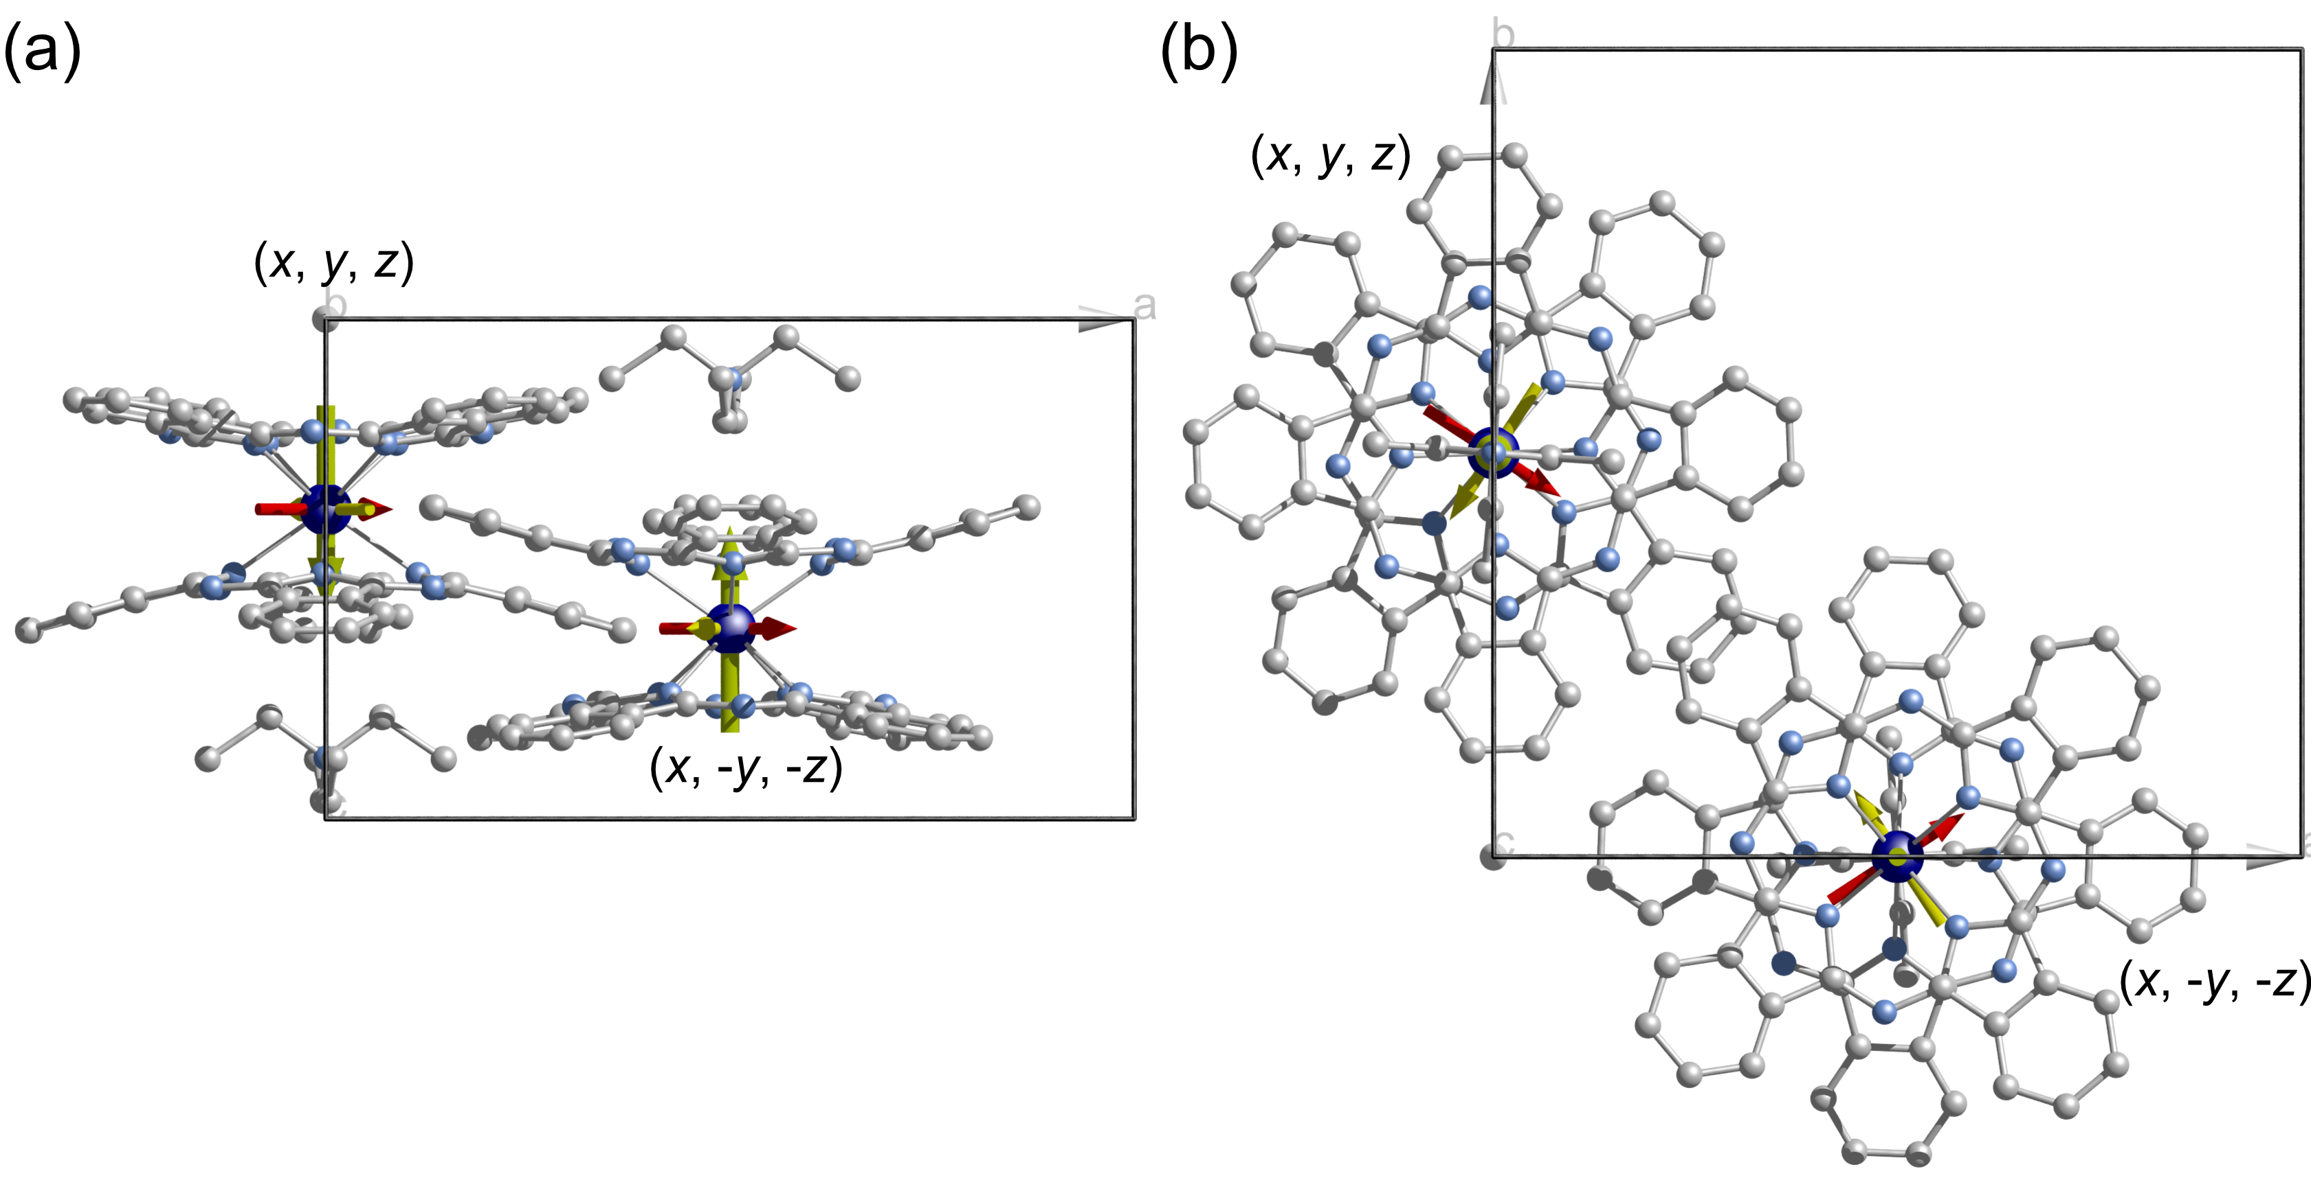
Figure S1. Packing view of the two differently oriented Et₄N[¹⁶⁰GdPc₂] molecules within the unit cell and the easy (green), medium (yellow) and hard (red) axes as determined from CASSCF calculations. The molecules are view along the b- crystallographic axis (a) and along the c-crystallographic axis. Colour code: Gd, purple; N, cyan, C, grey. Hydrogens and the Et₄N⁺ counter cation are omitted for clarity.
- Experimental details for µSQUID-EPR
To facilitate microwave-induced excitation of the molecular crystal while simultaneously measuring its magnetic response, a silver coplanar waveguide was integrated atop the µSQUIDs (Figure 1a in main article). This on-chip waveguide was wire-bonded to the coplanar waveguide of the sample holder, consisting of SMP and mini-SMP connectors for microwave input and output. To prevent excessive heating from impedance mismatch, the microwave line was not terminated at the sample holder. Instead, it was routed through the output SMP connector and externally terminated using a 50 Ω terminator block outside the dilution refrigerator. Microwave signals were generated by an AnaPico APSYN140-X frequency synthesizer, offering a broad frequency range of 100 kHz to 40 GHz with pulse modulation and an output power range spanning from -10 dBm to 25 dBm. The later could be reduced further (if needed) by using external attenuators.
As illustrated in the schematic Figure S2(a), the microwaves were pulsed to ensure that the ‘on time’ did not coincide with a µSQUID measurement. This precaution was necessary as microwaves could drive the Josephson junctions (or weak links) of the µSQUID into their normal (resistive) state, disrupting the magnetization measurement. Given the minimum time required for the µSQUID to recover after each critical current detection, i.e., the Josephson healing time τ_{h} ​∼100 µs, the period was set to 300 µs, with the pulse width (ON time) minimized to ~10 µs. However, the relaxation time of molecular magnet crystals is typically much longer than these time scales. Thus, from the perspective of crystal relaxation dynamics, the microwave excitation effectively behaves as a continuous wave.
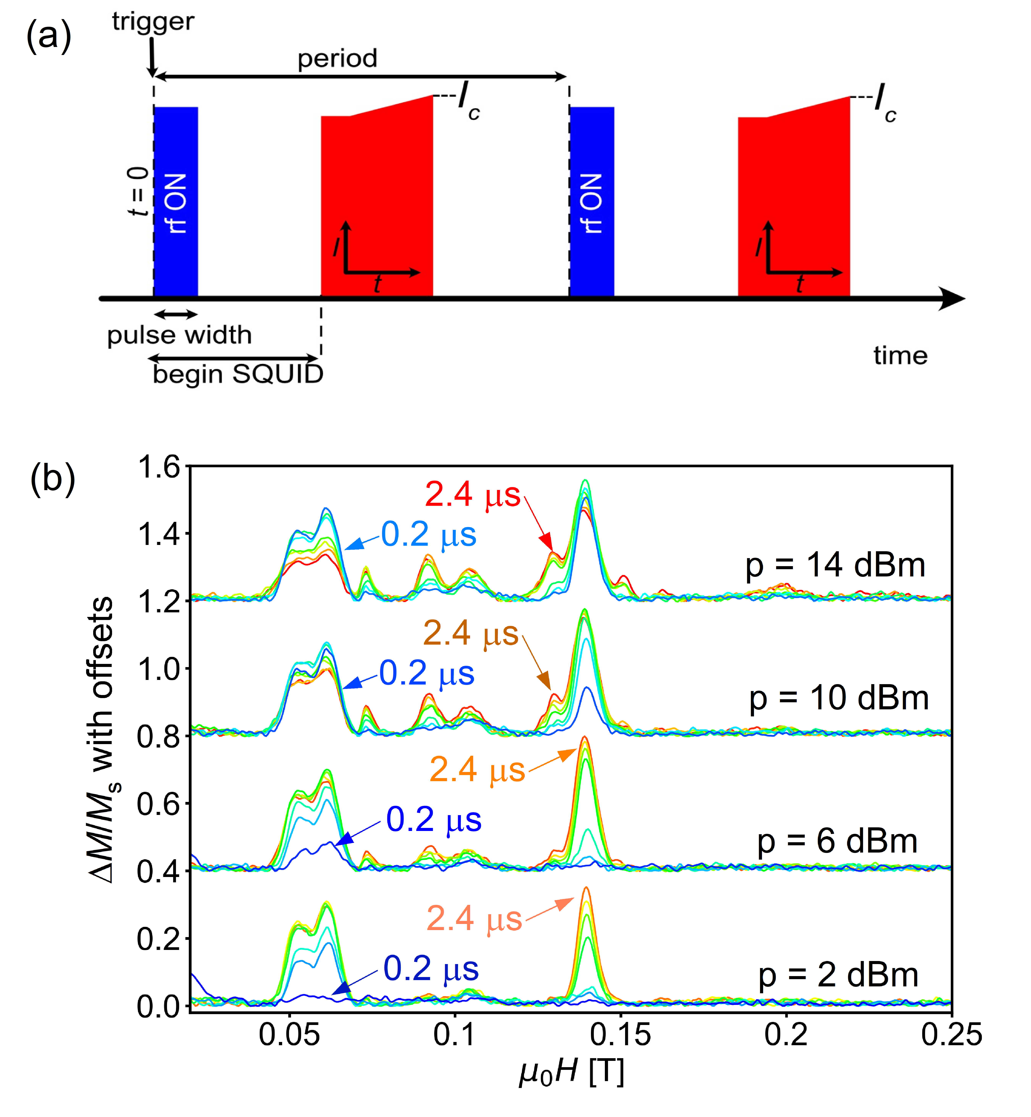
Figure S2. (a) Schematic of microwave pulse position with respect to µSQUID measurements to avoid microwave assisted heating of Josephson junctions (weak links) of the µSQUIDs. (b) Microwave absorption peak intensities as |ΔM/M_{s}|(H) (after baseline subtraction) are plotted for various microwave pulse width and power, while pulse period was kept fixed to 300 µS.
While the microwave pulse period (delay = ‘On time’ + ‘Off time’) is constrained to values > 150 µs due to the Josephson healing time, the optimum pulse width (‘On time’) and power need to be found for every single crystal. This is because the coupling of microwaves to a single crystal strongly depends on the crystal size and exact position in the trench of coplanar waveguide. The homogeneity of microwave induced field to the entire crystal also contributes to the effective coupling. Figure S2(b) represents how an optimum power and width is found for an individual crystal based on visibility of all peaks. The microwave absorption intensities are plotted as |ΔM/M_{s}|(H) (after baseline subtraction) for different values of power and width of the microwave pulse keeping the delay = 300 µs. For better visibility, the curves for different applied powers are plotted with offsets, while the curves for different pulse widths with same power are plotted together. Interestingly, the highest powers and widths do not necessarily provide highest visibility of the peaks accounted to undesired heating of the crystal. It is also found that beyond certain powers (p), the low widths (w) sometimes yield some very sharp and high peaks (see for example the curve with p = 10 dBm, w = 0.2 µs), while a neighbouring peak may not be visible. Such power and width combinations are useful to observe the transitions with optimum sharpness and minimized non-resonant absorption or heating of the crystal. However, in this study the visibility of all peaks is concerned, such that several anti-crossings are measurable in a frequency map. Hence, a different combination can be found best, for example, here p = 10 dBm, w = 1.6 µs yields among the highest visibilities considering all observable peaks.

- Estimation of axial parameters from the frequency map

Upon precise identification of the easy axis in the measurement plane using transverse field method and an angular map, the field direction (H||) is aligned with it. At 30 mK bath temperature, the M(H||) curves in presence of microwaves at a few fixed frequencies are shown in Figure S3(a). The peaks identified with the arrows are found to move as a function of frequency, indicating resonant absorption of microwaves as detailed in ref 4. Here, to clarify the correlation between these M(H||) curves with Figure 1(d) of the main article, the largest peaks for the curve at 12 GHz (blue curve) are projected on the frequency map, see yellow dashed lines in Figure S3(b).
The inset in Figure S3(b) indicates the slopes of linear regimes of the anti-crossing transitions (γ_{1,2}) to explain the correlation of δH|| and tunnel splitting Δ described in the ‘methods’ section. Note the slopes are calculated using a large range of the linear regime not entirely shown in the insets.
Figure S3(c) shows the Zeeman diagram (for H||, i.e. along the easy axis) simulated using Easyspin⁵ with appropriate axial parameters obtained via fitting of multiple transitions in the frequency map shown in Figure S3(c). As the transition (2,3) can be tracked with a vertical bar placed on the shaded region in Figure S3(c), all other mentioned transitions can be tracked in the same way. The approach shown in ref. 4 employing three linear equations and the slopes at high field linear region correspond to the (7/2 5/2), (5/2 3/2) and (3/2 1/2) transitions leads to a unique solution of axial parameters as: g = 2.00 and $B_{2}^{0}$ = -685 ± 2 MHz, $B_{4}^{0}$ = -1.45 ± 0.05 MHz, $B_{6}^{0}$ = 0.004 ± 0.004 MHz.
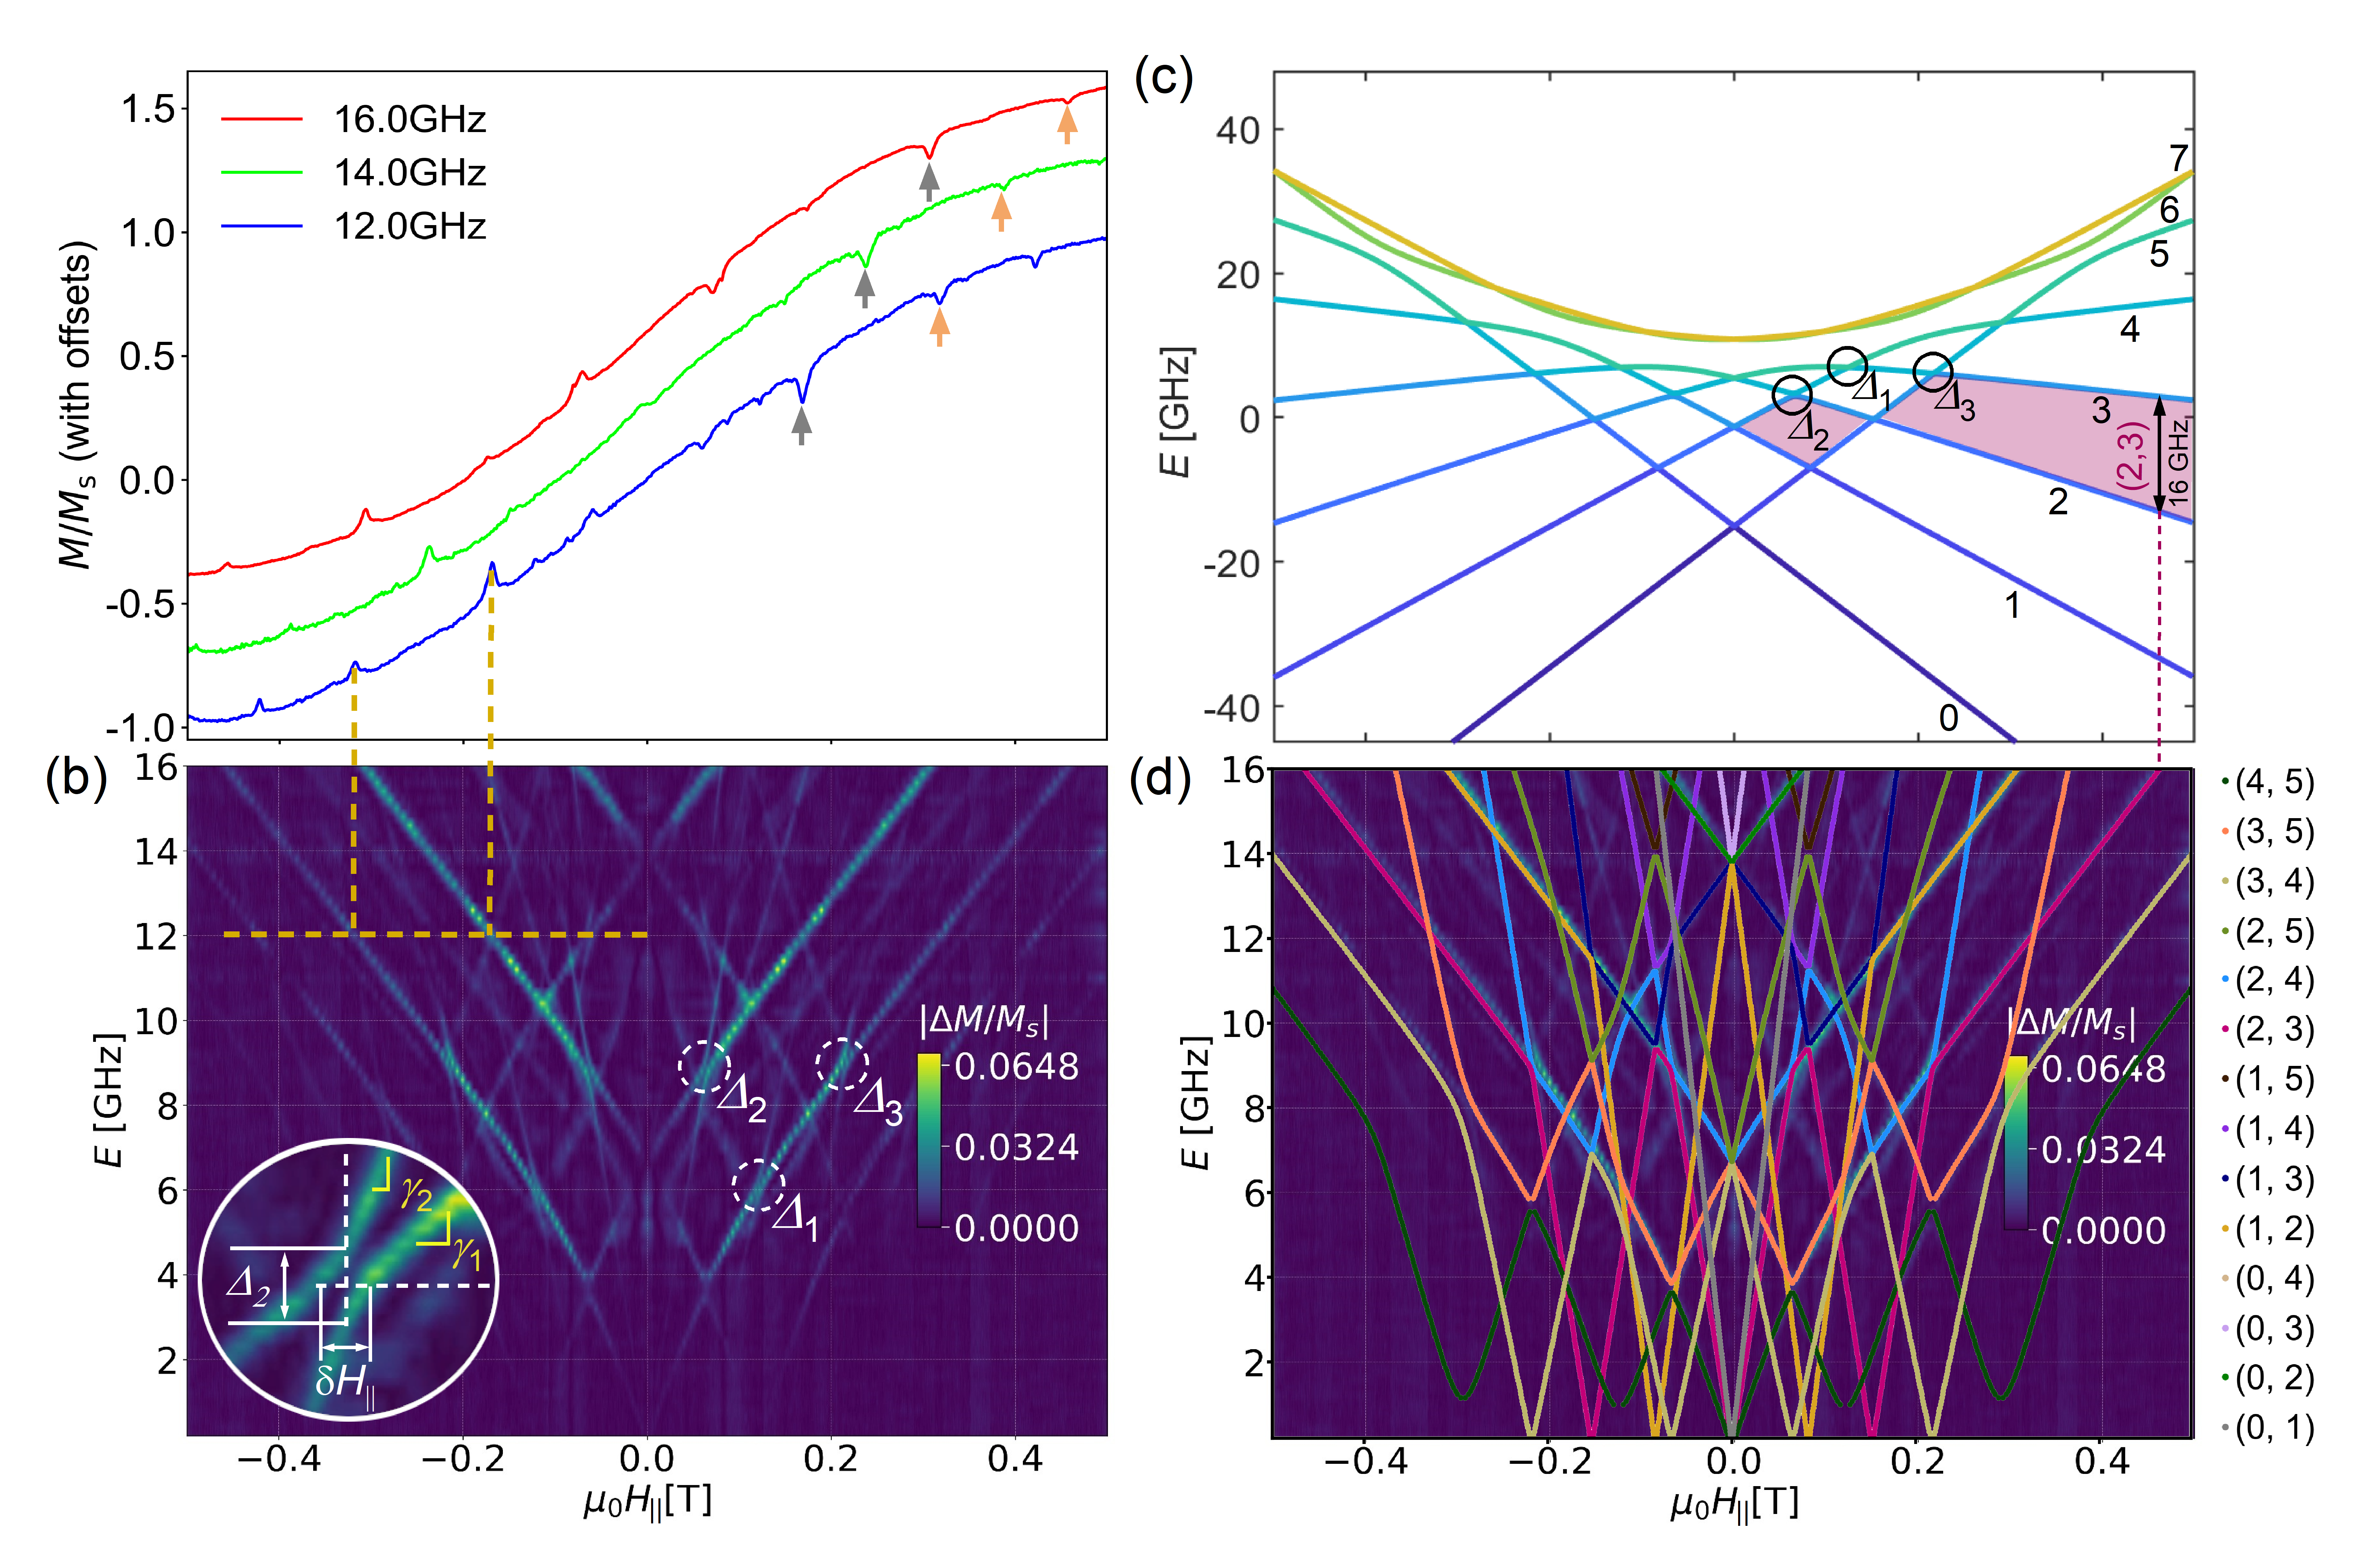
Figure S3. (a) M(H||) curves measured at 30 mK bath temperature (with H|| along the easy axis) in presence of microwave with fixed frequencies. (b) Microwave absorption peak intensities as |ΔM/M_{s}|(H||) (after baseline subtraction) plotted as a function of microwave frequency. Yellow dashed lines indicate the correspondence between (a) and (b). (c) The Zeeman diagram simulated for H|| along the easy axis. The required axial parameters are obtained from the fittings of several transitions in the frequency map as shown in (d). As an example, the transition (2,3) in (d) can be tracked from the shaded region in (c).
- Estimation of transverse parameters from an angular map

An angular map is obtained by keeping microwave frequency fixed and collecting M(H) for different in-plane angles of applied field. The field-direction dependent Zeeman diagrams were simulated using Easyspin to theoretically obtain direction dependent resonance fields (‘resfields’) for the EPR transitions at a given frequency. As the axial parameters are already obtained from the frequency map, an angular map at a randomly chosen microwave frequency (here at 10 GHz, see Figure S4(a)) is fitted keeping axial parameters fixed and varying only two relevant transverse ligand field parameters: $B_{2}^{2}$ and $B_{4}^{4}$. The best fitting considering the mentioned transitions (see Figure S4(b)) yields: $B_{2}^{2}$ = -275 ± 3 MHz and $B_{4}^{4}$ = 3 ± 2. Using these parameters, together with the axial parameters found before, the fitting quality of angular maps at different microwave frequency values were also checked and found to match very well. These values are a pre-requisite to analyse further the detailed observations related to topological quenching described in this work.
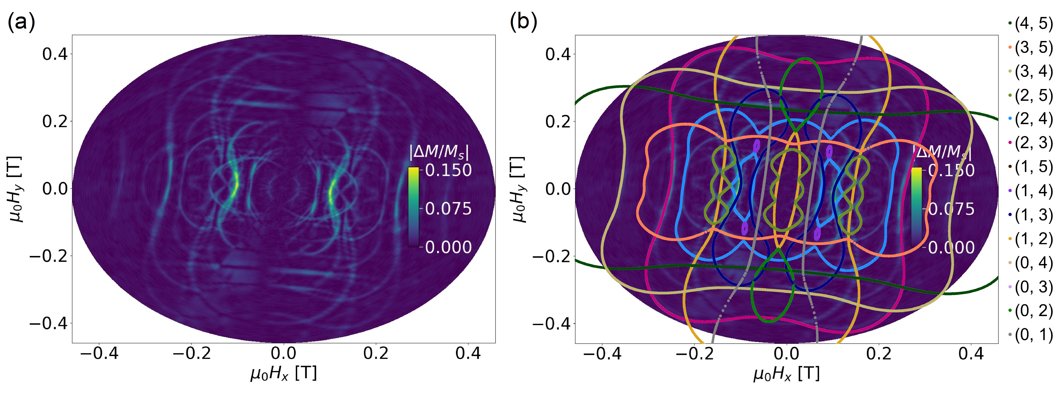
Figure S4. (a) Microwave absorption peak intensities as |ΔM/M_{s}|(H||) (after baseline subtraction) plotted as a function of applied field direction (H_{x,y}) at a fixed microwave frequency (10 GHz). The simulations in (b) show the angular dependence of individual resonant transitions (at 10 GHz) obtained from Zeeman diagrams for different field angles, providing the transverse ligand field parameters.
- Animation of experimental frequency maps
The animation SI.V1 shows several frequency maps (for H||, i.e. along the easy axis) at constant transverse field (H_{tr}) values stacked together to show how it evolves as H_{tr} is varied between -30 to 120 mT. As the H_{tr} is applied nearly along the hard axis of the system, the parity dependent oscillations in the avoided-level crossings (tunnel splittings) are observed. The animation compiles more than 72 hours of continuous data collection with a stable microwave, at a sweep rate for H|| <20 mT/s to maintain adiabatic sweep, very small steps (0.5 mT) in the constant H_{tr} values. Each frequency map at a fixed H_{tr} contains 0.1 GHz steps in frequency, allowing precise visualization of the tunnel splittings.
- Simulation of transverse field dependent Zeeman diagrams:
To simulate these maps, the Zeeman diagrams need to be simulated in the presence of transverse magnetic fields. To apply constant transverse field (H_{tr}) using the ‘levels’ function in EasySpin simulations, the orientation (‘theta’= θ, ‘phi’=φ) of the crystal with respect to the applied field (H_{z}) was varied as a function of the longitudinal field. More specifically, θ, φ values were chosen as: θ = tan⁻¹(H_{tr}/H||), and φ = 0 (π/2) for transverse field along the medium (hard) axis (and vice versa if the sign of $B_{2}^{2}$, $B_{4}^{4}$ are reversed).
The angular dependence of Δ_{2,3}(H_{tr}): In this way, the Zeeman diagrams are simulated (Figure S5) for different H_{tr} (at an angle φ = 100°) to compare with the experimental data. Notice that Δ_{1,2,3} do not oscillate in the same fashion, indicating the parity dependent features associated to QPI or topological quenching. Although here Δ_{2,3} oscillations cannot be clearly seen unless enlarged, it can be clearly understood from the fittings described in the main article. Figure 4(a) in the main article shows the fitted lines directly obtained by measuring Δ_{2,3} gaps from such Zeeman diagrams simulated at different H_{tr}.

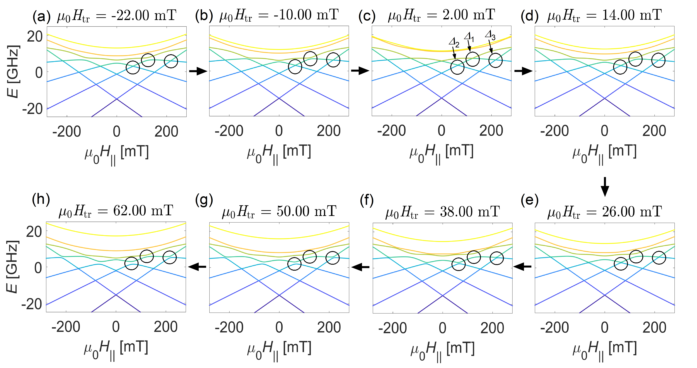
Figure S5. (a)-(h) Zeeman diagrams simulated for H|| along the easy axis, with different constant values of transverse fields (H_{tr}) nearly along the hard axis (φ = 100°). Chosen H_{tr} values correspond to experimental Figure 2. The parity dependent oscillations in tunnel splittings (Δ_{1,2,3}) can be observed. Notice that Δ₁ starts closing again from (f)-(h).
To show the complete set of simulations, the animation SI. V2 stacks several Zeeman diagrams (for H||, i.e. along the easy axis) at different H_{tr} values between -120 to +120 mT, with 1 mT steps is H_{tr} and at φ = 100°.
7. Angular dependence in Δ_{2,3}(H_{tr}) in hard-medium plane
Figure S6 shows Δ₂(H_{tr}) and Δ₃(H_{tr}) for two different cool-downs having different crystal orientations. In both cases the easy axis was aligned along H||. In the first case, when H_{tr} is nearly aligned with the hard axis of the system (blue shades), oscillatory features are observed in Δ_{2,3}(H_{tr}), consistent with QPI effects. While in the second case, when H_{tr} is nearly aligned with the medium axis of the system (green shades), more classical-like monotonic increase in Δ_{2,3}(H_{tr}) is visible.

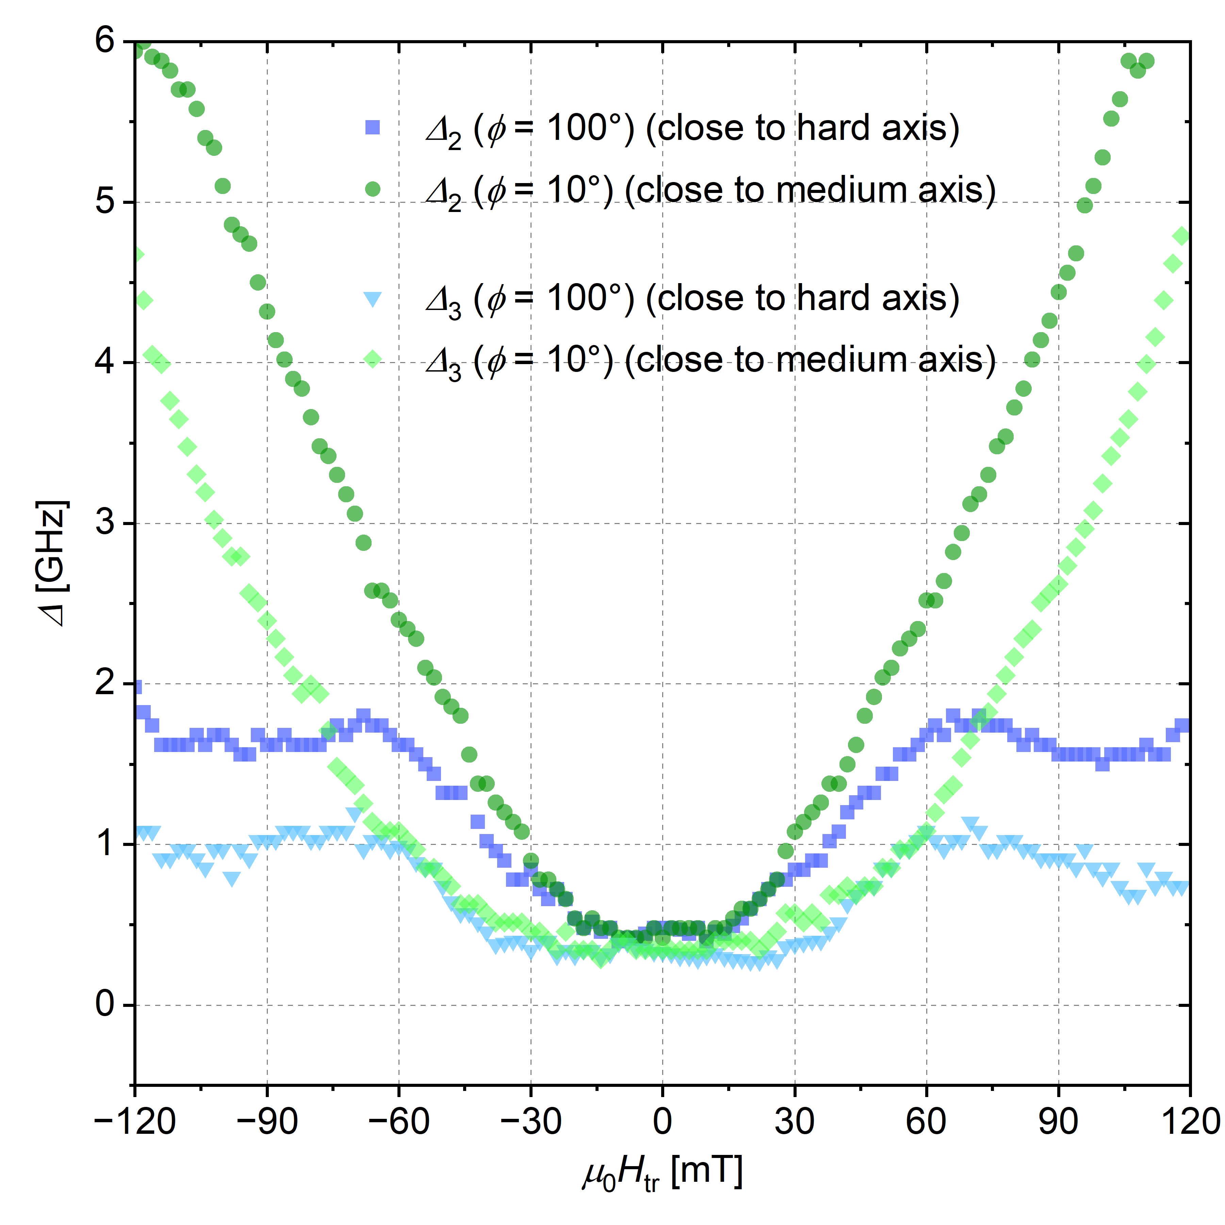
Figure S6. Experimentally obtained Δ_{2,3}(H_{tr}) at two different angles of H_{tr} in the hard-medium plane obtained in two different cool-downs by rotating the crystal.
- Classical energy diagram with 4th order transverse parameter
Figure S7: Classical energy E_{cl} mapped with classical spin orientation space (θ, φ) for the corresponding spin Hamiltonian (Eq. 1), with the ligand field parameters: $B_{2}^{0} = -685 MHz, B_{2}^{2} = -275 MHz$ and different values for $B_{4}^{0}, B_{4}^{4}$ in absence of any external magnetic field ((a)-(d)). In these maps, θ = 0° and 180° (the poles) indicate the easy axis of the system, while θ = 90° line (equator) indicates the hard-medium plane with the hard axis at φ = 90° and medium at φ = 0°. The saddle points in the map E_{cl}(θ, φ) dictate the minimum energy pathway of magnetization reversal (tunneling) through the medium axis. As $B_{4}^{4}$ values are increased (with a same sign as $B_{2}^{2}$), the two interfering tunnel paths is found to split into 4 interfering paths. As the transverse magnetic field (H_{tr}) applied along the hard axis (φ = 90°) is increased ((e)-(l)), the two minima (easy axis) bends towards each other and away from the poles, and as a result, the area enclosed by the interfering paths monotonically decreases with increasing (H_{tr}). The dashed rectangular box indicates the transverse field dependent evolution of E_{cl} for the experimentally obtained ligand field parameter values ($B_{2}^{0}, B_{2}^{2}, B_{4}^{0} and B_{4}^{4}$) in the [GdPc₂]⁻ molecule.
A non-zero value of $B_{2}^{2}$, the coefficient of the 2nd order transverse term $O_{2}^{2}\sim 1/2(S_{+}^{2}+S_{-}^{2})$, is a key ingredient to observe QPI in a spin system. This term, analogous to the transverse anisotropy coefficient E in the transition metal-based molecules, leads to anisotropy in the lateral plane, i.e. a hard and a medium axis. As a result, two preferred pathways (through the medium axis) dominate the quantum tunnelling rate between the two degenerate easy orientations. The QPI is therefore possible and can be detected as modulation of tunnel rate (QTM) by altering these two paths. For clarification and a qualitative overview of the QPI in the spin systems, a classical spin analogue (i.e. the magnetic moment $\vec{S}$ can orient freely in θ, φ space) is useful. Figure S7 shows the (classical) energy landscape obtained from the above spin Hamiltonian by expanding the Stevens operators in terms of ${\hat{S}}_{x,y,z}$ and then writing them as continuous functions of θ, φ. The two (or more) interfering minimum energy pathways for quantum tunnelling and their evolution with transverse magnetic fields and different values of 4th order ligand field parameters are indicated. The parameters chosen for these simulations are neighbouring values to the experimentally obtained ligand field parameters in [Et₄N]¹⁶⁰GdPc₂].
We can discuss the transverse field dependent oscillations in tunnel splittings from a qualitative point of view based on these energy diagrams. In the framework of time dependent Schrodinger’s equation (with a time dependent Hamiltonian), at the diabolical points (DPs) the quantum mechanical wave function tunnels from one eigen state to the other. The most contributing tunnelling paths (as in Figure S7) lead to different geometric phases due to the intrinsic curvature in the parameter space. This additional phase difference (i.e. the Bery phase) leads to a term ~ cos(S.Ω) in the analytical expression for the tunnel splitting, where S is the spin and Ω is the area enclosed by the two interfering paths on the surface of unit sphere. As Ω in Figure S7 monotonically reduces with increasing transverse fields, the tunnel rate exhibit oscillations as the signature of QPI (Berry phase) in the SMMs.
As further shown in Figure S7, the 4th order transverse terms, although apparently small, clearly play a significant role in magnetization dynamics by altering these QPI paths. A large value of $B_{4}^{4}$ can even result in four interfering paths (Figure S7(c)) instead of two. However, according to the details of QPI not entirely captured in the classical diagram, significant effect of $B_{4}^{4}$ starts to appear at much smaller values of it as described in the main article and the next section.
- Non-trivial shifts of DPs with 4th order transverse parameter
Figure S8 shows the simulated variation of tunnel splittings Δ_{1,2} as a function of H_{tr} -direction in the hard-medium plane by plotting corresponding intersecting energy branches (at specific non-zero H|| values). Eventually the gaps between these intersecting levels, i.e. Δ_{1,2} are plotted as contour maps with H_{tr} -direction. Note that as $B_{4}^{4}$ varies (hypothetically), the DPs at Δ₁ do not change its position, however in the case of Δ₂, certain DPs move away from the hard-axis (towards the medium axis) depending on the sign of $B_{4}^{4}$ (with respect to the sign of $B_{2}^{2}$).

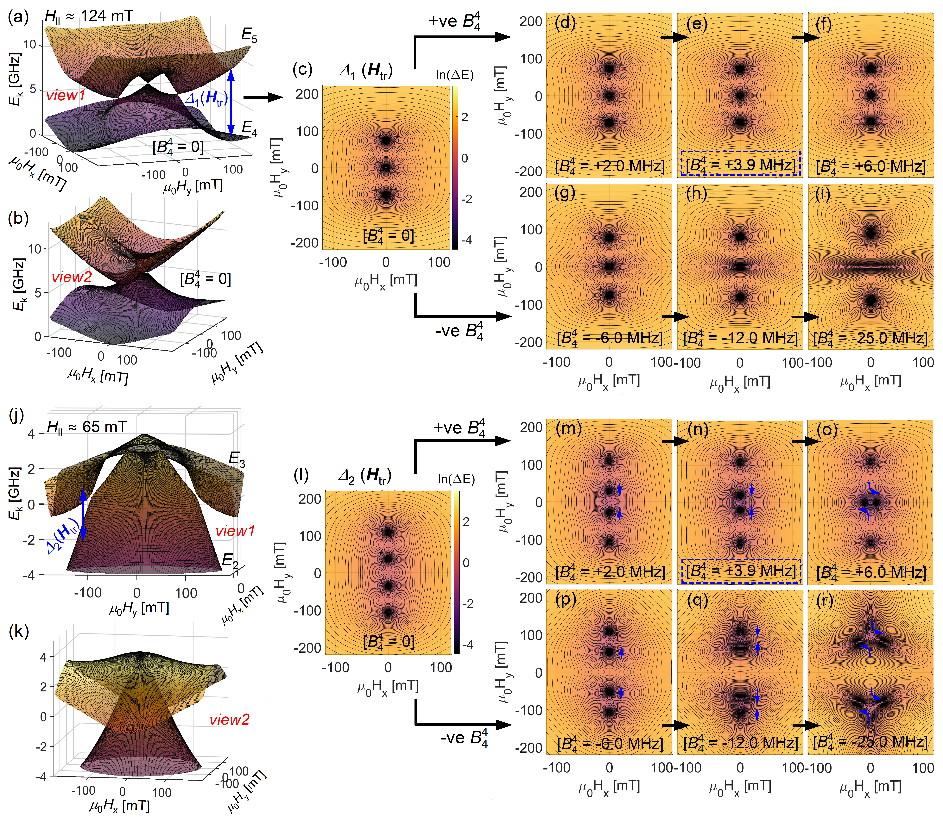
Figure S8: (a), (b) two different views of the simulated energy branches intersecting at Δ₁ (i.e. at H|| ~ 124 mT), highlighting the three DPs in the orientation-space of H_{tr} applied in the hard-medium plane. The corresponding gap between the two intersecting levels is plotted in (c) as a contour map for a clear 2D view. The DPs clearly appear as dark dots as the gaps are plotted in the logarithmic scale. (a)-(c) are simulated for $B_{4}^{4}$= 0, while (d)-(i) shows the same for non-zero $B_{4}^{4}$. Panel (j), (k) show the two intersecting energy levels at Δ₂ (i.e. at H|| ~ 65 mT), highlighting four DPs. The corresponding gaps between them, in (l)-(r) show the motion of DPs depending on sign of $B_{4}^{4}$.

References
- Li Manni, Li, et al., Journal of Chemical Theory and Computation 2023, 19, 6933-6991.
- F. Aquilante, F., et al., Journal of Chemical Physics 2020, 152, 214117.
- Fdez. Galván, F. et al., Journal of Chemical Theory and Computation 2019, 15, 5925-5964.
- Taran, G. et al. Nature Communications 14, 3361 (2023). https://doi.org/10.1038/s41467-023-39003-5
- Stoll, S. & Schweiger. J Magn Reson 178, 42-55 (2006). https://doi.org/10.1016/j.jmr.2005.08.013

