Table 1 Typical images and features of different architectural styles
Style | RS image | OAL image | Description
Su | 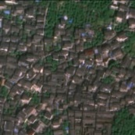  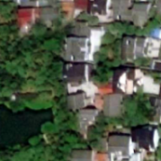 | 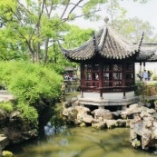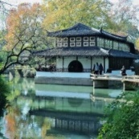 | RS Image: The roof is mainly gray and black, and the building is a compact single structure. Residential buildings are alternately distributed with water bodies and vegetation.  OAL Image: Pavilions and corridors are common forms of architecture with flying eaves and upturned corners, surrounded by ponds, vegetation, and landscape stones for decoration.
Hui | 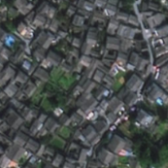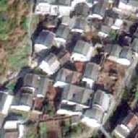 | 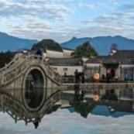 | RS Image: The roof is mainly gray and black, forming a compact and orderly layout of a single building.  OAL Image: The wall is white, and the facade presents a typical horsehead walls shape. The building is often surrounded by rivers and mountains.
Jing | 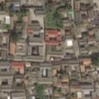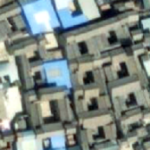 | 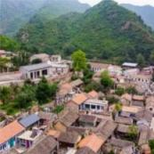 | RS Image: The roof is mainly gray, and the shape of the quadrangle is relatively regular. The houses are tightly enclosed, forming a central courtyard with obvious courtyard space.  OAL Image: The combination of blue bricks and gray tiles with vermilion red doorposts creates a symmetrical layout for both palace buildings and residential courtyards, often located at the foot of mountains.
Min | 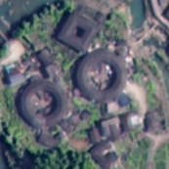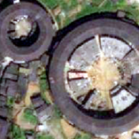 | 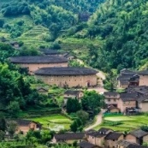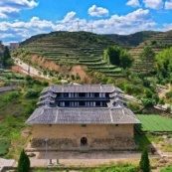 | RS Image: The roof is black or gray, mostly circular and square in shape.  OAL Image: The walls are constructed with rammed earth, and the building is grand in scale and mostly consists of two or more floors, located on terraced fields in the mountains and forests.
Chuan | 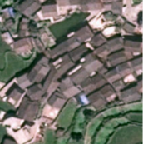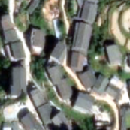 | 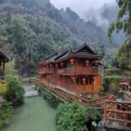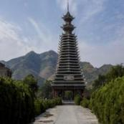 | RS Image: The roof is mainly dark gray and brown, and the shape of the roof is square.  OAL Image: The building takes stilted buildings, bamboo house and drum tower as its main shape, and mostly adopts bamboo and wood structure and green tile slope top, built near the mountain and water.
Jin | 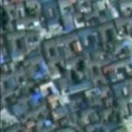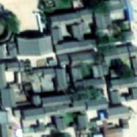 | 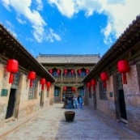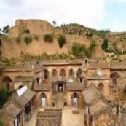 | RS Image: The roof is mainly black, and Shanxi merchants' architecture is mainly composed of courtyard combinations. The cave dwellings are mainly single-family buildings with courtyards.  OAL Image: Shanxi merchants' architecture are characterized by gray walls and arched eaves; The cave dwellings are based on earthen walls and are surrounded by vegetation landscapes unique to the Loess Plateau.
Table 6 Types and characteristics of roofs
Image | Roof type and their characteristics
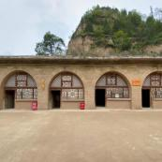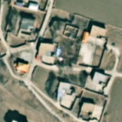 | Flat Roof(Ping)： It features a nearly level surface with minimal slope, and its structure is relatively simple.
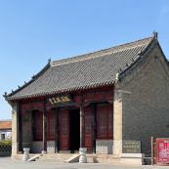 | Hard Mountain Roof(Yingshan)：It is a double-pitched roof, with two slopes divided by a main ridge. The gables on both sides are flush with or higher than the roof, and the eaves do not overhang the gables.
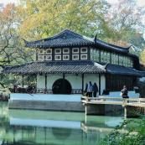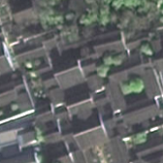 | Gable-on-hip Roof(Xieshan)：The upper half resembles the overhanging gable roof, whereas the lower half is similar to the hip roof. The four corners are upturned, with one main ridge, four vertical ridges, and four diagonal ridges.
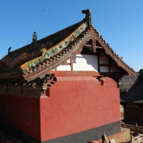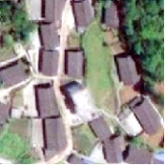 | Overhanging Gable Roof(Xuanshan)： The key difference from hard mountain roof lies in that the eaves extend beyond the gable walls, a design feature primarily intended to protect the walls from rainwater.
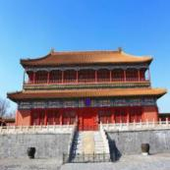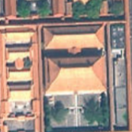 | Hip Roof(Wudian)：It is commonly used in palaces. A single eave sloping roof has a central main ridge and four vertical ridges extending to the four corners, while a double eave sloping roof has an additional lower eave that surrounds the four main ridges of the building's main body and forms four diagonal ridges in the corners.
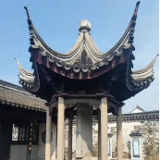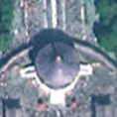 | Pyramid Roof(Cuanjian)： The roof features a steep surface and lacks a main ridge. Several vertical ridges converge at the top, which is crowned with a decorative finial, giving the roof its characteristic conical shape.
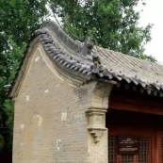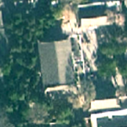 | Roll Shed Roof(Juanpeng)：The junction of the two slopes forms not a straight ridge but a curved surface, typically characterized by the absence of a central main ridge and a rounded ridge profile.

