SUPPLEMENTARY MATERIAL

Spatial transcriptomics links hepatocyte-macrophage interactions to viral signatures in seronegative hepatitis

Amber G. Bozward^{1,2,3,9*}, Mahboobeh Buhruznia⁴, John Cole⁵, Scott P. Davies^{1,2}, Kylie Savoye⁶, Chiranjit Das^{1,2}, Matthew Pugh¹, Grace Wootton¹, Patricia Reis Nisa⁷, Fabian Spill⁶, Owen Cain⁷, Adam P. Croft^{8,9}, Alan McNally⁴, Ye H. Oo^{1,2,3,9,10}

¹Department of Immunology and Immunotherapy, School of Infection, Inflammation and Immunology, College of Medicine and Health, University of Birmingham, Birmingham, United Kingdom
²Centre for Liver Research, University of Birmingham and University Hospital Birmingham NHS Foundation Trust, Birmingham, UK
³Centre for Rare Diseases, European Reference Network on Hepatological Diseases (ERN-RARE-LIVER) centre, Birmingham, UK
⁴Department of Microbes, Infection and Microbiome, School of Infection, Inflammation and Immunology, College of Medicine and Health, University of Birmingham, Birmingham, United Kingdom
⁵University of Glasgow, Bioinformatics facility, Glasgow, UK
⁶School of Mathematics, College of Engineering and Physical Sciences, University of Birmingham, UK
⁷Pathology department, Liver Unit, Queen Elizabeth Hospital, Birmingham, UK
⁸Rheumatology Research Group, Department of Inflammation and Ageing, College of Medicine and Health, University of Birmingham, Birmingham, UK.
⁹National Institute for Health and Care Research (NIHR) Birmingham Biomedical Research Centre, UK
¹⁰Liver Transplant and Hepatobiliary Unit, Queen Elizabeth Hospital, UHB NHS Foundation Trust, Birmingham, UK

Corresponding authors(*):
Dr Amber G. Bozward - a.g.bozward@bham.ac.uk;
Professor Ye H. Oo - y.h.oo@bham.ac.uk

Keywords: Autoimmune hepatitis, seronegative hepatitis, spatial transcriptome, meta-transcriptome, CD63, macrophage, virus, TNF receptor superfamily

Conflict of interest statement: The authors have nothing to declare.

Financial support statement: The authors thank Sir Jules Thorn Charitable Trust Programme Grant, Medical Research Foundation, Whitney Wood Fellowship grant from Royal College of Physicians (London) and QEHB Charity for their financial support.

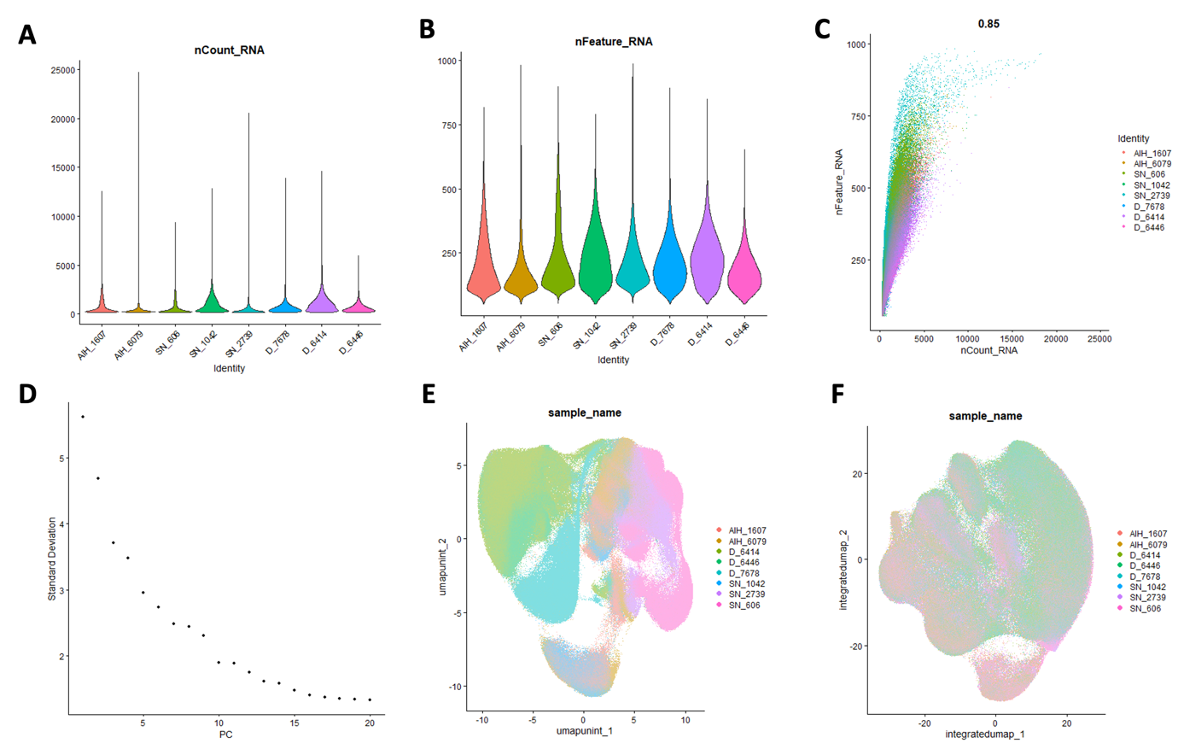
Supplementary Fig.1| Quality control and integration of CosMx spatial transcriptomics dataset
A Violin plot showing distribution of total transcript counts (nCount_RNA) per cell across samples. B Violin plot showing the distribution of detected features (nFeature_RNA) per cell across samples. C Scatterplot of nFeature_RNA vs nCount_RNA with Pearson correlation coefficient displayed. D Elbow plot showing standard deviation explained by the first 20 principal components (PCs). E UMAP visualisation of individual cells coloured by sample before integration. F UMAP visualisation of individual cells coloured by sample after dataset integration.

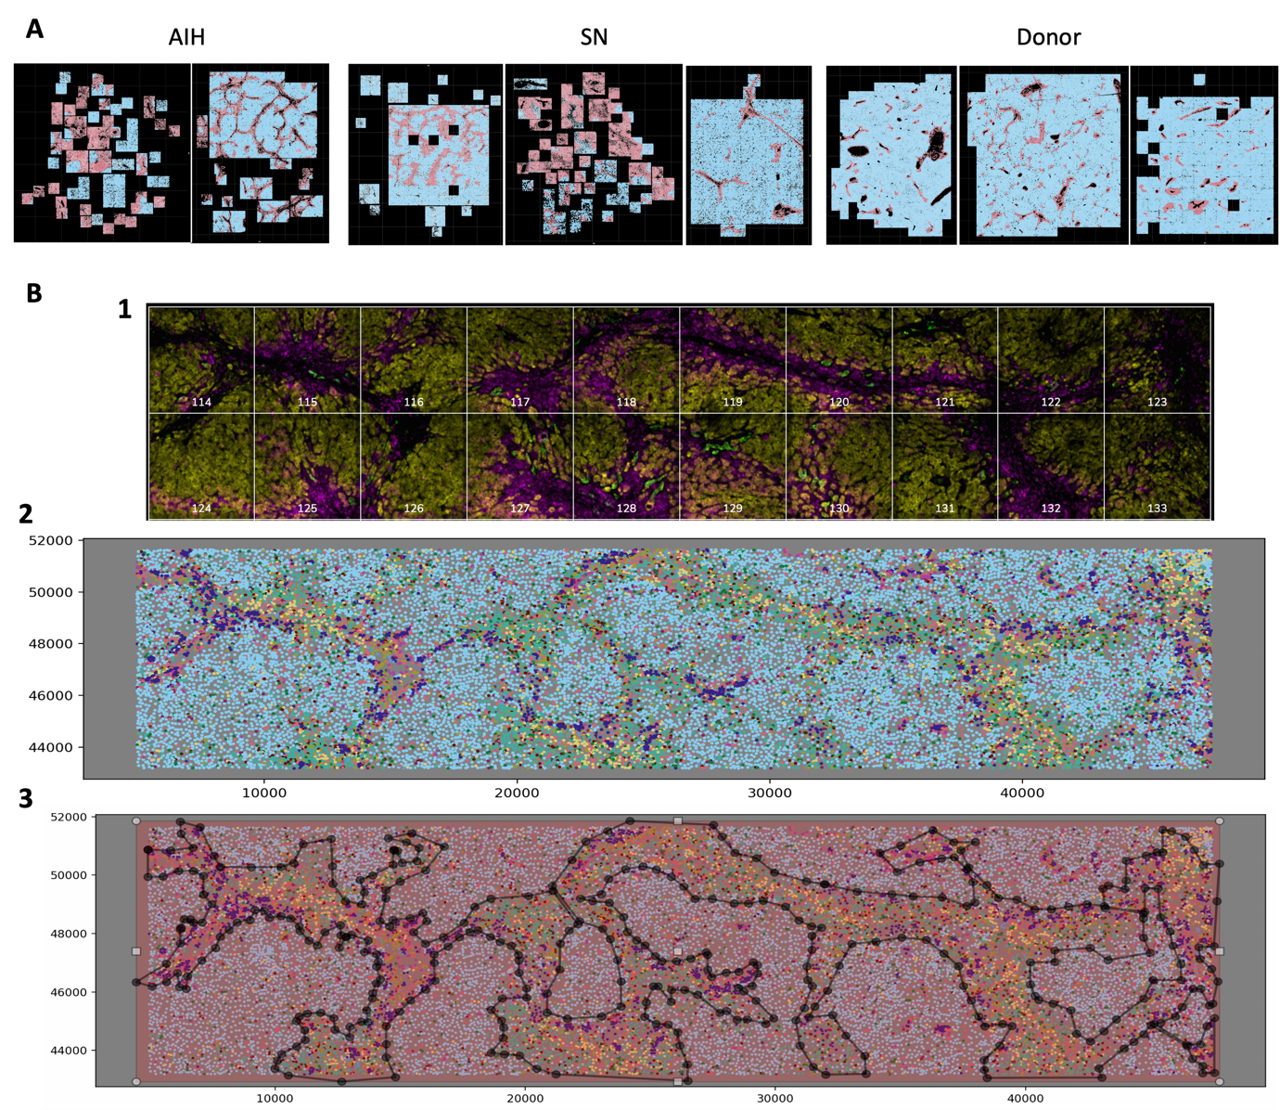
Supplementary Fig.2| Defining areas of parenchyma and non-parenchyma on CosMx images using a custom Python tool.
A Spatial maps of each CosMx samples separated into areas of parenchyma (blue) and non-parenchyma (red). B Three identical images of a representative area of SN liver tissues 1) stained immunofluorescence image for DNA, histone, membrane, CK8/18 and CD45, 2) Cell types identified using the gene signatures viewed spatially and 3) selected non-parenchyma areas drawn.

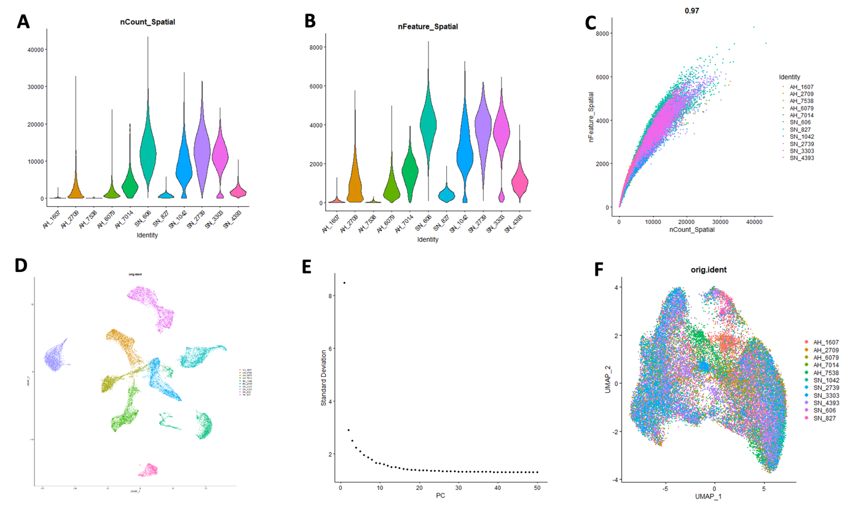
Supplementary Fig.3| Quality control and integration of Visium spatial transcriptomics dataset
A Violin plot showing distribution of total transcript counts (nCount_RNA) per cell across samples. B Violin plot showing the distribution of detected features (nFeature_RNA) per cell across samples. C Scatterplot of nFeature_RNA vs nCount_RNA with Pearson correlation coefficient displayed. D UMAP visualisation of individual cells coloured by sample before integration. E Elbow plot showing standard deviation explained by the first 20 principal components (PCs). F UMAP visualisation of individual cells coloured by sample after dataset integration.

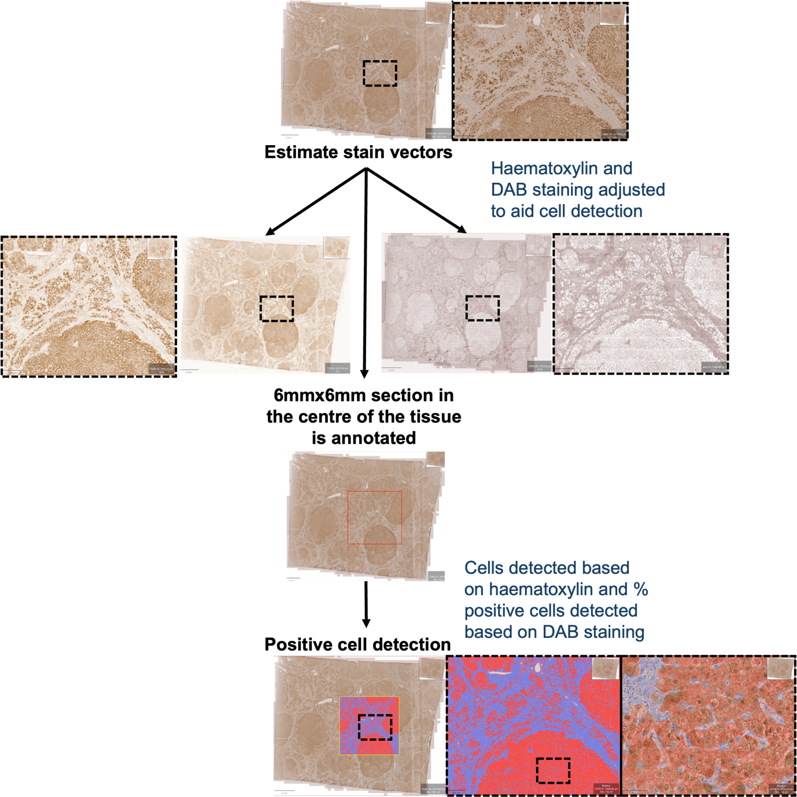Supplementary Fig.4| QuPath custom pipeline to quantify DAB staining using FFPE liver sections.
DAB-stained images are imported into QuPath, and the estimate stain vector function is used to optimise the brightness and saturation of haematoxylin and DAB staining which aids in the cell detection. Then, a 6mmx6mm square section is annotated in the centre of the section, this avoids any sub-optimal staining on the edges of the section. Positive and negative cells are assigned based on the DAB staining using the positive cell detection function.

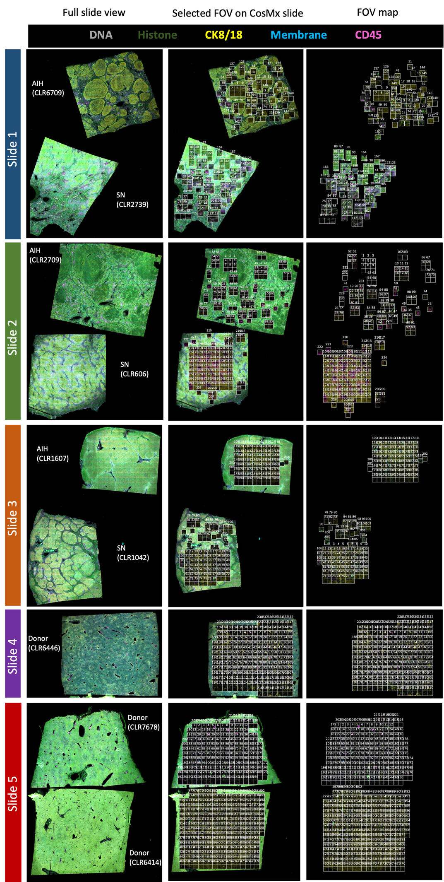
Supplementary Fig.5| Spatial organisation and field of view across liver tissue samples used for CosMx spatial transcriptomics.
Tissue sections from explant SN, AIH and Donor liver samples were visualised using nuclear (DNA; grey), nuclear histone (green), epithelial (CK8/18; yellow), membrane (cyan) and immune (CD45; magenta) markers across five slides. For each tissue, the left column shows raw immunofluorescent images with combined staining. The middle column shows the immunofluorescent images overlayed with the regions of interest (ROIs) and the right column shows only the ROIs. Each ROI is annotated with its corresponding grid number, facilitating downstream mapping and quantification.
SN: Seronegative hepatitis, AIH: Autoimmune hepatitis
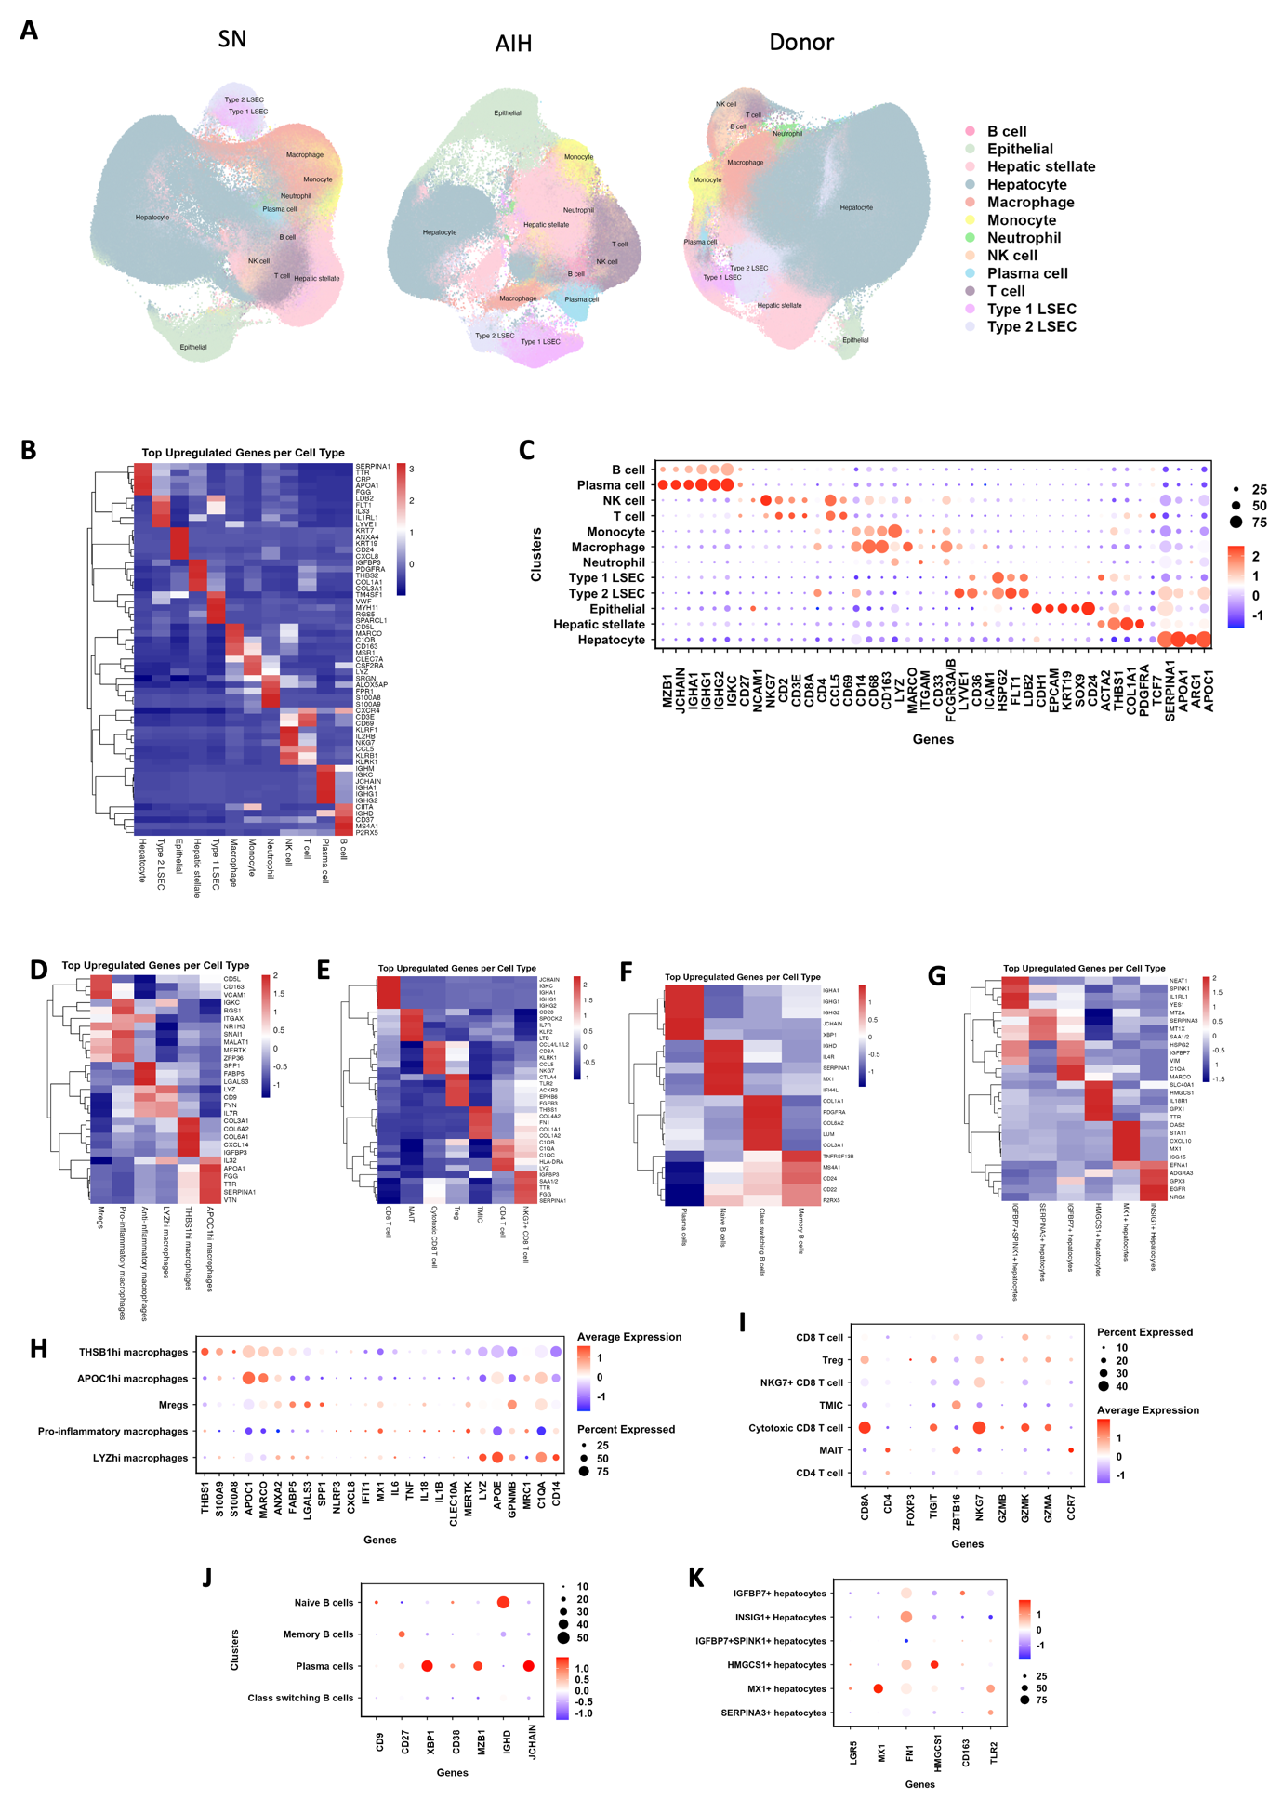
Supplementary Fig.6| Cell type annotation and marker gene expression in CosMx spatial transcriptomics data set.
A UMAP visualisation of cell populations identified from CosMx spatial transcriptomics for SN, AIH and donor samples separately. B Heatmap highlighting the top upregulated genes across each annotated cell type. Rows represent genes, and columns correspond to cell clusters. Gene expression is scaled, with red indicating higher expression and blue lower expression. C Dot plot of selected canonical marker genes across cell clusters. Dot size reflects the proportion of cells expressing the gene, while colour intensity represents scaled average expression levels. D-G Heatmap highlighting the top upregulated genes across each annotated cell subset for a macrophages, b T cells, c B cells and d hepatocytes. Rows represent genes, and columns correspond to cell clusters. Gene expression is scaled, with red indicating higher expression and blue lower expression. H-K Dot plot of selected canonical marker genes cell clusters for E macrophages, F T cells, G B cells and H hepatocytes. Dot size reflects the proportion of cells expressing the gene, while colour intensity represents scaled average expression levels.
SN: Seronegative hepatitis, AIH: Autoimmune hepatitis
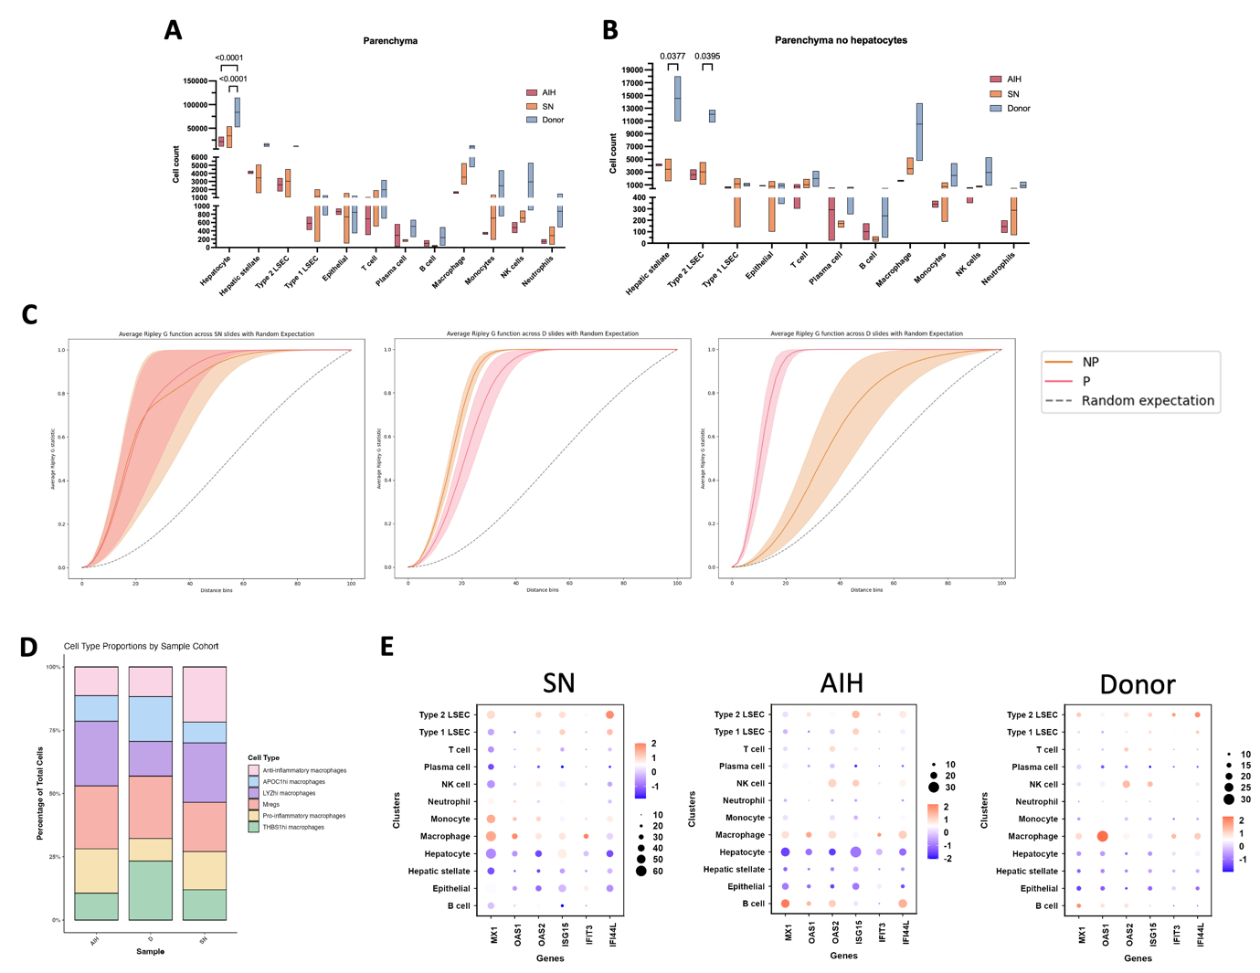
Supplementary Fig.7| Cell frequencies and relative enrichment in areas of parenchyma and non-parenchyma and the expression of anti-viral genes in cell types.
A-B Areas of parenchyma and non-parenchyma were spatially differentiated for each sample and combined to determine cell abundances for each cohort. Cell counts for areas of A parenchyma and B parenchyma without hepatocytes, were plotted and compared between AIH, SN and D cohorts using (Mann-Whitney test). C Average Ripley’s G function for parenchyma and non-parenchyma compared with random expectation in SN (left), donor (middle) and AIH (right). Shaded areas represent variability across samples. D Stacked bar plot showing the proportions of macrophage subpopulations across conditions (AIH, D, SN). E Dot plots of selected anti-viral marker genes (MX1, OAS1, OAS2, ISG15, IFIT3 and IFI44L) across cell clusters. Dot size reflects the proportion of cells expressing the gene, while colour intensity represents scaled average expression levels.
SN: Seronegative hepatitis, AIH: Autoimmune hepatitis, D: Donor

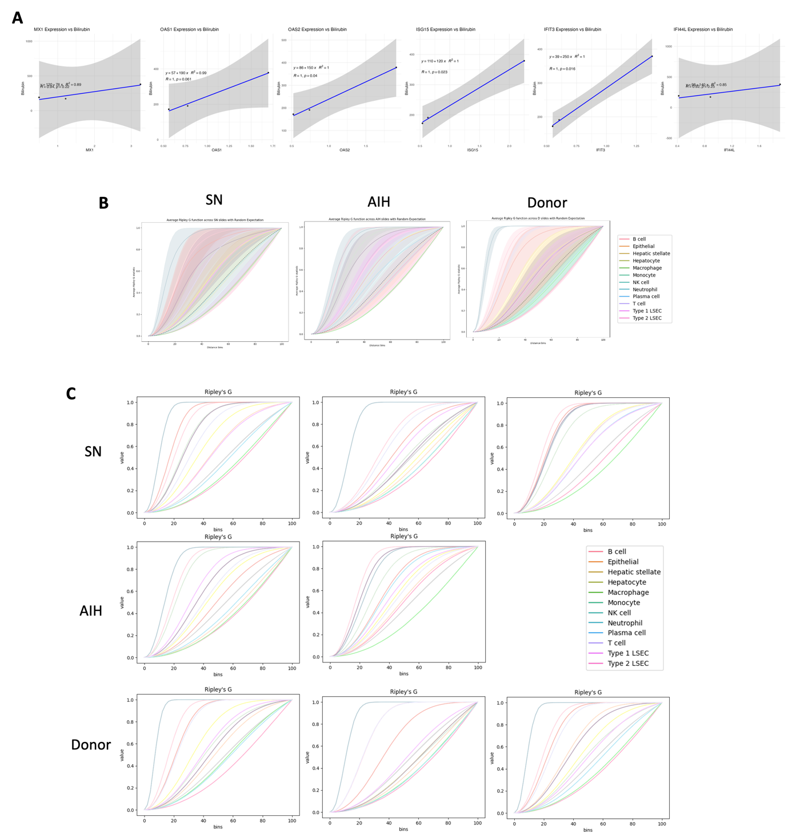
Supplementary Fig.8| Associated of antiviral gene expression with clinical markers and spatial clustering of liver cell types.
A Scatterplots showing correlations between serum bilirubin levels and expression of antiviral genes MX1, OAS1, OAS2, ISG15, IFIT3 and IFI44L in explant liver tissue. Linear regression lines with 95% confidence intervals are shown. B Average Ripley’s G functions for individuals cell types in SN, AIH and donor liver samples compared with random expectations. Shaded regions represent variability across samples. C Ripley’s G plots for individual samples within SN, AIH and donor groups, showing clustering patterns of major liver and immune cell types.
SN: Seronegative hepatitis, AIH: Autoimmune hepatitis

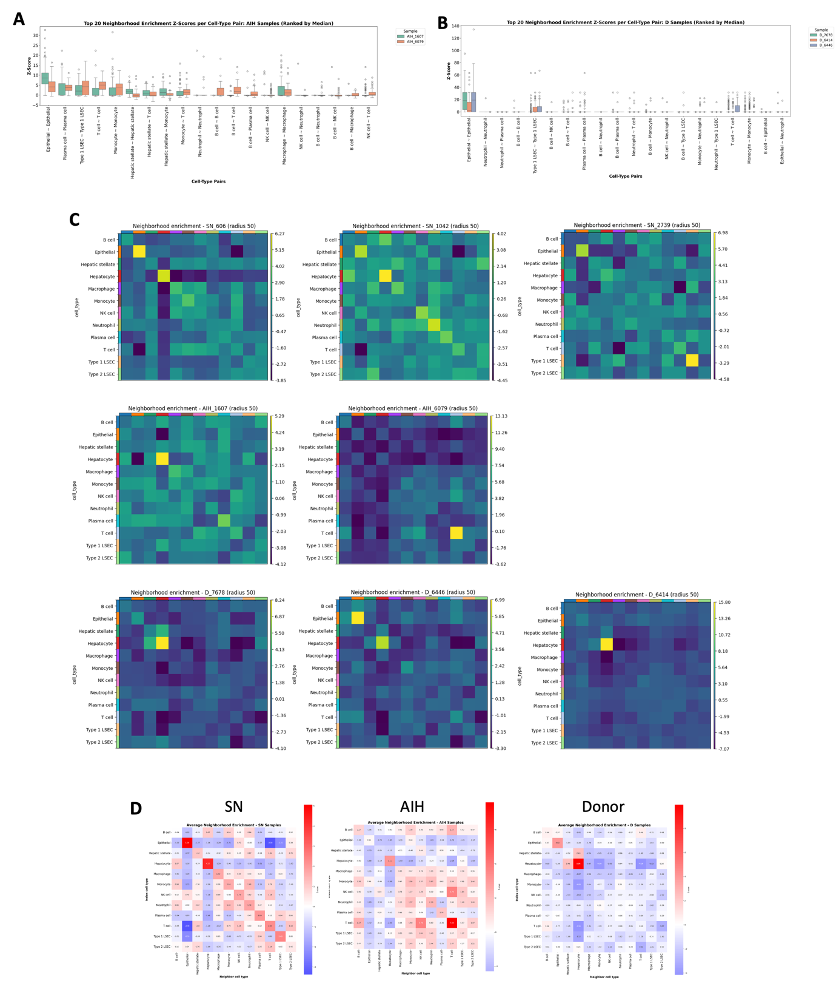
Supplementary Fig.9| Neighbourhood enrichment scores for individual samples and disease cohorts.
A-B Top 20 neighbourhood enrichment Z-scores for cell-cell clustering localisation in A AIH samples and B donor liver samples, ranked by median value across patients. C Heatmaps of differential neighbourhood enrichment for each individual sample, (top) SN, (middle) AIH and (bottom) donor. Positive values (yellow) indicate increased enrichment, while negative values (blue) indicate reduced enrichment. D Heatmaps of differential neighbourhood enrichment for sample cohorts. Positive values (Red) indicate increased enrichment in SN, while negative values (blue) indicate reduced colocalization relative to the comparator group.
SN: Seronegative hepatitis, AIH: Autoimmune hepatitis

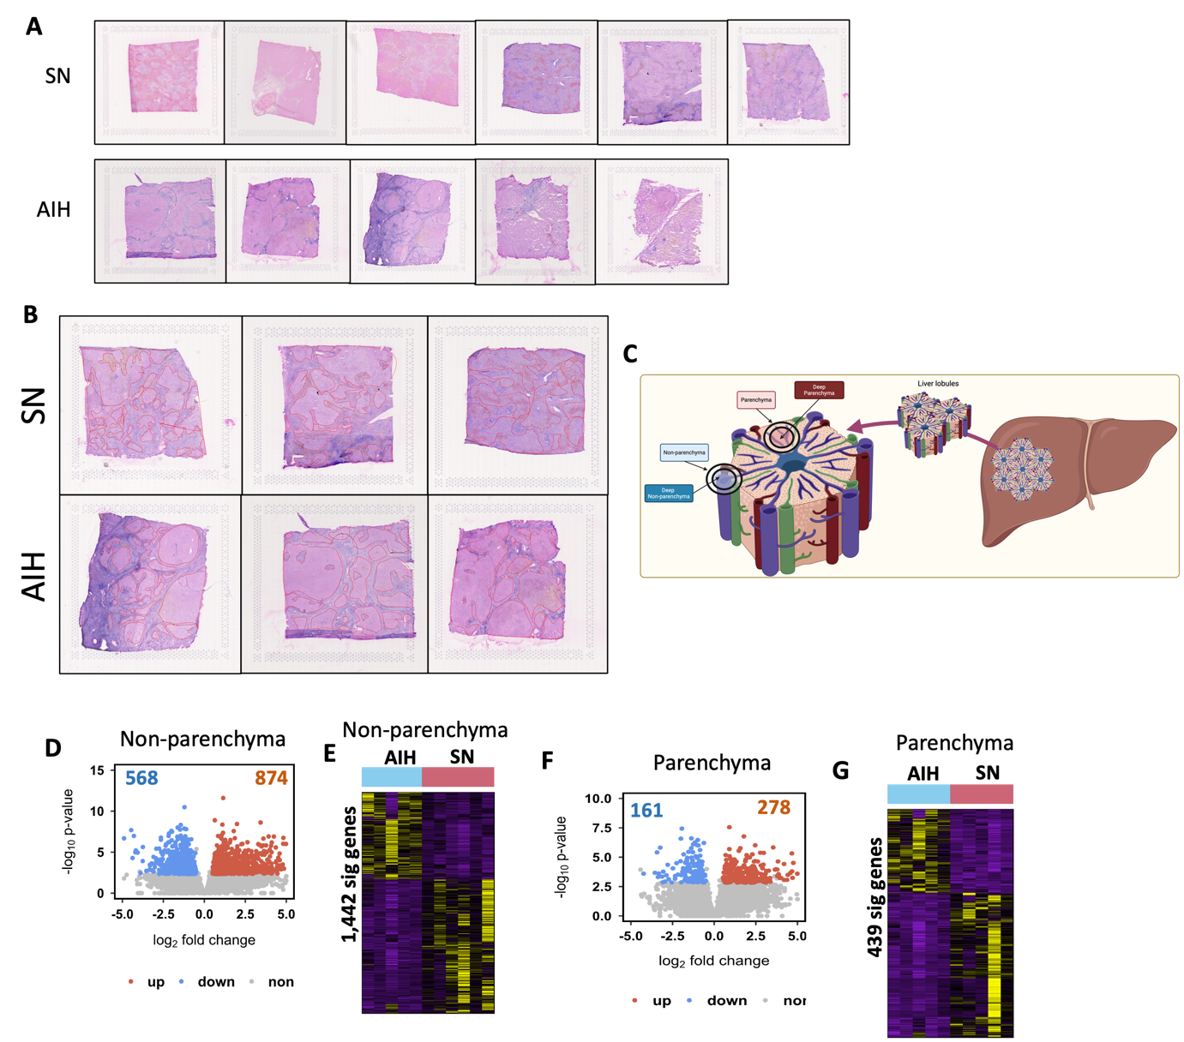
Supplementary Fig.10| Visium spatial transcriptomics detecting gene differences in areas of parenchyma and non-parenchyma
A H&E images from each of the SN and AIH samples used for the 10X Visium spatial transcriptomics. B Representative images of the areas chosen for parenchyma and non-parenchyma in SN and AIH samples. Red outline shows areas of parenchyma. C Schematic image to highlight histologically the areas of parenchyma, non-parenchyma, deep parenchyma and deep non-parenchyma with the liver tissue. D Volcano plot to show upregulated (red) and downregulated (blue) genes in areas of non-parenchyma in SN and AIH samples combined. E Heatmap showing upregulated genes in yellow and downregulated genes in purple in areas of non-parenchyma between AIH and SN cohorts. F Volcano plot to show upregulated (red) and downregulated (blue) genes in areas of parenchyma in SN and AIH samples combined. G Heatmap showing upregulated genes in yellow and downregulated genes in purple in areas of parenchyma between AIH and SN cohorts.
SN: Seronegative hepatitis, AIH: Autoimmune hepatitis
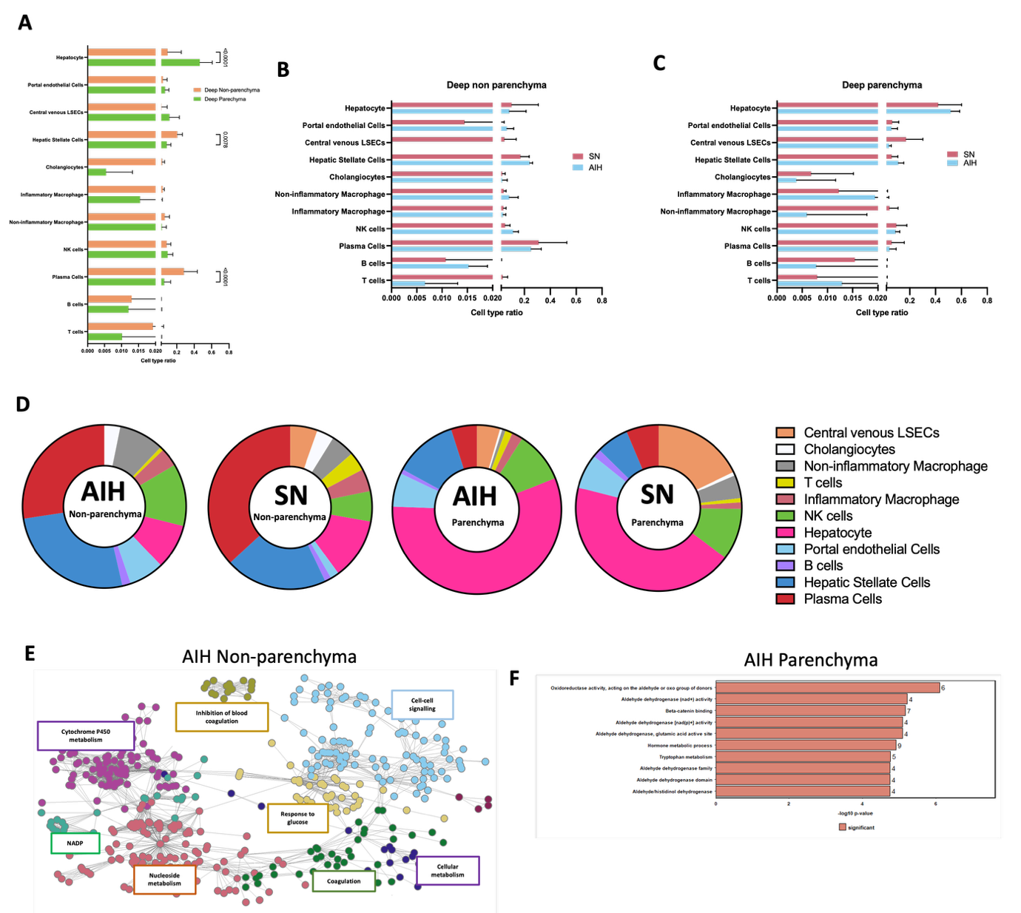
Supplementary Fig.11| Visium cell frequency comparison and network analysis.
A-C Horizontal bar plots showing the cell type ratio of cell types comparing A all cells in deep non-parenchyma (orange) and deep parenchyma (green), B cell frequencies between SN (red) and AIH (blue) in deep non-parenchyma areas and C deep parenchyma areas. D Donut plots summarising the proportional distribution of cell types within parenchyma and non-parenchyma of AIH and SN samples. Colours respond to cell types. E Functional network analysis of differentially expressed genes between non-parenchyma compartments in AIH samples. Networks are annotated with enriched biological processes. F Pathway enrichment analysis represented as a bar plot. Significantly enrichment pathways are ranked by -log10 adjusted p-value, with bar lengths indicating enrichment significance.
SN: Seronegative hepatitis, AIH: Autoimmune hepatitis, D: Donor
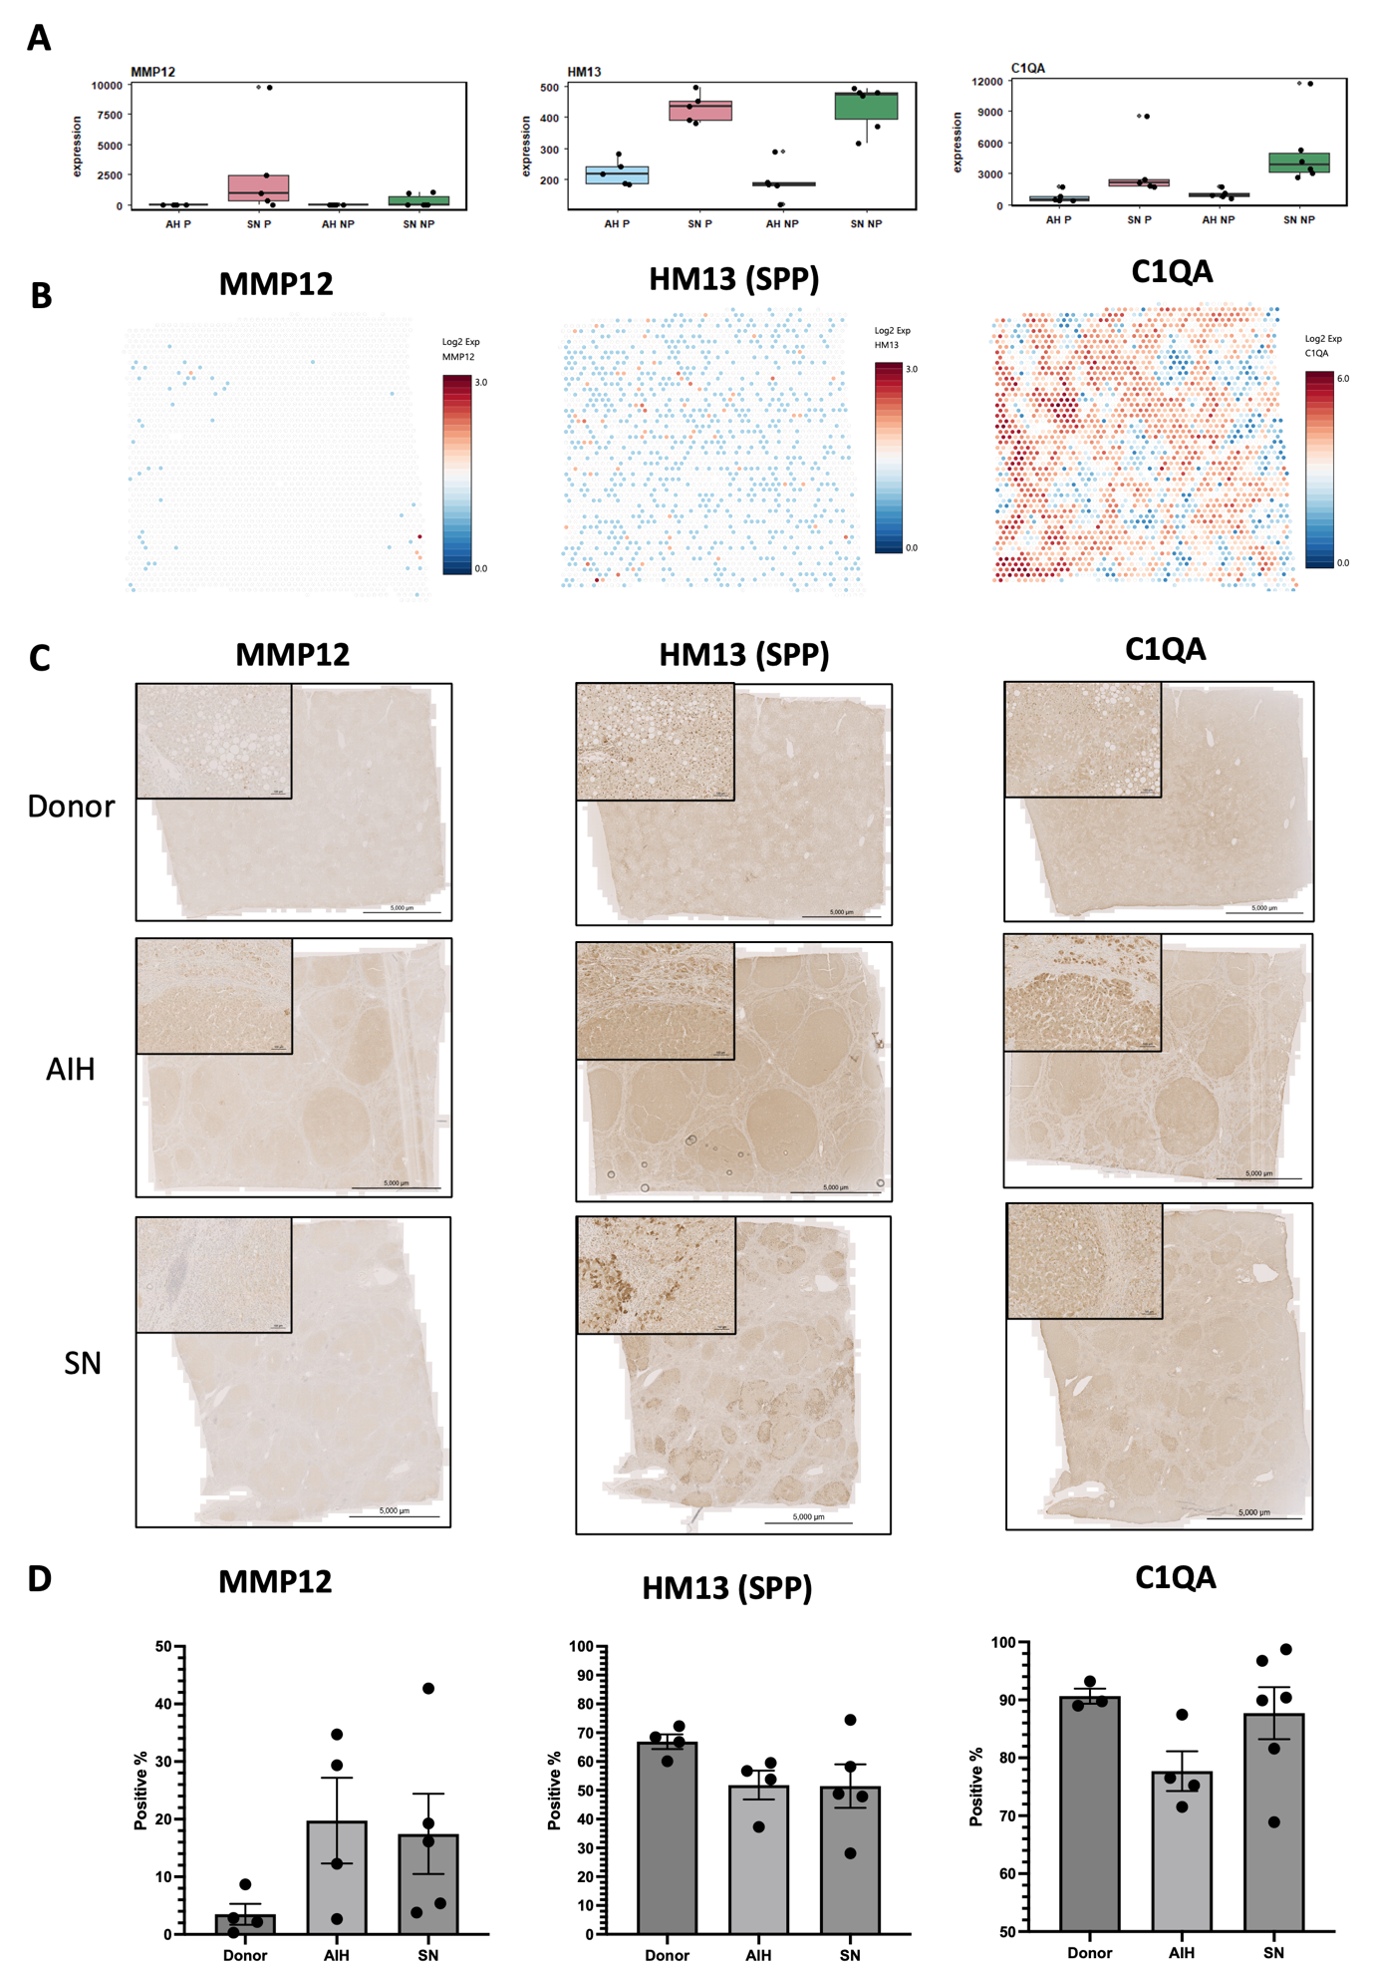
Supplementary Fig.12| Expression and localisation of MMP12, HM13 and C1QA in seronegative hepatitis, autoimmune hepatitis and donor liver.
A Boxplots showing normalised expression of MMP12 (left), HM13 (middle) and C1QA (right) across parenchymal (P) and non-parenchymal (NP) areas in SN and AIH liver tissue. B Spatial transcriptomics maps demonstrating the distribution of MMP12 (left), HM13 (middle) and C1QA (right) transcripts across liver tissue sections. Red indicates high expression and blue indicates low expression. C Representative immunohistochemistry images for MMP12 (left), HM13 (middle) and C1QA (right) in donor (top), AIH (middle) and SN (bottom). Insets show higher magnification views. D Quantification of positive IHC staining for MMP12 (left), HM13 (middle) and C1QA (right) across AIH, SN and donor samples. Quantified using QuPath (Supplementary Fig. 4) to detect positive staining. Bars represent mean ± SEM.
SN: Seronegative hepatitis, AIH: Autoimmune hepatitis, P: Parenchyma, NP: Non-parenchyma

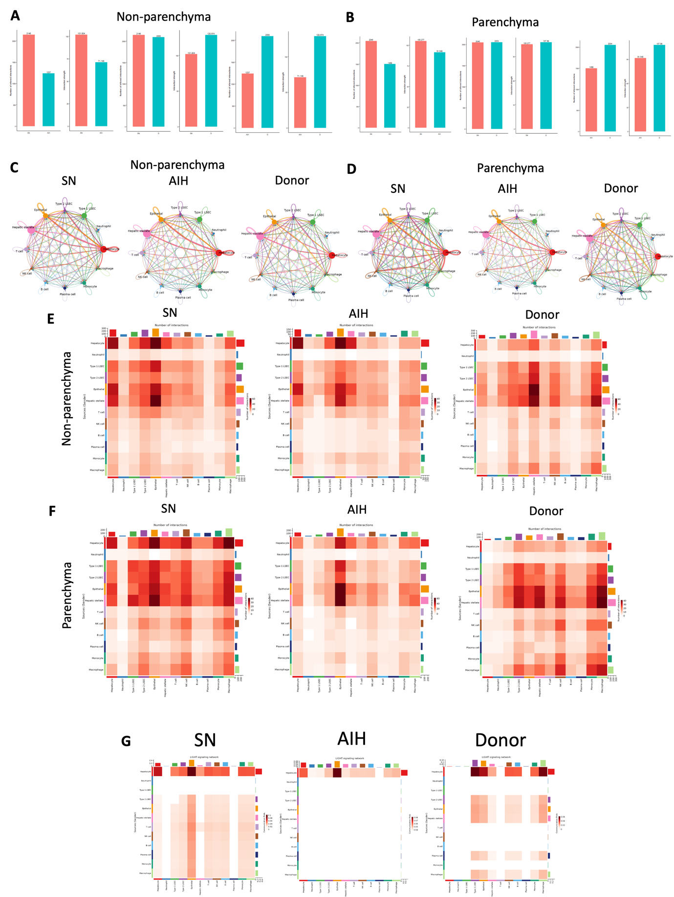
Supplementary Fig.13| Cell-cell interaction networks differ between seronegative hepatitis, autoimmune hepatitis and donor controls in parenchymal and non-parenchymal regions.
A-B Barplots showing the number of predicted ligand-receptor interactions across major cell types in A non-parenchymal and B parenchymal regions, stratified by disease group. C-D Circle plots of predicted ligand-receptor networks highlighting the strength and directionality of interactions between cell types in C non-parenchymal and D parenchymal regions for each condition. Line thickness corresponds to interaction strength. E-F Heatmaps of interaction strength across cell-cell pairs in E non-parenchymal and F parenchymal regions. Stronger interactions are depicted in red. G Heatmaps showing LIGHT expression in cell types, higher expression depicted in red.
SN: Seronegative hepatitis, AIH: Autoimmune hepatitis, D: Donor

