Supplementary Materials

Shared Genetic Underpinnings of Gray Matter Volume Alterations and Metabolic Traits in Major Depressive Disorder
Xiangzheng Wu^{1#}, Piaoran Wang^{1#}, Xu Lang^{1#}, Qingwei Guo^{2,3#}, Yurong Jiang¹, Jinglei Xu¹, Qiuhui Wang¹, Feng Liu¹*, Hao Ding⁵*, Huaigui Liu^{1,4}*
¹Department of Radiology, Tianjin Key Laboratory of Functional Imaging & Tianjin Institute of Radiology, Tianjin Medical University General Hospital, Tianjin, China
²First Teaching Hospital of Tianjin University of Traditional Chinese Medicine, Tianjin, China
³National Clinical Research Center for Chinese Medicine Acupuncture and Moxibustion, Tianjin, China
⁴Department of Radiology & Biomedical Imaging, Yale School of Medicine, New Haven, CT, USA.
⁵School of Medical Imaging, Tianjin Medical University, Tianjin, China
# These authors contributed equally to this study

*To whom correspondence should be addressed: Hao Ding, dhhere2005@163.com; Huaigui Liu, liuhuaigui@tmu.edu.cn; Feng Liu, fengliu@tmu.edu.cn.

Contents
Supplementary Methods 3
Meta-regression analysis and subgroup analysis 3
GWAS datasets 4
Supplementary Results 7
Meta-regression analysis 7
Subgroup analysis 7
Supplementary Figure 9
Figure S1 Gray matter volume alterations in the subgroups.. 9
Figure S2 The variance explained by the top five components following PLS regression. 10
References 11

Supplementary Methods

Meta-regression analysis and subgroup analysis
For exploratory analysis, we conducted the following experiments. First, meta-regression analysis was performed to investigate the effects of clinical factors such as mean age and illness duration on the alterations of gray matter volume (GMV). Second, subgroup meta-analyses were conducted to examine the robustness and consistency of the main findings by stratifying studies based on clinical and methodological homogeneity. Specifically, we performed subgroup meta-analyses on the following two subsets of (1) studies using 3.0 T MRI, and (2) studies applying an 8 mm full-width at half-maximum (FWHM) Gaussian smoothing kernel. Due to the limited number of studies, no further subgroup analyses were performed. For both meta-regression and subgroup analyses, we applied the same statistical thresholds as in the main analysis: the voxel-wise p < 0.005, the peak height Z > 1, and the clustering extent > 10 voxels. To evaluate between-study variability, we calculated Cochran's Q statistic and I² statistic. A p-value < 0.05 for Cochran's Q was considered indicative of significant heterogeneity. The I² index quantifies the proportion of total variance attributable to heterogeneity, with values of approximately 25%, 50%, and 75% representing low, medium, and high heterogeneity, respectively^{[1]}. Finally, Egger’s test was used to assess potential publication bias. Peak-level effect sizes were extracted, and a p-value < 0.05 was considered indicative of significant publication bias.

GWAS datasets
The aggregated GWAS statistics for MDD were obtained from the most recent study conducted by the Major Depressive Disorder Working Group of the Psychiatric Genomics Consortium^{[2]}. This analysis combined summary statistics from 73 cohorts of European ancestry, which included both case-control and population-based studies, with rigorous quality control, imputation, and harmonization procedures. In addition, the study incorporated data from ancestrally diverse cohorts, including 8 cohorts of African ancestry, 7 of East Asian ancestry, 1 of South Asian ancestry, and 5 of Hispanic/Latino ancestry, resulting in a total discovery sample of 688,808 major depression cases and 4,364,225 controls. To ensure population homogeneity and avoid potential confounding due to population stratification, our analysis focused exclusively on summary-level GWAS data from individuals of European ancestry (N_{case} = 357,636, N_{control} = 1,281,936).
The summary statistics for the genome-wide association study (GWAS) of random glucose were obtained from a recent publication by Vasiliki Lagou and colleagues^{[3]}. This study conducted a GWAS meta-analysis of glucose levels measured under non-standardized conditions in 476,326 individuals without diabetes, comprising 459,772 individuals of European ancestry and 16,554 individuals of diverse ancestries. Individuals with extremely high glucose levels (>20 mmol/L) or diagnosed diabetes were excluded. Glucose measurements were adjusted for age, sex, and time since last meal (where available) to minimize confounding effects. The analysis identified 120 loci influencing glucose regulation, including novel associations highlighting gastrointestinal tract involvement. For our current study, only summary statistics from European ancestry individuals were utilized.
The GWAS summary statistics for low-density lipoprotein cholesterol (LDL-C), triglycerides (TG), and high-density lipoprotein cholesterol (HDL-C) were obtained from a recent study published by Stavroula Kanoni and colleagues^{[4]}. This study compiled GWAS summary statistics from eight cohorts across six ancestral populations, including African/African American, East Asian, European, Hispanic, Middle Eastern, and South Asian populations, with a total sample size of 1.65 million individuals. In our study, we utilized the summary statistics derived from European ancestry samples for LDL-C, TG, and HDL-C (N = 1,320,016).
The GWAS summary statistics for glycated hemoglobin (HbA1c) were obtained from a recent study published by Ji Chen and colleagues^{[5]}. Ancestry was initially assigned at the cohort level and subsequently confirmed using genetic data, with ancestry outliers removed. Overall, participants of European ancestry represented the majority across all traits.. In the present study, we used only the summary statistics from individuals of European ancestry (N = 146,864).

Supplementary Results

Meta-regression analysis
Meta-regression analysis was performed to explore the potential influence of clinical variables on gray matter volume (GMV) alterations in MDD. A positive association was observed between mean age and GMV changes in the anterior cingulate cortex (MNI coordinates: x = 2, y = 30, z = 26; SDM-Z = 3.727, p = 0.001). Similarly, illness duration was positively correlated with GMV changes in the left ventral insular cortex (MNI coordinates: x = -18, y = 4, z = -12; SDM-Z =2.642, p = 0.008). These findings suggest that age and disease chronicity may be associated with specific regional GMV reductions in MDD.

Subgroup meta-analysis
Subgroup analyses were conducted to assess the robustness of GMV alterations across imaging protocol variables. Due to the limited number of studies eligible for stratified analysis, results were interpreted in an exploratory manner. The voxel-level threshold was set at p < 0.005, the peak height Z > 1, and the clustering extent > 10 voxels. After applying TFCE (Threshold-Free Cluster Enhancement) and voxel-based correction, no statistically significant clusters survived correction, and thus only uncorrected results are reported. The analyses were divided into two subgroups: (1) Studies using 3.0 T MRI scanners, (2) Studies using 8 mm FWHM smoothing. In both subgroups, we consistently observed GMV reductions in the superior temporal gyrus, the inferior frontal gyrus, and the insula, although with slight regional variations. These findings support the overall robustness of GMV alteration patterns in MDD (Figure S1A-B).

Supplementary Figures
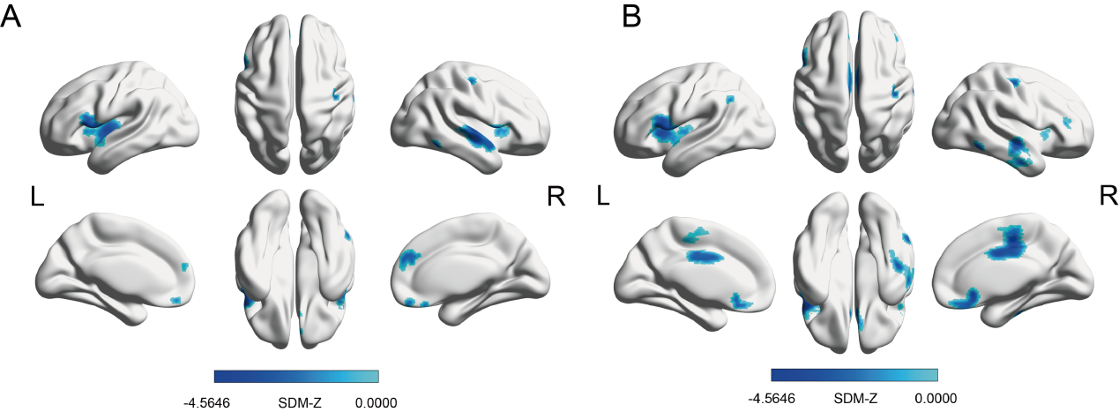
Figure S1. Gray matter volume alterations in the subgroups. A. FWHM with 8mm field. B. MRI with 3.0T field.
Abbreviations: FWHM, full width at half maxima; L, left; MDD, major depressive disorder; R, right; SDM, seed-based d mapping.

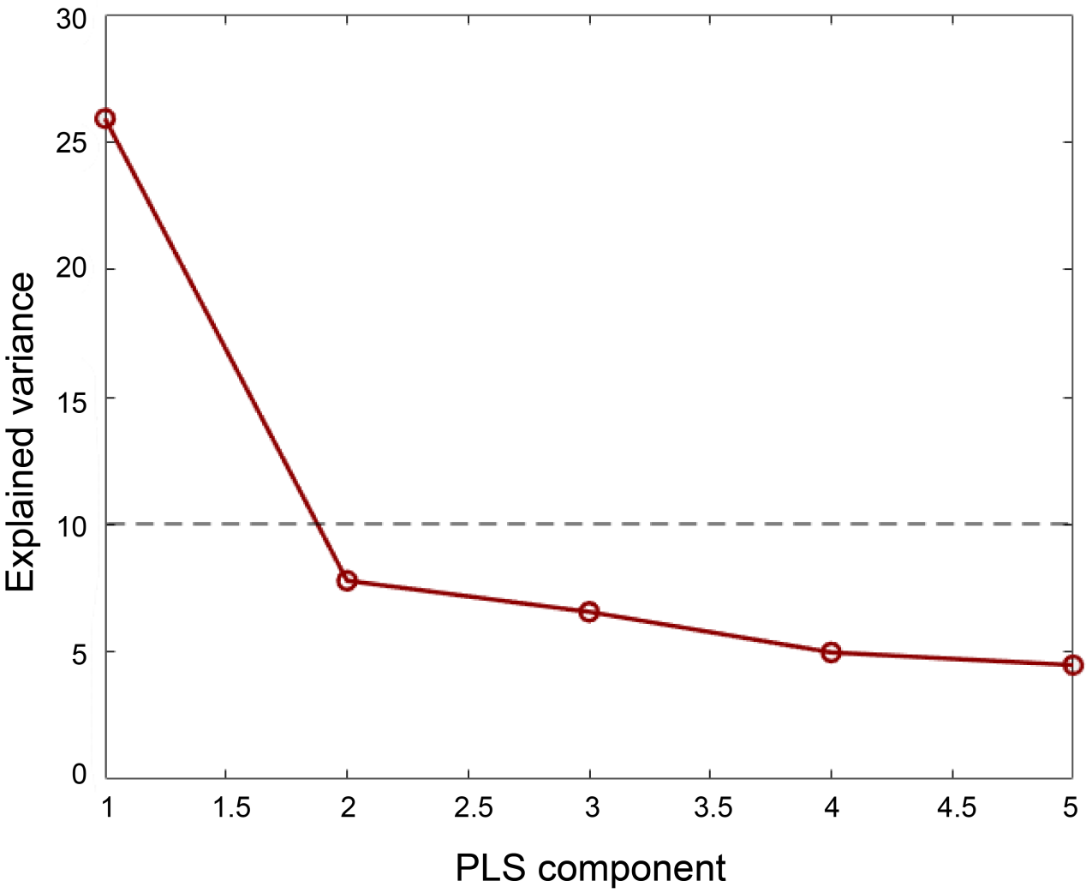

Figure S2. The variance explained by the top five components following PLS regression. The first PLS component (PLS1) explained > 10% of the variance.
Abbreviations: PLS, partial least squares.

References
[1] Higgins J P, Thompson S G, Deeks J J, et al. Measuring inconsistency in meta-analyses [J]. BMJ (Clinical research ed), 2003, 327(7414): 557-60.
[2] Trans-ancestry genome-wide study of depression identifies 697 associations implicating cell types and pharmacotherapies [J]. Cell, 2025, 188(3): 640-52.e9.
[3] Lagou V, Jiang L, Ulrich A, et al. GWAS of random glucose in 476,326 individuals provide insights into diabetes pathophysiology, complications and treatment stratification [J]. Nature genetics, 2023, 55(9): 1448-61.
[4] Kanoni S, Graham S E, Wang Y, et al. Implicating genes, pleiotropy, and sexual dimorphism at blood lipid loci through multi-ancestry meta-analysis [J]. Genome biology, 2022, 23(1): 268.
[5] Chen J, Spracklen C N, Marenne G, et al. The trans-ancestral genomic architecture of glycemic traits [J]. Nature genetics, 2021, 53(6): 840-60.

