SUPPLEMENTARY MATERIAL

This is a supplement to Lassen et al 2025 Seasonal Trends in Sperm Quality in Denmark and Florida (manuscript submitted). In this supplement we provide additional details about the datasets and statistical analyses reported in that paper, with analyses, figures, tables, and information in support of results and conclusions made in the main text.

1. Data and Code
This study is based on two datasets publicly available at (link), along with metadata describing the data and variables in a README file.

An anonymized dataset was downloaded in January 2025 from the Cryos International database, for sperm donor applicants who provided semen samples in 2017-2024. Observations (i.e. rows) with missing data and anomalies were deleted. Anomalies were identified as incorrect dates of birth (dates before 1971), ejaculate volumes >15 mL or recorded as zero. All such observations were deleted unless they could be reliably corrected. We calculated the age of each male on the date of each semen sample provided and deleted all data on date of birth to further anonymize the dataset. The final dataset is DATAcandidatesALL.csv.

Weather data were downloaded from Danish Meteorological Institute (Copenhagen, Denmark) and Climate Data Online (National Centers for Environmental Information) as mean monthly low, mean and high temperatures, calculated from the daily lows, means and highs for each month from January 2017 to December 2024. That dataset is DATAtemp.csv.

2. Statistical Analyses
We built Generalized Additive Models (GAMs) to predict semen parameters using a consistent model structure where the date (time), month (EjacMO), monthly mean temperature (tempM or teempMlag2mo, in °C) and man’s age (ManAge, in years) when the sperm sample was produced were entered as smooth terms, and, for Denmark, where City was a fixed effect.

We present summary tables here for the smooth terms where edf is the estimated degrees of freedom (where values near 1 indicate a linear effect), and the p-value is an approximation. In Figures S3-S8, the y-axes show the relative contribution of the predictor (±95%CL as dotted lines) to the values fitted by the model (not the predicted values as shown in Figure S2 and Figures 2-5 in the main text). When the 95%CL includes zero that portion of the predictor has no significant effect.

We initially tested models with monthly mean low, mean, and high temperatures but used only monthly mean daily temperature in the models below as (i) it was the most common of the three temperatures in the best-fitting models (lowest AIC), and (ii) using a single temperature avoided overparameterization and multicollinearity because the three temperature measures were highly correlated ). Each Summary Statistics Table below shows a list of predictors and their estimates (etc), an ANOVA table, and the results of Tukey posthoc tests comparing each pair of years.

For all Generalized Additive models we used the gam function in the mgcv package (v. 1.9-3), with smoothing parameters appropriate to the questions being asked. For example, for the predictor ‘month’ we used parameters bs = cc and k = 12, where ‘bs = cc’ is the cyclic smoothing effect as we were dealing with potentially seasonal variables, where the beginning and end of the cycle are connected; and ‘k = 12’ makes sense for monthly data to capture the seasonal pattern. Graphs showing predictions with 95%CL from those models were made using the ggpredict function in the ggeffects package (v. 2.3.0). We tested model fit rom the function gam.check in the mgcv package (Figure S1).

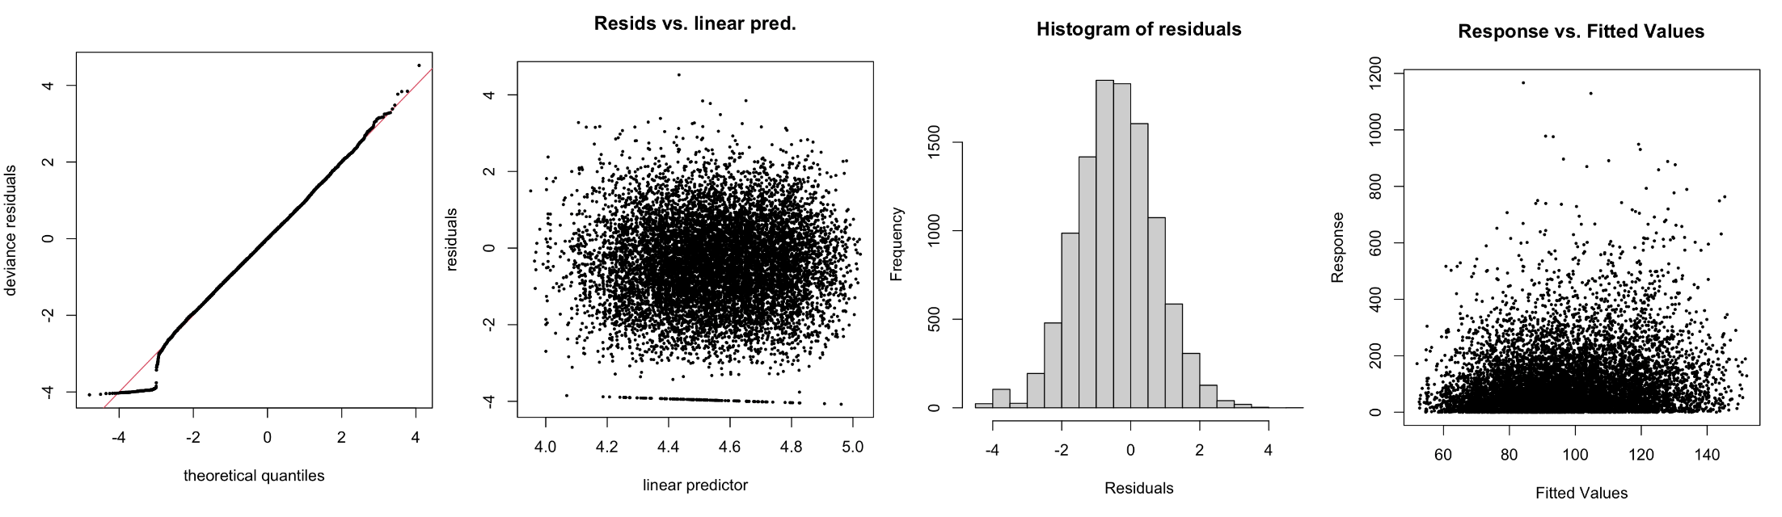
Figure S1 Example of model diagnostics from the model to predict TMSC for the data from Denmark. This output shows reasonably good model fit, with relatively few outliers given the size of the dataset.

3. Ejaculate Volume and Sperm Concentration

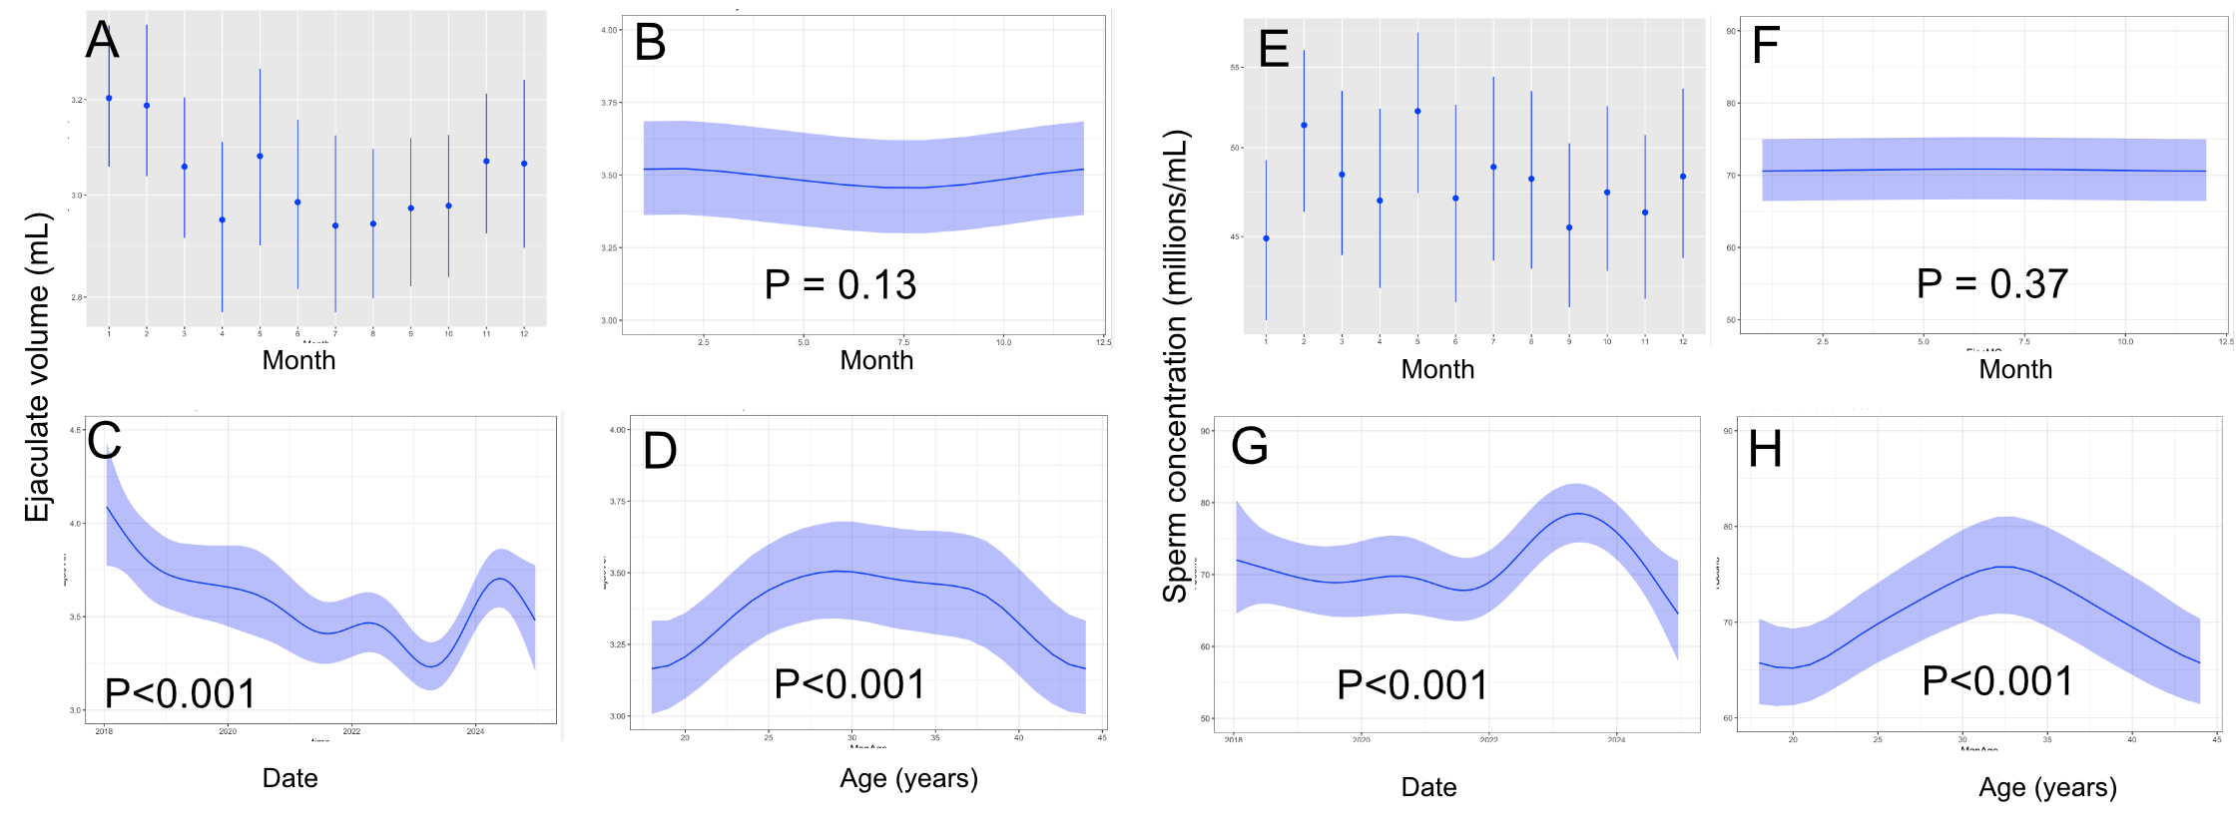
Figure S2. Figure S2. No seasonal variation in ejaculate volume or sperm concentration in Orlando. (A,D) Raw data (means ±95% CLs; log scale). (B,F) Monthly trends from GAM models with approximate P-values. (C,G) Trends across 7 years; (D,H) trends by age. Rug plots on x-axes show sample distributions. See Figure 2 for similar results in Denmark.

Table S1. Significance tests of current-month temperature (tempM) in GAMs predicting ejaculate volume and sperm concentration in Denmark and Orlando.
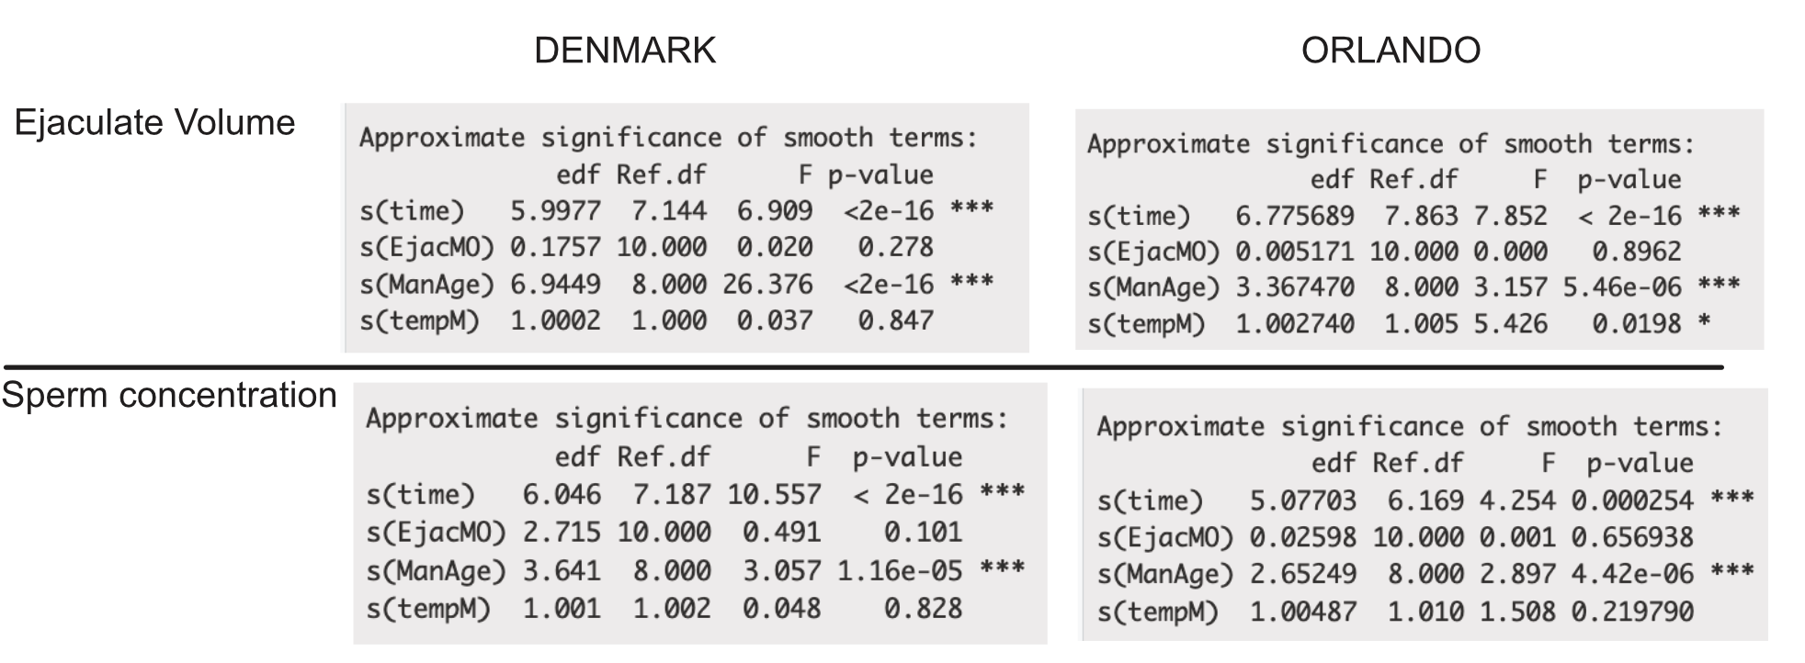

4 Grade b sperm concentration

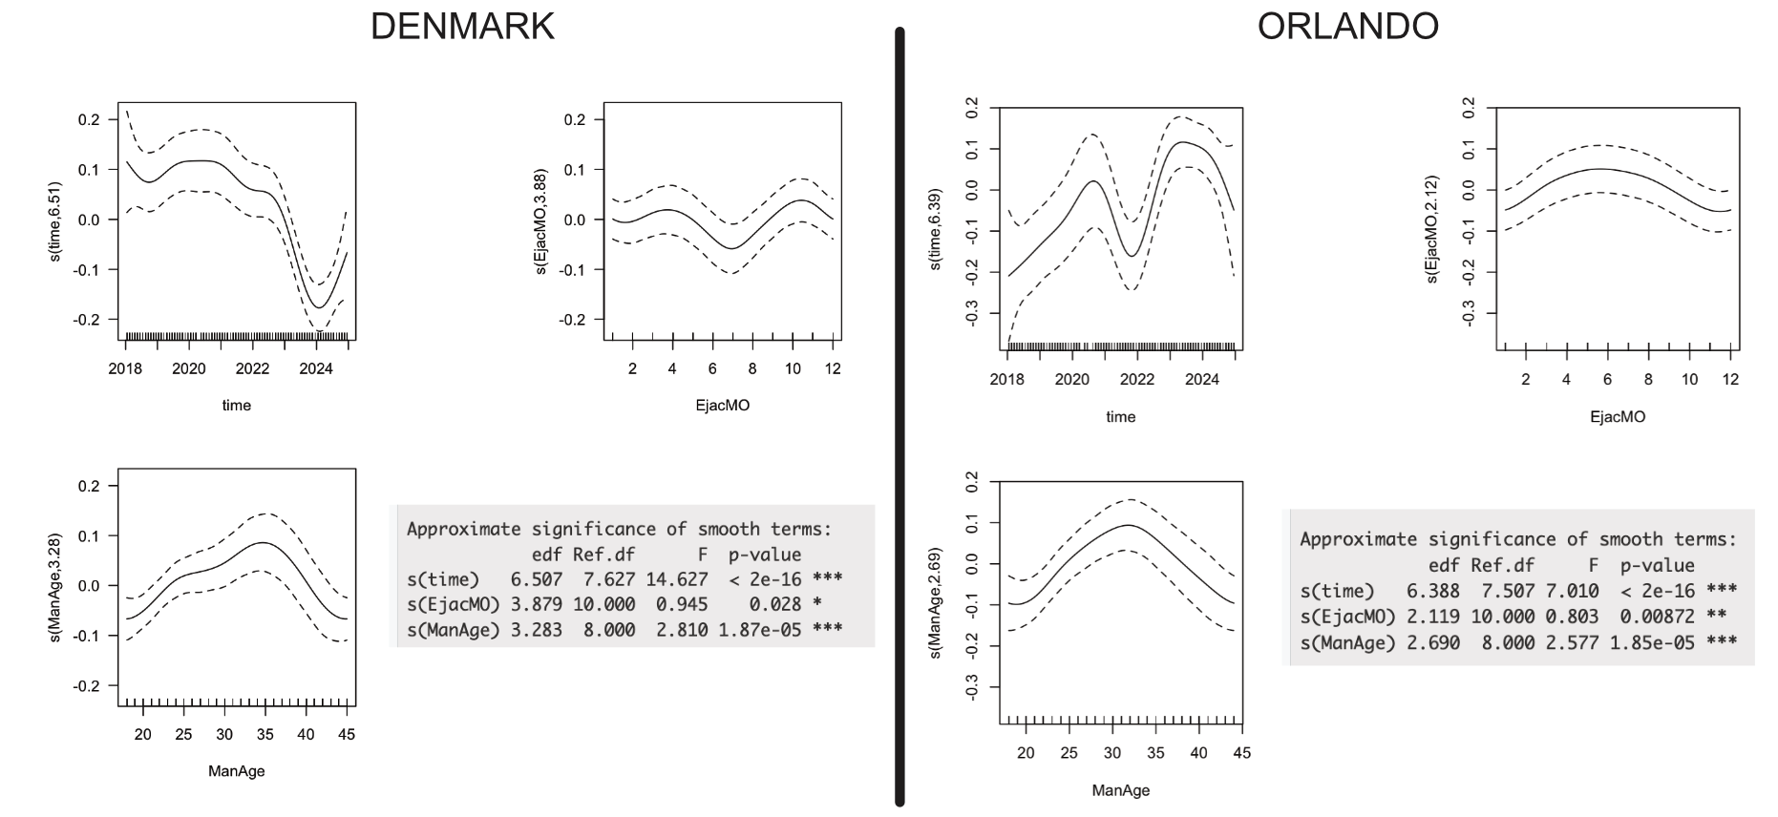
Figure S3. GAMs to predict the concentration of ‘grade b’ sperm in Denmark and Orlando.

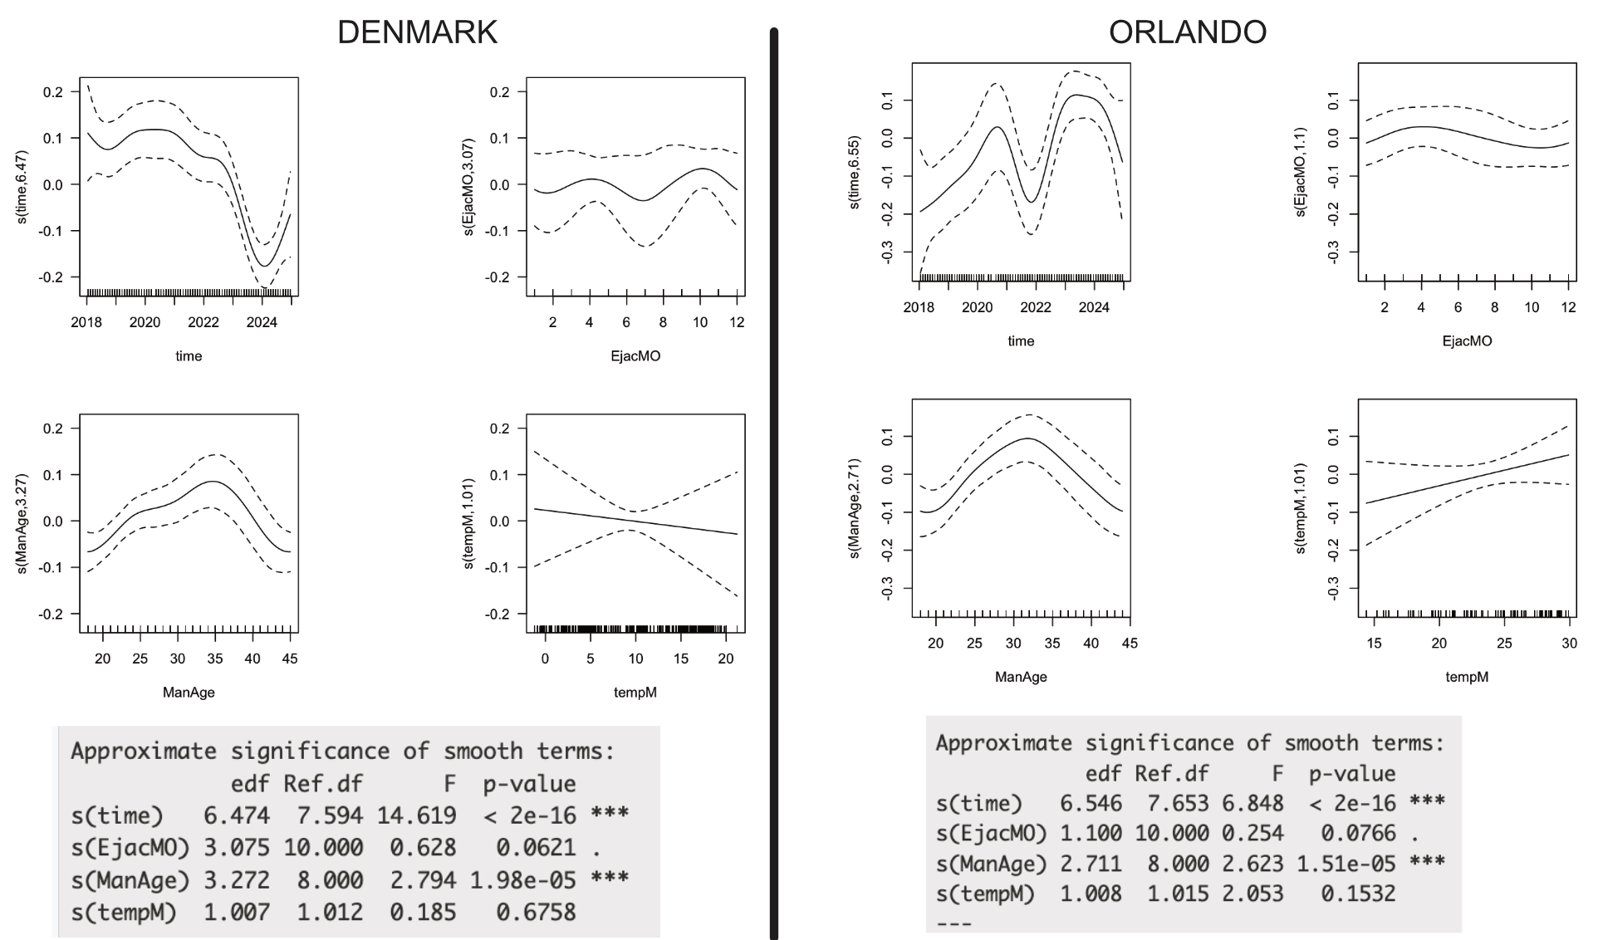
Figure S4. GAMs to predict the concentration of ‘grade b’ sperm in Denmark and Orlando, controlling for temperatures in the contemporaneous months.

5. Grades a+b sperm concentration
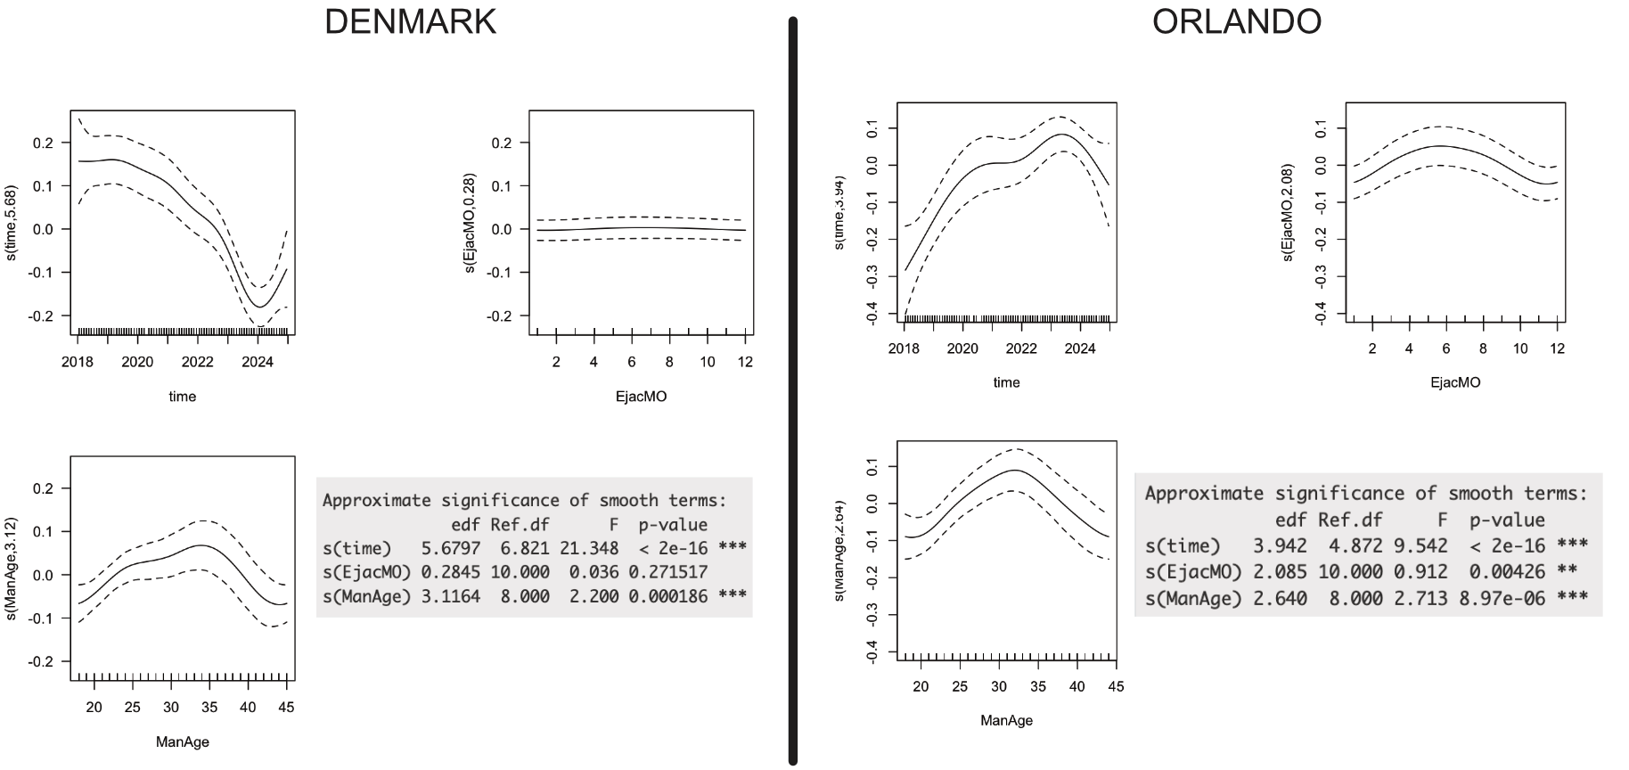
Figure S5. GAMs to predict the concentration of ‘grades a+b’ sperm (Total motile sperm concentration) in Denmark and Orlando.
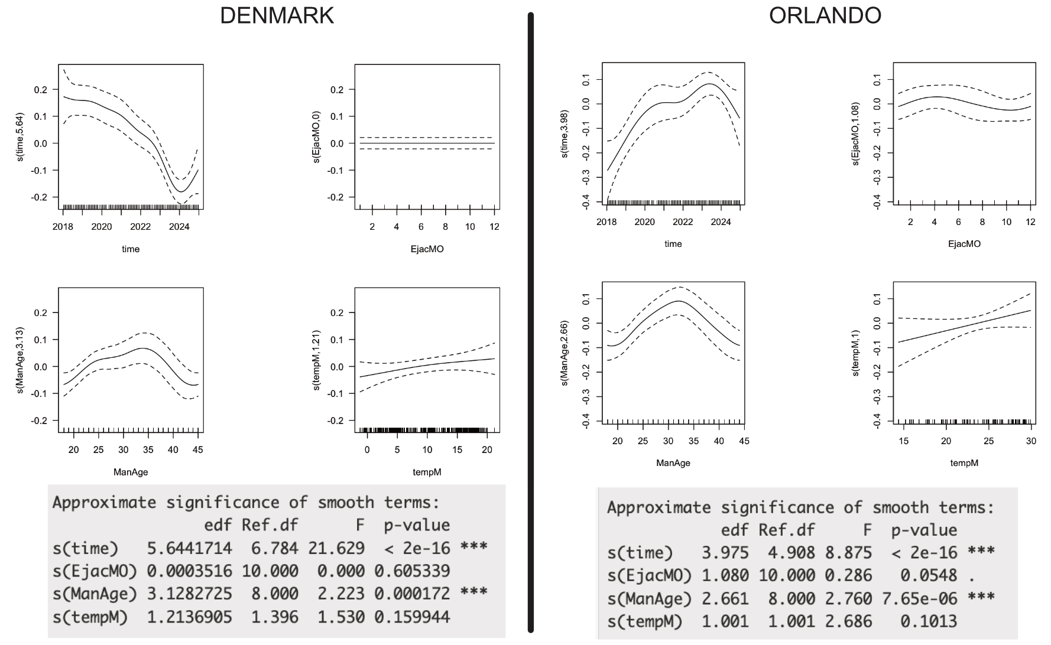
Figure S6. GAMs to predict the concentration of ‘grades a+b’ sperm in Denmark and Orlando, controlling for temperatures in the contemporaneous months.

6. Effects of temperature during spermatogenesis
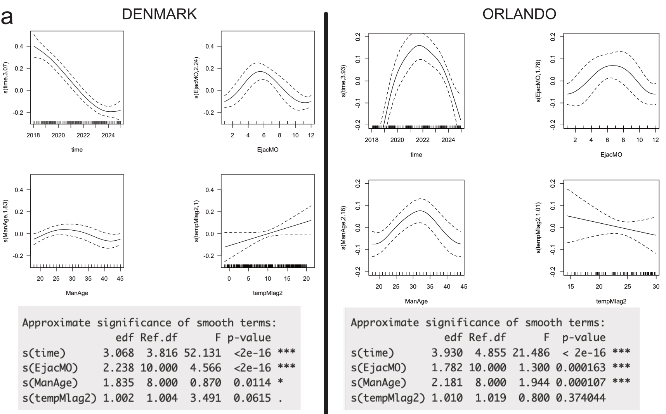
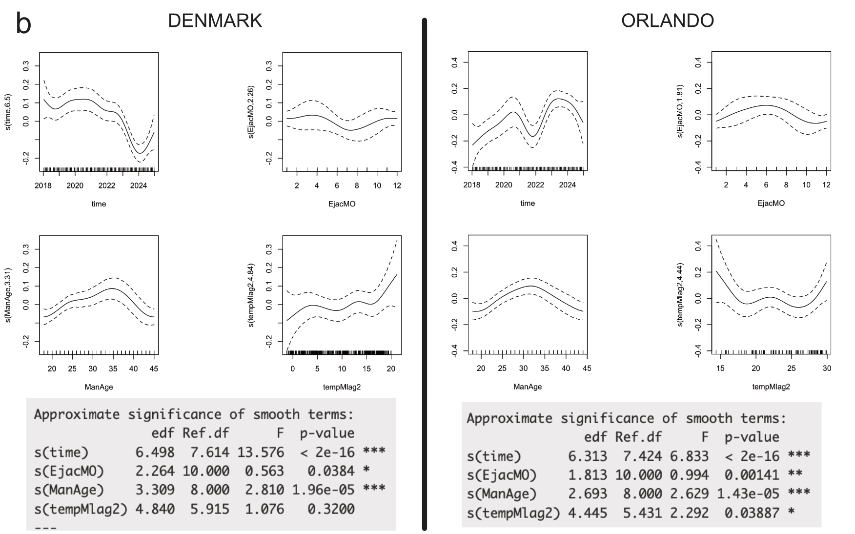
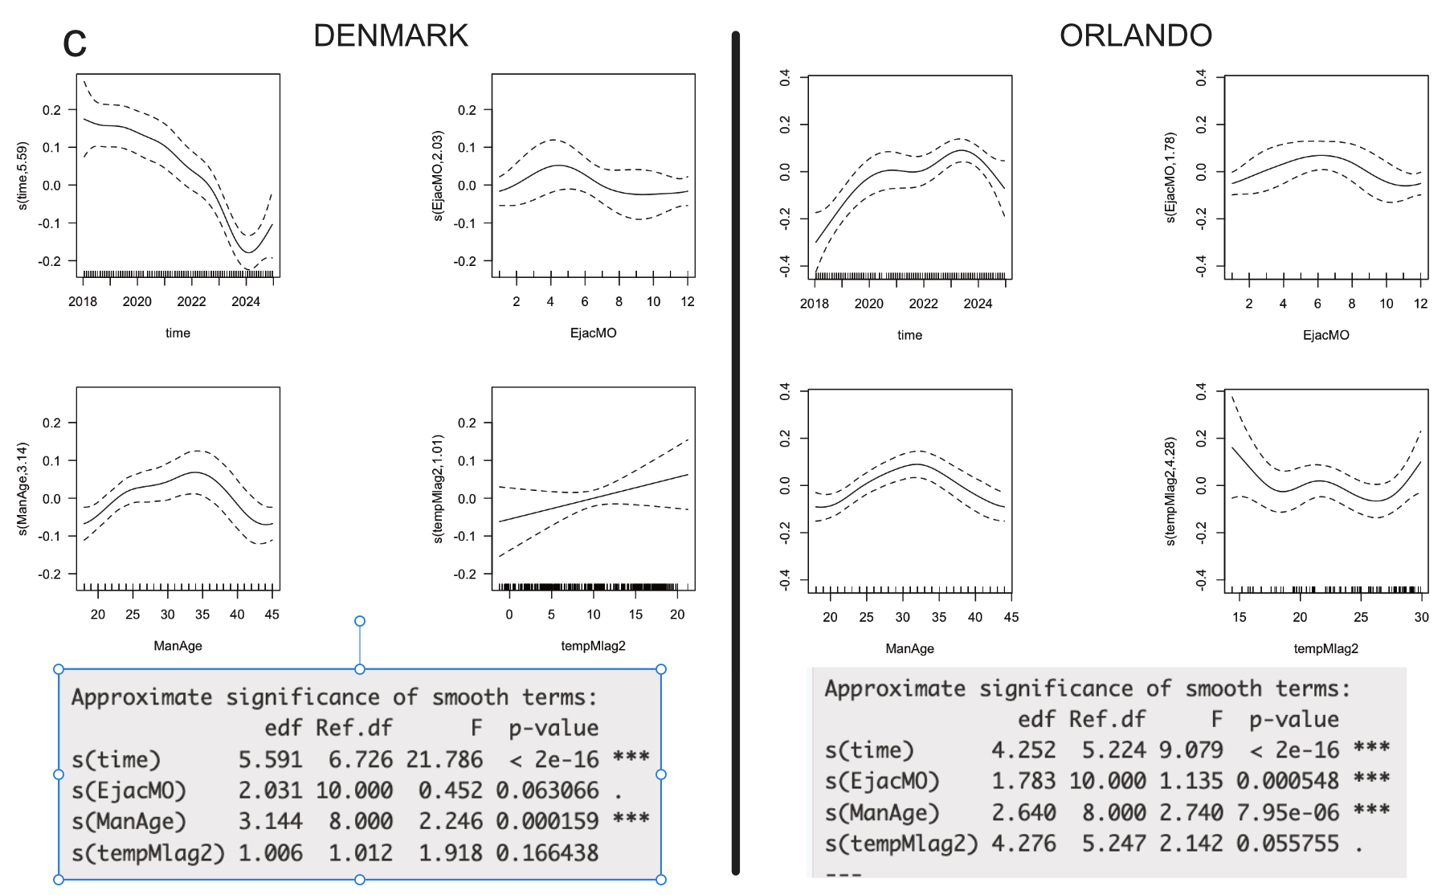
Figure S7. Effects of temperatures two months earlier on sperm concentrations in Denmark and Orlando. Predicted GAM trends for (a) grade A, (b) grade B, and (c) grades A + B (total motile sperm concentration).

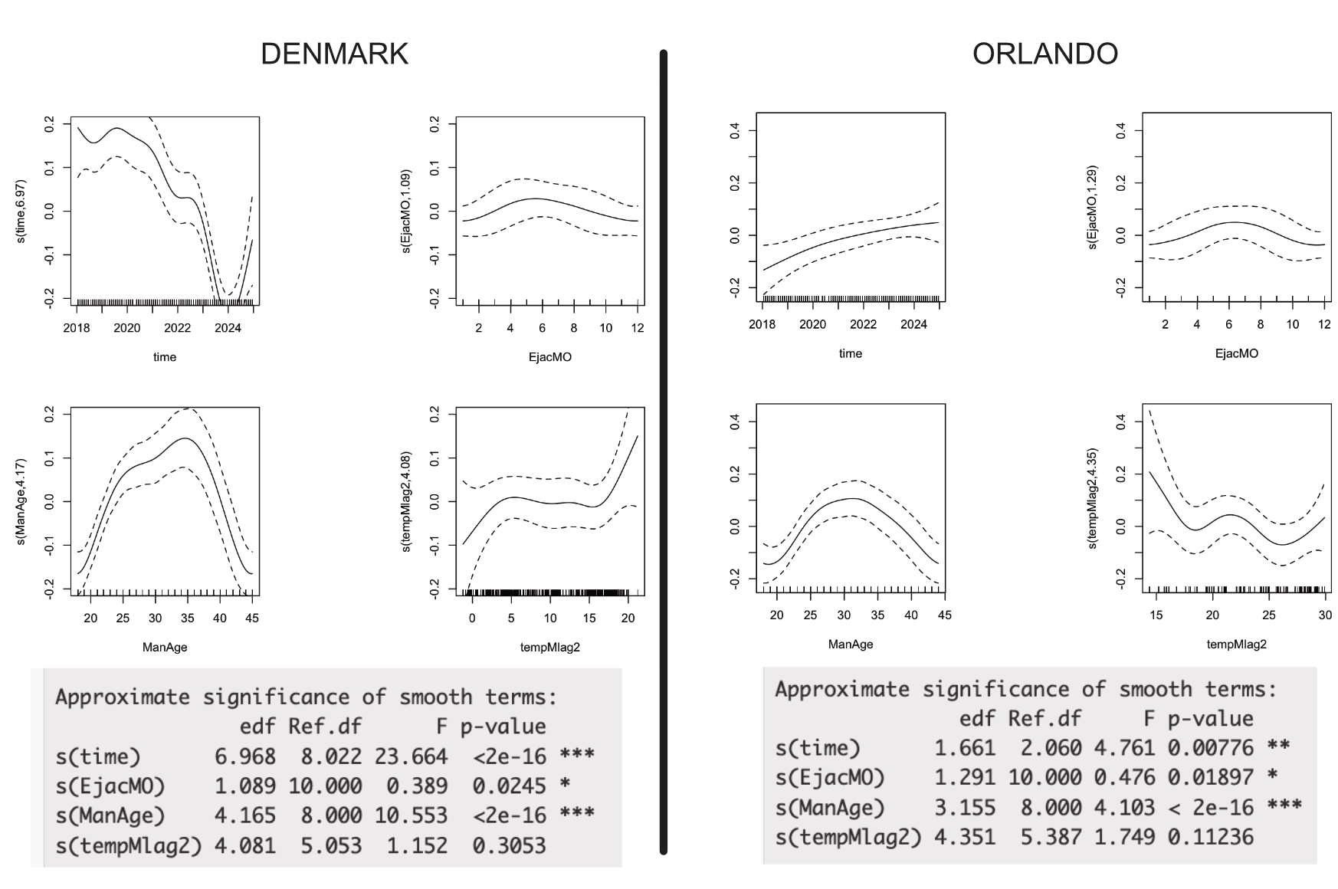
Figure S8. Effects of temperatures two months earlier on total motile sperm count (TMSC) in Denmark and Orlando. Predicted trends from GAM models.

