Supplementary Information: Male Wolbachia-infected Aedes aegypti deployments suppresses Aedes aegypti populations: a large-scale cluster-randomised controlled trial

Data
We extracted a set of spatially explicit variables to represent environmental heterogeneity across sectors.

Vegetation data Based on Sentinel-2 satellite data, a 10m vegetation map¹ of multiple classified vegetation types including grass, forest and managed vegetation was utilised to signify the availability of nectar availability and breeding areas for mosquitoes. For each sector, the percentage cover of each vegetation type was calculated as mosquitoes often show preferential areas to breed and rest. We also calculated the averaged Landsat Normalised Difference Vegetation Index (NDVI) per sector as another proxy².

Residential data
We collated data on the locations of public housing estates named Housing Development Board (HDBs) where over 76% of Singapore’s resident population reside was obtained from OneMap³ to represent urban mosquito breeding habitat density and the number of available human hosts. We additionally collected data on the average age of public housing estate buildings as buildings of older ages are at greater risk of having higher Gravitrap indices^{4,5}. Older buildings typically have structural deterioration which create additional breeding habitats in cracks and fissures as well as old undesirable design features such as laundry poles holders. Water pooling is more likely to occur in such features. Data on the average public housing estate house prices from 2015–2022, a proxy for household income and socioeconomic status, was calculated based on a previously used XGBoost model⁶. Another variable, building height, that is correlated to Gravitrap indices, was used to represent the number of available human hosts. We estimated the height as the number of floors at an average height of 3m per floor. Additional hosts from private housing including condominiums and houses were added in the calculations. Lastly, data from the Public Utilities Board on the open drainage network was obtained to represent the availability of key breeding sites for mosquitoes around public housing estates. For each sector, the average distance of each public housing estate block to a drain was measured as well as the length of the network⁷.

Meteorological data Well-established variables known to affect mosquito survival or fecundity were collected. We calculated the daily mean, total precipitation and mean wind speed, which were obtained from a total of 21 weather stations installed by the National Environment Agency. Rasters at a daily resolution were created through inverse distance weighting interpolation for full spatial coverage where cross validation of leave-one-out was used for the fitting of the power to minimise error. To estimate relative humidity, we utilised dewpoint and ambient ground air temperature from ERA5, published by ECMWF⁸ with standard formula, and aggregated the values to a weekly level to match spatial units of Gravitrap indices data.

Entomological data Adult Aedes aegypti and Ae. albopictus populations in all clusters were monitored weekly using an average of six Gravitraps⁹ per public housing apartment block. Gravitraps were placed in public spaces along corridors of public housing apartments in all intervention clusters, at the ratio of 1 trap for every 20 households, i.e. two to three traps on each of three floors per apartment block: lower floor (2nd), mid floor (5th or 6th floor) and high floor (10th or 11th floor). This trap-to-household ratio and deployment was based on logistic considerations for long term monitoring, and it provided an assessment of the density as well as vertical distribution of the mosquito population. Mosquito data was collected from all Gravitraps on a bi-weekly basis, and mosquito samples were sexed and morphologically identified. Female Aedes mosquitoes that cannot be speciated morphologically were identified using a multiplex Ae. aegypti- and Ae. albopictus-specific real-time qPCR assay targeting the COI gene (Aedes forward 5’-TCC CGC CTT CRG TGC GCG G-3’, Aedes reverse 5’-CGC GGG ATG TAY TCA TCA ACC-3’, probe AEG Cy5 – 5’-TAG TCA GAC GTG GTG GTG ACA CAC C-3’– BHQ2, and ALBO HEX – 5’-ACG GTG GCC GGC GTG CCA GTC GT-3’ – BHQ1). The multiplex qPCR reactions were performed in 20µl total volume containing 1X SensiFAST No-Rox Probe Mastermix (Bioline, USA); 0.15µM and 0.05µM COI primers and probes, respectively; 0.4 µM and 0.15µM wsp primers and probes, respectively; and 2µl. Cycling was carried out in a Rotorgene Q (Qiagen, Germany) using the following conditions: 95°C for 5 min, 40 cycles at 95°C for 10s, and 60°C for 30s.

Intervention
Spatial characterisation 8 intervention clusters and 7 control clusters were included. Aedes aegypti abundance as proxied by the Gravitrap Aedes aegypti index (GAI) was drastically reduced in intervention clusters (SI Figure 1), whereas GAI in control clusters remained fairly high throughout the intervention period (SI Figure 2). Aedes albopictus abundance as proxied by the Gravitrap Aedes albopictus index (GI_{albo}) 0.10 in intervention clusters (SI Figure 3), whereas that in control clusters remained 0.06 throughout the intervention period (SI Figure 4).

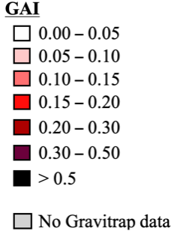
Intervention clusters | Choropleth maps |  |  | Temporal trends
Intervention clusters | May 2022 | May 2023 | Sep 2024 | 2019-2024
Bedok North | 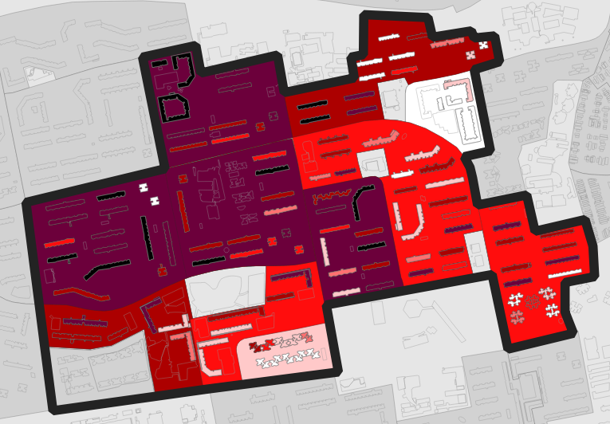 | 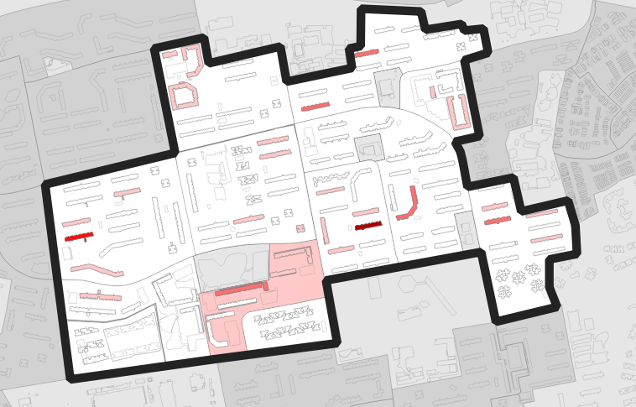 | 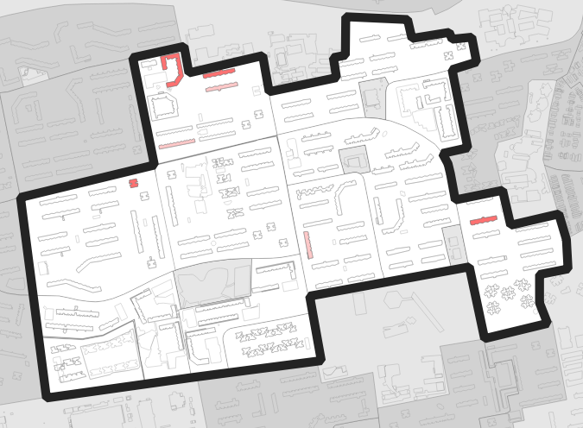 | 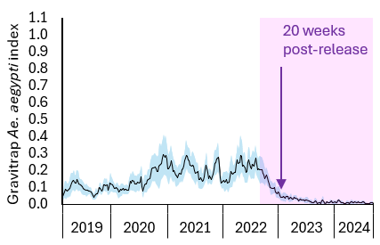
Bedok Reservoir | 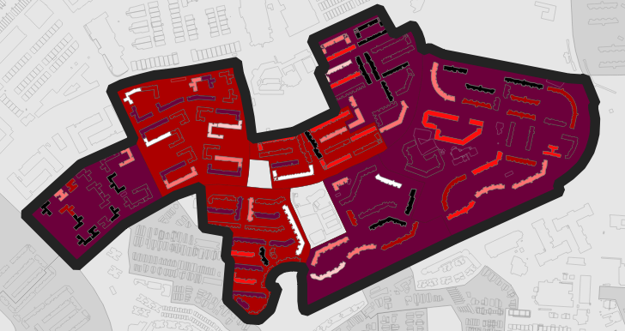 | 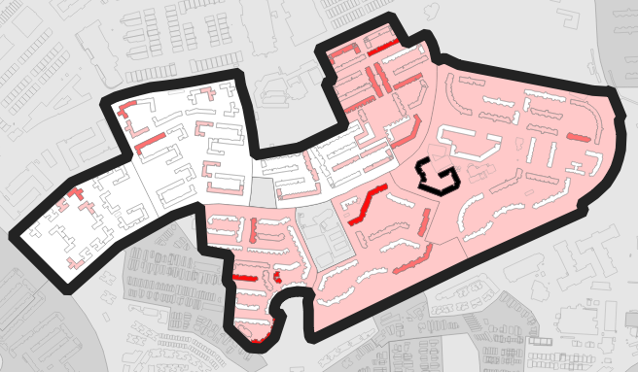 | 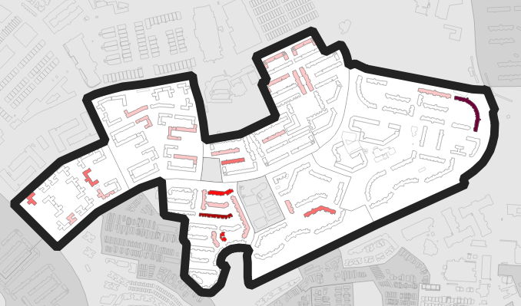 | 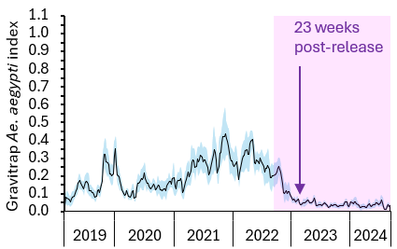
Circuit | 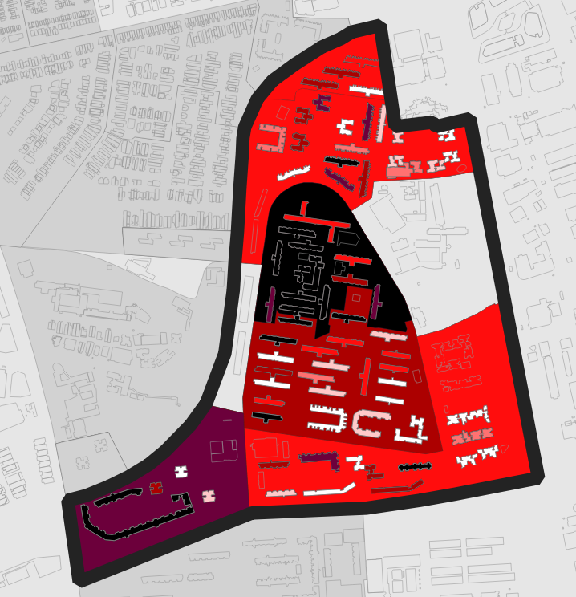 | 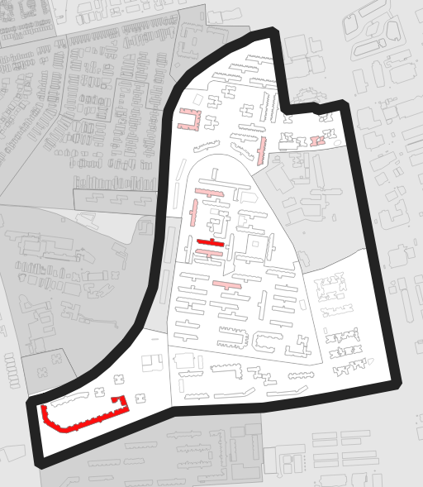 | 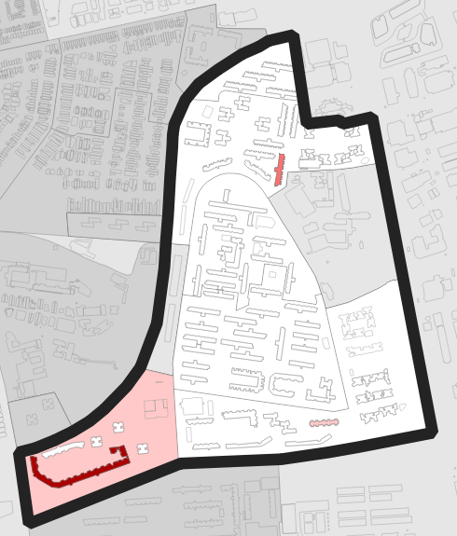 | 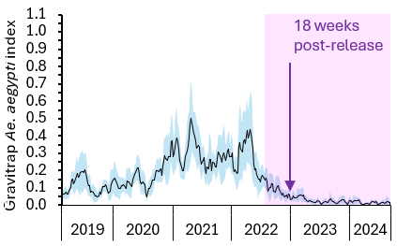
Hougang | 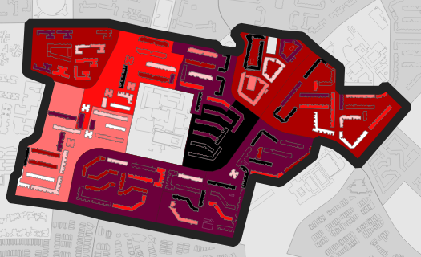 | 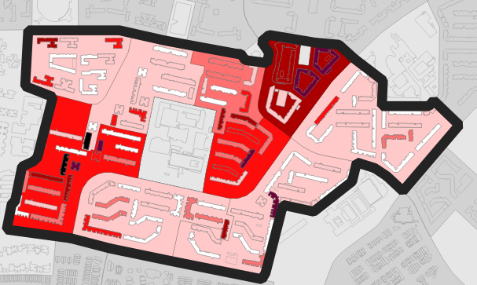 | 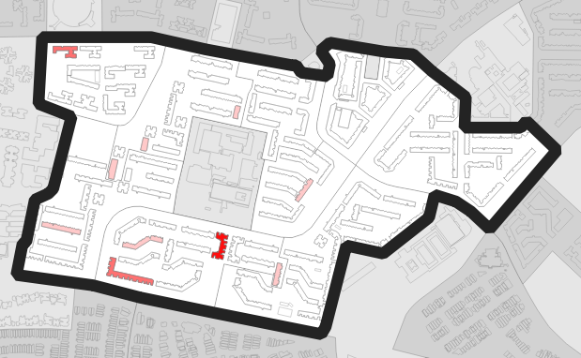 | 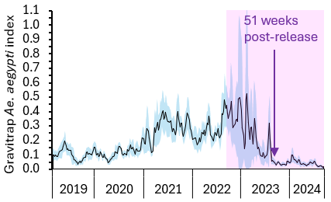
Punggol | 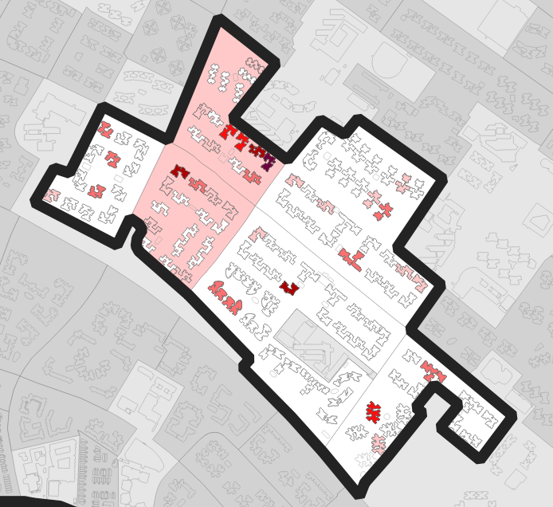 | 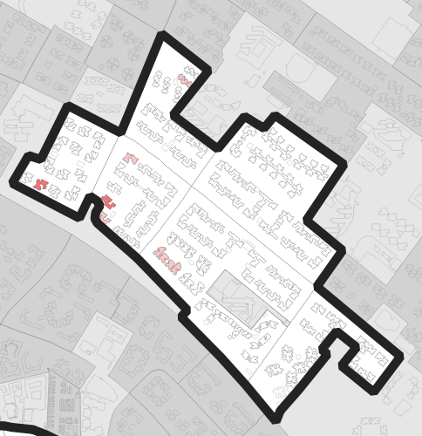 | 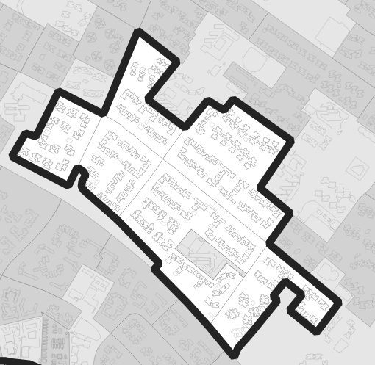 | 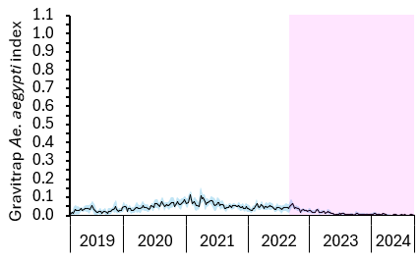
Sengkang | 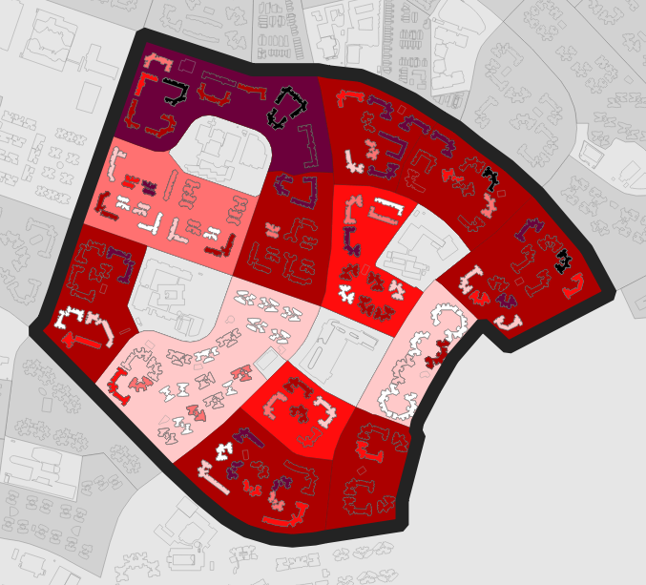 | 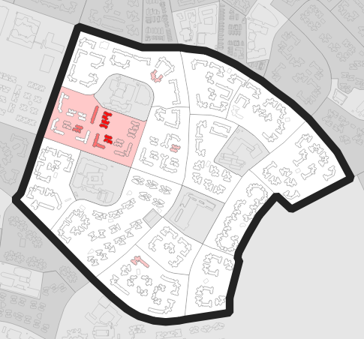 | 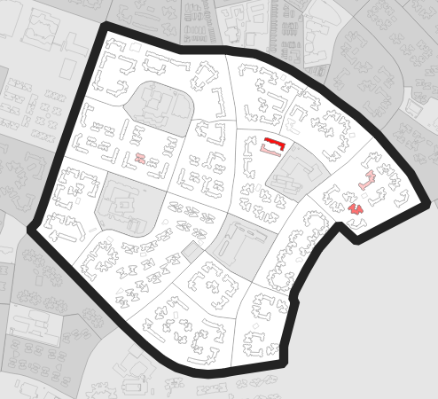 | 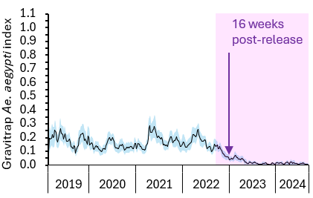
Woodlands | 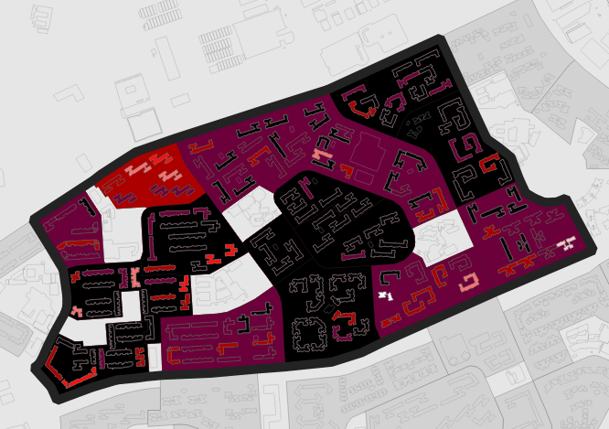 | 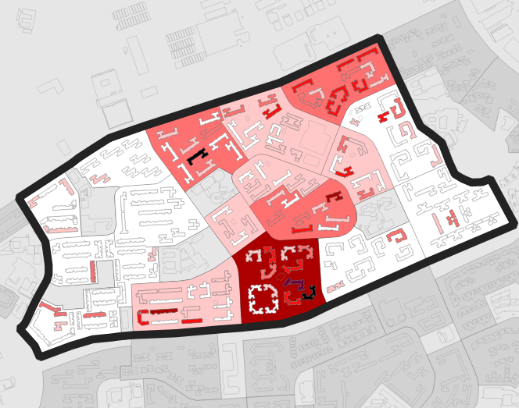 | 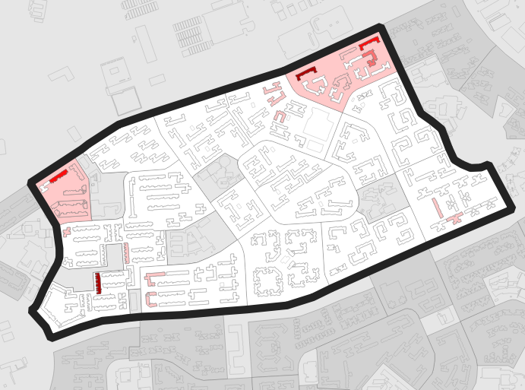 | 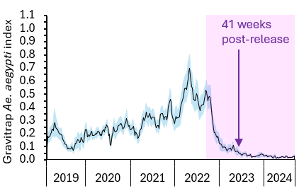
Yew Tee | 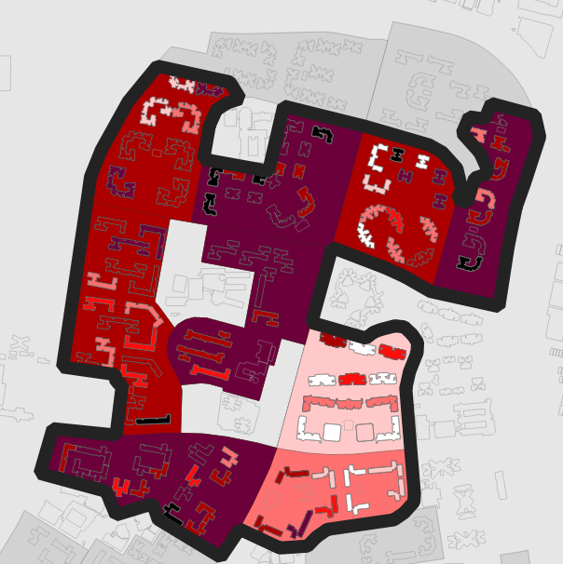 | 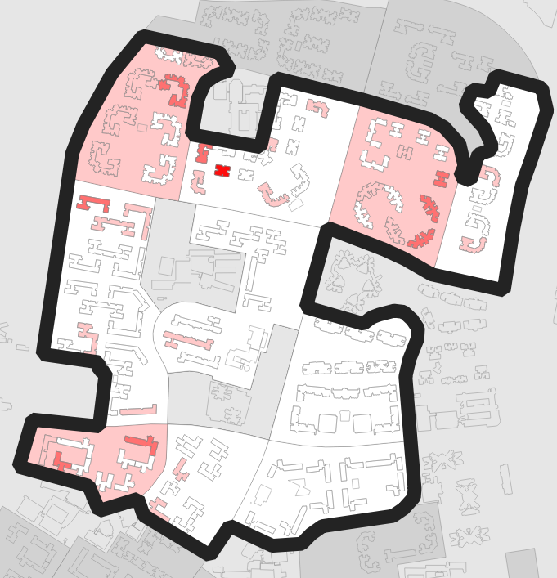 | 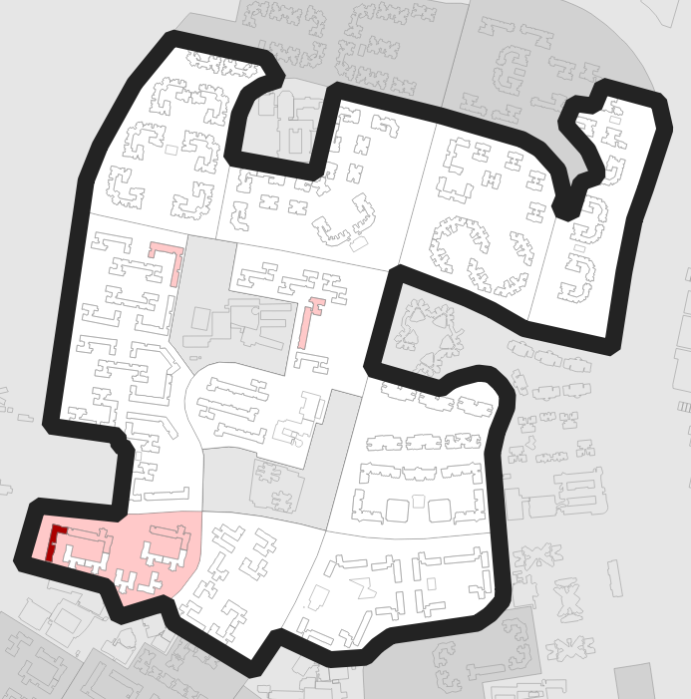 | 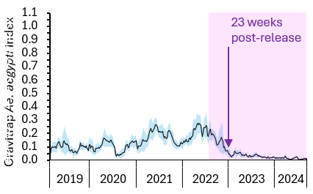
Supplementary Figure 1: Aedes aegypti abundance as proxied by the Gravitrap Aedes aegypti index (GAI) in 8 intervention clusters across calendar years of study. The choropleth maps show intervention clusters (black outline), with increasing Ae. aegypti abundance represented by darker shades of red. Temporal trend lines with 95% confidence intervals (blue shading) demonstrate the decline in Ae. aegypti abundance during the intervention period (pink shading). Arrows indicate when the GAI fell below 0.05, a threshold associated with reduced dengue transmission risk¹⁰.

Control clusters | Choropleth maps |  |  | Temporal trends
Control clusters | May 2022 | May 2023 | Sep 2024 | 2019-2024
Ang Mo Kio | 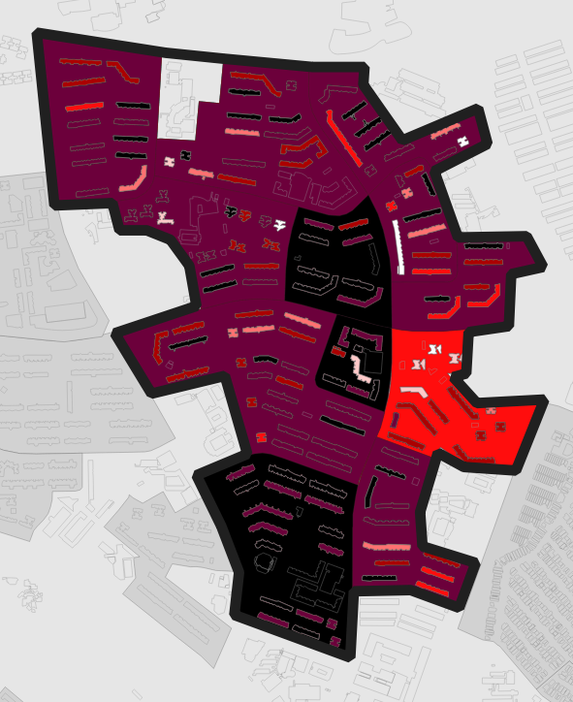 | 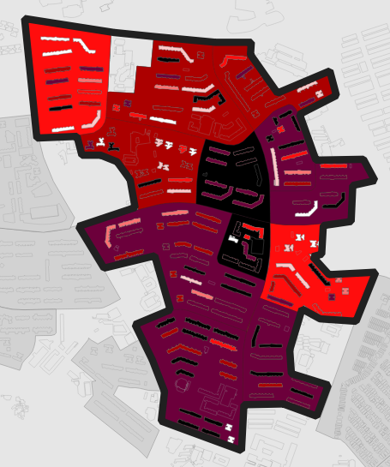 | 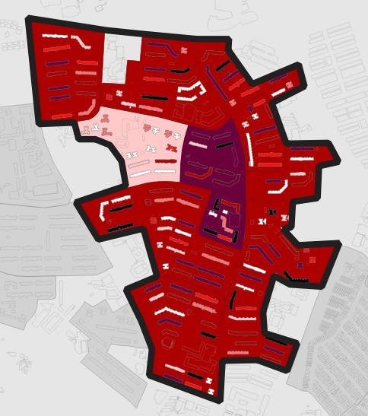 | 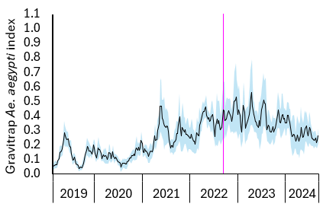
Bukit Panjang | 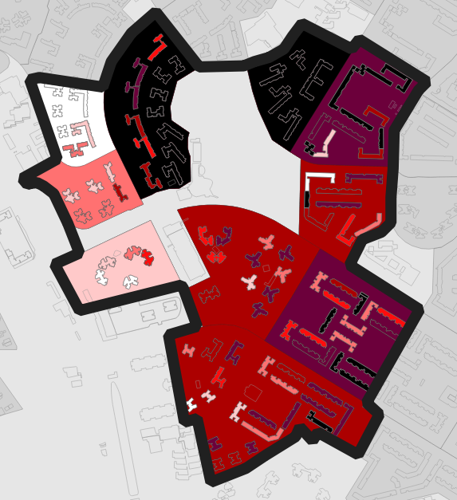 | 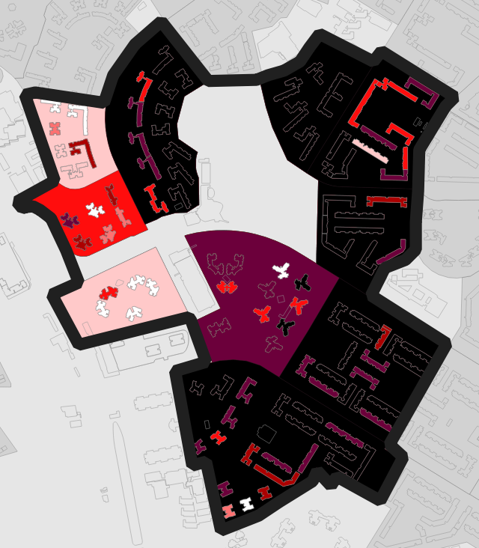 | 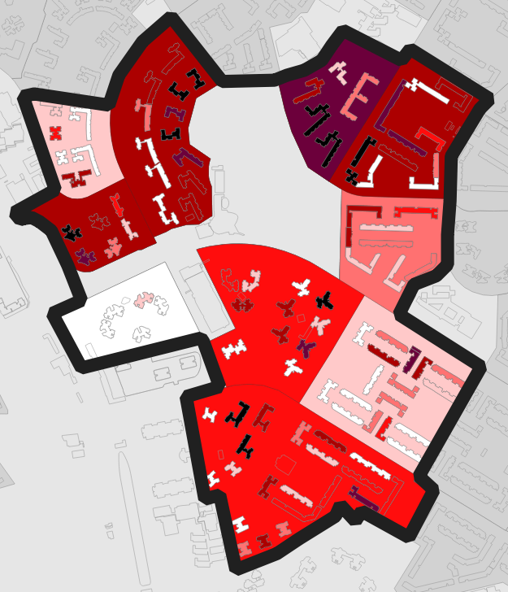 | 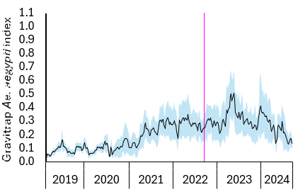
Pasir Ris | 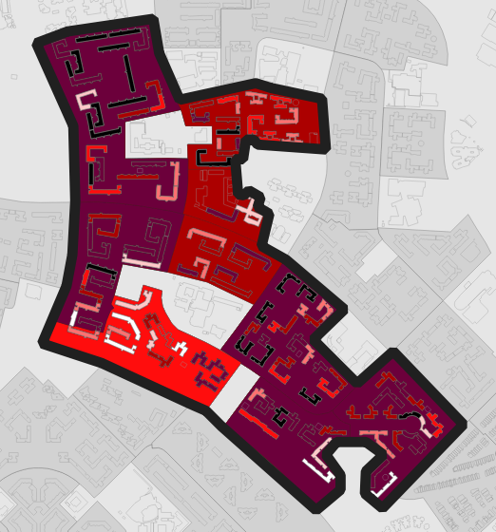 | 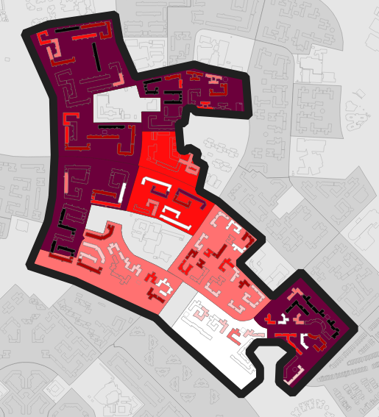 | 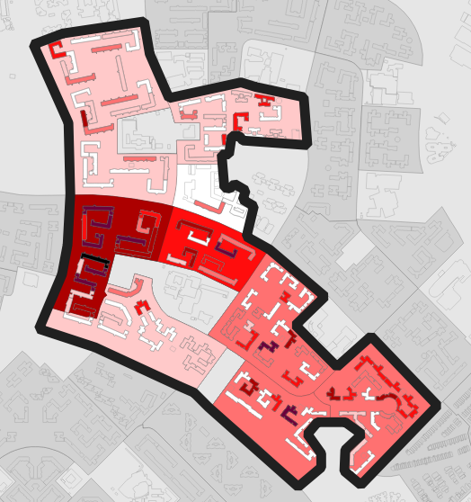 | 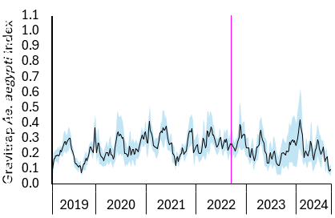
Pioneer | 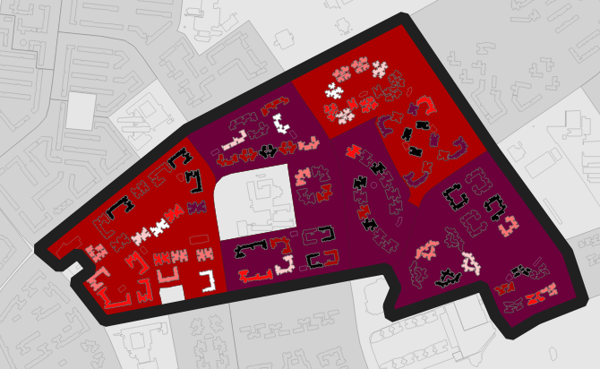 | 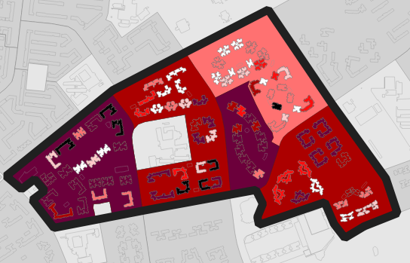 | 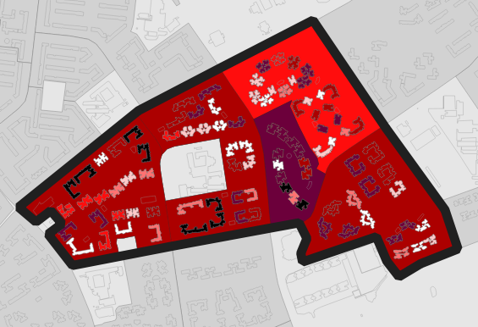 | 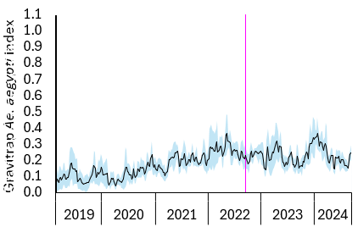
Serangoon Central | 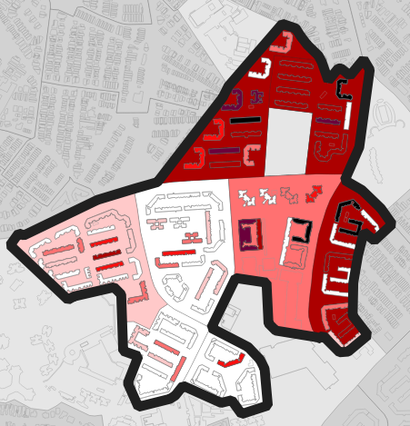 | 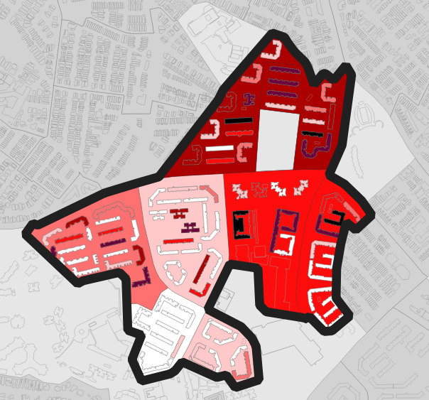 | 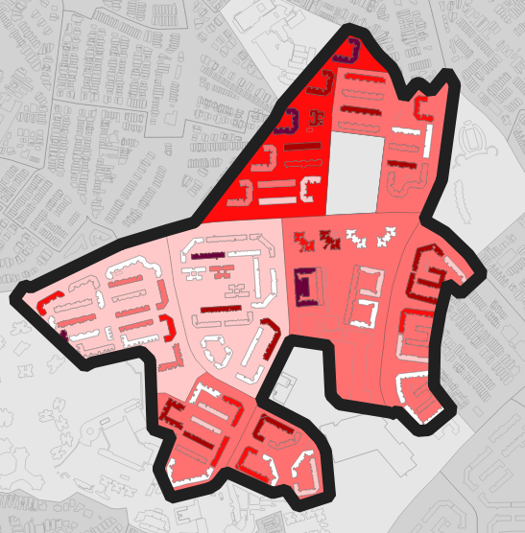 | 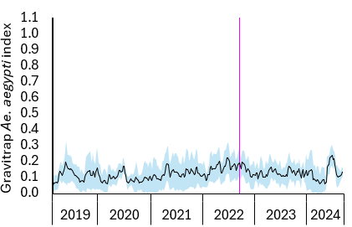
Toa Payoh | 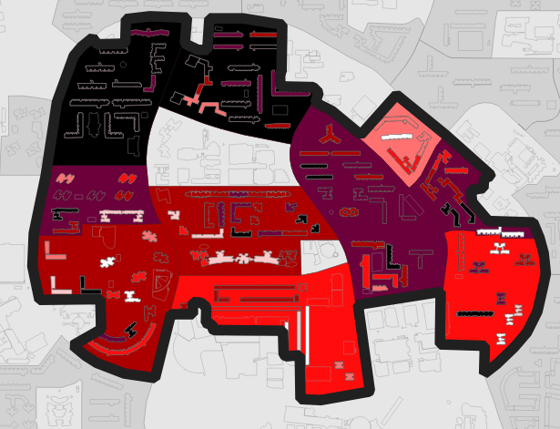 | 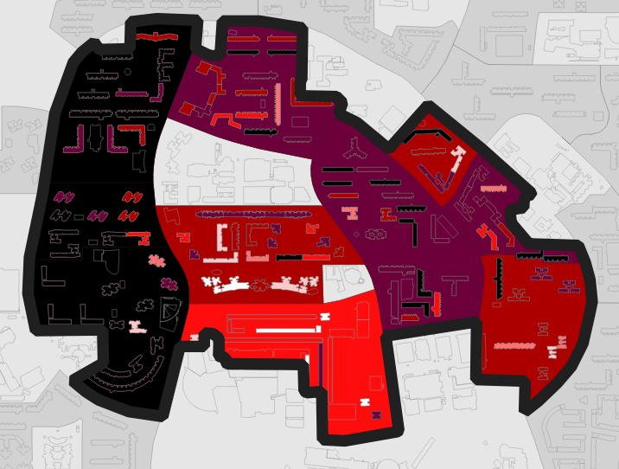 | 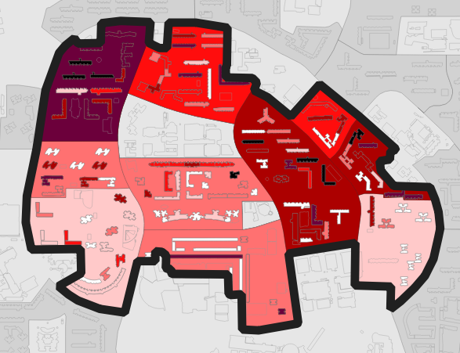 | 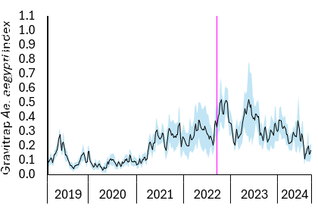
Yuhua | 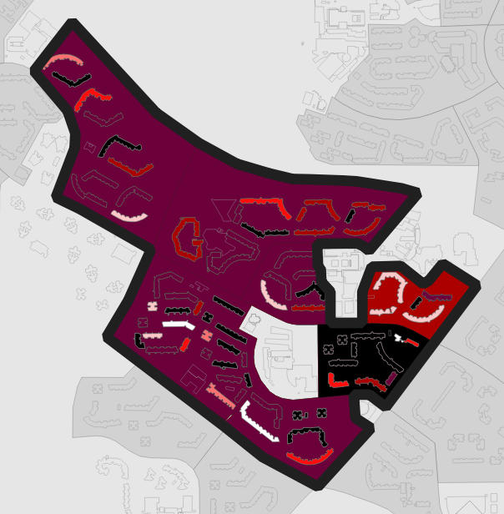 | 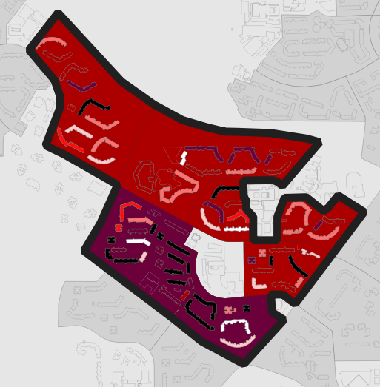 | 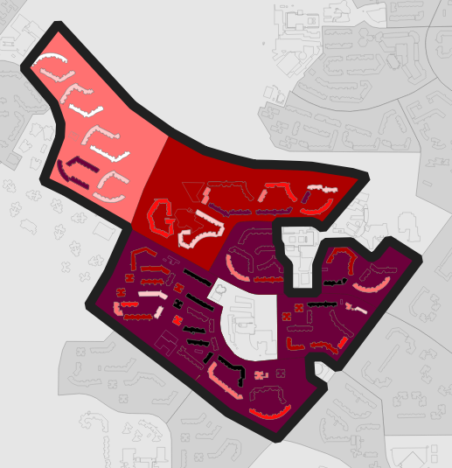 | 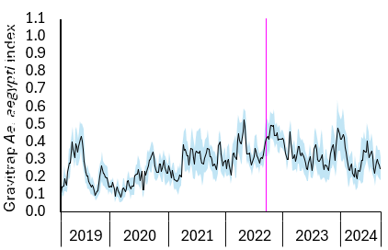
Supplementary Figure 2: Aedes aegypti abundance as proxied by the Gravitrap Aedes aegypti index (GAI) in 7 control clusters across calendar years of study. The choropleth maps show control clusters (black outline), with increasing Ae. aegypti abundance represented by darker shades of red. Temporal trend lines with 95% confidence intervals (blue shading) indicate high Ae. aegypti abundance during the intervention period. Vertical pink lines indicate trial commencement.

Intervention clusters | Choropleth maps |  |  | Temporal trends
Intervention clusters | May 2022 | May 2023 | Sep 2024 | 2019-2024
Bedok North | 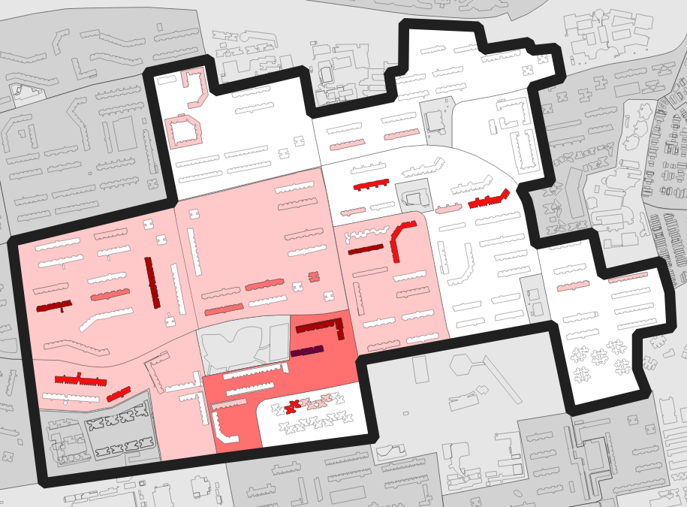 | 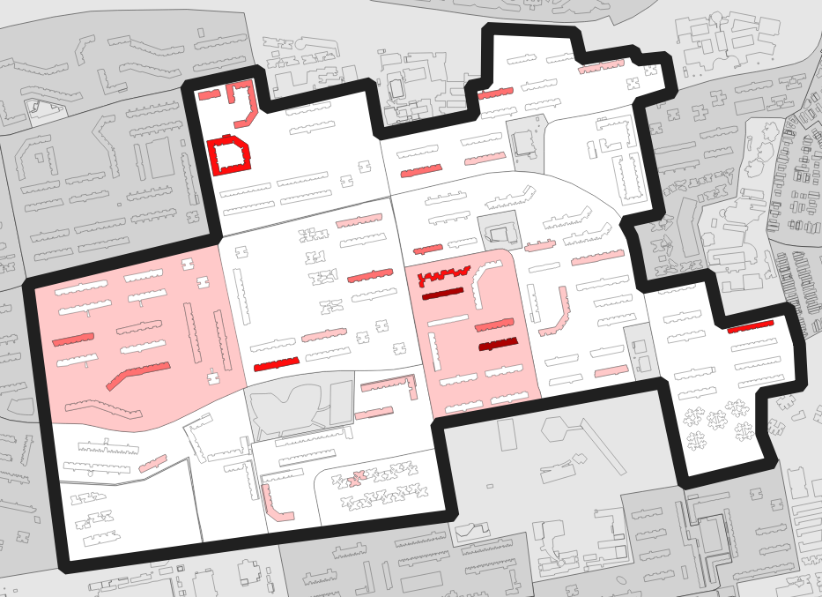 | 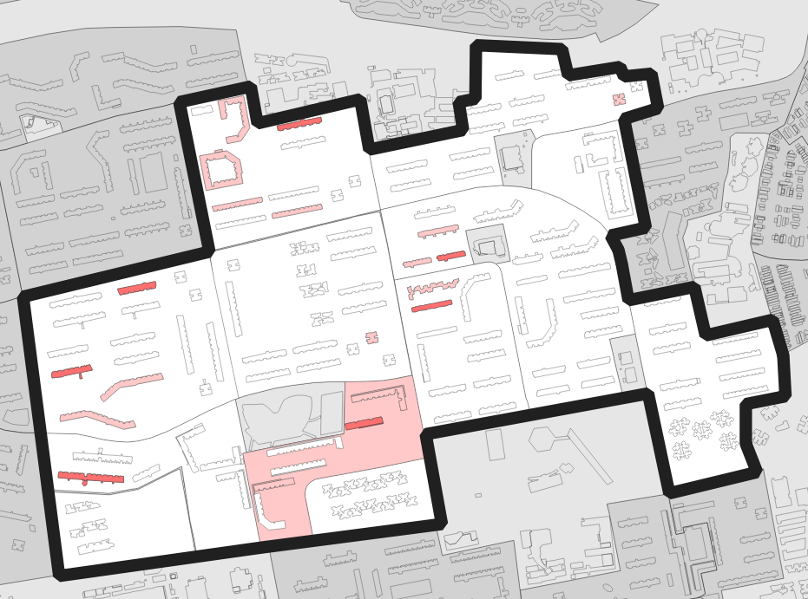 | 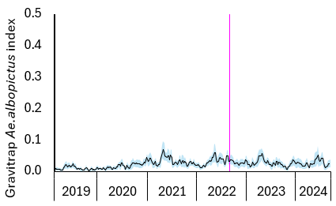
Bedok Reservoir | 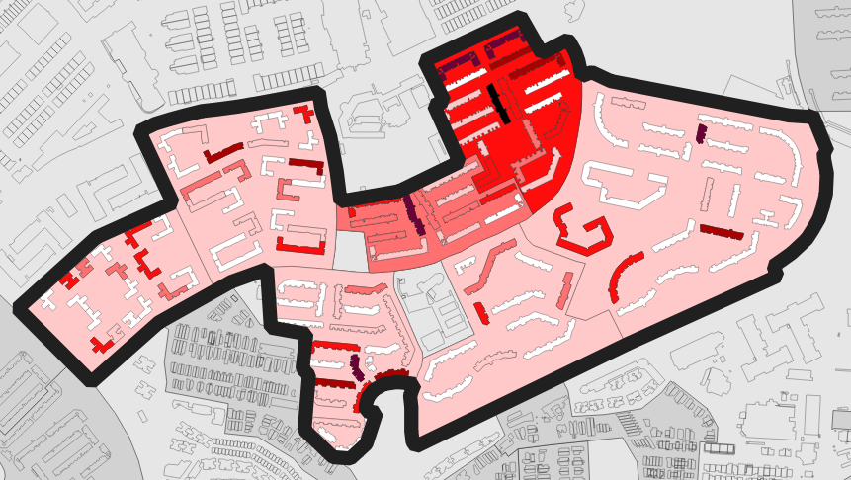 | 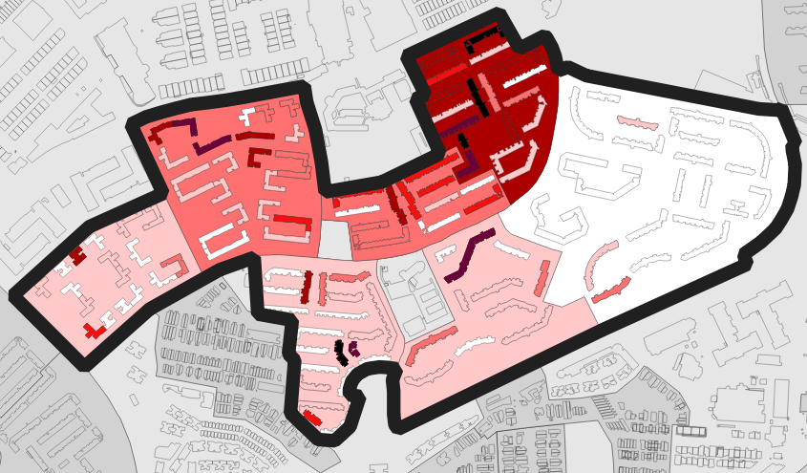 | 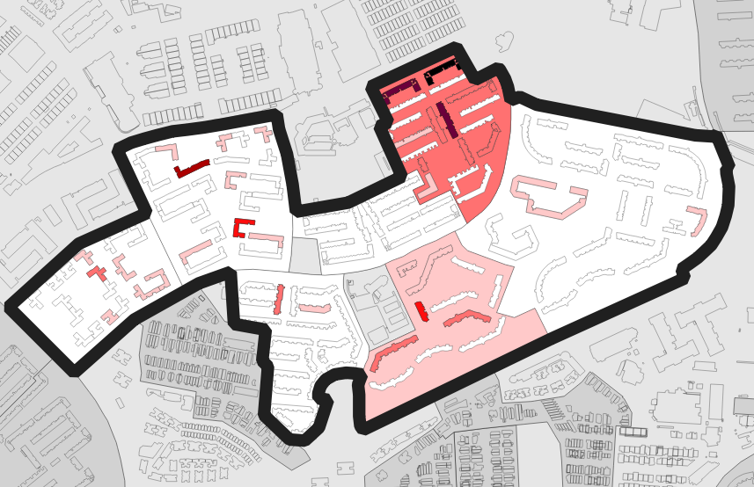 | 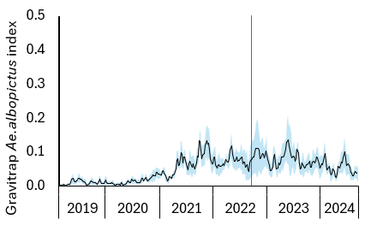
Circuit | 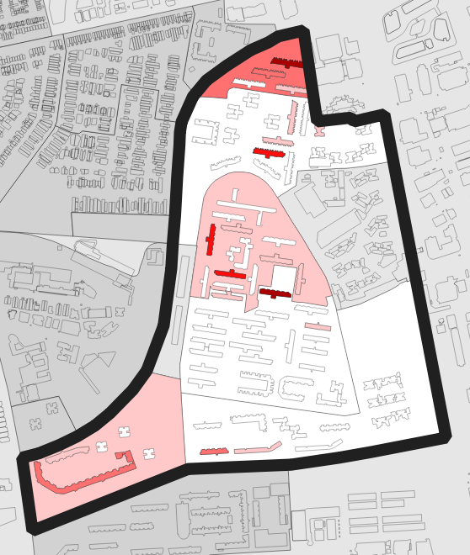 | 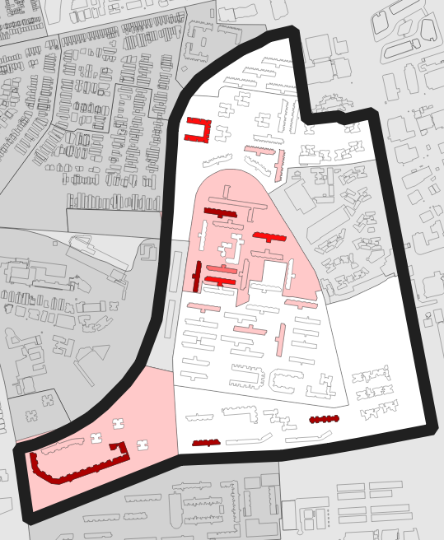 | 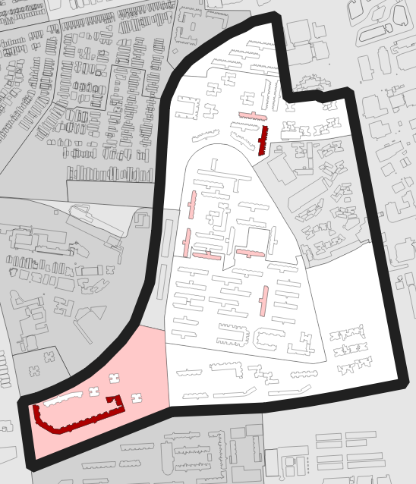 | 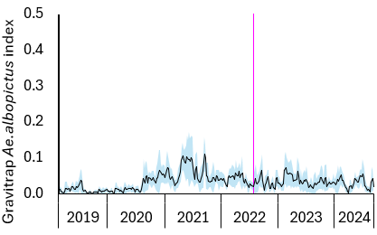
Hougang | 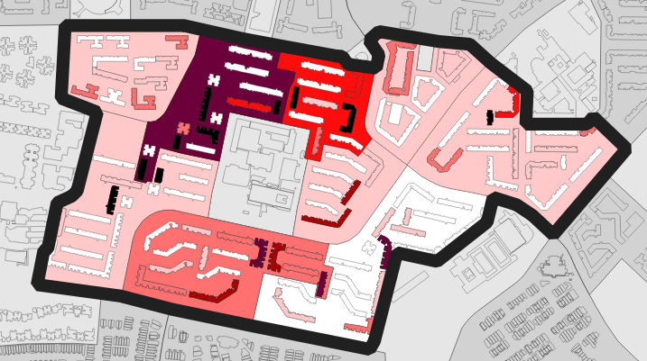 | 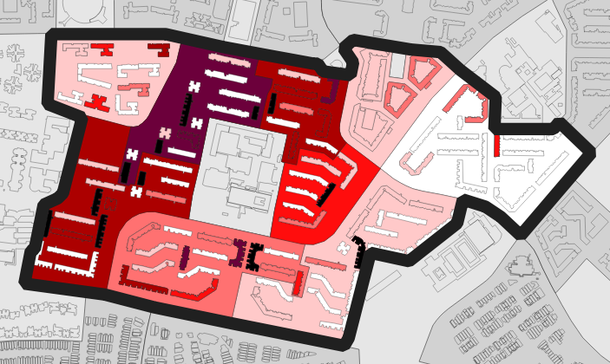 | 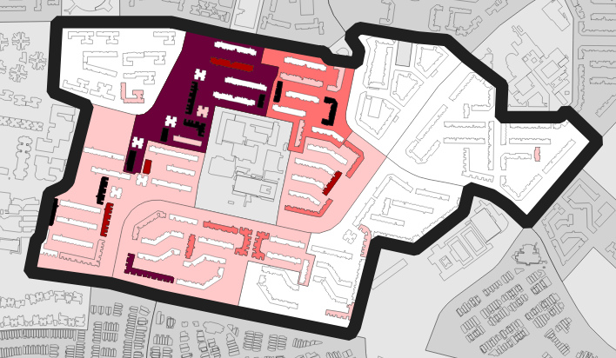 | 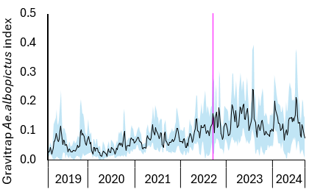
Punggol | 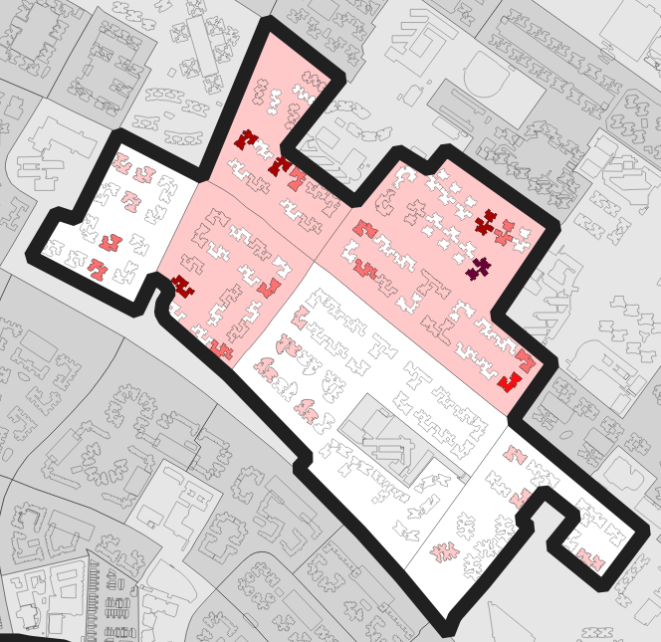 | 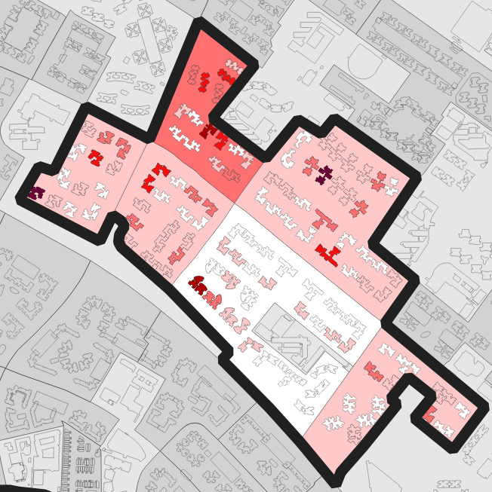 | 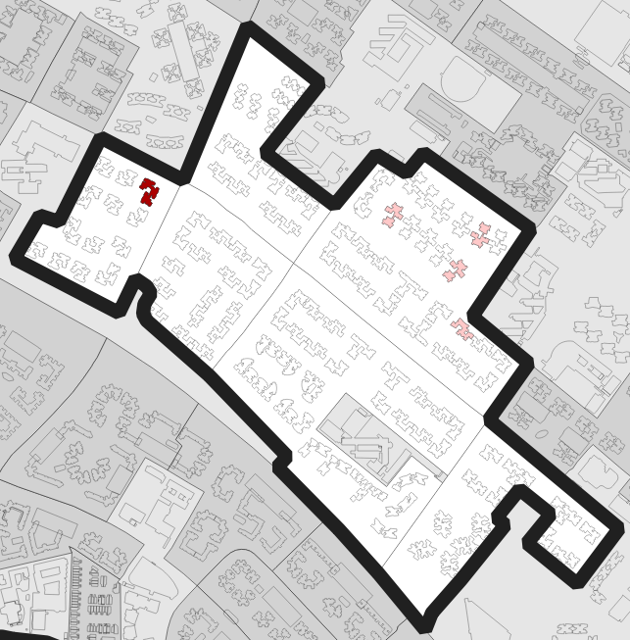 | 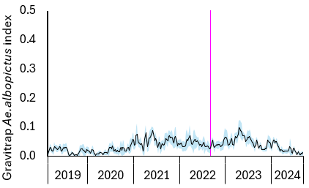
Sengkang | 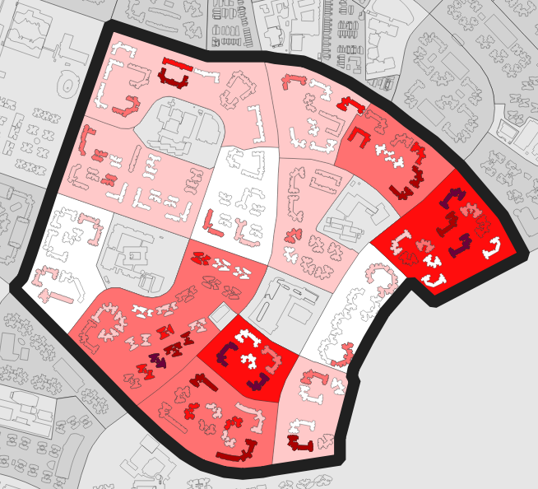 | 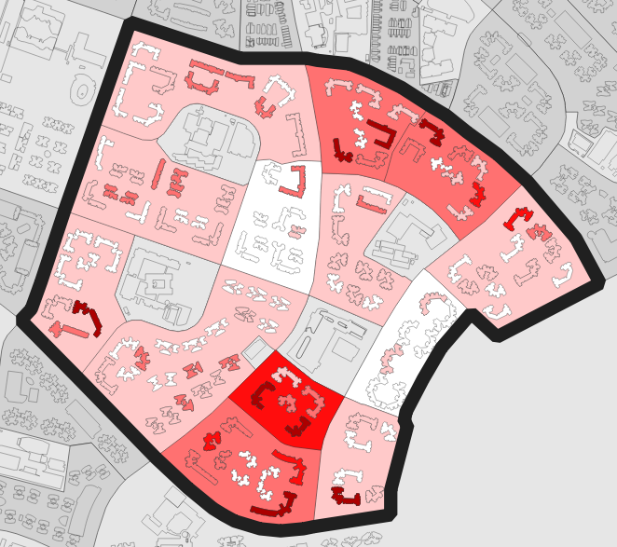 | 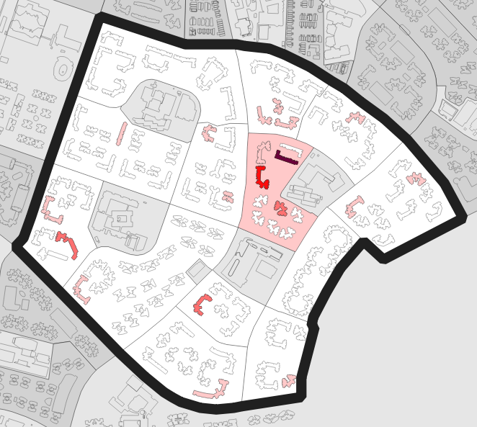 | 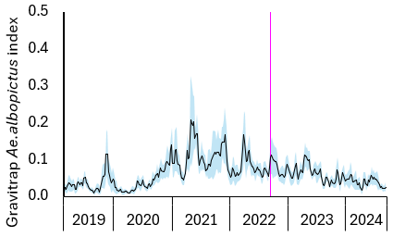
Woodlands | 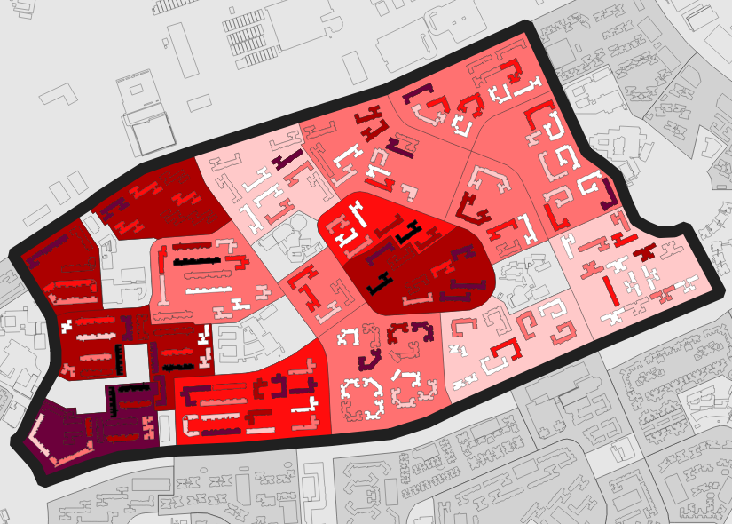 | 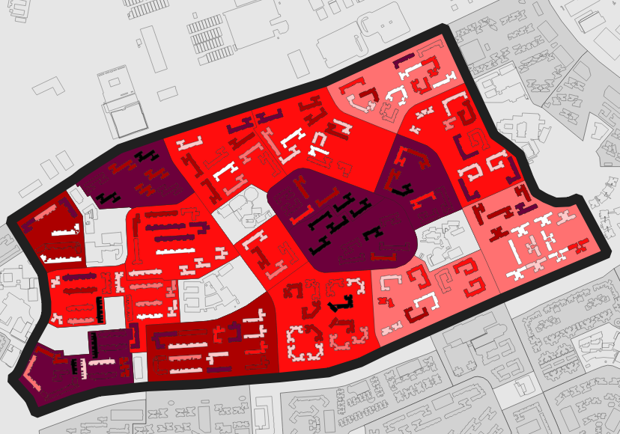 | 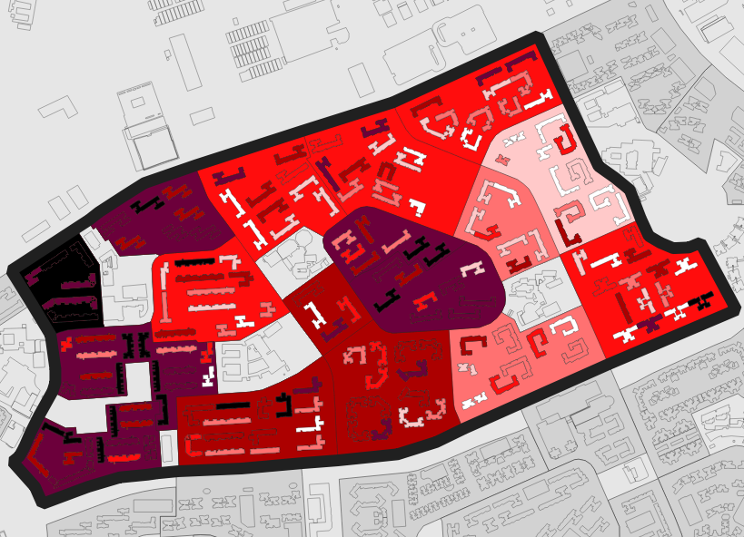 | 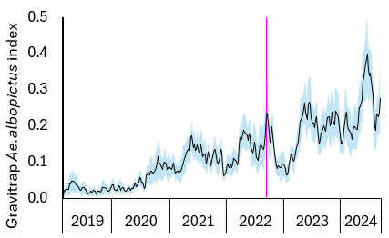
Yew Tee | 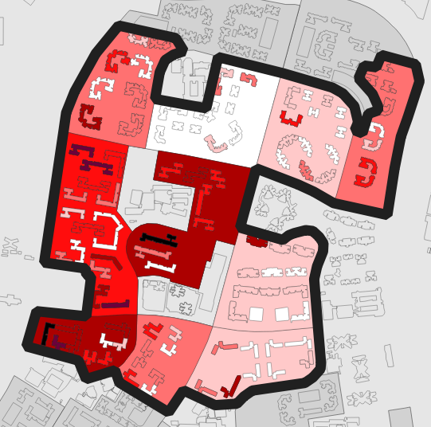 | 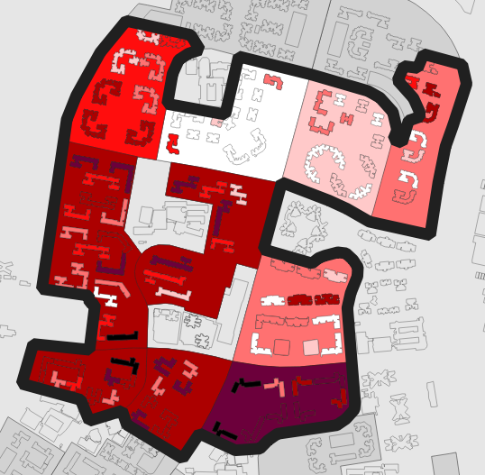 | 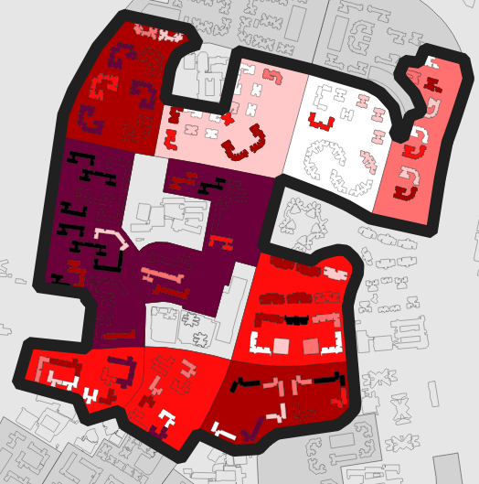 | 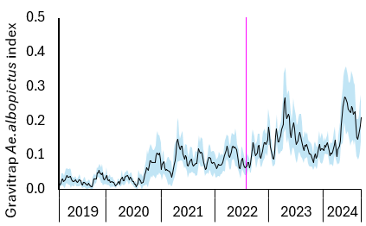
Supplementary Figure 3: Aedes albopictus abundance as proxied by the Gravitrap Aedes albopictus index (GI_{albo}) in intervention clusters across calendar years of study. The choropleth maps show intervention clusters (black outline), with increasing Ae. albopictus abundance represented by darker shades of red. Temporal trend lines with 95% confidence intervals (blue shading) indicate increased Ae. albopictus abundance in three clusters (Hougang, Woodlands and Yee Tee) during the intervention period. Vertical pink lines indicate trial commencement.

Control clusters | Choropleth maps |  |  | Temporal trends
Control clusters | May 2022 | May 2023 | Sep 2024 | 2019-2024
Ang Mo Kio | 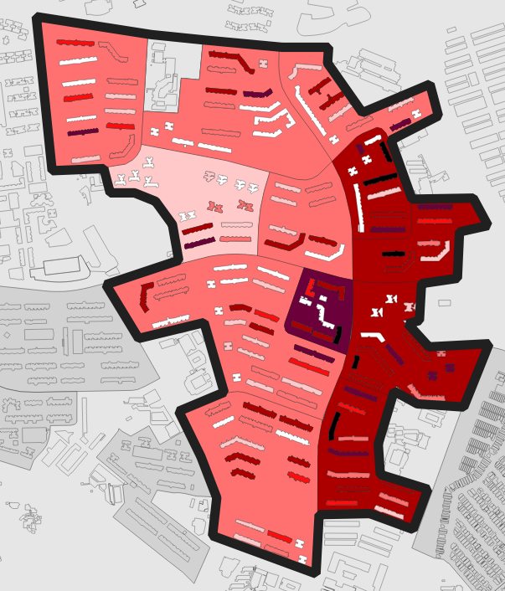 | 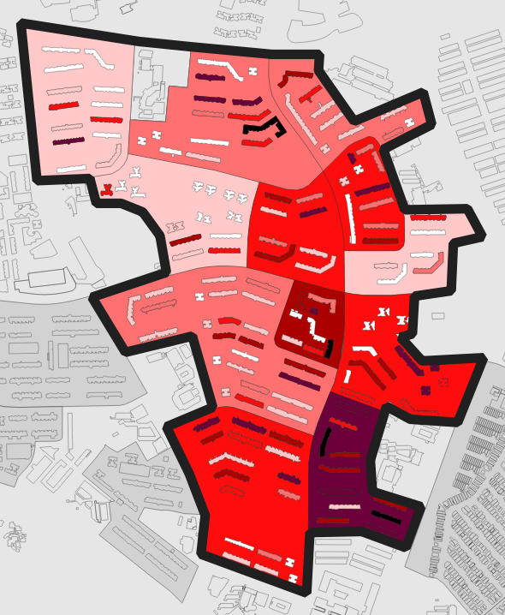 | 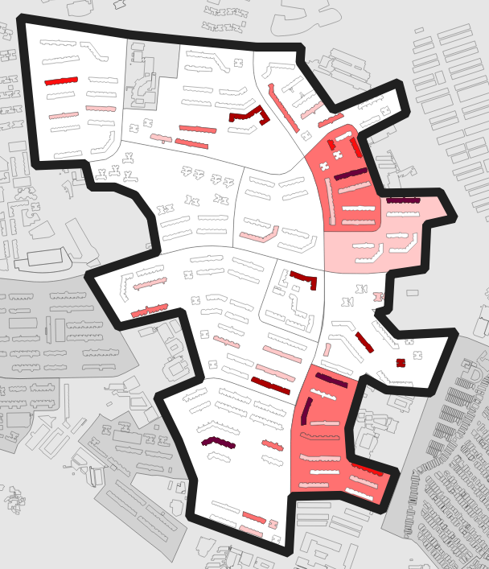 | 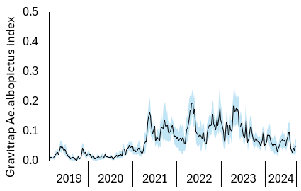
Bukit Panjang | 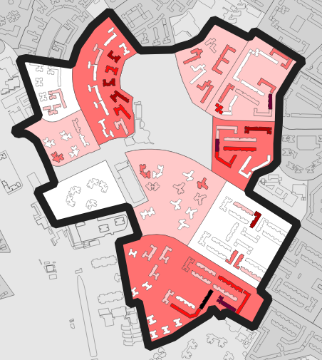 | 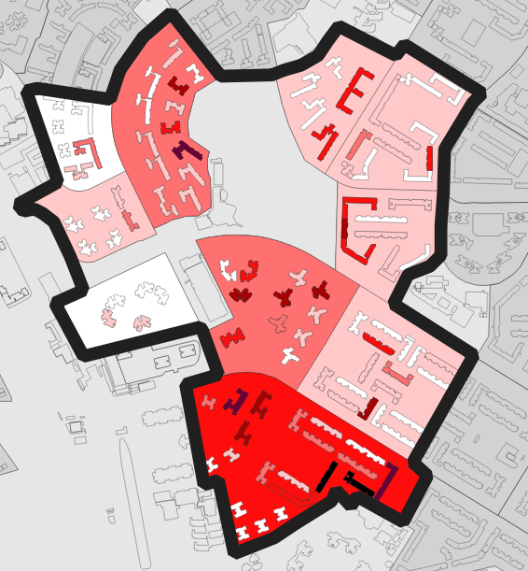 | 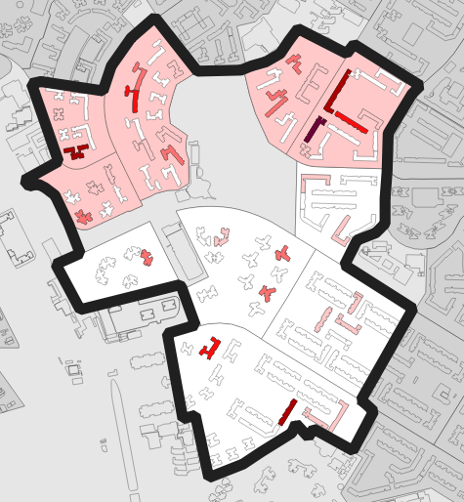 | 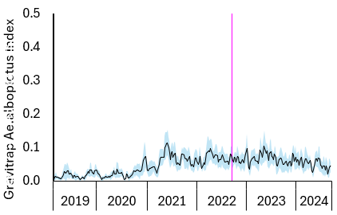
Pasir Ris | 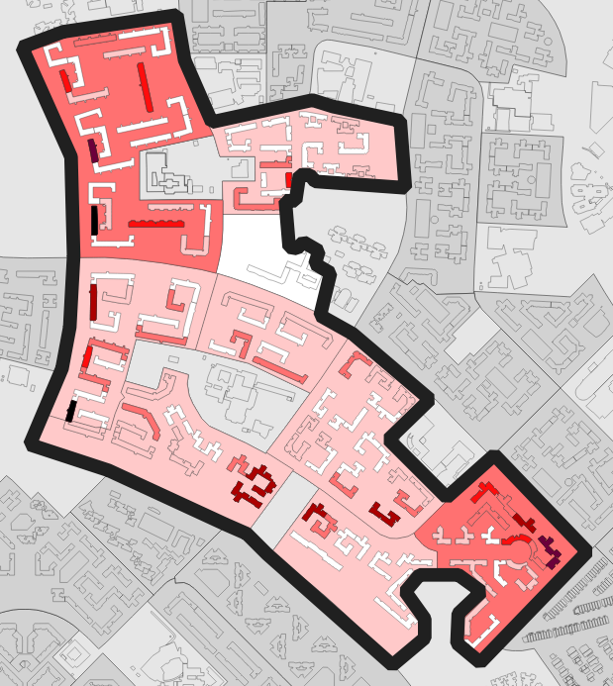 | 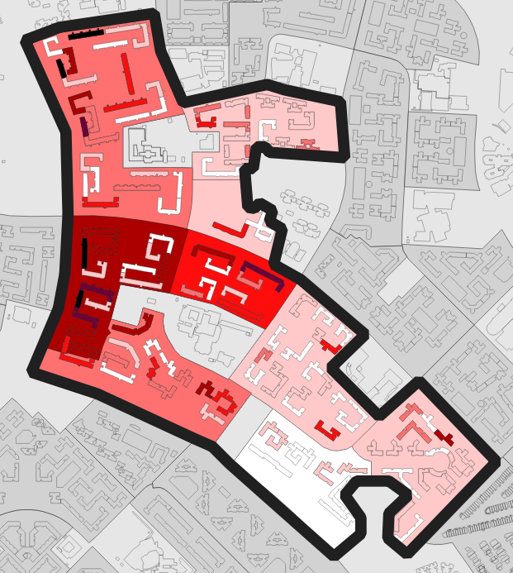 | 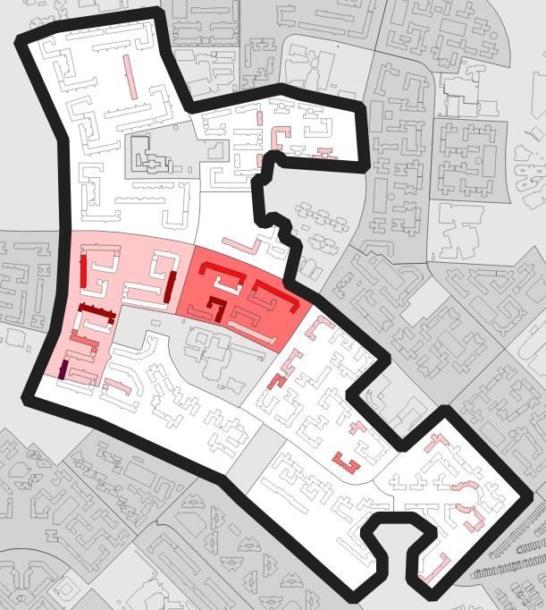 | 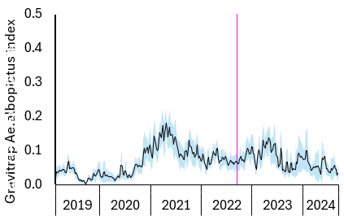
Pioneer | 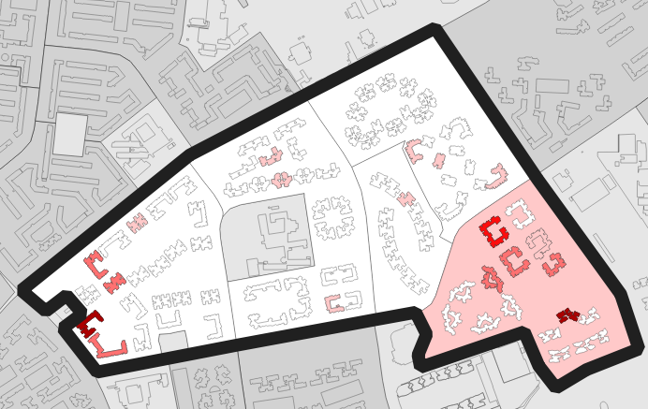 | 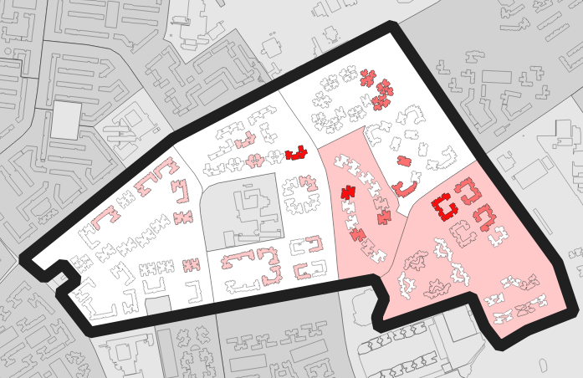 | 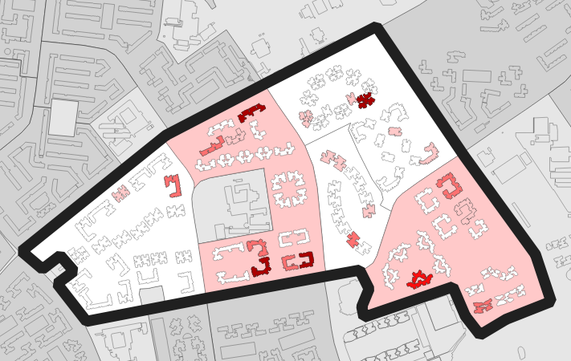 | 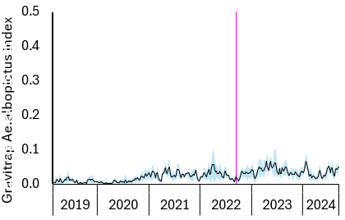
Serangoon Central | 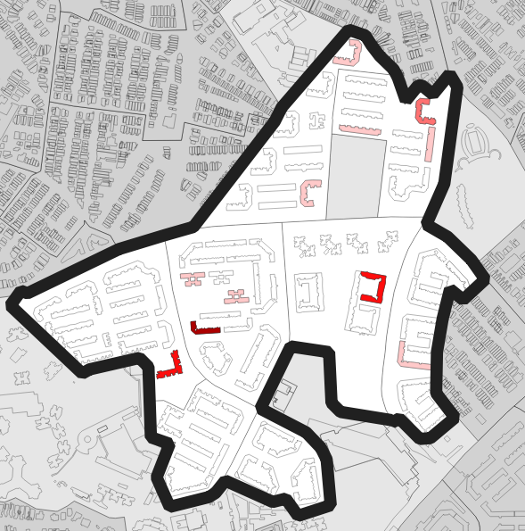 | 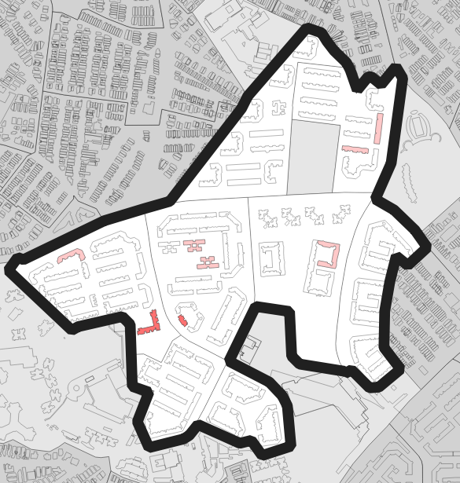 | 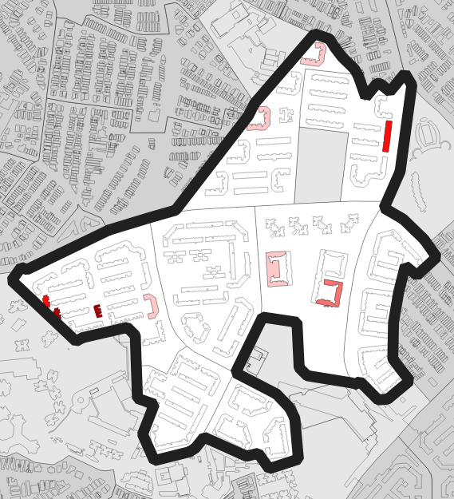 | 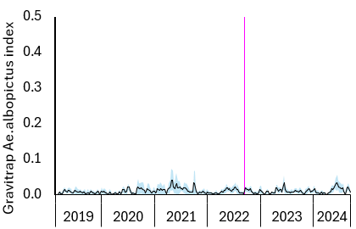
Toa Payoh | 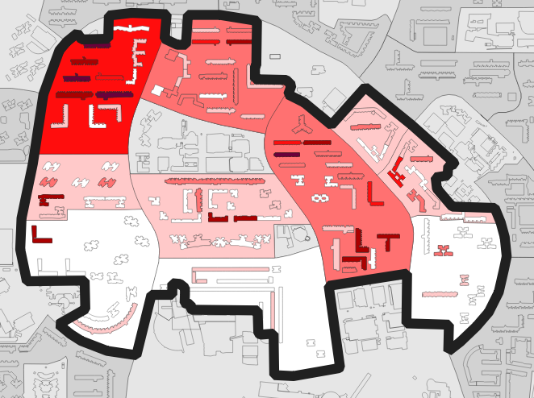 | 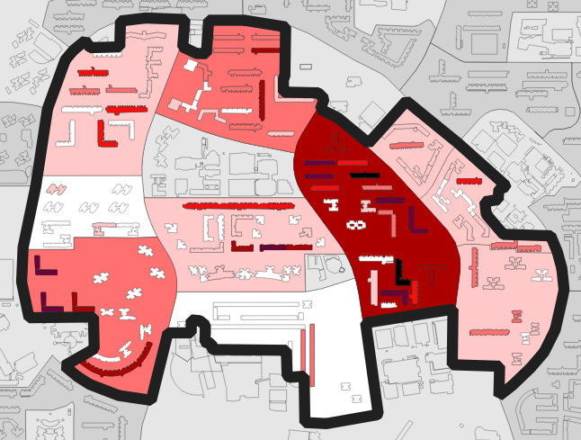 | 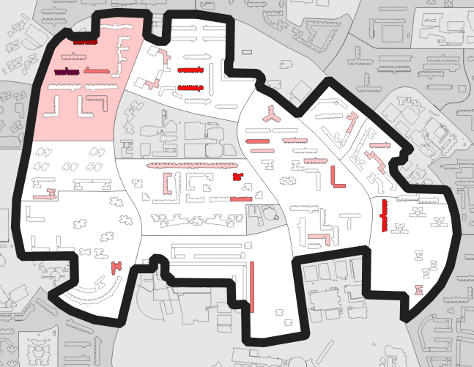 | 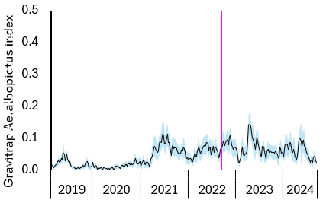
Yuhua | 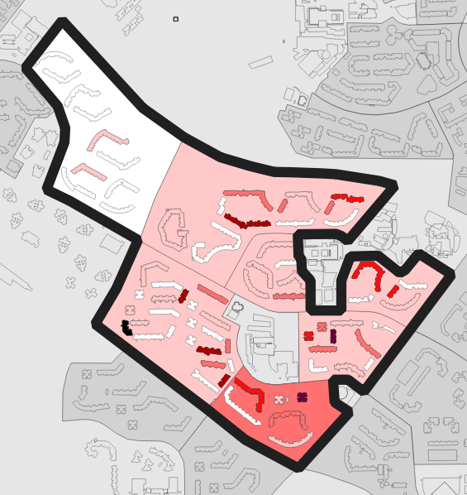 | 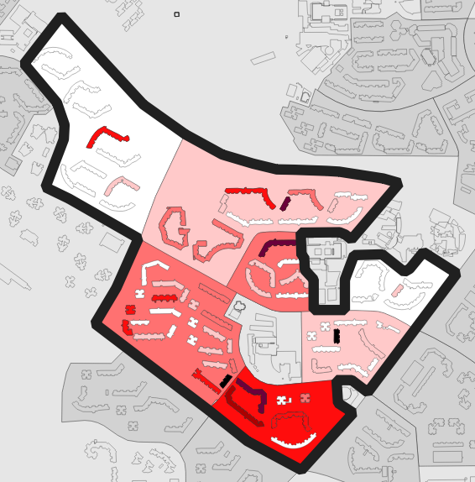 | 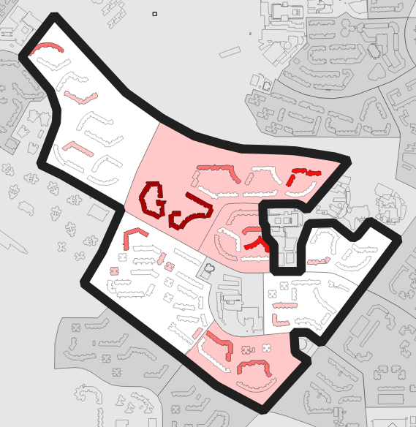 | 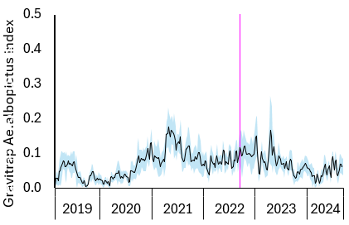

Supplementary Figure 4: Aedes albopictus abundance as proxied by the Gravitrap Aedes albopictus index (GI_{albo}) in control clusters across calendar years of study. The choropleth maps show control clusters (black outline), with increasing Ae. albopictus abundance represented by darker shades of red. Temporal trend lines with 95% confidence intervals (blue shading) indicate Ae. albopictus abundance. Vertical pink lines indicate trial commencement.

Category | Cluster | Size (km²)
Intervention | Bedok North Rd | 1.313246
Intervention | Bedok Reservoir Rd | 0.771667
Intervention | Circuit Rd | 0.605166
Intervention | Hougang | 0.615184
Intervention | Punggol | 0.635065
Intervention | Sengkang | 0.77341
Intervention | Woodlands | 1.122911
Intervention | Yew Tee | 0.690912
Control | Ang Mo Kio | 1.334438
Control | Bukit Panjang | 0.674506
Control | Pasir Ris | 0.706976
Control | Pioneer | 0.591289
Control | Serangoon Central | 0.615929
Control | Toa Payoh | 0.912129
Control | Yuhua | 0.640161
Total |  | 12.00299

SI Table 1: Size of intervention and control clusters

Production
Eggs were submerged in aged hatching broth to induce hatching. The broth (0.071g brewer’s yeast (MP Biomedicals, France), 0.535g nutrient broth (Liofilchem, Italy) and 1000ml reverse osmosis (RO) water) was prepared 15 hours before use. After induced hatching for 2 hours, larvae were counted using an automated larvae counter (Orinno Technology Pte Ltd, Singapore) and transferred to rearing trays that were placed in high-density rearing racks (Orinno Technology Pte Ltd, Singapore). Each rearing tray measured 103 x 63 x 3 cm and was filled with a density of four larvae per ml of RO water. Larvae were fed with a commercial arthropod larva feed (Altech Integrated, Singapore) in slurry form.

Six days post-hatching, the rearing trays were simultaneously tilted and the mixture of larvae and pupae was collected in a collection sieve. This mixture was first treated with 15% saltwater solution for 1 hour to kill larvae, followed by placing them in water to allow vertical separation of live pupae (surface) and dead larvae (bottom) (ref). Pupae were transferred to the Pupae Separation System (Orinno Technology Pte Ltd, Singapore) where male pupae were separated from female pupae. Male pupae were held for 30 minutes prior to irradiation.

Irradiation was performed using the RS2400V irradiator (Rad Source Technologies Inc., USA). Male pupae were irradiated in plastic containers measuring 6.5 cm in diameter and 7.0 cm in height. Containers were placed at the center of the irradiation chamber of the X-ray irradiator, and the effective dose was 40 Gy. Pupae were allowed to eclose inside release containers and a 20% sugar solution was provided ad libitum prior to releases.

Stakeholder and community engagement
As per protocol¹¹, briefings were conducted to community leaders and stakeholders prior to media announcement and releases in intervention clusters. Residents and establishments in such clusters were informed of releases through posters, banners, flyers, digital platforms and onsite engagement activities. Community leaders and volunteers helped raise awareness through house-to-house visits using NEA’s print materials, and social media.
Constrained randomisation protocol The randomisation protocol was described previously¹¹. Randomisation was conducted in February 2022 in the presence of the National Environment Agency’s Dengue Expert Advisory Panel and representatives from the Ministry of Sustainability and the Environment. Eight out of 15 clusters were randomly selected to receive male wAlbB-infected Ae. aegypti deployments (intervention clusters) and the rest designated as control clusters, which did not receive the intervention.

Due to the small number of clusters available for randomisation, selection of clusters relied on a constrained randomisation strategy to prevent chance imbalances in baseline characteristics between intervention and control clusters. The proportion of positive to negative dengue samples was used as the constraining variable. A large number of potential random clusters allocations in 8:7 intervention/non-intervention ratio were generated (n = 10,000). For each allocation, the value of the constraining variable was calculated in each study arm using the aggregate arm-level value. Each potential random allocation was evaluated against the pre-defined balancing criteria (i.e., no statistically significant difference in the proportion of positive to negative dengue samples between the two arms) and removed as a potential random allocation if they were not met. All potential allocations that satisfy the balancing criteria were kept (n = 3,151, exceeding the threshold of 100–150 allocations recommended in the literature), and a single allocation was randomly selected from within the restricted list of balanced allocations. Finally, a single random draw was used to determine which of the two study arms was to receive male wAlbB-infected Ae. aegypti releases.

Robustness checks (1 of 5) Examining the impact of covariates on estimated intervention efficacies We examined the impact of excluding covariates on the estimated intervention efficacies on Ae. aegypti and Ae. albopictus abundance. We estimated a sustained 90% suppression in Ae. aegypti abundance and a moderate rise in Ae. albopictus abundance in clusters with more than 1 year of male wAlbB-infected Ae. aegypti treatment. The estimated treatment effects were similar when excluding or including covariates (SI Table 2, SI Figure 5,6).

 | Average treatment effect (SE)
Weeks since intervention | Aedes aegypti |  | Aedes albopictus
Weeks since intervention | Covariates | No covariates | Covariates | No covariates
0 - 12 weeks | -0.0864*** (0.0141) | -0.0867*** (0.0140) | -0.0000837 | -0.0111. (0.0060)
13 - 25 weeks | -0.1603*** (0.0260) | -0.1573*** (0.0262) | -0.0166. (0.0088) | -0.0165. (0.0087)
26 - 38 weeks | -0.2212*** (0.0241) | -0.2197*** (0.0240) | 0.0042 (0.0092) | 0.0038 (0.0092)
39 - 51 weeks | -0.2218*** (0.0270) | -0.2199*** (0.0267) | 0.0105 (0.0091) | 0.0117 (0.0090)
52 - 64 weeks | -0.2125*** (0.0243) | -0.2104*** (0.0241) | 0.0160* (0.0080) | 0.0171* (0.0081)
65 - 77 weeks | -0.2446*** (0.0258) | -0.2417*** (0.0254) | 0.0103 (0.0075) | 0.0130. (0.0075)
78 - 90 weeks | -0.1913*** (0.0229) | -0.1887*** (0.0227) | 0.0234** (0.0083) | 0.0245** (0.0083)
91 - 103 weeks | -0.1793*** (0.0230) | -0.1757*** (0.0227) | 0.0482*** (0.0098) | 0.0484*** (0.0099)
104 and more weeks | -0.1114*** (0.0188) | -0.1096*** (0.0188) | 0.0642*** (0.0148) | 0.0627*** (0.0149)
SI Table 2: Average treatment effect and accompanying standard errors (SE) by weeks since intervention, using the interaction-weighted estimator with or without covariates incorporated. Values represent the average effect on either weekly Aedes aegypti or Ae. albopictus abundance in an intervention site at a specific week since intervention. ., *, ** and *** denote significance levels at 10%, 5%, 1% and 0.1%, respectively.

SI Figure 5: Visualisation of average treatment effects of male wAlbB-infected Ae. aegypti on weekly Aedes aegypti abundance by time to treatment under the model with and without covariates, respectively (left to right).

SI Figure 6: Visualisation of average treatment effects of male wAlbB-infected Ae. aegypti on weekly Aedes albopictus abundance by time to treatment under the model with and without covariates, respectively (left to right).

Robustness checks (2 of 5) Goodman-Bacon decompositions We used the Goodman-Bacon decompositions to ascertain number of bad comparisons under the standard two-way fixed effects differences-in-differences framework. While a large number of comparisons were not problematic (i.e. intervention vs. control), a small proportion comprised problematic comparisons between using earlier intervention units as the control for later intervention units, which biased average treatment effects (ATEs) downwards under the standard differences-in-differences setup (SI Table 3).

 | Aedes aegypti abundance |  | Aedes albopictus abundance
Comparison | Weight | Average treatment effect estimate | Weight | Average treatment effect estimate
Earlier vs later intervention | 0.01564 | -0.0732 | 0.01564 | -0.02494
Later vs earlier intervention | 0.00915 | -0.08038 | 0.00915 | -0.02098
Intervention vs Control | 0.97521 | -0.2057 | 0.97521 | 0.03136
SI Table 3: Estimated weights for different comparisons and ATE estimates produced under these comparisons under the two-way fixed effects differences-in-differences framework.

Robustness checks (3 of 5) In-time placebos checks We conducted in-time placebo checks in two ways. First, we examined the impact of our analytical framework in producing spurious and significant estimated average treatment effects in the pre-intervention period. Asides from Ae. albopictus abundance in around 186 to 118 weeks before the intervention, there were no significant estimated average treatment effects (SI Table 4). Secondly, we re-ran our analytical framework in only the dataset containing the pre-intervention period and estimated the average treatment effects in a placebo-intervention period spanning 26 or 52 weeks before the actual intervention began. There were no significant average treatment effects estimates in these placebo-intervention periods spanning 26 to 52 weeks prior to the actual intervention (SI Figures 7-10).

 | Average treatment effect (SE)
Weeks since intervention | Aedes aegypti |  | Aedes albopictus
Weeks since intervention | Covariates | No covariates | Covariates | No covariates
-186 - -183 weeks | 0.0064 (0.0315) | 0.0165 (0.0320) | -0.00038552 | -0.0419*** (0.0123)
-182 - -170 weeks | -0.0006 (0.0249) | 0.0081 (0.0251) | -0.0257** (0.0091) | -0.0283** (0.0090)
-169 - -157 weeks | -0.0172 (0.0257) | -0.0125 (0.0257) | -0.0283** (0.0093) | -0.0283** (0.0090)
-156 - -144 weeks | 0.0135 (0.0271) | 0.0178 (0.0269) | -0.0161. (0.0097) | -0.0172. (0.0096)
-143 - -131 weeks | 0.0176 (0.0247) | 0.0228 (0.0247) | -0.0170. (0.0093) | -0.00018584
-130 - -118 weeks | 0.0226 (0.0251) | 0.0253 (0.0251) | -0.0256** (0.0097) | -0.00023085
-117 - -105 weeks | 0.0340 (0.0256) | 0.0367 (0.0253) | -0.0153. (0.0089) | -0.0135 (0.0086)
-104 - -92 weeks | 0.0255 (0.0240) | 0.0297 (0.0239) | -0.0123 (0.0082) | -0.0116 (0.0080)
-91 - -79 weeks | 0.0335 (0.0247) | 0.0365 (0.0247) | -0.0110 (0.0095) | -0.0119 (0.0094)
-78 - -66 weeks | 0.0319 (0.0244) | 0.0346 (0.0240) | -0.0190. (0.0103) | -0.0180. (0.0102)
-65 - -53 weeks | 0.0253 (0.0226) | 0.0286 (0.0225) | -0.0001632 | -0.00015444
-52 - -40 weeks | 0.0198 (0.0217) | 0.0245 (0.0214) | -0.0094 (0.0091) | -0.0107 (0.0089)
-39 - -27 weeks | -0.0076 (0.0222) | -0.0021 (0.0221) | -0.00012948 | -0.00015484
-26 - -14 weeks | 0.0160 (0.0225) | 0.0187 (0.0226) | -0.0073 (0.0069) | -0.0065 (0.0067)
-13 - -2 weeks | -0.0019 (0.0146) | -0.0003 (0.0146) | -0.0077 (0.0052) | -0.0067 (0.0050)
SI Table 4: Average treatment effect and accompanying standard errors (SE) by weeks since intervention, using the interaction-weighted estimator with or without covariates incorporated. Values represent the average effect on either weekly Aedes aegypti or Ae. albopictus abundance in an intervention site at a specific week since intervention, in the pre-intervention period.
SI Figure 7: Visualisation of average treatment effects of male wAlbB-infected Ae. aegypti on weekly Aedes aegypti abundance by time to treatment under the model with covariates in the placebo intervention period spanning 26 or 52 weeks prior to the intervention (left to right).
SI Figure 8: Visualisation of average treatment effects of male wAlbB-infected Ae. aegypti on weekly Aedes aegypti abundance by time to treatment under the model without covariates in the placebo intervention period spanning 26 or 52 weeks prior to the intervention (left to right).

SI Figure 9: Visualisation of average treatment effects of male wAlbB-infected Ae. aegypti on weekly Aedes albopictus abundance by time to treatment under the model with covariates in the placebo intervention period spanning 26 or 52 weeks prior to the intervention (left to right).
SI Figure 10: Visualisation of average treatment effects of male wAlbB-infected Ae. aegypti on weekly Aedes albopictus abundance by time to treatment under the model without covariates in the placebo intervention period spanning 26 or 52 weeks prior to the intervention (left to right).

Robustness checks (4 of 5) In-space placebos We conducted in-space placebo checks by randomly reassigning clusters in the control arm to be intervention clusters and re-running our analytical framework to estimate average treatment effects and intervention efficacies in the actual intervention period. We conducted this exercise 1,000 times for both Ae. aegypti and Ae. albopictus abundance and found that in every period post-intervention, estimated placebo-intervention efficacies were centred at 0 (SI Figure 11, 12).

SI Figure 11: Visualisation of 1,000 average treatment effects of male wAlbB-infected Aedes aegypti on weekly Aedes aegypti abundance by time to treatment under the model with covariates, by allocating placebo interventions randomly to control clusters and taking the remaining controls as the comparator group. The same analytical framework was used as that of the main analysis.

SI Figure 12: Visualization of 1,000 average treatment effects of male wAlbB-infected Aedes aegypti on weekly Aedes albopictus abundance by time to treatment under the model with covariates, by allocating placebo interventions randomly to control clusters and taking the remaining controls as the comparator group. The same analytical framework was used as that of the main analysis.

Robustness checks (5 of 5) Parallel trends test We ran the parallel trends test to examine whether intervention and control arms had parallel trends for Ae. aegypti and Ae. albopictus abundance separately, in the pre-intervention period. The p-values for this test under Ae. aegypti and Ae. albopictus abundance were both 1. There was insufficient evidence to reject the hypothesis that there were no parallel trends between intervention and control arms for either Ae. aegypti and Ae. albopictus abundance in the pre-intervention period.

References
1 Gaw LY-F, Yee ATK, Richards DR. A High-Resolution Map of Singapore’s Terrestrial Ecosystems. Data 2019; 4: 116.
2 Landsat Normalized Difference Vegetation Index | U.S. Geological Survey. https://www.usgs.gov/landsat-missions/landsat-normalized-difference-vegetation-index (accessed Nov 9, 2023).
3 OneMap. OneMap. http://www.onemap.gov.sg (accessed Nov 9, 2023).
4 Sun H, Dickens BL, Richards D, et al. Spatio-temporal analysis of the main dengue vector populations in Singapore. Parasites & Vectors 2021; 14: 41.
5 Tewari P, Guo P, Dickens B, Ma P, Bansal S, Lim JT. Associations between Dengue Incidence, Ecological Factors, and Anthropogenic Factors in Singapore. Viruses 2023; 15: 1917.
6 Park SH, Nicolaou M, Dickens BSL, Yang Q, Tan KW, van Dam RM. Ethnicity, Neighborhood and Individual Socioeconomic Status, and Obesity: The Singapore Multiethnic Cohort. Obesity (Silver Spring) 2020; 28: 2405–13.
7 Fernandez SA, Sun H, Dickens BL, Ng LC, Cook AR, Lim JT. Features of the urban environment associated with Aedes aegypti abundance in high-rise public apartments in Singapore: An environmental case-control study. PLOS Neglected Tropical Diseases 2023; 17: e0011075.
8 ECMWF. ECMWF. 2023; published online Oct 3. https://www.ecmwf.int/ (accessed Nov 9, 2023).
9 Lee C, Vythilingam I, Chong C-S, et al. Gravitraps for Management of Dengue Clusters in Singapore. Am J Trop Med Hyg 2013; 88: 888–92.
10 Ong J, Aik J, Ng LC. Short Report: Adult Aedes abundance and risk of dengue transmission. PLoS Negl Trop Dis 2021; 15: e0009475.
11 Ong J, Ho SH, Soh SXH, et al. Assessing the efficacy of male Wolbachia-infected mosquito deployments to reduce dengue incidence in Singapore: study protocol for a cluster-randomized controlled trial. Trials 2022; 23: 1023.

