Supplementary information

Dual-independent vectorial nano-printing and holography based on orthogonal polarized synthesis metasurface
Hongqiang Zhou¹, Chongli Zhao¹, Meiqi Wang¹, Ruizhe Zhao¹, Cong He², Tianlong Man¹, Guangzhou Geng³, Yuhong Wan¹, Lingling Huang²
- School of Physics and Optoelectronic Engineering, Beijing University of Technology, Beijing, 100124, China
- Beijing Engineering Research Center of Mixed Reality and Advanced Display, School of Optics and Photonics, Beijing Institute of Technology, Beijing, 100081, China
- Institute of Physics, The Chinese Academy of Sciences, Beijing, 100191, China
S1: Sample fabrication and measurement
The fabrication process of metasurface devices can be consist of eight key steps. The first step is to form an α-Si thin film (n_{Si} = 3.802) layer of a 600 nm thickness on the silicon substrate (n_{sub} = 1.5) by plasma-enhanced chemical vapor deposition technology (PECVD). The second step is to perform spin coating on the α-Si film layer. For spin coating, polymethyl methacrylate (PMMA), a photoresist widely used in electron beam lithography (EBL), was selected. After the spin coating is completed, heat the sample in an oven to remove the residual solvent. The third step is EBL. Before EBL, the area to be exposed usually needs to be inspected with an optical microscope to ensure it is clean and dust-free. The fourth step is development. After exposure, the photoresist still completely covers the surface of the sample. In order to form the desired pattern, the unnecessary parts need to be removed through the development. This process usually employs a specific developer to dissolve the areas illuminated by the electron beam. Thereby revealing the predetermined graphic structure is achieved. The fifth step is electron beam evaporation. Due to the poor etching resistance of PMMA, pattern transfer is required. Chromium (Cr) is plated by electron beam evaporation as the mask material. Chromium has high hardness and thus is not etched, ensuring excellent etching selectivity. Moreover, chromium can be dissolved by ammonium cerium nitrate (Ce(NH₄)₂(NO₃)₆) solution, facilitating subsequent removal. The sixth step is stripping, which is a commonly used pattern transfer method. Stripping is to dissolve the photoresists and remove the metal. The seventh step is etching. Metal patterns are used as the etching barrier layer, and dry etching technology is adopted to transfer the nanostructure to the α-Si thin film layer. The eighth step is that the residual metal mask is removed, thus completing the preparation of the metasurface sample with design geometric size parameters. Three samples are fabricated on a substrate as shown in Figure S1. The scanning electronic microscopy images of linear polarizations synthesis sample, circular polarizations synthesis sample and linear polarization with Malus’s sample are shown in Fig. S1(a-c). we built the experimental setup with 808 nm laser incident and measure three samples by changing incident polarization state and analyzer angle. The schematic diagram of setup is in Figure S2.
S3: Coherent synthesis based on circular polarization basis method
As another prior verification base on circular polarization basis, we also sweep transmission amplitude and phase under the case of circular polarization incidence. Based on circular polarization beam synthesis method, the linear polarization channel information is observed after left and right circular polarization channel electric field. For T_{lr}/T_{rl} channels, the Jones vector of phase distributions (ϕ_{lr} and ϕ_{rl}) are expressed as:, respectively. For an anisotropic nanopillar, its optical properties can be represented by the Jones matrix J, given by:
where t_{x} and t_{y} represent the complex transmission coefficients for linearly polarized input light along the long and short axes of the nanopillar, respectively. The Jones matrix J(θ) for a nanopillar rotated by an angle of θ can be expressed using the rotation matrix R(θ) as follows:
(S2)
When light passes through the anisotropic nanopillar, the output electric field E_{c} can be calculated as follows:
(S3)
For achieving coherent synthesis, we consider the linearly polarized light as equal and opposite circularly polarized light as the incident light. The output vector field after analyzer with the same linearly polarized orientation is . where |R〉 and |L〉 are the normalized Jones vectors of the LCP and RCP light, respectively. The output normalized complex-amplitude field can be expressed further: . Therefore, in the case of the circularly polarized channel, the amplitude term can still be designed as a modulation dimension for near-field display, while being hidden when other polarizations are detected. And the phase term serves to generate the corresponding holographic display in the far-field through modulation.
S4: Experimental results of coherent synthesis holography under linear/circular polarization basis
For the prior experimental verification, we design a metasurface to modulate near-field based on Malus’ law and far-field based phase coherent synthesis holography under linear polarization basis as shown in Figure S3. Similarly, the Aries constellation logo of holographic reconstruction is captured when 0° linear polarization incident and 0° analyzer angle (0°/0°), in Fig. S3(a). The potted plant with part grayscale value is displayed in near field, in Fig. S3(g). When the analyzer angle to 30° (0°/30°), the intensity of holographic Aries constellation logo gradually weakens, while the intensity of Leo gradually increases. At the same time, different parts of potted plant change gradually due to preset nanofin rotation angles based on Malus’ polarization state. Flowerpot will be dark in Fig. S3(h). When both the incident polarization and the outgoing polarization states change to 45°/45°, the holographic reconstruction in the far-field appears as two constellation images (Aries and Leo) with the same brightness, while the information in the near-field is hidden in Fig. S3(c), (i). It should be particularly emphasized here that when we change the incident light to 0° polarized incident light again (0°/45°), the grayscale information in the near field is still encrypted in Fig. S3(j), while the holographic images of the two constellations (Aries and Leo) in the far field disappear. Instead, the logo of Sagittarius appeared in Fig. S3(d). This is also in line with the original intention of the design. That is to say, under this polarization combination, the two channel of phase light fields coherently fuse into a new holographic image (Sagittarius logo) and suppress the Aries and Leo logos that should have appeared simultaneously. Immediately afterwards, when the angle of the polarizer was further changed to 0°/60°, the logo of Leo and Aries reappeared in the far field in Fig. S3(e), and the ratio of their brightness was exactly the opposite of the reconstructed image with the 0°/30° polarizer in Fig. S3(b). And at this time in Fig. S3(k), the near-field image also shows a similar phenomenon. That is, the pattern of the potted plant becomes matte, while the background becomes brighter. It was not until the polarizer was completely orthogonal that the hologram of Leo took the lead while the logo of Aries disappeared as shown in Fig. S3(f). Similarly, the near-field patterns also change to the potted plants being dark grayscale in Fig. S3(l), while background is bright. This is exactly complementary to the result when it is co-polarization channel. This is consistent with the design principle of Malus' law. The gray-scale changes of different parts of the potted plant also match the angle of the polarizer.
For the circular basis coherent synthesis, we have achieved the experimental verify through the similar sample design. The circular polarization variant demonstrates orthogonal channel isolation Figure S4. Left-/right-circular polarization (LCP/RCP) channels project distinct 'NA' and 'NO' holograms (Fig. S4a, b), while linear polarization analysis reveals emergent 'TRUE' reconstructions (Fig. S4c) through complex-amplitude synthesis of LCP/RCP phase fields (45°/45°). Near-field projections exhibit polarization-controlled grayscale transitions: Uniform amplitudes under pure LCP/RCP illumination (Fig. S4e, f) evolve into synthesized grape patterns through coherent channel superposition (Fig. S4g). Polarization parametric control enables dynamic hologram transformation: 135° linear polarization induces destructive interference reconstruction (Fig. S4d), while 45° analyzer orientation inverts channel dominance to 'NANO' projection with simultaneous near-field grayscale encryption and conceal in Fig. S4h. Here, it is demonstrated that the coherent synthesis of the light field carries vectorial characteristics. Its vectorial angle is parallel at 45°, and exactly orthogonal and canceling each other out at 135°. This dual-domain modulation establishes a novel paradigm for optical information processing, where near-field grayscale manipulation serves as an independent degree of freedom for cryptographic applications.

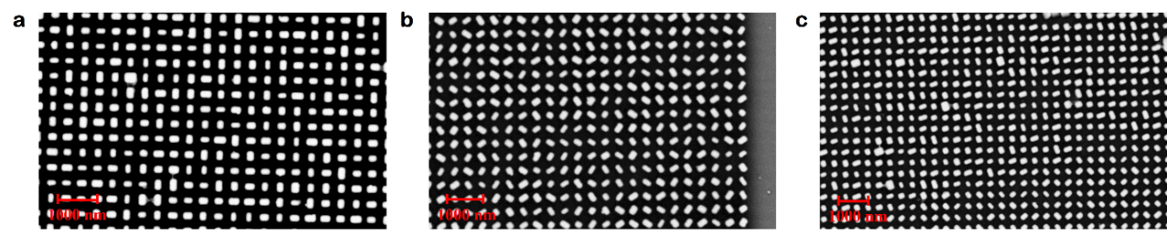
Figure S1: The scanning electron microscopy images. (a) the partial top view of linear polarization synthesis metasurface sample. (b) the partial top view of circular polarization synthesis metasurface sample. (c) the partial top view of Malus’ law-driven grayscale and holograms synthesis metasurface sample.

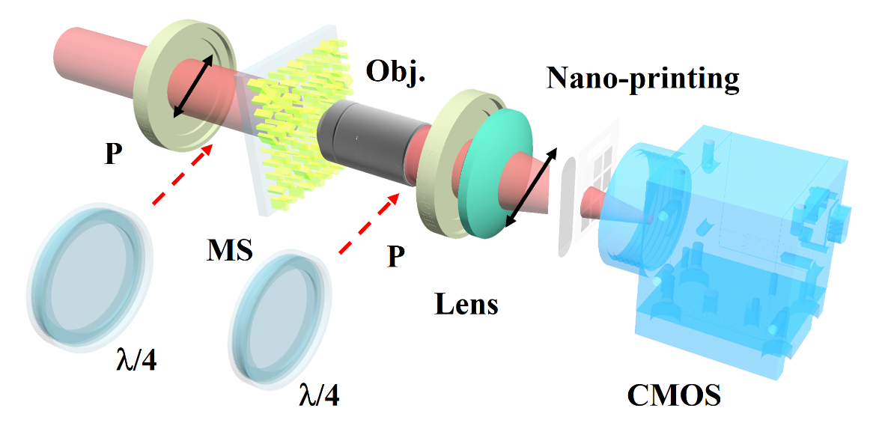
Figure S2: The schematic diagram of experimental setup. P: linear polarizer. MS: metasurface. Obj.: objective. λ/4: quarter waveplate. CMOS: image sensor.

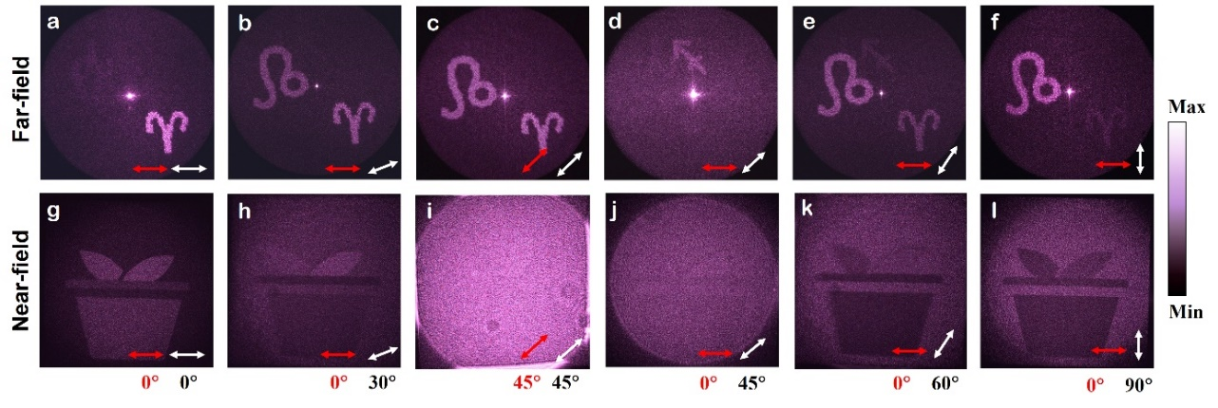
Figure S3. The experimental results based on linear polarization and Malus’ law coherent synthesis. (a) the far-field holographic reconstruction in 0° polarized incidence light (red arrow) and 0° analyzer (white arrow) channel. (b) the far-field holographic reconstruction in 0° polarized incidence light and 30° analyzer channel. (c) the far-field holographic reconstruction in 45° polarized incidence light and 45° analyzer channel. (d) the far-field holographic reconstruction in 0° polarized incidence light and 45° analyzer channel. (e) the far-field holographic reconstruction in 0° polarized incidence light and 60° analyzer channel. (f) the far-field holographic reconstruction in 0° polarized incidence light and 90° analyzer channel. (g-l) the near-field gray measurement corresponding to (a-f) in its polarized incidence light and analyzer channels.

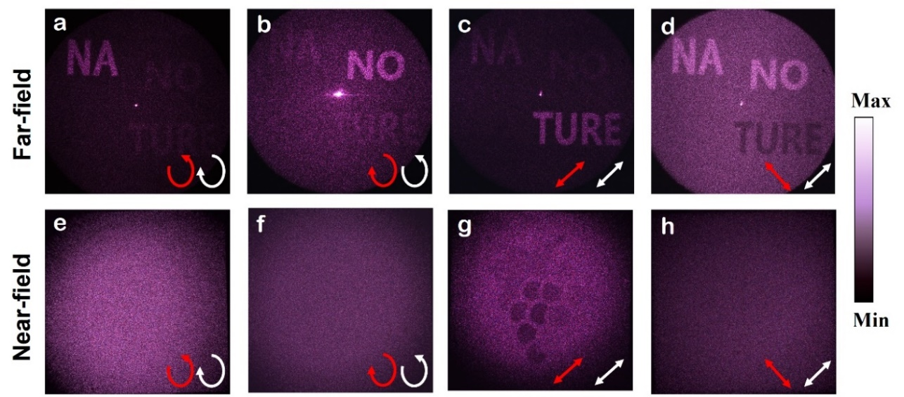
Figure 4. The experimental results based on circular polarization coherent synthesis. (a) the far-field holographic reconstruction in RCP−LCP channel, (incident (red arrow), output (white arrow)). (b) the far-field holographic reconstruction in LCP−RCP channel. (c) the far-field holographic reconstruction in LP₄₅-LP₄₅ channel. (d) the far-field holographic reconstruction in LP₁₃₅−LP₄₅ channel. (e−h) the near-field gray modulation corresponding to (a−d) polarization channel.

Email: hhzhou@bjut.edu.cn
Email: genggz@iphy.ac.cn
Email: yhongw@bjut.edu.cn
Email: huanglingling@bit.edu.cn

