Supplement

Journal: Environmental Science and Pollution Research
Title: A daily emission inventory based on multi-source data and its impact on air quality simulations over Jiangsu province
Authors: Chen Gu

Table List
Table S1. Sources and methodologies for developing daily temporal allocation factors.
Table S2. The WRF model performance for meteorological parameters in D3 in 2022.
Table S3. Mileage weight of vehicles on different types of roads.
Figure List
Figure S1. The locations of the Jiangsu province and the spatial distribution of ground observation stations. The map data provided by Resource and Environment Data Cloud Platform are freely available for academic use (http://www.resdc.cn/data.aspx?DATAID=201), © Institute of Geographic Sciences & Natural Resources Research, Chinese Academy of Sciences.
Figure S2. The daily traffic flow data for Jiangsu province in 2022.
Figure S3 Spatial distribution of PM_{2.5} from CMAQ simulation in January, April, July and October from 2015 to 2019. (μg/m³)
Figure S4 Spatial distribution of MDA8 O₃ from CMAQ simulation in January, April, July and October from 2015 to 2019. (μg/m³)

Table S1. Sources and methodologies for developing daily temporal allocation factors.
Emission sector | Data for temporal profiling | Sources | Update frequency
Power/Industry | CEMS data | Jiangsu Online Monitoring Data Platform | 1 hour
Power/Industry | Electricity load | China Electricity Council (CEC) | 1 month
Vehicle | Congestion Index | Gaode migration data | 5 minutes
Off-road | Construction information | Nanjing construction project platform | 1 month
Off-road | Rail passenger/freight volume | CEIC global economic database | 1 month
Off-road | Port vessel statistics | Marine Traffic database | 1 hour
Off-road | Commercial flight information | Flightradar24 Database | 1 day
Residential | Population Migration Index (PMI) | Baidu population big data | 1 day
Residential | Heating Degree Days (HDD) | ERA5/Population data | 1 hour
Agriculture | Meteorological data | ECMWF Reanalysis v5 (ERA5) | 1 hour

Table S2. The WRF model performance for meteorological parameters in D3 in 2022.
meteorological parameters | Evaluation Parameters | Jan | Apr | Jul | Oct | Recommended indicators
WS10 | observations (m/s) | 2.84 | 3.10 | 2.85 | 2.55
WS10 | simulations (m/s) | 3.53 | 3.48 | 3.33 | 3.13
WS10 | Bias (m/s) | 0.51 | 0.27 | 0.33 | 0.45 | ≤±0.5
WS10 | RMSE (m/s) | 2.25 | 2.11 | 1.82 | 2.2 | ≤2.0
WS10 | IOA | 0.71 | 0.71 | 0.73 | 0.68 | ≥0.6
T2 | observations (℃) | 3.18 | 17.89 | 28.84 | 17.60
T2 | simulations (℃) | 3.92 | 17.35 | 28.57 | 17.73
T2 | Bias (℃) | 0.53 | -0.22 | -0.35 | -0.17 | ≤±0.5
T2 | RMSE (℃) | 1.96 | 0.99 | 0.87 | 1.03 | ≤2.0
T2 | IOA | 0.95 | 0.98 | 0.99 | 0.94 | ≥0.8
RH2 | observations (%) | 73.09 | 68.08 | 78.00 | 64.65
RH2 | simulations (%) | 67.42 | 62.01 | 71.31 | 56.47
RH2 | Bias (%) | -4.01 | -6.06 | -6.88 | -7.43
RH2 | RMSE (%) | 12.27 | 16.85 | 15.22 | 16.28
RH2 | IOA | 0.97 | 0.99 | 0.97 | 0.92 | ≥0.7

Table S3. Mileage weight of vehicles on different types of roads.
Type | Motorway | Expressway | Trunk Road | Branch Road
Light passenger vehicles | 0.10 | 0.10 | 0.50 | 0.30
Medium passenger vehicles | 0.15 | 0.20 | 0.55 | 0.10
Heavy passenger vehicles | 0.10 | 0.10 | 0.35 | 0.45
Light goods vehicles | 0.20 | 0.20 | 0.40 | 0.20
Medium goods vehicles | 0.15 | 0.45 | 0.30 | 0.10
Heavy goods vehicles | 0.40 | 0.30 | 0.20 | 0.10
Motorcycles | 0 | 0 | 0.50 | 0.50
Taxis | 0 | 0 | 0.60 | 0.40

Figure S1
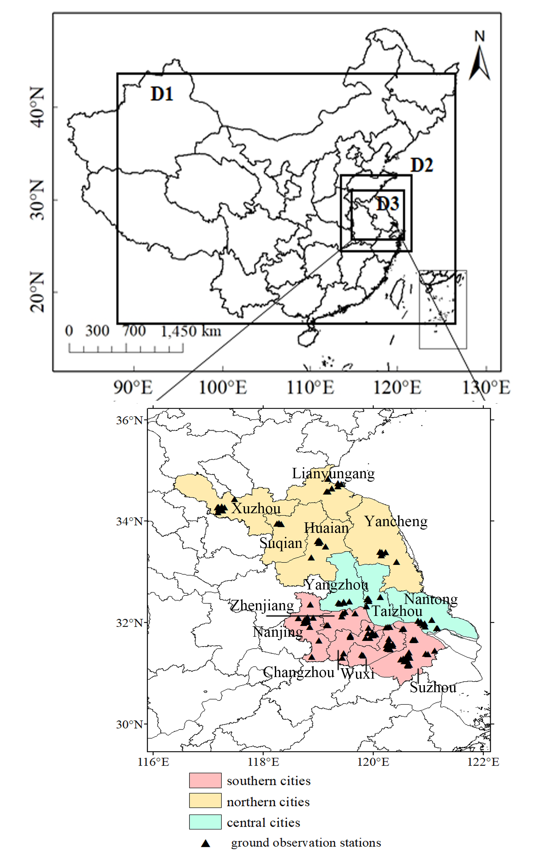

Figure S2
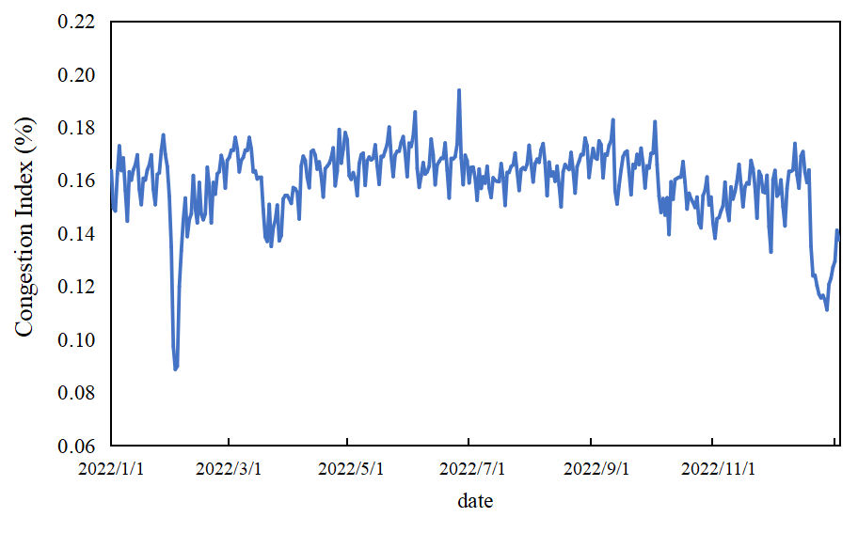

Figure S3

Figure S4

References
Department of ecological environment of Jiangsu, Notice of the Jiangsu Provincial Government on issuing the air pollution prevention and control action plan. http://www.jiangsu.gov.cn/art/2014/1/6/art_46690_2586827.html.
Department of ecological environment of Jiangsu, Air Pollution Remediation Work Plan for Coal-fired Boilers in Jiangsu. http://sthjt.jiangsu.gov.cn.
Dou X, Hong J, Ciais P, Chevallier F, Yan F, Yu Y, Hu Y, Huo D, Sun Y, Wang Y, Davis S J, Crippa M, Janssens-Maenhout G, Guizzardi D, Solazzo E, Lin X, Song X, Zhu B, Cui D, Ke P, Wang H, Zhou W, Huang X, Deng Z, Liu Z (2023) Near-real-time global gridded daily CO₂ emissions 2021. Sci Data, 10: 69. https://doi.org/10.1038/s41597-023-01963-0.
Wang Y, Zhao Y, Liu Y, Jiang Y, Zheng B, Xing J, Liu Y, Wang S, Nielsen C P (2023) Sustained emission reductions have restrained the ozone pollution over China. Nat. Geosci 16: 967-974, https://doi.org/10.1038/s41561-023-01284-2.
Zhou Y, Zhao Y, Mao P, Zhang Q, Zhang J, Qiu L, Yang Y (2017) Development of a high-resolution emission inventory and its evaluation and application through air quality modeling for Jiangsu Province, China. Atmos Chem Phys 17: 211–233. https://doi.org/10.5194/acp-17-211-2017.

