Increased production of the important broad-range endolytic protease proteinase K by the fungus Parengyodontium album through adaptation of the growth medium
Johannes Schlag¹, Kilian Witzgall², Harald Müssig², Karl-Heinz Preuß¹ and Matthias Mack¹*
*Corresponding author
¹Institute for Technical Microbiology, Department of Biotechnology, Technical University Mannheim, 68163 Mannheim, Germany
²Merck Life Science KGaA, Frankfurter Str. 250, 64293 Darmstadt, Germany

Contact
*Address correspondence to:
Matthias Mack, Technical University Mannheim, Paul-Wittsack-Str. 10, 68163 Mannheim, Germany, Phone:+49-621-292-6496, Fax:+49-621-292-6420, E-mail: m.mack@hs-mannheim.de.
ORCID: 0000-0002-7753-2422

Supplementary Tables and figures
Table S1: Experimental design and measured responses from the optimization study employing feather meal and wheat branª
Exp No | Exp name | Run order | Incl/Excl | Feather meal g/L | Wheat bran g/L | Aminopeptidase activity U/mL | Proteinase K activity U/mL | Dry mass g/L
1 | N1 | 11 | Incl | 3 | 8 | 0,0909 | 0,2949 | 7,7
2 | N2 | 5 | Incl | 13 | 8 | 0,051 | 0,2528 | 12,6
3 | N3 | 1 | Incl | 3 | 30 | 0,1649 | 0,5064 | 10,3
4 | N4 | 10 | Incl | 13 | 30 | 0,0349 | 0,1495 | 18,5
5 | N5 | 14 | Incl | 3 | 15,3333 | 0,1207 | 0,362 | 7,5
6 | N6 | 15 | Incl | 3 | 22,6667 | 0,1614 | 0,4316 | 9,3
7 | N7 | 8 | Incl | 13 | 15,3333 | 0,0369 | 0,2487 | 13,9
8 | N8 | 12 | Incl | 13 | 22,6667 | 0,0273 | 0,1743 | 15,8
9 | N9 | 7 | Incl | 6,33333 | 8 | 0,0906 | 0,462 | 8,9
10 | N10 | 4 | Incl | 9,66667 | 8 | 0,0498 | 0,3944 | 10,2
11 | N11 | 2 | Incl | 6,33333 | 30 | 0,0769 | 0,5572 | 10,3
12 | N12 | 13 | Incl | 9,66667 | 30 | 0,0498 | 0,3864 | 14,5
13 | N13 | 9 | Incl | 8 | 19 | 0,1169 | 0,5484 | 11,5
14 | N14 | 6 | Incl | 8 | 19 | 0,1007 | 0,5424 | 10,5
15 | N15 | 3 | Incl | 8 | 19 | 0,099 | 0,5572 | 11,5
16 | N16 | 16 | Excl | 8 | 19 | 0,0747 | 0,3459
17 | N17 | 17 | Incl | 3 | 30 | 0,1724 | 0,476 | 10,4615
18 | N18 | 18 | Incl | 6,33333 | 30 | 0,137 | 0,564 | 11,1538
19 | N19 | 19 | Incl | 8 | 19 | 0,1191 | 0,5504 | 11,4615
20 | N20 | 20 | Incl | 9,66667 | 8 | 0,0654 | 0,4136 | 9,69231
21 | N21 | 21 | Incl | 13 | 8 | 0,0482 | 0,2823 | 12,5385
22 | N22 | 22 | Incl | 8 | 19 | 0,123 | 0,5272 | 10,3846
23 | N23 | 23 | Incl | 6,33333 | 8 | 0,0943 | 0,4364 | 7,76923
24 | N24 | 24 | Incl | 13 | 15,3333 | 0,0416 | 0,2142 | 12,4615
25 | N25 | 25 | Incl | 8 | 19 | 0,0812 | 0,5644 | 10,3846
26 | N26 | 26 | Incl | 13 | 30 | 0,0406 | 0,1772 | 16,3846
27 | N27 | 27 | Incl | 3 | 8 | 0,0843 | 0,232 | 7,23077
28 | N28 | 28 | Incl | 13 | 22,667 | 0,04 | 0,1799 | 14,9231
29 | N29 | 29 | Incl | 9,667 | 30 | 0,0563 | 0,3978 | 13,7692
30 | N30 | 30 | Incl | 3 | 15,333 | 0,107 | 0,3147 | 7,38462
31 | N31 | 31 | Incl | 3 | 22,667 | 0,1536 | 0,402 | 9
32 | N32 | 32 | Incl | 8 | 19 | 0,1175 | 0,5488 | 11,8462
ªThe experiments were conducted in accordance with the run order. Values with a gray background were considered outliers and were excluded from the model.

Table S2: Model parameters for the wheat bran and feather meal containing mediumª
 | R2 | Q2 | Model validity | Reproducibility
Aminopeptidase activity | 0,917 | 0,869 | -0,200 | 0,969
Proteinase K activity | 0,960 | 0,935 | -0,200 | 0,980
Dry mass | 0,947 | 0,921 | 0,645 | 0,946
ªThe table shows the model parameters for evaluating the model. R2 shows the model fit to the measured datapoints and should be >0.5. Q2 estimates the prediction precision and should be greater than 0.1. The model validity is a test of several model problems and should be greater than 0.25. In very good models, a reproducibility of >0.95 may lead to low or negative values (as is the case here). The reproducibility is the variation of the replicates within the testing series.

Table S3: Experimental design and measured responses from the optimization study of the animal-free mediumª
Exp No | Exp Name | Run Order | Incl/Excl | Glucose g/L | Soy Supro g/L | Phosphate g/L | Proteinase K activity U/mL
1 | N1 | 8 | Incl | 7 | 5,5 | 8 | 0,204966
2 | N2 | 15 | Incl | 13 | 5,5 | 8 | 0,236724
3 | N3 | 3 | Incl | 7 | 8,5 | 8 | 0,140611
4 | N4 | 2 | Incl | 13 | 8,5 | 8 | 0,206912
5 | N5 | 12 | Incl | 7 | 5,5 | 15 | 0,231155
6 | N6 | 18 | Incl | 13 | 5,5 | 15 | 0,236263
7 | N7 | 4 | Incl | 7 | 8,5 | 15 | 0,235976
8 | N8 | 17 | Incl | 13 | 8,5 | 15 | 0,279774
9 | N9 | 6 | Incl | 5,94062 | 7 | 11,5 | 0,194492
10 | N10 | 13 | Incl | 14,0594 | 7 | 11,5 | 0,242133
11 | N11 | 9 | Incl | 10 | 4,97031 | 11,5 | 0,231638
12 | N12 | 1 | Incl | 10 | 9,02969 | 11,5 | 0,193156
13 | N13 | 11 | Incl | 10 | 7 | 6,76406 | 0,255229
14 | N14 | 7 | Incl | 10 | 7 | 16,2359 | 0,251124
15 | N15 | 5 | Incl | 7 | 5,5 | 8 | 0,20081
16 | N16 | 16 | Incl | 10 | 7 | 11,5 | 0,271317
17 | N17 | 10 | Incl | 10 | 7 | 11,5 | 0,269
18 | N18 | 14 | Incl | 10 | 7 | 11,5 | 0,272424
19 | N19 | 19 | Incl | 7 | 8,5 | 15 | 0,216
20 | N20 | 20 | Incl | 10 | 7 | 16,2359 | 0,244
21 | N21 | 21 | Incl | 10 | 7 | 15 | 0,23
22 | N22 | 22 | Incl | 11 | 7,2 | 15 | 0,239
23 | N23 | 23 | Incl | 12,5 | 7,2 | 15 | 0,234
24 | N24 | 24 | Incl | 13 | 8,5 | 15 | 0,288
25 | N25 | 25 | Incl | 11,5 | 6,3 | 10 | 0,252
26 | N26 | 26 | Incl | 12 | 6,3 | 11 | 0,235
27 | N27 | 27 | Incl | 10 | 7 | 11,5 | 0,284
ªThe experiments were conducted in accordance with the run order. Values with a gray background were considered outliers and excluded from the model.

Table S4: Model parameters for the animal-free mediumª
 | Num | R2 | Q2 | Model validity | Reproducibility
Proteinase K | 1 | 0,704636 | 0,493701 | -0,2 | 0,969601
ªThe table shows the model parameters for evaluating the model. R2 shows the model fit to the measured datapoints and should be >0.5. Q2 estimates the prediction precision and should be greater than 0.1. The model validity is a test of several model problems and should be greater than 0.25. The reproducibility is the variation of the replicates within the testing series.

Table S5: Experimental design and measured responses from the optimization study employing a lentil-based mediumª
Exp Name | Run Order | Incl/Excl | Soy Supro g/L | Lentils g/L | Glucose g/L | Proteinase K activity U/mL | Aminopeptidase activity | pH | Dry Weight g/L
N1 | 3 | Incl | 2,5 | 5 | 2 | 0,26 | 0,022 | 7,623 | 5,7
N2 | 1 | Incl | 8,5 | 5 | 2 | 0,292 | 0 | 7,89 | 6,6
N3 | 6 | Incl | 2,5 | 25 | 2 | 0,380635 | 0,042 | 7,833 | 10,7
N4 | 14 | Incl | 8,5 | 25 | 2 | 0,325 | 0,011 | 7,883 | 14,2
N5 | 7 | Incl | 2,5 | 5 | 10 | 0,199422 | 0,016 | 7,302 | 7,5
N6 | 16 | Incl | 8,5 | 5 | 10 | 0,462 | 0,017 | 7,76 | 7,5
N7 | 12 | Incl | 2,5 | 25 | 10 | 0,3056 | 0,027 | 7,414 | 13,2
N8 | 4 | Incl | 8,5 | 25 | 10 | 0,386 | 0,042 | 7,855 | 20,3
N9 | 13 | Incl | 1,44062 | 15 | 6 | 0,246939 | 0,017 | 7,294 | 9,8
N10 | 9 | Incl | 9,55938 | 15 | 6 | 0,449452 | 0,012 | 7,774 | 9,3
N11 | 17 | Incl | 5,5 | 1,46873 | 6 | 0,349 | 0,019 | 7,616 | 6,7
N12 | 11 | Incl | 5,5 | 28,5313 | 6 | 0,422343 | 0,033 | 7,758 | 17,7
N13 | 5 | Incl | 5,5 | 15 | 0,587493 | 0,371 | 0,02 | 7,627 | 8,5
N14 | 10 | Incl | 5,5 | 15 | 11,4125 | 0,402973 | 0,036 | 7,616 | 12,8
N15 | 8 | Incl | 5,5 | 15 | 6 | 0,439203 | 0,03 | 7,616 | 10,6
N16 | 2 | Incl | 5,5 | 15 | 6 | 0,441 | 0,037 | 7,677 | 10,8
N17 | 15 | Incl | 5,5 | 15 | 6 | 0,463 | 0,028 | 7,64 | 9,9
N18 | 18 | Incl | 5,5 | 15 | 6 | 0,455 | 0,033 | 7,673 | 11,1
N19 | 19 | Incl | 5,5 | 15 | 6 | 0,418 | 0,047 | 7,718 | 12
N20 | 20 | Incl | 8,5 | 5 | 2 | 0,324 | 0,008 | 7,851 | 5,3
N21 | 21 | Incl | 9,56 | 15 | 6 | 0,445 | 0,016 | 7,938 | 10,7
N22 | 22 | Incl | 7,8 | 14,9 | 8,8 | 0,454 | 0,022 | 7,846 | 12,3
N23 | 23 | Incl | 7,8 | 14,9 | 8,8 | 0,441 | 0,031 | 7,769 | 12,3
N24 | 24 | Incl | 7,8 | 14,9 | 8,8 | 0,465 | 0,028 | 7,859 | 12,7
N25 | 25 | Incl | 8,4 | 10,7 | 8,5 | 0,468 | 0,022 | 7,786 | 9,8
N26 | 26 | Incl | 8,4 | 10,7 | 8,5 | 0,481 | 0,023 | 7,7 | 9,7
ªThe experiments were conducted in accordance with the run order. Values with a gray background were considered outliers and excluded from the model.

Table S6: Model parameters for the lentil-based mediumª
X-label | Num | R2 | Q2 | Model validity | Reproducibility
Proteinase K | 1 | 0,952734 | 0,764384 | 0,257577 | 0,96776
Aminopeptidase | 2 | 0,849154 | 0,643706 | 0,673775 | 0,855677
pH | 3 | 0,874575 | 0,708394 | 0,785251 | 0,858939
Dry Weight | 4 | 0,957187 | 0,719932 | 0,447319 | 0,965882
ªThe table shows the model parameters for evaluating the model. R2 shows the model fit to the measured datapoints and should be >0.5. Q2 estimates the prediction precision and should be greater than 0.1. The model validity is a test of several model problems and should be greater than 0.25. The reproducibility is the variation of the replicates within the testing series.

Fig. S1 Production of aminopeptidase using a wheat bran and feather meal containing growth medium. A model was developed predicting the influence of feather meal and wheat bran on aminopeptidase production. Parengyodontium album was grown for 96 h in the presence of varying amounts of wheat bran and feather meal. Aminopeptidase activities in the supernatants of the cultures were determined. The color code (blue, green, yellow to red) indicates whether low (blue, 0.02 U/mL) or high (red, 0.16 U/mL) aminopeptidase levels were present. An ideal combination was predicted to be 30 g/L wheat bran and 3.2 g/L feather meal.

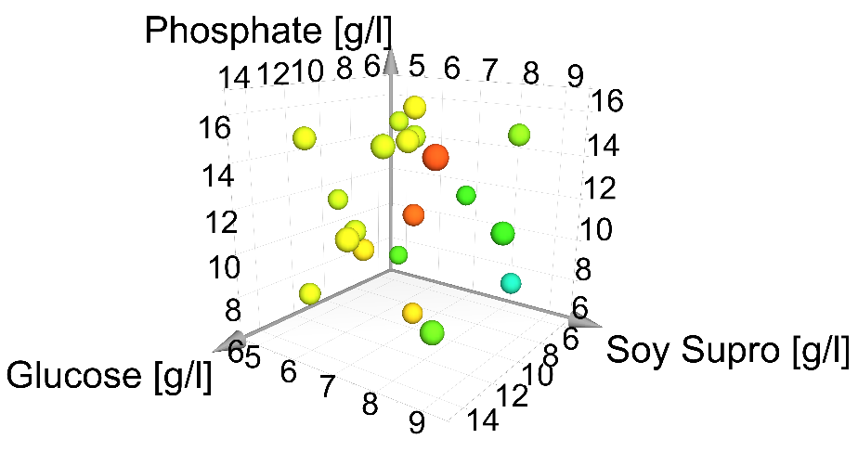
Fig. S2 Identification of an optimal combination of KH₂PO₄/K₂HPO₄ (“phosphate”, creating the buffer system), glucose, and soy bean protein (Soy Supro) with regard to proteinase K production in Parengyodontium album using statistical experimental design. P. album was grown for 72 h in the presence of varying amounts of the shown components. Proteinase K activity in the supernatants of the cultures was determined. The color code (blue, green, yellow to red) indicates whether lower (e.g. blue, 0.1 U/mL) or higher (e.g. red, 0.3 U/mL) proteinase K levels were present.
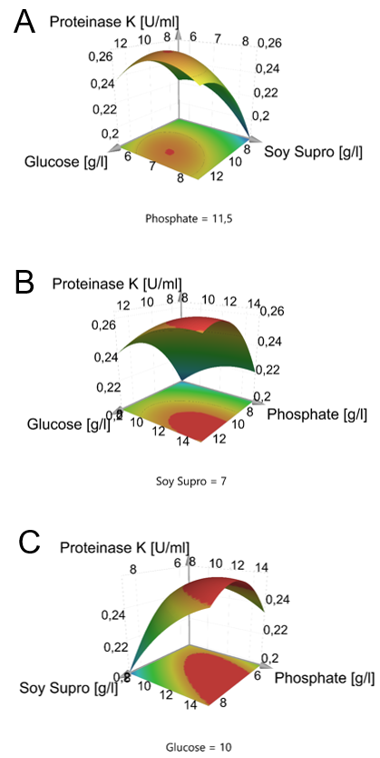
Fig. S3 Surface response diagrams showing the influence of the addition of KH₂PO₄/K₂HPO₄ (“phosphate”, creating the buffer system), glucose, and soy bean protein (Soy Supro) with regard to proteinase K production in Parengyodontium album using statistical experimental design. The predicted influence of the additives on proteinase K activity is shown. While two substances are varied, one substance remains constant at the specified level in [g/L]. The optimal amounts of glucose, soy protein, and phosphate predicted in this model were 11 g/L, 7.2 g/L, and 15 g/L, respectively.

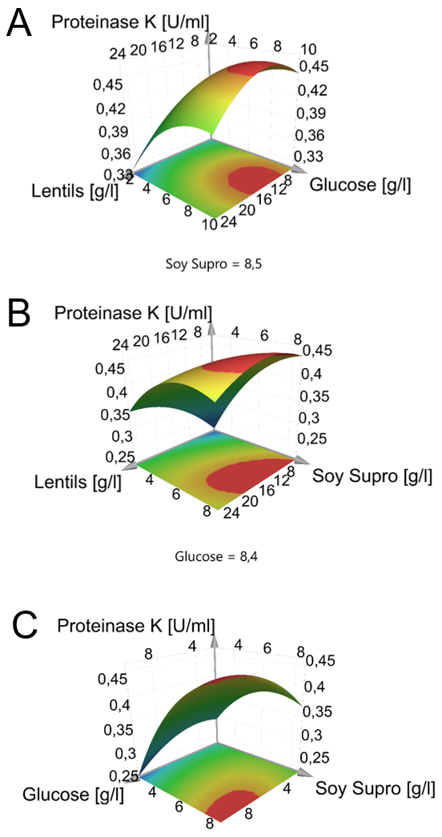
Fig. S4 Surface reaction diagrams showing the predicted effect of glucose, soy protein (“Soy Supro”), and lentils on proteinase K production. The predicted influence of the various compounds on proteinase K activity is shown in these diagrams. While two substances are varied, one remains constant at the specified concentration [g/L]. The predicted optimum is 8.4 g/L glucose, 8.5 g/L soy protein, and 9 g/L lentils after 96 hours of fermentation.
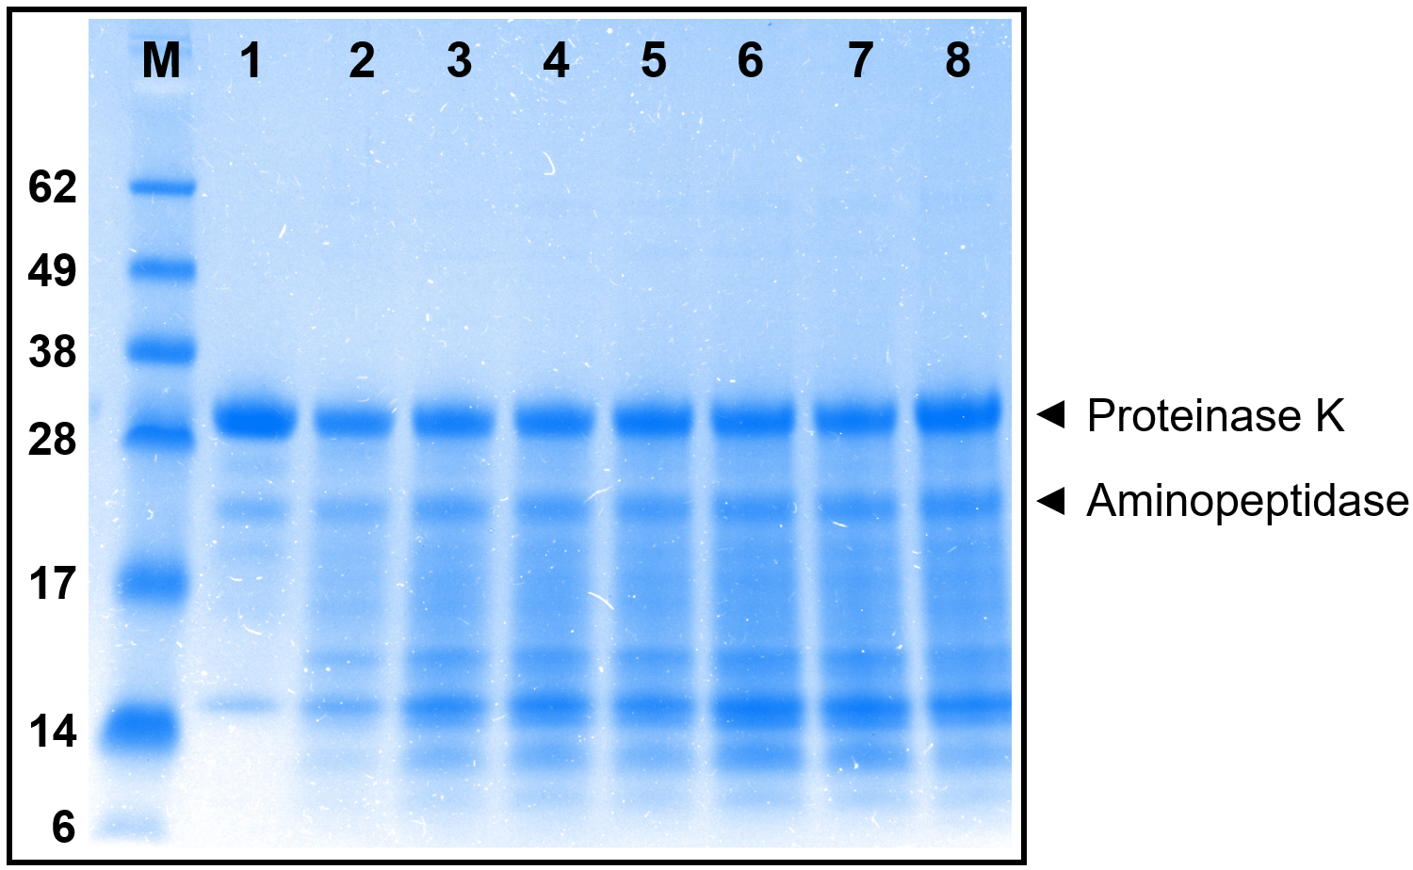
Fig. S5 SDS-PAGE analysis of supernatants (lanes 2 to 8) from Parengyodontium album cultures grown in different growth media. Samples were taken at different time points. A total protein amount of 8 µg was added to each lane. A protein ladder (M) is shown for size comparison (PageRuler™ Plus Prestained Protein Ladder) whereby the molecular masses are given in kDa. The arrows show the positions of proteinase K and aminopeptidase. The gel was stained with Coomassie Brilliant Blue R-250. The proteases in the supernatant were not purified. The multiple bands indicate that degradation products of proteinase K and aminopeptidase are present. The supernatant analyzed in lane 1 is derived from a culture grown in the conventional reference medium. Supernatants analyzed in lanes 2, 3, 4, 5 and 6 (cells were grown in an animal-free medium) were sampled at 24h, 36h, 48h, 72h and 96h, respectively. In lanes 7 and 8 supernatant from cultures grown in the presence of Pardina lentils were analyzed.

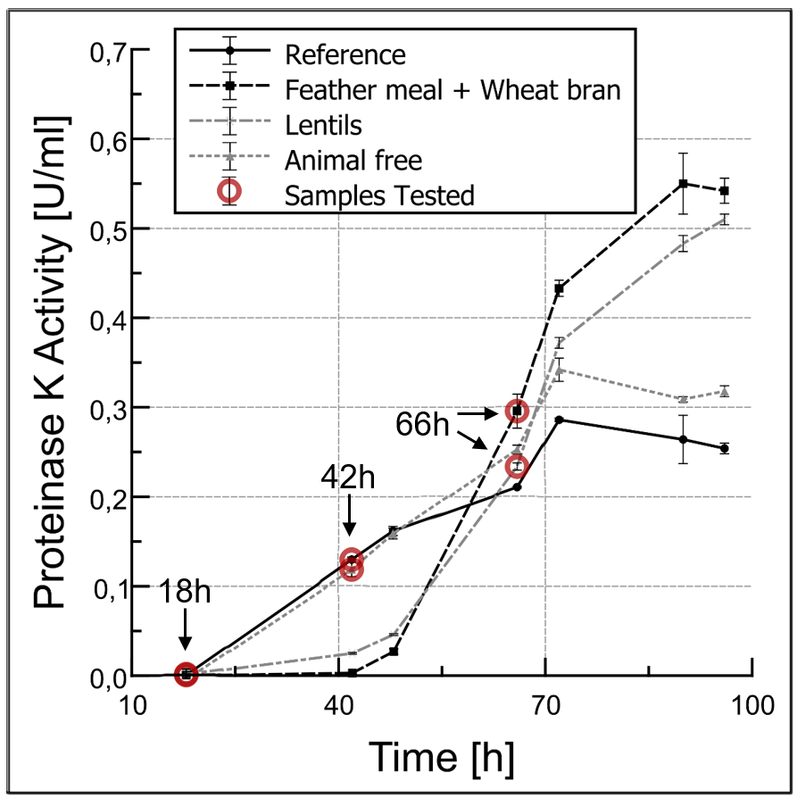
Fig. S6 Sampling times for the analysis of expression of the gene encoding proteinase K from Parengyodontium album. Different culture media were used to grow Parengyodontium album in shake flask cultures. The novel feather meal and wheat bran-based medium and the novel lentil-based medium led to a significantly higher volume activity of proteinase K in the supernatants of the cultures (compare also Fig. 4 and 8). The animal-free medium was modified only in terms of the buffer (KH₂PO₄/K₂HPO₄), glucose, and soy bean meal and yielded a similar volume activity of proteinase K when compared to the original reference medium. mRNA was isolated from all cultures at 18h to set a baseline expression. In case of the reference medium and the animal-free medium a second mRNA sample was isolated at 42h, whereas in case of the media containing feather meal and wheat bran mRNA was isolated at 66h. The differences in proteinase K gene expression from 18h to the medium dependent time point is described as “mRNA change during induction” while the differences in proteinase K gene expression between the 42h-66h samples is described as “mRNA change compared to the reference medium”.

