SUPPLEMENTARY INFORMATION
Development of tBu-phenyl acetamide appended thiacalix[4]arene as “Turn-ON” fluorescent probe for selective recognition of Hg(II) ions
Ashukumar Verma¹, Krunal Modi², Shuvankar Dey¹, Anita Kongor¹, Manthan Panchal¹, Manoj Vora¹, Falak Panjwani¹, V K. Jain^{1*}
¹Department of Chemistry, School of Sciences, Gujarat University, Navrangpura, Ahmedabad – 380009, India
²Mehsana Urban Institute of Science, Department of Chemistry, Ganpat University, Kherva, Gujarat, 384012, India
Email*: drvkjain@hotmail.com
S1. Synthesis of parent thiacalix[4]arene
Parent thiacalix[4]arene was synthesized by base-catalyzed condensation reaction of p-tert butyl phenol and elemental sulfur (S₈). A mixture of p-tert butyl phenol (32 g, 0.213 mol), elemental sulfur (S_{8,} 13.6 g, 0.42 mol) and NaOH (4.34 g, 0.108 mol) was added to 250 mL round bottom flask using diphenyl oxide (30 mL) as solvent and stirred under nitrogen atmosphere. The stirred mixture was heated slowly to 230 ⁰C over a period of 7 h associated with removal of the evolving hydrogen sulfide with slow stream of nitrogen. The resulting dark-red product was cooled to room temperature and diluted with acetonitrile, followed by addition of conc. HCl with constant stirring to give a suspension. The precipitate was collected by filtration, recrystallized in chloroform and dried in vacuo to give a pure sample of thiacalix[4]arene (15.15 g, 39 % ). Further column chromatography of the residue was done on silica gel (hexane:ethyl acetate) as eluents (9:1) which afforded additional thiacalix[4]arene (5.75 g, 15 %), with the combined yield (54 %) (Scheme 1).
MS (ESI): m/z for C₄₀H₄₈N₄O₄ Calcd: 721.1 [M], Found 719.1 [M-2]⁻ (Fig. S1); ¹H-NMR (400 MHz, CDCl₃): δ (ppm): 1.35 (36 H, s, -CH₃), 6.9-7.4 (8H, s, Ar), and 8.1 (4H, s, -OH) (Fig. S2); ¹³C NMR (100 MHz, CDCl₃): δ (ppm): 31.3 (-CH₃), 35.2 (-C(CH₃)₃), 122.5, 136.4, 144.7 and 156.6 (Fig. S3); M.P: 320-322°C.
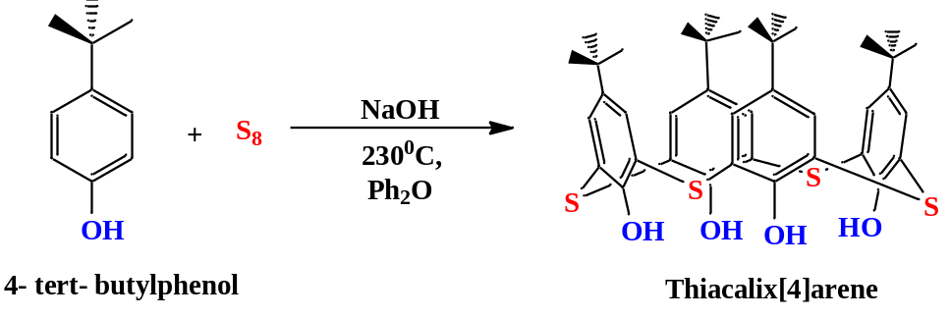
Scheme 1 Synthesis of parent thiacalix[4]arene
S2. Synthesis of N-(4-(tert-butyl)phenyl)-2-chloroacetamide (NTP2CA)
A mixture of the 4-tert butyl aniline (1.0 g, 0.006 mol) was reacted with chloroacetyl chloride (1.135 g, 0.010 mol) in dichloromethane (MDC) (15 mL) in the presence of triethylamine (TEA) as base (1.01 g, 0.010 mol). The reaction was monitored by Thin-layer chromatography (TLC). The reaction mixture was concentrated in vacuum to get the product as brown solid (Scheme 2).
MS (ESI): m/z for C₁₂H₁₆ ClNO Calcd: 225.7 [M], Found 243.5 [M+18]⁺ (Fig. S4), ¹H-NMR (400 MHz, CDCl₃): δ (ppm): 1.33 (9H, s, -CH₃), 4.20 (2H, s, –CH₂), 7.38 (2H, d, Ar-CH), 7.46 (2H, d, Ar-CH), 8.30 (1H, s, NH) (Fig. S5); ¹³C NMR (100 MHz, CDCl₃): δ (ppm): 31.38, 34.48, 42.90, 120.10, 125.97, 133.99, 148.38, 164.02 (Fig. S6); ¹³C DEPT (100 MHz, CDCl₃): δ (ppm): 42.92 (Fig. S7); M.P : 110.0 °C.
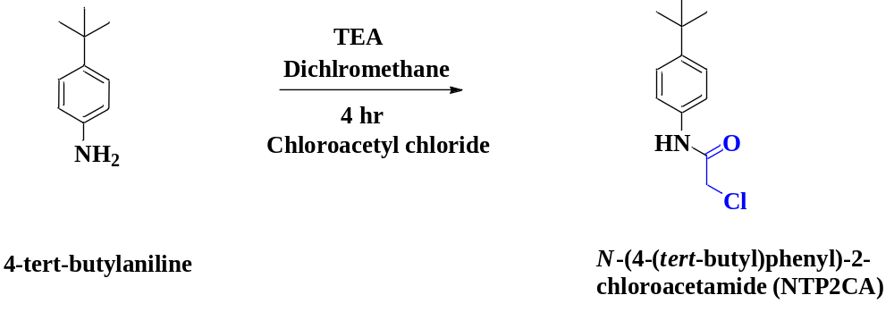
Scheme 2 Synthesis of N-(4-(tert-butyl)phenyl)-2-chloroacetamide
S3. Optimization of reaction conditions
To understand the stability of the probe TCAN2PA, the variation of emission spectra of the probe was recorded for 72 hrs. With an interval of 12 hrs. The resulting spectra indicate that there are no considerable changes in emission maxima within the experimental time scale (Fig. S11). Moreover, to investigate the response time of the receptor TCAN2PA toward Hg(II), absorption spectra of the TCAN2PA- Hg(II) system were recorded up to 20 minutes with an interval of 1 minute. The plot of A₃₃₄ vs. response time indicates that the absorption intensity increases up to 7 minutes and thereafter no significant change was observed (Fig. S12). Additionally, the emission spectra of the probe were recorded with varying temperatures from 20 - 40°C. The output emission spectra indicate no such substantial variation within the experimental temperature range (Fig. S13). Therefore, all the experiments pertaining to the sensing experiments were conducted at 25°C with a 7-minute incubation time.

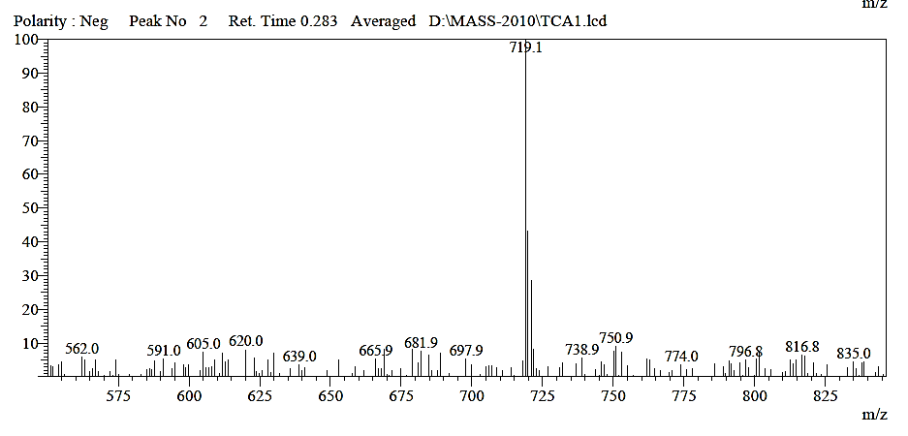
Figure S1 ESI-MS spectra of parent thiacalix[4]arene

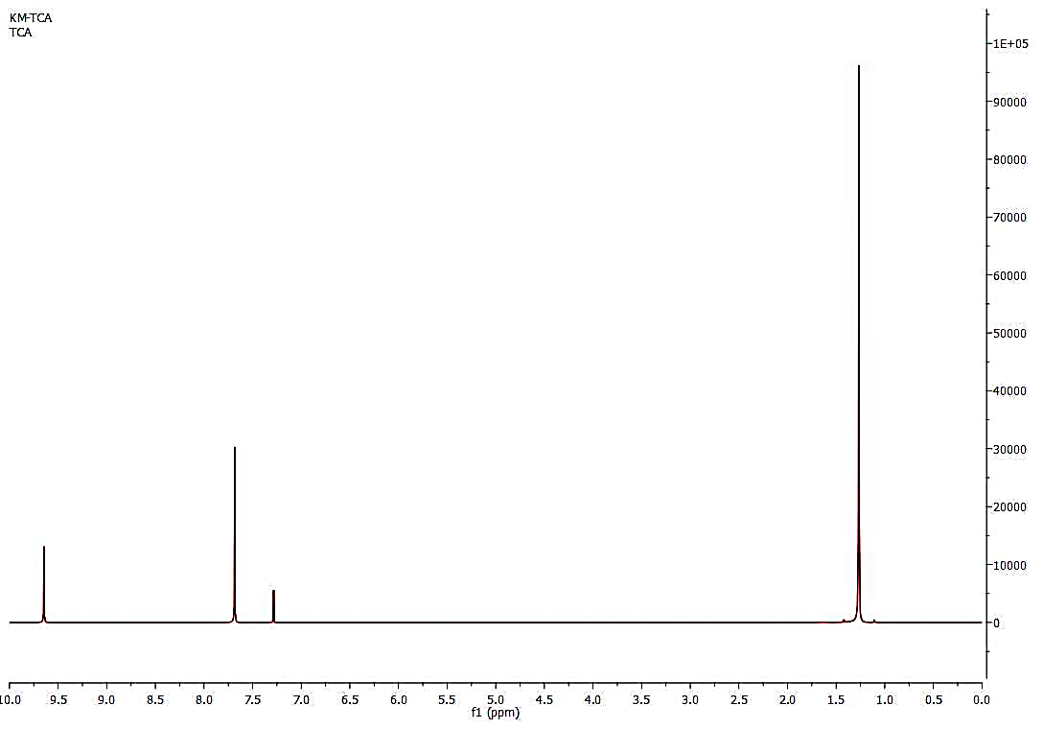
Figure S2 ¹H NMR spectra of parent thiacalix[4]arene
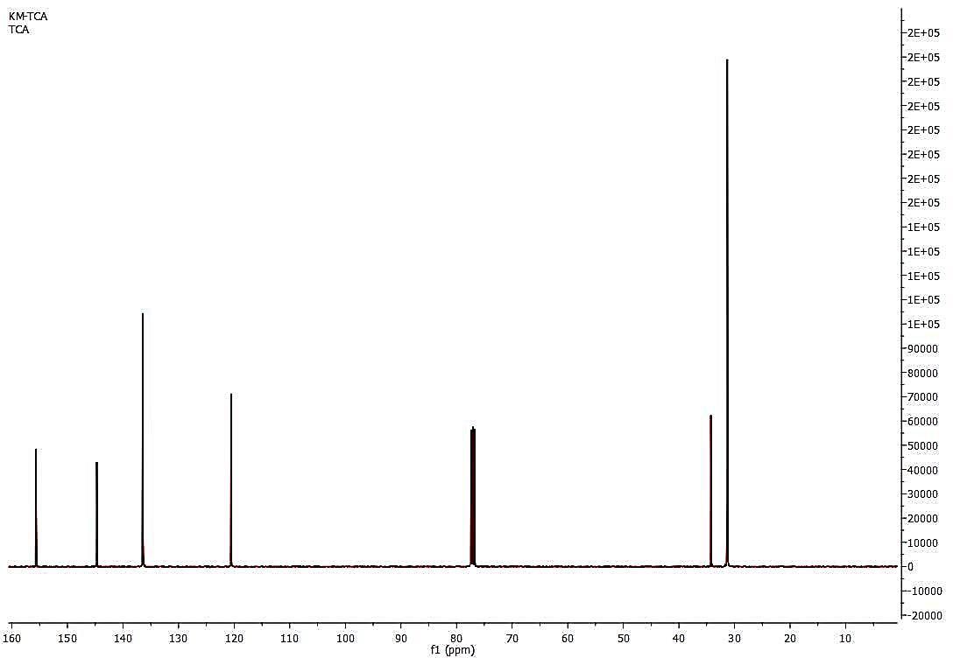
Figure S3 ¹³C NMR spectra of parent thiacalix[4]arene

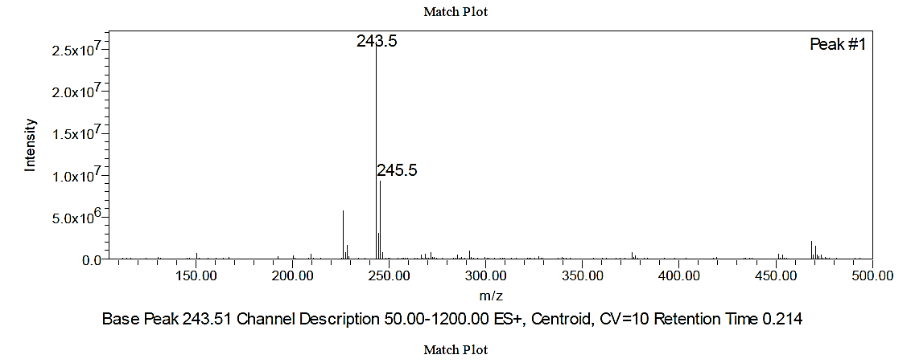
Figure S4 ESI-MS spectra of N-(4-(tert-butyl)phenyl)-2-chloroacetamide

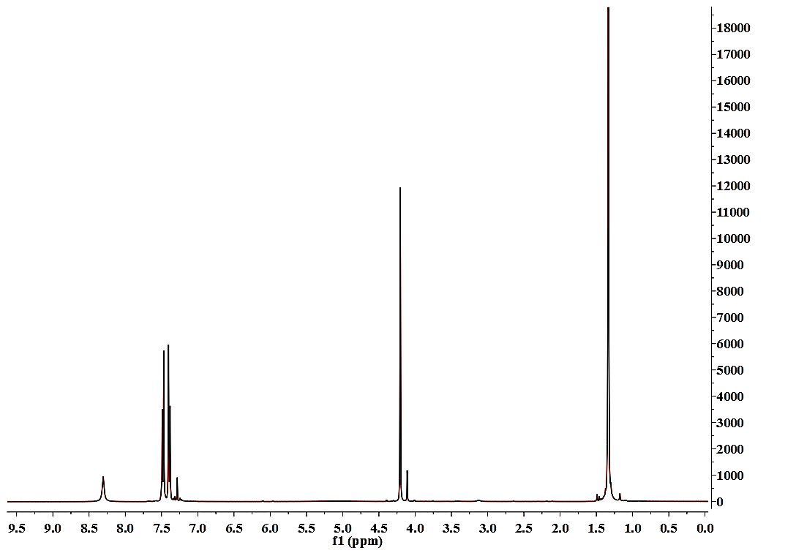
Figure S5 ¹H NMR spectra of N-(4-(tert-butyl)phenyl)-2-chloroacetamide

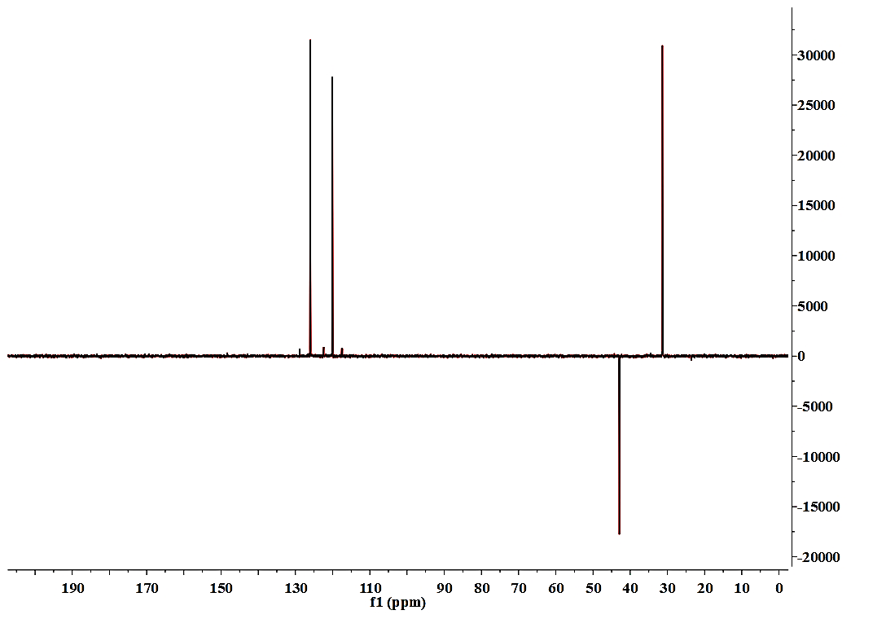
Figure S6 ¹³C DEPT spectra of N-(4-(tert-butyl)phenyl)-2-chloroacetamide
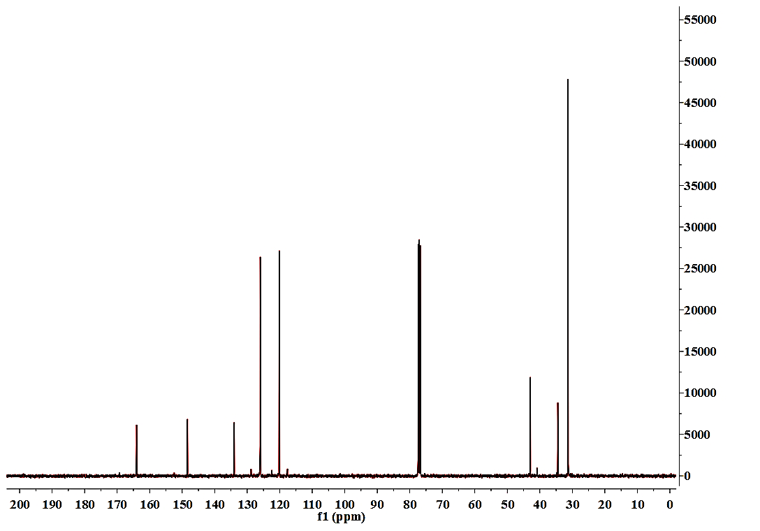
Figure S7 ¹³C NMR spectra of N-(4-(tert-butyl)phenyl)-2-chloroacetamide
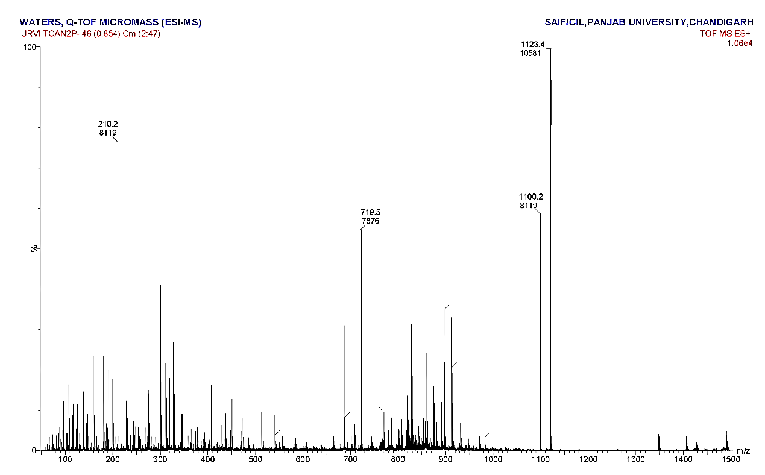
Figure S8 ESI-MS spectra of thiacalix[4]arene N-(4-(tert-butyl)phenyl)-2-chloroacetamide

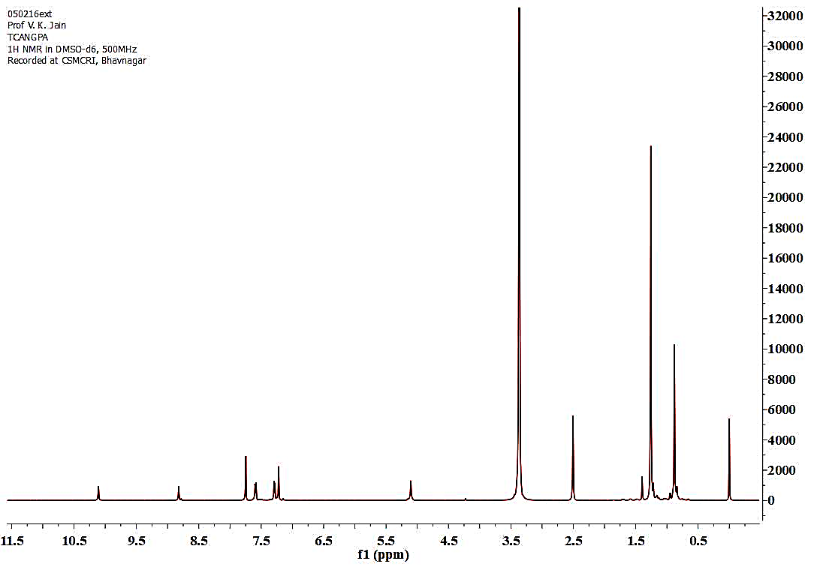
Figure S9 ¹H NMR spectra of thiacalix[4]arene N-(4-(tert-butyl)phenyl)-2-chloroacetamide

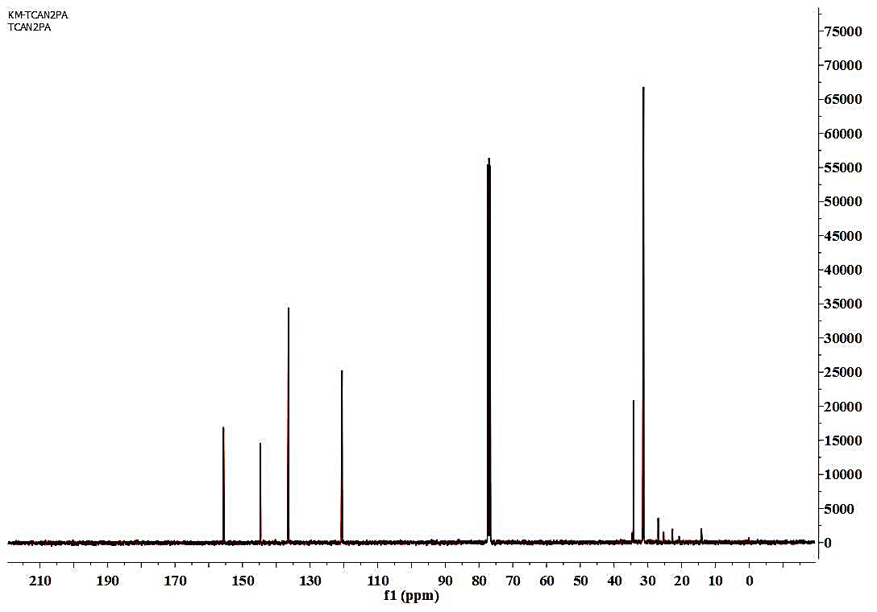
Figure S10 13C NMR spectrum of thiacalix[4]arene N-(4-(tert-butyl)phenyl)-2-chloroacetamide

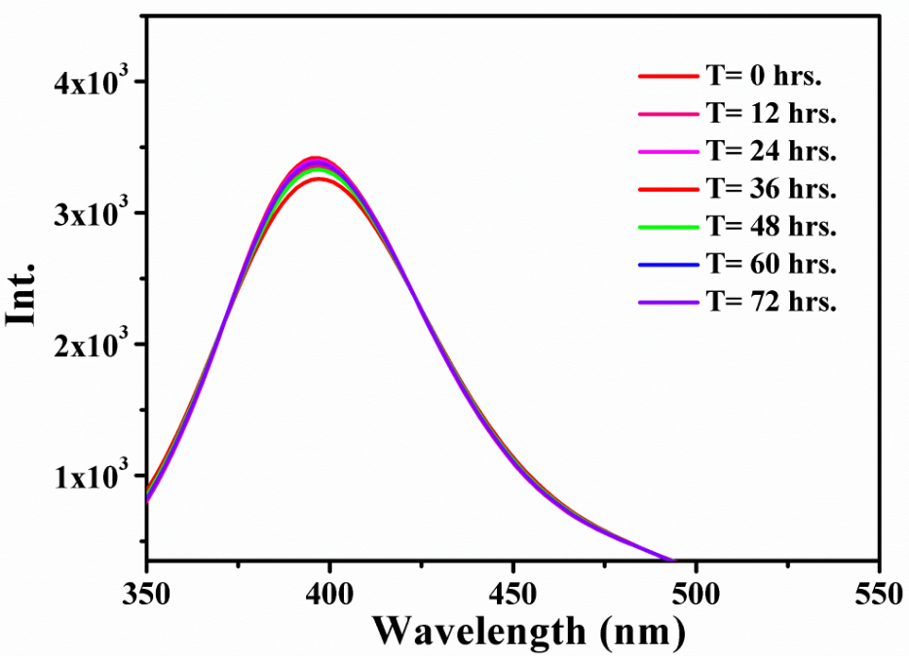
Figure S11 Variation in emission maxima of TCAN2PA up to 72 hrs. with a regular interval of 12 hrs.

.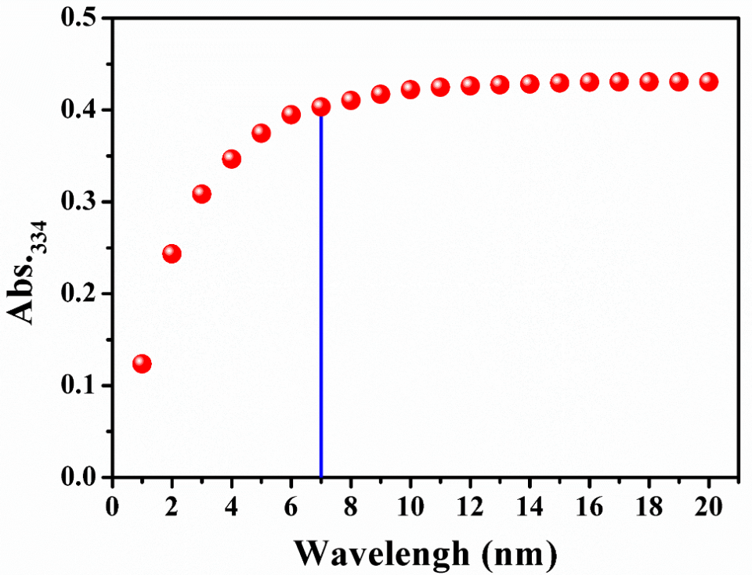
Figure S12 Variation in absorption intensity of the probe TCAN2PA upon addition of 1 equiv. of Hg²⁺ (0-20 min.)
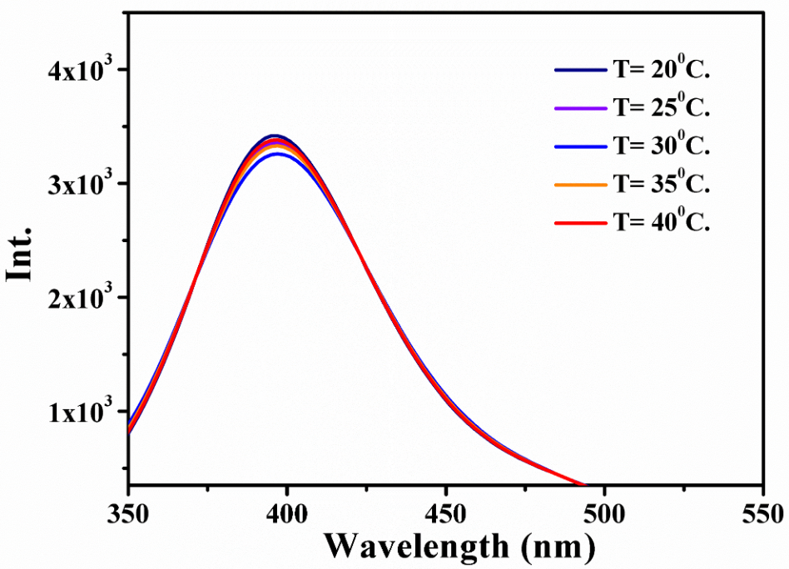
Figure S13 Change in emission spectra of TCAN2PA with varying temperature from 20 - 40°C.

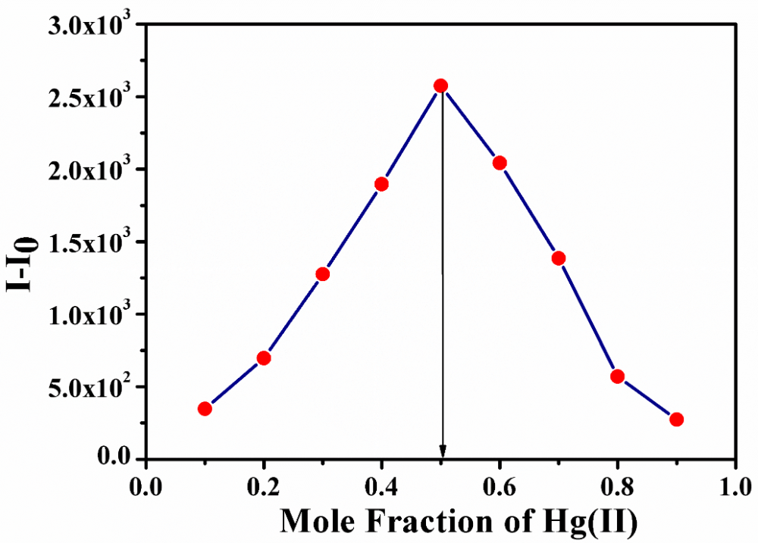
Figure S14 Jobs plot analysis of TCAN2PA-Hg(II) system
Figure S15 Stern-Volmer plot for TCAN2PA-Hg(II) system, Inset: linear regression curve

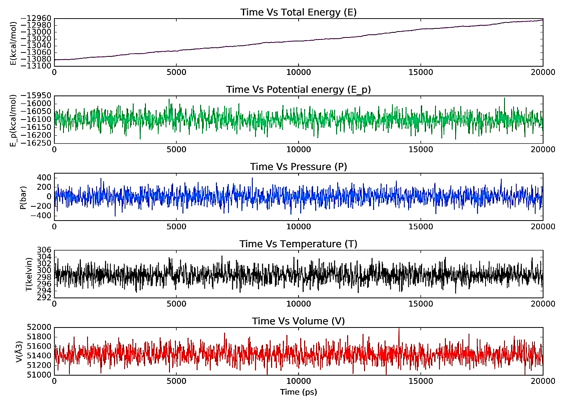
Figure S16 MD Simulations quality analysis graph plots during the 20 ns time trajectory

Table S1. Simulations event analysis
Sr. No. | Parameters | Average | Standard deviation | Slope (ps⁻¹)
1 | Total energy (kcal/mol) | -13023.999 | 34.677 | 0.006
2 | Potential energy (kcal/mol) | -16099.142 | 36.411 | -0.000
3 | Temperature (K) | 298.735 | 1.770 | 0.000
4 | Pressure (bar) | 4.798 | 201.908 | -0.000
5 | Volume (Å³) | 51434.883 | 135.317 | 0.001

