Supplementary Information
Interaction of a Biologically Active Zn²⁺ Complex with Human Serum Albumin: Experimental and Theoretical Insights
Suparna Rudra Hariª, Subrata Ghosh^{b} and Harasit Kumar Mandal^{c*}

ªAssistant Professor in Chemistry, Department of Chemistry, Brainware University, West Bengal 700125, India
^{b}Department of Central Scientific Services, Indian Association for the Cultivation of Science, West Bengal 700030, India
^{c}Assistant Professor in Chemistry, Department of Chemistry, Sree Chaitanya College, Habra, West Bengal 743268, India
*Corresponding author, e-mail: harasitju@gmail.com

1. Fluorescence Quenching and Binding Mechanism
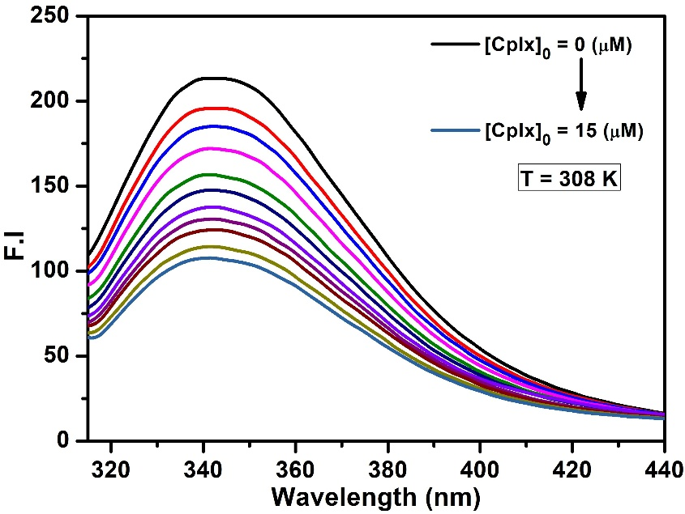
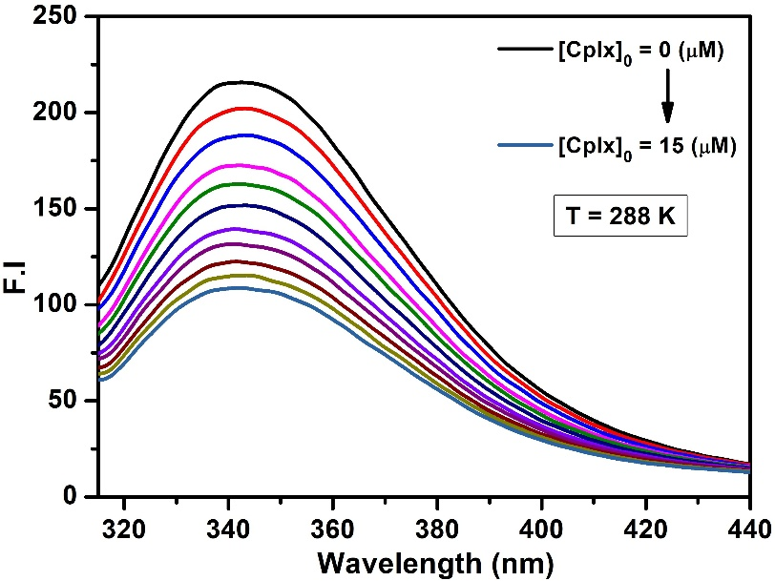

Fig. S1. Quenching of fluorescence intensity (F.I) of HSA protein due to interaction with synthesized metal complex, [HSA]₀ =5 µM, [complex]₀ = 0 to 15 µM, pH =7.4, at 288 K and at 308 K respectively.
Table S1: Fluorescence intensity (F.I) of HSA protein due to interaction with metal complex at different temperatures. [HSA]₀ =5 µM, [complex]₀ = 0 to 15 µM, pH =7.4

[Complex]₀  (µM) | 298 K |  | 308 K |  | 318 K
[Complex]₀  (µM) | F | F₀/F | F | F₀/F | F | F₀/F
0 | 243.25 | 1.00 | 215.8 | 1.00 | 213.01 | 1.00
1.5 | 210.31 | 1.1566 | 193.57 | 1.11482 | 198.64 | 1.07235
3.0 | 190.92 | 1.27408 | 177.84 | 1.21345 | 186.84 | 1.14008
4.5 | 174.80 | 1.39156 | 164.47 | 1.31209 | 176.36 | 1.20781
6.0 | 161.19 | 1.50905 | 152.97 | 1.41073 | 166.99 | 1.27553
7.5 | 149.55 | 1.62653 | 142.97 | 1.50937 | 158.58 | 1.34326
9.0 | 139.48 | 1.74401 | 134.18 | 1.60831 | 150.96 | 1.41099
10.5 | 131.50 | 1.84974 | 127.18 | 1.69678 | 144.71 | 1.47194
12.0 | 122.92 | 1.97897 | 119.54 | 1.80528 | 137.74 | 1.54644
13.5 | 116.68 | 2.08471 | 113.94 | 1.89405 | 132.52 | 1.60741
15.0 | 110.46 | 2.20219 | 108.29 | 1.99269 | 127.16 | 1.67512

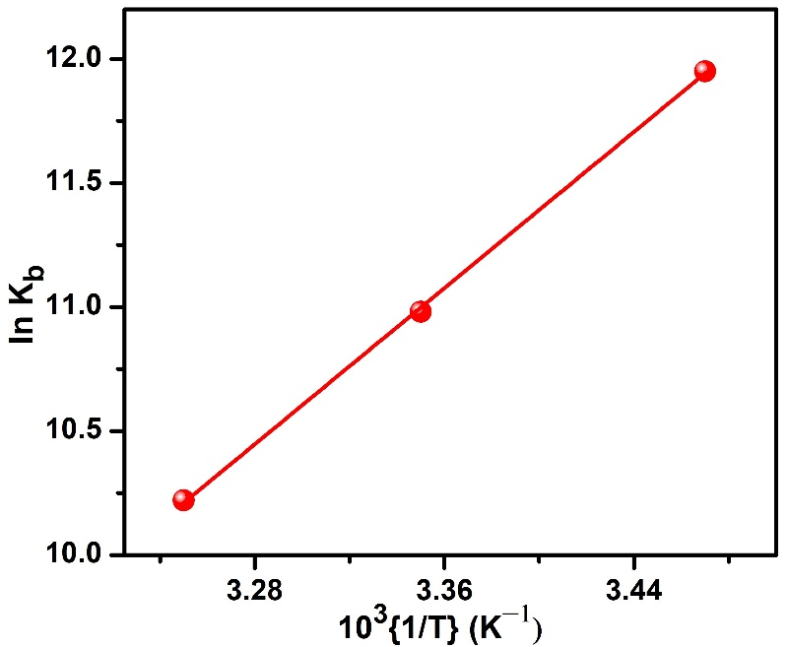
Fig. S2. The linear plot of ln K_{b} versus 1/T demonstrates that the binding constant diminishes as the temperature increases.
2. Stoichiometry of protein-ligand complex
Spectral data obtained from the emission titration experiments were used to determine the stoichiometry of the ligand–protein complex using the Benesi–Hildebrand equation [Eq. 1] [1].
$\frac{1}{F_{0}-F}=\frac{1}{F_{0}-F_{1}}+\frac{C^{0}}{\left(F_{0}-F_{1}\right)K\left[Q\right]}$ (1)
Where, F₁ is the emission intensity of HSA at infinite concentration of cplx, K is the binding constant and Q is the quencher (cplx). The plot of 1/[F₀ − F] versus 1/[Q] exhibited excellent linearity (Fig. S3), indicating a 1:1 interaction between the complex and HSA. However, to further confirm this stoichiometry and eliminate the possibility of 1:2 complex formation, a modified Benesi–Hildebrand equation was also employed. The inset plot of Fig. S3, presenting 1/(F₀ − F) versus 1/[Q]², shows a clear deviation from linearity, confirming the absence of any 1:2 complex formation [2].

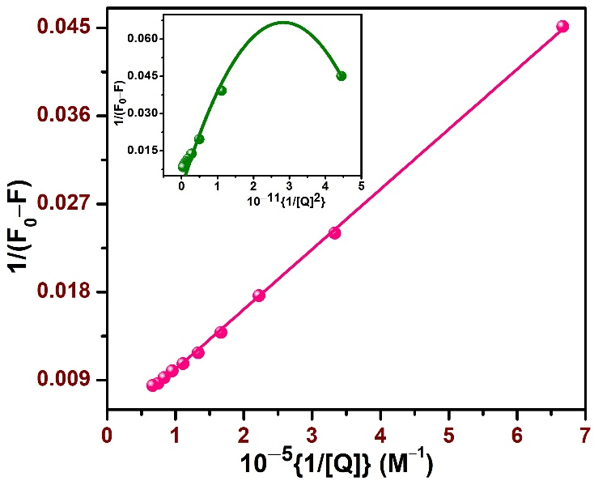
Fig. S3. Benesi–Hildebrand plot of 1/[F₀ − F] versus 1/[Q] for the binding of the complex with HSA. The inset displays the modified Benesi–Hildebrand plot of 1/[F₀ − F] versus 1/[Q]² for the HSA–complex system.

References:
1. Benesi HA., Hildebrand JH (1949) A spectrophotometric investigation of the interaction of iodine with aromatic hydrocarbons. Journal of American Chemical Society 71, 2703–2707. https://doi.org/10.1021/ja01176a030
2. Shanmugaraj K, Anandakumar S, Ilanchelian M (2014) Exploring the biophysical aspects and binding mechanism of thionine with bovine hemoglobin by optical spectroscopic and molecular docking methods. Journal of Photochemistry and Photobiology B: Biology 131, 43–52. https://doi.org/10.1016/j.jphotobiol.2014.01.001

