Supplementary Information for

Geostationary Observations Reveal Widespread Underestimation of Current Ambient NO₂ from Strong Diurnal Variability

Figures S1-S19
Tables S1-S6
References

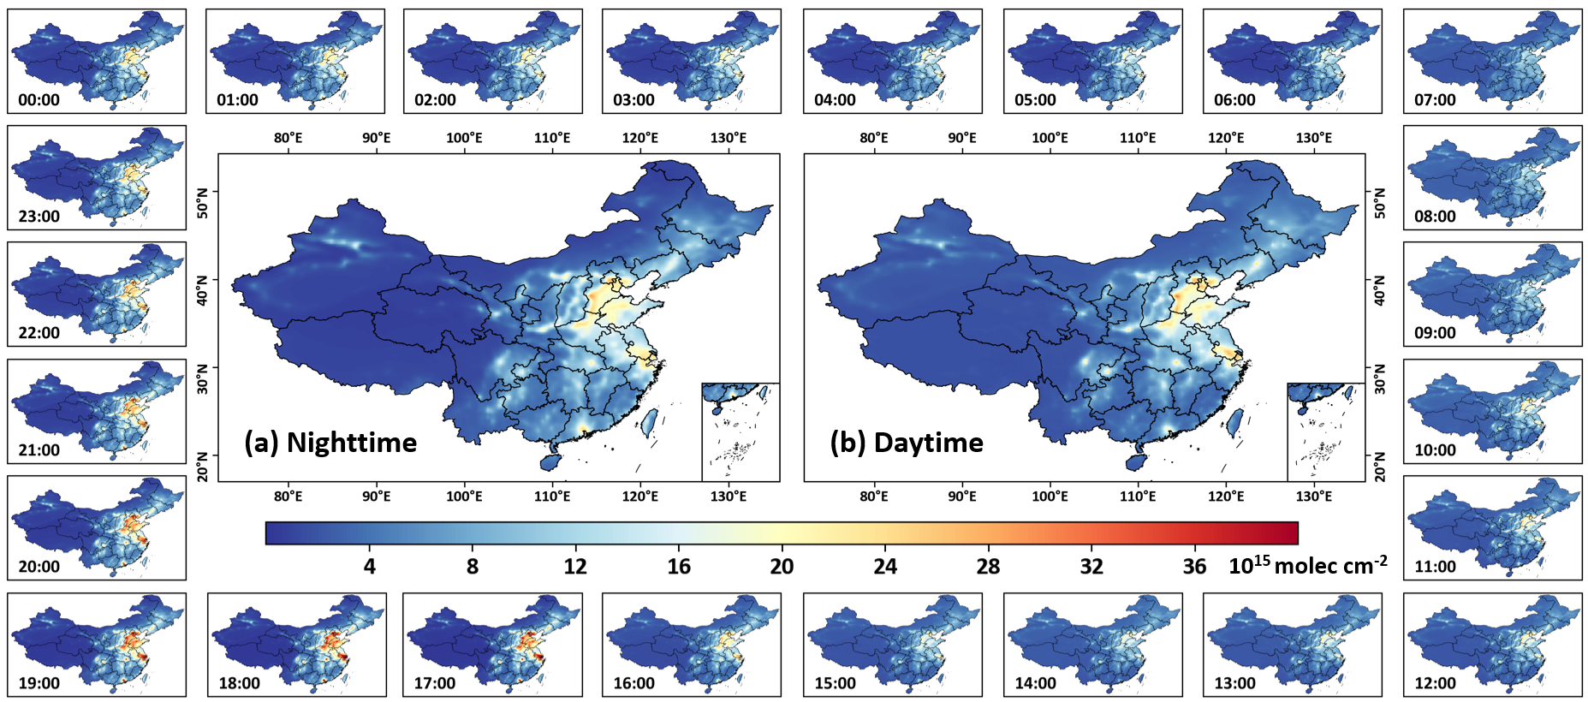

Fig. S1 | Diurnal variation of tropospheric NO₂ across China. Hourly spatial distributions of tropospheric NO₂ columns (10¹⁵ molec cm⁻²) across China for 2023. Surrounding subplots show concentrations for each hour of the day (00:00–23:00 China Standard Time, CST), while panels (a) and (b) present maps of average tropospheric NO₂ columns during the nighttime (20:00–08:00 CST) and daytime (08:00–20:00 CST), respectively.

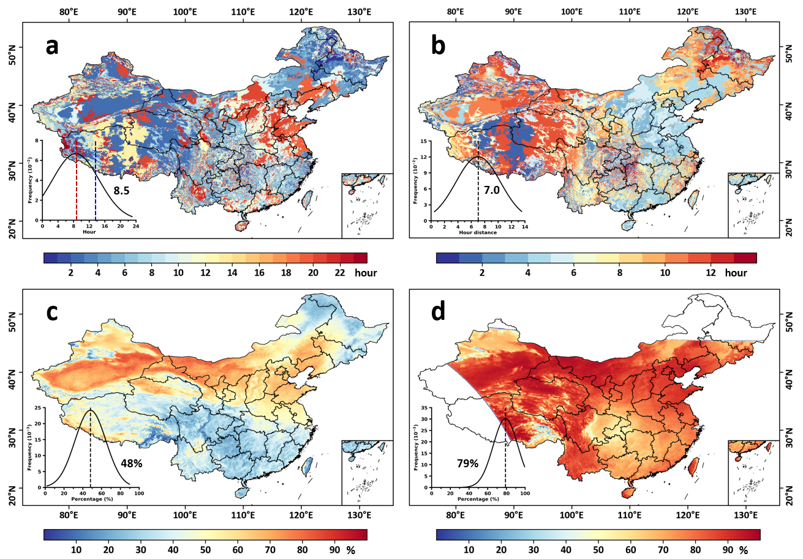

Fig. S2 | Spatial distributions of the hour of surface NO₂ closest to the daily mean and spatial coverage of satellite tropospheric NO₂ retrievals in China. Spatial distribution of (a) the hour of surface NO₂ that most closely matches the daily mean and (b) its difference from the TROPOMI overpass time (13:30 LT) across China in 2023, along with the spatial coverage (%) in tropospheric NO₂ products from (c) GEMS and (d) TROPOMI. Insets show frequency histograms, with black numbers indicating the mean value.

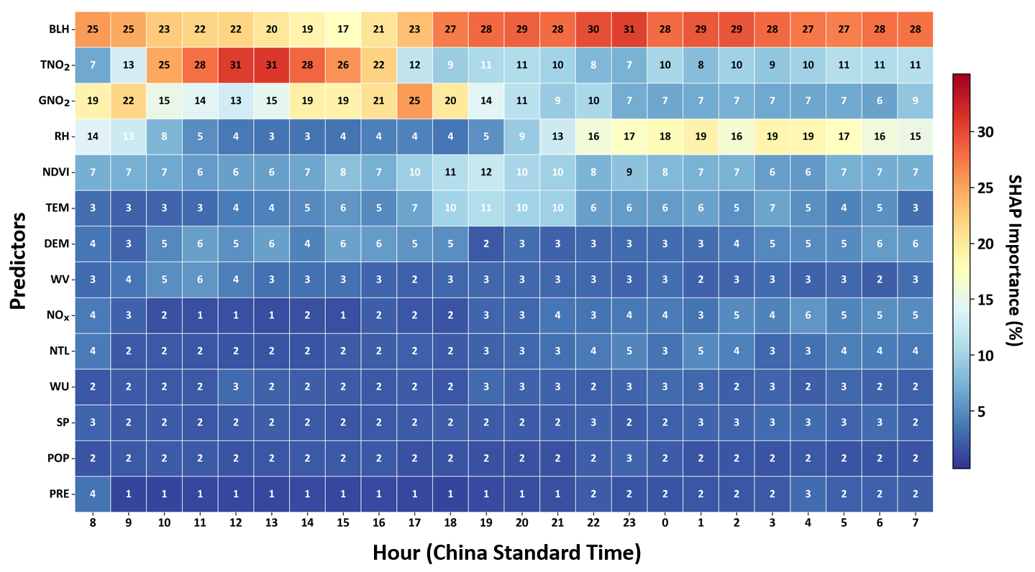Fig. S3 | Drivers of diurnal variations in ambient NO₂ across China. Heatmap showing the hourly percentage contribution of each predictor to the machine learning model output, evaluated by the SHAP (SHapley Additive exPlanations) method.

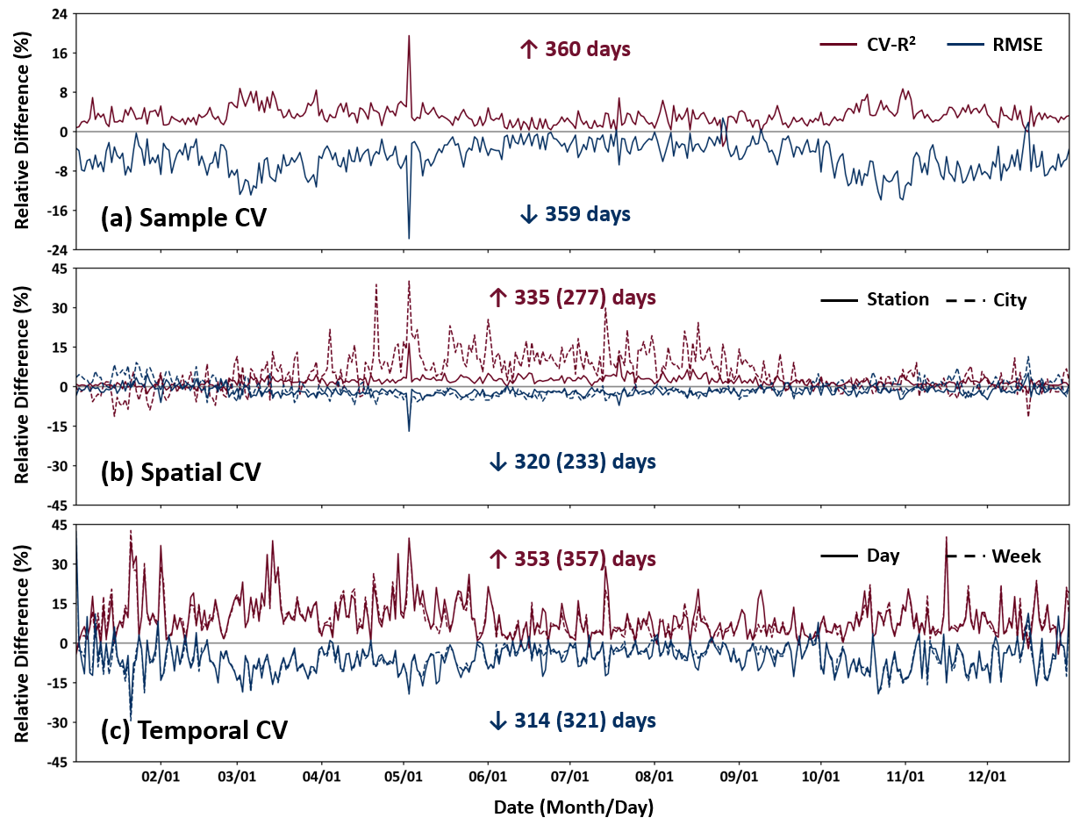

Fig. S4 | Accuracy comparison of daily NO₂ retrievals from GEMS and TROPOMI. Time series of daily improvements in (a) sample-, (b) spatial-, and (c) temporal-based cross-validated coefficient of determination (CV-R²) and root mean square error (RMSE) in China in 2023, comparing GEMS- and TROPOMI-derived daily NO₂ retrievals under different cross-validation approaches. Red numbers indicate the number of days with improved CV-R², and blue numbers indicate days with reduced RMSE.
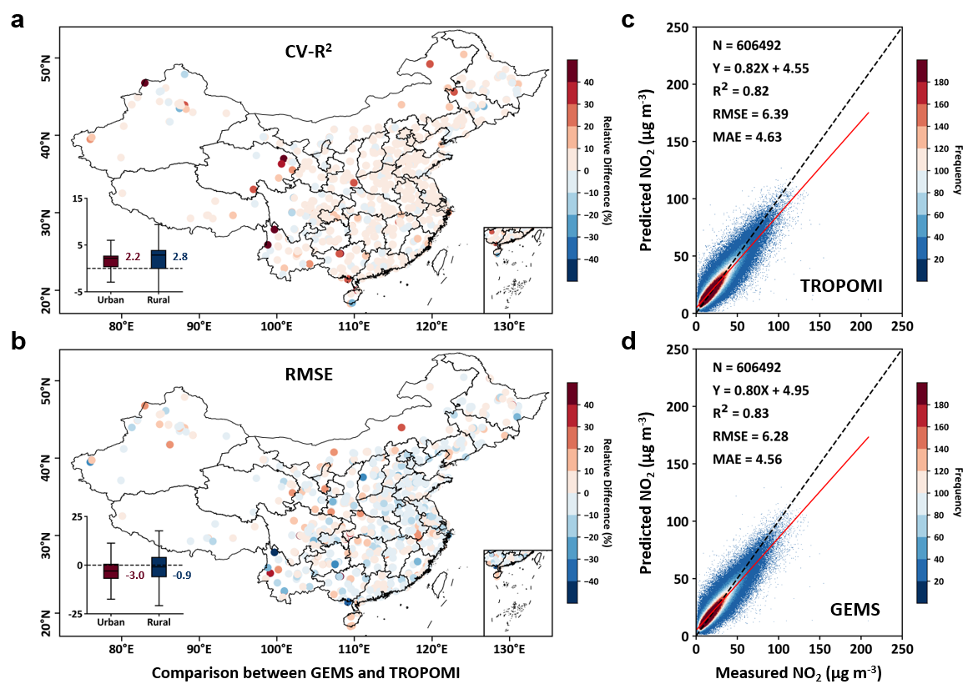

Fig. S5 | Accuracy comparison of daily NO₂ predictions from GEMS and TROPOMI. Spatial improvements (%) in (a) cross-validated coefficient of determination (CV-R²) and (b) root mean square error (RMSE) at each monitoring station across China in 2023, comparing GEMS- and TROPOMI-derived daily ambient NO₂ predictions using the station-based 10-fold cross-validation approach. Inset box plots illustrate the improvements in urban and rural areas, with colored numbers indicating the mean relative differences. Panels (c) and (d) show comparisons between predicted and measured daily ambient NO₂ concentrations (µg m⁻³) derived from (c) TROPOMI and (d) GEMS observations across all monitoring stations in China.

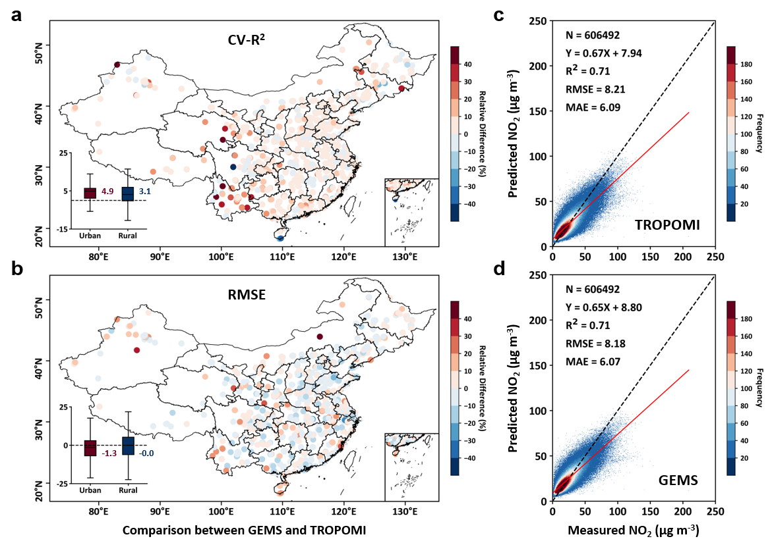

Fig. S6 | Accuracy comparison of daily NO₂ predictions from GEMS and TROPOMI. Spatial improvements (%) in (a) cross-validated coefficient of determination (CV-R²) and (b) root mean square error (RMSE) at each monitoring station across China in 2023, comparing GEMS- and TROPOMI-derived daily ambient NO₂ predictions using the city-based 10-fold cross-validation approach. Inset box plots illustrate the improvements in urban and rural areas, with colored numbers indicating the mean relative differences. Panels (c) and (d) show comparisons between predicted and measured daily ambient NO₂ concentrations (µg m⁻³) derived from (c) TROPOMI and (d) GEMS observations across all monitoring stations in China.

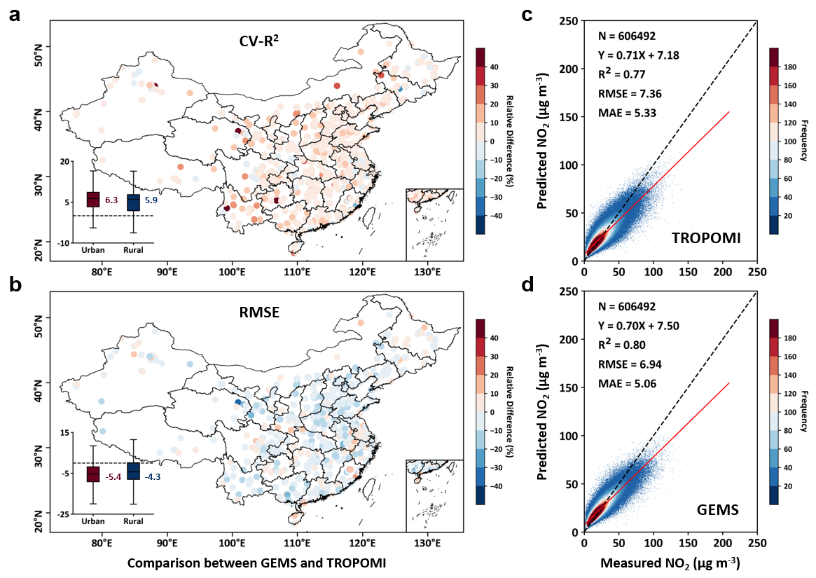

Fig. S7 | Accuracy comparison of daily NO₂ predictions from GEMS and TROPOMI. Spatial improvements (%) in (a) cross-validated coefficient of determination (CV-R²) and (b) root mean square error (RMSE) at each monitoring station across China in 2023, comparing GEMS- and TROPOMI-derived daily ambient NO₂ predictions using the day-based 10-fold cross-validation approach. Inset box plots illustrate the improvements in urban and rural areas, with colored numbers indicating the mean relative differences. Panels (c) and (d) show comparisons between predicted and measured daily ambient NO₂ concentrations (µg m⁻³) derived from (c) TROPOMI and (d) GEMS observations across all monitoring stations in China.

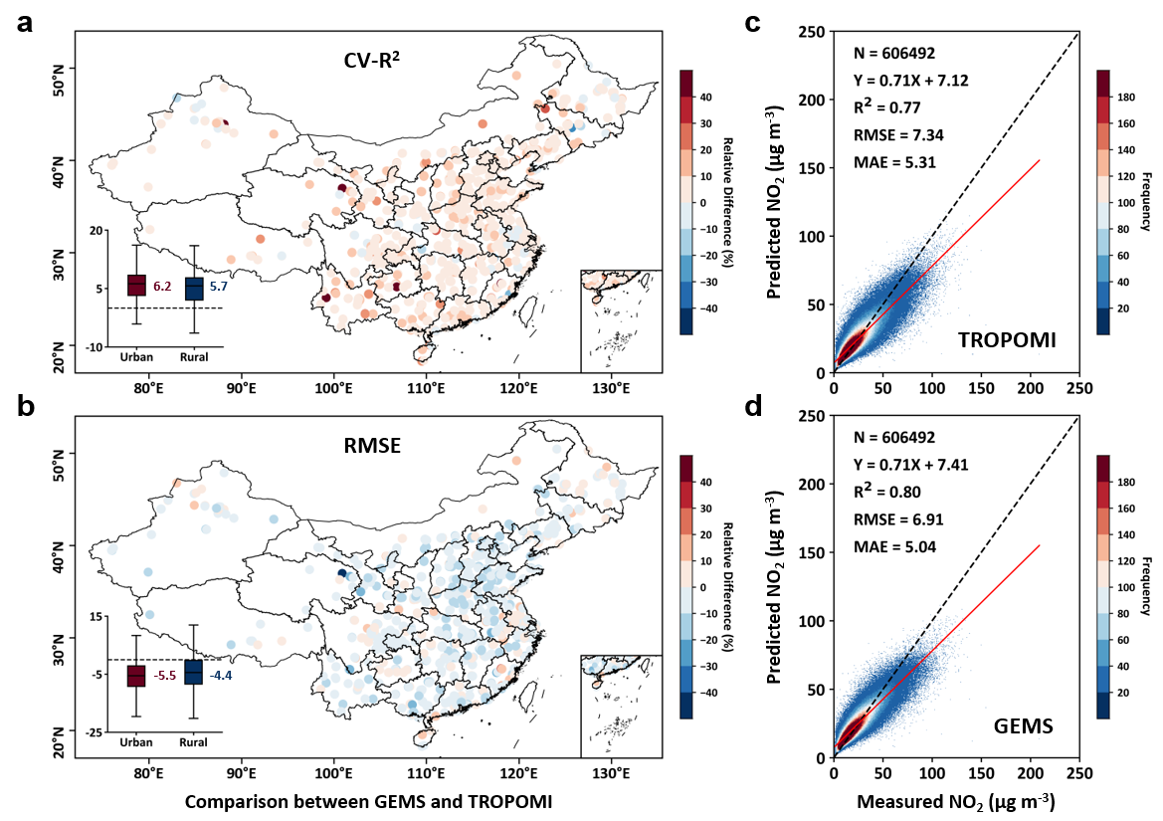

Fig. S8 | Accuracy comparison of daily NO₂ predictions from GEMS and TROPOMI. Spatial improvements (%) in (a) cross-validated coefficient of determination (CV-R²) and (b) root mean square error (RMSE) at each monitoring station across China in 2023, comparing GEMS- and TROPOMI-derived daily ambient NO₂ predictions using the week-based 10-fold cross-validation approach. Inset box plots illustrate the improvements in urban and rural areas, with colored numbers indicating the mean relative differences. Panels (c) and (d) show comparisons between predicted and measured daily ambient NO₂ concentrations (µg m⁻³) derived from (c) TROPOMI and (d) GEMS observations across all monitoring stations in China.

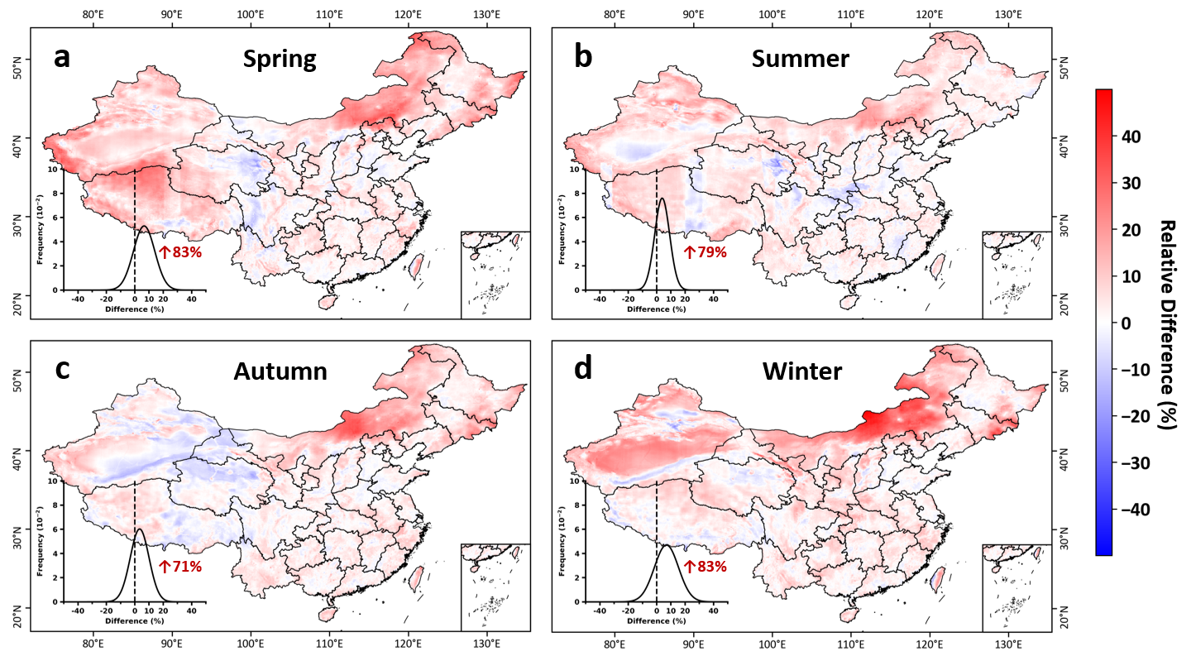

Fig. S9 | Disparities in seasonal ambient NO₂ concentrations in China. Spatial distributions of the relative differences (%) between GEMS- and TROPOMI-derived ambient NO₂ concentrations for the four seasons: (a) spring, (b) summer, (c) autumn, and (d) winter. Inset plots display frequency histograms, with red numbers indicating the percentage of pixels showing positive differences.

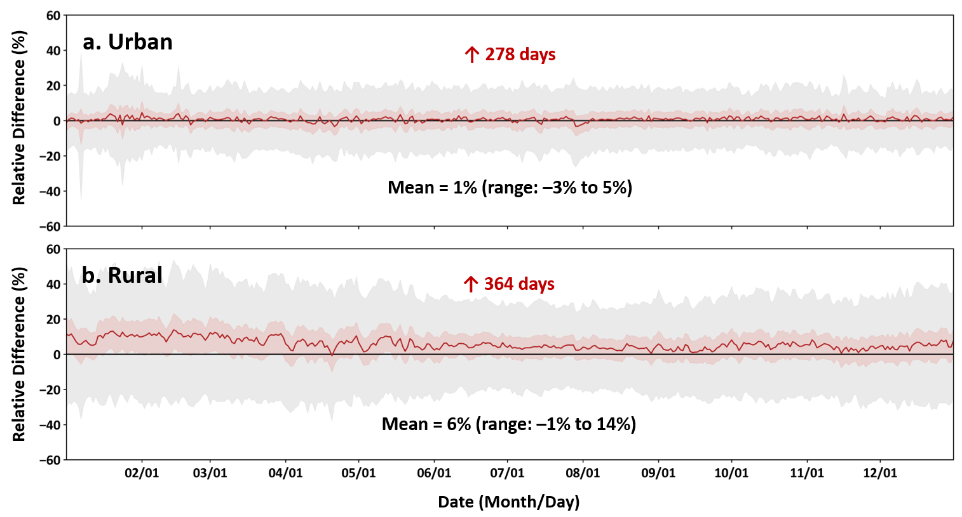

Fig. S10 | Disparities in urban and rural ambient NO₂ estimates in China. Time series of daily mean differences (µg m⁻³) in ambient NO₂ concentrations derived from GEMS and TROPOMI in 2023 for (a) urban and (b) rural areas across China. Black numbers indicate the range and mean of the differences, while red numbers indicate the number of days with positive differences.

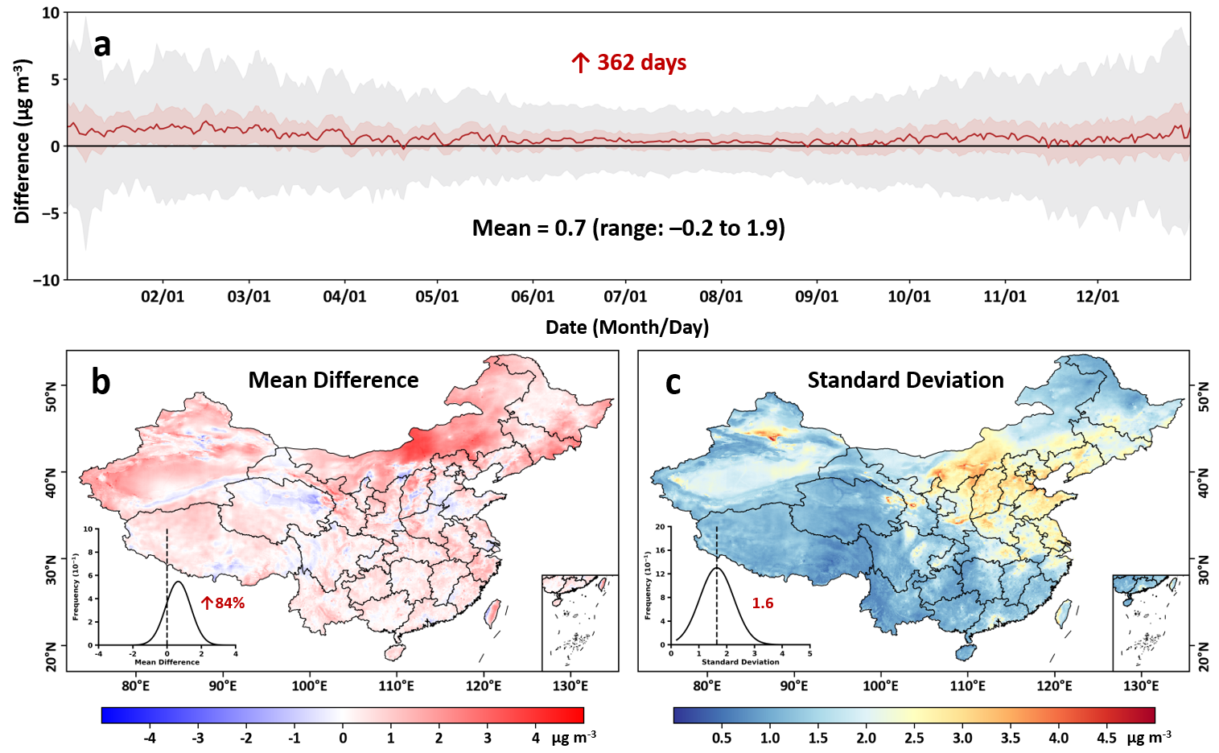

Fig. S11 | Disparities in daily ambient NO₂ concentrations in China. (a) Time series of daily differences (µg m⁻³) in ambient NO₂ concentrations derived from GEMS and TROPOMI in 2023 in China, along with spatial distributions of (b) the mean difference (µg m⁻³) and (c) the standard deviation (µg m⁻³) between GEMS and TROPOMI-derived daily NO₂ concentrations. Black numbers in (a) indicate the range and mean of the differences. Inset plots in (b) and (c) show frequency histograms. Red numbers in (a) and (b) indicate the number of days and percentage of pixels with positive differences, and in (c), the mean standard deviation, respectively.

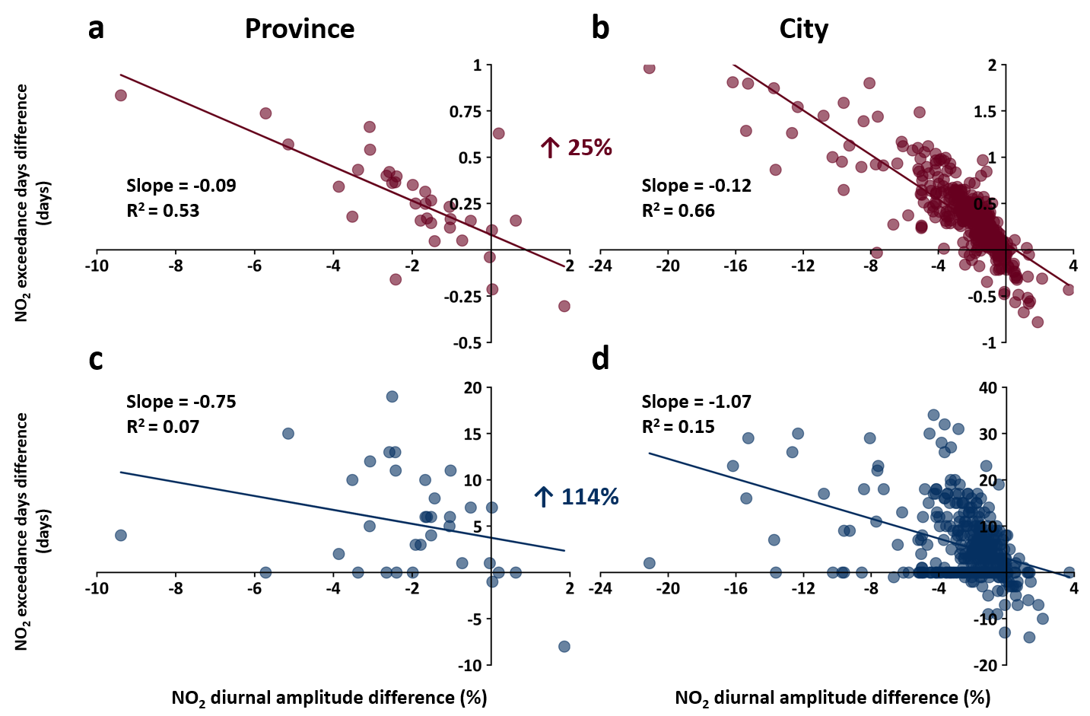

Fig. S12 | Enhanced disparities between NO₂ exposure and diurnal amplitude across spatial scales. Scatter plots show the relationship between the NO₂ diurnal amplitude difference (%) and the difference in (a-b) daily population-weighted mean NO₂ concentrations (µg m⁻³) and (c-d) the number of days exceeding the WHO air quality guideline of 25 µg m⁻³, as derived from GEMS and TROPOMI, comparing provincial (left) and city-level (right) scales. Colored values indicate the relative change in correlation (R²) between the two scales.

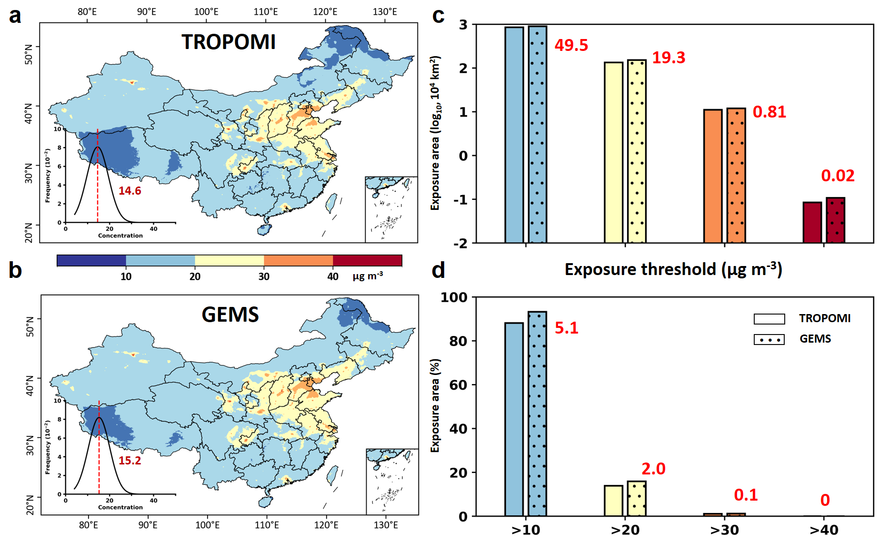

Fig. S13 | Disparities in estimated exposure risk areas in China. Spatial distribution of Spatial distribution of areas exceeding the WHO’s recommended annual thresholds (IT-1, IT-2, IT-3, and AQG at 40, 30, 20, and 10 µg m⁻³), derived from (a) TROPOMI and (b) GEMS observations, as well as the histogram statistics show (c) the area and (d) the percentage of regions exceeding each threshold, with red numbers indicating the differences between the two datasets.

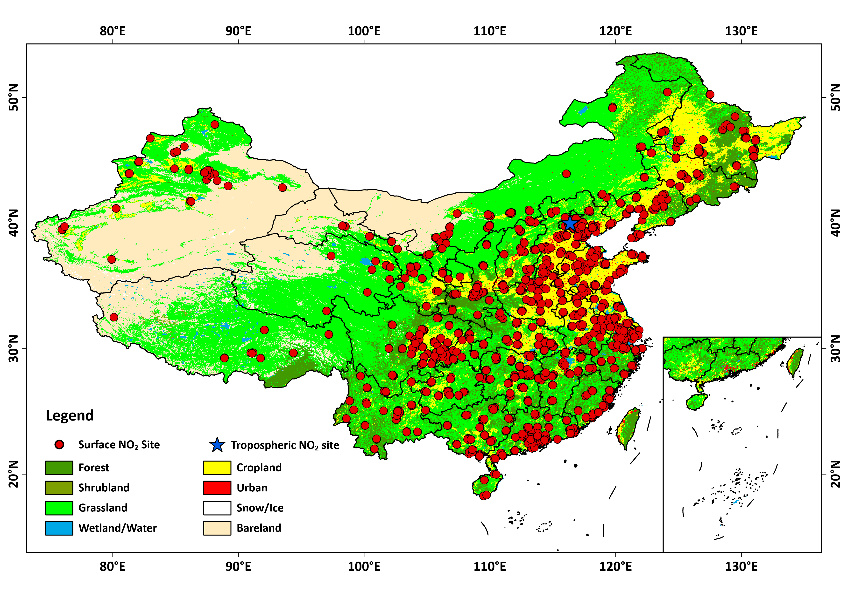

Fig. S14 | Locations of ambient NO₂ monitoring stations. Spatial distribution of ground-based surface NO₂ (red dots) and tropospheric NO₂ (blue stars) ground-based monitoring stations. The background map is the MODIS land-use cover product.

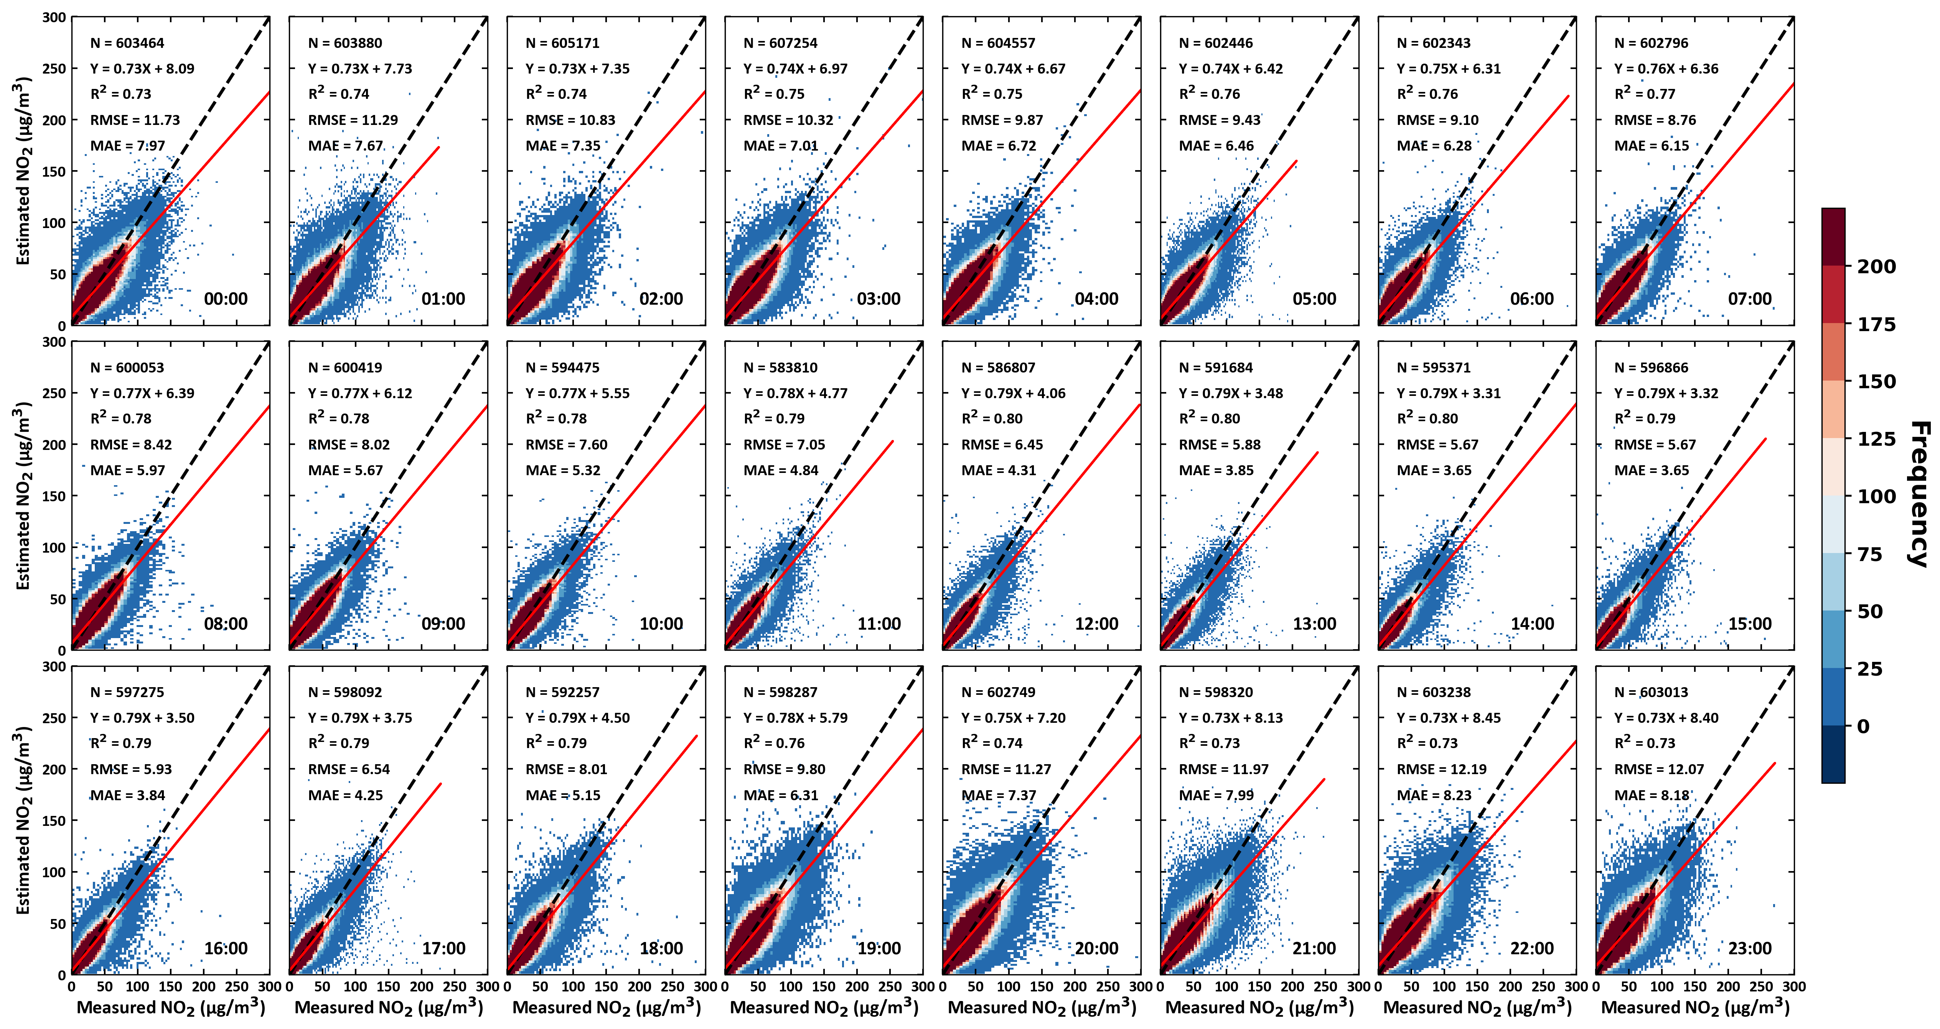

Fig. S15 | Overall accuracy of hourly NO₂ estimates across China. Validation of hourly NO₂ estimates (µg m⁻³) from 00:00 to 23:00 local time for the year 2023 in China, using the sample-based 10-fold cross-validation approach. Black dashed lines denote 1:1 lines, and red solid lines denote best-fit lines from linear regression. The sample size (N), linear regression equation, coefficient of determination (CV-R²), root-mean-square error (RMSE, µg m⁻³), and mean absolute error (MAE, µg m⁻³) are also given.

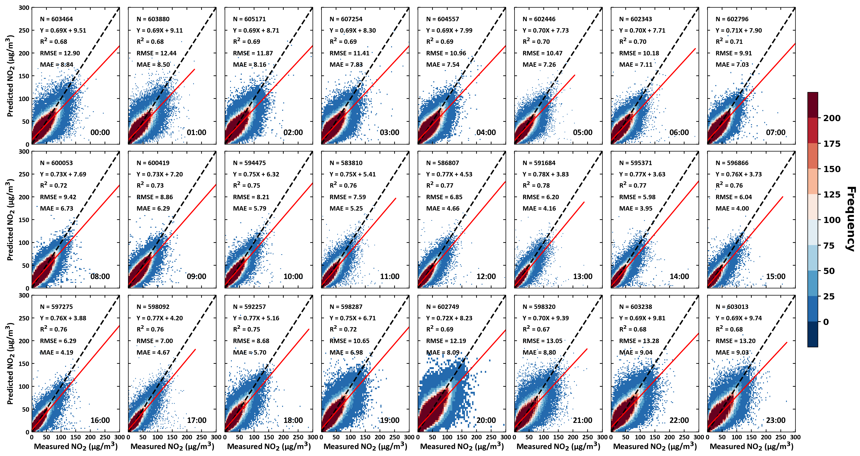

Fig. S16 | Spatial accuracy of hourly NO₂ predictions across China. Validation of ambient NO₂ predictions (µg m⁻³) from 00:00 to 23:00 local time for the year 2023 in China, using the station-based 10-fold cross-validation approach. Black dashed lines denote 1:1 lines, and red solid lines denote best-fit lines from linear regression. The sample size (N), linear regression equation, coefficient of determination (CV-R²), root-mean-square error (RMSE, µg m⁻³), and mean absolute error (MAE, µg m⁻³) are also given.

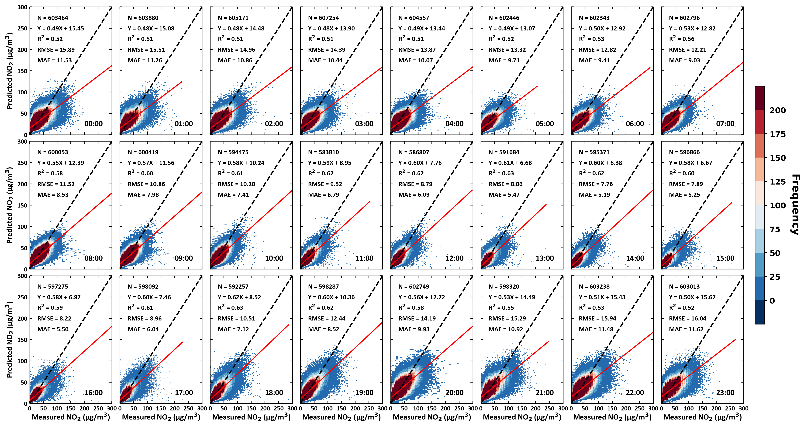

Fig. S17 | Spatial accuracy of hourly NO₂ predictions in China. Validation of hourly ambient NO₂ predictions (µg m⁻³) from 00:00 to 23:00 local time for the year 2023 in China, using the city-based 10-fold cross-validation approach. Black dashed lines denote 1:1 lines, and red solid lines denote best-fit lines from linear regression. The sample size (N), linear regression equation, coefficient of determination (CV-R²), root-mean-square error (RMSE, µg m⁻³), and mean absolute error (MAE, µg m⁻³) are also given.

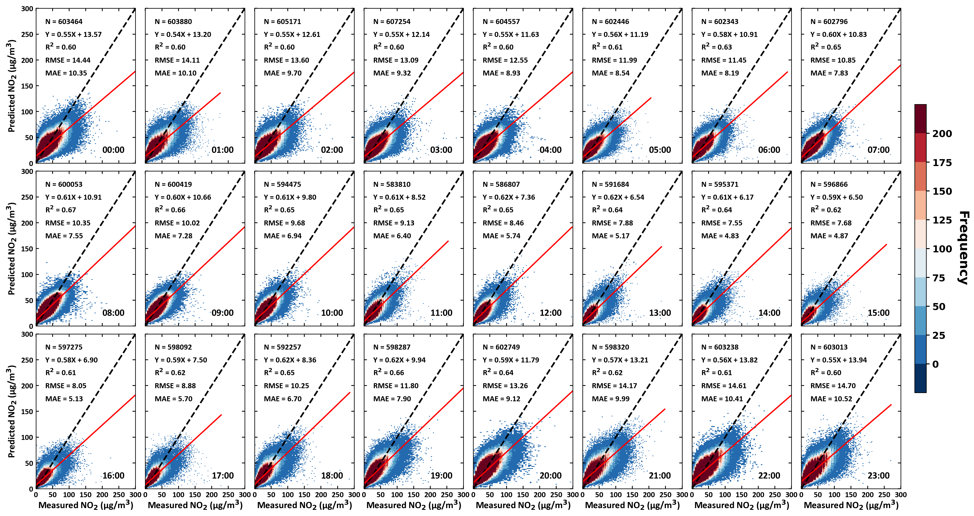

Fig. S18 | Temporal accuracy of hourly NO₂ predictions in China. Validation of hourly ambient NO₂ predictions (µg m⁻³) from 00:00 to 23:00 local time for the year 2023 in China, using the day-based 10-fold cross-validation approach. Black dashed lines denote 1:1 lines, and red solid lines denote best-fit lines from linear regression. The sample size (N), linear regression equation, coefficient of determination (CV-R²), root-mean-square error (RMSE, µg m⁻³), and mean absolute error (MAE, µg m⁻³) are also given.

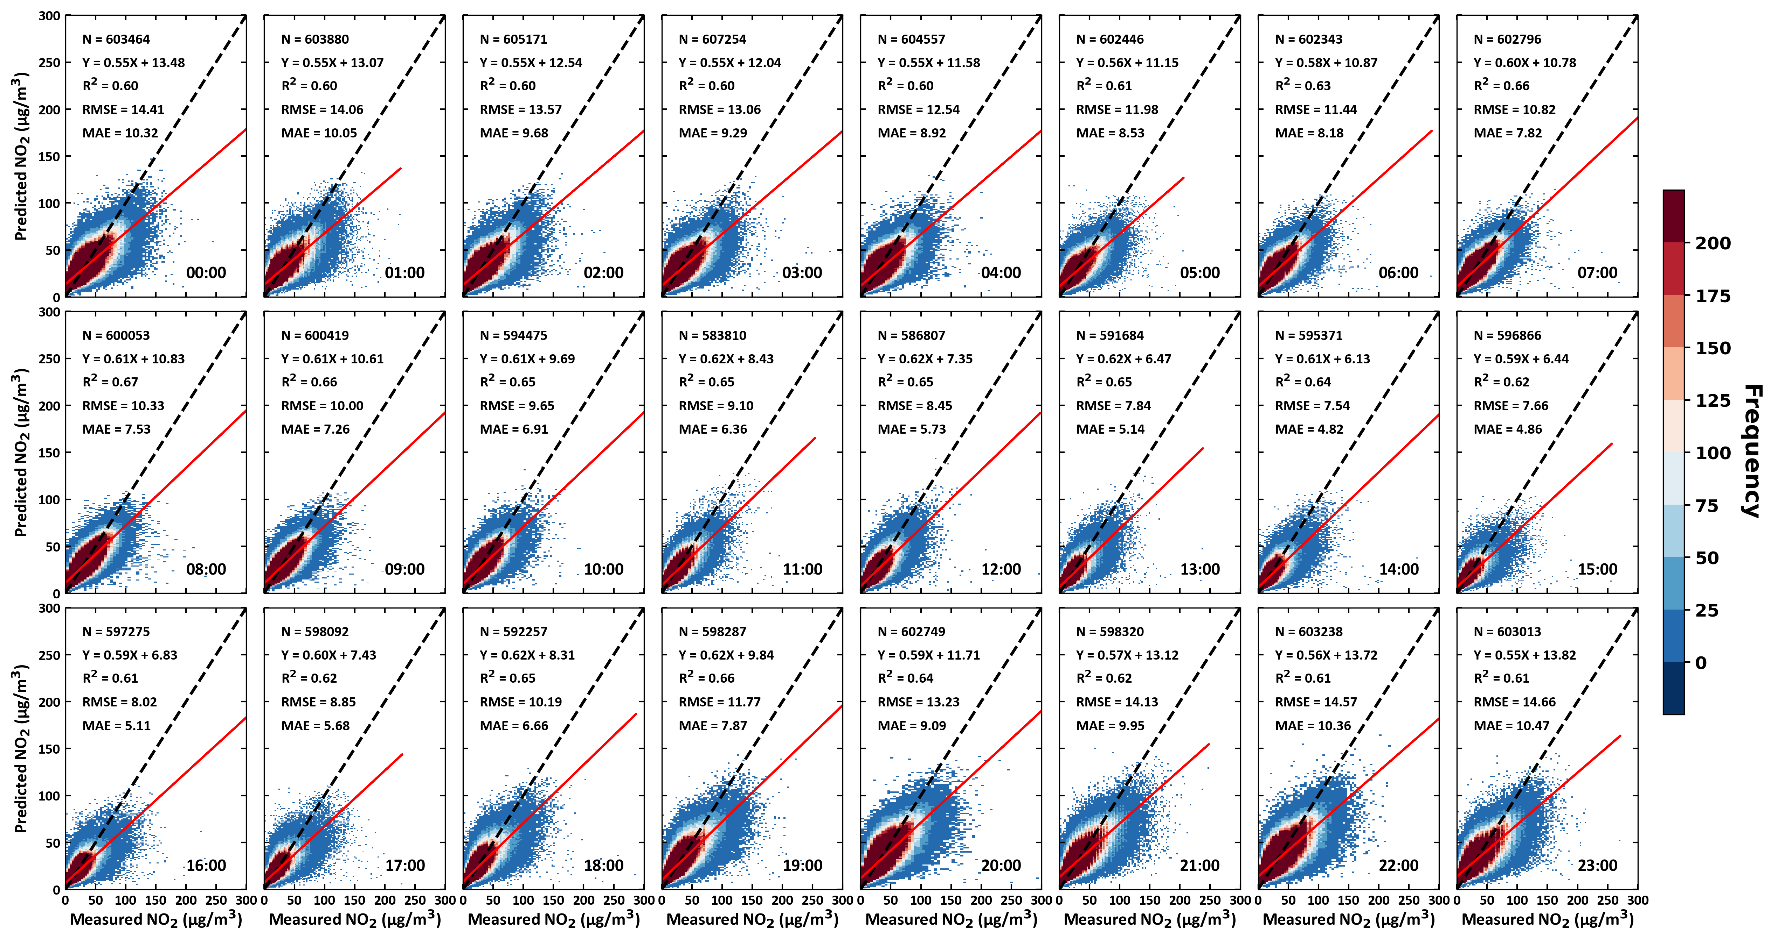

Fig. S19 | Temporal accuracy of hourly ambient NO₂ predictions in China. Validation of hourly ambient NO₂ predictions (µg m⁻³) from 00:00 to 23:00 local time for the year 2023 in China, using the week-based 10-fold cross-validation approach. Black dashed lines denote 1:1 lines, and red solid lines denote best-fit lines from linear regression. The sample size (N), linear regression equation, coefficient of determination (CV-R²), root-mean-square error (RMSE, µg m⁻³), and mean absolute error (MAE, µg m⁻³) are also given.

Table S1. Top 10 provinces in China with the largest disparities in acute mortality (in people) attributable to daily ambient NO₂ pollution, derived from GEMS and TROPOMI observations in 2023.
Province | GEMS | TROPOMI | Disparity
Province | Deaths (95% CI) | Deaths (95% CI) | Deaths (95% CI)
Anhui | 5,716 (4,694–6,734) | 5,509 (4,524–6,490) | 207 (171–244)
Henan | 9,575 (7,863–11,279) | 9,427 (7,742–11,104) | 148 (122–174)
Hubei | 4,753 (3,903–5,599) | 4,616 (3,791–5,438) | 137 (112–161)
Zhejiang | 5,256 (4,317–6,191) | 5,123 (4,207–6,034) | 133 (109–157)
Inner Mongolia | 2,018 (1,657–2,378) | 1,887 (1,550–2,223) | 131 (108–155)
Yunnan | 1,814 (1,488–2,139) | 1,696 (1,391–1,999) | 118 (97–139)
Gansu | 2,292 (1,882–2,700) | 2,186 (1,795–2,575) | 106 (87–125)
Hunan | 3,422 (2,809–4,033) | 3,320 (2,725–3,913) | 102 (81–120)
Xinjiang | 1,972 (1,620–2,323) | 1,873 (1,539–2,206) | 99 (82–117)
Jilin | 2,188 (1,797–2,579) | 2,089 (1,715–2,462) | 99 (81–117)

Table S2. Top 10 provinces in China with the largest disparities in chronic mortality (in people) attributable to annual ambient NO₂ pollution, derived from GEMS and TROPOMI observations in 2023.
Province | GEMS | TROPOMI | Disparity
Province | Deaths (95% CI) | Deaths (95% CI) | Deaths (95% CI)
Anhui | 28,003 (7,256–41,041) | 26,910 (6,968–39,455) | 1,093 (288–1,585)
Henan | 47,223 (12,253–69,143) | 46,440 (12,049–68,004) | 782 (205–1,139)
Hubei | 23,000 (5,956–33,720) | 22,269 (5,766–32,654) | 731 (191–1,066)
Inner Mongolia | 9,655 (2,506–14,135) | 8,944 (2,323–13,088) | 711 (183–1,046)
Zhejiang | 25,898 (6,729–37,888) | 25,199 (6,545–36,873) | 699 (184–1,015)
Yunnan | 7,817 (2,001–11,548) | 7,184 (1,838–10,616) | 633 (163–932)
Gansu | 11,148 (2,897–16,309) | 10,585 (2,750–15,488) | 563 (147–821)
Hunan | 15,551 (3,994–22,920) | 14,988 (3,849–22,093) | 563 (145–826)
Xinjiang | 9,596 (2,502–14,009) | 9,062 (2,364–13,224) | 534 (138–784)
Jilin | 10,583 (2,736–15,535) | 10,057 (2,598–14,767) | 527 (137–769)

Table S3. Top 10 provinces in China with the largest disparities in asthma mortality (in people) attributable to annual ambient NO₂ pollution, derived from GEMS and TROPOMI observations in 2023.
Province | GEMS | TROPOMI | Disparity
Province | DALYs (95% CI) | DALYs (95% CI) | DALYs (95% CI)
Anhui | 1,761 (232–3,175) | 1,676 (221–3,027) | 84 (11–148)
Henan | 3,029 (401–5,443) | 2,968 (393–5,335) | 61 (8–108)
Hubei | 1,390 (183–2,507) | 1,333 (176–2,405) | 57 (8–102)
Zhejiang | 1,663 (221–2,978) | 1,609 (214–2,883) | 54 (7–95)
Yunnan | 299 (38–554) | 252 (32–467) | 47 (6–87)
Inner Mongolia | 580 (77–1,039) | 533 (71–953) | 47 (6–86)
Gansu | 688 (92–1,231) | 644 (86–1,152) | 44 (6–78)
Xinjiang | 595 (80–1,055) | 553 (75–978) | 42 (5–77)
Hunan | 779 (101–1,433) | 738 (95–1,357) | 42 (5–76)
Jilin | 637 (84–1,155) | 596 (78–1082) | 41 (5–74)

Table S4. Comparison of model performance in estimating hourly surface NO₂ concentrations in China from previous studies.
Model | Satellites | Duration | Spatial  Resolution | Overall accuracy |  |  | Gap filling | Region | Literature
 |  |  |  | CV-R² | RMSE | MAE | Gap filling | Region | Literature
XGBoost | Himawari-8 | 08:00-16:00 | 5 km | 0.81 | 9.7 | – | No | BTH | Liu and Chen, 2022
XGBoost | GEMS | 08:00-15:00 | 5 km | 0.73–0.93 | 4.19–8.06 | – | Yes | Eastern China | Ahmad et al., 2024
CatBoost | GEMS | 07:00-16:00 | 5 km | 0.84 | 5.51 | 3.87 | No | China | He et al., 2024
2DCNN-LSTM | Himawari-8 | 09:00-16:00 | 5 km | 0.85 | 5.60 | – | No | China | Chen et al., 2023
RF | GEMS | 07:00-16:00 | – | 0.87 | 6.68 | 4.57 | No | China | Yang et al., 2023
4D-STET | GEMS | 00:00-23:00 | 5 km | 0.77 | 9.18 | 6.01 | Yes | China | Our study
 |  | 08:00-20:00 | 5 km | 0.80 | 7.19 | 4.73 | Yes
 |  | 20:00-08:00 | 5 km | 0.74 | 10.79 | 7.28 | Yes
2DCNN-LSTM: Two-Dimensional Convolutional Neural Network – Long Short-Term Memory.

Table S5. Summary of satellite, ground, and auxiliary datasets used in this study.
Category | Variable | Unit | Temporal Resolution | Spatial Resolution | Data Source
Ground truth | Surface NO₂ | µg m⁻³ | 1 hour | In situ | MEE
Remote sensing NO₂ products | Tropospheric NO₂ | molec cm⁻² | 1 hour | 3 km × 8 km | GEMS
Remote sensing NO₂ products | Tropospheric NO₂ | molec cm⁻² | 1 day | 3.5 km × 5.5 km | TROPOMI
Chemical transport model | Surface NO₂ | mg m⁻³ | 1 hour | 0.25° × 0.25° | GEOS-CF
Chemical transport model | Tropospheric NO₂ | molec cm⁻² | 1 hour | 0.25° × 0.25° | GEOS-CF
Meteorological data | Boundary layer height | m | 1 hour | 0.25° × 0.25° | ERA5
Meteorological data | Relative humidity | % | 1 hour | 0.25° × 0.25°
Meteorological data | Surface pressure | hPa | 1 hour | 0.1° × 0.1° | ERA5-Land
Meteorological data | Air temperature | K | 1 hour | 0.1° × 0.1°
Meteorological data | Total precipitation | mm | 1 hour | 0.1° × 0.1°
Meteorological data | V-component of wind | m s⁻¹ | 1 hour | 0.1° × 0.1°
Meteorological data | U-component of wind | m s⁻¹ | 1 hour | 0.1° × 0.1°
Anthropogenic Emission | Nitrogen oxides (NO_{X}) | Tg | 1 month | 0.1° × 0.1° | CAMS-GLOB-ANT
Auxiliary variable | NDVI | / | 1 month | 0.05° × 0.05° | MODIS
Auxiliary variable | DEM | m | 1 year | 90 m | SRTM
Auxiliary variable | Nighttime Light | nw cm⁻² sr⁻¹ | 1 month | 500 m | VIIRS
Auxiliary variable | Population | people | 1 year | 1 km | LandScanTM
MEE: Ministry of Ecology and Environment.

Table S6. Validation statistics of hourly NO₂ retrievals (μg m⁻³) for all-day, daytime, and nighttime periods in China. “All-day” refers to 00:00–24:00 CST, “daytime” to 08:00–20:00 CST, and “nighttime” to the remaining hours.
Period | Sample-CV |  |  | Station-CV |  |  | City-CV
Period | R² | RMSE | MAE | R² | RMSE | MAE | R² | RMSE | MAE
All-day | 0.77 | 9.18 | 0.77 | 0.73 | 10.05 | 6.66 | 0.58 | 12.39 | 8.60
Daytime | 0.80 | 7.19 | 0.80 | 0.77 | 7.78 | 5.19 | 0.64 | 9.66 | 6.65
Nighttime | 0.74 | 10.79 | 0.74 | 0.69 | 11.88 | 8.10 | 0.53 | 14.58 | 10.52
Period | Day-CV |  |  | Week-CV
Period | R² | RMSE | MAE | R² | RMSE | MAE
All-day | 0.65 | 11.43 | 7.79 | 0.65 | 11.39 | 7.77
Daytime | 0.67 | 9.19 | 6.17 | 0.68 | 9.16 | 6.14
Nighttime | 0.62 | 13.27 | 9.41 | 0.62 | 13.24 | 9.38

References:
Ahmad, N. et al. Estimation of ground-level NO₂ and its spatiotemporal variations in China using GEMS measurements and a nested machine learning model. Atmos. Chem. Phys. 24, 9645–9665 (2024).
Chen, R. et al. The Spatiotemporal distribution of NO₂ in China based on refined 2DCNN-LSTM model retrieval and factor interpretability analysis. Remote Sens. 15, 4261 (2023).
He, Q., Qin, K., Cohen, J. B., Li, D. & Kim, J. Quantifying Uncertainty in ML-derived atmosphere remote sensing: hourly surface NO₂ estimation with GEMS. Geophys. Res. Lett. 51, e2024GL110468 (2024).
Liu, J. & Chen, W. First satellite-based regional hourly NO₂ estimations using a space-time ensemble learning model: A case study for Beijing-Tianjin-Hebei Region, China. Sci. Total Environ. 820, 153289 (2022).
Yang, Q. et al. A synchronized estimation of hourly surface concentrations of six criteria air pollutants with GEMS data. NPJ Clim. Atmos. Sci. 6, 94 (2023).

