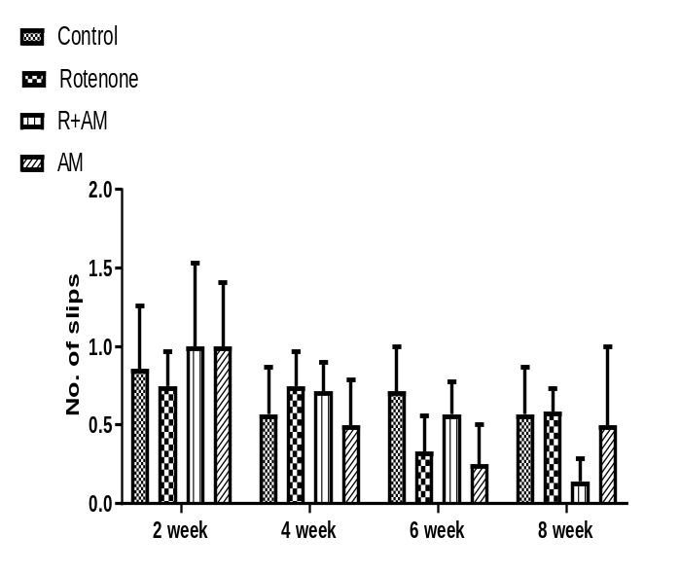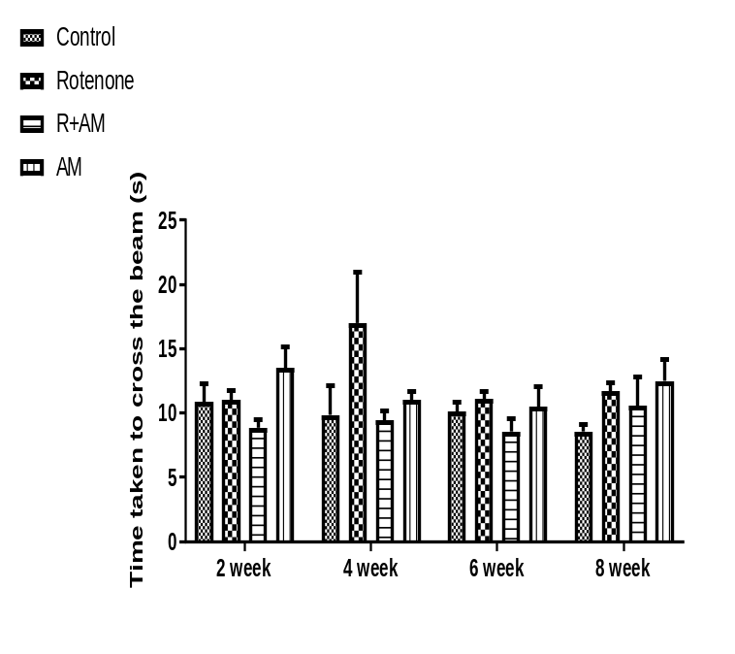
B.
A.
Figure 1:

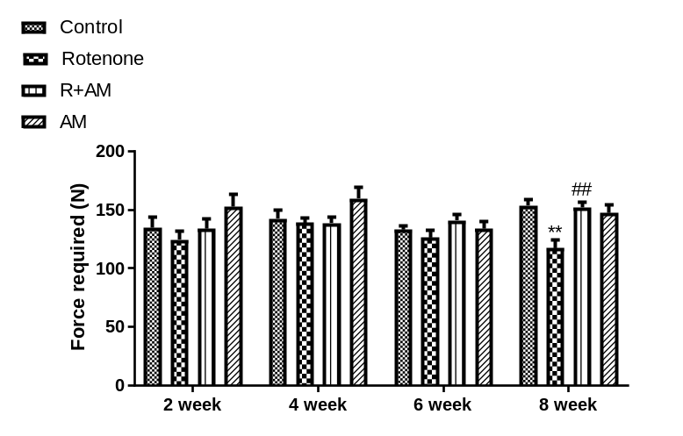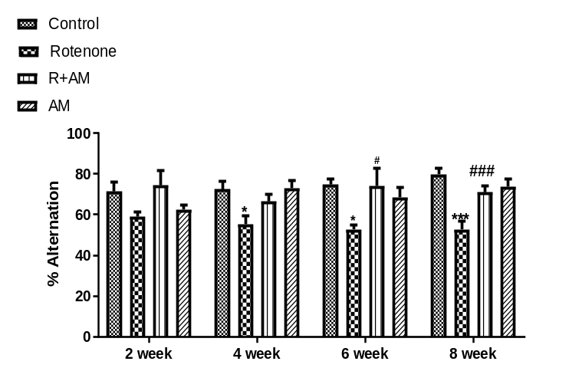
D.
C.

Fig 1: Effect of alpha mangostin starting from 2nd, 4th, 6th, and 8th on behavioral parameters in rotenone induced Parkinson’s mice model. a) Time taken to cross the beam, b) Number of foot slips are from the round beam walk test c) Muscle strength in grip strength test and d) Memory impairment in Y-maze test. Data is presented as Mean ± SEM (n=5). **p < 0.01, ***p < 0.001 vs control group, ##p < 0.01, ###p < 0.001 vs rotenone group. Statistical analysis was performed using one-way analysis of variance (ANOVA) followed by Tukey’s test.

