Supplementary information

Acoustic vortex tweezers selectively manipulated intelligent microbots to achieve in situ explosive antibody production for precise immunotherapy

Ya et al

Supplementary Figures
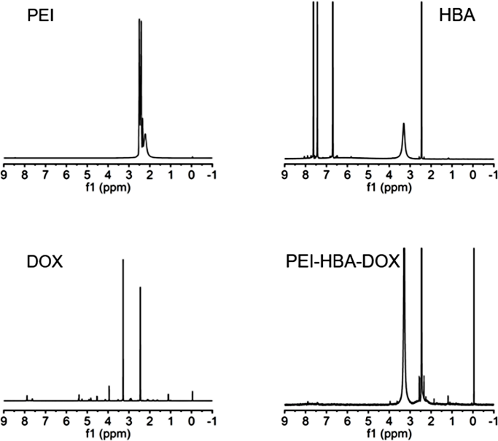
Supplementary Figure 1. ¹HNMR spectra of PEI, HBA, DOX and PEI-HBA-DOX.
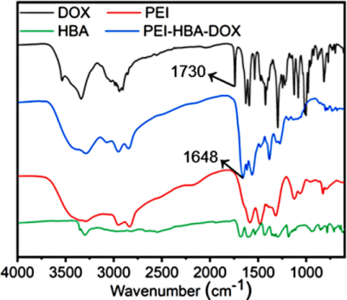
Supplementary Figure 2. FITR spectra of HBA, DOX, PEI, and PEI-HBA-DOX.
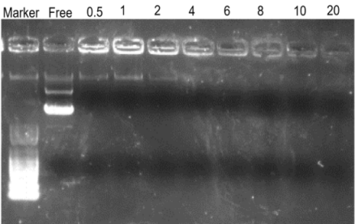
Supplementary Figure 3. Agarose gel electrophoresis analysis.

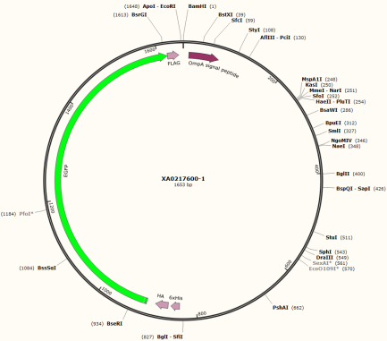
Supplementary Figure 4. The map of plasmid sequence.
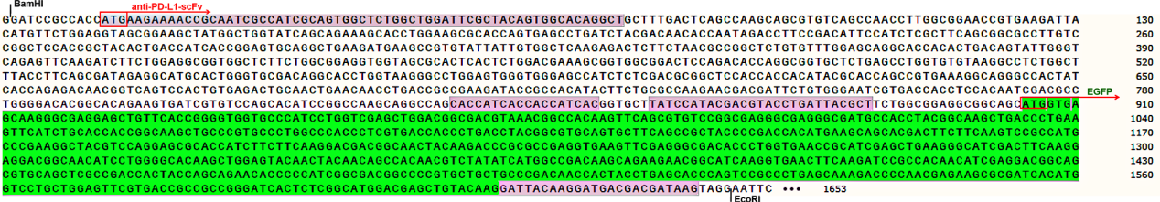
Supplementary Figure 5. The sequence of plasmid that conjugating anti-PD-L1-scFv with EGFP. The original sequence of anti-PD-L1-scFv was obtained from the previous study [x].
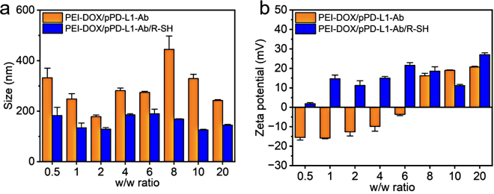
Supplementary Figure 6. Size distribution and Zeta potential of polyplex in different w/w ratio.
Supplementary Figure 7. TEM image of CD/pAb@Lip.
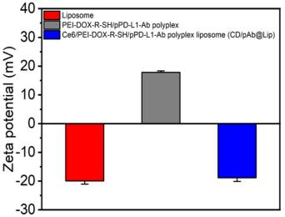
Supplementary Figure 8. Zeta potential of different particles.
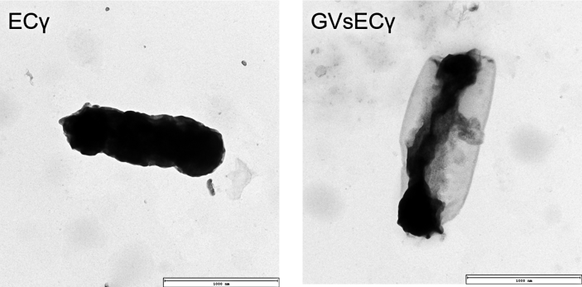
Supplementary Figure 9. TEM image of ECγ and GVsECγ.
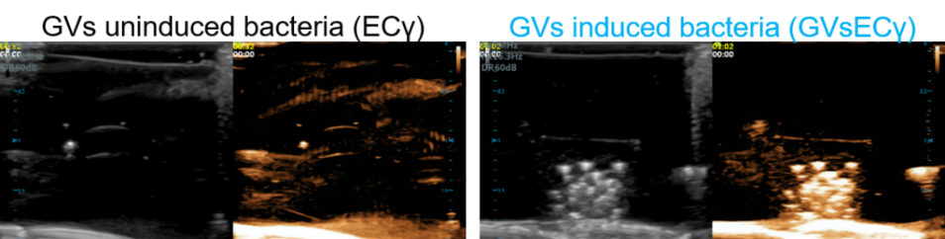
Supplementary Figure 10. Ultrasonic images of ECγ and GVsECγ
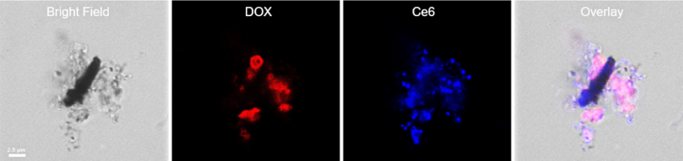
Supplementary Figure 11. Fluorescent image of CD/pAb@Lip@GVsECγ.
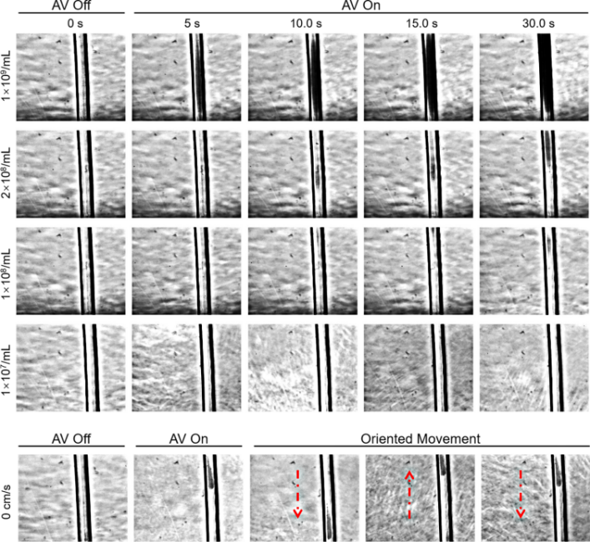
Supplementary Figure 12. In vitro AV manipulation of CD/pAb@Lip@GVsECγ in different concentration.
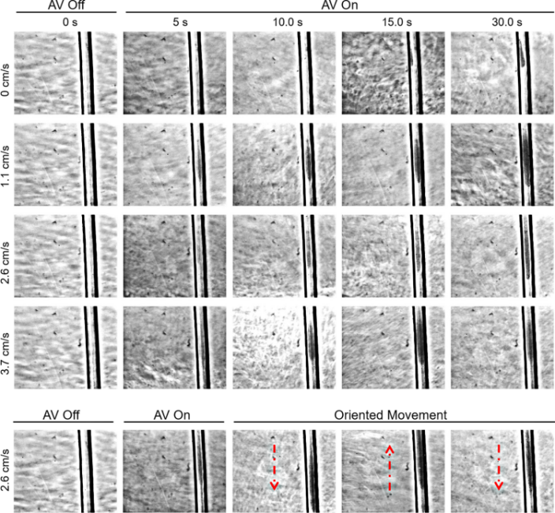
Supplementary Figure 13. In vitro AV manipulation of CD/pAb@Lip@GVsECγ in different flow velocity.
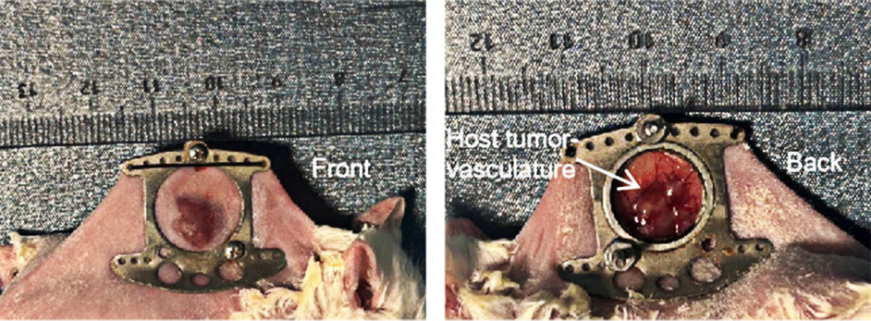
Supplementary Figure 14. Establish of tumor window chamber model.
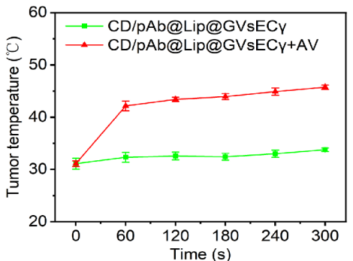
Supplementary Figure 15. Temperature change of tumor during AV irradiation.
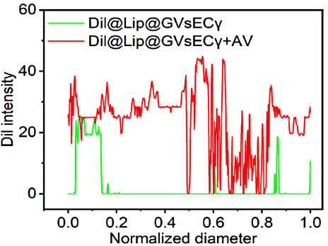
Supplementary Figure 16. Fluorescence intensity analysis of tumor section after AV irradiation.
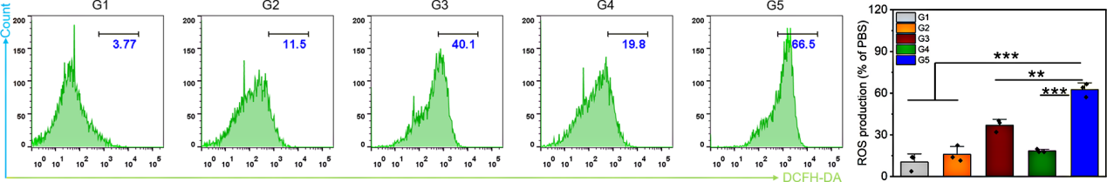
Supplementary Figure 17. ROS detection in different groups at celluar level. Noted: G1: PBS, G2: FAV, G3: CD@Lip@GVsECγ + AV, G4: CD/pAb@Lip@GVsECγ, G5: CD/pAb@Lip@GVsECγ + AV.
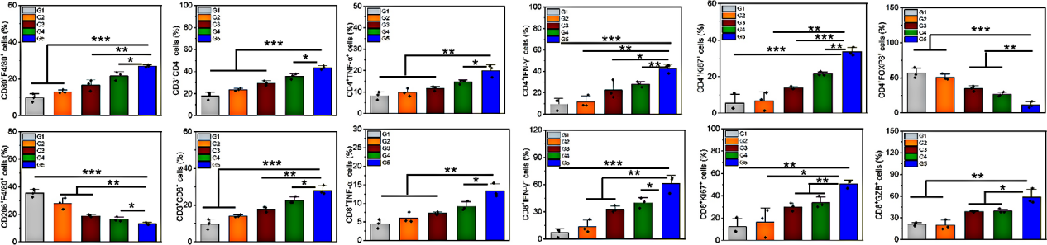
Supplementary Figure 18. Quantitative analysis of immune cell infiltration in primary tumor. Noted: G1: PBS, G2: FAV, G3: CD@Lip@GVsECγ + AV, G4: CD/pAb@Lip@GVsECγ, G5: CD/pAb@Lip@GVsECγ + AV.
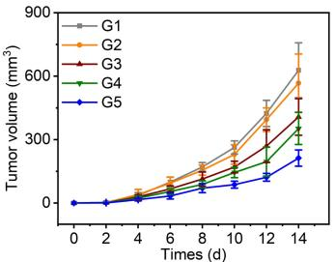
Supplementary Figure 19. Distant tumor growth in different groups within 14 days. Noted: G1: PBS, G2: FAV, G3: CD@Lip@GVsECγ + AV, G4: CD/pAb@Lip@GVsECγ, G5: CD/pAb@Lip@GVsECγ + AV.
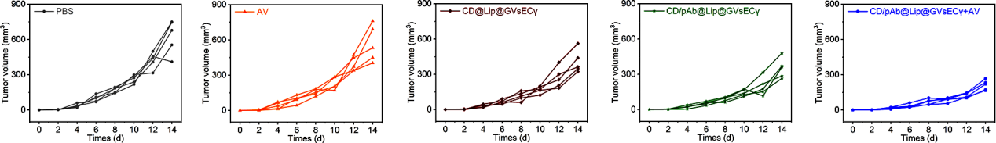
Supplementary Figure 20. Individual distant tumor growth in different groups within 14 days.
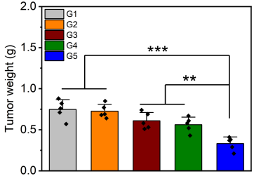
Supplementary Figure 21. In vitro tumor weighing in different groups after treatments. Noted: G1: PBS, G2: FAV, G3: CD@Lip@GVsECγ + AV, G4: CD/pAb@Lip@GVsECγ, G5: CD/pAb@Lip@GVsECγ + AV.
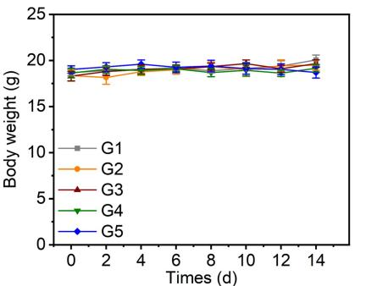
Supplementary Figure 22 Body weight change in different groups within 14 days. Noted: G1: PBS, G2: FAV, G3: CD@Lip@GVsECγ + AV, G4: CD/pAb@Lip@GVsECγ, G5: CD/pAb@Lip@GVsECγ + AV.
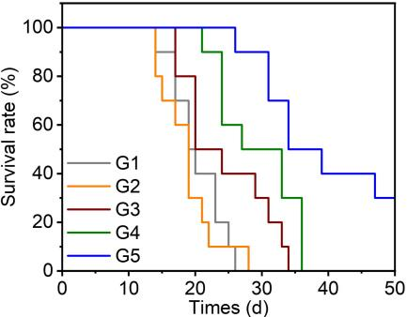
Supplementary Figure 23. Survival rate of mice in different groups within 50 days. Noted: G1: PBS, G2: FAV, G3: CD@Lip@GVsECγ + AV, G4: CD/pAb@Lip@GVsECγ, G5: CD/pAb@Lip@GVsECγ + AV.
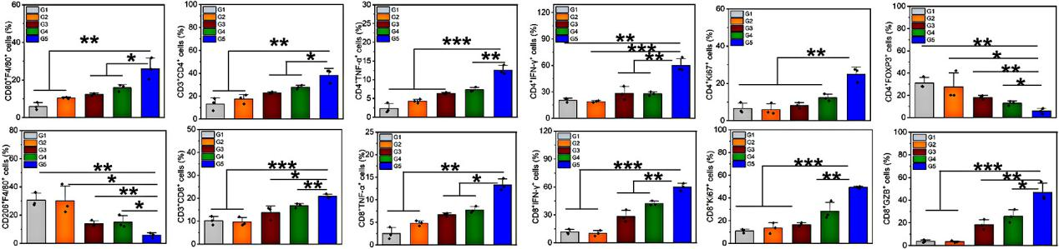
Supplementary Figure 24. Quantitative analysis of immune cell infiltration in distant tumor. Noted: G1: PBS, G2: FAV, G3: CD@Lip@GVsECγ + AV, G4: CD/pAb@Lip@GVsECγ, G5: CD/pAb@Lip@GVsECγ + AV.

