Supporting Information

Title: Isolation and Characterization of a Penta(imido)uranate Tetraanion

Authors: Kelly L. Gullett,¹ Clara L. Silva,^{2,3,4} Arturo Sauza-de la Vega,⁵ Thomas E. Shaw,² Felipe A. Pereiro,^{2,6} Tyler S. Collins,¹ Ezra J. Coughlin,¹ Ekaterina Lapsheva,⁷ Nickolas H. Anderson,¹ Carlo Gaggioli,⁵ Matthias Zeller,¹ Monica S. Mullis,² Jenifer C. Shafer,⁶ Stosh A. Kozimor,² Laura Gagliardi,⁵ Eric J. Schelter,⁷ and Suzanne C. Bart¹ *

Affiliations:
¹ H.C. Brown Laboratory, James Tarpo Jr. and Margaret Tarpo Department of Chemistry, Purdue University, West Lafayette, IN 47907, United States
² Chemistry Division, Los Alamos National Lab, Los Alamos, New Mexico 87545, United States
³ The Rossendorf Beamline at ESRF—The European Synchrotron, CS40220, 38043, Grenoble Cedex, France
⁴ Helmholtz-Zentrum Dresden-Rossendorf (HZDR), Institute of Resource Ecology, 01314, Dresden, Germany
⁵ Department of Chemistry, University of Chicago, Chicago, Illinois 60637, United States;
Pritzker School of Molecular Engineering, University of Chicago, Chicago, Illinois 60637, United States
⁶ Department of Chemistry, Colorado School of Mines, Golden, CO 80401, United States
⁷ Vagelos Laboratory for Energy Science and Technology, Department of Chemistry, University of Pennsylvania, Philadelphia, PA 19104, USA

Table of Contents:

General Considerations…………………………………………………………………………..S3
Synthetic Procedures……………………………………………………………………………..S5
Spectroscopy……………………………………………………………………………………..S6
Magnetism……………………………………………………………………………………...S12
XANES…………………………………………………………………………………………S13
Crystallography……………………………………………………………………………...….S15
Computational Details……………...………………………………………………… ………..S23
References………………………………………………………………………………………S29

General Considerations. All air- and moisture-sensitive manipulations were performed using standard Schlenk techniques or in an MBraun inert atmosphere drybox with an atmosphere of purified nitrogen. The MBraun drybox was equipped with two −35 °C freezers for cooling samples and crystallizations. Solvents for sensitive manipulations were dried and deoxygenated using literature procedures with a Seca solvent purification system.¹ Benzene-d₆ was purchased from Cambridge Isotope Laboratories, dried with molecular sieves and sodium, and degassed by three freeze−pump−thaw cycles. Potassium graphite², UI₂(NDIPP)THF_{4,}³ UI₂(NDIPP)₂THF₄,⁴ U(NDIPP)₃THF₄,⁵ [U(NDIPP)₄]K₂,⁶ [U(NDIPP)₄]Li₂,⁶ [U(NDIPP)₄]Cs₂,⁶ and 2,6-diisopropylphenyl azide⁷ were synthesized according to literature procedures.

Caution: U-238 is a weak α-emitter with a half-life of t_{1/2} = 4 × 10⁹ years. All manipulations were performed in an inert atmosphere glovebox in a laboratory equipped with proper detection equipment.

¹H NMR spectra were recorded at 25 °C on a Bruker AV400 spectrometer operating at a frequency of 400 MHz, or a Bruker NEO-500 instrument operating at a frequency of 500 MHz. All chemical shifts are reported relative to the peak for SiMe₄, using ¹H (residual) chemical shifts of the solvent as a secondary standard. ¹³C(¹H) NMR spectra were recorded on a Bruker Avance-III 800 MHz instrument operating at a frequency of 201.19 MHz. For all molecules, the NMR data are reported with the chemical shift, followed by the multiplicity, any relevant coupling constants, the integration value, and the peak assignment. Inversion recovery experiments were conducted on a Bruker NEO-500 instrument operating at a frequency of 500 MHz at room temperature and analyzed using TopSpin 4.4.1.
Infrared spectra were recorded using a Thermo Nicolet 6700 spectrometer; samples were prepared by using KBr salt plates. Elemental analyses were performed by Midwest Microlab (Indianapolis, IN). Samples for variable temperature and variable field magnetic measurements were precisely weighed and packed into plastic drinking straws with 10 mg quartz wool. DC moment magnetic measurements were performed on a Quantum Design MPMS 7 Tesla magnetometer. Diamagnetic corrections were made using Pascal constants.⁸
Single crystals of [K(Et₂O)]₄[U(NDIPP)₅] 1-K4 (CCDC:2497540) suitable for X-ray diffraction, were coated with poly(isobutylene) oil in a glovebox and quickly transferred to the goniometer head of a Bruker Quest diffractometer with a fixed chi angle, a sealed fine-focus X-ray tube, single-crystal curved graphite incident beam monochromator and a Photon100 CMOS area detector. Examination and data collection were performed with Mo Kα radiation (λ = 0.71073 Å). Data were collected with Oxford Cryosystems low temperature devices operating at 150 K. Data were collected, reflections were indexed and processed, and the files scaled and corrected for absorption using APEX3⁹ and Sadabs.¹⁰
Single crystals of Li₂[U(UNHDIPP)₂(NDIPP)₃] 2-Li2 (CCDC:2497539) suitable for X-ray diffraction, were coated with poly(isobutylene) oil in a glovebox and quickly transferred to the goniometer head of a Nonius KappaCCD diffractometer equipped with a graphite crystal incident beam monochromator and examined with Mo Kα radiation (λ = 0.71073 Å). They were cooled in-situ to 150(2) K and examined with Mo Kα radiation (λ = 0.71073 Å). Data were collected using the Nonius Collect software¹¹, processed using HKL3000¹² and data were corrected for absorption and scaled using Scalepack.¹²

For both structures the space groups were assigned and the structures were solved by direct or dual methods using XPREP within the SHELXTL suite of programs¹⁴ and refined by full matrix least squares against F² with all reflections using Shelxl2019^{15,16} using the graphical interface Shelxle.¹⁷ H atoms attached to C atoms were positioned geometrically and constrained to ride on their parent atoms, with carbon hydrogen bond distances of 0.95 Å for and aromatic C-H, 1.00, 0.99 and 0.98 Å for aliphatic C-H, CH₂ and CH₃ moieties, respectively. Methyl H atoms were allowed to rotate, but not to tip, to best fit the experimental electron density. For treatment of H atoms bonded to N atoms, see the details provided for each structure. U_{iso}(H) values were set to a multiple of U_{eq}(C) with 1.5 for N-H and CH₃, and 1.2 for CH₂ and C-H units, respectively.

U L₃ – Edge XANES Measurements.

Sample preparation for XANES of UI₂(NDIPP)THF_{3,} U(NDIPP)₃THF₄, [U(NDIPP)₄]K₂, [U(NDIPP)₄]Cs₂, and 1. Uranium complexes were synthesized at Purdue University and prepared for the XANES investigations at Los Alamos National Laboratory (LANL). In an argon filled glovebox and with rigorous exclusion of air and moisture, samples were diluted with boron nitride (BN; dried at 200 ºC under vacuum, 10^{–3} torr, 24 h), such that the U L₃-edge jump was calculated to be at 0.1 absorption length. In general, ~4 mg of sample was combined with ~116 mg of BN in a polycarbonate tube. A Teflon ball was added, the tube capped, and the sample ground in a Wig-L-Bug grinder/mixer (2 min). The intimate mixture was then loaded into a Teflon tube (3 mm inner diameter, 4 mm outer diameter). The powder was packed with a plunger to give a pellet. This quantity of sample and BN typically filled the tube by 2 cm. A Teflon plug was slid into the tube. This plug sealed the tube and butted against the sample plug. The tube was loaded into two nested aluminum sample holders equipped with Kapton windows. One set of windows was glued on, and one set was sealed with indium wire. Under argon atmospheres, the samples were sealed in plastic jars that were taped shut. The assembly was brought out of the glovebox, and shipped to the Stanford Synchrotron Lightsource, SSRL. Once unpackaged, the samples were immediately attached to the cold finger of a liquid N₂ cryostat, loaded into the cryostat, and the cryostat was quickly evacuated (10⁻⁵ Torr). The cryostat was attached to the beamline 11-2 XAFS rail (SSRL).
Data Acquisition and Analysis. The U L₃-edge XANES measurements were performed at SSRL under dedicated operating conditions (3.0 GeV, 5%, 500 mA) at beamline 11-2. This beamline was equipped with a 26-pole and a 2.0 tesla wiggler. A double-crystal monochromator with Si(111) crystals (φ = 0º) was used. The beam was fully tuned, and higher harmonics were rejected by a Rh harmonic rejection mirror. The 11-2 beamline rail consisted of three ionization chambers (30 cm long) through which nitrogen gas was continuously flowed. A potential of 1600 V was applied to the ion chambers. One chamber was positioned before the cryostat to monitor the incident radiation (I₀; nitrogen). The second chamber was positioned after the cryostat so that sample transmission (I₁; nitrogen) could be evaluated against I₀ and so that the absorption coefficient (μ) could be calculated as ln(I₀/I₁). The third chamber (I₂; nitrogen) was positioned downstream from I₁ so that the XANES of a calibration foil could be measured against I₁. Samples were calibrated in-situ to the energy of the first inflection point of the K-edge of an yttrium foil (17038.4 eV). There were also upstream slits (before I₀) controlling the beam size. They were set to 0.5 mm (vertical) by 3 to 4 mm (horizontal). Samples were positioned within the cryostat at 45º to the incident radiation so that data could be collected in both transmission and fluorescence modes. The cryostat was also filled with liquid nitrogen, such that thermal conductivity cooled the samples to a temperature estimated to be >77 K. The fluorescence signal was measured with a 100-element solid state Ge detector. Between the detector and the cryostat was a set of Soller slits and a Sr filter (3 absorption lengths). Spectra were collected in duplicate, after radiation damage studies had been conducted. These radiation damage studies involved collecting a series of five fast XANES measurements to check for any variation in absorption peak intensity and energy.
For the data analysis, the U L₃-edge XANES data were calibrated in energy to the first inflection point of the Y K-edge (17038.4 eV). Within the Igor platform, data were deadtime corrected and averaged. Within the ATHENA¹⁹ software, the data were analyzed by fitting a line to the pre-edge region of the spectrum. Subsequently subtracting this line from the experimental data eliminated the background of the spectrum. Those data were then normalized by fitting a first-order polynomial to the post-edge region of the spectrum and setting the edge jump to an intensity of 1.0. This normalization procedure gave spectra normalized to a single U atom.²⁰⁻³⁰

Synthesis of [K(Et₂O)]₄[U(NDIPP)₅] (1-K4) from UI₃(THF)₄
A 20-mL scintillation vial was charged with UI₃(THF)₄ (0.150 g, 0.165 mmol) and toluene (10 mL) and stirred for five minutes making a royal blue solution. Five equivalents of 2,6-diisopropylphenyl azide (N₃DIPP) (0.163 g, 0.802 mmol) were added to the vial and stirred for 15 minutes, causing the color to change to dark amber-red. The reaction was then frozen in the coldwell using liquid nitrogen. Upon thawing, seven equivalents of solid KC₈ (0.156 g, 1.155 mmol) were carefully added to the vial all at once. This was stirred for 20 min to allow loss of N₂ gas, which was evident by bubbling of the reaction. The vial was then capped and allowed to stir for 3 hours. After this time, the black reaction mixture was filtered through Celite and the Celite washed with toluene until the washings came out clear. This solution was then dried to a black residue. The residue was dissolved in diethyl ether (3 mL) and dried (x2), leaving a matte black powder assigned as [U(NDIPP)₅][K(Et₂O)]₄ (0.150 g, 77 %). Repetition of the experiment with one additional equivalent of N₃DIPP and two additional equivalents of KC₈ increase the overall yield to 94%. Elemental Analysis, calculated: C 56.71%, H 6.74%, N 5.51%, found: C 56.07%, H 7.01%, N 5.13%. ¹H NMR (C₇D₈, ambient temperature) δ: 1.09-1.22 (60 H, d, i-Pr CH₃), 4.14 (6 H, sext, i-Pr CH), 4.92 (3 H, t, para-Ar-H), 5.10 (4 H, sext, i-Pr CH), 5.96 (2 H, t, para-Ar-H), 7.71 (4 H, d, meta-Ar-H), 7.92 (6 H, d, meta-Ar-H). IR (KBr salt plate, cm⁻¹): 497 w, 507 w, 697 w, 747 m, 856 m, 881 m, 1109 w, 1136 m, 1222 s (v_{N-U-N}), 1318 s, 1339 s, 1460 m, 1577 s, 2864 m, 2957 s, 3032 w.

Synthesis of 1-K4 from UI₂(NDIPP)(THF)₃
Using the same solvents, reaction conditions and workup procedure as for 1-K4 from UI₃(THF)₄, four equivalents of N₃DIPP (0.079 g, 0.389 mmol) were added to UI₂(NDIPP)(THF)₃ (0.100 g, 0.097 mmol), and six equivalents of KC₈ (0.079, 0.585 mmol) were used. A matte black powder assigned as [U(NDIPP)₅][K(Et₂O)]₄ (0.117 g, 77 %) was recovered.

Synthesis of 1-K4 from UI₂(NDIPP)₂(THF)₃
Using the same solvents, reaction conditions and workup procedure as for 1-K4 from UI₃(THF)₄, three equivalents of N₃DIPP (0.107 g, 0.526 mmol) were added to UI₂(NDIPP)₂(THF)₃ (0.200 g, 0.177 mmol), and six equivalents of KC₈ (0.143 g, 1.06 mmol) were used. A matte black powder assigned as [U(NDIPP)₅][K(Et₂O)]₄ (0.177 g, 64 %) was recovered.

Synthesis of 1-K4 from U(NDIPP)₃(THF)₄
Using the same solvents, reaction conditions and workup procedure as for 1-K4 from UI₃(THF)₄, two equivalents of N₃DIPP (0.083 g, 0.408 mmol) were added to (0.200 g, 0.204 mmol) of U(NDIPP)₃(THF)₄, and four equivalents of KC₈ (0.110 g, 0.814 mmol) were used. A matte black powder assigned as [U(NDIPP)₅][K(Et₂O)]₄ (0.222g, 69 %) was recovered.

Synthesis of 1-K4 from [U(NDIPP)₄]K₂
Using the same solvents, reaction conditions and workup procedure as for 1-K4 from UI₃(THF)₄, one equivalent of N₃DIPP (0.050 g, 0.246 mmol) was added to [U(NDIPP)₄]K₂ (0.250 g, 0.246 mmol), and two equivalents of KC₈ (0.060 g, 0.444 mmol) were used. A matte black powder assigned as [U(NDIPP)₅][K(Et₂O)]₄ (0.234 g, 61 %) was recovered.

Synthesis of Li₂[U(UNHDIPP)₂(NDIPP)₃] (2-Li2) from [U(NDIPP)₄]Li₂
Crystallization of [U(NDIPP)₄]Li₂ in the presence of one equivalent of NH₂DIPP in a concentrated THF/Pentane 1:1 mixture at -35 ºC allowed for the isolation of brown crystals assigned as [U(NDIPP)₃(NHDIPP)₂]Li₂. Attempts to obtain additional spectroscopic information about this complex were complicated by an equilibrium between free aniline and [U(NDIPP)₄]Li₂.

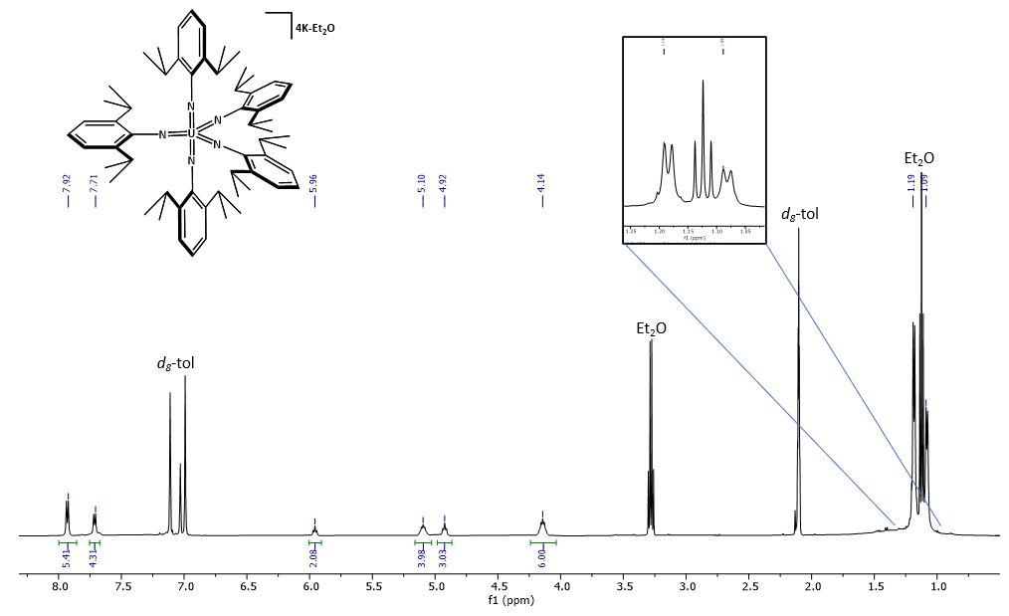
Figure S1. ¹H NMR spectrum of 1-K4 (500 MHz, C₇D₈, 25 °C).

Table S1. Calculated T₁ relaxation time for selected ¹H NMR signals, measured in C₆D₆. Values are reported as averages from inversion recovery experiments run in triplicate using TopSpin 4.4.1.
Resonance (ppm) | T1 relaxation (s)
4.14 | 0.535
4.92 | 1.110
5.10 | 0.548
5.96 | 1.215

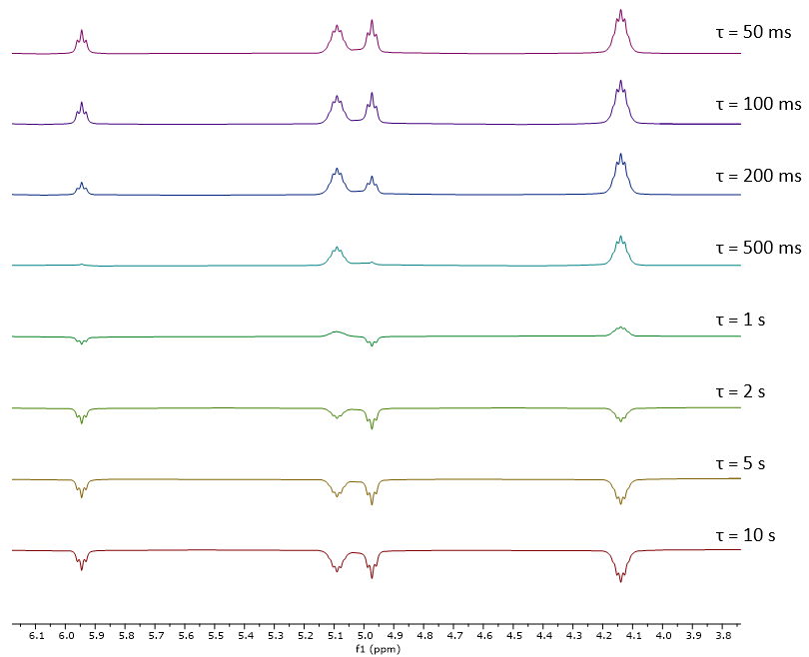
Figure S2. ¹H (500 MHz, C₆D₆ , 25 °C) inversion recovery experiments for 1-K4.
Figure S3. ¹³C{¹H} NMR spectrum of 1-K4 (800 MHz, C₇D₈, 25 °C).

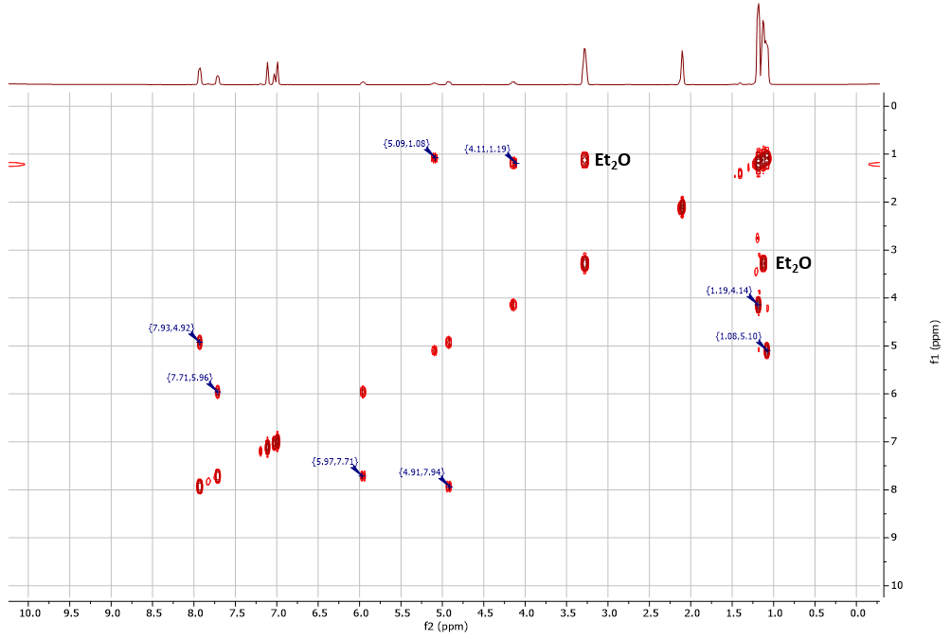
Figure S4. COSY 2D ¹H NMR spectrum of 1-K4 (500 MHz, C₇D₈, 25 °C).
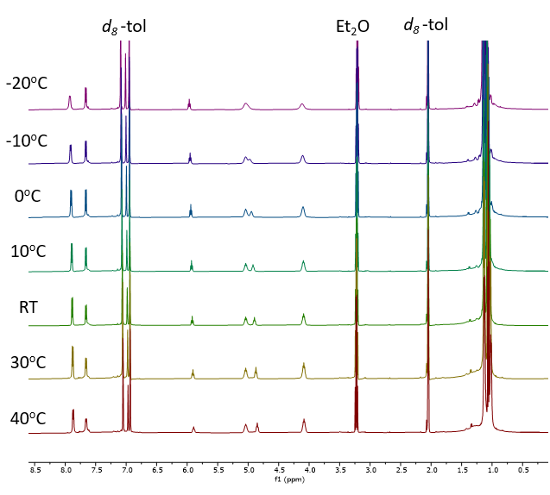
Figure S5. Variable temperature (253K – 313K) ¹H NMR spectra of 1-K4 (500 MHz, C₇D₈).

Figure S6. Infrared spectrum of 1-K4 (KBr Salt Plate). Absorption at 2279 cm⁻¹ is assigned to C₆D₆ that was present in the sample.

Figure S7. Electronic absorption spectra (UV-Vis region) of 1-K4 recorded in THF at 25 °C.
Figure S8. Electronic absorption spectra (NIR region) of 1-K4 recorded in THF 25 °C. Notably, sharp f-f transitions are absent, corroborating the assignment of a U(VI) oxidation state for each molecule.
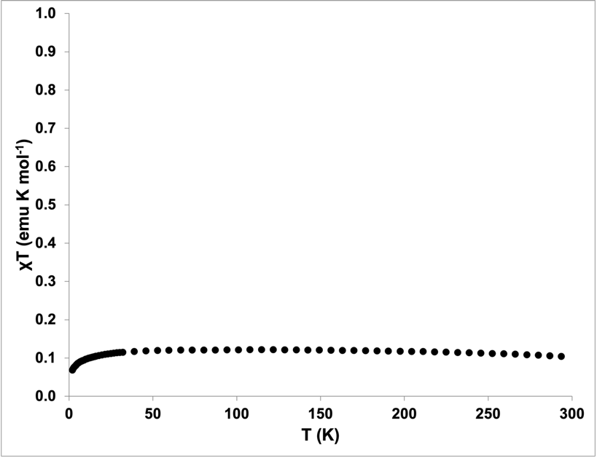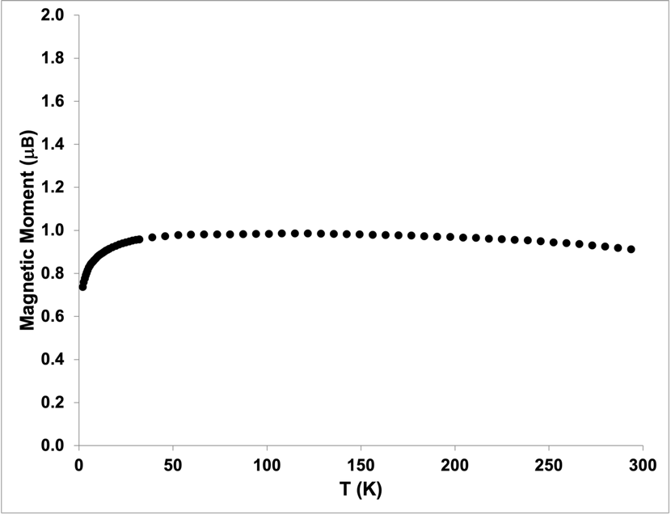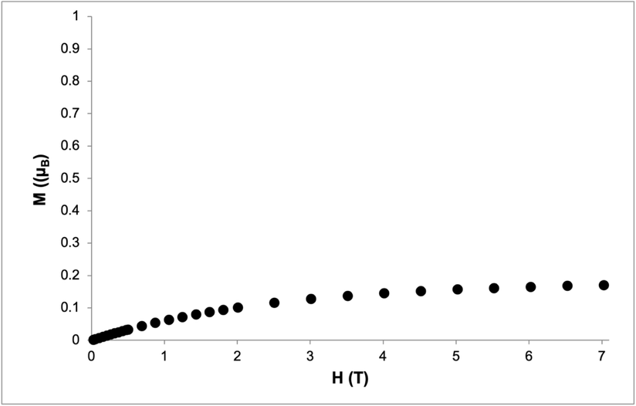
Figure S9. Variable temperature and variable field magnetic data collected for 1-K4. Temperature dependent data (top, middle) were collected at 1 T. M v H data (bottom) were collected at 2 K.

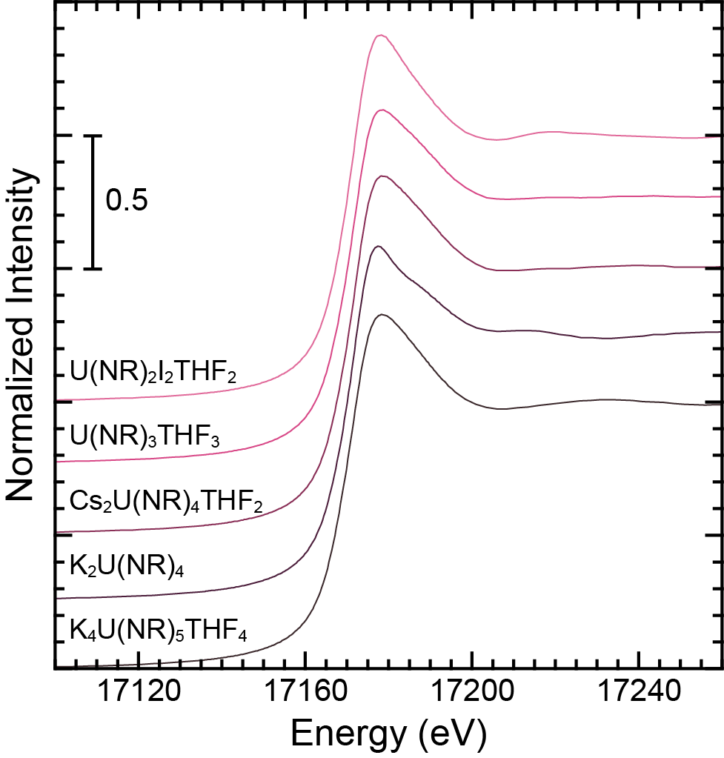
Figure 10. Background subtracted and normalized U L₃-edge XAS spectra from U(NR)₂I₂THF₂, U(NR)₃THF₃, Cs₂U(NR)₄THF₂, K₂U(NR)₄, [K(crypt)]₄U(NR)₅, and K₄U(NR)₅THF₄ (R = 2,6-diisopropylphenyl) collected in the solid-state and at low temperature.
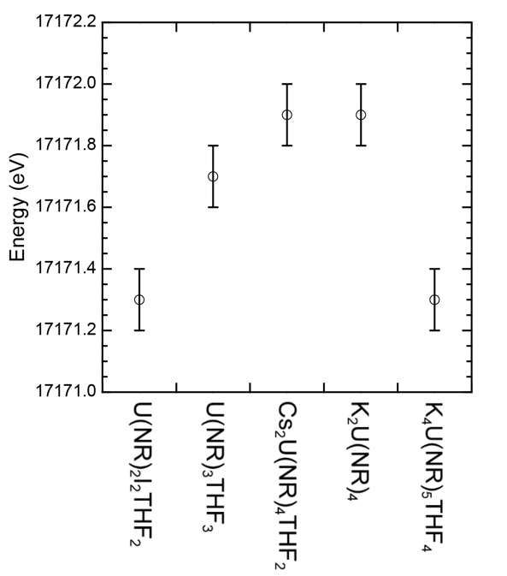
Figure 11. Inflection point energies obtained from U L₃-edge XAS data for the U(NR)₂I₂THF₂, U(NR)₃THF₃, Cs₂U(NR)₄THF₂, K₂U(NR)₄, and K₄U(NR)₅THF₄ (R = 2,6-diisopropylphenyl) series of uranium imido complexes.

Table 2. Inflection points determined for U L₃-edge XAS data obtained from the uranium complexes varying the amount of imido ligands bound to it (bottom to top).
Compound | Inflection Point (eV)
U(NR)₂I₂(THF)₂ | 17171.3(1)
U(NR)₃(THF)₃ | 17171.7(1)
Cs₂U(NR)₄(THF)₂ | 17171.9(1)
K₂U(NR)₄ | 17171.9(1)
K₄U(NR)₅(THF)₄ | 17171.3(1)

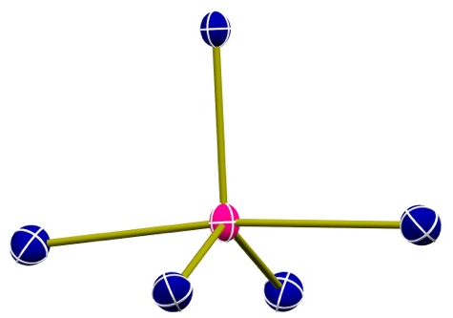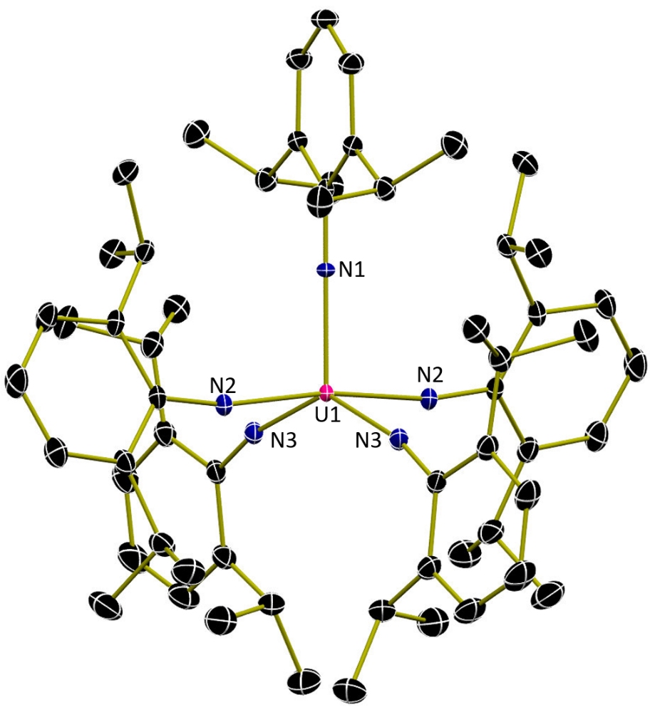
Figure S12. Molecular structure of 1-K4 shown with 30% probability ellipsoids. This side-on view shows geometry around the uranium ion, which is intermediate of trigonal bipyramidal and square pyramidal. Hydrogen atoms, potassium ions, and potassium coordinated co-crystallized solvent molecules have been omitted for clarity.

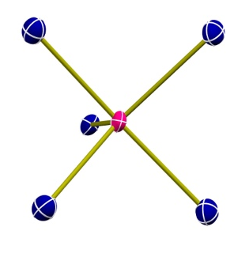
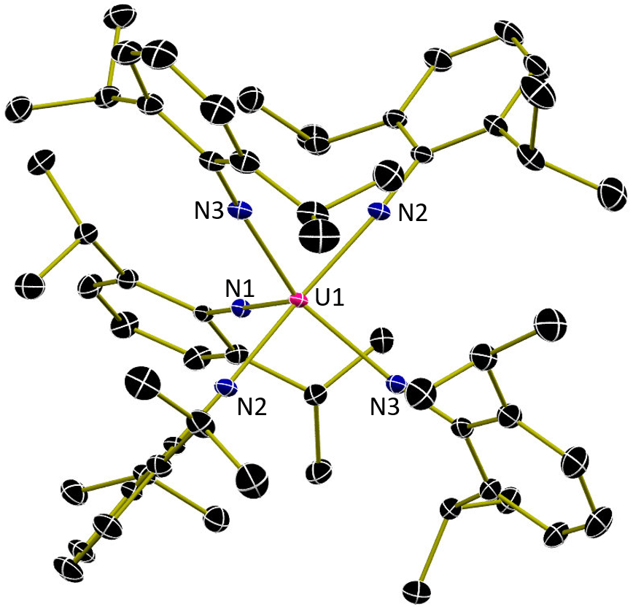
Figure S13. Molecular structure of 1-K4 shown with 30% probability ellipsoids. This bottom-up view shows the geometry around the uranium ion, which is intermediate of trigonal bipyramidal and square pyramidal. Hydrogen atoms, potassium ions, and potassium coordinated co-crystallized solvent molecules have been omitted for clarity.
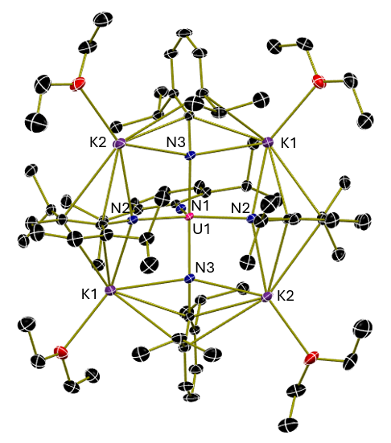
Figure S14. Molecular structure of 1-K4 shown with 30% probability ellipsoids. Hydrogen atoms have been omitted for clarity.
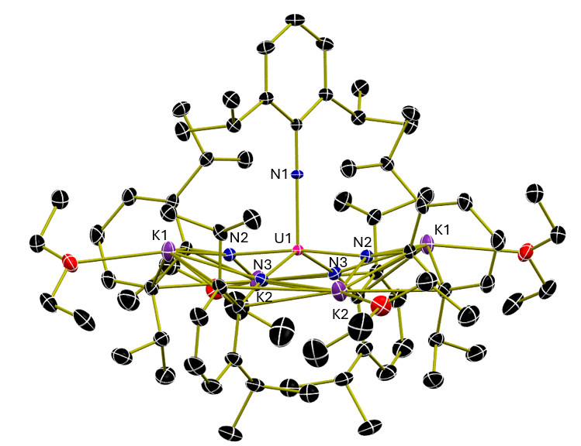
Figure S15. Molecular structure of 1-K4 shown with 30% probability ellipsoids. Hydrogen atoms and have been omitted for clarity.

Table S3: Selected metrical parameters of 1-K4.
Selected Atoms | Bond Distance/Angle (Å,°)
U1-N1 | 2.0818(19)
U1-N2 | 2.1502(16)
U1-N3 | 2.2071(16)
N1-U1-N2 | 93.99(4)
N1-U1-N3 | 109.33(4)
N2-U1-N2 | 172.03(9)
N2-U1-N3 | 88.69(6)
N3-U1-N3 | 141.34(9)
U1-N1-C1 | 180.0(0)
U1-N2-C8 | 169.65(14)
U1-N3-C20 | 168.59(14)

Table S4: Experimental details of 1-K4.
CCDC number | 2497540
Empirical formula | C₇₆H₁₂₅K₄N₅O₄U
Formula weight | 1567.23
Temperature [K] | 150(2)
Crystal system | orthorhombic
Space group (number) | $Ibca$ (73)
a [Å] | 23.0613(9)
b [Å] | 21.5918(8)
c [Å] | 31.8077(12)
α [°] | 90
β [°] | 90
γ [°] | 90
Volume [Å³] | 15838.2(10)
Z | 8
ρ_{calc} [gcm⁻³] | 1.315
μ [mm⁻¹] | 2.307
F(000) | 6528
Crystal size [mm³] | 0.200×0.200×0.200
Crystal colour | Black
Crystal shape | Cube
Radiation | MoK_{α} (λ=0.71073 Å)
2θ range [°] | 5.12 to 59.15 (0.72 Å)
Index ranges | −32 ≤ h ≤ 32  −29 ≤ k ≤ 29  −44 ≤ l ≤ 44
Reflections collected | 106186
Independent reflections | 11097  R_{int} = 0.0216  R_{sigma} = 0.0123
Completeness to θ = 25.242° | 99.9
Data / Restraints / Parameters | 11097 / 0 / 422
Absorption correction T_{min}/T_{max} (method) | 0.5033 / 0.5699  (multi-scan)
Goodness-of-fit on F² | 1.076
Final R indexes  [I≥2σ(I)] | R₁ = 0.0248  wR₂ = 0.0503
Final R indexes  [all data] | R₁ = 0.0345  wR₂ = 0.0572
Largest peak/hole [eÅ⁻³] | 1.44/−0.78

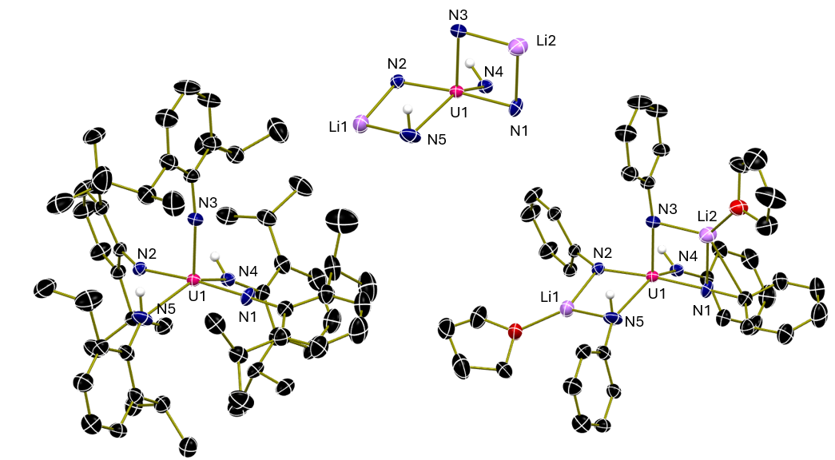
Figure S16. Molecular structure of 2-Li2 shown with 30% probability ellipsoids. (Left) Non-anilido hydrogen atoms, lithium atoms, and lithium coordinated co-crystallized solvent molecules have been omitted for clarity, (top middle) core view, (right) non-anilido hydrogen atoms and isopropyl groups omitted for clarity.
Table S5: Selected metrical parameters of 2-Li2.
Selected Atoms | Bond Distance/Angle (Å,°)
U1-N1 | 2.006(4)
U1-N2 | 2.013(4)
U1-N3 | 2.102(5)
U1-N4 | 2.280(4)
N4-H4N | 0.890(19)
U1-N5 | 2.432(6)
N5-H5N | 0.86(2)
N1-U1-N2 | 174.48(17)
N1-U1-N3 | 89.20(19)
N3-U1-N4 | 112.38(18)
N4-U1-N5 | 144.83(17)
U1-N1-C10 | 179.1(4)
U1-N2-C20 | 148.6(3)
U1-N3-C30 | 166.8(5)
U1-N4-C40 | 150.3(4)
U1-N5-C50 | 156.3(5)

Table S6: Experimental details of 2-Li2.
CCDC number | 2497539
Empirical formula | C₆₈H₁₀₃Li₂N₅O₂U
Formula weight | 1274.46
Temperature [K] | 150(2)
Crystal system | monoclinic
Space group (number) | $P2_{1}/c$ (14)
a [Å] | 19.1169(2)
b [Å] | 16.8263(2)
c [Å] | 23.7598(3)
α [°] | 90
β [°] | 96.5600(10)
γ [°] | 90
Volume [Å³] | 7592.70(15)
Z | 4
ρ_{calc} [gcm⁻³] | 1.115
μ [mm⁻¹] | 2.177
F(000) | 2640
Crystal size [mm³] | 0.300×0.420×0.480
Crystal colour | brown
Crystal shape | block
Radiation | MoK_{α} (λ=0.71073 Å)
2θ range [°] | 2.14 to 54.97 (0.77 Å)
Index ranges | 0 ≤ h ≤ 26  0 ≤ k ≤ 23  −32 ≤ l ≤ 32
Reflections collected | 17390
Independent reflections | 17390  R_{int} = 0.036  R_{sigma} = 0.0565
Completeness to θ = 25.242° | 99.8
Data / Restraints / Parameters | 17390 / 5 / 729
Absorption correction T_{min}/T_{max} (method) | 0.0340 / 0.5200  (multi-scan)
Goodness-of-fit on F² | 1.110
Final R indexes  [I≥2σ(I)] | R₁ = 0.0496  wR₂ = 0.1092
Final R indexes  [all data] | R₁ = 0.0802  wR₂ = 0.1209
Largest peak/hole [eÅ⁻³] | 3.08/−1.93

Additional refinement details for 2-Li2: N-bound H atoms were assigned based on electron density as well as N-U bond lengths of the associated N atoms. N-H distances were restrained to a target value of 0.88(2) Ångström and a mild anti-bumping restraint was applied. The structure contains additional 1609 Å³ of solvent accessible pores. No substantial electron density peaks were found in the solvent accessible pores (less than 2.2 electron per cubic Å) and the residual electron density peaks were only partially arranged in an interpretable pattern (vaguely resembling pentane or ether). The structure factors were instead augmented via reverse Fourier transform methods using the SQUEEZE routine¹⁸ as implemented in the program Platon. The resultant FAB file containing the structure factor contribution from the electron content of the pore space was used together with the original hkl file in the further refinement. (The FAB file with details of the Squeeze results is appended to this cif file). The Squeeze procedure corrected for 364 electrons within the solvent accessible pores.

Computer programs: Apex3 v2016.9-0,⁹ SAINT V8.37A,¹³ SHELXS97,¹⁴ SHELXL2019/2.¹⁵

Computational Details: DFT calculations were performed using the PBE³¹ functional with the D3 dispersion model and Becke-Johnson damping factor³² as implemented in Gaussian 16 rev. C02³³ software package. Geometry optimization calculations were performed for two model structures of the pentakis(imido) uranate (VI) complex, (i) including the four K^+ counterions, and (ii) excluding the counterions. The two models considered singlet states as the ground state with uranium (VI). The model (i) was computed with a total charge of zero, while model (ii) considered a total charge of -4. The SCF procedure considered tolerances of 1x10-6 and 1x10-8 a.u. on the maximum and root-mean-square (RMS) changes in the density matrix, respectively. The thresholds considered for geometry optimizations are 4.5x10-4 and 3x10-4 a.u. on the maximum force and its corresponding RMS. The SDD pseudopotential³⁴ was used for the uranium, and the def2-TZVP basis functions³⁵ were used for all the remaining atoms in both models. The PBE functional was employed, along with Grimme's D3 dispersion correction and the Becke-Johnson damping factor. All structures were confirmed as local minimum energy geometries by computing the molecule's normal modes, where all frequencies were found to be positive.
The optimized structures were further analyzed by performing single-point calculations with all electron basis sets for all atoms and include scalar relativistic effects in the calculation. For this purpose, the relativistic effects were included by using the second-order Douglas- Kroll-Hess Hamiltonian (DKH2)^{36,37} and employing the all-electron basis sets SARC-DKH2³⁸ for uranium and cc-pVTZ-DK³⁹⁻⁴¹ for the H, C, N, and K atoms. Wiberg bond orders for all U N bonding interactions were calculated using the Multiwfn 3.8 program.⁴² In terms of the quantum theory of atoms in molecules (QTAIM),⁴³ the electronic densities were analyzed at both, the optimization (OPT) and single-point (SP) levels of theory using Aimall 2019⁴⁴ software package. We computed the electron density at the bond critical points (ρ(r)) for the corresponding bond paths between the U and the N_{imido} basins.

Figures S17 and S18 display the DFT optimized molecular geometries of complex 1-K4 and 1⁴⁻comp. The differences between the structures are minimal. The root mean square deviation between the two molecules is of 0.761 Å. In Table S7 we can observe the U-N bonds in 1^{4—}comp are closer to each other when comparing with 1-K4. Similarly, in Table S8 we observe the 1^{4—}comp has a larger τ value, indicating this structure is closer to a bipyramid molecule.
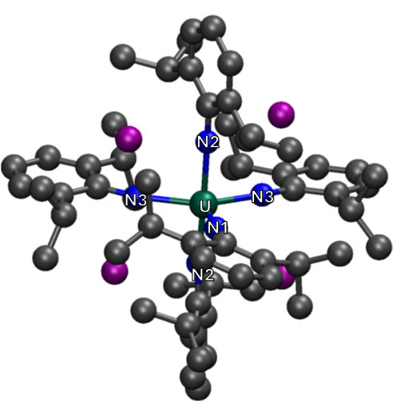
Figure S17. Optimized geometry of 1-K4. The carbon, nitrogen, potassium and uranium atoms are shown in gray, blue, purple and green, respectively as spheres. Hydrogen atoms are hidden for clarity.
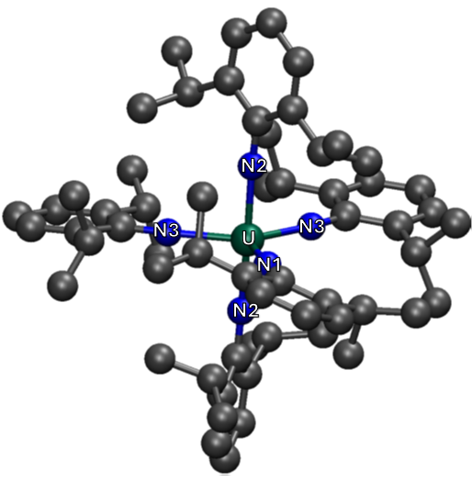
Figure S18. Optimized geometry of 1⁴⁻-comp. The carbon, nitrogen, and uranium atoms are shown in gray, blue, and green, respectively as spheres. Hydrogen atoms are hidden for clarity.
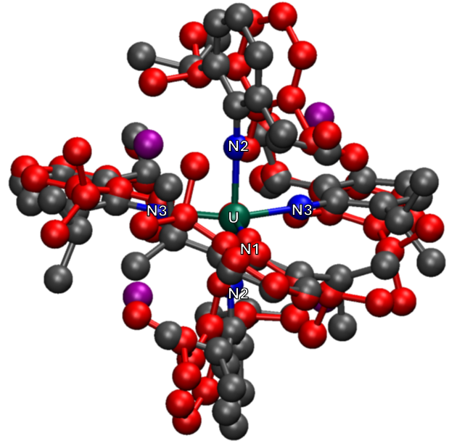
Figure S19. Optimized geometry of 1-4K overlayed with 1⁴⁻-comp. 1-4K is shown in full color while 1⁴⁻-comp is depicted in red. Hydrogen atoms are hidden for clarity.

Table SXX. Comparison of computed Wiberg bond orders, and electron densities at the bond critical points for both, OPT and SP level of theories for the optimized 1-4K molecule.

 | OPT |  | SP
Bond | Bond order | ρ(r) | Bond order | ρ(r)
U-N₁ | 1.95 | 0.13 | 1.91 | 0.14
U-N₂ | 1.71 | 0.12 | 1.63 | 0.12
U-N₃ | 1.54 | 0.10 | 1.47 | 0.11

When using all-electron basis functions for all atoms and DKH2 Hamiltonian, the trends between the U-N bonds remain. However, the value of Wiberg bond orders decreases, while the electron density at the bond critical points increases only for U-N₁ and U-N₃ bonds.

Table S7. Experimental and computational values associated to the U(IV)-N_{imido} bonding interactions of 1-K4 and 1^{4—}comp, Wiberg bond orders and electron densities at the bond critical points The bond length values are reported in Å. (SP): PBE-D3BJ/SARC-DKH2(U), cc-pVTZ-DK(H,C,N,K).
 | Bond | U-N expt | U-N theory | Bond order | ρ(r)
1-K4 | U-N₁ | 2.082 | 2.090 | 1.91 | 0.14
1-K4 | U-N₂ | 2.150 | 2.141 | 1.63 | 0.12
1-K4 | U-N₃ | 2.207 | 2.210 | 1.47 | 0.11
1⁴⁻-comp | U-N₁ |  | 2.161 | 1.70 | 0.12
1⁴⁻-comp | U-N₂ |  | 2.104 | 1.88 | 0.13
1⁴⁻-comp | U-N₃ |  | 2.200 | 1.64 | 0.11
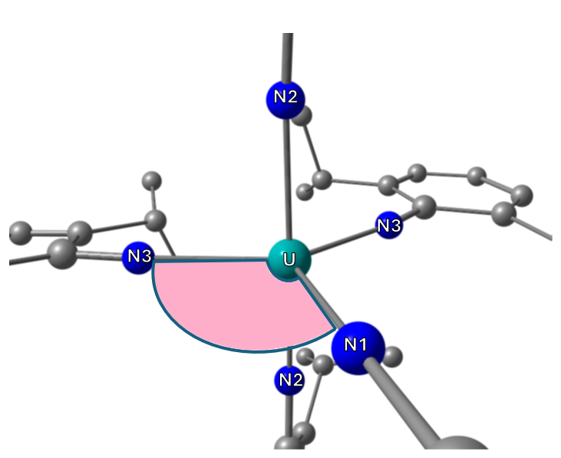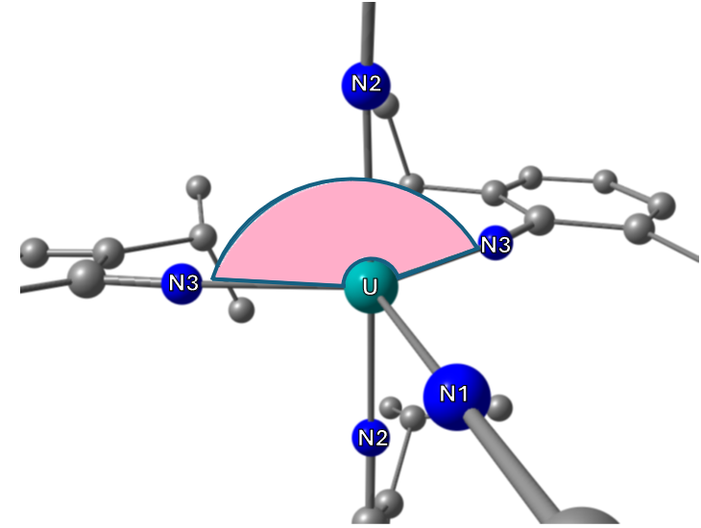
Figure S20. Core image of the geometry optimized structure of 1-K4 with N1-U-N3 (left) and N3-U-N3 (right) angles highlighted. The highlighted angles show the most significant changes between 1-K4 and 1⁴⁻-comp. Hydrogen and potassium atoms omitted for clarity.
Table S8. Experimental and computational N-U-N bond angles of 1-K4 and 1⁴⁻-comp. The bond angle values are reported in degrees.
Bond | U-N expt | 1-K4 | 1⁴⁻-comp
N1-U-N2 | 94.0 | 93.8 | 92.6
N1-U-N3 | 109.3 | 109.5 | 113.1
N2-U-N3 | 88.7 | 89.0 | 87.7
N2-U-N2 | 172.0 | 172.3 | 174.9
N3-U-N3 | 141.3 | 140.8 | 133.8
τ5 | 0.51 | 0.52 | 0.68

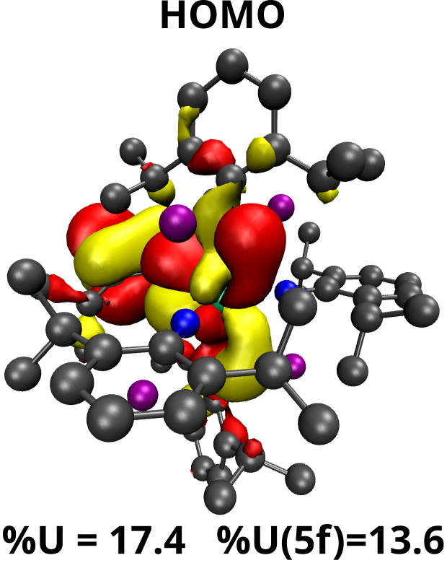
Figure S20. Molecular orbital depictions for the HOMO of 1-K4. %U refers to the total uranium atom contribution while %U(5f) refers to only the 5f orbital contribution to the bonding orbitals, which will remain consistent in the following figure. Hydrogen atoms are omitted for clarity. The HOMO is a π(U=N)-bonding interaction made up of primarily U 5f and N 2p and shows delocalization into the adjacent aromatic ring. The HOMO is primarily isolated onto the one NDIPP substituent which does not interact with the charge balancing potassium atoms.
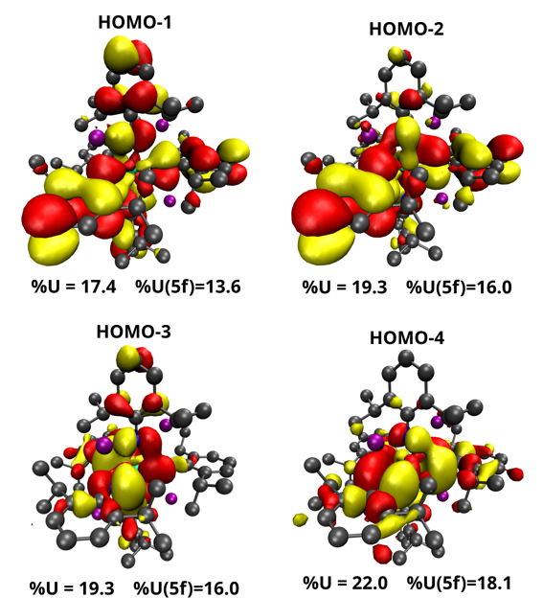
Figure S21. Molecular orbital depictions for the HOMO-1 through HOMO-4 of 1-K4. Hydrogen atoms are omitted for clarity. HOMO-1 through HOMO-4 are additional π(U=N)-bonding interactions made up of primarily U 5f and N 2p and show also delocalization into the adjacent aromatic ring.

Synthetic References:
[1] A. B. Pangborn, M. A. Giardello, R. H. Grubbs, R. K. Rosen, F. J. Timmers, Organometallics 1996, 15, 1518.
[2] C. Soma, C. Jayanta, G. Wenhua, G. W. Edward, Angew. Chem. Int. Ed. 2007, 46, 4486.
[3] R. E. Jilek, L. P. Spencer, D. L. Kuiper, B. L. Scott, U. J. Williams, J. M. Kikkawa, E. J. Schelter, J. M. Boncella, Inorg. Chem. 2011, 50(10), 4235–4237.
[4] T. W. Hayton, J. M. Boncella, B. L. Scott, E. R. Batista, P. J. Hay, J. Am. Chem. Soc. 2006, 128, 10549.
[5] N. H. Anderson, H. Yin, J. J. Kiernicki, P. E. Fanwick, E. J. Schelter, S. C. Bart, Angew. Chem. Ed. Int. 2015, 54, 9386.
[6] N. H. Anderson, J. Xie, D. Ray, M. Zeller, L. Gagliardi, S. C. Bart, Nat. Chem. 2017, 9, 850.
[7] K. Barral, A. D. Moorhouse, J. E. Moses, Org. Lett. 2007, 9, 1809–1811.
[8] G. A. Bain, J. F. Berry, J. Chem. Educ. 2008, 85(4), 532.

Crystallography References:
[9] Bruker, Apex3 v2016.9-0, 2016, Bruker AXS Inc.
[10] Krause, L., Herbst-Irmer, R., Sheldrick, G.M. & Stalke, D., J. Appl. Cryst. 2015, 48, 3-10.
[11] Nonius, 1998. Collect Users Manual, Nonius Delft, The Netherlands.
[12] Otwinowski Z, Minor W., Methods Enzymol. 1997, 276, 307–326.
[13] Bruker, Saint V8.37A, 2016, Bruker AXS Inc.
[14] Sheldrick, G. M. Acta Cryst. 2008, A64, 112-122.
[15] Sheldrick, G. M., 2019, SHELXL2019, University of Gӧttingen, Germany.
[16] Sheldrick, G. M. Acta Cryst., 2015, C71, 3.
[17] C. B. Hubschle, G. M. Sheldrick, B. Dittrich, J. Appl. Cryst., 2011, 44, 1281.
[18] van der Sluis, P., Spek A.L., Acta Cryst. 1990, A46, 194-201.

XANES References:
[19] Ravel, B., Newville, M. ATHENA , ARTEMIS , HEPHAESTUS : data analysis for X-ray
absorption spectroscopy using IFEFFIT. J. Synchrotron Radiat., 2005, 12, 537 (2005).
[20] Kraft, S. J., Williams, U. J., Daly, S. R., Schelter, E. J., Kozimor, S. A., Boland, K. S.,
Kikkawa, J. M., Forrest, W. P., Christensen, C. N., Schwarz, D. E., Fanwick, P. E., Clark
D. L., Conradson, S. D., Bart, S. C. Inorg. Chem. 2011, 50, 9838.
[21] Vlaisavljevich, B., Diaconescu, P. L., Lukens, W. L., Jr., Gagliardi, L., Cummins, C. C.
Organometallics , 2013, 32, 1341.
[22] Kosog, B., LaPierre, H. S., Denecke, M. A., Heinemann, F. W., Meyer, K. Inorg. Chem.
2012, 51, 7940.
[23] Brendebach, B., Banik, N. L., Marquardt Christian, M., Rothe, J., Denecke, M., Geckeis,
H. Radiochim. Acta, 2009, 97, 701.
[24] Chiang, M.-H., Williams, Clayton W., Soderholm, L., Antonio, Mark R. Eur. J. Inorg.
Chem. 2003, 2663.
[25] Lukens, W. W., Jr., Allen, P. G., Bucher, J. J., Edelstein, N. M., Hudson, E. A., Shuh, D.
K., Reich, T., Andersen, R. A. Organometallics, 1999, 18, 1253.
[26] Kalkowski, G., Kandl, G., Bertram, S., Schmiester, G., Rebizant, J., Spirlet, J. C., Vogt, O.
Solid State Commun., 1987, 64, 193.
[27] Bertram, S., Kaindl, G., Jové, J., Pagès, M., Gal, J. Phys. Rev. Lett , 1989, 63, 2680 (1989).
[28] Kosog, B., La Pierre, H. S., Denecke, M. A., Heinemann, F. W., Meyer, K. Inorg. Chem.
2012, 51, 7940.
[29] Bès, R., Rivenet, M., Solari, P.-L., Kvashnina, K. O., Scheinost, A. C., Martin, P. M. Inorg.
Chem. 2016, 55, 4260.
[30] Anderson, N. H., Odoh, S. O., Williams, U. J., Lewis, A. J., Wagner, G. L., Pacheco, J. L.,
Kozimor, S. A., Gagliardi, L., Schelter, E. J., Bart, S. C. J. Am. Chem. Soc , 2015, 137,
4690.

Computational refs:

[31] Perdew, J. P.; Burke, K.; Ernzerhof, M. Phys. Rev. Lett. 1996, 77, 3865–3868.
[32] Grimme, S. Ehrlich, S. Goerigk, L. J. Comput. Chem. 2011, 32, 1456-1465.
[33] Frisch, M. J. et al. Gaussian~16 Revision C.02. 2016; Gaussian Inc. Wallingford CT.
[34] Bergner, A.; Dolg, M.; Kuchle, W.; Stoll, H.; Preus, H. Mol. Phys. 1993, 80 (6), 1431-
1441.
[35] Weigend, F.; Ahlrichs, R. Phys. Chem. Chem. Phys. 2005, 7, 3297–3305.
[36] Douglas, M.; Kroll, N. M. Ann. Phys. 1974, 82 (1), 89-155.
[37] Hess, B. A. Phys. Rev. A 1986, 33 (6), 3742-3748.
[38] Pantazis, D. A.; Neese, F.. J. Chem. Theory Comput. 2011, 7, 677–684.
[39] Dunning, T. H. Jr. J. Chem. Phys. 1989, 90(2), 1007–1023.
[40] de Jong, W. A.; Harrison, R. J.; Dixon, D. A. J. Chem. Phys. 2001, 114 (1), 48–53.
[41] Bross, D. H.; Peterson, K. A. Theor. Chem. Acc. 2013, 133 (2), 1434.
[42] Lu, T.; Chen, F. J. Comput. Chem. 2012, 33 (5),580-592.
[43] Bader, R. F. W. Atoms in molecules: A Quantum Theory; Oxford University Press,
1990.
[44] Keith, A. T. AIMALL (Version 19.10.12). 2019; TK Gristmill Software, Overland Park
KS, USA,(aim.tkgristmill.com).

