Supplementary Information

Kinetic study of the methoxycarbonylation of 1,5-pentanediamine with dimethyl carbonate using sodium methoxide catalyst
Qing Zhang¹ · Xinyu Du¹ · Guirong Wang¹ · Yanji Wang^{1,2*}

¹ Hebei Provincial Key Laboratory of Green Chemical Technology and High Efficient Energy Saving, School of Chemical Engineering and Technology, Hebei University of Technology,Tianjin 300130, China
² Tianjin Key Laboratory of Chemical Process Safety, Tianjin 300130, China
*Corresponding author. E-mail: yjwang@hebut.edu.cn

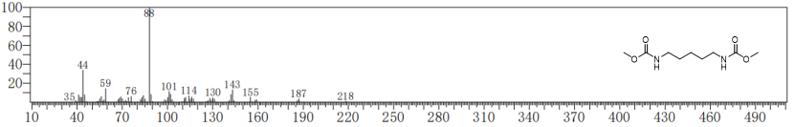
Fig. S1 GC-MS spectra of pentamethylene-1,5-dicarbamate (PDC)

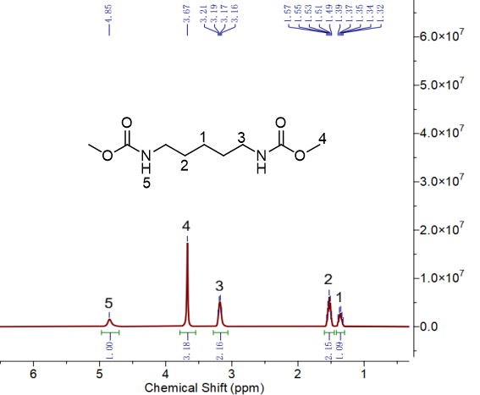

Fig. S2 NMR hydrogen spectra of pentamethylene-1,5-dicarbamate (PDC)

Fig. S3 FT-IR spectra of pentamethylene-1,5-dicarbamate (PDC)

