Table S1. XRF compositions of raw powders (wt%).
Powder | Fe (wt%) | Si (wt%) | Cr (wt%) | P (wt%) | Remarks
FeSiCr (matrix) | 88.5 | 5.1 | 6.1 | — | Fe–Si–Cr solid solution
RIP (SiO₂-coated) | > 98 | trace | — | — | Si from silica shell
CIP (SiO₂-coated) | > 98 | trace | — | — | Si from silica shell
CIP-P (phosphate-coated) | > 98 | — | — | trace | P from phosphate shell

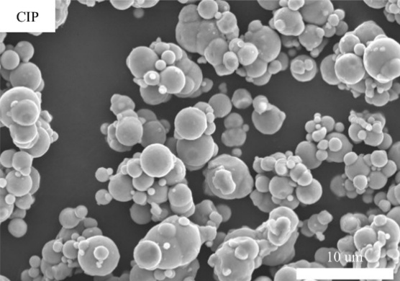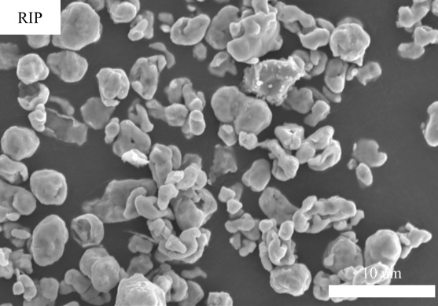
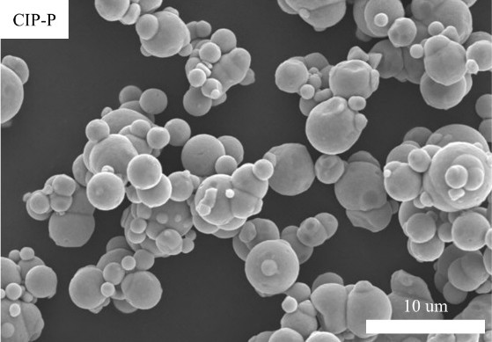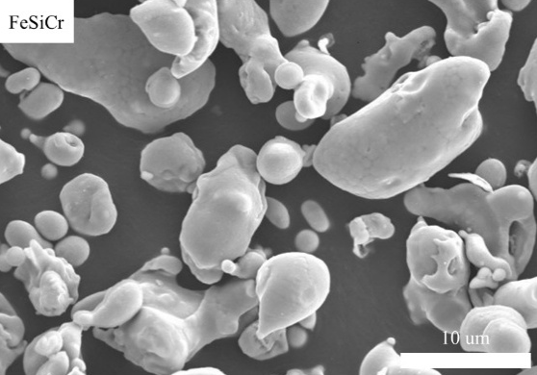
Fig.S1 SEM images of the raw materials.

