DiNetxify—a Python package for three‑dimensional disease network analysis based on electronic health record data
Can Hou, Haowen Liu, Viktor H. Ahlqvist, Elisabet Unnur Gisladottir, Yao Yang, Huazhen Yang, Fang Fang, Unnur A. Valdimarsdóttir, Huan Song

Supplementary Figures

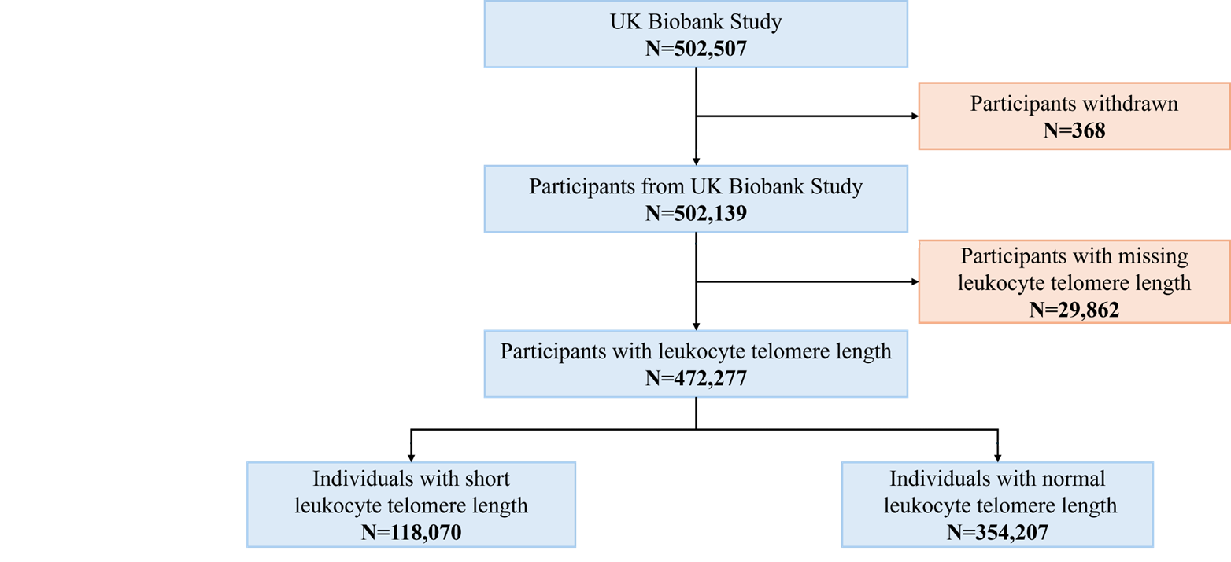
Supplementary Figure 1 Flowchart for the case study using the UK Biobank data
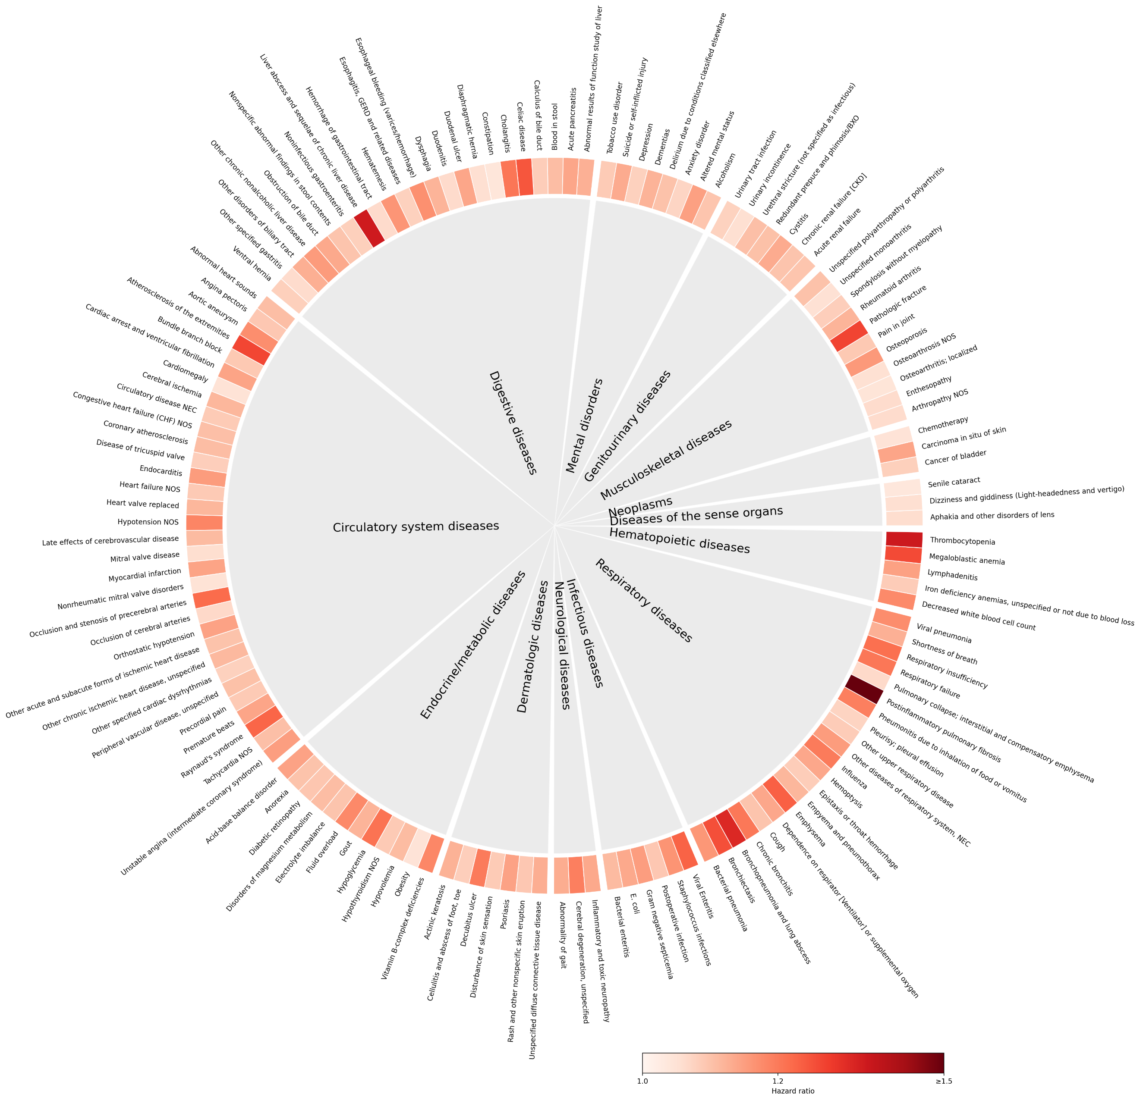
Supplementary Figure 2 PheWAS analysis results in the case study.
The ring shows a Hazard Ratio for medical conditions in case study 1 with color intensity reflecting the magnitude of the Hazard Ratio.
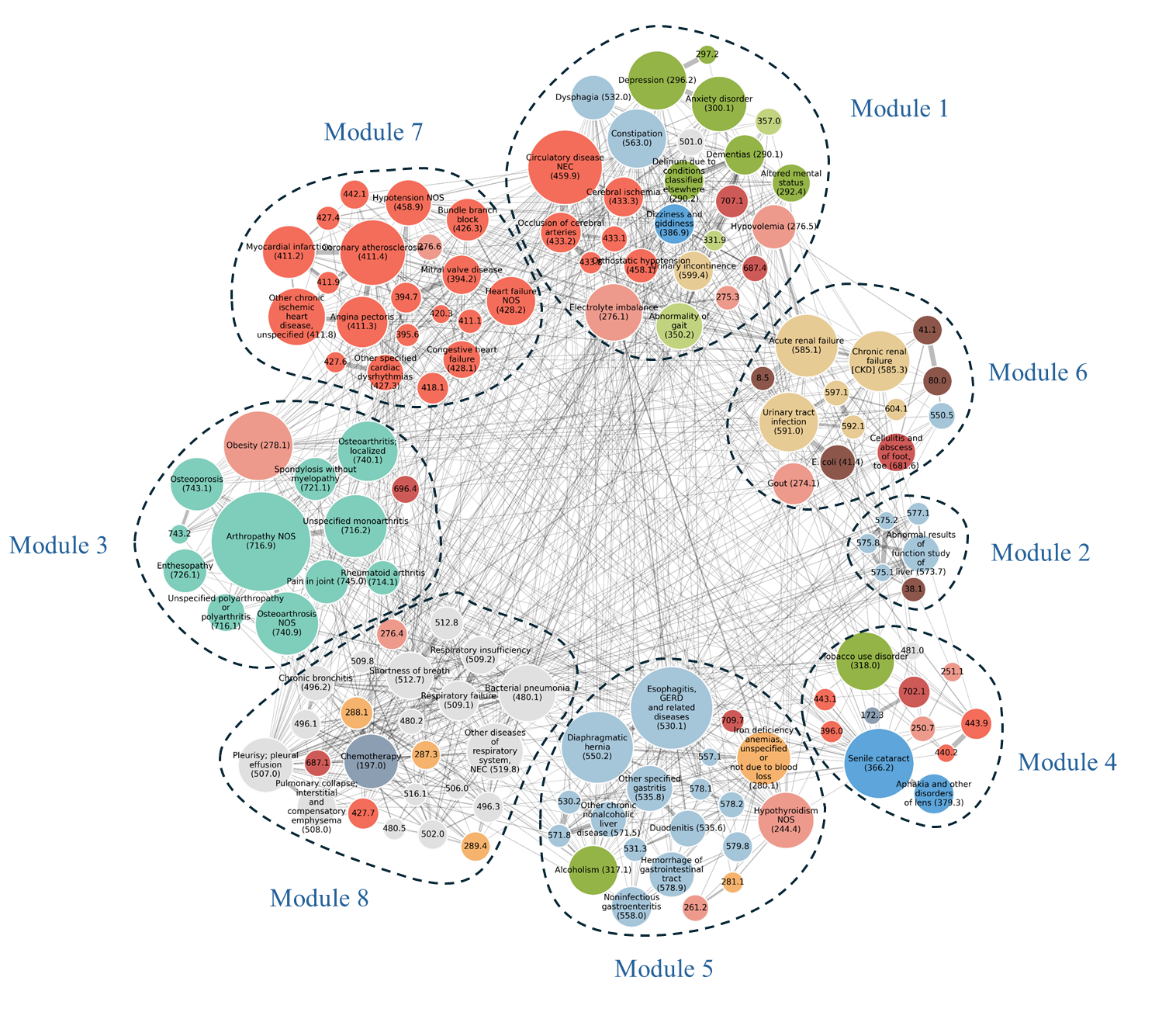
Supplementary Figure 3 Comorbidity networks following short leukocyte telomere length in the case study based on the original regularized partial correlation approach.
Each node represents a disease, where node size indicates prevalence and node color represents the disease category. Both the Louvain and Greedy algorithms partitioned the network into eight modules.
Supplementary Figure 4 Computational performance of DiNetxify in the UK Biobank case study
Wall clock runtimes for the 3D disease network workflow in UK Biobank based case study. Analyses ran on an Intel Xeon Gold 6248 server, 2.5 GHz, with 10, 20, or 40 CPU cores and 25 to 100 GB RAM allocated. Columns report step specific runtimes, including data harmonization, PheWAS, comorbidity strength estimation, comorbidity network analysis, disease trajectory analysis, and the bars at right show total runtime per configuration. Blue indicates regularized partial correlation approach, yellow indicates the principal component analysis (PCA) based approximation approach.

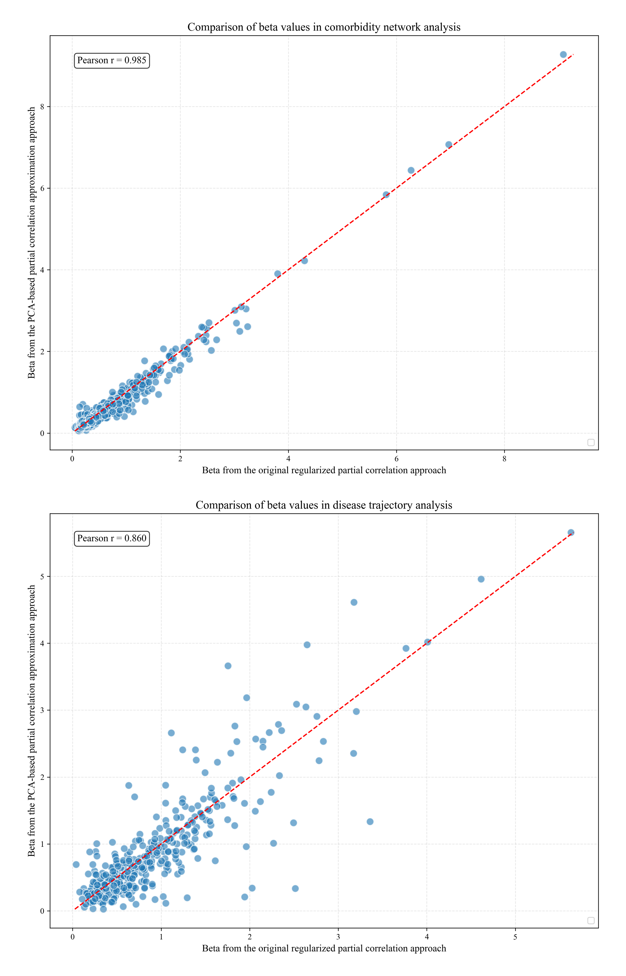
Supplementary Figure 5 Comparative analysis of two approaches in the case study.
The top one is the correlation of beta in the comorbidity network analysis from two approaches. The bottom one is correlation of beta in the disease trajectory analysis from two approaches.
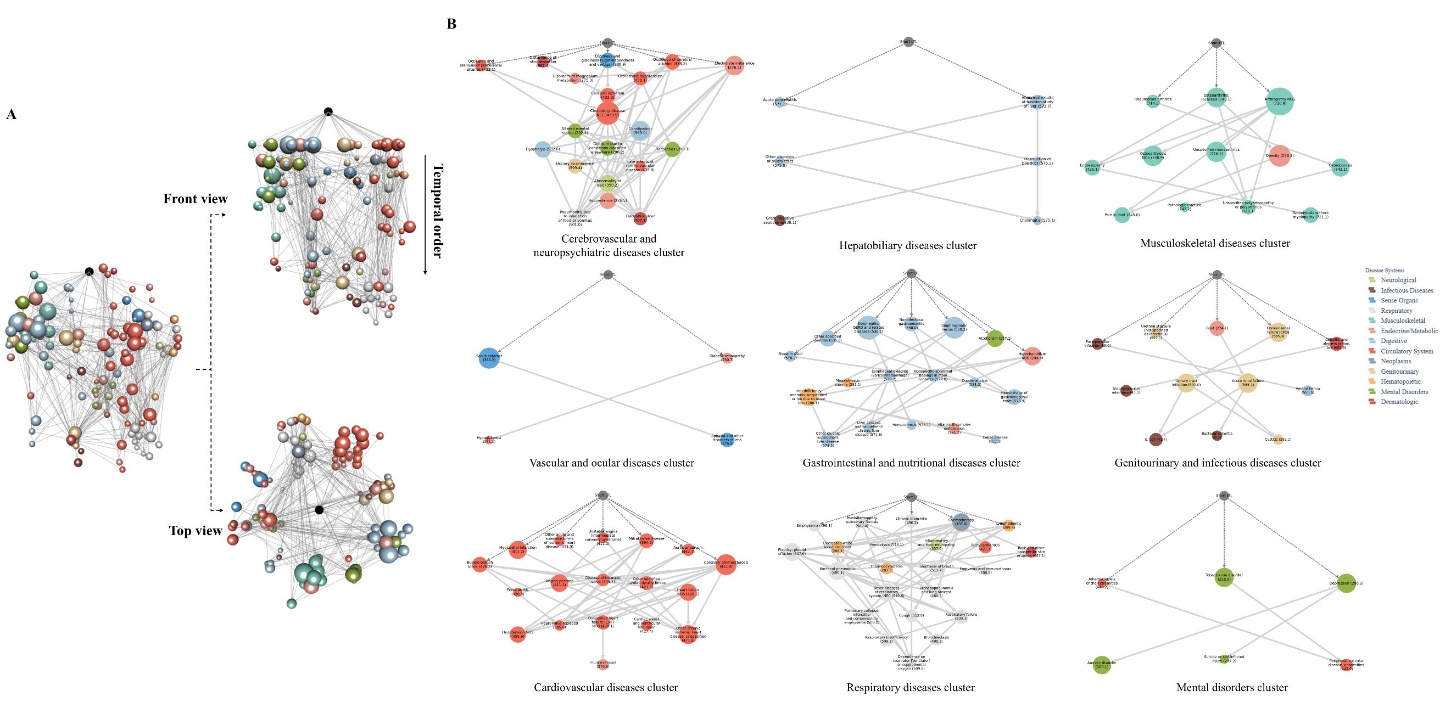
Supplementary Figure 6 Three-dimensional disease network and the reliable disease clusters associated with short leukocyte telomere length (from PCA-based approximation approach).
Visualization of the disease network associated with short leukocyte telomere length. Nodes represent medical conditions defined by level 2 ‘phecodes’, sized by incidence and colored by disease category. (A) Integrated three-dimensional network plot combining the comorbidity network (viewed from above) and temporal disease trajectory network (viewed from the side), interactive version at https://hzcohort.github.io/DiNetxify/LTL_PCA.html. (B) Nine robust disease clusters revealed through both comorbidity network and disease trajectory analyses.

