SUPPORTING INFORMATION

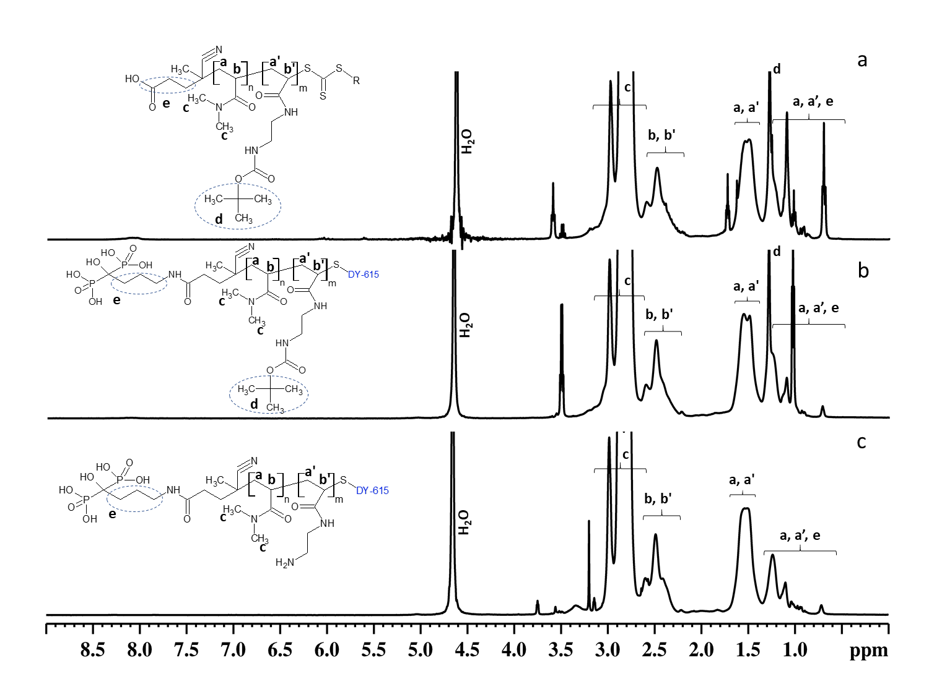
Figure S1. ¹H NMR spectra of (a) P(DMA-AEC-Boc), (b) Ale-P(DMA-AEC-Boc)-DY-615, and (c) Ale-P(DMA-AEC)-DY-615 copolymers.

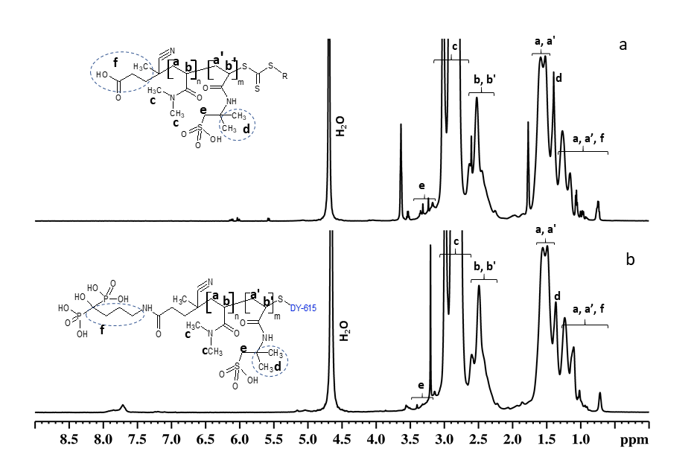
Figure S2. ¹H NMR spectra of (a) P(DMA-AMPS) and (b) Ale-P(DMA-AMPS)-DY-615 copolymers.
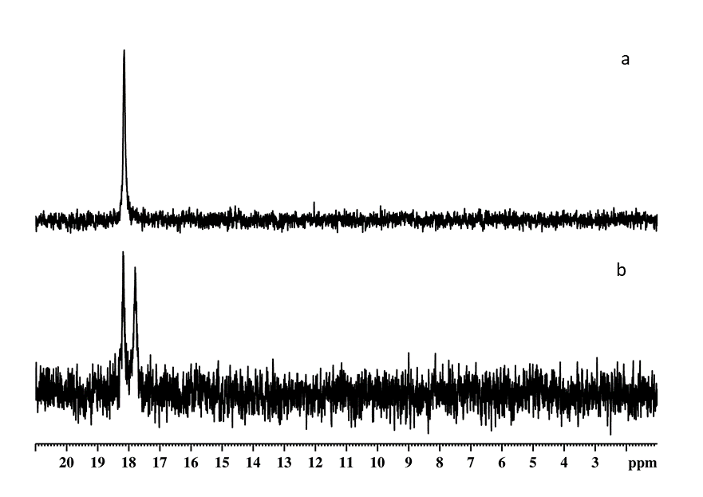
Figure S3. ³¹P NMR spectra of (a) Ale-P(DMA-AEC-Boc)-DY-615 and (b) Ale-P(DMA-AMPS)-DY-615 copolymers.

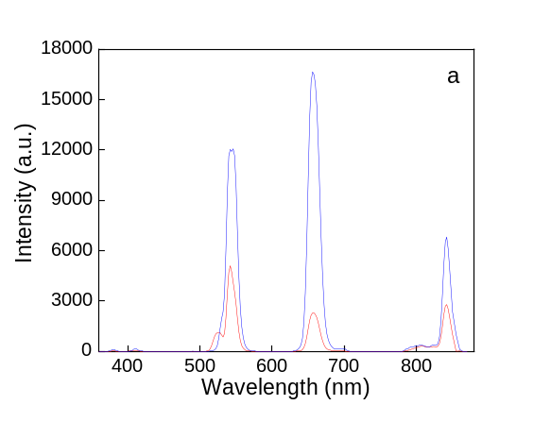 | 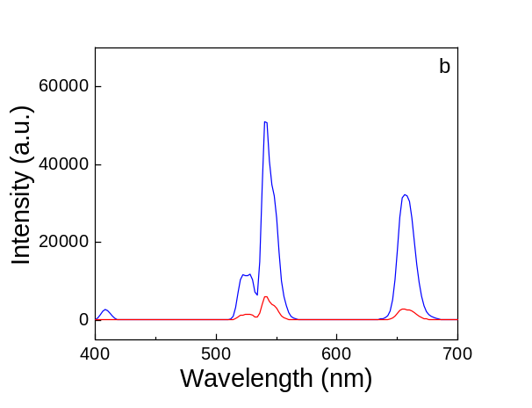
Figure S4. Photoluminescence upconversion spectra of C-UCNP (red) and CS-UCNP (blue) nanoparticles (1.5 mg/ml) in (a) hexane and (b) water at 980 nm excitation. C-UCNP - NaYF₄:Yb,Er; CS-UCNP - NaYF₄:Yb,Er@NaYF₄:Nd.

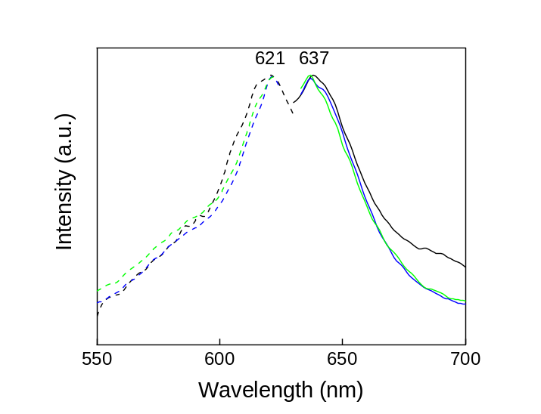
Figure S5. Normalized photoluminescence excitation (dash; λ_{em} 637 nm) and emission (solid; λ_{ex} 621 nm) spectra of Ale-P(DMA-AEC)-DY-615- (blue), Ale-P(DMA-AMPS)-DY-615- (green), and Ale-PDMA-coated CS-UCNP (black) particles.
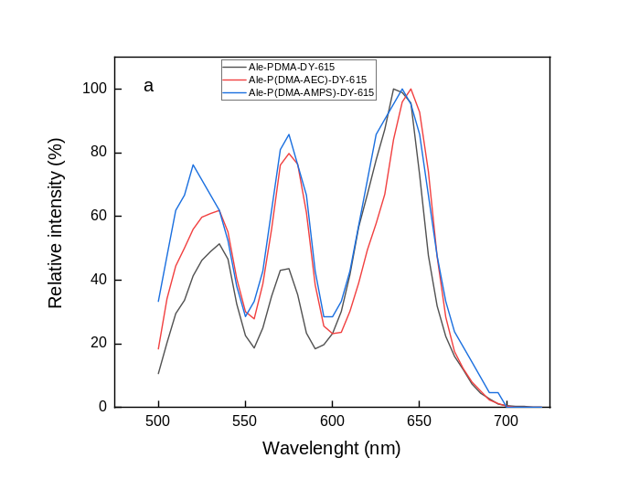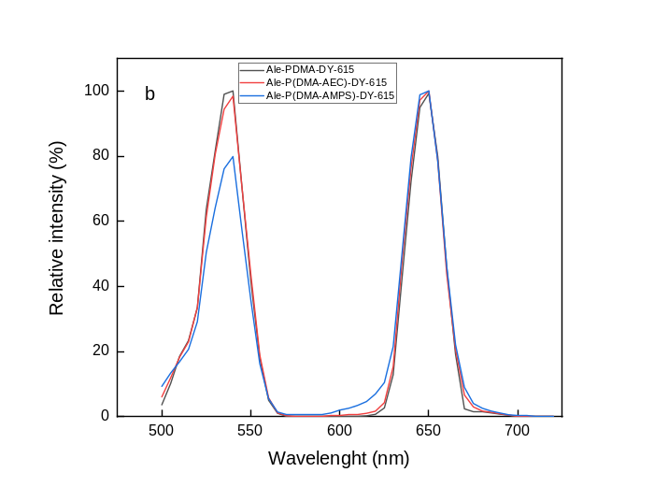
Figure S6. Photoluminescence upconversion spectra of Ale-P(DMA-AEC)-DY-615- (red), Ale-P(DMA-AMPS)-DY-615- (blue), and Ale-PDMA-DY-615-coated CS-UCNP (black) particles excited with 140 fs pulsed laser at (a) 808 and (b) 980 nm.

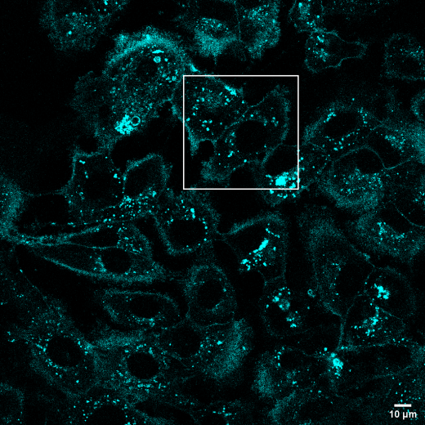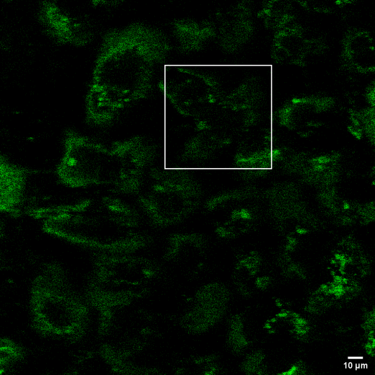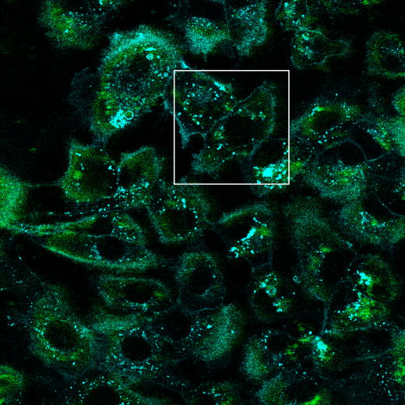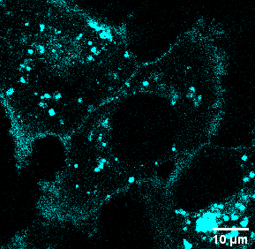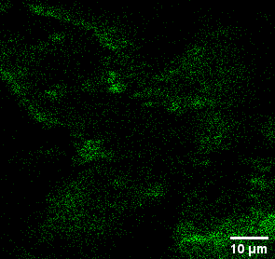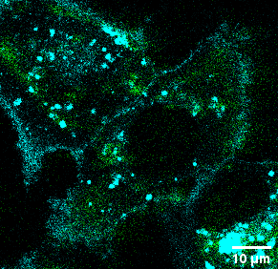
a
b
c
d
e
f
Figure S7. Distribution of CS-UCNP@Ale-P(DMA-AEC)-DY-615 nanoparticles in hepatocellular carcinoma cells at 980 nm excitation (laser power of 30–50 mW). (a, d) Cell membranes (blue) were stained with CellMaskTM green and (b, e) nanoparticles were green; (c, f) overlay of (a, b) and (d, e); (d, e, f) detailed section of (a, b, c). CS-UCNP - NaYF₄:Yb,Er@NaYF₄:Nd.

