Supplementary file in support of information for Vegetation cover change associated with changes in hydro-climatic variables in northern Sub-Saharan Africa in recent decades.

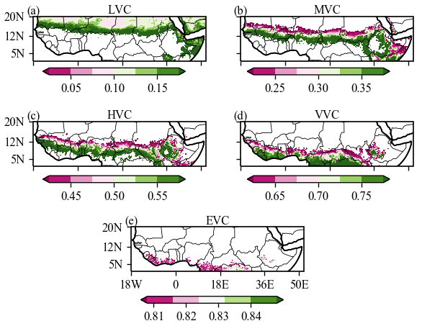
Figure S1: Spatial distribution of NDVI classes for the period from 1982 to 2015.

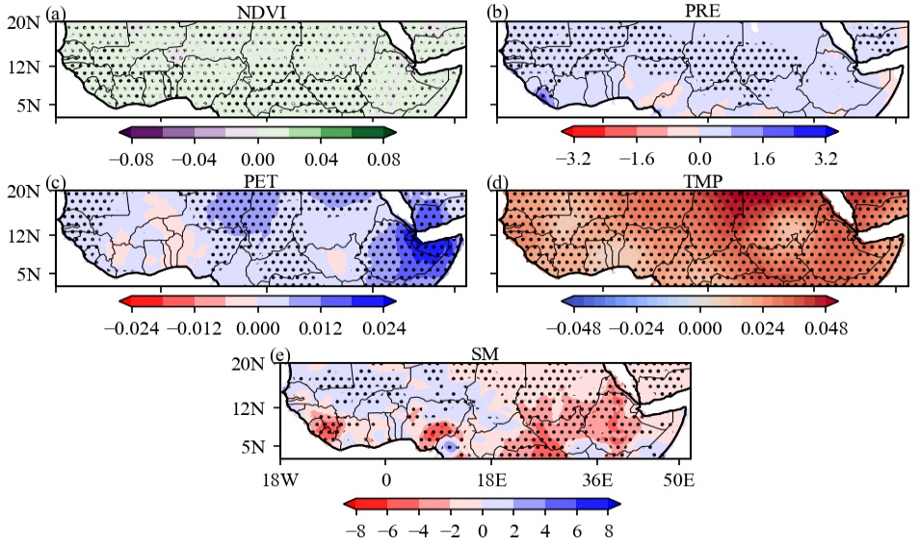
Figure S2: Spatial distribution of trends in (a) NDVI, (b) PRE (mm), (c) PET (mm day⁻¹), (d) TMP (℃) and (e) SM (mm) for the period from 1982 to 2015 using linear regression test. The dots indicate significance at the 5% level.

Table S1: Sen’ slope trend (T_{m}) at the 5% level over four sub-regions of the NSSA
 | NDVI | PRE | PET | TMP | SM
NSSA | 0.0005 | 0.2121 | 0.0043 | 0.0261 | -0.8196
GC | 0.0008 | 0.2694 | 0.0030 | 0.0234 | -1.5007
NS | 0.0001 | 0.1441 | 0.0040 | 0.0300 | -0.0842
ES | 0.0002 | 0.1037 | 0.0133 | 0.0240 | -0.2610

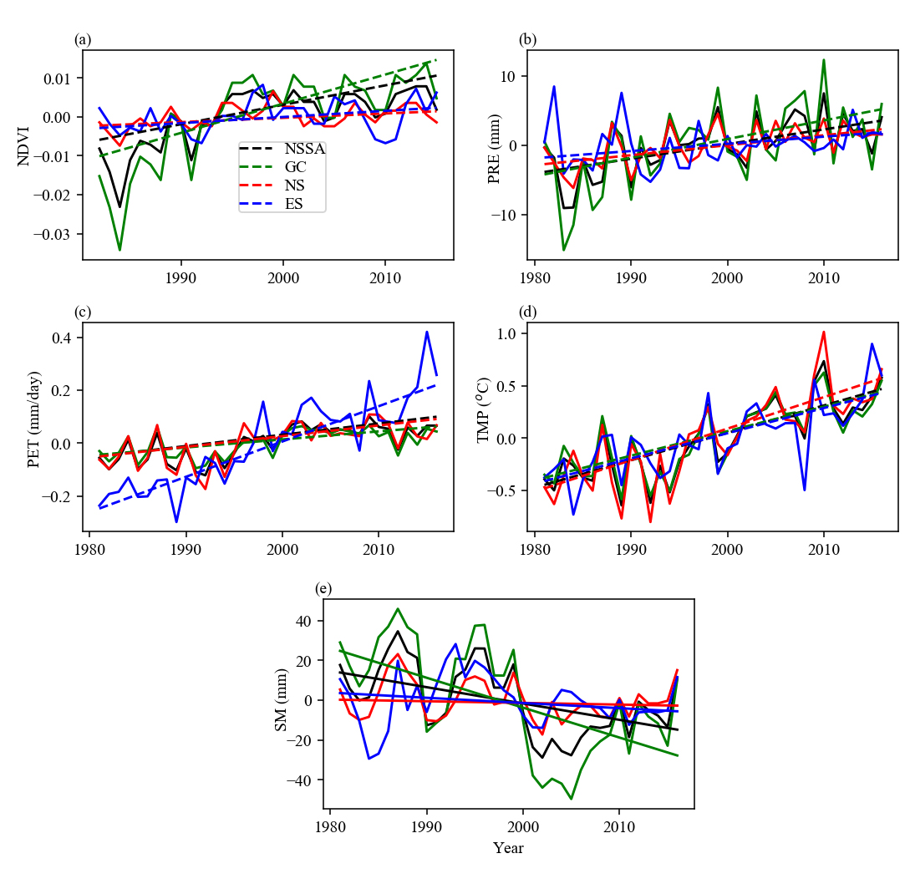
Figure S3: Variations and its linear trend based on Sen’ slope test at the 5% level for four sub-regions of NSSA.

Table S2: MK trend (S) for four sub-regions of NSSA
 | NDVI | PRE | PET | TMP | SM
NSSA | 0.5358 (0.00) | 0.3714 (0.00) | 0.5235 (0.00) | 0.6127 (0.00) | -0.3175 (0.01)
GC | 0.5606 (0.00) | 0.3302 (0.00) | 0.3943 (0.00) | 0.5746 (0.00) | -0.3619 (0.00)
NS | 0.3025 (0.02) | 0.4095 (0.00) | 0.4102 (0.00) | 0.6413 (0.00) | -0.0762 (0.51)
ES | 0.2278 (0.06) | 0.2349 (0.04) | 0.7091 (0.00) | 0.5829 (0.00) | -0.1143 (0.33)
Values in parentheses denoted the probability.

