Supplementary Information

Tailoring Transition Intensity of Ruthenium(II) Complexes with π-Elongated Phenyl Ligands: Experimental and Computational Insights
Zi Ying Yeoh^{1,2}, Yoshitada Morikawa², Mohammad B. Kassim³, Siow-Ping Tan¹, Mohd Azlan Nafiah⁴, Siew San Tan¹*
¹ Department of Physical Science, Faculty of Applied Sciences, Tunku Abdul Rahman University of Management and Technology, Jalan Genting Kelang, Setapak, 53300 Kuala Lumpur, Malaysia.
² Department of Precision Engineering, Graduate School of Engineering, The University of Osaka, 2-1 Yamada-oka, Suita, Osaka, 565-0871 Japan.
³Department of Chemical Sciences, Faculty of Science and Technology, Universiti Kebangsaan Malaysia, 43600 Bangi, Selangor, Malaysia.
⁴Department of Chemistry, Faculty of Mathematics and Science, Universiti Pendidikan Sultan Idris, 35900 Tanjung Malim, Perak, Malaysia.
*Corresponding author: siewsan@tarc.edu.my

Supplementary Figures:
Figure S1. ¹H NMR spectrum of complex 1 (R = H).
Figure S2. ¹³C and DEPT NMR spectra of complex 1 (R = H).
Figure S3. H-H COSY spectrum of complex 1 (R = H).
Figure S4. HMQC spectrum of complex 1 (R = H).
Figure S5. HMBC spectrum of complex 1 (R = H).
Figure S6. ¹H NMR spectrum of complex 2 (R = OCH₃).
Figure S7. ¹³C and DEPT NMR spectra of complex 2 (R = OCH₃).
Figure S8. H-H COSY spectrum of complex 2 (R = OCH₃).
Figure S9. HMQC spectrum of complex 2 (R = OCH₃).
Figure S10. HMBC spectrum of complex 2 (R = OCH₃)
Figure S11. ¹H spectrum of complex 3 (R = NO₂).
Figure S12. ¹³C and DEPT spectra of complex 3 (R = NO₂)
Figure S13. H-H COSY spectrum of complex 3 (R = NO₂)
Figure S14. HMQC spectrum of complex 3 (R = NO₂).
Figure S15. HMBC spectrum of complex 3 (R = NO₂)
Figure S16. Theoretical absorption spectra of [Ru(phen)₂(phen-n-ph-OCH₃)]²⁺ (A2-F2) and [Ru(phen)₂(phen-n-ph-NO₂)]²⁺(A3-F3) complexes with n = 0, 1, 2, 3, 4, or 5.
Figure S17: Simulated FMOs with energy levels of complex A1-A3 that contribute to the MLCT excitation in the visible region.
Figure S18: Simulated FMOs with energy levels of complex B1-B3 that contribute to the MLCT excitation in the visible region.
Figure S19: Simulated FMOs with energy levels of complex C1-C3 that contribute to the MLCT excitation in the visible region.
Figure S20: Simulated FMOs with energy levels of complex D1-D3 that contribute to the MLCT excitation in the visible region.
Figure S21: Simulated FMOs with energy levels of complex D1-D3 that contribute to the MLCT excitation in the visible region.
Figure S22: Simulated FMOs with energy levels of complex E1-E3 that contribute to the ILCT excitation in the visible region.
Figure S23: Simulated FMOs with energy levels of complex E1-E3 that contribute to the ILCT excitation in the visible region.
Figure S24: Simulated FMOs with energy levels of complex F1-F3 that contribute to the ILCT excitation in the visible region.
Figure S25: Simulated FMOs with energy levels of complex F1-F3 that contribute to the ILCT excitation in the visible region.
Figure S26. Simulated transition density of [Ru(phen)₂(phen-n-ph-R)]²⁺ complex (B1-B3) with n = 1 and R = H (B1), OCH₃, (B2), and NO₂ (B3). Isosurface level: 1×10⁻⁴.
Figure S27. Simulated transition density of [Ru(phen)₂(phen-n-ph-R)]²⁺ complex (C1-C3) with n = 2 and R = H (C1), OCH₃, (C2), and NO₂ (C3). Isosurface level: 1×10⁻⁴.
Figure S28. Simulated transition density of [Ru(phen)₂(phen-n-ph-R)]²⁺ complex (D1-D3) with n = 3 and R = H (D1), OCH₃, (D2), and NO₂ (D3). Isosurface level: 1×10⁻⁴.
Figure S29. Simulated transition density of [Ru(phen)₂(phen-n-ph-R)]²⁺ complex (E1-E3) with n = 4 and R = H (E1), OCH₃, (E2), and NO₂ (E3). Isosurface level: 1×10⁻⁴.
Figure S30. 3D molecular electrostatic potential of [Ru(phen)₂(phen-n-ph-OCH₃)]²⁺ (A2-F2) with n = (a) 0, (b) 1, (c) 2, (d) 3, (e) 4, or (f) 5. The color scheme for the MESP surface is blue, electron rich, partially negative charge; red, electron deficient, partially positive charge; yellow, slightly electron deficient region; light blue, slightly electron rich region; green, neutral; respectively.
Figure S31. 3D molecular electrostatic potential of [Ru(phen)₂(phen-n-ph-NO₂)]²⁺ (A3-F3) with n = (a) 0, (b) 1, (c) 2, (d) 3, (e) 4, or (f) 5. The color scheme for the MESP surface is blue, electron rich, partially negative charge; red, electron deficient, partially positive charge; yellow, slightly electron deficient region; light blue, slightly electron rich region; green, neutral; respectively.
Figure S32: Simulated (a) absorption spectra and (b) optimized geometries with dihedral angle of [Ru(phen)₂(phen-N-ph)]²⁺ (N=CH) and [Ru(phen)₂(phen-p-HCA)]²⁺ (NHCO) complexes in their neutral and protonated states, respectively.
Figure S33: Simulated FMOs with energy levels of [Ru(phen)₂(phen-N-ph)]²⁺ in neutral (N=CH) and protonated (⁺NH=CH) states, that contribute dominantly to the lowest energy absorption band in the visible region. The isosurface value = 0.25.

Supplementary Tables:
Table S1. DFT-derived isosurface of FMOs (from HOMO-2 to LUMO+2) for complex A1-A3 (n = 0), accompanied by corresponding orbital number and energy levels. The isosurface value = 0.25.
Table S2. DFT-derived isosurface of FMOs (from HOMO-2 to LUMO+2) for complex B1-B3 (n = 1), accompanied by corresponding orbital number and energy levels. The isosurface value = 0.25.
Table S3. DFT-derived isosurface of FMOs (from HOMO-2 to LUMO+2) for complex C1-C3 (n = 2), accompanied by corresponding orbital number and energy levels. The isosurface value = 0.25.
Table S4. DFT-derived isosurface of FMOs (from HOMO-2 to LUMO+2) for complex D1-D3 (n = 3), accompanied by corresponding orbital number and energy levels. The isosurface value = 0.25.
Table S5. DFT-derived isosurface of FMOs (from HOMO-2 to LUMO+2) for complex E1-E3 (n = 4), accompanied by corresponding orbital number and energy levels. The isosurface value = 0.25.
Table S6. DFT-derived isosurface of FMOs (from HOMO-2 to LUMO+2) for complex F1-F3 (n = 5), accompanied by corresponding orbital number and energy levels. The isosurface value = 0.25.
Table S7. DFT-derived isosurface of FMOs (from HOMO-2 to LUMO+2) for complex [Ru(phen)₂(phen-N-n-ph)]²⁺, where n=2 (complex G2), 3 (complex G3), and 4 (complex G4), accompanied by corresponding orbital number and energy levels, respectively. The isosurface value = 0.25.
Table S8. DFT-derived isosurface of FMOs (from HOMO-2 to LUMO+2) for complex [Ru(phen)₂(phen-N-ph)]²⁺ in neutral (N=CH) and protonated (⁺NH-CH) states, accompanied by corresponding orbital number and energy levels, respectively. The isosurface value = 0.25
1D an 2D NMR spectra complex 1 (R = H).
Figure S1. ¹H NMR spectrum of complex 1 (R = H).
Figure S2. ¹³C and DEPT NMR spectra of complex 1 (R = H).

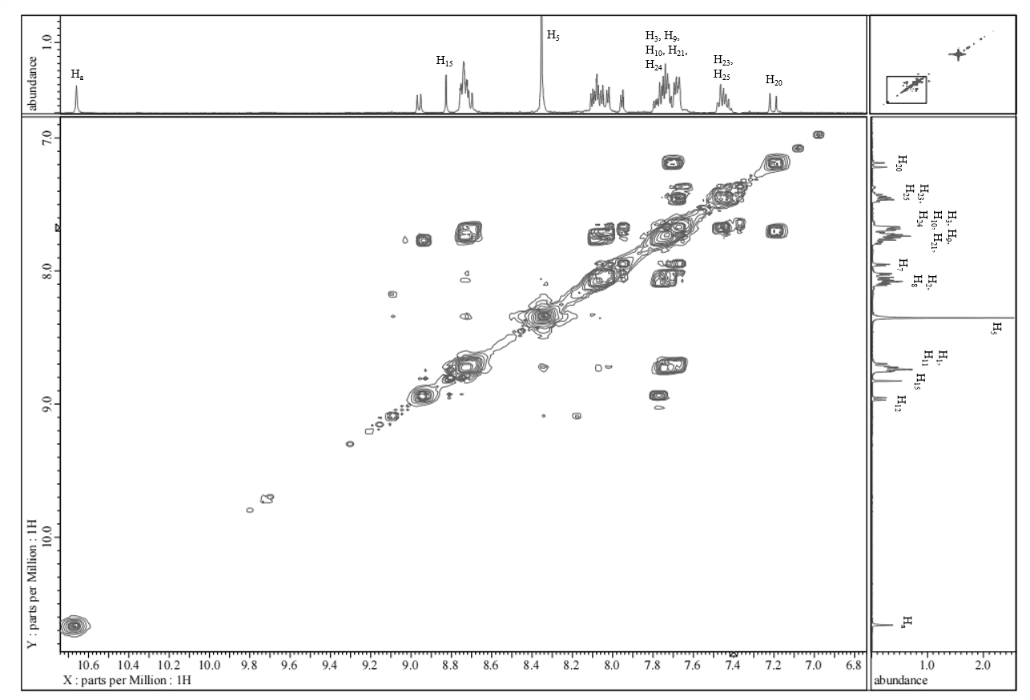
Figure S3. H-H COSY spectrum of complex 1 (R = H).

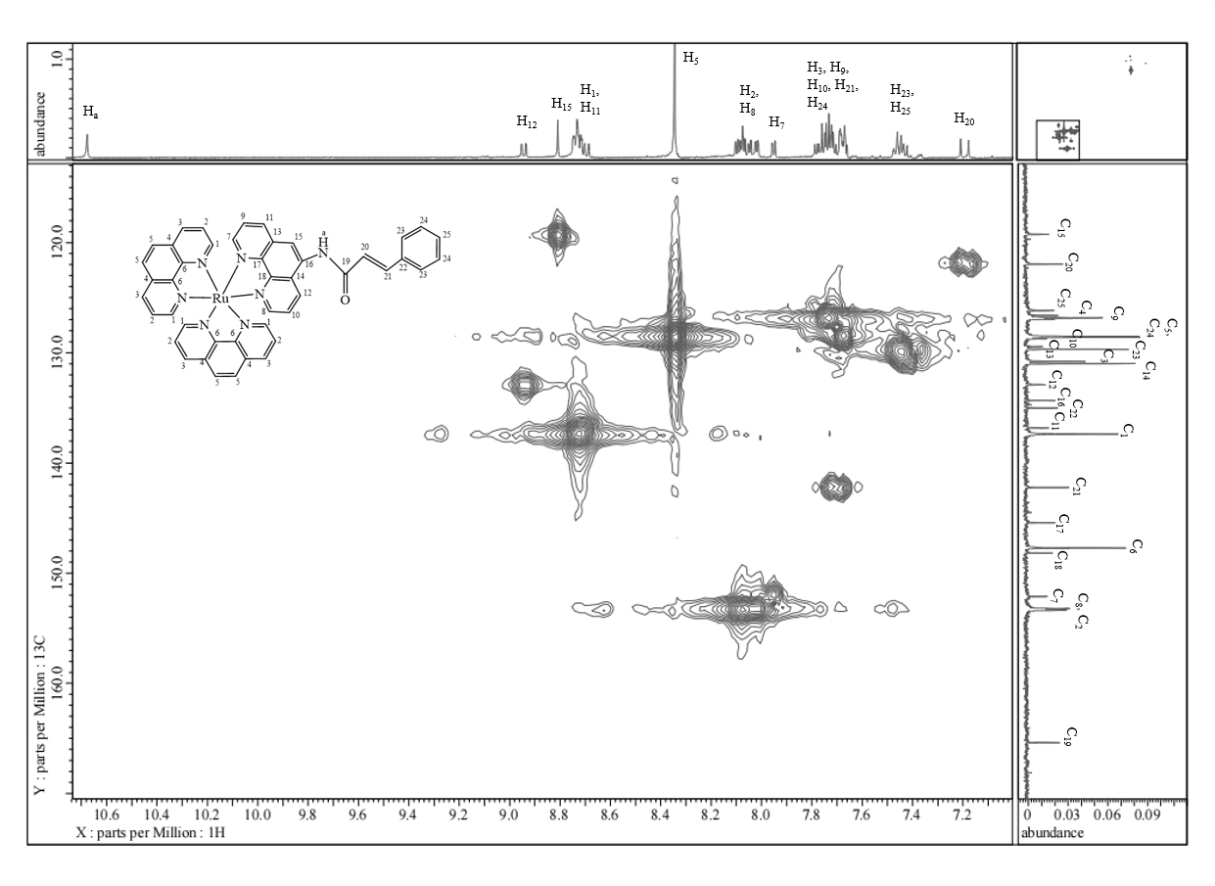
Figure S4. HMQC spectrum of complex 1 (R = H).
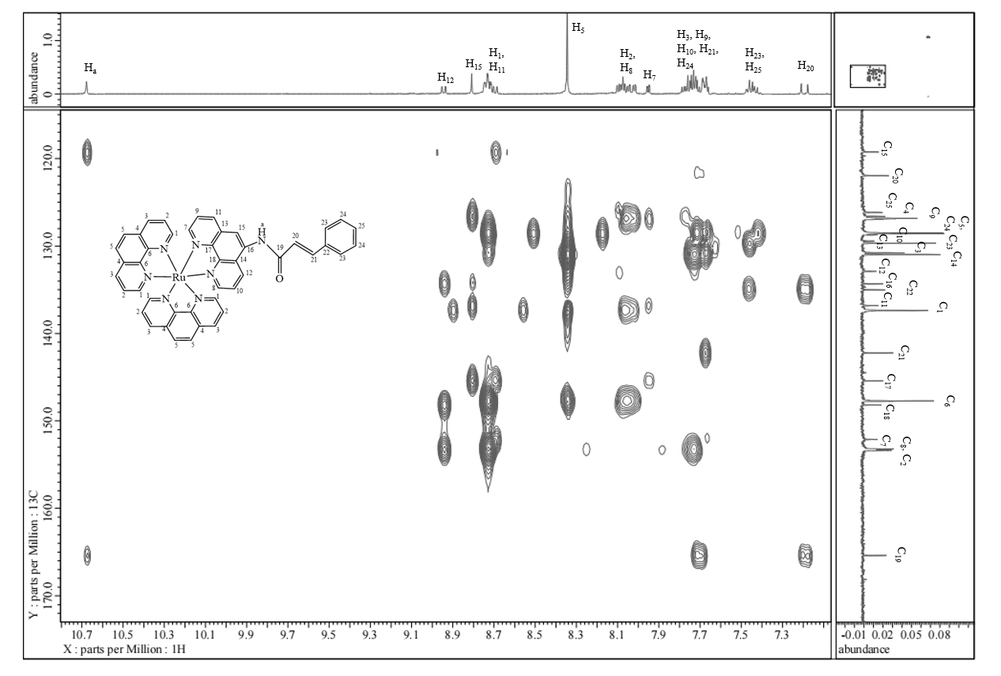
Figure S5. HMBC spectrum of complex 1 (R = H).
1D an 2D NMR spectra complex 2 (R = OCH₃).
Figure S6. ¹H NMR spectrum of complex 2 (R = OCH₃).
Figure S7. ¹³C and DEPT NMR spectra of complex 2 (R = OCH₃).

Figure S8. H-H COSY spectrum of complex 2 (R = OCH₃).
Figure S9. HMQC spectrum of complex 2 (R = OCH₃).

Figure S10. HMBC spectrum of complex 2 (R = OCH₃).
1D and 2D NMR spectra of complex 3 (R = NO₂).

Figure S11. ¹H spectrum of complex 3 (R = NO₂).

Figure S12. ¹³C and DEPT spectra of complex 3 (R = NO₂).
Figure S13. H-H COSY spectrum of complex 3 (R = NO₂).
Figure S14. HMQC spectrum of complex 3 (R = NO₂).
Figure S15. HMBC spectrum of complex 3 (R = NO₂).
Table S1. DFT-derived isosurface of FMOs (from HOMO-2 to LUMO+2) for complex A1-A3 (n = 0), accompanied by corresponding orbital number and energy levels. The isosurface value = 0.25.
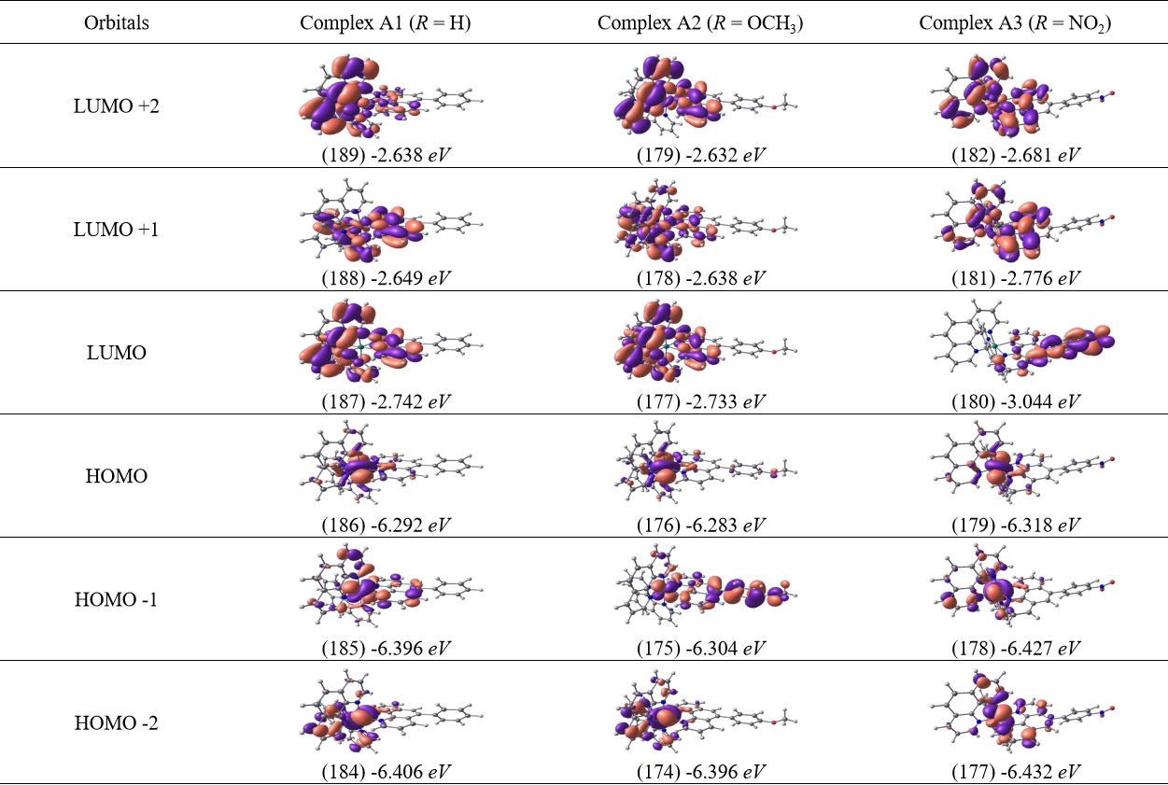

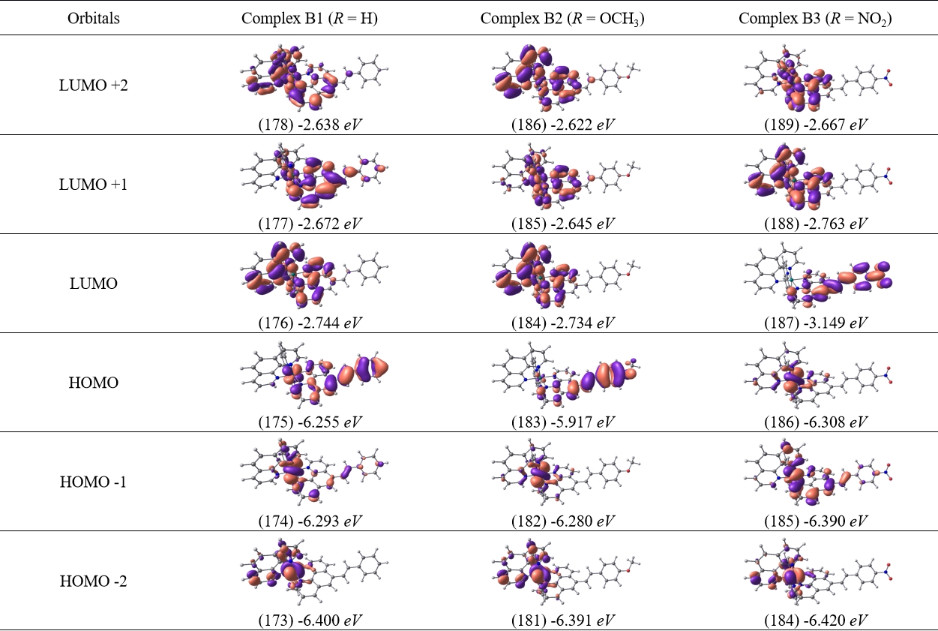
Table S2. DFT-derived isosurface of FMOs (from HOMO-2 to LUMO+2) for complex B1-B3 (n = 1), accompanied by corresponding orbital number and energy levels. The isosurface value = 0.25.
Table S3. DFT-derived isosurface of FMOs (from HOMO-2 to LUMO+2) for complex C1-C3 (n = 2), accompanied by corresponding orbital number and energy levels. The isosurface value = 0.25.
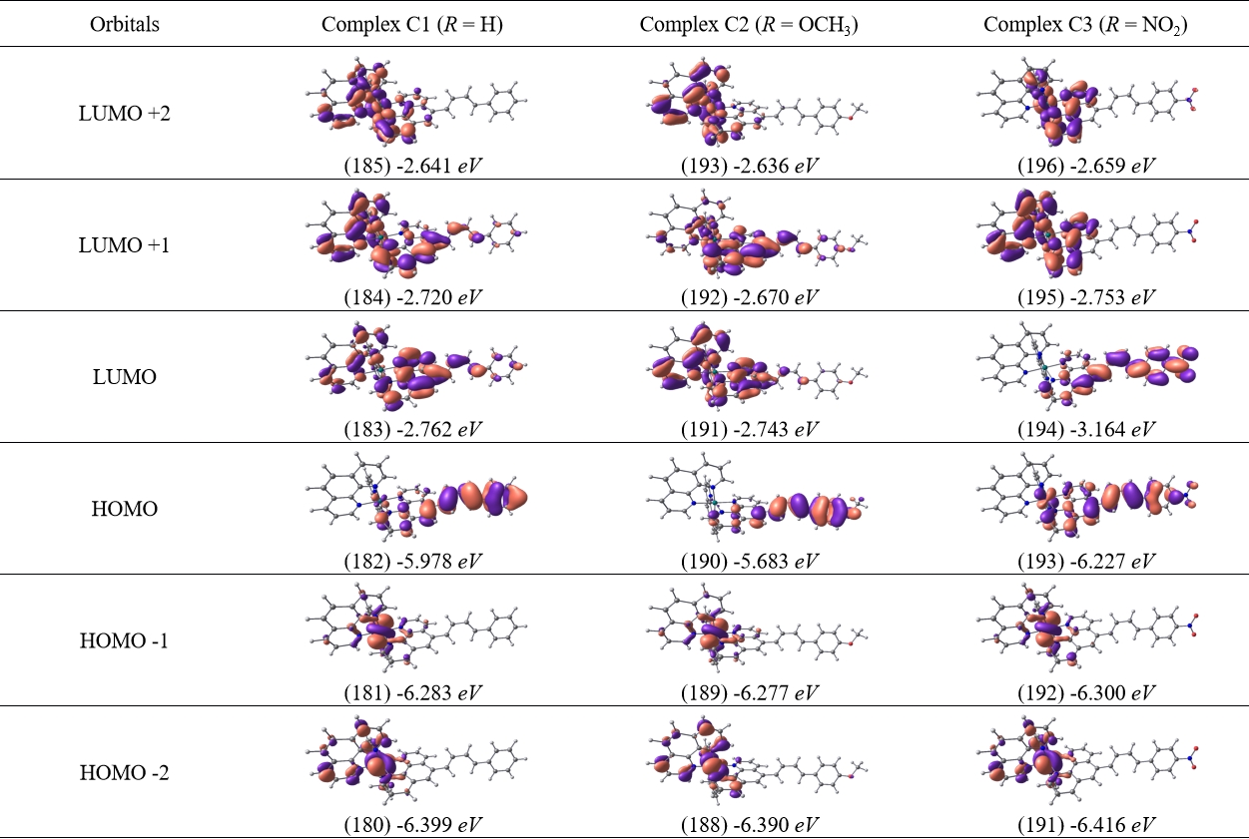

Table S4. DFT-derived isosurface of FMOs (from HOMO-2 to LUMO+2) for complex D1-D3 (n = 3), accompanied by corresponding orbital number and energy levels. The isosurface value = 0.25.
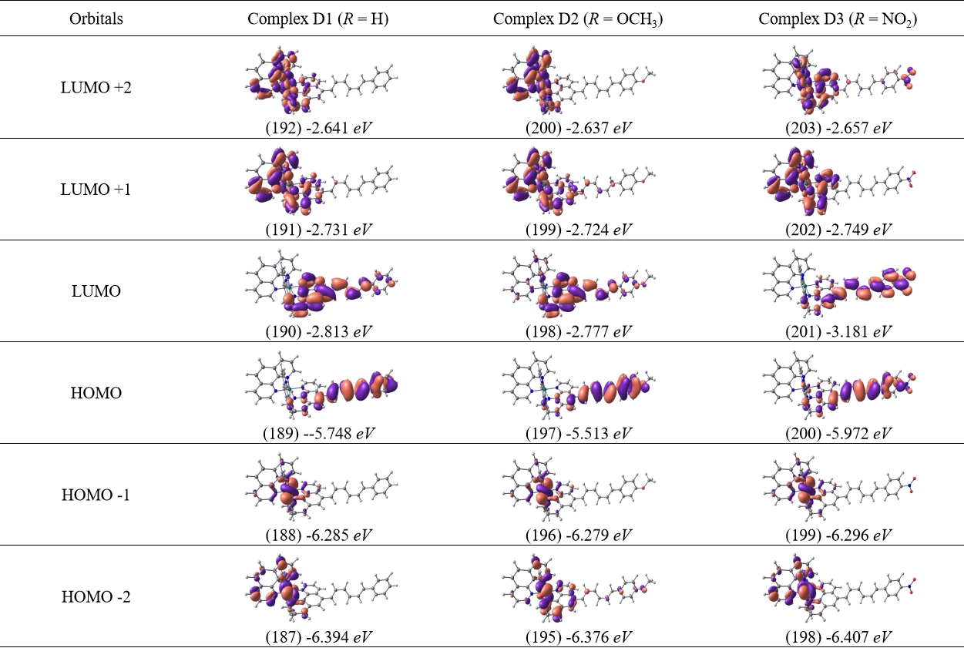
Table S5. DFT-derived isosurface of FMOs (from HOMO-2 to LUMO+2) for complex E1-E3 (n = 4), accompanied by corresponding orbital number and energy levels. The isosurface value = 0.25.
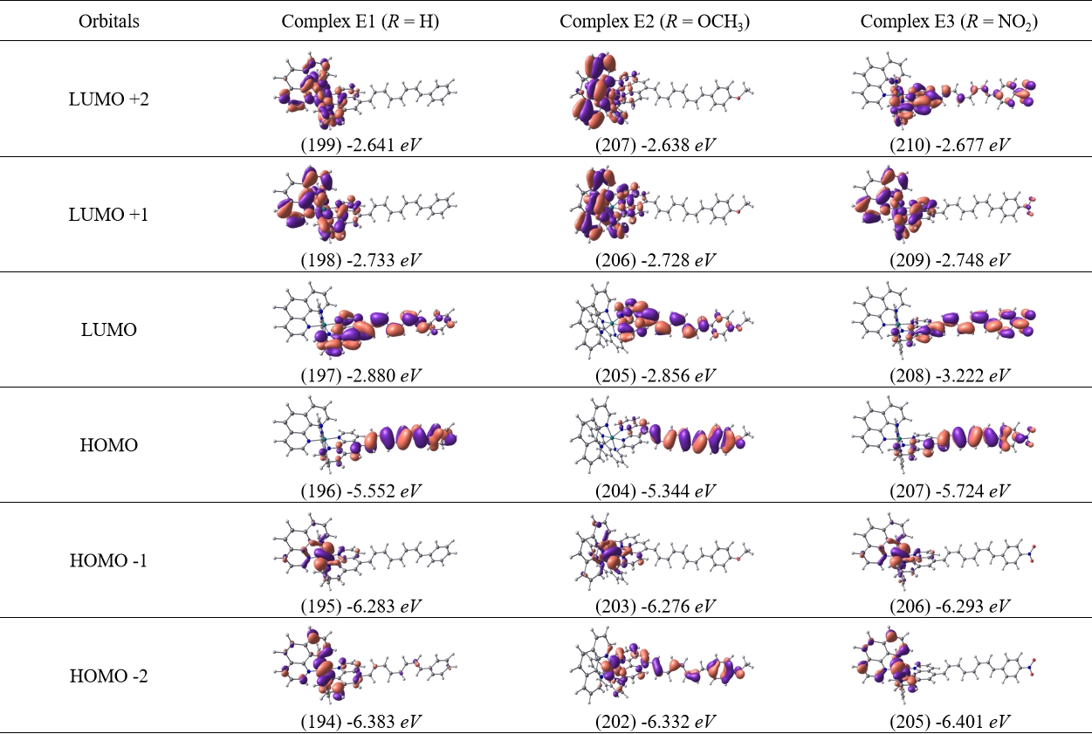
Table S6. DFT-derived isosurface of FMOs (from HOMO-2 to LUMO+2) for complex F1-F3 (n = 5), accompanied by corresponding orbital number and energy levels. The isosurface value = 0.25.
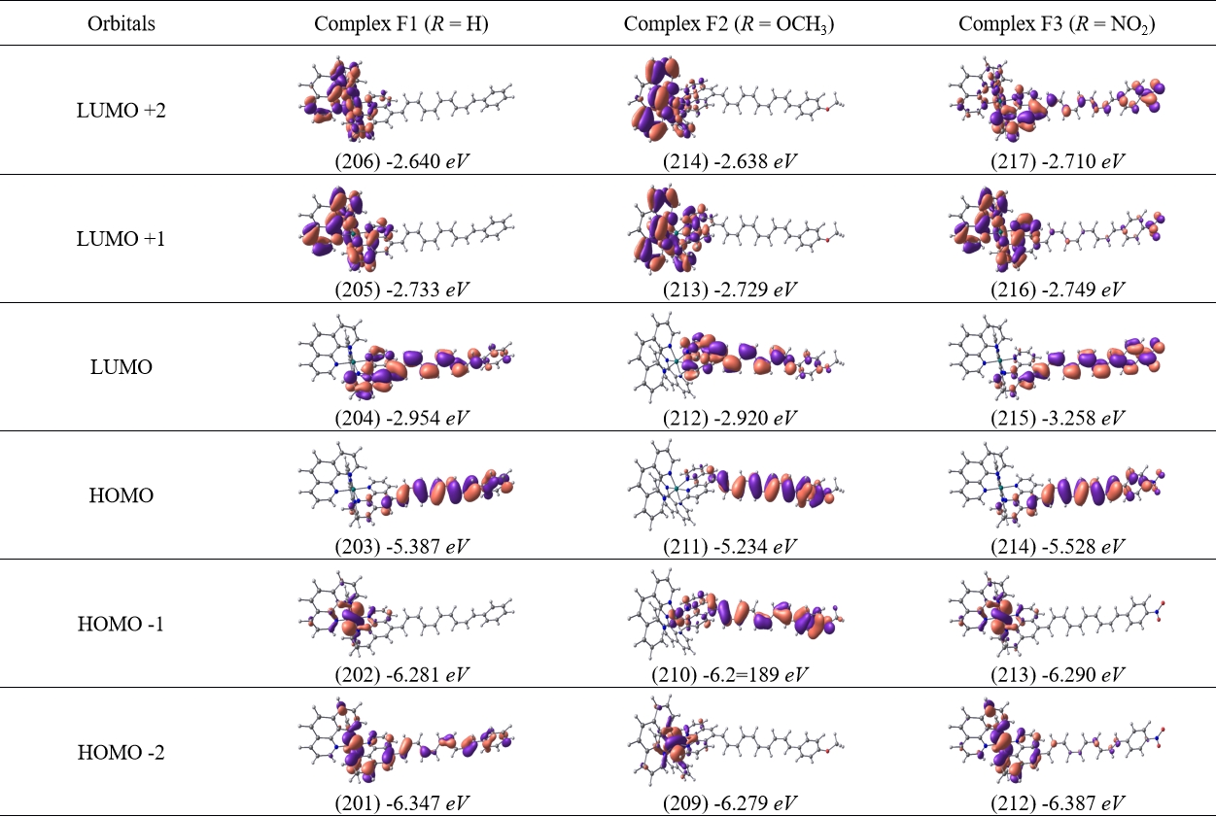
Theoretical absorption spectra of [Ru(phen)₂(phen-n-ph-OCH₃)]²⁺ (A2-F2) and [Ru(phen)₂(phen-n-ph-NO₂)]²⁺ (A3-F3) complexes with n = 0, 1, 2, 3, 4, or 5.

Figure S16. Theoretical absorption spectra of [Ru(phen)₂(phen-n-ph-OCH₃)]²⁺ (A2-F2) and [Ru(phen)₂(phen-n-ph-NO₂)]²⁺(A3-F3) complexes with n = 0, 1, 2, 3, 4, or 5.

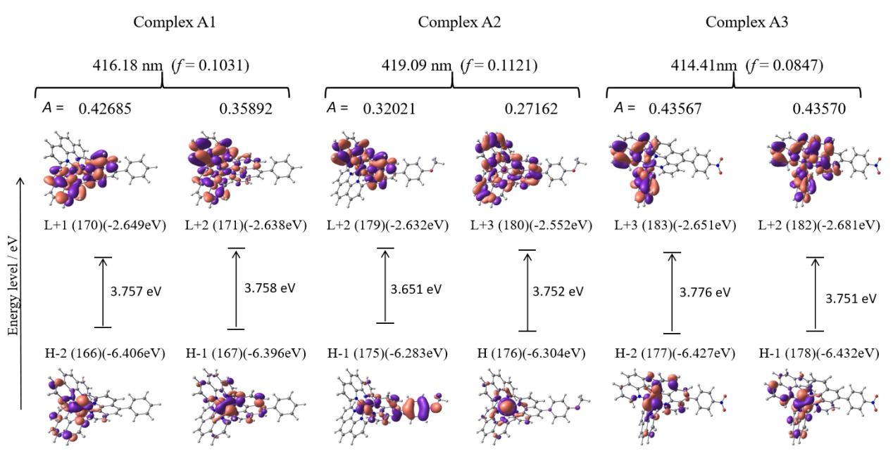
Figure S17: Simulated FMOs with energy levels of complex A1-A3 that contribute to the MLCT excitation in the visible region.
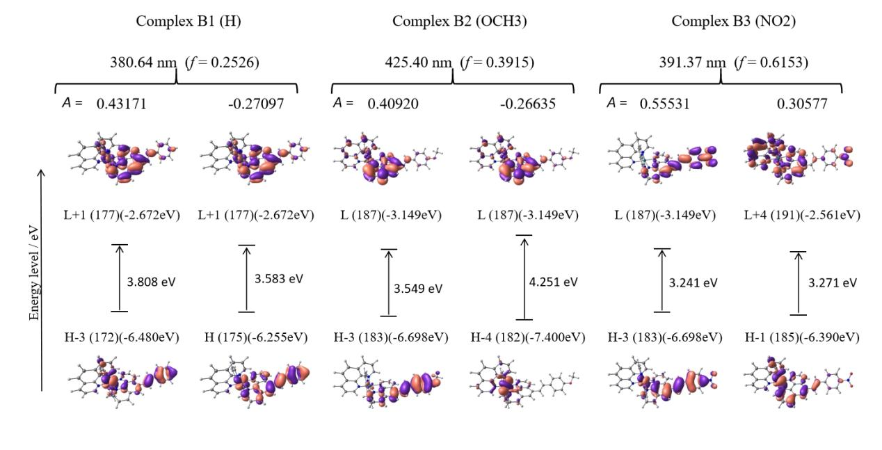
Figure S18: Simulated FMOs with energy levels of complex B1-B3 that contribute to the MLCT excitation in the visible region.

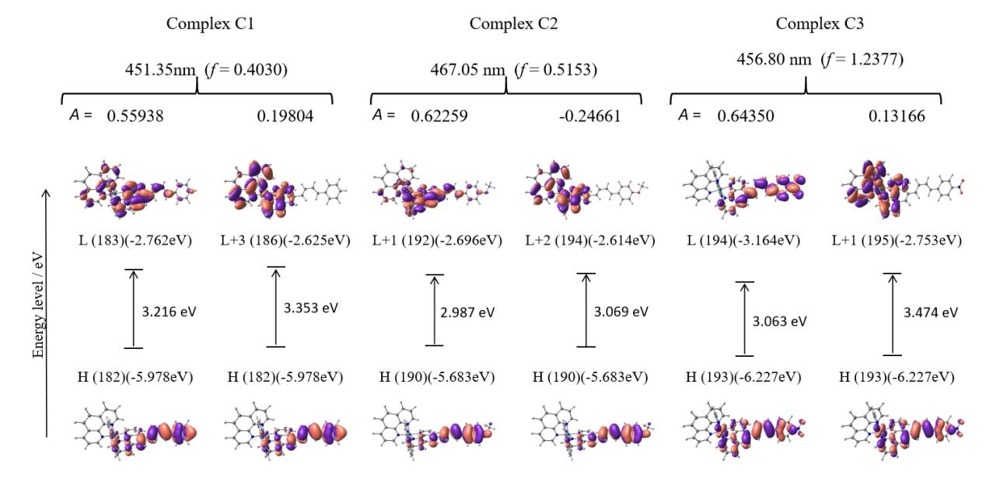
Figure S19: Simulated FMOs with energy levels of complex C1-C3 that contribute to the MLCT excitation in the visible region.

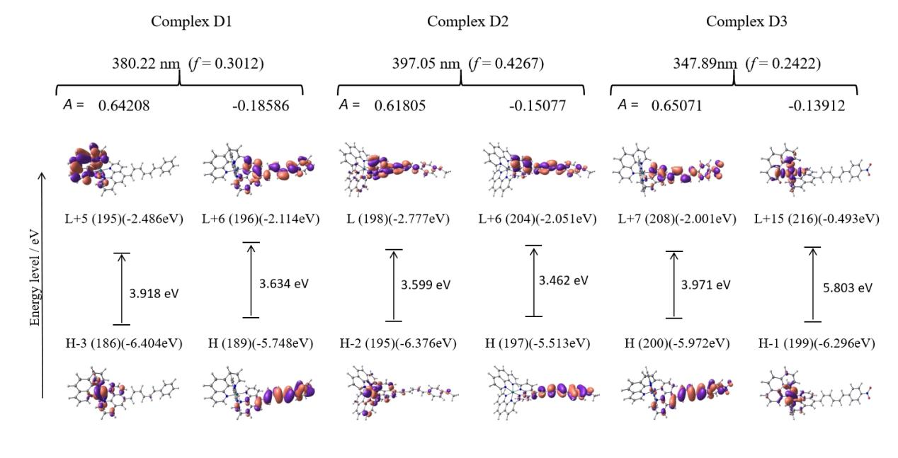
Figure S20: Simulated FMOs with energy levels of complex D1-D3 that contribute to the MLCT excitation in the visible region.

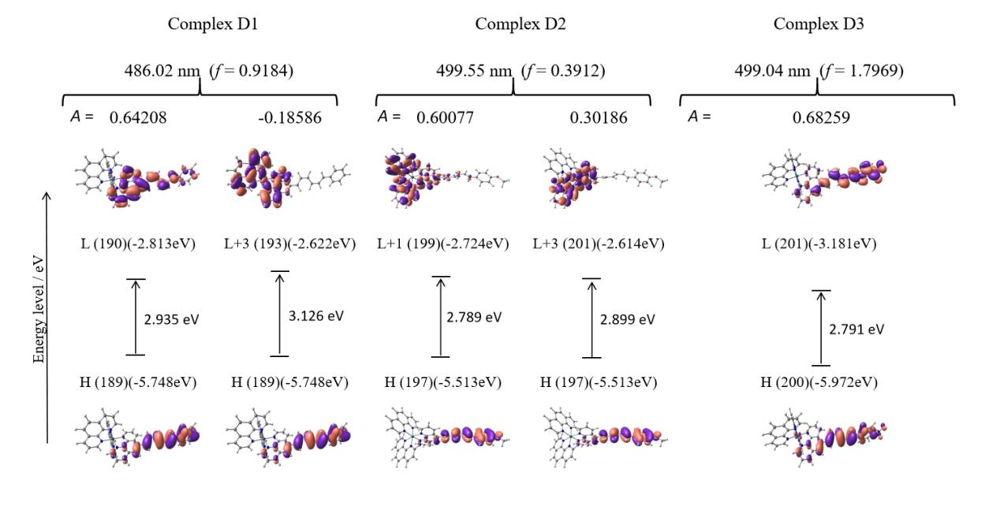
Figure S21: Simulated FMOs with energy levels of complex D1-D3 that contribute to the MLCT excitation in the visible region.
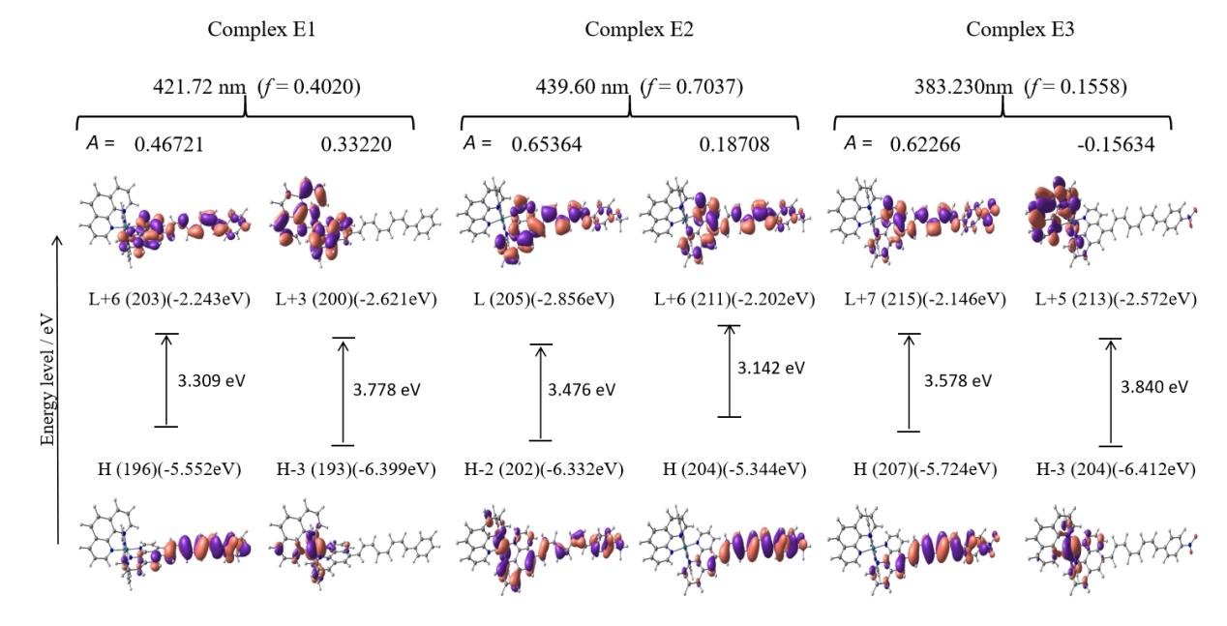

Figure S22: Simulated FMOs with energy levels of complex E1-E3 that contribute to the ILCT excitation in the visible region.

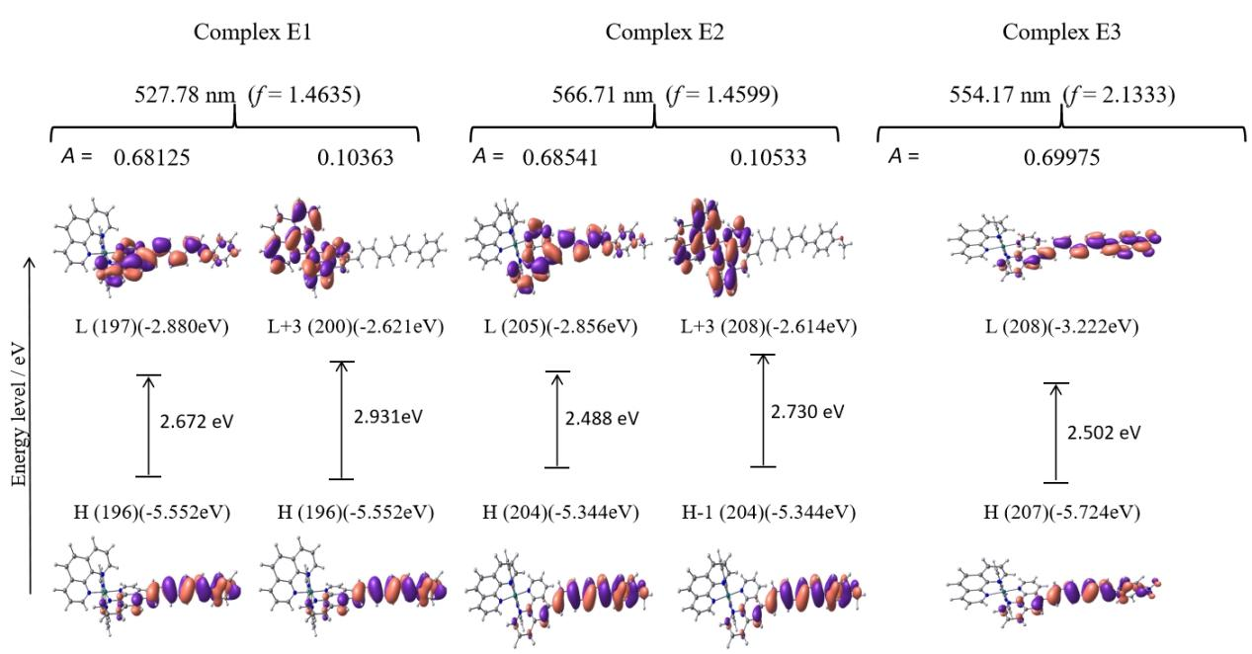
Figure S23: Simulated FMOs with energy levels of complex E1-E3 that contribute to the ILCT excitation in the visible region.

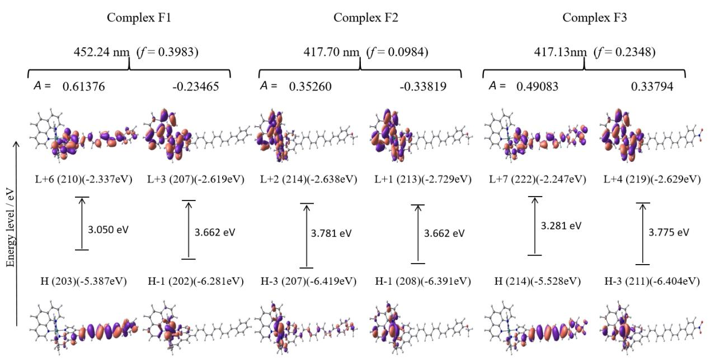
Figure S24: Simulated FMOs with energy levels of complex F1-F3 that contribute to the ILCT excitation in the visible region.

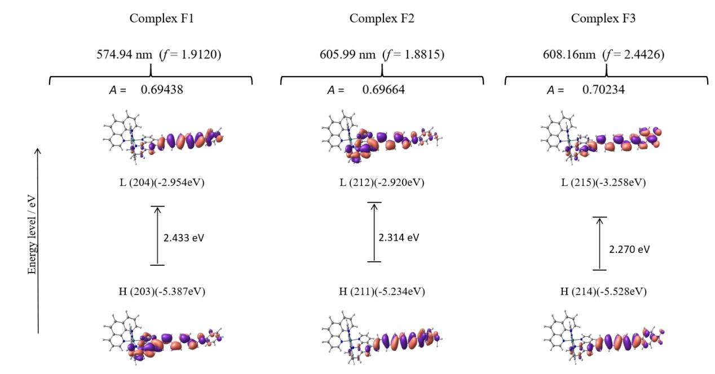
Figure S25: Simulated FMOs with energy levels of complex F1-F3 that contribute to the ILCT excitation in the visible region.

Simulated transition density for each absorption band in visible regions of [Ru(phen)₂(phen-n-ph-R)]²⁺ complex with n = 1-4.

Figure S26. Simulated transition density of [Ru(phen)₂(phen-n-ph-R)]²⁺ complex (B1-B3) with n = 1 and R = H (B1), OCH₃, (B2), and NO₂ (B3). Isosurface level: 1×10⁻⁴.

Figure S27. Simulated transition density of [Ru(phen)₂(phen-n-ph-R)]²⁺ complex (C1-C3) with n = 2 and R = H (C1), OCH₃, (C2), and NO₂ (C3). Isosurface level: 1×10⁻⁴.

Figure S28. Simulated transition density of [Ru(phen)₂(phen-n-ph-R)]²⁺ complex (D1-D3) with n = 3 and R = H (D1), OCH₃, (D2), and NO₂ (D3). Isosurface level: 1×10⁻⁴.

Figure S29. Simulated transition density of [Ru(phen)₂(phen-n-ph-R)]²⁺ complex (E1-E3) with n = 4 and R = H (E1), OCH₃, (E2), and NO₂ (E3). Isosurface level: 1×10⁻⁴.

3D molecular electrostatic potential (MESP) maps of [Ru(phen)₂(phen-n-ph-OCH₃)]²⁺ (A2-F2) and [Ru(phen)₂(phen-n-ph-NO₂)]²⁺ (A3-F3) complexes with n = 0, 1, 2, 3, 4, or 5.

Figure S30. 3D molecular electrostatic potential of [Ru(phen)₂(phen-n-ph-OCH₃)]²⁺ (A2-F2) with n = (a) 0, (b) 1, (c) 2, (d) 3, (e) 4, or (f) 5. The color scheme for the MESP surface is blue, electron rich, partially negative charge; red, electron deficient, partially positive charge; yellow, slightly electron deficient region; light blue, slightly electron rich region; green, neutral; respectively.

Figure S31. 3D molecular electrostatic potential of [Ru(phen)₂(phen-n-ph-NO₂)]²⁺ (A3-F3) with n = (a) 0, (b) 1, (c) 2, (d) 3, (e) 4, or (f) 5. The color scheme for the MESP surface is blue, electron rich, partially negative charge; red, electron deficient, partially positive charge; yellow, slightly electron deficient region; light blue, slightly electron rich region; green, neutral; respectively.

Table S7. DFT-derived isosurface of FMOs (from HOMO-2 to LUMO+2) for complex [Ru(phen)₂(phen-N-n-ph)]²⁺, where n=2 (complex G2), 3 (complex G3), and 4 (complex G4), accompanied by corresponding orbital number and energy levels, respectively. The isosurface value = 0.25.
Comparison of [Ru(phen)₂(phen-p-HCA)]²⁺ and [Ru(phen)₂(phen-N-ph)]²⁺ complexes in neutral and protonated states.
The simulated geometries and absorption spectra changes upon protonation of [Ru(phen)₂(phen-N-ph)]²⁺ compared with [Ru(phen)₂(phen-p-HCA)]²⁺ [], are illutrated in Figure S32. As shown in Figure S33, the lowest energy band is mainly originated from MLCT and ILCT transitions. The dominant transition in the neutral state originates from MLCT, whereas in the protonated state it arises from ILCT. Referring to Table S8, protonation of [Ru(phen)₂(phen-N-ph)]²⁺ induces a red shift in the lowest-energy absorption band together with an increase in ε, in contrast to the trend observed for [Ru(phen)₂(phen-p-HCA)]²⁺. This phenomenon might be attributed to stabilization of the LUMO through lowering the energy level (-4.014 eV), which exhibited lower energy than the neutral complex (-2.837 eV). Moreover, protonation narrows the HOMO–LUMO gap from 3.432 eV to 2.413 eV relative to the neutral complex, thereby promoting electronic excitation in the lower-energy region. Despite previous studies have concluded the dihedral angle between phen and extended segment as a significant factor affecting ε, protonation in this case leads to insignificant change, from 43.9 to 43.3°, suggesting that orbital stabilization rather than structural distortion governs the observed spectral response.
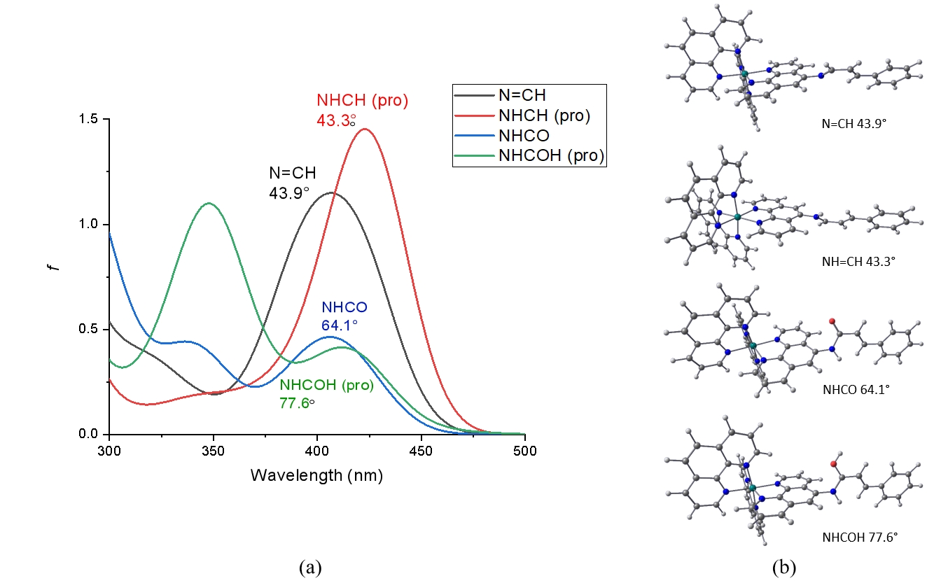
Figure S32: Simulated (a) absorption spectra and (b) optimized geometries with dihedral angle of [Ru(phen)₂(phen-N-ph)]²⁺ (N=CH) and [Ru(phen)₂(phen-p-HCA)]²⁺ (NHCO) complexes in their neutral and protonated states, respectively.

Figure S33: Simulated FMOs with energy levels of [Ru(phen)₂(phen-N-ph)]²⁺ in neutral (N=CH) and protonated (⁺NH=CH) states, that contribute dominantly to the lowest energy absorption band in the visible region. The isosurface value = 0.25.

Table S8. DFT-derived isosurface of FMOs (from HOMO-2 to LUMO+2) for complex [Ru(phen)₂(phen-N-ph)]²⁺ in neutral (N=CH) and protonated (⁺NH-CH) states, accompanied by corresponding orbital number and energy levels, respectively. The isosurface value = 0.25.

