Supplementary Information of the manuscript: Emergent Altermagnetism and Topological Response In Janus MnPSX Monolayers
J. Guerrero-Sanchez¹, R. Ponce-Perez¹, D.M. Hoat^{2,3}, R. Gonzalez-Hernandez^{4,*}
¹Universidad Nacional Autónoma de México, Centro de Nanociencias y Nanotecnología, Apartado Postal 14, Ensenada, Baja California, Código Postal 22800, Mexico
²Institute of Theoretical and Applied Research, Duy Tan University, Ha Noi 100000, Viet Nam
³School of Engineering and Technology, Duy Tan University, Da Nang 550000, Viet Nam
⁴Grupo de Investigación en Física Aplicada, Departamento de Física, Universidad del Norte, Barranquilla, Colombia.
*Author to whom correspondence should be addressed: rhernandezj@uninorte.edu.co.

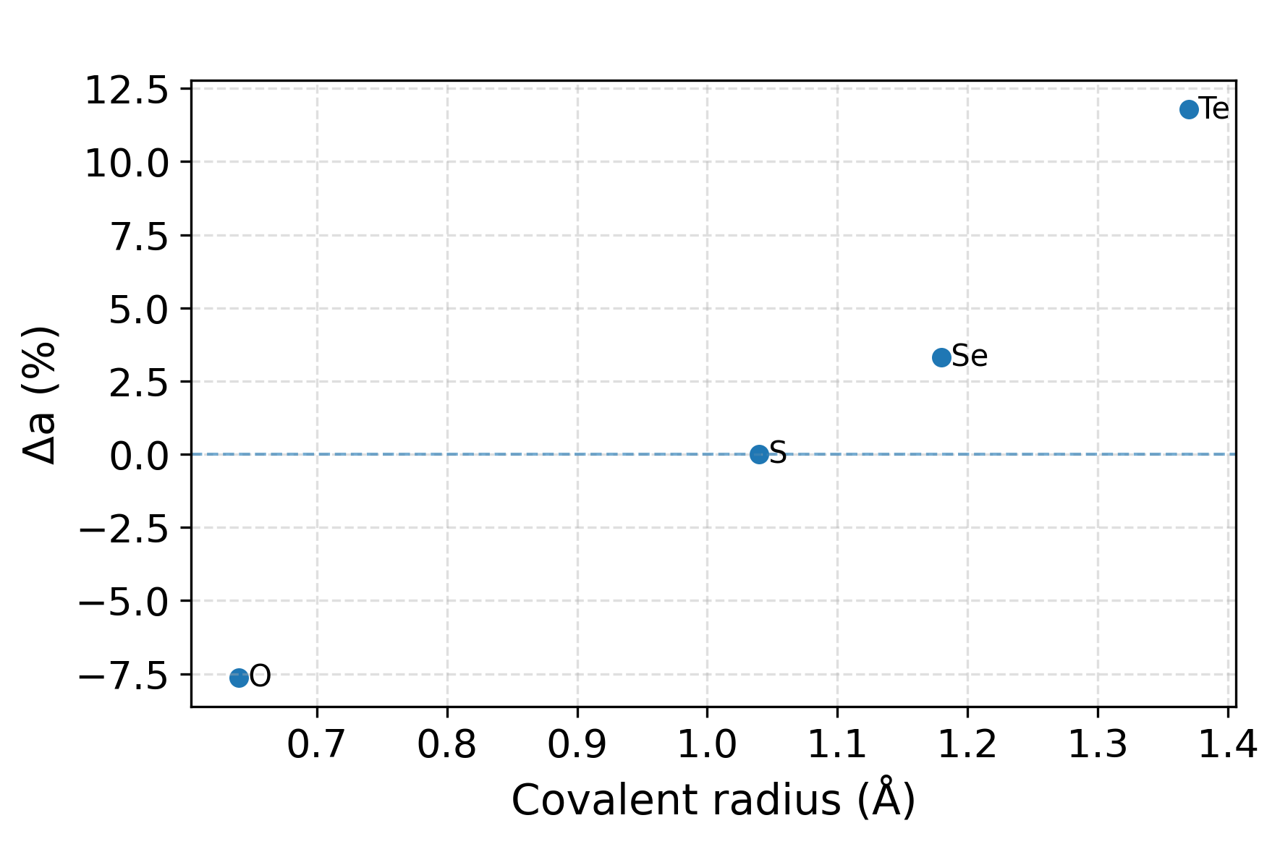
Figure S1. Lattice parameter variations vs. the covalent radius of the incorporated chalcogens on the MnPS₃ monolayer.

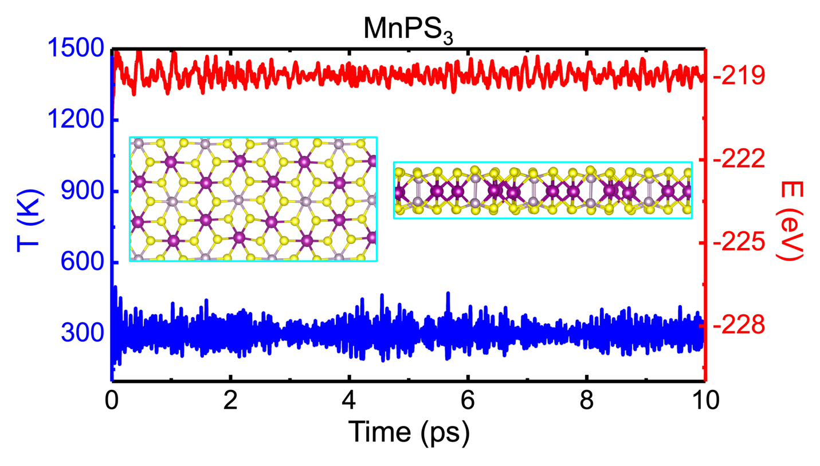
Figure S2. Fluctuation of temperature and energy, and the final structure obtained via AIMD simulations at 300 K of the MnPS₃ monolayer.

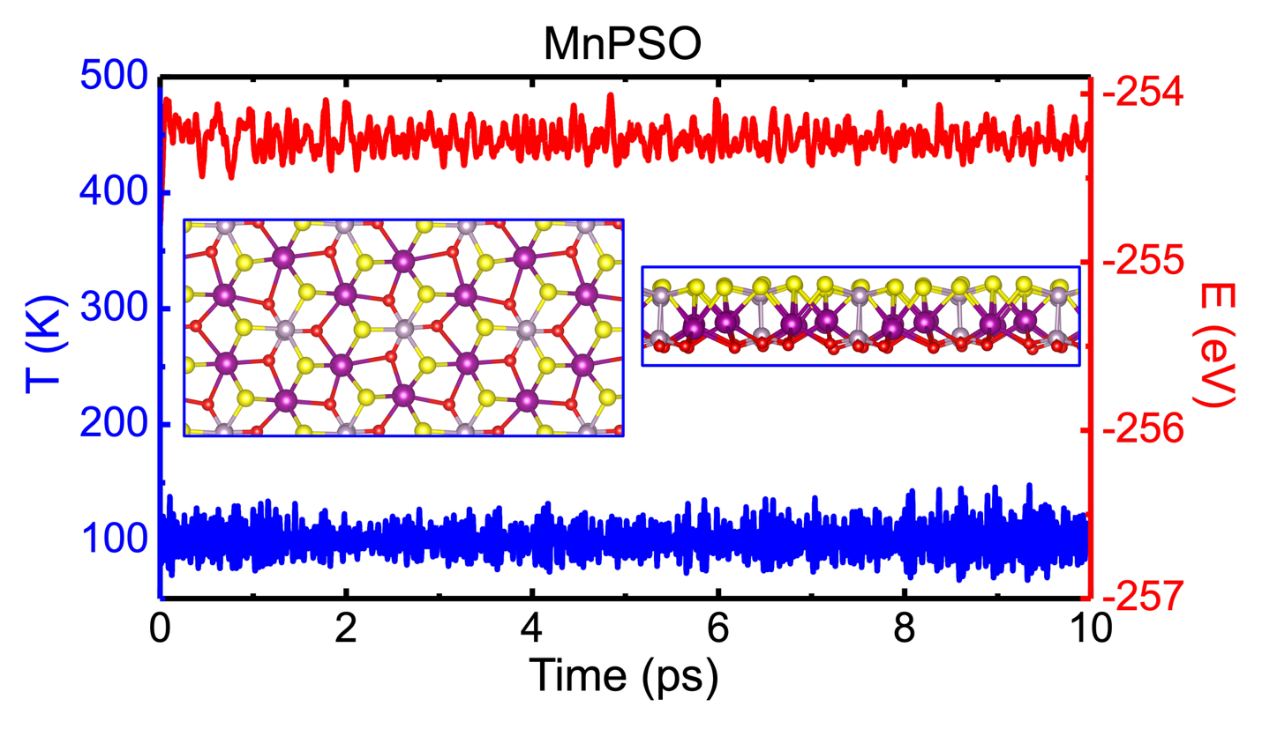
Figure S3. Fluctuation of temperature and energy, and the final structure obtained via AIMD simulations at 300 K of the MnPSO monolayer.
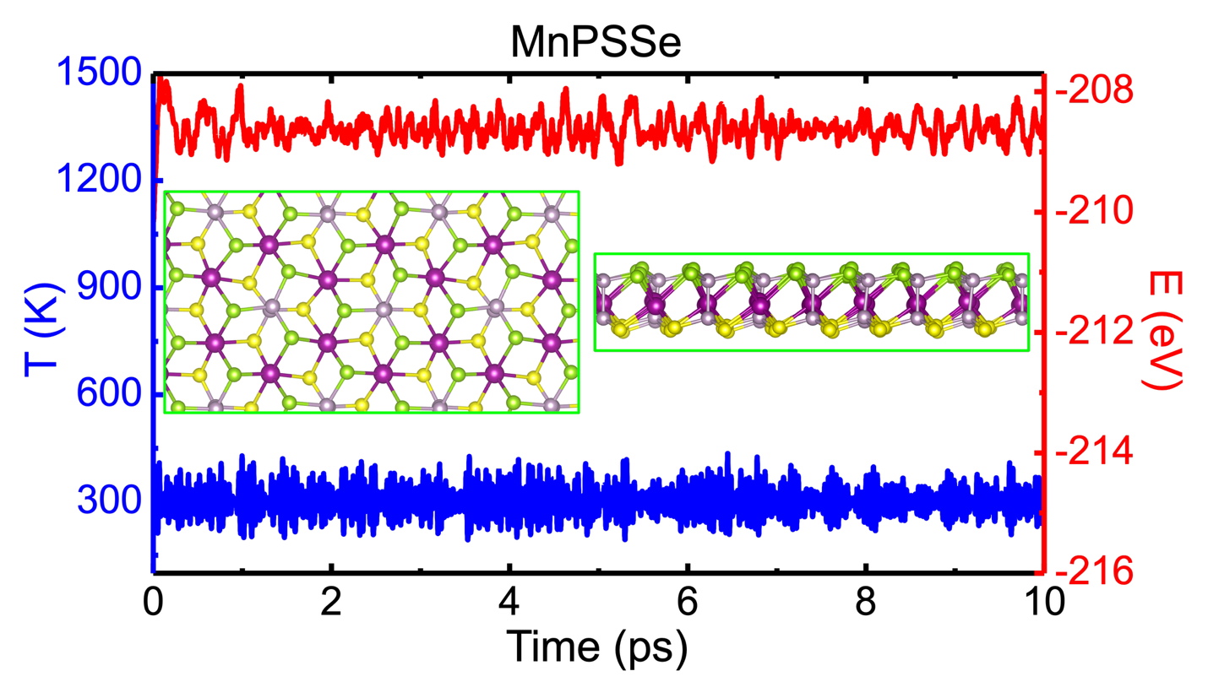
Figure S4. Fluctuation of temperature and energy, and the final structure obtained via AIMD simulations at 100 K of the MnPSSe monolayer.
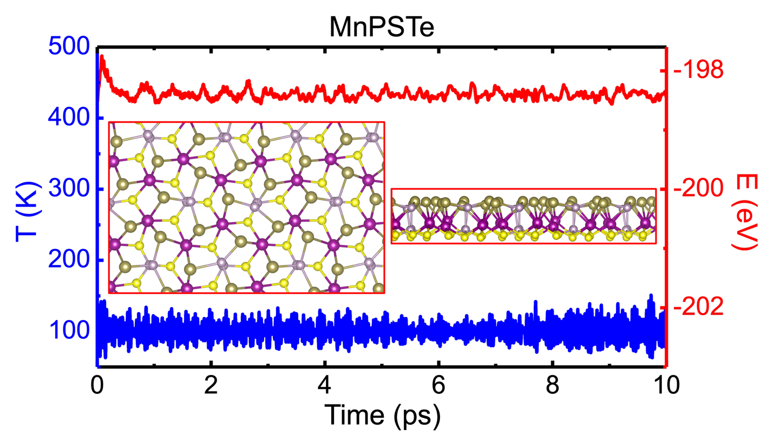
Figure S5. Fluctuation of temperature and energy, and the final structure obtained via AIMD simulations at 100 K of the MnPSTe monolayer.
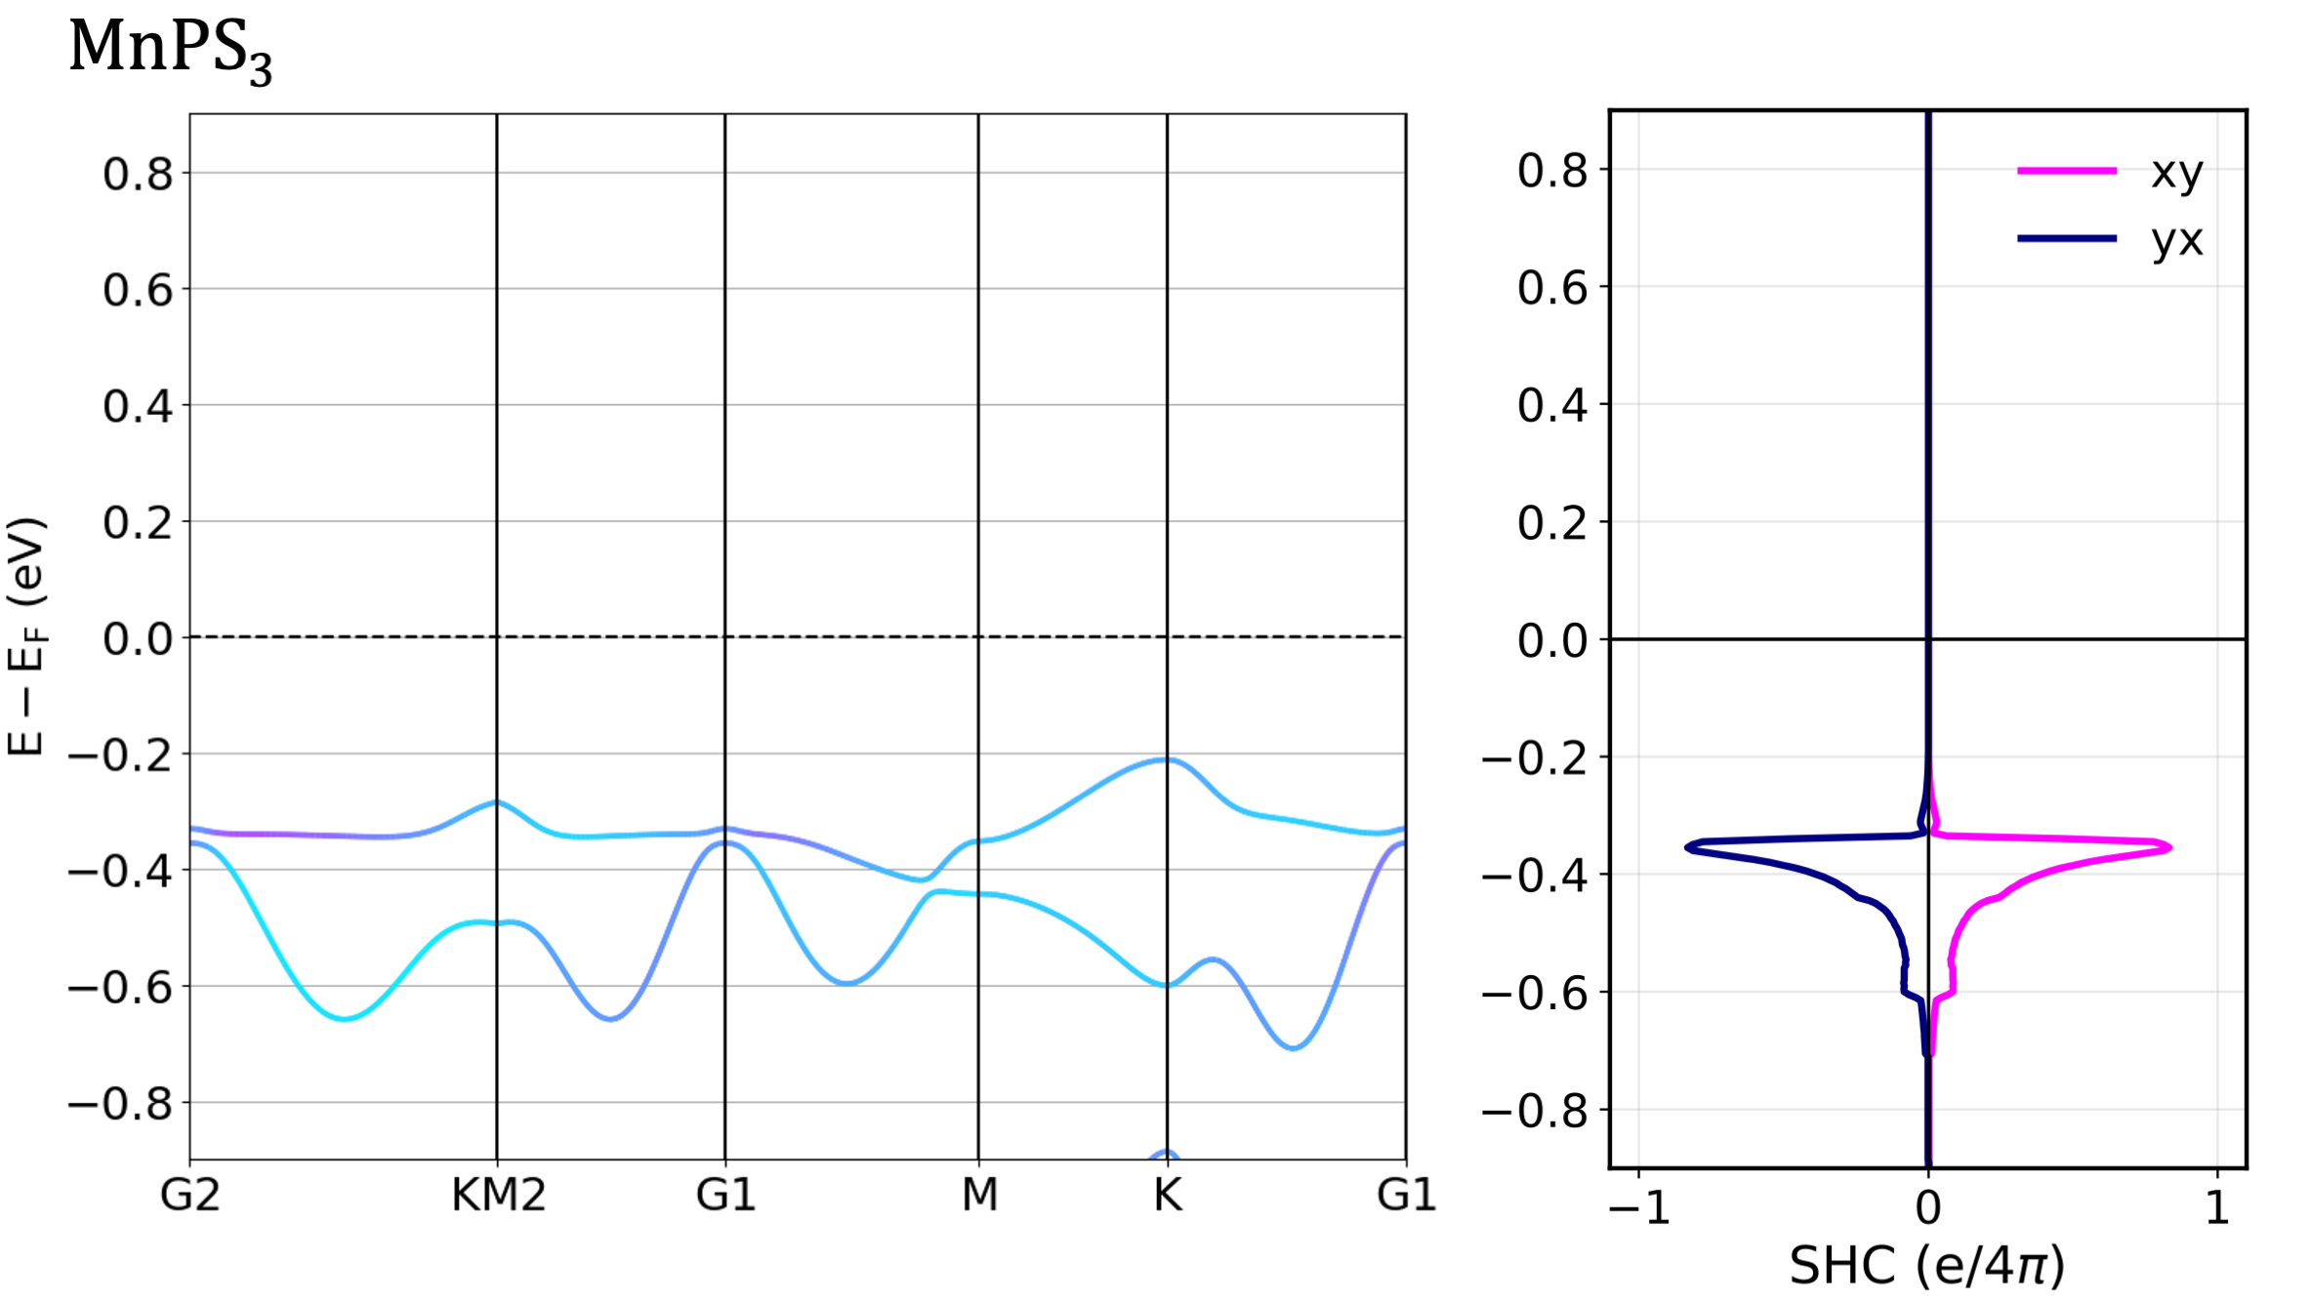
Figure S6. Spin–orbit–coupling band structure and spin Hall conductivity (SHC) of pristine MnPS₃ monolayer. Band dispersions (left) and SHC (right) reveal a topologically trivial character.
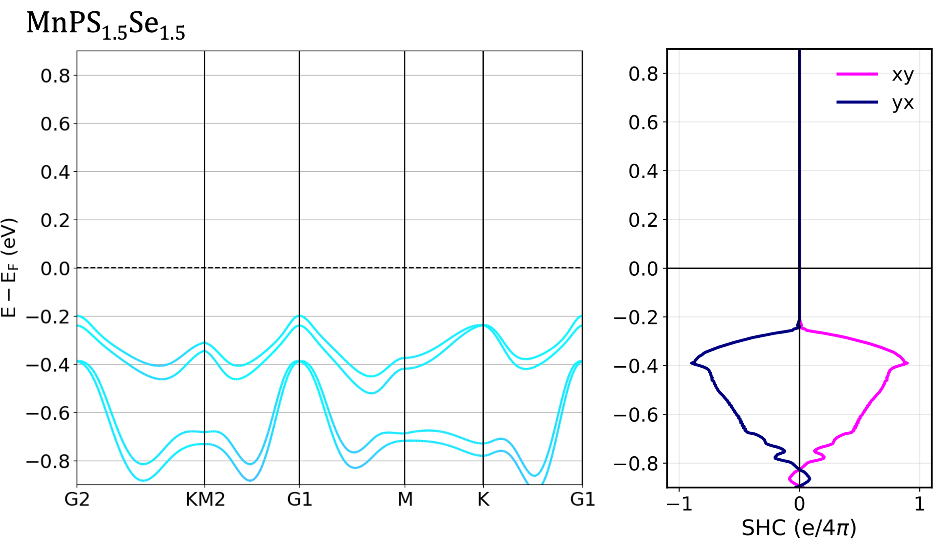
Figure S7. Spin–orbit–coupling band structure and spin Hall conductivity (SHC) of Janus MnPS_{1.5}Se_{1.5} monolayer. Band dispersions (left) and SHC (right) reveal a topologically trivial character.

