Supplementary Information

Integrating concentrated solar power with a prototype photoelectrochemical reactor

G. H. Creasey^{1,2*}, A. W. Moelich^{3*}, J. W. Rodriguez Acosta¹, J. J. H. Videira⁴, J. Zhu¹, S. Halder¹, C. McGregor³, A. Kafizas² and A. Hankin¹

¹ Imperial College London, Department of Chemical Engineering, London, SW7 2AZ, United Kingdom
² Imperial College London, Department of Chemistry, London, W12 0BZ, United Kingdom
³ Stellenbosch University, Department of Mechanical and Mechatronic Engineering, Stellenbosch, 7602, South Africa
⁴ Imperial College London, Department of Physics, London, SW7 2AZ, United Kingdom

*These authors contributed equally

System overview 3
System parameters 4
System boundaries 5
Electronic and optical configurations of the PEC reactor 6
Optical system development 7
Ray tracing 7
Finalised design description 8
Optical system characterisation 9
Concentration and efficiency characterisation 9
Optical geometry of the linear Fresnel lenses 9
Acceptance angle determination 10
Characterisation of Al-coated mirror 12
Bench-scale photoelectrochemical characterisation 13
Reactor and system design 15
Reactor configuration and assembly 15
Cathode compartment. 15
Membrane 16
Photoanode compartment. 16
System design and operation 19
System operating conditions 23
Photoanode fabrication 25
Pre-treatment of FTO glass substrates 25
AA-CVD of WO₃ layer 25
AA-CVD of BiVO₄ layer 25
AA-CVD of NiFeOOH layer 25
Physical materials characterisation 25
Scanning electron microscopy (SEM) 26
UV-vis spectroscopy 27
X-ray diffraction (XRD) 28
Raman spectroscopy 28
X-ray photoelectron spectroscopy (XPS) 29
Time-of-flight secondary ion mass spectrometry (ToF-SIMS) 31
Photovoltaic characterisation & prediction of performance under concentrated radiation 32
Prediction of Ohmic drop across the PEC reactor 38
Hydrogen production efficiency in the PEC reactor 41
Headline solar to hydrogen efficiency (STH) and system efficiency of the PV-PEC reactor 41
Performance of the PV-PEC reactor in operation mode ‘B’ 44
Photographs of photoanode degradation during PV-PEC testing with concentrated irradiance 46
References 47

System overview
Photographs of the photoelectrochemical (PEC) reactor system being irradiated by concentrated light during on-sun operation are shown in Figure S1.
Figure S1. Photographs of the PEC reactor system during on-sun operation showing (a) the top view with dual-sided irradiation, (b) the side-view with dual-sided irradiation and (c) the photoanode side of the reactor viewed laterally from inside the lightguide.

System parameters
The system parameters are summarised in Table S1.
Table S1. Parameters characterising the PV-PEC reactor system.
Sub-category | Parameter | Value / Description
Reactor system | Photo-absorbing area | 60 cm² (30 cm² photoanode + 30 cm² PV)
Reactor system | Photoanode | FTO | WO₃ | BiVO₄ | NiFeOOH  170 mm × 40 mm (total dimensions)  150 mm × 20 mm (photo-electroactive area, isolated via an O-ring)
Reactor system | Cathode | Nickel foil  180 mm × 20 mm (total dimensions)  150 mm × 20 mm (electroactive area, isolated via an O-ring)
Reactor system | External PV | c-Si (30 cm², V_{OC} ≈ 2.3 V and I_{SC} ≈ 302 mA at AM 1.5G and 70.8 ˚C)  170 mm × 40 mm (total dimensions)  150 mm × 20 mm (photo-absorber area)
Reactor system | Membrane | Nafion™ 115
Reactor system | Electrolyte | 1 M borate buffer (pH 9)
Reactor system | Electrolyte flowrate | ≈ 0.5 L min⁻¹ in each half of the reactor
Optical system | Optical components for non-concentrated light | UV-enhanced Al mirror (>85% reflectivity, 250-700 nm)  Positioned at 45° relative to incoming solar rays
Optical system | Optical components for concentrated light | Dual-sided linear Fresnel lens assembly (each half comprising three 250 mm × 150 mm × 2 mm lenses) and stepped lightguides
Optical system | Lenses | PMMA (250 mm × 150 mm * × 2 mm, each. * indicates the focussing dimension)
Optical system | Lightguides | Alanod Miro4® 4400GP reflective sheet (95% reflectivity, DIN 5036-3)
Optical system | Entry aperture area | 0.0375 m² per lens  0.225 m² for all six lenses (three on each side of the PEC reactor)
Optical system | Exit aperture area | 0.00925 m² (total irradiated area offered collectively by the two linear Fresnel lens assemblies)
Optical system | Geometric concentration ratio | 24.3
Combined system | Overall dimensions (horizontal footprint) | 1000 mm × 400 mm × 400 mm

System boundaries

Figure S2. System boundaries and definitions. (a) The characteristic entry length of the linear Fresnel lens assembly is the sum of the focussing dimensions of the three linear Fresnel lenses: d1, d2 and d3. Since the assembly concentrates light in a singular dimension, the geometric concentration ratio is defined as the sum of the characteristic entry length of the linear Fresnel lenses divided by the assembly’s characteristic exit length, the height of the exit aperture (d4). (b) The photo-absorbing area of the reactor (the irradiated photoanode area) and the PV cell are shown in yellow. Figures (a) and (b) are not drawn to scale. (c) The system boundaries, optical system boundaries and PEC system are shown schematically. Solar energy is guided by the optics to the PEC reactor. The reactor converts the solar energy to chemical energy stored in hydrogen molecules, which is transported away through the balance-of-system (BoS) subsystem. Energy losses between the sun and the system boundary (e.g., energy absorbed by the atmosphere), and between the system boundary and the BoS subsystem (e.g., energy required to increase the pressure of the hydrogen gas), are not considered.

Electronic and optical configurations of the PEC reactor
Table S2 shows the optical and electronic configurations of the PEC reactor, constructed following the methodology presented by Holmes-Gentle et al.¹
Table S2. Electronic and optical configurations of the PEC reactor.
Photo-absorbers | - FTO|WO₃|BiVO₄|NiFeOOH photoanode  - c-Si PV
Electronic configurations | 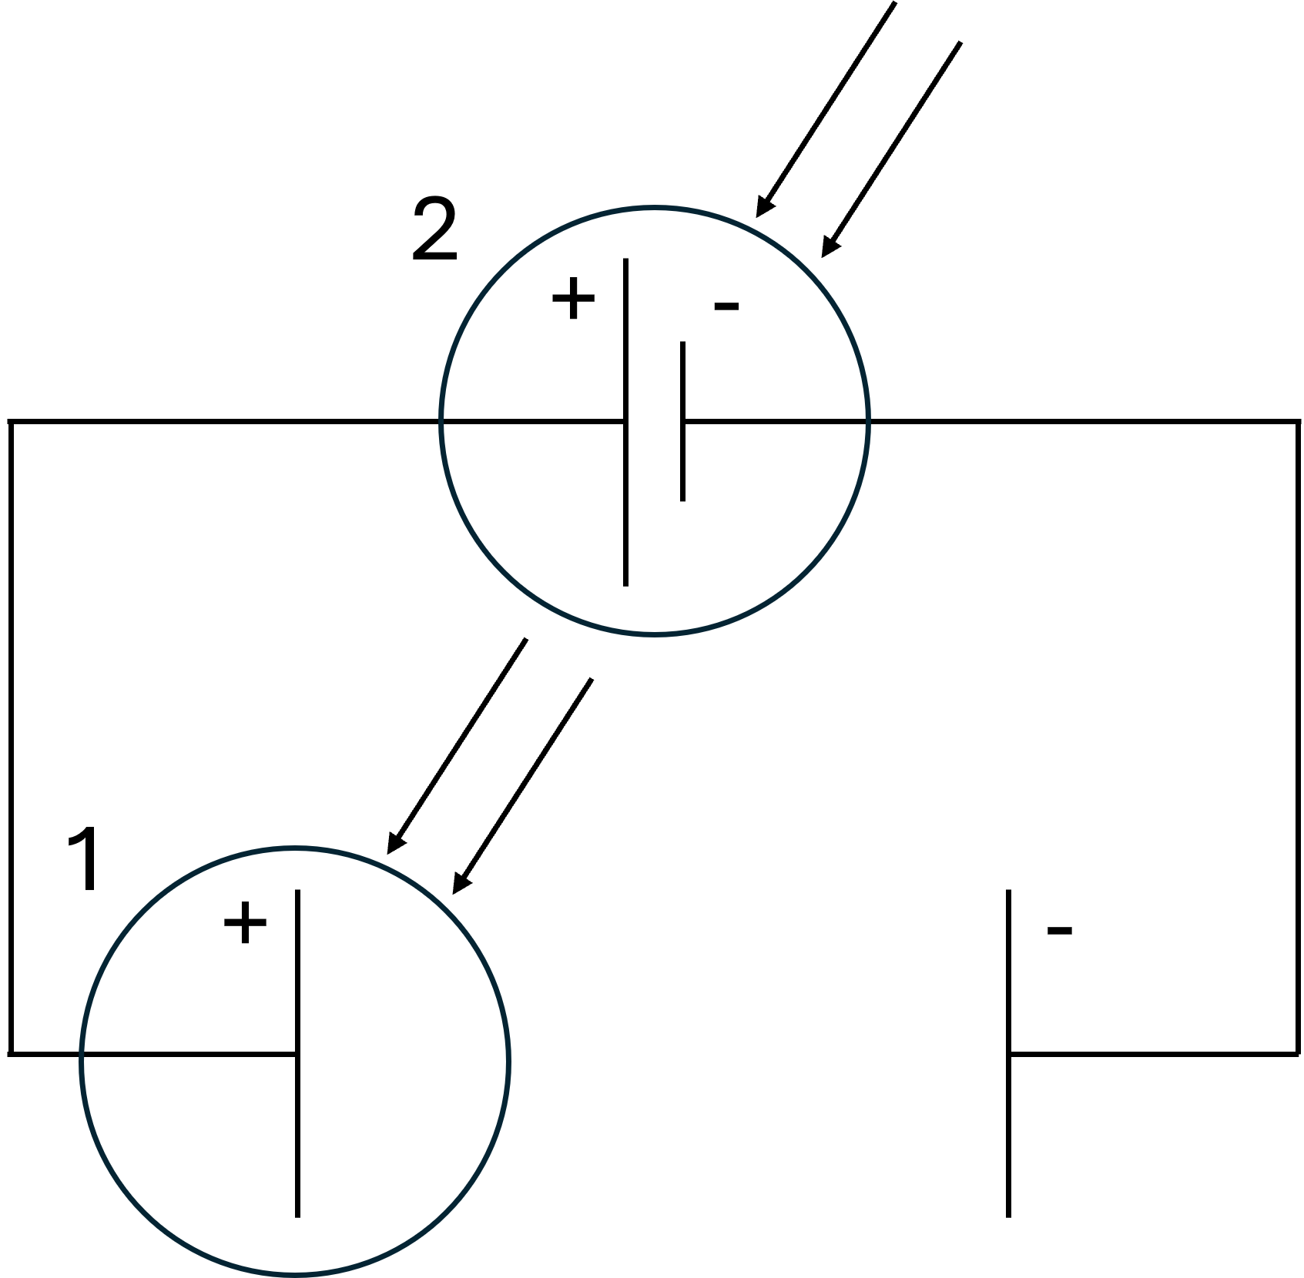
Optical configurations | 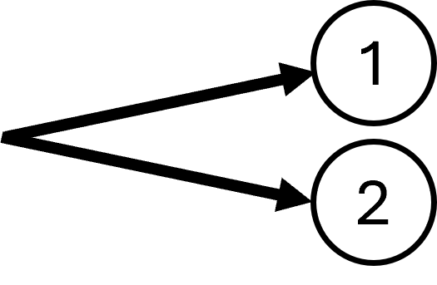

Optical system development

Ray tracing
The propagation of light through the optical system was simulated using COMSOL Multiphysics®. As input, monochromatic solar irradiance was assumed to be vertically incident on the geometry, while corrections were made for the finite size of the solar disc via introduction of angular perturbations of the incident rays. The simulation was used to determine the concentration ratio of the optical system, accounting for potential sources of energy losses.
A simplified geometry of the optical sub-assembly, consisting of three linear Fresnel lenses and a lightguide, was simulated and is shown in Figure S3. The linear Fresnel lenses were simulated as concentrators using parabolic surfaces with perfect geometry. The alanod sheets of the lightguide were merged into a singular 0.5 mm thick solid. Features that did not play a significant optical role (such as positioning tabs), as well as fine geometrical features (such as bending radii), were removed. The lightguide exit aperutre was capped with a surface representing a single reactor window, with area equivalent to that of a photoelectrode (30 cm²). Finally, a large box was created around the geometry to catch stray rays exiting the system. This bounding box is hidden in Figure S3 to reveal the geometry of the lightguide. The boundary conditions used in the simulation are summarised in Table S3.
Figure S3. Ray tracing geometry of the three-lens + lightguide assembly that was used for irradiating each side of the PEC reactor.

Table S3. Primary boundary conditions used in the ray tracing simulation
Type | Condition | Surface | Input | Value | Unit
Source | Illuminated surface | Parabolic surfaces | Flux | 100 $×τ$ = 92 | mW cm⁻²
Wall | Specular reflection | Lightguide surfaces | Reflectivity | 0.95
 | Freeze | Bounding box
Target | Wall – freeze | Target

A total input flux of 100 mW cm⁻², with adjustments for the transmission losses (transmittance: $τ$ = 0.92) in the Fresnel lenses, was applied to the illuminated surface boundary condition on the ideal concentrators. At the source boundary, 75,000 rays were released. The flux was integrated over the source area to determine the total input power of the simulation. The starting position of the rays on the boundaries were randomly distributed. Since the sun is not an ideal point light source and therefore does not produce perfectly parallel rays, a random angular perturbation was introduced to adjust for the shape of the sun. The perturbation was sampled from a cone with half cone angle of 4.65 mrad. An additional angular perturbation parameter, which was varied between simulations, was added to allow the effects of tracking error to be included in the model.
A specular reflection boundary condition, with a reflectivity of 95%, was applied to the inner walls of the lightguide. The reflection losses in the lightguide were determined by adding an accumulating variable to the specular reflection boundary condition. The variable summed the total flux lost due to reflection losses in the simulation.
A “freeze” boundary condition was applied to the target surface. Upon hitting the boundary, the ray was terminated, and its properties were stored. A similar condition was applied to the faces of the boundary box, allowing it to catch any stray rays. Any ray escaping the optical system and extending into free space was captured by the bounding box.

Finalised design description
An image of the assembled system in operation is shown in Figure S4. The parameters characterising the Fresnel lenses are summarised in Table S1.
Figure S4. Images of the linear Fresnel lens + lightguide assemblies during testing.

Optical system characterisation

Concentration and efficiency characterisation

Optical geometry of the linear Fresnel lenses
A Fresnel lens is produced by dividing an optical surface into segments and removing unnecessary material in the optical, condensing the form factor of the lens. The result is a lens with a jagged edge, with the diagonal of each segment representing a segment of the original optical surface.
The radius of curvature, $R$, of the optical surface of a plano-convex lens (which a Fresnel lens approximates) in air can be determined using the Lensmaker’s equation, shown in Equation (S1) ²:
$$\frac{1}{f}=\left(n-1\right)×\frac{1}{R}$$ | (S1)
For a lens with focal length $f$ and refractive index $n$, the radius of curvature can be determined as:
$$R=\left(n-1\right)×f$$ | (S2)
In the case of the procured linear Fresnel lenses, however, the radius of curvature of the optical surface (calculated using the refractive index of PMMA and the focal length specified by the supplier) was smaller than the width of the lens. Therefore, the regions of the lens at a distance larger than $R$ from its centre did not have a physical solution for the optical geometry required to refract an incident light ray onto the focal point. In these regions, the pattern of the inner parts of the lens were merely repeated. Therefore, the rays refracted by these regions exited the lens in (approximately) parallel directions, resulting in a “focal area”, rather than a sharp focal line. This effect can be seen in the optical microscope images of the Fresnel lenses used in this study shown in Figure S5.
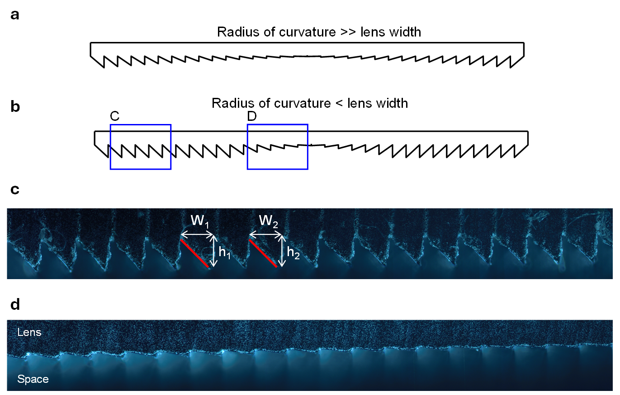
Figure S5. A cross-section of a typical Fresnel lens is shown schematically in (a), illustrating the reduction in height of the segments close to the centre relative to the outer segments. However, in the case of the procured lenses, the inner segments are repeated towards the outer edges of the lens, as illustrated in (b). The segments in the outer sections of the procured lenses, shown in (c), have equal height and equal width, and consequently parallel optical surfaces (indicated in red). Consequently, the refracted rays are parallel and do not focus onto a singular focal point. (d) shows a subsegment of the lens close to the centre of the lens, where the heights of the segments decrease as expected. The images in (c) and (d) were taken using an optical microscope.

Acceptance angle determination
The acceptance angle of an optical system describes the sensitivity of the system to angular deviations between the normal to the entry aperture plane and the direction of travel of incident rays. Such angular deviations are described by a ray’s incidence angle – the angle between the vector describing its direction of travel and the vector normal to the optical system’s entry aperture. Figure S6 shows rays N, A and B with incidence angles θ, α, and β, respectively. The acceptance angle can be determined based on the geometry of the optical components. The acceptance angle is the largest incidence angle at which the ray successfully reaches the target (illustrated by ray A in Figure S6). Therefore, any ray with an incidence angle greater than the acceptance angle of the optical system will not reach the target (illustrated by ray B in Figure S6). In practical systems, the presence of manufacturing and assembly errors require the acceptance angle to be determined experimentally. For such cases, optical systems are tested under a range of incidence angles. The acceptance angle is then defined as the incidence angle at which the flux at the target is reduced with 10% relative to the maximum. This is also the definition used for the work presented here. The approach to determine the acceptance angle of the linear Fresnel assembly is described below.
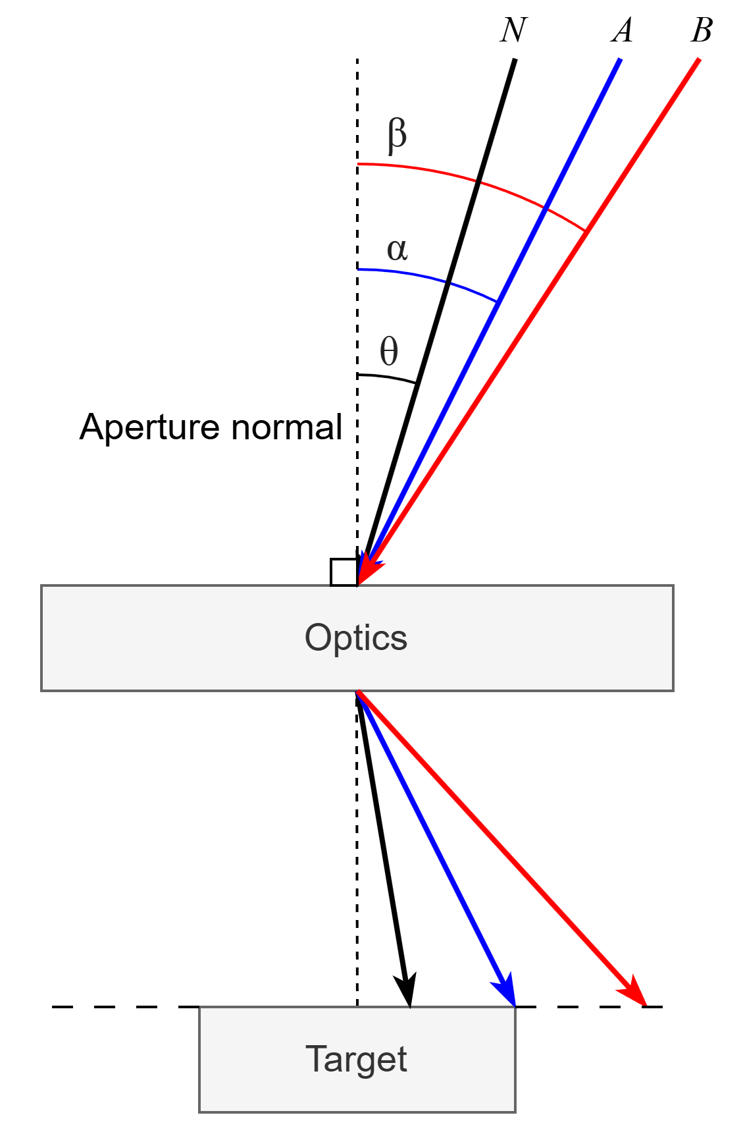
Figure S6. Schematic illustrating the influence of the incident angle on the destination of a ray relative to the target.
Tracking sensitivity tests were performed to evaluate the acceptance angle of the optical system. To establish the acceptance angle of the optical system, the normalised output flux at a range of incidence angles had to be determined.
Using the StellarNet BLACK-Comet UV-VIS spectrometer (280 nm to 900 nm) or the StellarNet DWARF-Star Miniature NIR spectrometer (900 nm to 1600 nm), flux measurements were taken at the centre location of the optical system’s exit aperture. The test was for both the UV-vis and NIR wavelength ranges. The proprietary software package, StellarPro, was used to automate the recording of the measured values at regular intervals of 15 seconds, over a duration of 6 minutes. The recordings were timestamped, allowing the solar position at each timestamp to be calculated using the sun-observer angle in equations³ (S3) - (S5).
The incidence angle for each flux recording was determined as follows: An initial orientation of the optical system was set by placing the system in the on-sun position. In this position, the tracking error was assumed to be zero. Once aligned, the solar tracking was deactivated, fixing the optical system in its initial position. At this point, the measurement of the output flux of the optical system started as the sun continued along its perceived trajectory through the sky with passing time. Using the solar equations, the angular displacement of the sun could be calculated at different time steps.
The output flux measurements for each 6-minute-run were normalised with the flux at the initial time to produce a normalised flux value. The angular displacement of the sun at each time of measurement, relative to the solar position at the initial time, was calculated to determine the incidence angle. Using the clock time of each measurement, the observer angles, (azimuth, $α$, and elevation, $ζ$), of the sun were calculated at each time step. The unit solar vector, $S_{t}$, at time $t$ was calculated using Equation (S3):
$$S_{t}={\left[\begin{matrix}S_{n} \\ S_{e} \\ S_{z}\end{matrix}\right]}_{t}={\left[\begin{matrix}\sin{ζ}×\cos{α} \\ \sin{ζ}×\sin{α} \\ \cos{ζ}\end{matrix}\right]}_{t}$$ | (S3)
The angular displacement of the sun, $ω$, relative to the reference position $S_{t0}$ at $t_{0}$ could therefore be calculated as follows:
$$S_{t0}⋅S_{t}=\left|S_{t0}\right|\left|S_{t}\right|\cos\left(ω\right)$$ | (S4)
$$ω=\cos^{-1}\left(S_{t0}⋅S_{t}\right)$$ | (S5)
The incidence angle was assumed to be equal to $ω$.
Figure S7. Solar vectors at two reference times.

Characterisation of Al-coated mirror
Figure S8 illustrates the results from optical characterisation of the Al-coated mirror used in field testing experiments. Optical characterisation was conducted in the laboratory using a solar simulator at a fixed light intensity equivalent to one sun (100 mW cm⁻²).
Figure S8. Spectral irradiance of direct light and light reflected by (a) an Al-coated mirror and (b) the cumulative power over increasing wavelengths. Simulated sunlight was prouced by a Class A Sun2000 Solar Simulator (Abet Technologies) equipped with an AM 1.5G filter. The spectral irradiance was measured by BLACK-Comet UV-vis and DWARF-Star miniature NIR spectrophotometers (StellarNet), equipped with cosine receptors and placed at a working distance of 110 cm from the solar simulator.

Bench-scale photoelectrochemical characterisation
Small-scale (1.5 cm × 2.5 cm) FTO | WO₃ | BiVO₄ | NiFeOOH electrodes (prepared using the same synthesis procedure as the up-scaled electrodes) were characterised in the laboratory under simulated solar irradiance. The electrodes were placed in a PTFE Photo-electrochemical Flow H-Cell (Redox.me) and back-illuminated under the irradiance of a Sun2000 Solar Simulator (Class A, Abet Technologies, equipped with a 550 W Xe arc lamp and AM 1.5G filter). Figure S9 shows the spectrum of the solar simulator at one sun equivalent light intensity, compared to AM 1.5G.
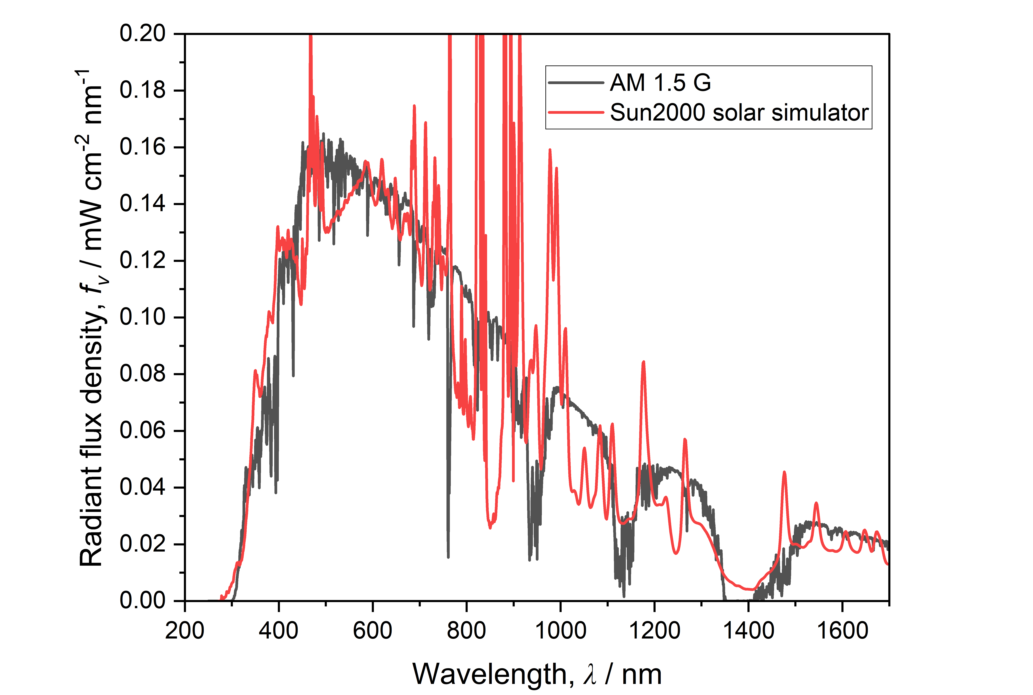
Figure S9. Spectral irradiance of the Class A Sun2000 solar simulator (Abet Technologies) equipped with an AM 1.5G filter, compared with the NREL AM 1.5G reference spectrum.⁴ The spectral irradiance was measured by BLACK-Comet UV-vis and DWARF-Star miniature NIR spectrophotometers (StellarNet), equipped with cosine receptors and placed at a working distance of 110 cm from the solar simulator.
Various working distances were used to deliver different irradiances to the photoelectrochemical cell. The light spectrum and intensity were characterised by StellarNet Black Comet UV/vis (280 – 900 nm) and Dwarf Star (900 – 1700 nm) spectrophotometers, interfaced with StellarPro software. Representative light spectra are provided in Figure S10. Light intensity in suns was defined as the ratio between the cumulative incident irradiance from the solar simulator at the working distance to the cumulative light intensity of the AM 1.5G spectrum measured over the same wavelengths. This is represented by Equation (S6).
$$I=\frac{{\left(\int_{λ_{1}}^{λ_{2}}{f_{v}∙dλ}\right)}_{measured}}{{\left(\int_{λ_{1}}^{λ_{2}}{f_{v}∙dλ}\right)}_{AM 1.5G}}$$ | (S6)
where $I$ = incident light intensity (suns), $f_{v}$ = radiant flux density (mW cm⁻² nm⁻¹), $λ$ = wavelength (nm)
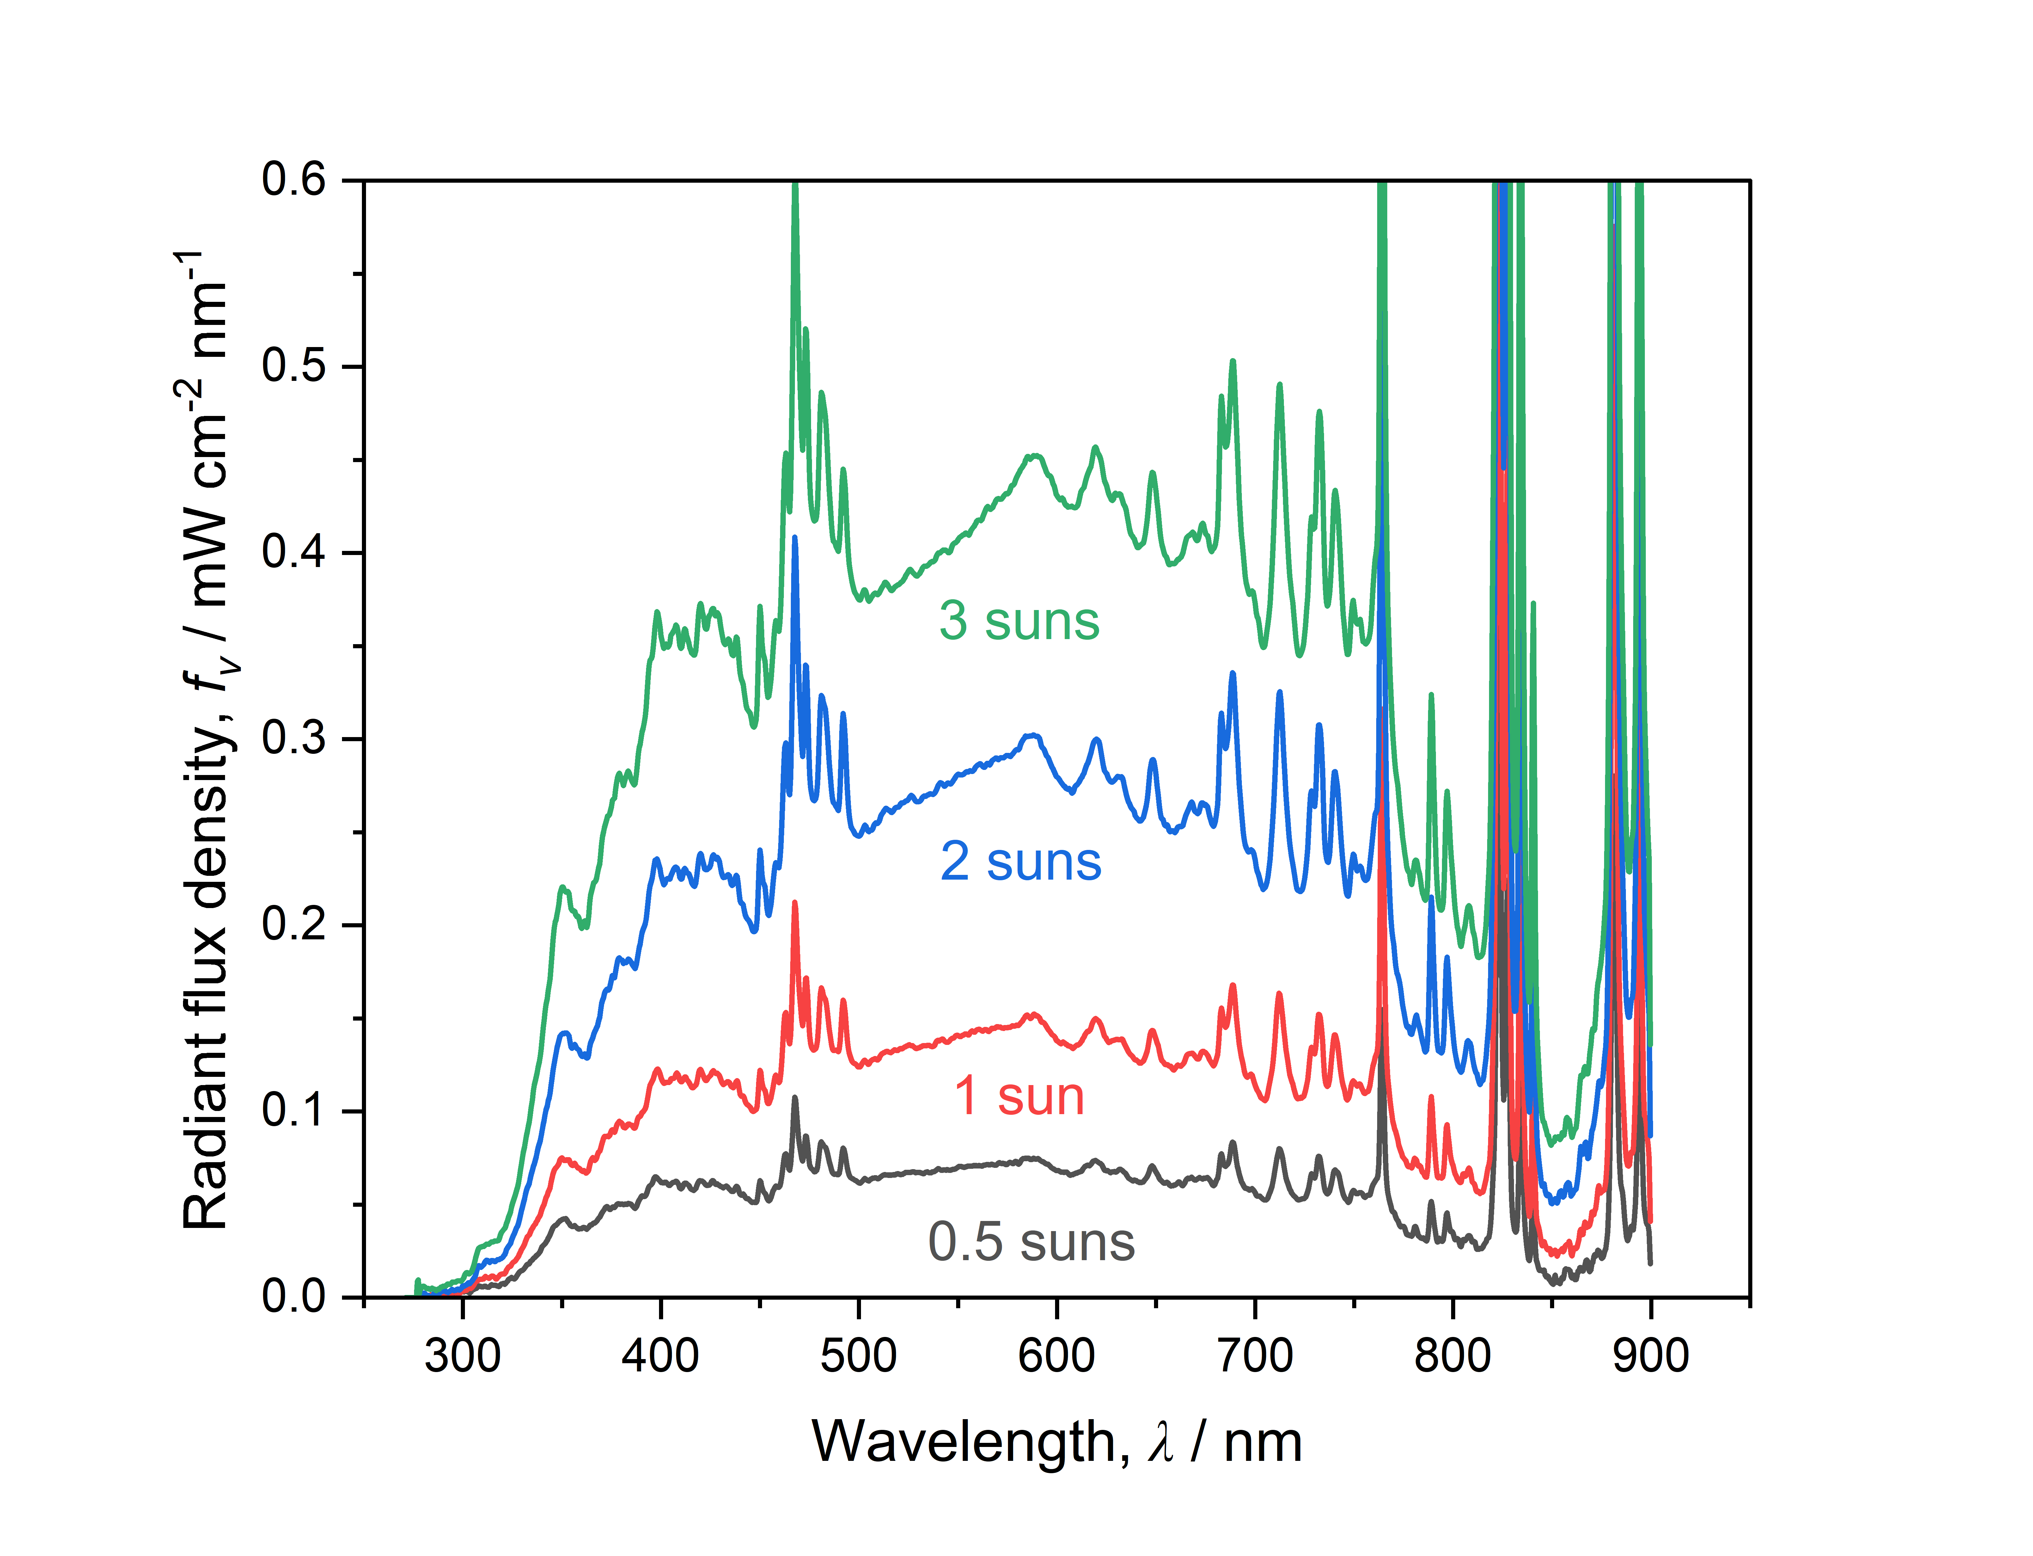
Figure S10. Representative light spectra of the Sun2000 solar simulator at various light intensities.

Reactor and system design

Reactor configuration and assembly
The photoelectrochemical reactor comprised several components that were compressed together, ensuring liquid- and gas-tight seals via the use of silicon O-rings and gaskets. Assembly schematics are shown in Figure 8 in the main manuscript. Photographic images of reactor components are presented below.
Cathode compartment. First, the cathode backing pate was laid flat and all the other components were positioned over the top sequentially. Figure S11 shows the cathode backing plate with the inward-facing side facing upwards. The recess was designed to accommodate the flat plate Ni cathode, to which two spring loaded electronic point contacts were made from the rear. Each point contact was protected from any contact with the electrolyte by an O-ring. Figure S12 shows the Ni cathode in place. Figure S13 and Figure S14 show the successive superposition of the catholyte frame and membrane-supporting frame (cathode side), respectively.
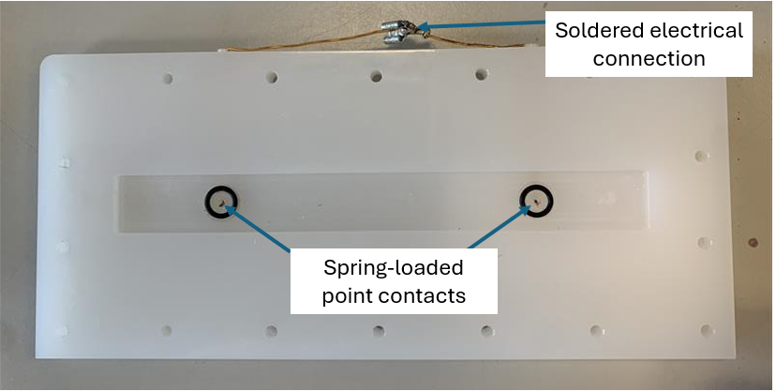
Figure S11. Photograph of the reactor cathode supporting frame (without the cathode in place).

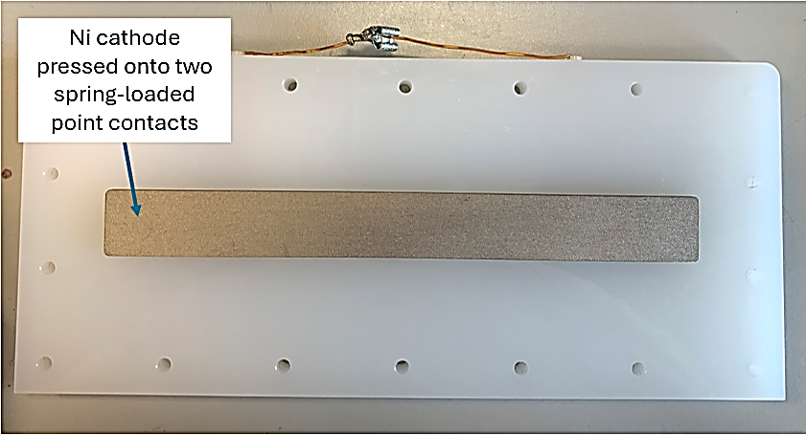
Figure S12. Photograph of the reactor cathode supporting frame (with the Ni cathode in place).

Figure S13. Photograph of the reactor catholyte compartment positioned on top of the cathode supporting frame. The slant in the compartment wall above the electrode was designed to prevent bubble accumulation and to facilitate bubble removal by the flowing electrolyte.

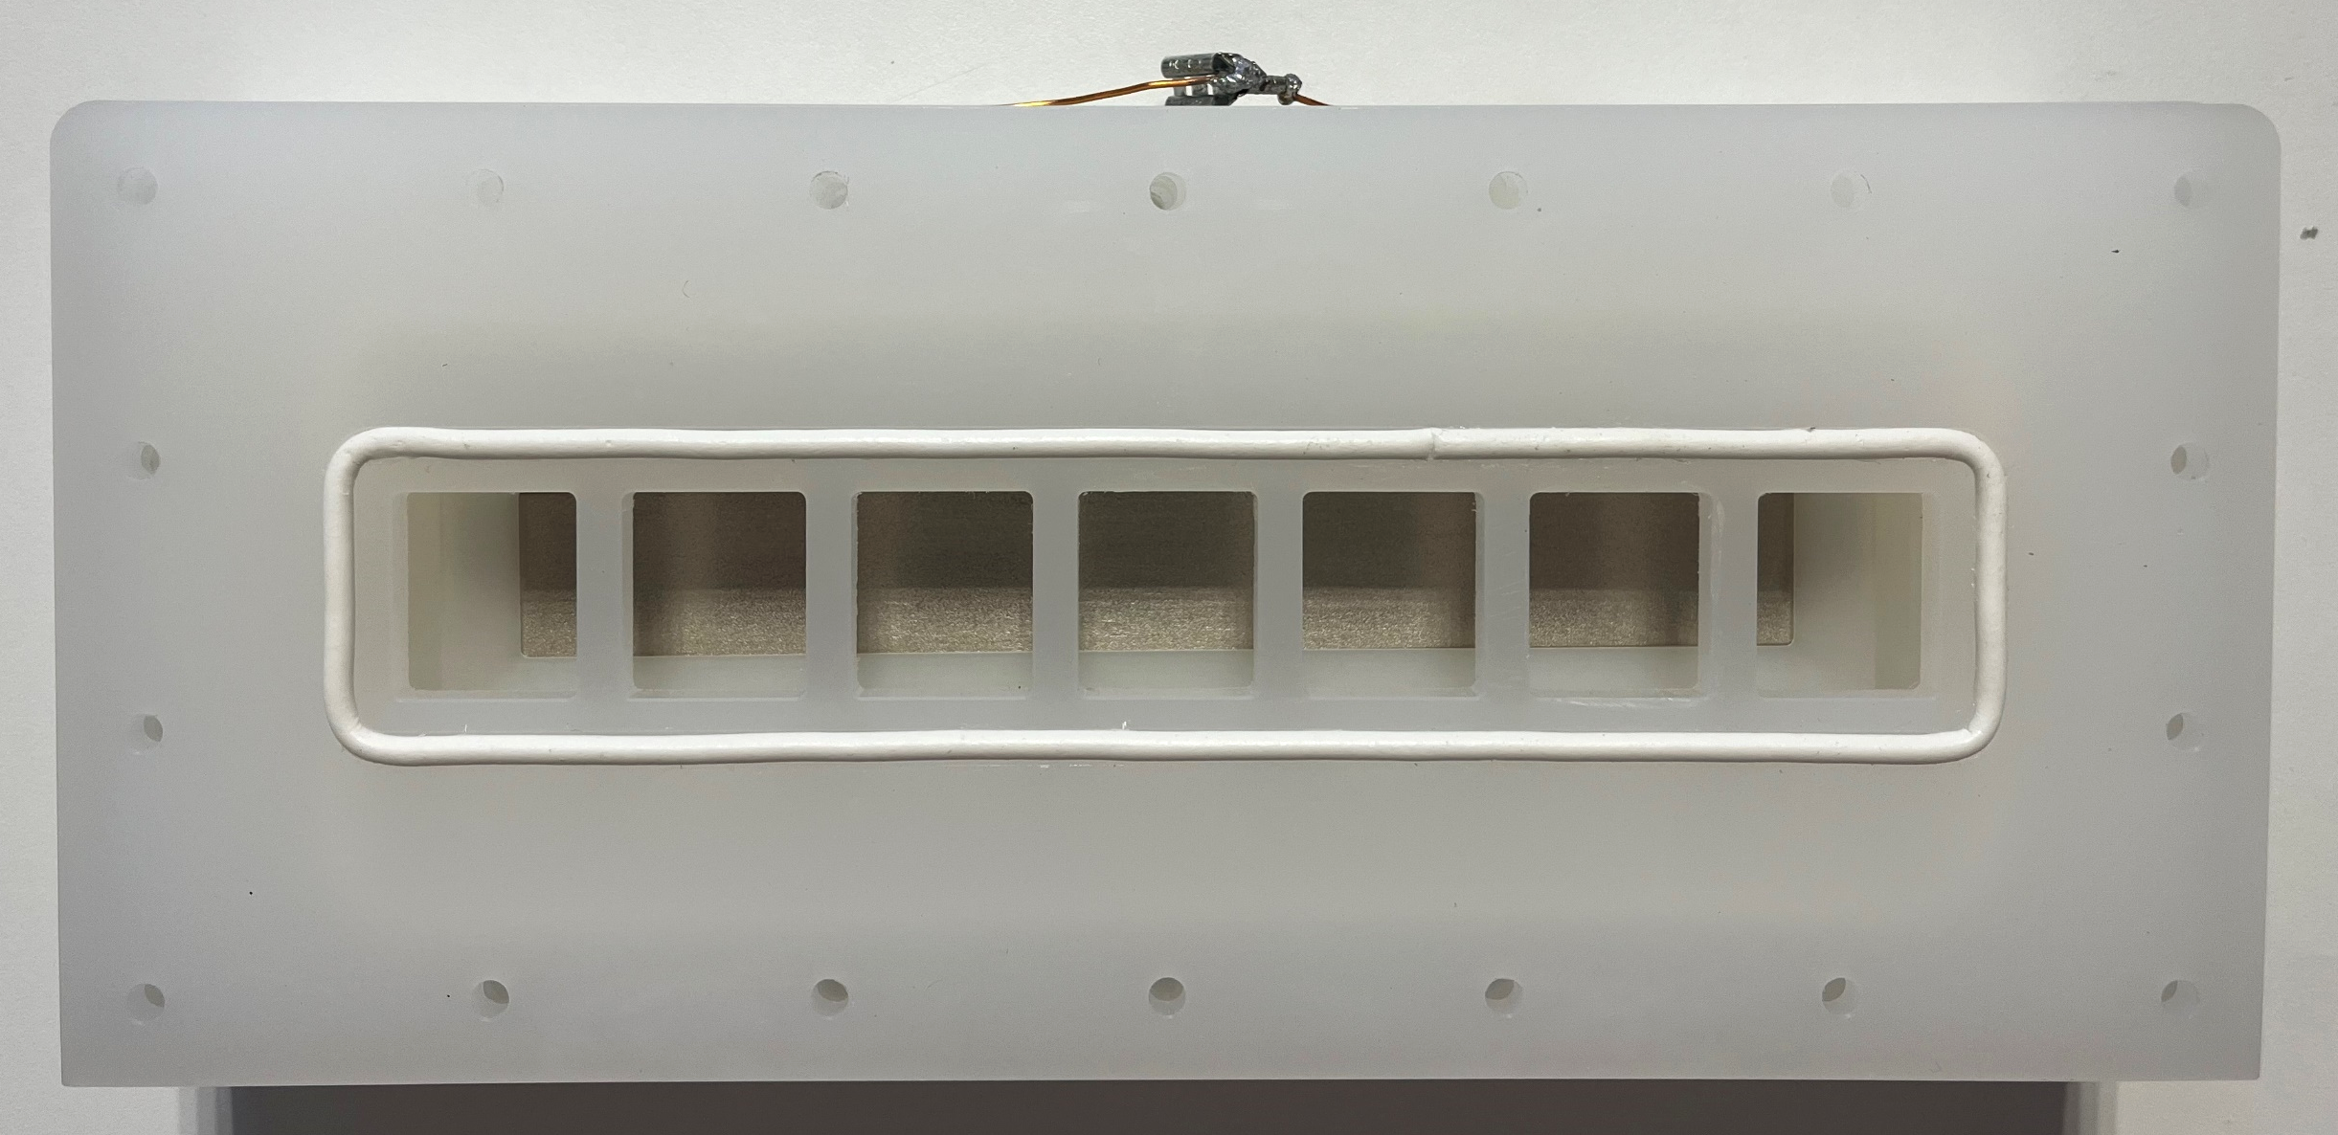
Figure S14. Photograph of the membrane-supporting frame (cathode side) positioned over the catholyte compartment.

Membrane. The Nafion 115 membrane was sealed in place in between the cathode and anode membrane-supporting frames (image not shown, as the pre-wetted membrane needed to be positioned and fixed in place very quickly, to avoid shrinkage and consequent poor sealing).

Photoanode compartment. The photoanode compartment (shown in Figure S15) was then bolted onto the anode-side membrane supporting frame. The photoanode compartment piece was machined to simultaneously house the anolyte and act as the photoanode supporting frame. Electrical connections to the photoanode were made using six copper point contacts, which were polished at the start of each experiment to remove residual copper oxides. The point contacts were then externally consolidated at a single soldered connection. A rectangular tantalum foil gasket was placed directly over the copper contacts, acting as a feeder plate to the overlying photoanode. A silicon O-ring in the photoanode compartment ensured the photoanode was sealed in place and prevented the leakage of electrolyte. The reactor pieces were bolted together at this stage. 18 bolts were used to distribute pressure evenly around the perimeter of the reactor assembly. Similarly to the cathode compartment, a slant was machined into the photoanode compartment wall above the photoanode to prevent bubble accumulation and to facilitate bubble removal by the flowing electrolyte.
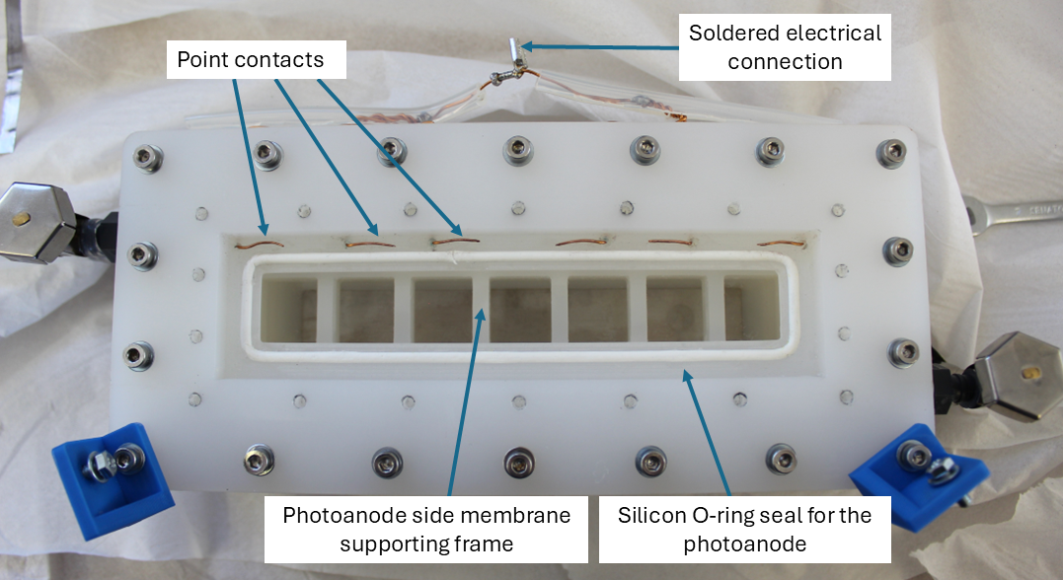
Figure S15. Photograph of the anolyte compartment, which simultaneously acted as the photoanode supporting frame
Figure S16 shows the photoanode in place in its compartment in the reactor. The photoanode was placed face down against the tantalum gasket. The photoanode was pressed in firmly to ensure that it was level and did not protrude from its compartment.
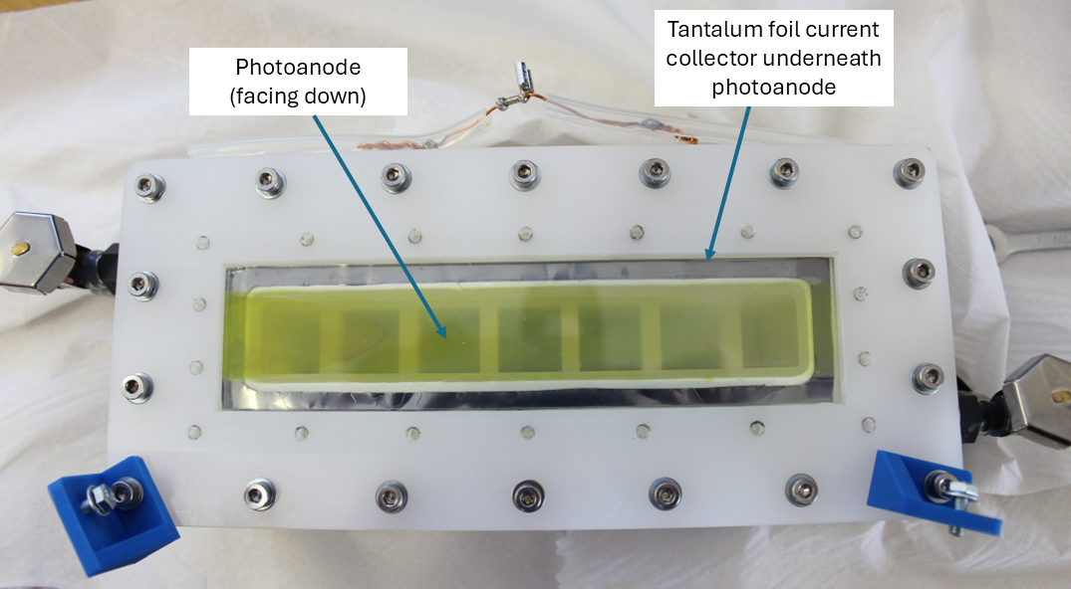
Figure S16. Photograph of the photoanode reactor compartment showing the photoanode in place, facing down on a tantalum foil current collector, prior to being compressed by the outer frame.
In the final assembly step, the photoanode was secured in place using an outer photoanode supporting frame, tightened using 18 bolts to achieve even pressure distribution and ensure a good seal, whilst avoiding pressure points that would crack the FTO glass. The assembled reactor, observed laterally from the photoanode side, is shown in Figure S17.
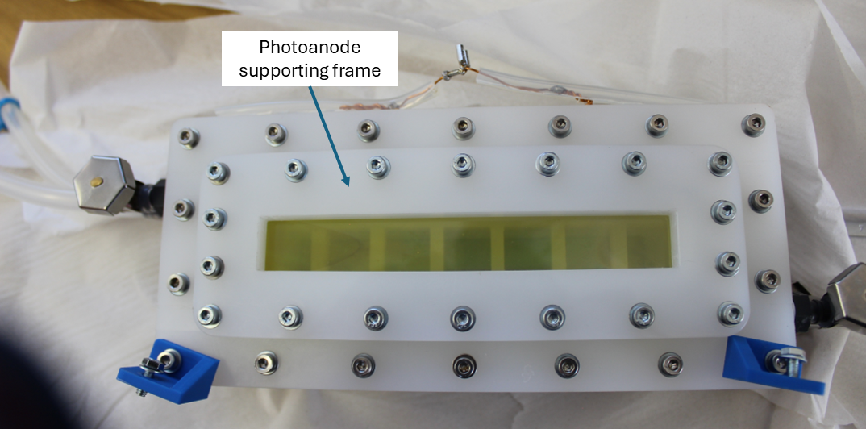
Figure S17. Photograph of the reactor observed laterally from the side of the photoanode, which is sealed in place by the photoanode supporting frame.

Reference electrodes were inserted from the top through dedicated fittings, as shown in Figure S18.
Figure S18. Insertion of one of the two reference electrodes into the reactor.

System design and operation
The reactor system was designed with consideration to chemical engineering principles, to facilitate safe and easy operation. Some aspects of the design were simplified to minimise the number of valves and fittings in the system.
The as-designed system is illustrated by a piping and instrumentation diagram (P&ID), shown in Figure S19.
Figure S19. P&ID of the photoelectrochemical reactor system during normal operation. A key to the P&ID is shown in Table S4.
Table S4. Key to the P&ID in Figure S19.
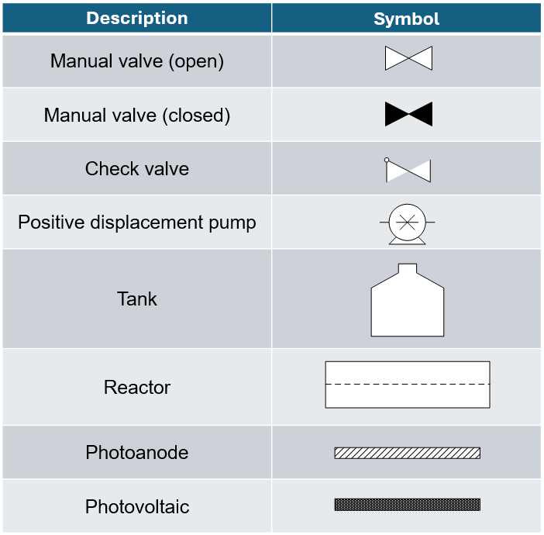

List of equipment, valves and instrumentation:
Tanks:
T-01: Washing tank – contains mainly water and small amounts (< 1%) of anolyte and catholyte from washing procedure.
T-02: Borate buffer (electrolyte) tank – contains pH 9.3 sodium borate buffer (1 mol dm⁻³ boric acid + sodium hydroxide in deionised water).
T-03: Electrolyte waste tank – contains electrolyte drained during cleaning and water used in the wash cycle.
Other vessels:
R-01: Prototype photoelectrochemical water splitting reactor
Pumps:
P-01: Anolyte line positive displacement pump
P-02: Catholyte line positive displacement pump
Valves:
Manually operated valves: V-01, V-02, V-03, V-04, V-05, V-06, V-07, V-08, V-09, V-12, V-13, V-14, V-15, V-16, V-17, V-18, V-19, V-20, V-21
Check valves: V-10, V-11
Flow meters:
F-01: In-line anolyte flow meter
F-02: In-line catholyte flow meter

Start-up and shutdown procedures
Example start-up procedure for normal operation mode:
- Elevate the tracking platform such that the reactor and optical assembly are upright, as shown in Figure S20.
- Open V-06 to enable flow from the electrolyte tank into anolyte and catholyte streams.
- Place anolyte and catholyte outlets into T-02, as shown in Figure S19.
- Ensure V-01, V-03, V-04, V-07, V-08, V-09, V-12, V-13, V-16 and V-17 are closed.
- Ensure V-14 and V-15 are open.
- Open V-02, and V-05 to begin the flow of electrolyte from T-02.
- Open and close V-09 and V-12 successively to purge air from the anolyte side, draining a small amount of anolyte to secondary containment.
- Open and close V-08 and V-13 successively to purge air from the catholyte side, draining a small amount of catholyte to secondary containment.
- Ensure V-18, V-19, V-20 and V-21 are open, then start the flow of anolyte and catholyte to the reactor at the desired flowrate by switching on the positive displacement pumps, P-01 and P-02.
- As necessary, purge air from the system by opening and closing bleed valves.
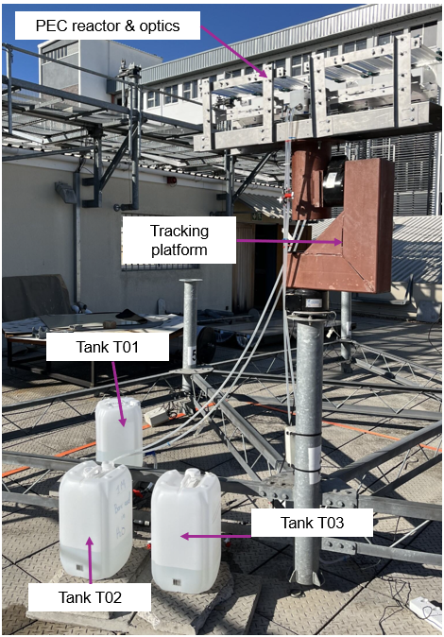
Figure S20. Photograph of the photoelectrochemical reactor system during the normal start-up procedure.
Example shutdown procedure for normal operation mode:
- Switch off P-01 and P-02 to stop the flow to the reactor.
- Close V-02 to stop electrolyte flow from T-02.
- Simultaneously switch on P-02 and open V-08 to begin to drain the catholyte line.
- Switch off P-02 as soon as the catholyte from the upstream to P-02 is drained.
- Simultaneously switch on P-01 and open V-06 to begin to drain the anolyte line.
- Switch off P-01 as soon as the anolyte from the upstream to P-01 is drained.
- Open V-16 and drain the anolyte into T-02.
- Open V-17 and drain the catholyte into T-02.
- Close V-05, V-08, V-16 and V-17.
- Connect the anolyte and catholyte outlets from the reactor to T-03.
- Open V-01 and V-04 to begin the flow of water from T-01.
- Switch on P-01 and P-02 to begin the flow of water through the system and into the reactor. A relatively low flowrate of approximately 0.5 L min⁻¹ should be used.
- Purge bleed lines by opening and closing V-08, V-09, V-12, V-13, V-16 and V-16 and draining wastewater to secondary containment.
- After the reactor has been filled, switch off P-01 and P-02 and then close V-01 to stop the flow of water.
- Connect the anolyte and catholyte outlets from the reactor to T-01.
- Switch on P-01 and P-02 to continue the flow of water at a steady flow rate from T-01. During the rinse cycle, approximately 5 L of water should be recirculated into T-01.
- At the end of the rinse cycle, switch off P-01 and P-02 and then close V-01 to stop the flow of water.
- Drain the reactor and the rest of the system through the bleed valves, V-08, V-09, V-12, V-13, V-16 and V-17.
Normal operation during the rinse cycle can be illustrated by the P&ID in Figure S21.
Figure S21. P&ID of the photoelectrochemical reactor system during the rinse cycle. A key to the P&ID is shown in Table S4.

System operating conditions
The reactor system was operated with continuous electrolyte flow in batch recycle mode. An electrolyte flow velocity of 2.1 cm s⁻¹ was selected. This was based on previous optimisation of a small-scale system for aiding bubble removal, consideration of reasonable operating fluxes of the positive displacement pumps used, and shear stress exerted on the electrode surface by the electrolyte.⁵ Based on the internal dimensions of the reactor, this corresponded to anolyte and catholyte flowrates of ≈ 0.5 L min⁻¹. To maintain constant anolyte and catholyte flowrates, the two positive displacement pumps (P-01 and P-02) were operated at a fixed level, and the flowrates were monitored by in-line flowmeters (F-01 and F-02) during the experiment.
Calculation of anolyte and catholyte flowrates, based on optimised operational flow velocity:
Catholyte/Anolyte cross-sectional area: 3.912 × 10⁻⁴ m²
Optimal flow velocity = 0.021 m s⁻¹
$$Anolyte flowrate \left(F_{A}\right)=Optimal flow velocity \left(v_{optimal}\right) ×Anolyte cross sectional area (A_{c,A})$$
$$Catholyte flowrate \left(F_{C}\right)=Optimal flow velocity\left(v_{optimal}\right) ×Catholyte cross sectional area (A_{c,C})$$
$$A_{c,A}=A_{c,C}∴F_{A}=F_{C}$$
$$F_{A}=v_{optimal}×A_{c,A}$$
$$F_{A}=0.021 \left[m s^{-1}\right]×3.912 ×{10}^{-4} [m^{2}]$$
$$F_{A}=8.215 {10}^{-4} {[m}^{3} s^{-1}]$$
$$F_{A}=F_{C}=0.49≈0.5 [L \min^{-1}]$$
The system temperature was not controlled, but the operation temperature was monitored throughout the experiment by thermocouples placed in T-01, T-02 and T-03. During operation, the electrolyte was sufficiently agitated to ensure that it remained well-mixed, but it was prone to recrystallisation over time due to the saturation limit of boric acid, which is approximately 0.9 M at 25 °C.⁶ T-02 was therefore stored indoors when the system was not being operated, to prevent exposure to low overnight temperatures. In a pilot scale system, or a system in which it is impractical to move the tank when not in operation, the cost of active temperature control to prevent recrystallisation of the anolyte should be traded off with reduced electrolyte ionic conductivity and therefore reduced reaction yields resulting from using lower concentrations of boric acid in the anolyte.

Photoanode fabrication
All photoanodes were prepared using 40 mm x 170 mm TEC-7 FTO glass substrates (Solaronix), with sheet resistance of 7 Ω sq⁻¹. Layers of WO₃, BiVO₄ and NiFeOOH were synthesised sequentially by aerosol assisted chemical vapour deposition (AA-CVD), using an in-house designed rig.⁵ The photoanodes were fabricated using a method adapted from previous work by the authors to prepare larger electrodes.⁵

Pre-treatment of FTO glass substrates
Before deposition of the WO₃ layer, the FTO substrates were first pre-treated in a five-step cleaning process. Firstly, the substrates were rinsed in a 1:5 mixture of detergent and deionised water, then wiped dry with lint free Kimtech® wipes, to remove any large pieces of debris, smudges or fingerprints on the FTO active layer. Following this, the substrates were placed in solutions of 1:1 detergent and deionised water, deionised water, acetone, and isopropanol, and ultrasonicated for 15 minutes in each solution.

AA-CVD of WO₃ layer
The WO₃ precursor solution was prepared by dissolving 0.2 g of W(CO)₆ (Merck, 97%) in 33.3 ml of acetone and 16.7 ml of methanol. To fully dissolve the solids, the mixture was placed in an ultrasonication bath for five minutes.
WO₃ films were prepared by placing the substrates onto the graphitic carbon block, which was heated to 350 °C. The precursor was then passed through the chamber, carried by N₂ gas at a flowrate of 2,200 sccm. Following the deposition, the substrates were annealed in a muffle furnace (Nabertherm, UK) for two hours in air at 500 °C.

AA-CVD of BiVO₄ layer
The BiVO₄ layer was deposited onto the WO₃ layer, forming a conformal and homogenous coating. The precursor solution was prepared by dissolving 0.044 g of V(acac)₃ (Merck, ≥ 97%) and 0.055 g of Bi(Ph)₃ (Merck, ≥ 99%) in 18.75 ml of acetone and 6.25 ml of methanol. To fully dissolve the solids, the mixture was placed in an ultrasonication bath for two minutes.
BiVO₄ films were prepared by placing the substrates onto the graphitic carbon block, which was heated to 400 °C. The precursor was then passed through the chamber, carried by air at a flowrate of 1,500 sccm. Following the deposition, the substrates were annealed in a muffle furnace (Nabertherm, UK) for two hours in air at 500 °C.

AA-CVD of NiFeOOH layer
Finally, the NiFeOOH layer was deposited onto the BiVO₄. The precursor was prepared by completely dissolving 4 mM of Ni(acac)₃ (Merck, ≥ 97%) and 1 mM of Fe(acac)₃ (Merck, ≥ 97%) in 16.67 ml of acetone and 8.33 ml of methanol. This was then passed through the chamber, which was at 160 °C, with a N₂ gas flowrate of 2,000 sccm. Following the deposition, the substrates were annealed in a muffle furnace (Nabertherm, UK) for two hours in air at 160 °C.

Physical materials characterisation
The as-synthesised photoanodes were characterised by scanning electron microscopy (SEM), X-ray diffraction (XRD), ultraviolet-visible (UV-vis) spectroscopy, Raman spectroscopy and Time-of-flight secondary ion mass spectrometry (ToF-SIMS). Additionally, analogous electrodes were characterised by X-ray photoelectron spectroscopy (XPS) and high-resolution transmission electron microscopy (HR-TEM) in previous work.⁵
SEM images were captured using a Zeiss Gemini Sigma300 FEG SEM, at magnifications between 10,000 and 100,000 times, with an accelerating voltage of 5 keV and typical working distances between 5 to 6 mm.
XRD patterns were measured using a Bruker D2 Phaser diffractometer with parallel beam optics, equipped with a Lynx-Eye detector, using a Cu K_{α} X-ray source (V = 30 kV, I = 10 mA, λ₁ = 1.54056 Å, λ₂ = 1.54439 Å, with K-alpha 1 and 2 emitted with an intensity of 2:1. Diffraction patterns were recorded at scattering angles between 10° ≤ 2θ ≤ 55°, with a step size of 0.02°every second.
Raman spectra were obtained using a Bruker SENTERRA II Raman Microscope, equipped with 50 μm diameter beam spots with 532 nm wavelength excitation and 6.25 mW power. Spectra were recorded with Raman shift from 50 cm⁻¹ to 3000 cm⁻¹ at 1.5 cm⁻¹ intervals.
UV-vis transmittance and reflectance were obtained using a Shimadzu UV-2600 UV-vis spectrometer over wavelengths from 200 to 1400 nm. The absorbance was then determined using the relation: Absorbance = 100 – Transmittance – Reflectance. The optical band gap was obtained graphically using the Tauc relation, based on the method outlined by Chen and Jaramillo.⁷
Representative samples were analysed and secondary ions collected using a IONTOF ToF-SIMS V instrument, with a 25 keV Bi⁺ ion beam in high current bunched mode HCBM over an area of 100 μm². A 1 keV Cs⁺ ion beam with a current of 85 nA was used to depth profile the samples over an area of 300 μm². A flood gun was also used for surface charge compensation during the depth profiling. Subsequent data was analysed using IONTOF Surface lab 7.

Scanning electron microscopy (SEM)
Scanning electron microscopy (SEM) images (shown in Figure S22) showed that the photoanodes had a nanoporous morphology, with BiVO₄ and NiFeOOH homogeneously and conformally coated on the WO₃ scaffold. The coral-like morphology of the resulting WO₃ | BiVO₄ | NiFeOOH was in line with the photoanode materials developed by the authors in previous work.⁵
Figure S22. SEM images of representative WO₃ | BiVO₄ | NiFeOOH photoanodes at 10,000 times (main image) and 100,000 times (inset image) magnification.

UV-vis spectroscopy
UV-vis characterisation (shown in Figure S23) provided verification that the up-scaled photoelectrodes had analogous optical properties to the small-scale WO₃ | BiVO₄ | NiFeOOH photoanodes developed by the authors previously.⁵ The UV-vis absorptance showed a sharp absorption band edge at around 510 nm, whilst the calculated direct and indirect band gaps were 2.43 eV (≈ 510 nm) and 2.51 eV (≈ 494 nm), respectively. These values are in line with typically reported band gaps for the WO₃ | BiVO₄ heterojunction.^{8,9}
Figure S23. (a) UV-vis transmittance, (b) absorptance and (c) reflectance, and (d) band gap calculation from Tauc plot for WO₃ | BiVO₄ | NiFeOOH photoanodes.

X-ray diffraction (XRD)
Physical characterisation of the WO₃ | BiVO₄ | NiFeOOH photoanodes by X-ray diffraction (XRD) (shown in Figure S24), was in line with literature and previous work by the authors, with XRD peaks corresponding to monoclinic WO₃ and BiVO₄.^{5,10–12} No additional peaks were observed for NiFeOOH, in line with expectations that the layer is amorphous.
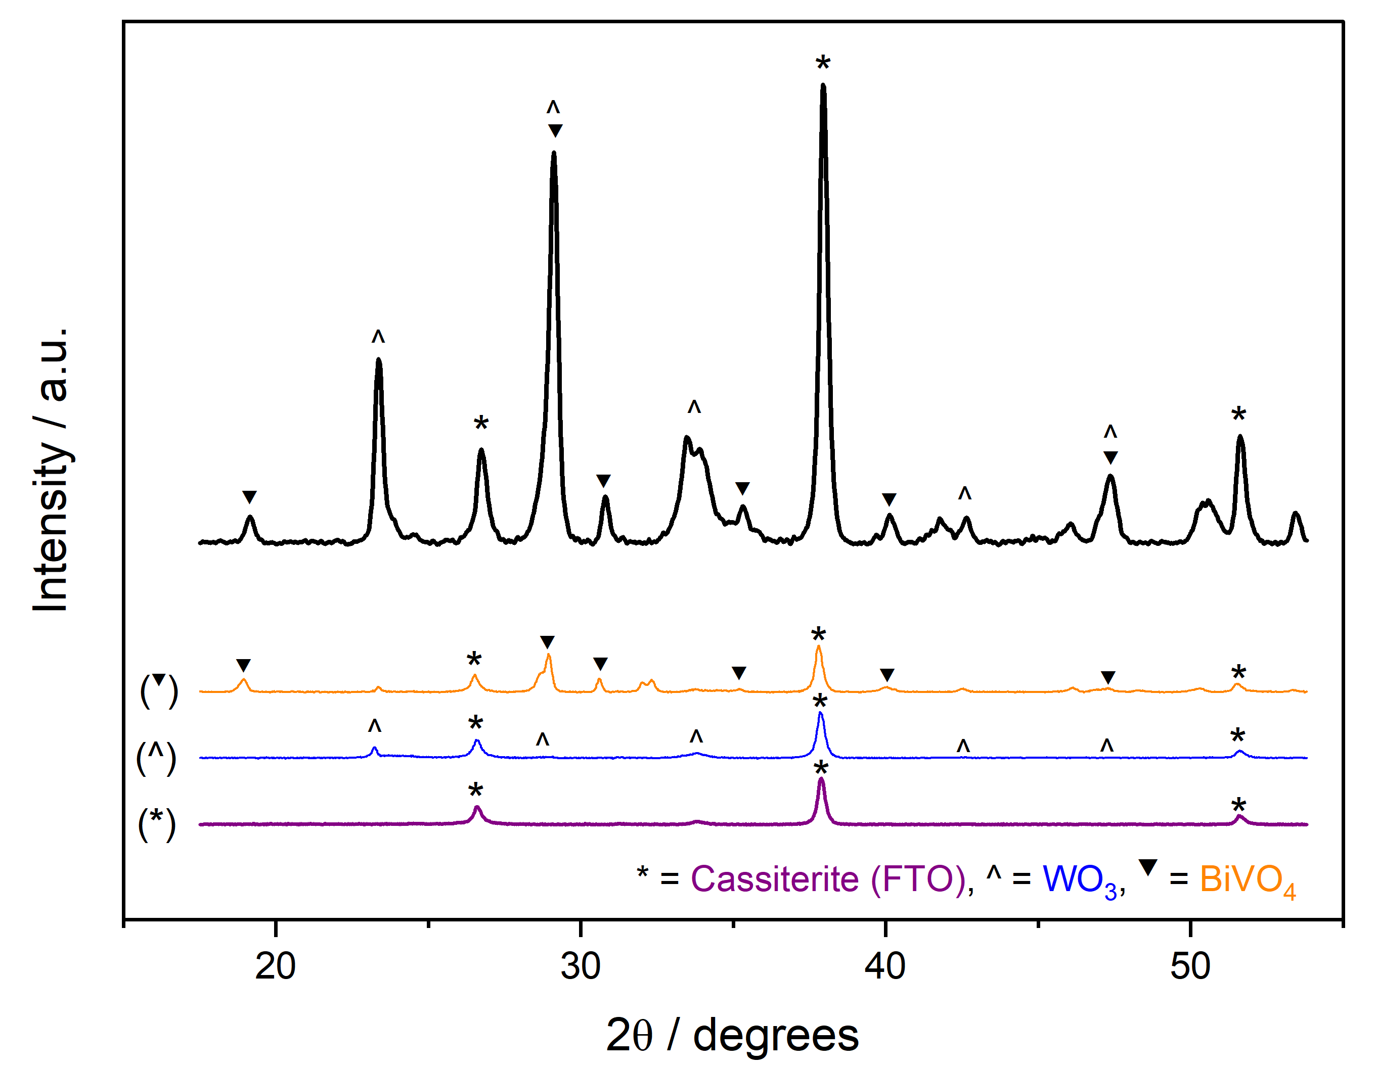
Figure S24. XRD pattern of a representative FTO | WO₃ | BiVO₄ | NiFeOOH photoanode, plotted alongside literature standards for FTO, WO₃ and BiVO₄. ^{10–12}

Raman spectroscopy
Physical characterisation of the WO₃ | BiVO₄ | NiFeOOH photoanodes by Raman spectroscopy (shown in Figure S25), was in line with literature and previous work by the authors, with Raman bands corresponding to monoclinic WO₃ and BiVO₄.^{5,13,14} No additional peaks were observed for NiFeOOH.
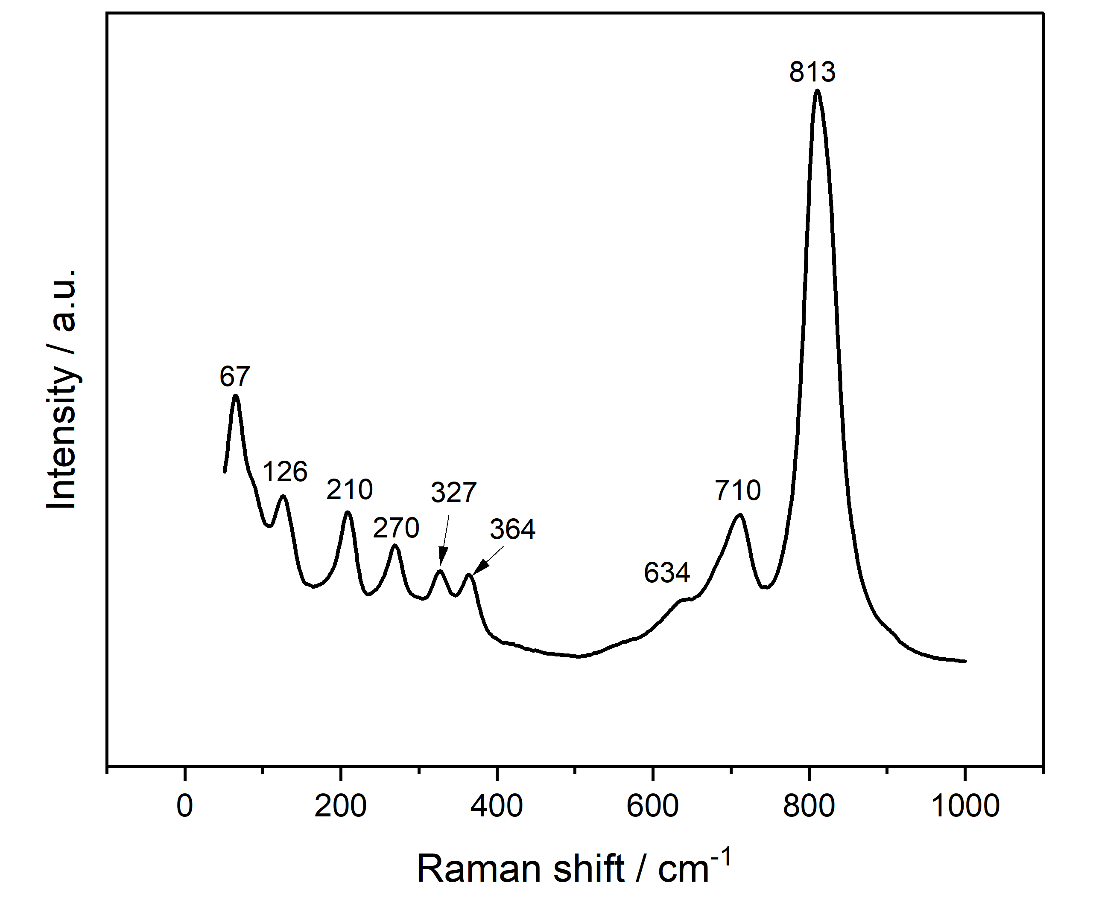
Figure S25. Raman spectrum of a representative FTO | WO₃ | BiVO₄ | NiFeOOH photoanode.

X-ray photoelectron spectroscopy (XPS)
X-ray photoelectron spectroscopy (XPS) analysis (shown in Figure S26) provided evidence for the expected oxidation states of WO₃, BiVO₄ and NiFeOOH, confirming their successful fabrication by AA-CVD. An XPS survey is shown in Figure S26a. Binding energies were referenced to the adventitious carbon (C-C) peak seen in the C 1s binding energy region (Figure S26b). In the C 1s region, peaks at 284.8 eV, 286.6 eV and 288.5 eV corresponded to the (C-C), (C-O) and (C=O) components of adventitious carbon.¹⁵ Components in the O 1s environment (shown in Figure S26c) were represented by two peaks at 530.3 eV (representing metal-oxygen (M-O) components) and 532.0 eV (representing the (C-O) component of adventitious carbon). (M-O) components are represented in a single peak due to the difficulty in deconvoluting components of tungsten, bismuth, vanadium, iron and nickel oxides, which are all present in this environment and have similar binding energies. In the Bi 4f environment (shown in Figure S26d) there were two peaks corresponding to the 7/2 and 5/2 peaks of Bi³⁺, as well as two peaks corresponding to metallic Bi⁰ and impurity compounds.^{16,17} The two peaks in the W 4f environment (shown in Figure S26e), at 35.5 eV and 37.7 eV, corresponded to 7/2 and 5/2 peaks of W⁶⁺, which provides evidence for the expected oxidation state of tungsten for WO₃.¹⁸ Analysis of the V 2p environment, supported by the Bi 4f environment, evidenced the expected oxidation states of bismuth and vanadium that are found in pure BiVO₄. The V 2p environment (shown in Figure S26f) gave rise to peaks at 517.0 eV and 524.5 eV, corresponding to the 3/2 and 1/2 peaks of V⁵⁺.¹⁹ Characterisation of the NiFeOOH co-catalyst layer was supported by XPS analysis of the Ni 2p and Fe 2p environments, although peaks in these environments can be difficult to deconvolute due to overlapping binding energies. The Ni 2p (shown in Figure S25g) and Fe 2p (shown in Figure S25h) environments herein show analogous shape to previously reported XPS spectra for NiFeOOH in these environments, while characteristic features of de-hydroxylated NiFeOOH, such as multiplet splitting in the Ni 2p environment, are not seen.^{20–22} The Fe 2p environment provides confirmation of the successful loading of Fe, with analogous shapes and peaks to previously reported β-FeOOH XPS spectra.^{23,24}
Figure S26. X-ray photoelectron spectroscopy (XPS) spectra of a representative FTO | WO₃ | BiVO₄ | NiFeOOH photoanode. (a) XPS survey scan, (b) C 1s, (c) O 1s, (d) Bi 4f, (e) W 4f, (f) V 2p, (g) Ni 2p and (h) Fe 2p environments. Adapted under the terms of the Creative Commons BY 3.0 licence.⁵ Copyright 2025, The Royal Society of Chemistry.

Time-of-flight secondary ion mass spectrometry (ToF-SIMS)
Time-of-flight secondary ion mass spectrometry of a representative FTO | WO₃ | BiVO₄ | NiFeOOH photoanode (shown in Figure S27) provided evidence of intercalation between distinct FTO, WO₃, BiVO₄ and NiFeOOH layers.⁵ The total thickness of the AA-CVD fabricated WO₃, BiVO₄ and NiFeOOH layers was approximately 500 nm, with the NiFeOOH co-catalyst thickness less than 10 nm.
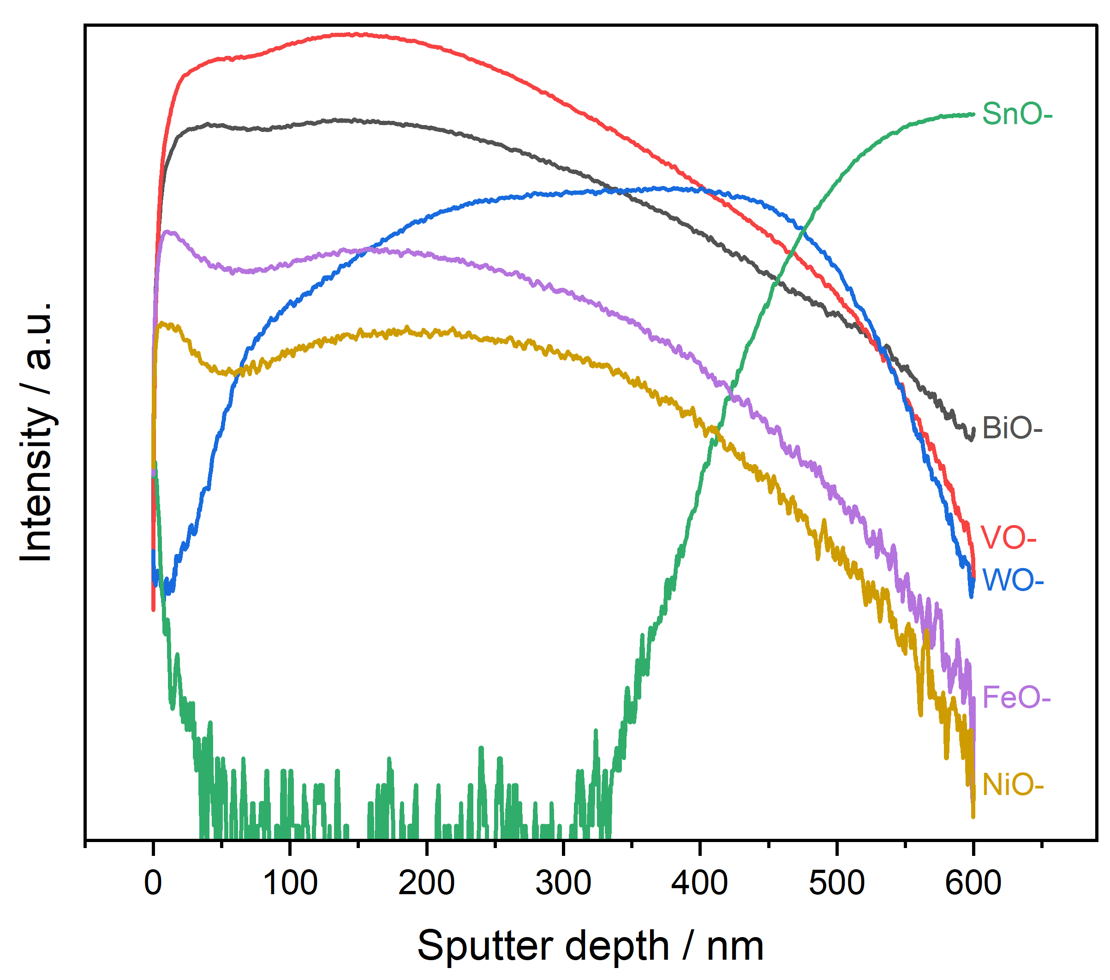
Figure S27. Representative signals from time-of-flight secondary ion mass spectrometry (ToF-SIMS) of a FTO | WO₃ | BiVO₄ | NiFeOOH electrode. Adapted under the terms of the Creative Commons BY 3.0 licence.⁵ Copyright 2025, The Royal Society of Chemistry.

Photovoltaic characterisation & prediction of performance under concentrated radiation
Performance under 1 sun at room temperature. The j-V curve characterising the performance of the PV from Mr Watt is presented in Figure S28. It was recorded in a 2-electrode configuration using a potentiostat/galvanostat (Autolab PGSTAT 302N, Metrohm AG) under direct irradiation by the Sun2000 Solar Simulator (Class A, Abet Technologies, equipped with a 550 W Xe arc lamp and AM 1.5G filter). The light spectrum, is presented in Figure S9. Characterisation at irradiances above AM 1.5G was not possible because the width of the PV exceeded the width of the light beam when the working distance from the light source was reduced to enable increased irradiance. The key performance indicators for current, voltage and power corresponding to the curve in Figure S28 are presented in Table S5. Since our PV was made of crystalline silicon at delivered a V_{oc} of ≈ 2.3 V, we surmise that it contained four individual cells connected in series. A photograph of the cell is shown in Figure S29. The temperature of the PV was not controlled during the j-V measurement, but was measured; the recorded temperature is shown in Figure S30. The j-V curve in Figure S28 was recorded at the steady state temperature of 70.8 ˚C.
Figure S28. Performance of the 30 cm² PV cell (Mr Watt, Italy) recorded under continuous direct illumination by simulated sunlight (AM 1.5G, 100 mWcm⁻²); a cell temperature of 70.8 ˚C was recorded. This same PV cell was used for spontaneous PV-assisted photoelectrochemical operation during outdoor field tests in Stellenbosch.
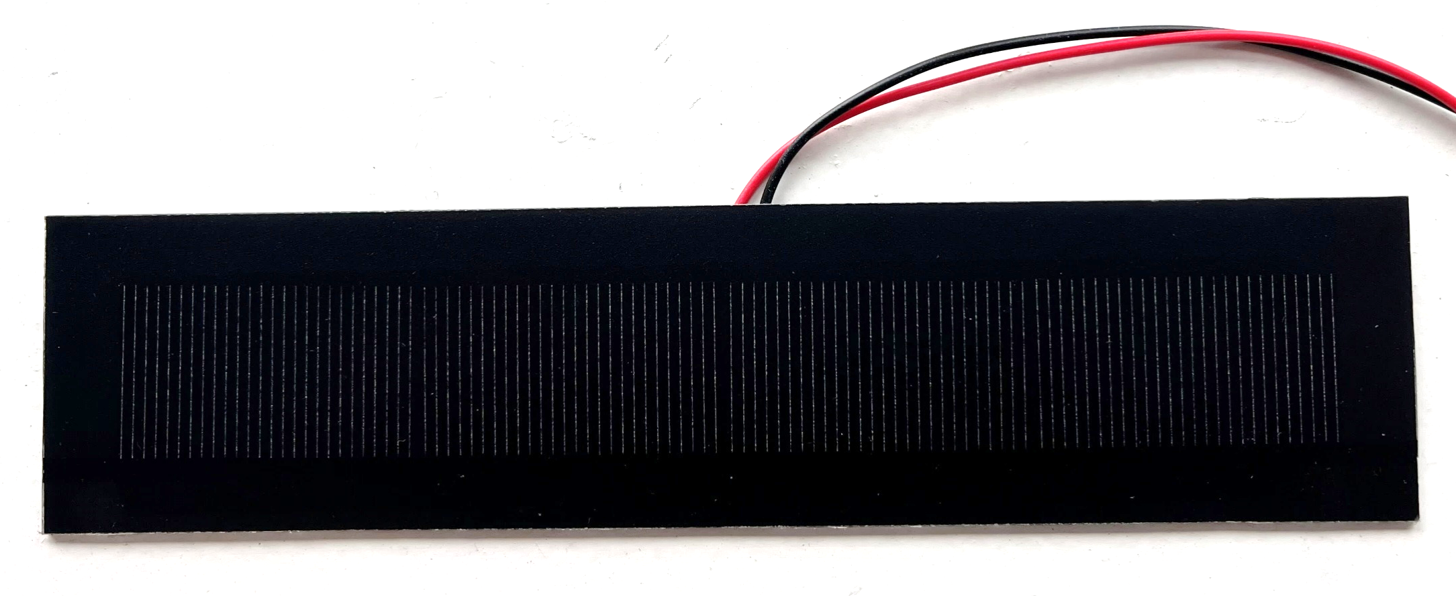
Figure S29. Photograph of the c-Si PV cell from Mr Watt, Italy. Dimensions are presented in Table S1.
Figure S30. Temperature of the Mr Watt PV cell recorded during irradiation by the Sun2000 solar simulator (AM 1.5G, 100 mW cm⁻²). The steady state temperature was 70.8 ˚C.

Table S5. Parameters characterising the performance of the 30 cm² PV under AM 1.5G irradiance and at 70.8 ˚C. V_{oc}, I_{sc}, j_{sc}, P and FF are the open circuit voltage, short circuit current, short circuit current density, power density and fill factor, respectively. The subscript ‘mpp’ refers to the maximum power point.
Parameter | Value | ±Error | Unit
V_{oc} | 2.287 | 0.001 | V
I_{sc} | 301.758 | 0.092 | mA
j_{sc} | 10.062 | 0.003 | mA cm⁻²
V_{oc} × j_{sc} | 23.014 | 0.019 | mW cm⁻²
V_{mpp} | 1.810 | 0.068 | V
I_{mpp} | 285 | 12 | mA
j_{mpp} | 9.51 | 0.41 | mA cm⁻²
P_{mpp} | 17.2 | 1.4 | mW cm⁻²
FF | 74.8 | 6.1 | %

The current generated by the PV is fundamentally described by Equations (S7) and (S8) and the equivalent electronic circuit describing its operation illustrated in Figure S31.
Figure S31. Electronic circuit representing the workings of the PV, which is characterised using Equation (S8).

$$I= I_{ph}- I_{d}- I_{R_{sh}}$$ | (S7)
$$I= I_{ph}- I_{0}\left(e^{\frac{q\left(V+IR_{s}\right)}{aNk_{B}T}} - 1\right)- \left(\frac{V+IR_{s}}{R_{sh}}\right)$$ | (S8)
where I and V are the current and voltage extracted from the solar cell, respectively, I_{ph} is the photocurrent generated by light absorption, I_{d} is the diode current, R_{s} is the series resistance, while I_{Rsh} is the parasitic current through the shunt resistor, R_{sh}. The current through the diode and the shunt resistor are dependent on additional parameters: a is the diode ideality factor (values between 1 and 2), N is the number of individual solar cells coupled in the PV (in our case we presume that N is either 3 or 4; based on visual examination of the PV cell N is probably 4, but we treat it as an unknown in our parameter estimation exercise), I₀ is the reverse saturation current, T is temperature, k_{B} is the Boltzmann constant and q is the electronic charge.
R_{sh} is determined from the magnitude of the dV/dI slope at short circuit. R_{s}, however, needs to be determined by fitting the I-V curve to Equation (S8), into which it can be substituted via Equation (S9), where the magnitude of the dV/dI slope can be determined from the experimental data at open circuit, but the product a·N is unknown:
$$R_{s}= -{\left[\frac{dV}{dI}\right]}_{oc}- \frac{aNk_{B}T}{qI_{sc}}$$ | (S9)

I₀ is calculated according to Equation (S10) and is also a function of the unknown product a·N:
$$I_{0}= \frac{I_{sc}- \frac{V_{oc}}{R_{sh}}}{e^{\frac{{qV}_{oc}}{aNk_{B}T}}}$$ | (S10)

gPROMS was used to compute the unknown parameters for Equation (S8); these are presented in
Table S6. Representative curves for 25 ˚C (corresponding to the standard test condition, STC) and 57.5 ˚C (nominal operating cell temperature, NOCT) were also obtained by adjusting the temperature in the calculation of I_{sc}, V_{oc}, I₀ and R_{s}, while keeping a·N constant. As expected, the V_{oc} and FF were higher at 25 ˚C than at 70.8 ˚C, with values of 2.591 V and 77.5 %, respectively. The methodology for introducing temperature dependence of V_{oc} and I_{sc} is described in the subsequent section.

Table S6. Calculated parameters characterising the 30 cm² PV used in this work under AM 1.5G irradiation, when the temperature of the cell was recorded as 70.8 ˚C (343.95 K).
Parameter | Value | Unit
I_{ph} (≈ I_{sc}) | 0.302 | A
I₀ | 3.54 × 10⁻¹² | A
R_{s} | 0.70 | Ω
R_{sh} | 668 | Ω
a·N | 3.068 | 1

The agreement between the experimental and simulated j-V curves at 70.8 ˚C is shown in Figure S32, together the prediction of the PV cell performance at 25 ˚C and 57.5 ˚C. The PV cell area used for calculating the current density from the simulated current was 30 cm².
Figure S32. Experimental and simulated PV cell performance under AM 1.5G irradiation at 70.8 ˚C, together the prediction of the PV cell performance at 25 ˚C and 57.5 ˚C. The simulated curves were calculated using Equation (S8) with parameters from Table S6.
.

Performance at different irradiance levels and temperatures. Irradiance affects not only the number of photons reaching photoabsorbers, thereby determining the photocurrent limit, but also the temperature – both the ambient temperature and the local temperature of the PV.
The photocurrent, which is approximated as the short circuit current, I_{ph} ≈ I_{sc}, is directly proportional to the irradiance but will also vary with the PV temperature as shown in Equation (S11), where I_{sc(STC)} is the short circuit current measured under standard test conditions (STC), ${TC}_{I_{sc}}$ is the temperature coefficient for I_{sc}, ΔT is the difference between the PV cell temperature and the STC value of 25 ˚C and Q and Q_{STC} are the irradiances in any given circumstance and irradiance at STC, respectively.
$$I_{ph}(T)≈I_{sc}(T) = I_{sc(STC)}∙\left(1+\frac{{TC}_{I_{sc}}}{100}∙∆T\right)\frac{Q}{Q_{STC}}$$ | (S11)
ΔT is calculated as the difference between the real PV cell temperature, T_{PVcell}, and the T_{STC} value of 25 ˚C:
$$∆T= T_{PVcell}-T_{STC}$$ | (S12)
The temperature coefficient for the short circuit current, ${TC}_{I_{sc}}$, is usually positive, meaning that temperatures above 25 ˚C will contribute to increasing the photocurrent. A temperature coefficient is not available for our c-Si PV from Mr Watt, hence we take a representative value of +0.07 % ˚C⁻¹ for our estimations. []
The effect of temperature on the open circuit voltage is shown in Equation (S13).
$$V_{oc}(T)= V_{oc(STC)}∙\left(1+\frac{{TC}_{V_{oc}}}{100}∙∆T\right)$$ | (S13)
In this case, the temperature coefficient ${TC}_{V_{OC}}$, is negative, representing an unfavourable effect. We use a value of approximately -0.29 % ˚C⁻¹ for our estimations.[*] The magnitude of this value is significantly larger than that for the short circuit current. Hence, temperature has a more significant effect on the open circuit voltage than on the short circuit current.
The operating PV cell temperature can be estimated using the Nominal Operating Cell Temperature (NOCT) model, in the absence of concrete information regarding its absorption coefficient and heat transfer properties. The NOCT condition corresponds to an irradiance of 80 mW cm⁻², air temperature of 20 °C and wind speed of 1 m s⁻¹.
$$T_{PVcell}= T_{ambient}+Q∙\left(\frac{T_{NOCT}-20}{80}\right)$$ | (S14)
The dependence of the PV cell temperature on irradiance is presented in Figure S33. These results are approximate, of course, but they enable us to show the impact of temperature on the PV output and the extent to which this was likely to have influenced our experimental observations. To verify this, the temperature of the PV over time under simulated one sun irradiance was recorded using a RS PRO RS-833 Infrared Thermometer (±1 °C Accuracy). The results of this measurement are presented in Figure S30. After 5 minutes, the temperature of the PV exceeded 60 °C before plateauing at ≈ 70.8 °C after 10 minutes. The value of 70.8 ˚C is significantly greater than the value of 57.5 ˚C predicted using Equation (S14). The most likely reason for this is the absence of any wind in the lab, whereas Equation (S14) assumes the presence of 1 m s⁻¹ wind speed that would have a cooling effect.
Hence our approach to making all PV performance predictions was to extract the unknown parameters from the real experimental j-V measurement at 70.8 ˚C and then use/correct those parameters for NOCT temperature for all subsequent predictions of the PV performance outdoors (where some wind would usually be present). Hence, the plot in Figure S32 includes the lower temperature of 57.5 ˚C, which would be expected for the PV outdoors under 100 mW cm⁻² irradiance. The j-V curves presented in Figure 3e of the main manuscript correspond to PV cell temperatures of 41.25, 57.5, 90 and 122.5 ˚C, which would be expected outdoors at irradiances of 50, 100, 200 and 300 mW cm⁻², respectively, when the ambient temperature is 25 ˚C.

Figure S33. Predictions for the PV cell temperature as a function of ambient temperature and solar irradiance, made using the Nominal Operating Cell Temperature (NOCT) model in Equation (S14). PV cell temperatures of 41.25, 57.5, 90 and 122.5 ˚C would be expected at irradiances of 50, 100, 200 and 300 mW cm⁻², respectively, when the ambient temperature is 25 ˚C.

Prediction of Ohmic drop across the PEC reactor
The total estimated Ohmic drop across the PEC reactor considered Ohmic losses in the anode compartment, the cathode compartment and through the Nafion™ 115 membrane. Parameters used in the Ohmic drop calculation are displayed in Table S7.

Table S7. Parameters used in Ohmic loss calculations.
Parameter | Symbol | Value | Unit
Nafion™ 115 thickness | $$z_{membrane}$$ | 0.01375* | cm
Nafion™ 115 conductivity | $$κ_{membrane}$$ | 0.10** | S cm⁻¹
1 M borate buffer conductivity | $$κ_{electrolyte}$$ | 0.0236 | S cm⁻¹
Cross-sectional areas of membrane supporting frame and exposed membrane | $$A_{msf}$$ | 29.74 | cm²
Anode compartment thickness (depth), including the membrane supporting frame | $$z_{anode}$$ | 2.20 | cm
Cathode compartment thickness (depth), including the membrane supporting frame | $$z_{cathode}$$ | 2.20 | cm
Approximate cell potential difference during all experiments | $$E_{cell}$$ | 2.25 | V
(* accounting for 10% swelling; ** assuming it is fully hydrated)²⁵

The Ohmic losses were then calculated using the following equations:
$${∆E}_{loss, anode}=\frac{I_{photo}×z_{anode}}{{A_{msf}}/{κ_{electrolyte}}}$$ | (S15)
$$∆E_{loss, cathode}=\frac{I_{photo}×z_{cathode}}{{A_{msf}}/{κ_{electrolyte}}}$$ | (S16)
$${∆E}_{loss,membrane}=\frac{I_{photo}×z_{membrane}}{{A_{msf}}/{κ_{membrane}}}$$ | (S17)
$${∆E}_{loss, ohmic}={∆E}_{loss, anode}+{∆E}_{loss, cathode}+{∆E}_{loss,membrane}$$ | (S18)
$$η_{loss}=\frac{{∆E}_{loss}}{E_{cell}}$$ | (S19)
where ${∆E}_{loss, anode}$ is the Ohmic loss in anode compartment in mV, $∆E_{loss, cathode}$ is the Ohmic loss in cathode compartment in mV, $∆E_{loss,membrane}$ is the Ohmic loss through the membrane, ${∆E}_{loss, ohmic}$ is the total Ohmic loss in mV, and $η_{loss}$ is the Ohmic loss as a fraction of cell potential difference. $I_{photo}$ is the photocurrent in mA.
The Ohmic losses as a function of various photocurrents are presented in Table S8.

Table S8. Ohmic loss predictions across the PEC reactor.
I_{photo} / mA | ${∆E}_{loss, anode}$ / mV | $∆E_{loss, cathode}$ / mV | $∆E_{loss,membrane}$ / mV | $∆E_{loss, ohmic}$ / mV | $$η_{loss}$$ | $η_{loss}$ / %
1 | 3.135 | 3.135 | 0.005 | 6.274 | 0.003 | 0.3
5 | 15.675 | 15.675 | 0.023 | 31.372 | 0.014 | 1.4
10 | 31.349 | 31.349 | 0.046 | 62.745 | 0.028 | 2.8
15 | 47.024 | 47.024 | 0.069 | 94.117 | 0.042 | 4.2
20 | 62.699 | 62.699 | 0.092 | 125.490 | 0.056 | 5.6
25 | 78.373 | 78.373 | 0.116 | 156.862 | 0.070 | 7.0
30 | 94.048 | 94.048 | 0.139 | 188.235 | 0.084 | 8.4
35 | 109.723 | 109.723 | 0.162 | 219.607 | 0.098 | 9.8
40 | 125.397 | 125.397 | 0.185 | 250.980 | 0.112 | 11.2
45 | 141.072 | 141.072 | 0.208 | 282.352 | 0.125 | 12.5
50 | 156.747 | 156.747 | 0.231 | 313.724 | 0.139 | 13.9
55 | 172.421 | 172.421 | 0.254 | 345.097 | 0.153 | 15.3
60 | 188.096 | 188.096 | 0.277 | 376.469 | 0.167 | 16.7
65 | 203.771 | 203.771 | 0.301 | 407.842 | 0.181 | 18.1
70 | 219.445 | 219.445 | 0.324 | 439.214 | 0.195 | 19.5
75 | 235.120 | 235.120 | 0.347 | 470.587 | 0.209 | 20.9
80 | 250.795 | 250.795 | 0.370 | 501.959 | 0.223 | 22.3
85 | 266.469 | 266.469 | 0.393 | 533.331 | 0.237 | 23.7
90 | 282.144 | 282.144 | 0.416 | 564.704 | 0.251 | 25.1
95 | 297.819 | 297.819 | 0.439 | 596.076 | 0.265 | 26.5
100 | 313.493 | 313.493 | 0.462 | 627.449 | 0.279 | 27.9

The cell voltage requirement was predicted on the basis of the Ohmic loss predictions (shown in Table S8) and the experimental j-V curves for the cathode and for the photoanode at one sun and three suns (shown in Figures 3d in the main manuscript).
Data interpolation was used to combine the anodic photocurrents (recorded on the FTO | WO₃ | BiVO₄ | NiFeOOH photoanodes at different irradiances) and cathodic current (recorded on Ni) obtained using 3-electrode setups into current density vs cell voltage predictions in the absence of any Ohmic losses.
The predicted cell voltage requirement as a function of current density is illustrated in Figure 3f-g in the main manuscript for 1 sun and 3 suns, showing contributions from the photoanode kinetics, cathode kinetics and Ohmic losses.
In line with expectations, the use of concentrated light decreased the cell voltage requirement to achieve a given current density. This confirms that higher current densities are enabled with concentrated solar irradiance with the same cell bias. It is also clear that as the photoanode current densities increase (with increasing irradiance), the fraction of the cell voltage required to compensate for the Ohmic loss increases as well. Hence, as with all electrochemical devices, Ohmic losses can be decreased via: (i) minimising the inter-electrode separation to minimise the distance over which ions need to migrate and (ii) increasing the electrolyte conductivity (by either going to acid or base). While the cell voltages and current densities under spontaneous operation are not an exact match to the experimentally determined values (in fact they are underestimates), they are sufficiently close to support out overall conclusions regarding the limitations to device performance. The discrepancy is greatest for illumination mode ‘B’ and is most likely a result of the PV cell temperature overestimation under 3-sun irradiation; we know this to be the case because the cell voltage measured in mode ‘B’ very obviously exceeded our predication of the V_{oc}.

Hydrogen production efficiency in the PEC reactor
The Faradaic hydrogen production efficiency was determined from a voltammetric sweep in a three-electrode measurement of the reduction kinetics of the nickel cathode. The mass transport limited O₂ (aq) reduction current density was determined to be -0.253 mA cm⁻², as shown in Figure S34a. Subsequently, the partial hydrogen current density was calculated by subtracting the mass transport limited O₂ (aq) reduction current density from the total cathodic current density. The hydrogen production efficiency of the PEC reactor (shown in Figure S34b) was calculated using Equation (S20).
$$H_{2} production efficiency \left(\%\right)=\frac{\left|Partial H_{2} current density\right| (mA {cm}^{-2})}{\left|Total cathodic current density\right| (mA {cm}^{-2})}×100\%$$ | (S20)

Figure S34. (a) Cathodic current density and partial hydrogen current density of a nickel cathode in a quiescent 1 M borate buffer (pH 9) during linear sweep voltammetry. (b) Hydrogen production efficiency of the PEC reactor as a function of current density.
This confirms that the Fradaic efficiency of hydrogen production of the PEC reactor increases with current density, since at higher current densities, the proportion of mass transport limited O₂ (aq) reduction current density as a percentage of the total will decrease. Consequently, the hydrogen production efficiency will be higher under concentrated irradiation than non-concentrated irradiation. Based on experimentally characterised current densities under non-concentrated and concentrated operation modes, hydrogen production efficiencies of 84.53 % and 90.21 % were calculated, respectively, and were used in calculations of hydrogen production rates and solar to hydrogen efficiencies.

Headline solar to hydrogen efficiency (STH) and system efficiency of the PV-PEC reactor
Figure S35a shows the headline solar-to-hydrogen efficiency ($η_{STH}$) of the PEC reactor system during different reactor operation modes, based on the system characterisation tests presented in Figure 4a,b in the main manuscript). The $η_{STH}$ was calculated using the formula outlined in the Methodology of the main paper. As actual hydrogen production rates were not quantified, Faradaic efficiencies of 84.53 % and 90.21 % were assumed for non-concentrated and concentrated irradiation respectively, based on quantitative analysis of hydrogen production efficiencies at the nickel cathode as illustrated in Figure S34. The overall system efficiency, $η_{system}$ (shown in Figure S35b), was then determined as the product of $η_{STH}$ and $η_{optical}$. The overall system efficiency can also be considered to represent the energy conversion losses of the whole system from the optical and photoelectrochemical systems (represented by $η_{optical}$ and $η_{STH}$ respectively). To illustrate the optical and photoelectrochemical contributions to the system efficiency, energy flow diagrams for each operation mode are presented in Figure S36.

Figure S35. Headline values from representative 15-minute characterisation tests of (a) solar-to-hydrogen efficiencies and (b) system efficiencies of the PEC reactor system under concentrated and reflected irradiance.

Figure S36 illustrates energy flow diagrams of the system in each operation mode. Energy flows were obtained experimentally during system characterisation tests and are based on average values. Solar energy inputs to the system were determined based on a nominal solar power density of 100 mW cm⁻². In operation mode ‘A’ (Figure S36a), the solar energy input to the system was 50.6 W, with solar energy losses of 39.7 W, resulting in an $η_{optical}$ in the order of 22 % for this operation mode. After energy losses in solar-to-hydrogen conversion, the overall system efficiency for operation mode ‘A’ was 0.3 %. Comparatively, in operation mode ‘B’, there was a higher solar energy input (87.4 W) on the photoabsorbers and higher solar energy losses (79.4 W), due to the use of the linear Fresnel lens array and light guides on both sides of the PEC reactor. Despite the increased energy input to the PV in this operation mode, its performance was enhanced by a negligible amount, resulting in a lower overall system efficiency for operation mode ‘B’ of 0.2 %. In operation mode ‘C’, the solar energy input was 4.0 W, significantly less than in either of the operation modes employing concentrating optics. As a result of the lower energy input and simplistic optics system (only an Al-coated mirror), solar energy losses were less, at 0.3 W. Given the similar $η_{STH}$ to operation mode ‘A’, this yielded the highest overall system efficiency of the three modes, of 1.1 %.
Although the overall system efficiency was lower with concentrating optics (operation modes ‘A’ and ‘B’), the energy output (corresponding to the calculated hydrogen production rate) was higher, at 0.2 W in operation modes ‘A’ and ‘B’ compared to 0.05 W in operation mode ‘C’. This suggests an important trade-off in terms of increasing system complexity, typically yielding lower overall system efficiencies, versus obtaining higher production yields for the same photoelectrochemical reactor footprint.
Figure S36. Energy flow diagrams based on system characterisation data for operation modes ‘A’, ‘B’ and ‘C’ (a, b, c respectively). Energy flows are not drawn to scale.

Performance of the PV-PEC reactor in operation mode ‘B’
Figure S37 illustrates the system performance over a 120-minute period on 28th April 2024 under concentrated irradiation. Both the photoanode and PV were irradiated by concentrated light (operation mode ‘B’). During the experiment, there were significant fluctuations in the direct solar irradiance (shown in Figure S37a) as a result of scattered clouds, meaning that the light delivered by the Fresnel lens array was limited at various times. For example, after 42 mins of the experiment until 52 mins, significant cloud cover caused the DNI to drop to a minimum of 10.5 mW cm⁻², significantly reducing the light delivered to the photo-absorbing components. Although the PV and photoanode were well-matched at AM 1.5G, the PV provided excessive bias to the photoanode at low irradiances. Consequently, the photoanode potential was forced to more anodic values by the PV, with the undesirable dark current contribution increasing under very low irradiances as the photoanode was forced to continue delivering current. This subsequently resulted in the degradation of the BiVO₄ by photo-corrosion, and ultimately the delamination of the photocatalyst from the FTO substrate. The current (shown in Figure S37b) fluctuated with changing irradiance but declined as the photoanode degraded. Fluctuations in the photoanode potential (shown in Figure S37c) are undesirable for photoelectrodes, which tend to function better under steady state conditions. The electrolyte temperature (Figure S37d) fluctuated in line with irradiance changes, increasing when high levels of light were delivered to the photo-absorbers, but decreasing during periods of cloud cover, when the photo-absorbers were more shaded. The electrolyte flowrates (shown in Figure S37e) remained stable throughout.
DNI was recorded at minute intervals, whilst the current was measured every five seconds. The irradiance graph was therefore less sensitive to the dynamic conditions of the experiment. Although such time intervals were adequate during most experiments, where the irradiance remained relatively constant, they proved limiting under rapidly changing conditions such as those with scattered clouds. For experiments in highly variable solar conditions, it is therefore recommended that measurement intervals should be shortened as far as practicable.
A failure in automatic photoanode potential logging necessitated manual recording, which began in the eighth minute after identifying the fault and setting up a backup system. To allow for monitoring and maintenance of the rest of the system, these readings could only be taken every five minutes, further reducing the sensitivity under dynamic conditions. In the field, more rapid changes in the photoanode potential were observed during the changing solar conditions, namely the increase in potential during cloud-induced low light periods and decrease in potential as light levels recovered when the clouds passed.
Figure S37. System performance during photoelectrochemical testing with concentrated solar irradiance on the photoanode and the PV (operation mode ‘B’), starting at 12:08 PM on 28^{h} April 2024. (a) Incident solar irradiance and irradiance delivered to the photoelectrochemical reactor. (b) Spontaneous photocurrent and calculated hydrogen production rate. (c) Cell and photoanode potentials. (d) Air temperature and temperature of the electrolyte tank. (e) Flow rates of the anolyte and catholyte.

Photographs of photoanode degradation during PV-PEC testing with concentrated irradiance
Figure S38 illustrates the progression of photoanode degradation over the course of a 120-minute experiment undertaken on 29th April 2024 under concentrated irradiation (operation mode ‘A’). After one hour, the photoanode showed signs of photo-corrosion, appearing paler in colour. Shortly afterwards, the photocatalyst began to delaminate from the FTO, with the majority having been removed by the end of the 2-hour experiment.
Figure S38. Degradation of the photoanode during PV-PEC testing on 29th April 2024 under concentrated irradiation (operation mode ‘A’). Photographs of the photoanode after (a) 10 mins, (b) 70 mins and (c) after 100 mins.

References
1. I. Holmes‐Gentle, F. Alhersh, F. Bedoya‐Lora, K. Hellgardt, in Photoelectrochemical Solar Cells (Wiley, 2018), pp. 1–41.
2. Eugene. Hecht, Optics (Addison-Wesley, Reading, Mass, 2nd ed., 1987), World student series edition.
3. W. B. Stine, R. W. Harrigan, Solar energy fundamentals and design (John Wiley and Sons, Inc.,New York, NY, 1984).
4. NREL, Resource Spectra AM 1.5 (2023), (available at https://www.nrel.gov/grid/solar-resource/spectra-am1.5.html).
5. G. H. Creasey, T. W. McCallum, G. Ai, B. Tam, J. W. Rodriguez-Acosta, A. M. Yousuf, S. Fearn, F. Eisner, A. Kafizas, A. Hankin, J Mater Chem A Mater (2025), doi:10.1039/D5TA00440C.
6. Y. S. Lim, S. S. Hwang, D. J. Kim, J. Y. Lee, Nuclear Engineering and Technology. 52, 1222–1230 (2020).
7. Z. Chen, T. Jaramillo, Department of Chemical Engineering, Stanford University. 9 (2017).
8. K. Sivula, R. van de Krol, Nat Rev Mater. 1, 15010 (2016).
9. C. Reddick, C. Sotelo-Vazquez, B. Tam, A. Kafizas, K. Reynolds, S. Stanley, G. Creasey, A. Hankin, C. Pablos, J. Marugán, Catal Today. 437, 114783 (2024).
10. J. Sánchez-Martín, D. Errandonea, J. Pellicer-Porres, D. Vázquez-Socorro, D. Martínez-García, S. N. Achary, C. Popescu, The Journal of Physical Chemistry C. 126, 7755–7763 (2022).
11. W. H. Baur, Acta Crystallogr B. 32, 2200–2204 (1976).
12. P. M. Woodward, A. W. Sleight, T. Vogt, Journal of Physics and Chemistry of Solids. 56, 1305–1315 (1995).
13. C. Ràfols i Bellés, S. Selim, N. M. Harrison, E. A. Ahmad, A. Kafizas, Sustain Energy Fuels. 3, 264–271 (2019).
14. A. Kafizas, L. Francàs, C. Sotelo-Vazquez, M. Ling, Y. Li, E. Glover, L. McCafferty, C. Blackman, J. Darr, I. Parkin, The Journal of Physical Chemistry C. 121, 5983–5993 (2017).
15. G. S. Kamble, Y.-C. Ling, Sci Rep. 10, 12993 (2020).
16. W. E. Morgan, W. J. Stec, J. R. Van Wazer, Inorg Chem. 12, 953–955 (1973).
17. T. P. Debies, J. W. Rabalais, Chem Phys. 20, 277–283 (1977).
18. S. F. Ho, S. Contarini, J. W. Rabalais, J Phys Chem. 91, 4779–4788 (1987).
19. B. Barbaray, J. P. Contour, G. Mouvier, Environ Sci Technol. 12, 1294–1297 (1978).
20. A. P. Grosvenor, M. C. Biesinger, R. St. C. Smart, N. S. McIntyre, Surf Sci. 600, 1771–1779 (2006).
21. J. Gallenberger, H. Moreno Fernández, A. Alkemper, M. Li, C. Tian, B. Kaiser, J. P. Hofmann, Catal Sci Technol. 13, 4693–4700 (2023).
22. N. Weidler, J. Schuch, F. Knaus, P. Stenner, S. Hoch, A. Maljusch, R. Schäfer, B. Kaiser, W. Jaegermann, The Journal of Physical Chemistry C. 121, 6455–6463 (2017).
23. J. Cui, M. Daboczi, M. Regue, Y. Chin, K. Pagano, J. Zhang, M. A. Isaacs, G. Kerherve, A. Mornto, J. West, S. Gimenez, J. Kim, S. Eslava, Adv Funct Mater. 32, 2207136 (2022).
24. W. Zhang, J. Ma, L. Xiong, H.-Y. Jiang, J. Tang, ACS Appl Energy Mater. 3, 5927–5936 (2020).
25. Nafion, Nafion N115, N117, N1110 Ion Exchange materials (2016), (available at http://www.scimaterials.cn/upload/P320b0bc42a274c109166af0e910a177c.pdf).

From the data sheet for Solar World SWA 290 - 300 MONO c-Si PV modules

