Residue-level determinants of thermal stability in the extremophilic Ts2631 endolysin
Karolina Ciemińska¹, Anna-Karina Kaczorowska², Lukasz Pawel Kozlowski³, Marcin Gorniak⁴, Olafur H. Fridjonsson⁵, Gudmundur O. Hreggvidsson⁵, Tadeusz Kaczorowski¹, Magdalena Plotka^{1,2*}
¹Laboratory of Extremophiles Biology, Department of Microbiology, University of Gdansk, Gdansk, Poland
²Collection of Plasmids and Microorganisms | KPD, Department of Microbiology, Faculty of Biology, University of Gdansk, Gdansk, Poland
³Institute of Informatics, Faculty of Mathematics, Informatics and Mechanics, University of Warsaw, Warsaw, Poland
⁴Department of Evolutionary Genetics and Biosystematics, Faculty of Biology, University of Gdansk, Gdansk, Poland
⁵Matis ohf, Reykjavik, Iceland
*Correspondence: Magdalena Plotka; magdalena.plotka@ug.edu.pl
Keywords: bacteriophage, thermostable endolysin, extremophile, mutagenesis

Table S1. Sixty two N-acetylmuramoyl-L-alanine amidases and peptidoglycan recognition proteins (PGRPs) used for phylogenetic tree construction.
No | NCBI accession/PDB ID/UniProtKB | Organism
1 | 6FHG | Thermus phage 2631
2 | MDM7323587.1 | Thermus sp.
3 | 6SU5 | Thermus phage 2119
4 | MDA1317314.1 | bacterium
5 | MBD3279583.1 | Candidatus Pacebacteria bacterium
6 | 6SSC | Clostridium intestinale
7 | phiKo | Thermus thermophilus HB27
8 | MCS7107721.1 | Acidilobaceae archaeon
9 | DAE43342.1 | Caudoviricetes sp.
10 | MCH5213438.1 | Oscillospiraceae bacterium
11 | WP_241078918.1 | Natranaerofaba carboxydovora
12 | WP_303342367.1 | Paracoccus sp. in a proteobacteria
13 | RMH34273.1 | Acidobacteriota bacterium
14 | NLO20643.1 | Syntrophomonadaceae bacterium
15 | MBR0519315.1 | bacterium
16 | MGE4353143.1 | Oscillospiraceae bacterium
17 | WP_270478853.1 | Butyricicoccus sp. AF18-9LB
18 | WP_084413195.1 | Desulfovirgula thermocuniculi
19 | WP_013822190.1 | Desulfofundulus kuznetsovii
20 | OPX87006.1 | Pelotomaculum sp. PtaB.Bin104
21 | WP_206155540.1 | Caldanaerobacter subterraneus
22 | WP_013411805.1 | Caldicellulosiruptor owensensis
23 | 1LBA | Escherichia phage T7
24 | WP_313216519.1 | Soonwooa sp.
25 | WP_018675537.1 | Riemerella columbina
26 | WP_223929162.1 | Prevotella lacticifex
27 | OFY23091.1 | Bacteroidetes bacterium GWF2 33 38
28 | P20331.3 | Enterobacteria phage T3
29 | WP_102980123.1 | Chryseobacterium scophthalmum
30 | MCC6371195.1 | Bacteroidia bacterium
31 | MBI3519188.1 | Bacteroidetes bacterium
32 | UCC89574.1 416-534 | Anaerolineales bacterium
33 | MEM2567417.1 | Bathyarchaeia archaeon
34 | UCC89574.1 644-764 | Anaerolineales bacterium
35 | WP_376794482.1 | Thermogemmatispora sp.
36 | WP_099150147.1 | Flavilitoribacter nigricans
37 | MDR7399681.1 | Armatimonadota bacterium
38 | MCD6283567.1 | bacterium
39 | MFY9739136.1 | Candidatus Cybelea sp.
40 | TMJ10783.1 | Candidatus Segetimicrobium genomatis
41 | MFW5828630.1 | Planctomycetota bacterium
42 | GDY14718.1 | Planctomycetota bacterium
43 | 7NSX | Drosophila melanogaster
44 | 2F2L | Drosophila melanogaster
45 | 2RKQ | Drosophila melanogaster
46 | 2APH | Homo sapiens
47 | 7NT0 | Drosophila melanogaster
48 | 5XZ4 | Bombus
49 | 5XZ3 | Apis mellifera
50 | 2EAX | Homo sapiens
51 | 1YCK | Homo sapiens
52 | 4Z8I | Branchiostoma belcheri tsingtauense
53 | XP_053407394.1 | Mercenaria mercenaria
54 | XP_052231305.1 | Dreissena polymorpha
55 | XP_052773324.1 | Mya arenaria
56 | XP_017866568.1 | Drosophila arizonae
57 | XP_044844983.1 | Mauremys mutica
58 | XP_039366792.1 | Mauremys reevesii
59 | XP_063287732.1 | Pelobates fuscus
60 | XP_053329975.1 | Spea bombifrons
61 | XP_073454243.1 | Aquarana catesbeiana
62 | XP_044161290.1 | Bufo gargarizans

Table S2. Melting temperature of Ts2631 endolysin and its conserved residues substitution variants. * lytic activity measured in previous studies by the turbidity reduction assay indicated as +++ more than 60% activity relative to Ts2631_WT; ++ between 50 - 60%; + between 30 - 40%; − less than 20% or no visible activity (1).
No | Protein variant | Lytic activity* | T_{m} (°C) | Temp. difference (°C)
1 | Ts2631_WT | +++ | 104.73 ± 0.17
2 | H31A | − | 97.59 ± 0.11 | - 7.14
3 | T32A | − | 97.92 ± 0.03 | - 6.81
4 | A33G | +++ | 103.46 ± 0.14 | - 1.27
5 | D65A | + | 98.00 ± 0.07 | - 6.73
6 | K70A | − | 104.26 ± 0.06 | - 0.47
7 | I79A | ++ | > 110
8 | N85A | − | > 110
9 | G95A | +++ | > 110
10 | D96A | +++ | 101.07 ± 0.34 | - 3.66
11 | N133A | +++ | 102.56 ± 0.11 | - 2.17
12 | V135A | ++ | > 110
13 | E138A | +++ | 104.87 ± 0.03 | + 0.14

Table S3. Primers for PCR used for site-directed mutagenesis of the ts2631 gene.
Primer name | Oligonucleotide sequence  (5’ - 3’) | Change
Ts2631_R2A_F | GCGCGGCAGCCATATGGCGATACTAGAACCATGG | AGG GCG
Ts2631_R2A_R | CCATGGTTCTAGTATCGCCATATGGCTGCCGCGC
Ts2631_P6A_F | CCATATGAGGATACTAGAAGCATGGAATAGGTGGTACAG | CCAGCA
Ts2631_P6A_R | CTGTACCACCTATTCCATGCTTCTAGTATCCTCATATGG
Ts2631_W7A_F | CATATGAGGATACTAGAACCAGCGAATAGGTGGTACAGGCAAAA | TGG GCG
Ts2631_W7A_R | TTTTGCCTGTACCACCTATTCGCTGGTTCTAGTATCCTCATATG
Ts2631_R9A_F | ATATGAGGATACTAGAACCATGGAATGCGTGGTACAGGCAAAAG | AGG GCG
Ts2631_R9A_R | CTTTTGCCTGTACCACGCATTCCATGGTTCTAGTATCCTCATAT
Ts2631_W10A_F | CTAGAACCATGGAATAGGGCGTACAGGCAAAAGAGGGC | TGG GCG
Ts2631_W10A_R | GCCCTCTTTTGCCTGTACGCCCTATTCCATGGTTCTAG
Ts2631_R12A_F | CATGGAATAGGTGGTACGCGCAAAAGAGGGCCTACC | AGG GCG
Ts2631_R12A_R | GGTAGGCCCTCTTTTGCGCGTACCACCTATTCCATG
Ts2631_R15A_F | TGGTACAGGCAAAAGGCGGCCTACCGGGTACG | AGG GCG
Ts2631_R15A_R | CGTACCCGGTAGGCCGCCTTTTGCCTGTACCA
Ts2631_R18A_F | CAAAAGAGGGCCTACGCGGTACGGCTAACGCC | CGG GCG
Ts2631_R18A_R | GGCGTTAGCCGTACCGCGTAGGCCCTCTTTTG
Ts2631_R20A_F | GAGGGCCTACCGGGTAGCGCTAACGCCTAT | CGG GCG
Ts2631_R20A_R | ATAGGCGTTAGCGCTACCCGGTAGGCCCTC
Ts2631_P23A_F | CGGGTACGGCTAACGGCTATCCATTACGTTGT | CCT GCT
Ts2631_P23A_R | ACAACGTAATGGATAGCCGTTAGCCGTACCCG
Ts2631_P35A_F | CACACGGCGGGGGCGGAGAACCAAA | CCG GCG
Ts2631_P35A_R | TTTGGTTCTCCGCCCCCGCCGTGTG
Ts2631_P40A_F | CCGGAGAACCAAACCGCCGAAGCGATAAAAC | CCC GCC
Ts2631_P40A_R | GTTTTATCGCTTCGGCGGTTTGGTTCTCCGG
Ts2631_R45A_F | CAAACCCCCGAAGCGATAAAAGCCTACCACGAGGA | CGC GCC
Ts2631_R45A_R | TCCTCGTGGTAGGCTTTTATCGCTTCGGGGGTTTG
Ts2631_R51A_F | ACGAGGAGGCCGCGGGGTGGCCCC | CGG GCG
Ts2631_R51A_R | GGGGCCACCCCGCGGCCTCCTCGT
Ts2631_W53A_F | GAGGCCCGGGGGGCGCCCCATATCGG | TGG GCG
Ts2631_W53A_R | CCGATATGGGGCGCCCCCCGGGCCTC
Ts2631_P73A_F | GGTGTACAAAACGCTCGCGAATAACGCCGTACC | CCG GCG
Ts2631_P73A_R | GGTACGGCGTTATTCGCGAGCGTTTTGTACACC
Ts2631_P78A_F | CCCGAATAACGCCGTAGCTATTTGCGTTAGGGA | CCT GCT
Ts2631_P78A_R | TCCCTAACGCAAATAGCTACGGCGTTATTCGGG
Ts2631_R82A_F | ACGCCGTACCTATTTGCGTTGCGGAGTTTAACCCTGTTTC | AGG GCG
Ts2631_R82A_R | GAAACAGGGTTAAACTCCGCAACGCAAATAGGTACGGCGT
Ts2631_P86A_F | GCGTTAGGGAGTTTAACGCTGTTTCCATTTGTGTG | CCT GCT
Ts2631_P86A_R | CACACAAATGGAAACAGCGTTAAACTCCCTAACGC
Ts2631_W102A_F | ATTTTTCAGCAGGTGTGGCGCCTGATGACGCTCCAG | TGG GCG
Ts2631_W102A_R | CTGGAGCGTCATCAGGCGCCACACCTGCTGAAAAAT
Ts2631_P103A_F | AGCAGGTGTGTGGGCTGATGACGCTCC | CCT GCT
Ts2631_P103A_R | GGAGCGTCATCAGCCCACACACCTGCT
Ts2631_P107A_F | CCTGATGACGCTGCAGGATGGCGGG | CCA GCA
Ts2631_P107A_R | CCCGCCATCCTGCAGCGTCATCAGG
Ts2631_W109A_F | GCCTGATGACGCTCCAGGAGCGCGGGCTCTA | TGG GCG
Ts2631_W109A_R | TAGAGCCCGCGCTCCTGGAGCGTCATCAGGC
Ts2631_R110A_F | CGCTCCAGGATGGGCGGCTCTATGGGAG | CGG GCG
Ts2631_R110A_R | CTCCCATAGAGCCGCCCATCCTGGAGCG
Ts2631_W113A_F | AGGATGGCGGGCTCTAGCGGAGTTGAAGCAGG | TGG GCG
Ts2631_W113A_R | CCTGCTTCAACTCCGCTAGAGCCCGCCATCCT
Ts2631_P124A_F | CCCTAGCAAAAGCGTATGCTAAGGCGCTTTTTGTA | CCT GCT
Ts2631_P124A_R | TACAAAAAGCGCCTTAGCATACGCTTTTGCTAGGG
Ts2631_P136A_F | CTGCACAAAAACCTTGTAGCCACAGAATGCCCTGG | CCC GCC
Ts2631_P136A_R | CCAGGGCATTCTGTGGCTACAAGGTTTTTGTGCAG
Ts2631_P140A_F | ACCCACAGAATGCGCTGGGCGGTTGAC | CCT GCT
Ts2631_140A_R | GTCAACCGCCCAGCGCATTCTGTGGGT
Ts2631_R142A_F | CAGAATGCCCTGGGGCGTTGACCTGGGAAC | CGG GCG
Ts2631_R142A_R | GTTCCCAGGTCAACGCCCCAGGGCATTCTG
Ts2631_W145A_F | CCTGGGCGGTTGACCGCGGAACTGATACAGAG | TGG GCG
Ts2631_W145A_R | CTCTGTATCAGTTCCGCGGTCAACCGCCCAGG
Ts2631_R150A_F | CTGGGAACTGATACAGGCGAAGGGGGGAGGTGG | AGG GCG
Ts2631_R150A_R | CCACCTCCCCCCTTCGCCTGTATCAGTTCCCAG

Figure S1. Pie charts of amino acid distribution in Ts2631 endolysin sequence and viral and bacterial proteins. Amino acid composition and their frequency in the Ts2631 protein sequence compared to the frequency of individual amino acids in viral (10 064 proteomes with 518 140 proteins in total), and bacterial proteomes (8 108 proteomes with 30 290 647 proteins in total) according to Kozlowski LP, 2022 (2).

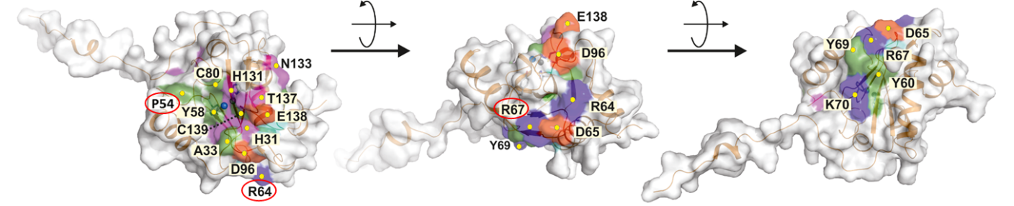
Figure S2. Surface representation of Ts2613 endolysin (PDB 6FHG) with conserved residues highlighted. Based on a multiple sequence alignment, conserved residues on the surface of Ts2631 endolysin were identified. These residues cluster around the active site (left picture) and on the opposite side of the molecule. Five single amino acid substitution variants (H30N, Y58F, H131N, T137K and C139S) were previously constructed to validate the catalytic site of the protein (3). Recently nineteen other variants (H31A, T32A, A33G, P54A, Y60A, R64A, D65A, R67A, Y69A, K70A, L72A, I79A, C80A, N85A, G95A, D96A, N133A, V135A, E138A) were designed and purified to investigate the influence of conserved residues on lytic activity of the enzyme and its ability to interact with peptidoglycan (1). Note, that in exception to proline P54 and arginines R64, R67 (marked by red circles), other tryptophans, arginines and prolines are not conserved in the primary sequence of the Ts2631 endolysin.
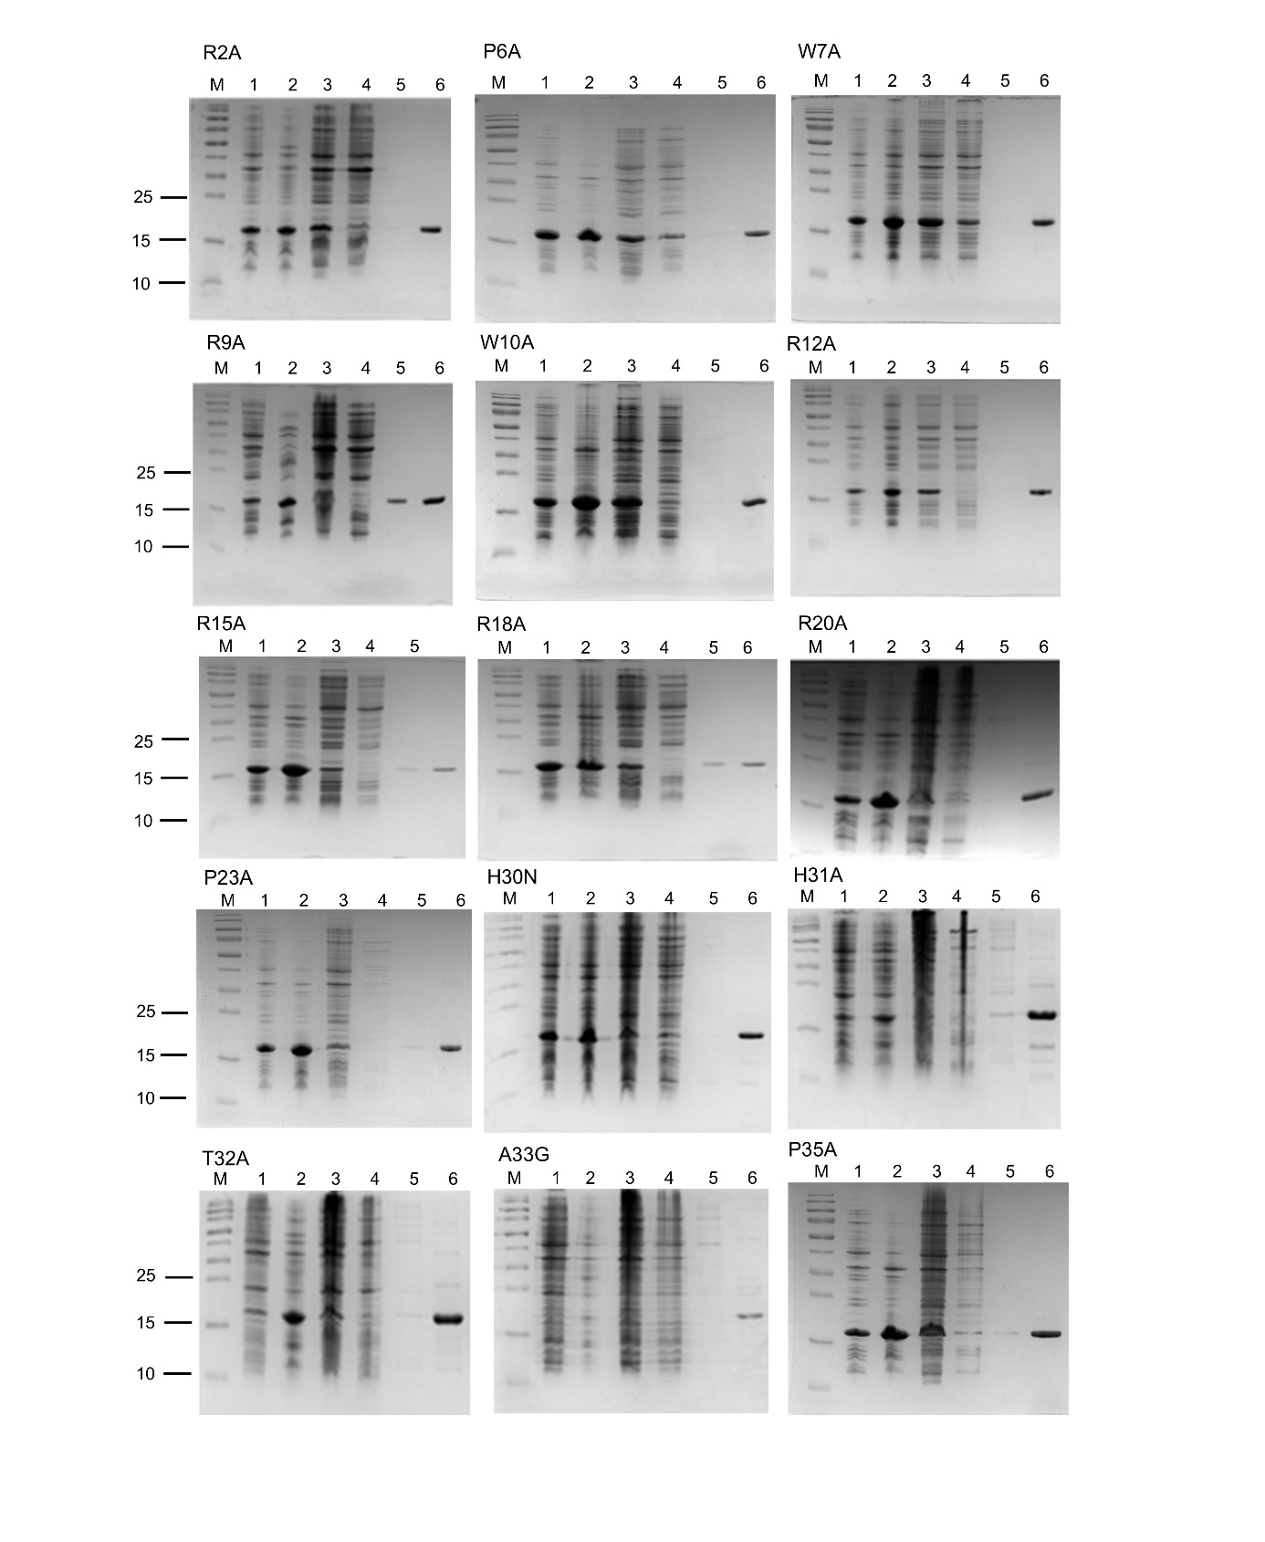
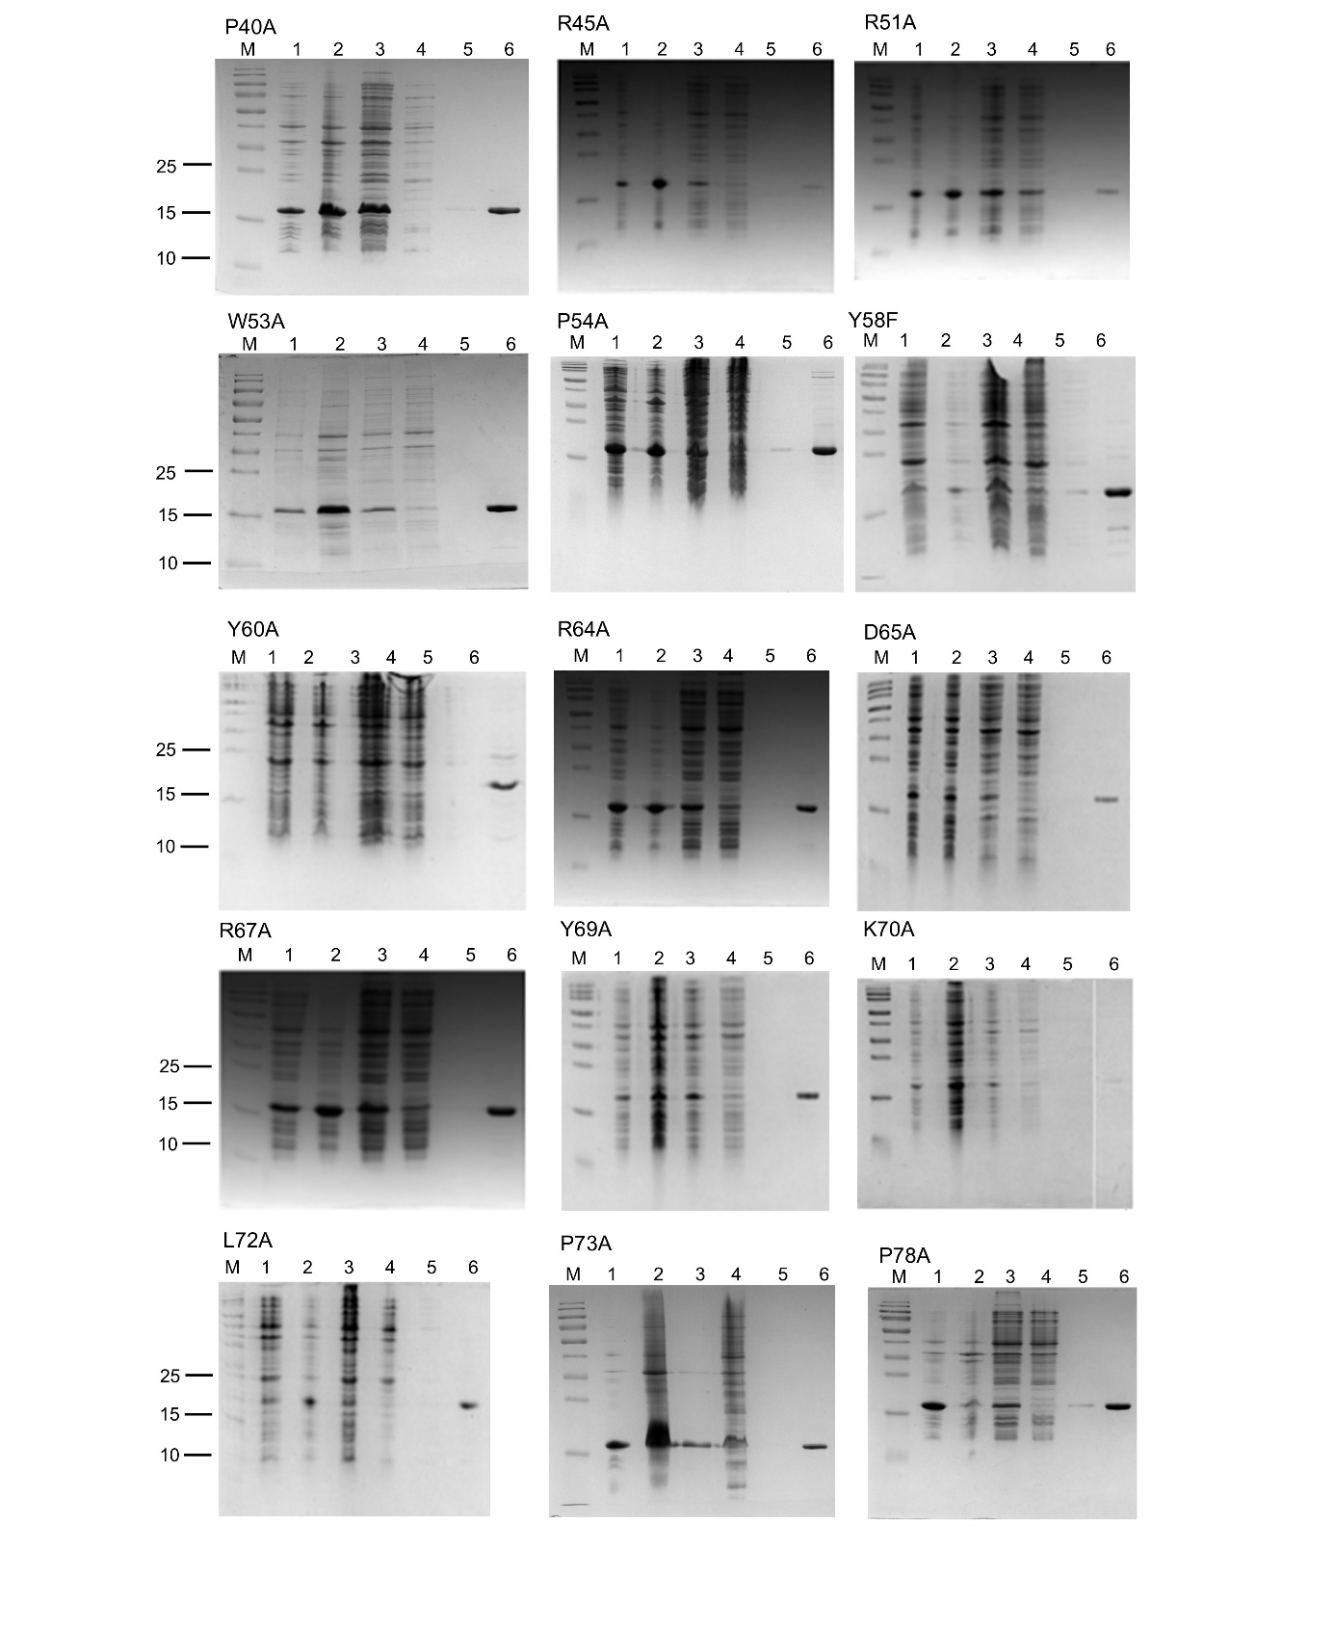
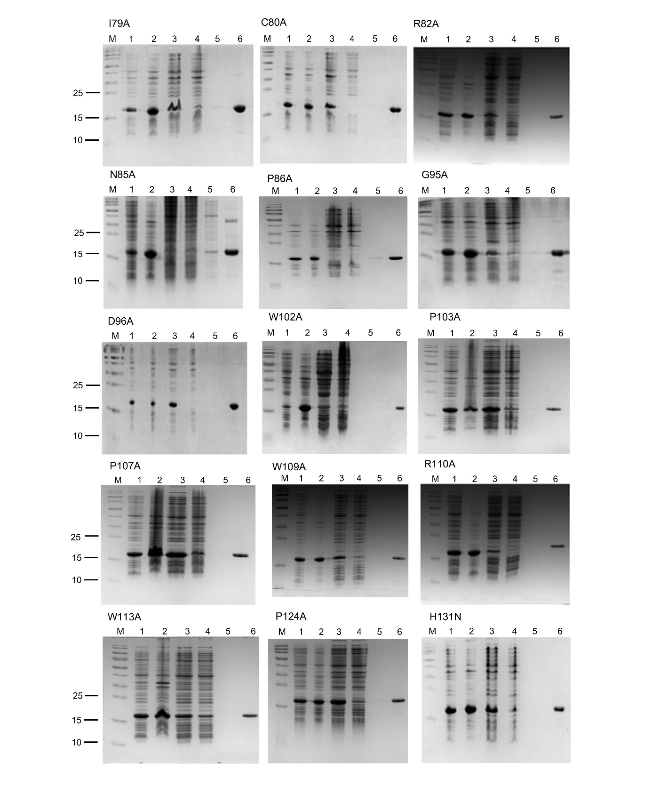
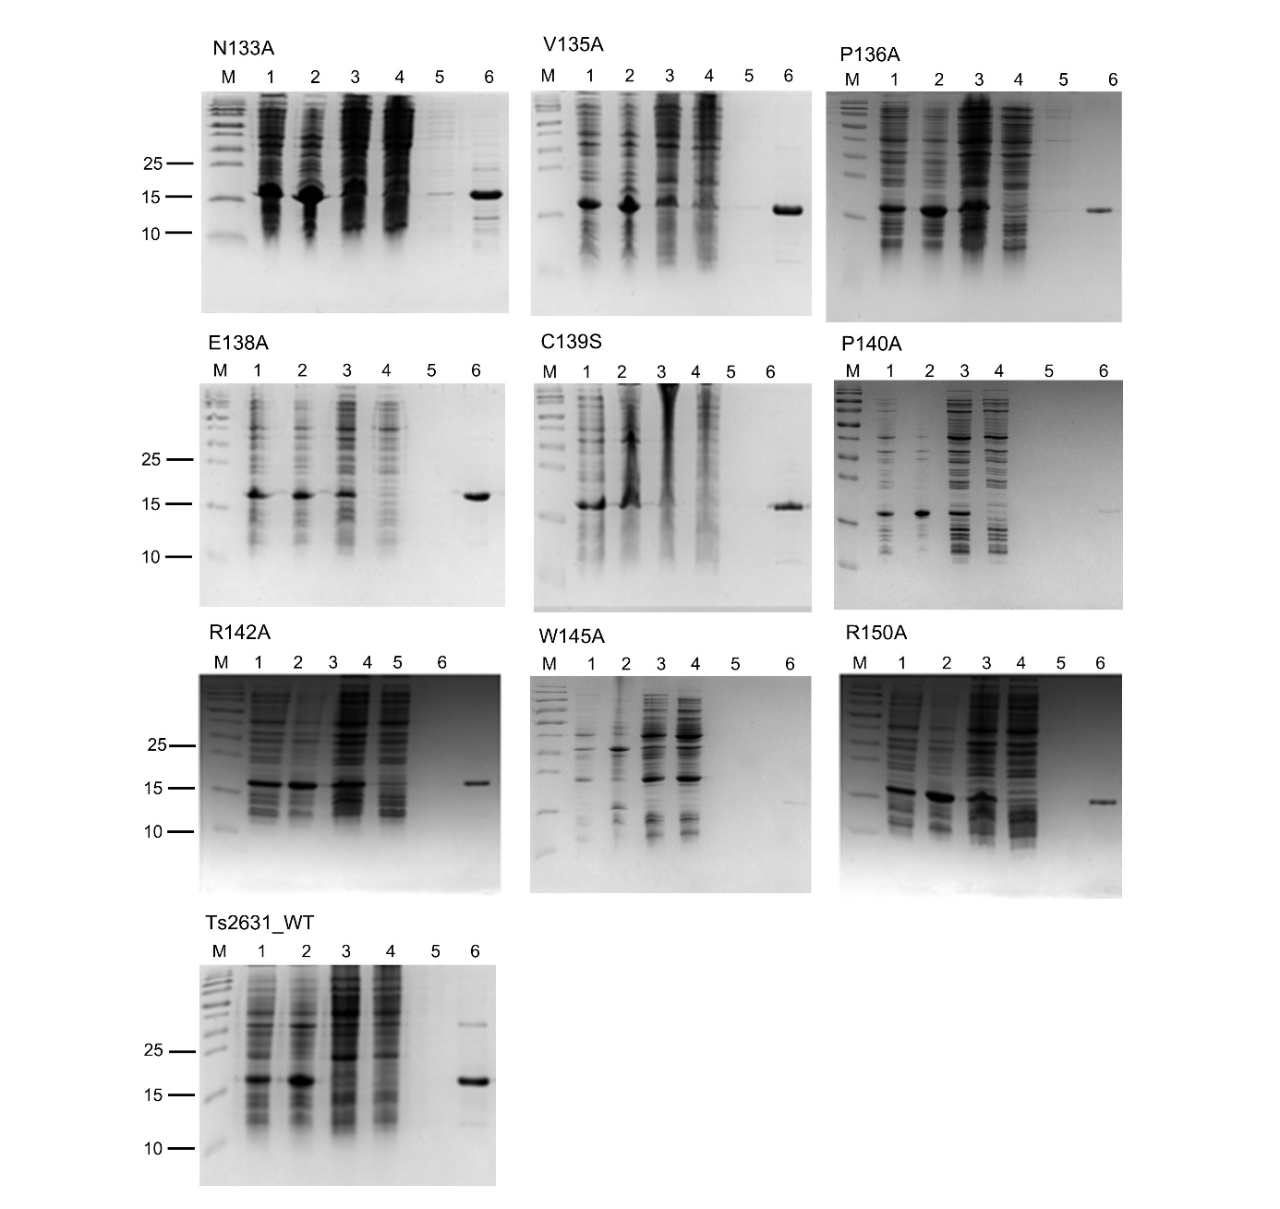
Figure S3. Ts2631 endolysin and its variants purification. Proteins were purified with metal ion affinity chromatography method. Evaluation of the purification was analysed with SDS-PAGE. M - PageRuler prestained protein ladder, 10 to 180 kDa (Thermo Fisher Scientific), 1 – lysate, 2 – pellet, 3 – supernatant, 4 – filtrate of proteins not bound to the resin, 5 – rising, 6 – purified protein.

Figure S4. Far-UV circular dichroism spectra and Ts2631 endolysin and its variants: R20A, R51A, W53A, R82A. Proteins were dialysed against buffer: 10 mM potassium phosphate buffer, pH 8.0, 150 mM ammonium sulphate and 10% glycerol. Protein concentration was adjusted to 7.41 µM and spectra were measured at room temperature. The spectra overlapped what can suggest that the substitution in given variant did not influence the structure.

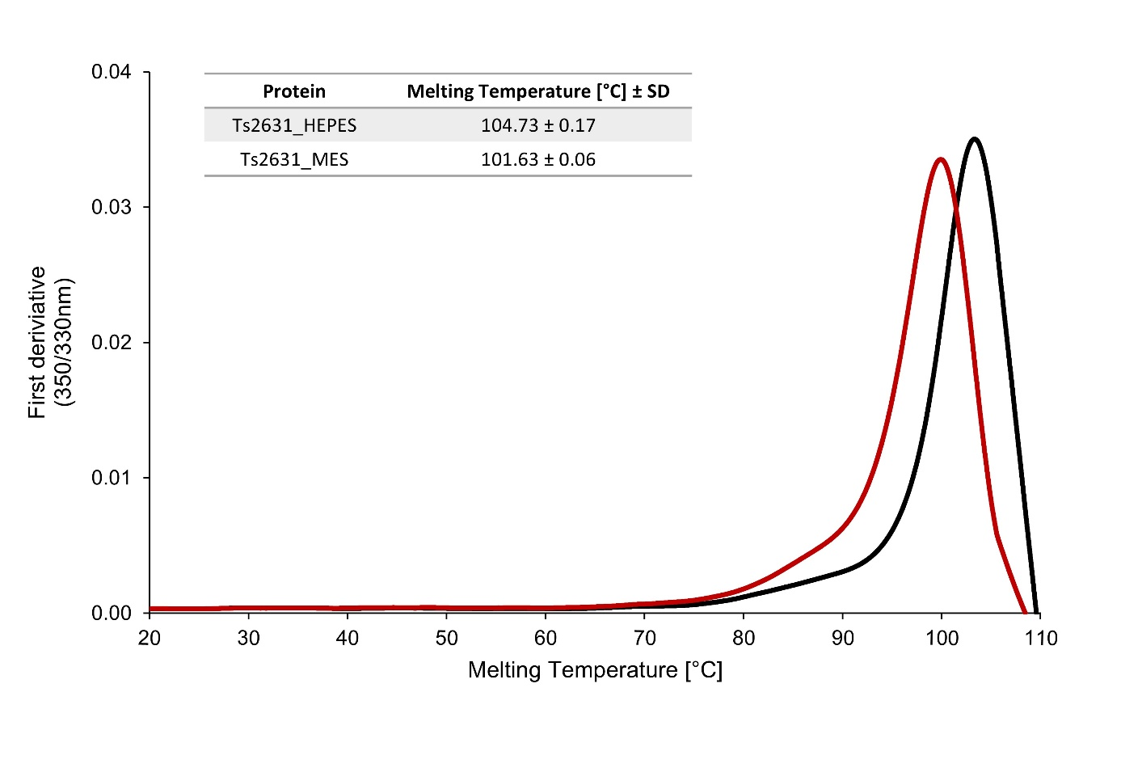
Figure S5. The melting temperature of Ts2631 endolysin measured by nanoDSF. Ts2631 endolysin was firstly dialysed against two different buffers: A - 20 mM HEPES pH 7.4, 25 mM NaCl and 10% glycerol and B - 20 mM MES pH 6.0, 25 mM NaCl, 10% glycerol. Protein were analysed at temperature range from 20°C to 110°C. The experiment was repeated four times, black colour indicate Ts2631 in buffer A and red colour in buffer B.

1. Plotka M, Sancho-Vaello E, Dorawa S, Kaczorowska AK, Kozlowski LP, Kaczorowski T, Zeth K. 2019. Structure and function of the Ts2631 endolysin of Thermus scotoductus phage vB_Tsc2631 with unique N-terminal extension used for peptidoglycan binding. Sci Rep 9:1261.
2. Kozlowski LP. 2022. Proteome-pI 2.0: proteome isoelectric point database update. Nucleic Acids Res 50:D1535-D1540.
3. Plotka M, Kaczorowska AK, Morzywolek A, Makowska J, Kozlowski LP, Thorisdottir A, Skírnisdottir S, Hjörleifsdottir S, Fridjonsson OH, Hreggvidsson GO, Kristjansson JK, Dabrowski S, Bujnicki JM, Kaczorowski T. 2015. Biochemical Characterization and Validation of a Catalytic Site of a Highly Thermostable Ts2631 Endolysin from the Thermus scotoductus Phage vB_Tsc2631. PLoS One 10:e0137374.

