Supplementary Data
(Supplementary Fig. S1A and S1B)
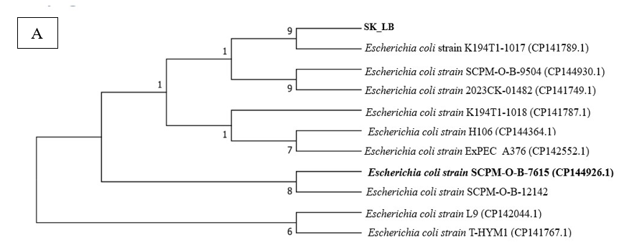

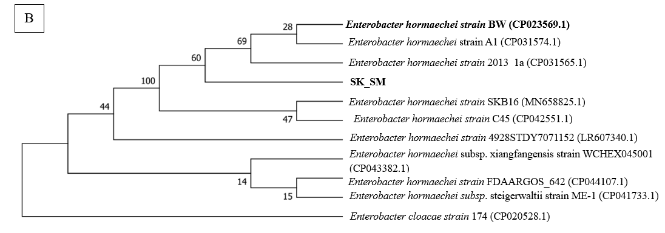

Figure S1(A and B). Evolutionary Relatedness Analysis of UPEC and E. hormaechei based on 16S rRNA Gene Sequences.

(Supplementary Figure S2a and S2b)
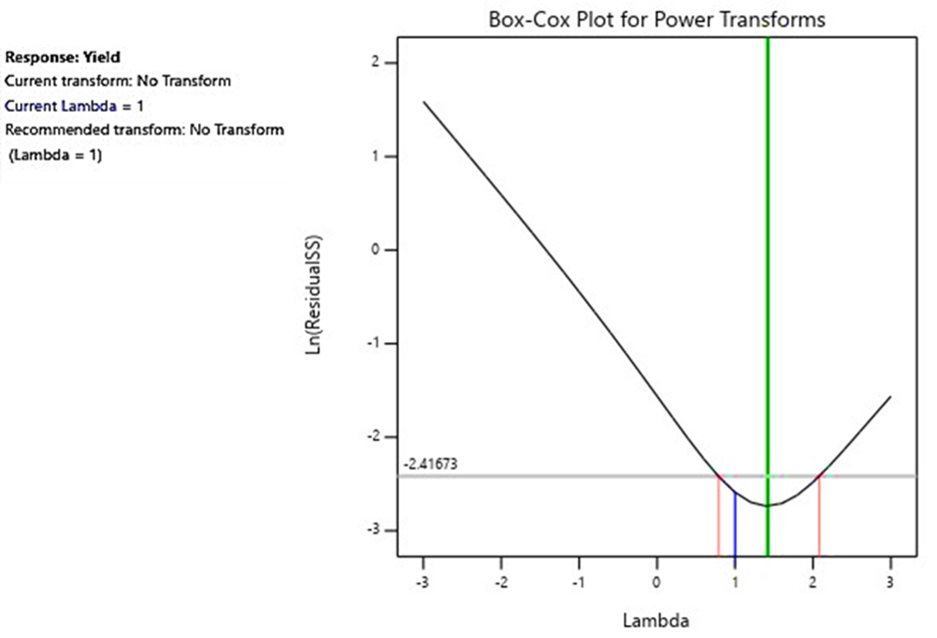

Figure S2a. Box–Cox plot for evaluation of data transformation requirements.

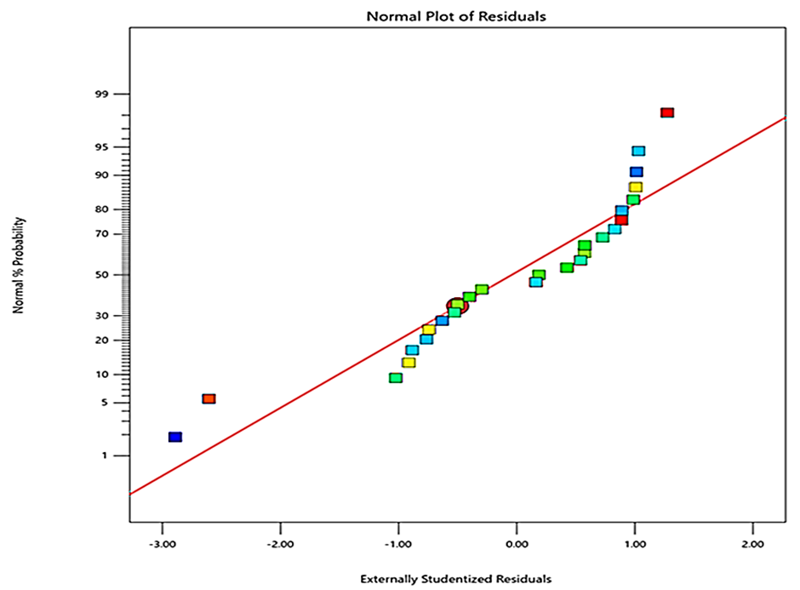

Figure S2b. Normal probability plot of residuals validating model assumptions

