Supplementary Information

Determination of Natural Uranium and Thorium Levels in Environmental Matrices Surrounding Uranium Mining Sites via ICP-MS

Joel Augusto Moura Portoª, Lander de Jesus Alves^{b}, Hector Hugo Silva Medrado^{c}, Josilene da Silva Rocha^{c}, Rodrigo Gibaut de Souza Góis^{c}, Fábio Carvalho Nunes^{d}, Marcelo Machado Vianaª, and Ana Paula de Carvalho Teixeiraª*
ªDepartment of Chemistry, Federal University of Minas Gerais (UFMG), Belo Horizonte, Minas Gerais, Brazil

^{b}State University of Santa Cruz (UESC), Postgraduate Program in Biology and Biotechnology of Microorganisms, Ilhéus, Bahia, Brazil

^{c}Indústrias Nucleares do Brasil (INB) - Uranium Concentration Unit, Security, Radioprotection and Environment Management, Caetité, Bahia, Brazil

^{d}Federal Institute of Education, Science and Technology of Bahia, Santa Inês, Bahia, Brazil

_____________________________________
* anapaula.cta1@gmail.com

Table S1. Operating parameters adopted for PerkinElmer NexION® 300X ICP-MS.
Instrumental parameters
Equipment used | PerkinElmer NexION® 300X ICP-MS
²³²Th detection limit | < 0.5 ng.L⁻¹ (ppt)
RF Power | 1600W
Plasma gas flow | 18 L min⁻¹
Auxiliary gas flow | 1.2 L min⁻¹
Gas flow in the nebulizer | 1.01 L min⁻¹
KED Mode
input voltage | -3.00 V
Output voltage | -32.00 V
CROª | -15.00 V
QRO^{b} | -12.00 V
Data acquisition parameters
Number of sweeps per read | 50
Number of readings | 1
Number of replicates | 3
Dwell Time | 25 s
Collision gas | -
RPq^{c} | 0.25 V
Gas flow in the Collision Cell | -
Calibration range | 5.0 - 40.0µg L⁻¹
ª CRO (Cell Rod Offset) – voltage applied to the quadrupole of the reaction/collision cell;
^{b} QRO (Quadrupole Rod Offset) – voltage applied to the mass analyzer quadrupole;
^{c} RPq relates the voltage applied to the quadrupole rods and needs to be optimized.

Figure S1. Location of collection points.

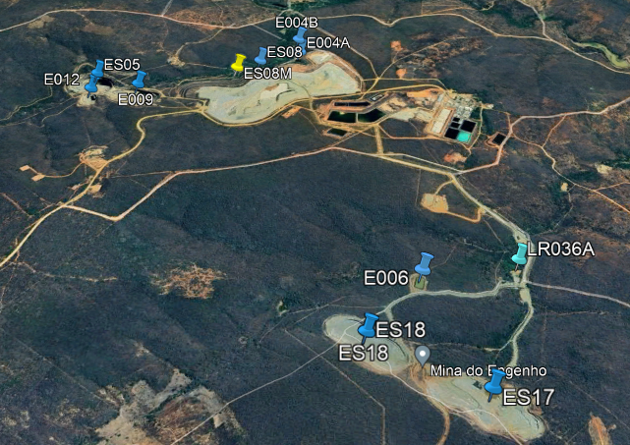

Figure S2. Location of collection points – Cachoeira Mine.

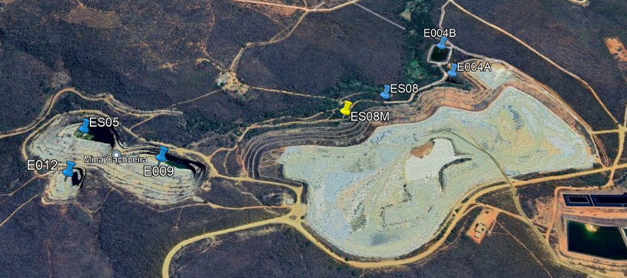

Figure S3. Location of collection points – Engenho Mine.

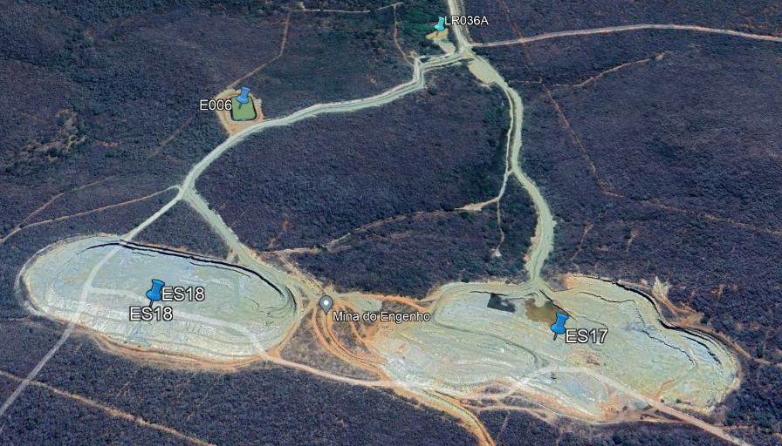
Figure S4. Calibration curve used in the determination of natural uranium.

Figure S5. Calibration curve used in the determination of natural thorium.

