Supplementary data
β-Oxoanilides in Heterocyclic Synthesis: Synthesis of polyfunctionally substituted Pyridines Incorporating Pyrimidine Moiety: Quantum Chemical Calculations for Corrosion Inhibition using DFT Studies
Abdel Haleem M. Hussein¹, Ashraf M. Ashmawy^{2*},Mohamed. Abdel Rady³, Mohamed A. M. Gad-Elkareem¹, and M. A. Mostafa⁴
¹ Department of Chemistry, Faculty of Science, Al-Azhar University, Assiut 71524, Egypt.
²Chemistry Department, Faculty of Science, Al-Azhar University, Nasr City 11884, Cairo, Egypt
³Assiut International Center of Nanomedicine, Al-Rajhy Liver Hospital, Assiut University.
⁴ Department of Chemistry Faculty of Science Luxor University, Egypt.
* Email: Ma.Abdelhakeim@sci.luxor.edu.eg

Contents:
- Experimental data: page 1
- Spectral charts (IR, ¹H NMR, ¹³C NMR and MS): page 4

Ethyl 2-amino-4-methyl-6-oxo-1-(pyrimidin-2-yl)-1,6-dihydropyridine-3-carboxylate (10):
A solution of compound 9 (54.85 mg, 0.20 mmol) in sodium ethoxide (formed from 30 ml ethanol and 4.6 mg, 0.20 mmol of sodium metal), was refluxed for 3 hrs. and after cooling, the reaction mixture was poured into ice cold water, acidified by dilute HCl, the solid product formed was filtered off and crystallized from ethanol to give 10 (29.62 mg, 54 %) as yellow crystals; m.p = 257-260 ⁰C; IR cm⁻¹ ν = 3465, 3400 (NH₂), 1686 (CO); Anal. Calcd. for C₁₃H₁₄N₄O₃ (274.28): C 56.93, H 5.14, N 20.43%. Found: C 56.93, H 5.15, N 20.43%.
Synthesis of nicotinonitrile derivatives 15 and 17; General procedure:
A mixture of 1 (35.8 mg, 0. 20 mmol) and each of (arylidinecyanothioacetamide of P-chlorobenzaldehyde (44.54 mg, 0.20 mmol)) or (mixture of cyanothioacetamide and acetaldehyde (25.23 mg. 0.20 mmol)) in ethanol (30 ml) was treated with a few drops of piperidine and refluxed for 5 hrs., then left to cool and poured into crushed ice and acidified with HCl. The solid product was collected and recrystallized from ethanol to give the nicotinonitrile derivatives 15 and 17 respectively.
5-Acetyl-4-(4-chlorophenyl)-2-mercapto-6-(Pyrimidin-2-ylamino)-nicotinonitrile (15): yellow crystals of yield (63.83 mg, 83%), m.p.= 243-245 °C. IR cm⁻¹ ν = 3432 (NH), 2222 (CN), 1670 (CO); ¹H NMR δ ppm = 2.44 (s, 3H, CH₃), 6.8 (s, 1H, SH), 7.25-7.78 (m, 8H, Ar-H and NH); ¹³C NMR δ C= 110.2 (q), 111 (s), 114 (d), 117 (SCN) 128.9 (d), 130.5 (d), 131.4 (s), 134.9 (s), 154 (d), 155.8 (d), 158 (d), 178 (CO); MS: m/z = 382 (M⁺); Anal. Calcd. for C₁₈H₁₂ClN₅OS (381.84): C 56.62, H 3.17, N 18.34%. Found: C 56.62, H 3.17, N 18.34%.
5-Acetyl-2-mercapto-4-methyl-6-(Pyrimidin-2-ylamino) nicotinonitrile (17):
Yellow crystals of yield (38.23 mg, 67%), m.p.= 258-260 °C, IR cm⁻¹ ν = 3350 (NH), 2220 (CN), 1670 (CO). ¹H NMR (DMSO) δ ppm = 2.34 (s, 3H, CH₃), 2.47 (s, 3H, CH₃), 7.05-7.26 (d, 1H, J = 8.4 Hz, pyrimidine-H), 8.69 (s, 2H, pyrimidine-H’s), 11.24 (s, 1H, NH) 14.06 (s, 1H, NH); ¹³C NMR δC = 17.8 (q), 19.3 (q), 114.6 (s), 114.6 (s), 116.4 (SCN), 118.2 (s), 124.3 (s), 153.9 (s), 157.4 (d), 157.4 (d), 177.7 (CO); MS: m/z = 287 (M⁺²); Anal. Calcd. for C₁₃H₁₁N₅OS (285.32): C 54.72, H 3.89, N 24.55%. Found: C 54.72, H 3.90, N 24.57%.
4-(4-Chlorophenyl)-5-[(1E)-ethanehydrazonoyl]-2-hydrazino-6-(pyrimidin-2-ylamino) nicotinonitrile (18):
A solution of compound 15 (62.04 mg; 0.20 mmol) in ethanol (10 ml) was treated with an excess of hydrazine hydrate (10 ml). The mixture was heated under reflux for 12 hrs. and left to stand. Poured on ice cold water and acidified with HCl. The solid product so formed was obtained by filtration and recrystallized from ethanol to give 18 (68.52 mg; 87%); as yellow crystals; m.p = 292-294°C; IR cm⁻¹ ν = 3434-3100 (NH₂ and NH), 2221 (CN); ¹H NMR (DMSO) δ ppm = 2.39 (s, 3H, CH₃), 6.45 (s, 4H, 2NH₂), 7.34-7.63 (m, 7H, Ar-H),13.97 (br, 2H, 2NH). Anal. Calcd. for C₁₈H₁₆ClN₉ (393.833): C 54.89; H 4.09; N 32.01 % Found: C 54.91; H 4.10; N 32.03 %
Ethyl {[5-acetyl-4-(4-chlorophenyl)-3-cyano-6-(pyrimidin)-2-ylamino)pyridin-2-yl]thio}acetate (19):
To a solution of 15 (62.04 mg; 0.20 mmol) in ethanol, ethyl chloroacetate (24.5 mg; 0.20 mmol) and sodium acetate (0.5g) were added. The mixture was refluxed for 4 hrs. cooled, poured into crushed ice and acidified with HCl and the precipitate was recrystallized from ethanol to give 19 (77.67 mg; 83 %) as brown crystals ; m.p = 166-168°C; IR cm⁻¹ ν =3481 (NH) , 2218 (CN), 1735 (CO), 1672 (CO); ¹H NMR (CDCl₃) δ ppm = 1.31-1.33 (t, 3H, J = 7.2 Hz, CH₃), 2.60 (s, 3H, CH₃), 4.03 (s, 2H, CH₂), 4.24-4.27 (q, 2H, J = 7.2 Hz, CH₂), 6.92-7.55 (m, 6H, Ar-H), 8.43-8.45 (d, 1H, J = 7.8 Hz, pyrimidine-H), 9.17 (br, 1H, NH) ; ¹³C NMR δ C = 14.22(q), 32.6(q), 60.6(t), 61.7(t), 114.4(d), 116.5(s, CN), 128.2(s), 128.6(d), 129.2(d), 152.6(s), 158.3(d), 158.3(d), 161.7(d), 168.6(s, CO), 168.8(s, CO). Anal. Calcd. for C₂₂H₁₈ClN₅O₃S (467.929): C 56.47; H 3.88; N 14.97 % Found: C56.49; H 3.89; N 14.99 %.
Ethyl 5-acetyl-3-amino-4-(4-chlorophenyl)-6-(pyrimidin-2-ylamino)thieno[2,3-b]-pyridine-2-carboxylate (20):
To a solution of sodium ethoxide prepared from sodium metal (1gm) and ethanol (10 ml), a solution of 15 (62.04 mg; 0.20 mmole) in ethanol (20 ml) was added. The reaction mixture was refluxed for 3 hrs., after cooling the reaction mixture was poured into cold water (50 ml) and acidified with HCl. The product formed was collected by filtration and recrystallized from ethanol to give 20 (67.38 mg; 72 %). as brown crystals; m.p = 190-192°C; IR cm⁻¹ ν =3483, 3436, 3354 (NH₂ and NH), 1731 (CO), 1673 (CO); ¹H NMR (CDCl₃) δ ppm =1.36-1.38 (t, 3H, J = 7.2 Hz, CH₃), 2.60 (s, 3H, CH₃), 4.28-4.30 (q, 2H, J = 7.2 Hz, CH₂), 6.98-7.47 (m, 8H, Ar-H and NH₂) ; 8.40-8.42 (d, 1H, J = 7.8 Hz, (pyrimidine-H), 9.16 (br, 1H, NH) ; ¹³C NMR δ ppm C =14.21(q) ;14.49(q) ;60.51(t) ;128.2(d) ;128.6(s)129.0(s) ;129.3(d) ;152.6(d) ;152.6(d) ;156.5(s) ;159.2(s) ;168.8(s. CO) ;168.8(s, CO). Anal. Calcd. for C₂₂H₁₈ClN₅O₃S (467.929): C 56.44; H 3.87; N 14.77 % Found: C 56.42; H 3.85; N 14.79 %.
1-[3-Amino-6-(pyrimidin-2-ylamino)-4-sulfanylthieno[3,4-c]pyridin-7-yl]ethenone (21):
Equimolar amount of 17 (57.06 mg; 0.20 mmole) and elemental sulfur (6.4 mg; 0.20 mmole) in ethanol (30 ml) were treated with triethylamine (0.5 ml) and refluxed for 4 hrs., the solid that formed after cooling was collected and recrystallized from benzene to give 21 (39.98 mg; 63 %) as dark green crystals ; m.p = 293-295°C; IR cm⁻¹ ν = br 3437 (NH_{2,} SH), 1725(CO); ⁻¹H NMR (DMSO) δ ppm = 2.25 (s, 3H, CH₃), 6.80-8.60 (m, 6H, Ar-H and NH₂), 11.27 (s, 1H, NH), 14.20 (s, 1H, SH). Anal. Calcd. for C₁₃H₁₁N₅OS₂ (317.329): C 49.19; H 3.49; N 22.07 % Found: C 49.20; H 3.50; N 22.09 %
Preparation of compounds (22a,b):
General procedure:
A mixture of 17 (57.06 mg; 0.20 mmole), α-cyano-4-substituted cinnamonitrile (0.20 mmole) in ethanol (30 ml) was treated with a little amount of piperidine and heated under reflux for 8 hrs. The reaction mixture allowed to cool and poured into crushed ice and acidified with HCl. The solid product was filtered off and recrystallized from the proper solvent to give 22a,b.
4-Acetyl-8-amino-6-(4-chlorophenyl)-1-mercapto-3-(pyrimidin-2-ylamino)-isoquinoline-7-carbonitrile (22a):
It was obtained as brown crystals from ethanol; yield 47.37 mg; 53%; m.p =193-195°C; IR cm⁻¹ ν = br 3352-3100 (NH₂ and SH), 2210 (CN), 1707 (CO); ¹H NMR (DMSO) δ ppm = 2.37 (s, 3H, CH₃), 7.04-7.95 (m, 9H, Ar-H and NH₂), 11.23 (s, 1H, NH), 14.06 (s, 1H, SH). Anal. Calcd. for C₂₂H₁₅ClN₆OS (446.913): C 59.12; H 3.38; N 18.80 % Found: C 59.14; H 3.40; N 18.81 %.
4-Acetyl-8-amino-1-mercapto-6-(4-methoxyphenyl)-3-(pyrimidin-2-ylamino)-isoquinoline-7-carbonitril(22b):
It was obtained as dark brown crystals from ethanol ; yield 61.06 mg; 69 %; m.p = 258-260°C; IR cm⁻¹ ν = br 3226-3100 (NH_{2,} SH), 2222 (CN), 1672 (CO); ¹H NMR (DMSO) δ ppm = 2.46 (s, 3H, CH₃), 3.90 (s, 3H, OCH₃), 7.0-7.13 (d, 4H, J = 7.8 Hz, Ar-H), 7.9-8.02 (d, 4H, J = 7.8 Hz, Ar-H and NH₂); 8.31-8.42 (m, 2H, Ar-H), 11.32 (s, 1H, NH), 14.06 (s, 1H, SH); ¹³C NMR δ ppm C =22.6(q), 55.1(q), 113.8(s), 114.1(s), 114.4(d), 114.7(d), 115.9(s), 117.7(d), 124.1(d), 131.7(d), 133.3(d), 133.5(d), 158.5(s), 158.5(d), 158.5(d), 160.4(d), 164.3(s, CO). Anal. Calcd. for C₂₃H₁₈N₆O₂S (442.494): C 62.43; H 4.10; N 18.99 % Found: C 62.44; H 4.12; N 19.01 %.

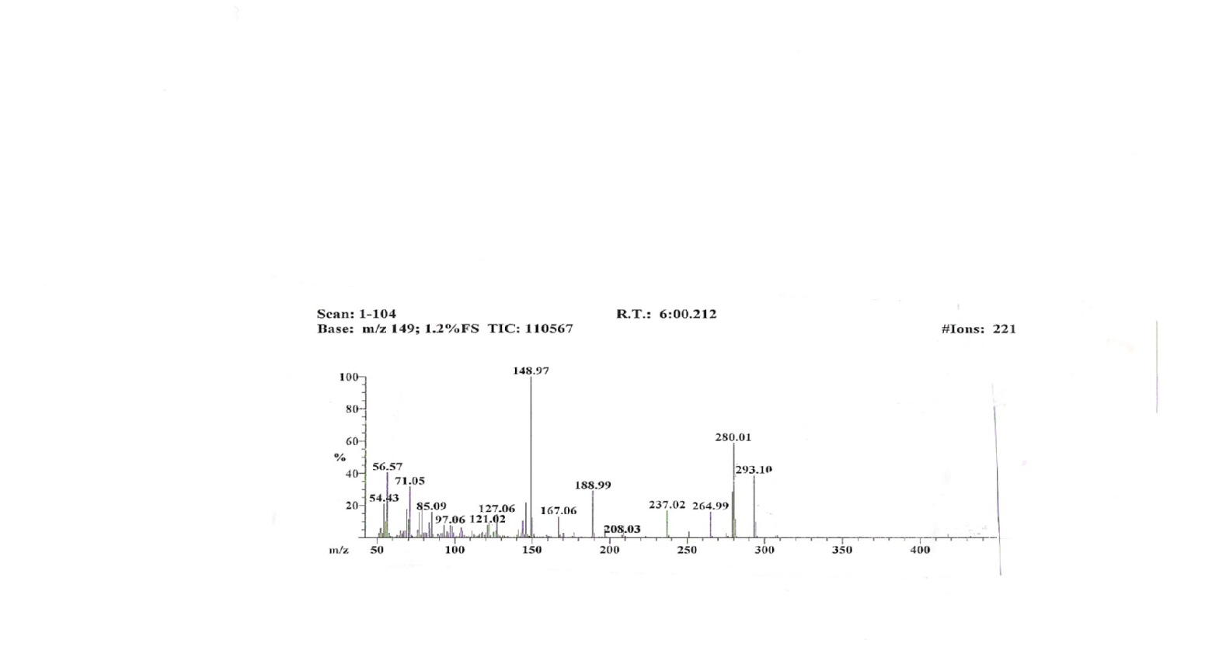

Fig (1): Mass spectrum of Compound 5:
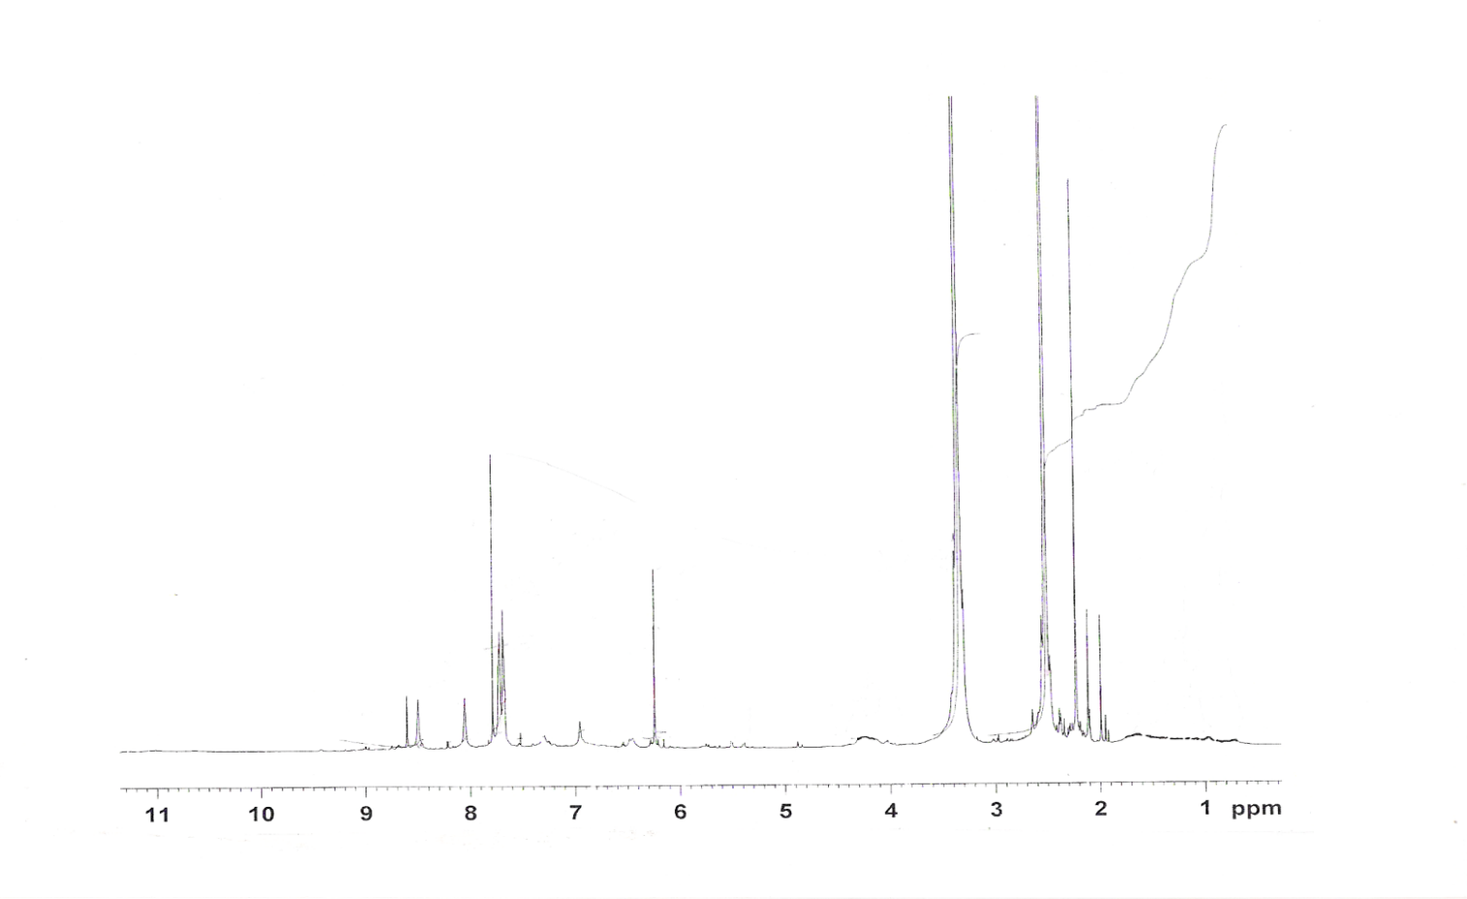
Fig ( 2 ): ¹H NMR Spectrum of Compound (5)

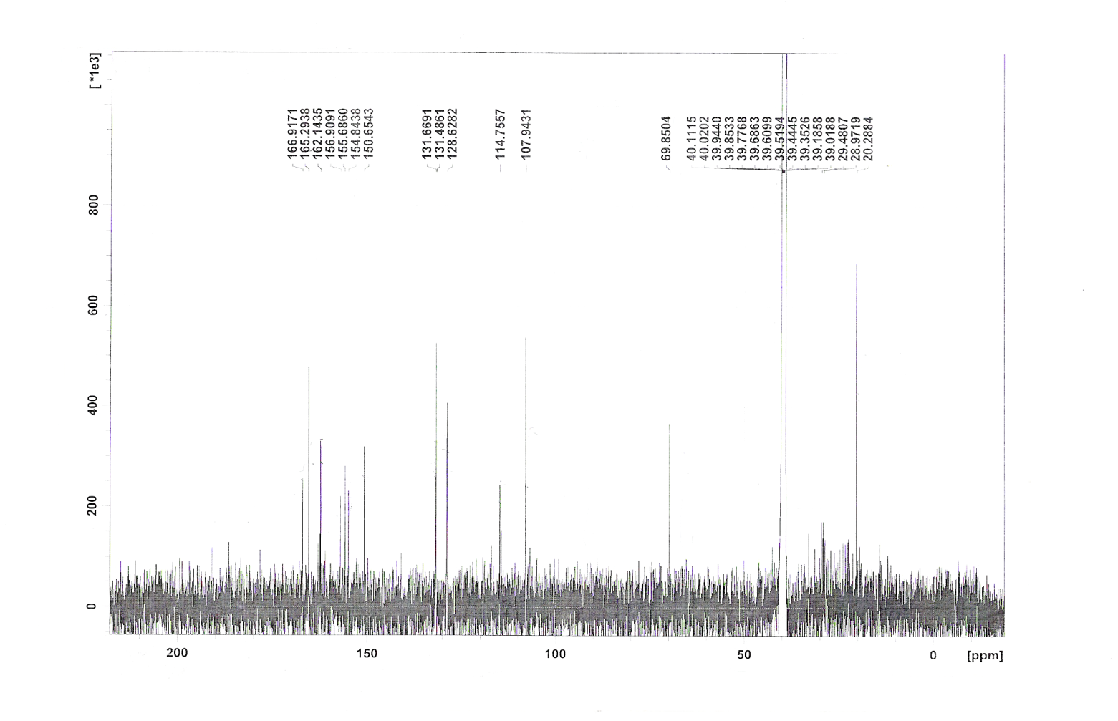
Fig ( 3 ): ¹³C NMR Spectrum of compound (5)…….Solvent DMSO

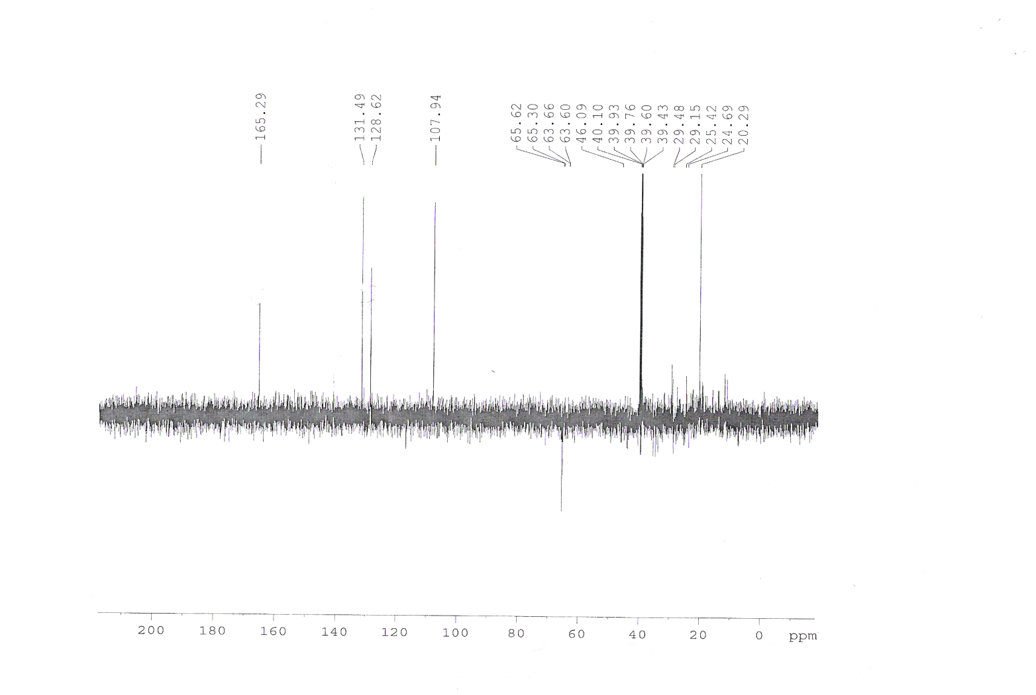
Fig ( 4 ): Dept.135 NMR Spectrum of compound (5)…Solvent DMSO

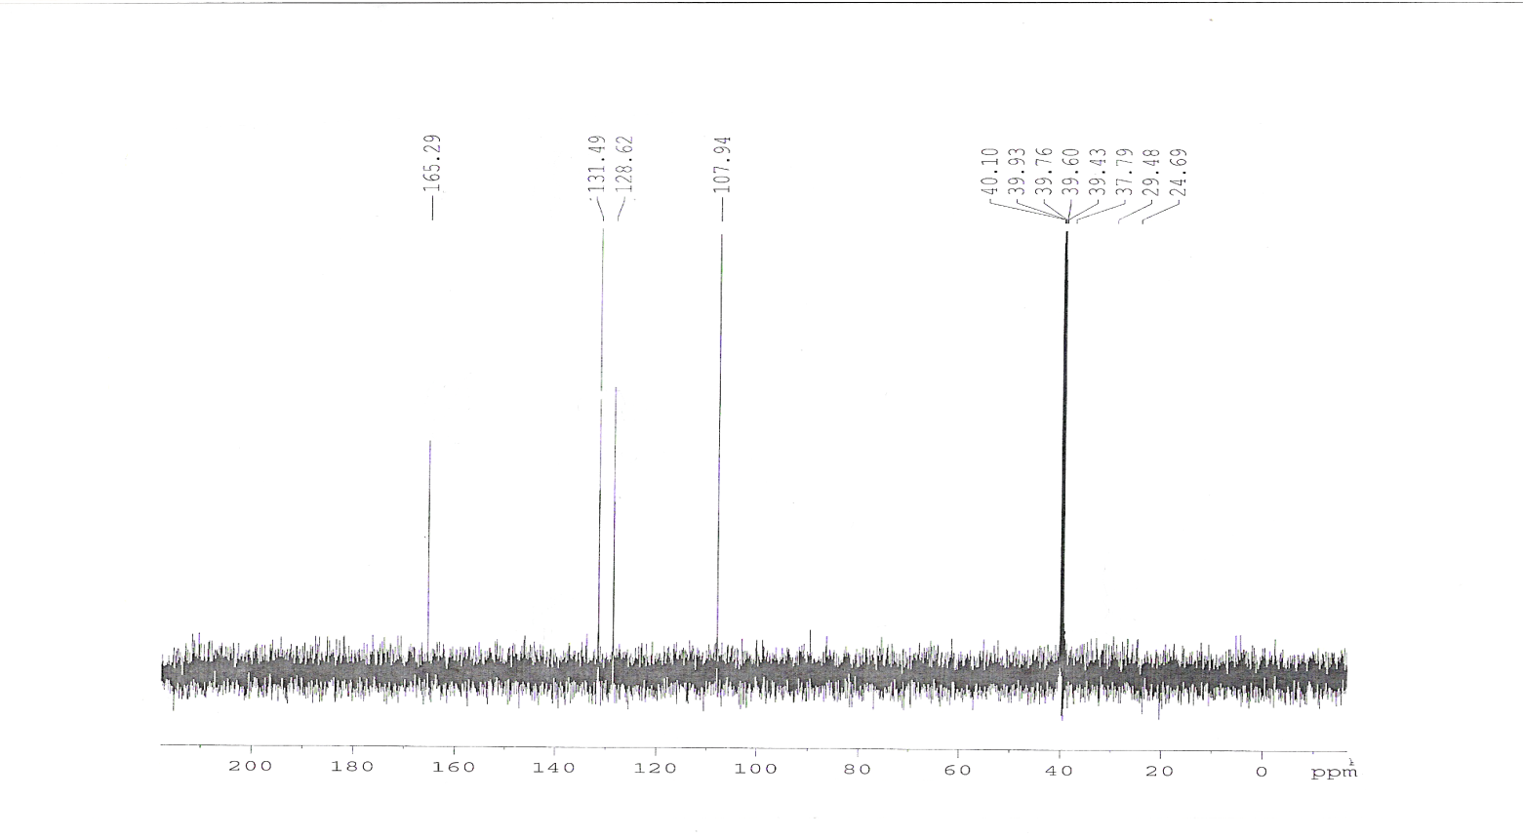
Fig ( 5 ): Dept.90 ¹³C NMR Spectrum of compound (5)…Solvent DMSO

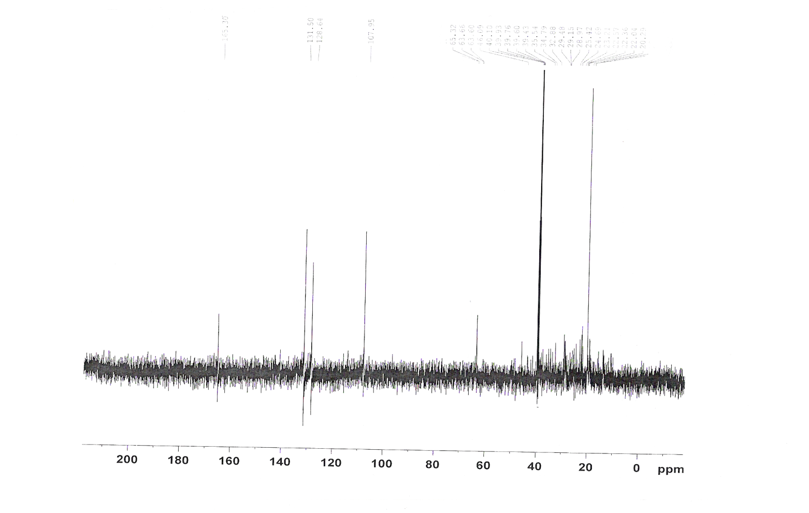
Fig ( 6 ): Dept.45 ¹³C NMR Spectrum of compound (5)…Solvent DMSO

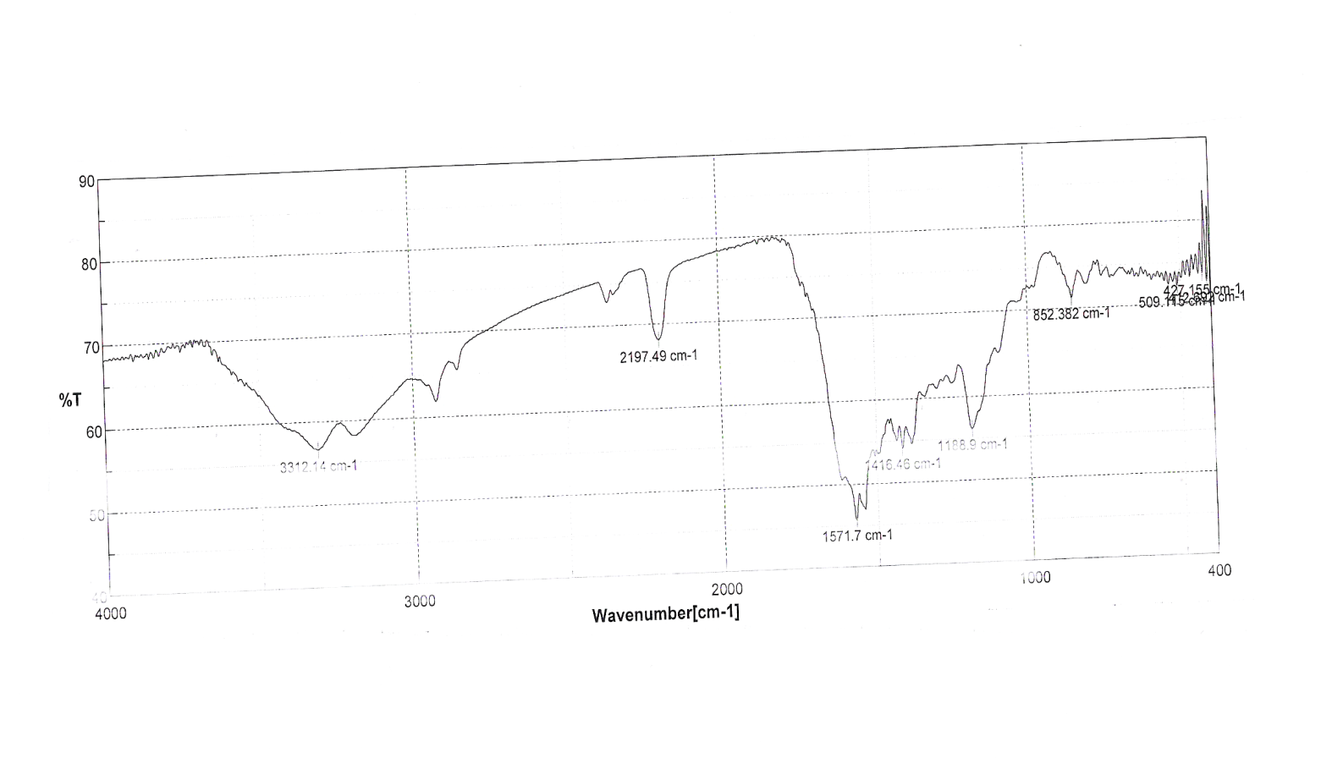
Fig ( 7 ): IR Spectrum of Compound (7)

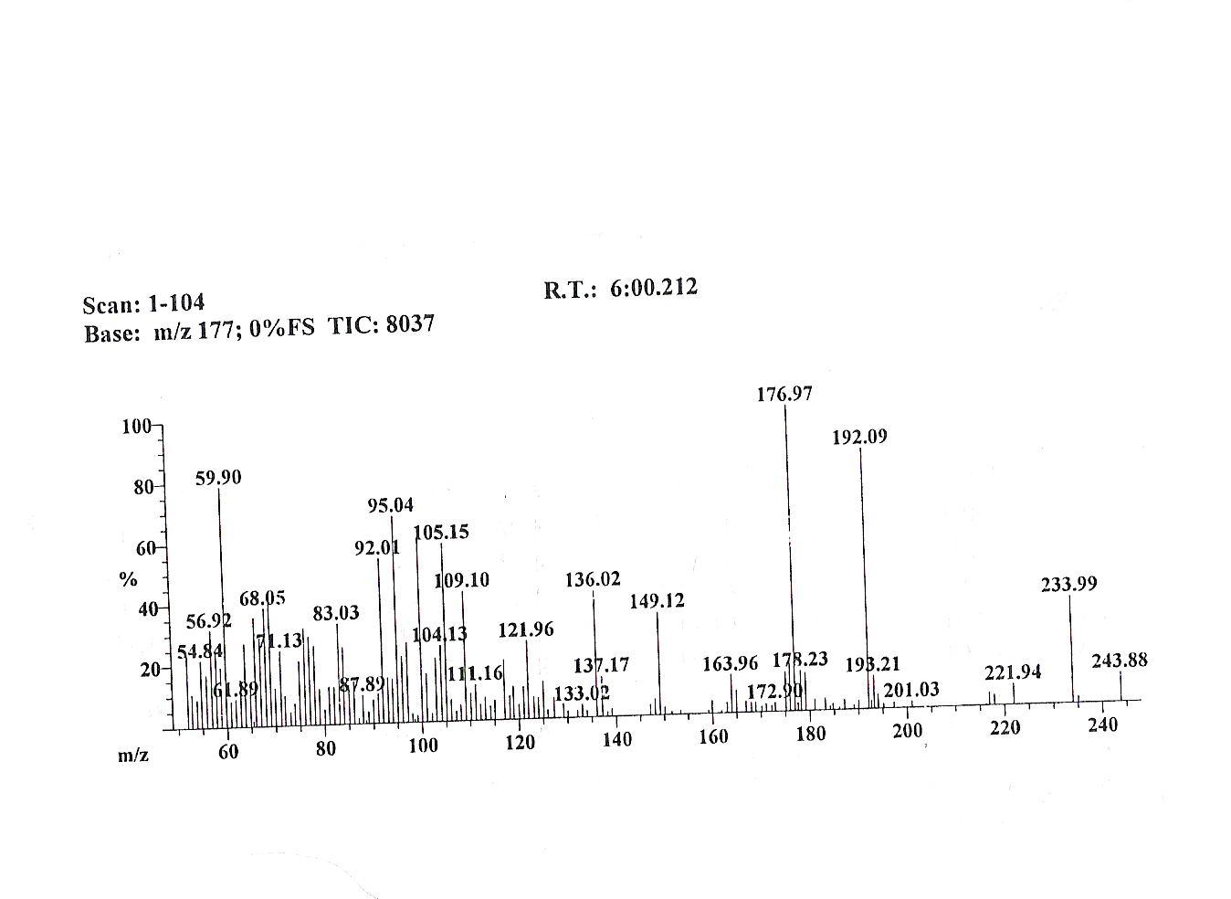
Fig ( 8 ): Mass spectrum of Compound (7)

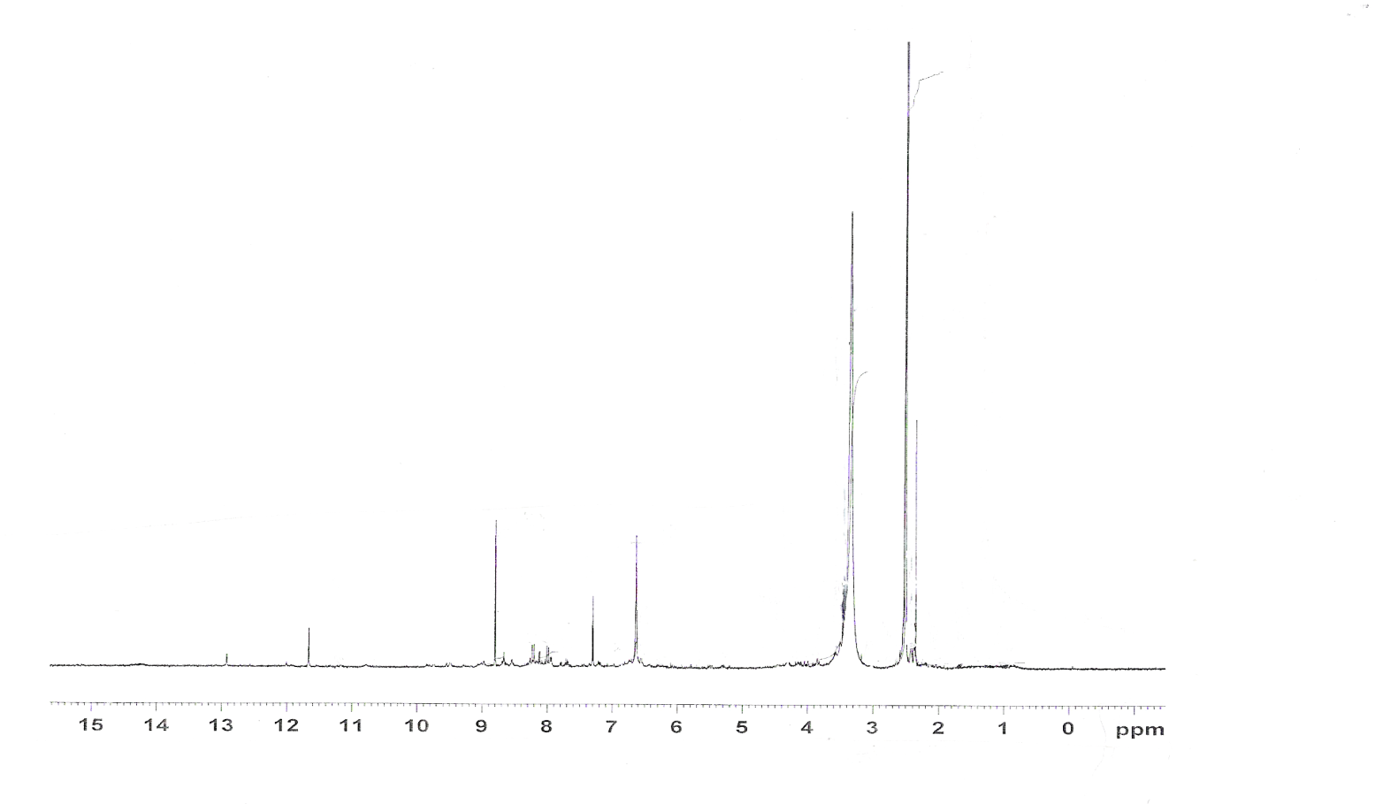
Fig ( 9 ): ¹H NMR Spectrum of Compound (7)…..Solvent DMSO

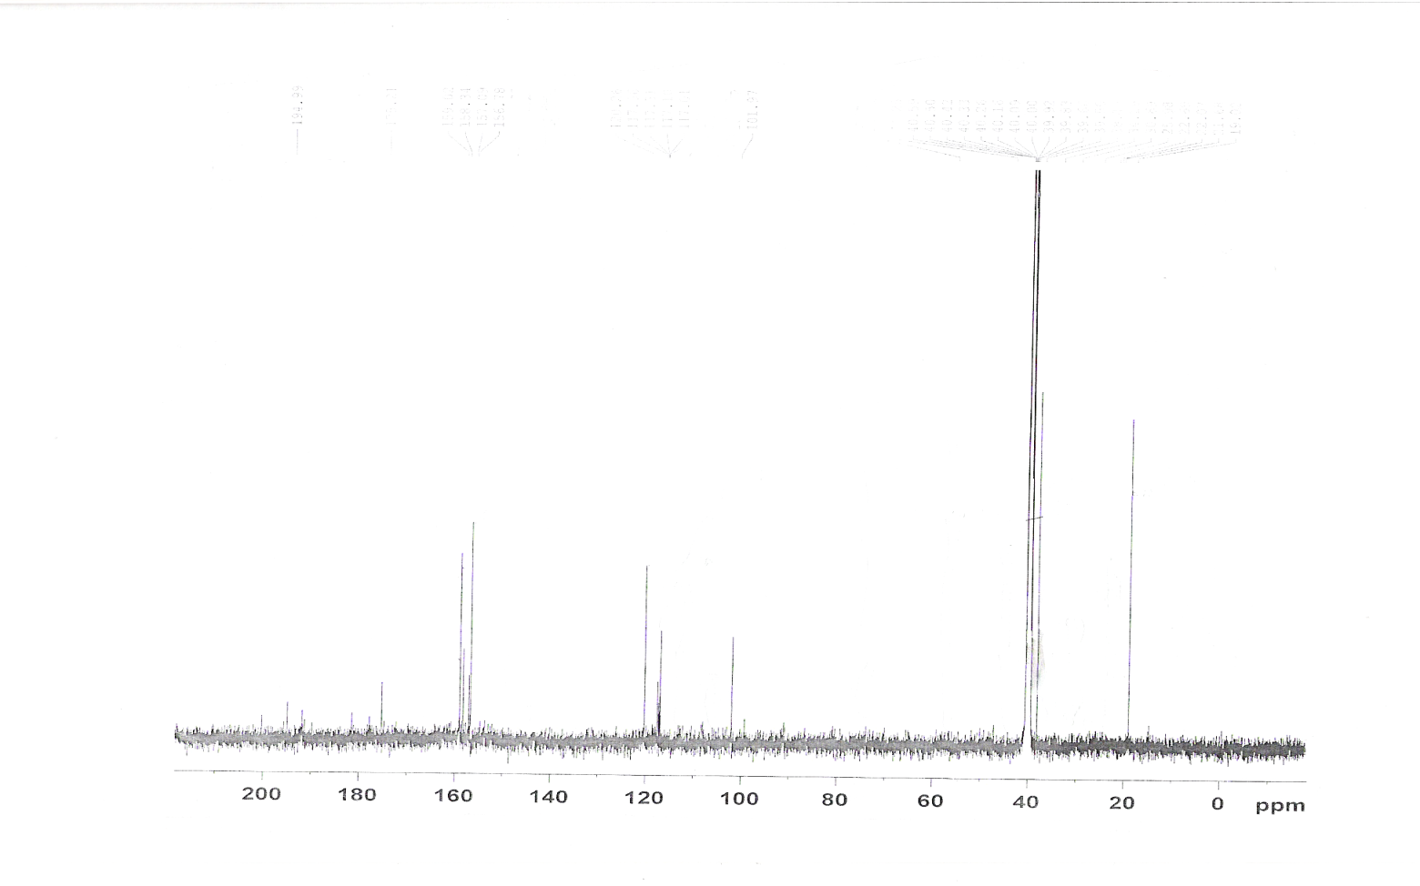
Fig ( 10 ): ¹³C NMR Spectrum of Compound (7)…….Solvent DMSO

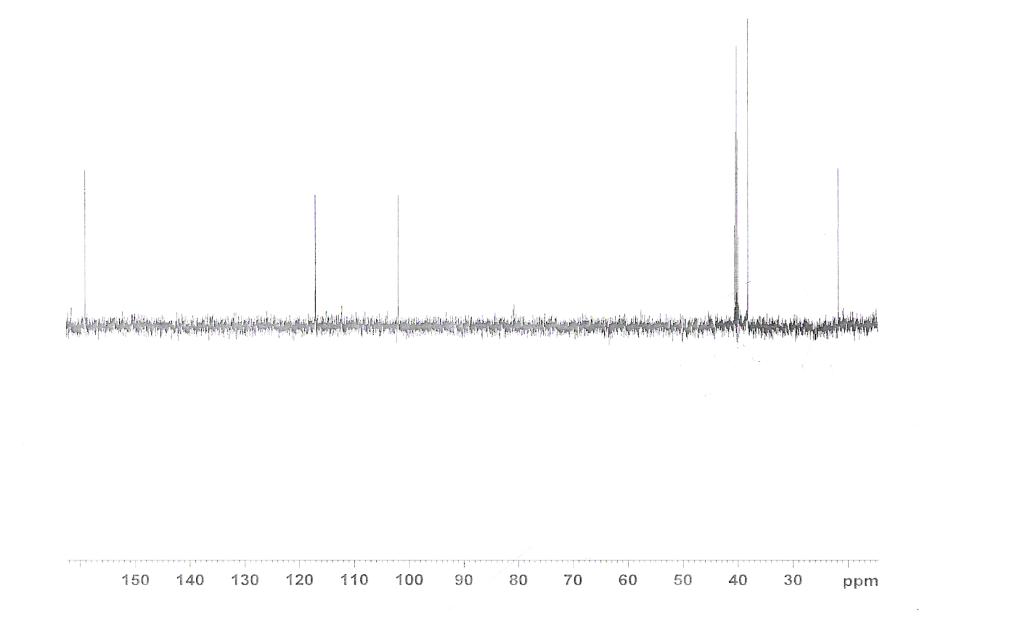
Fig ( 11 ): Dept. 135 ¹³C NMR Spectrum of Compound (7)…….Solvent DMSO

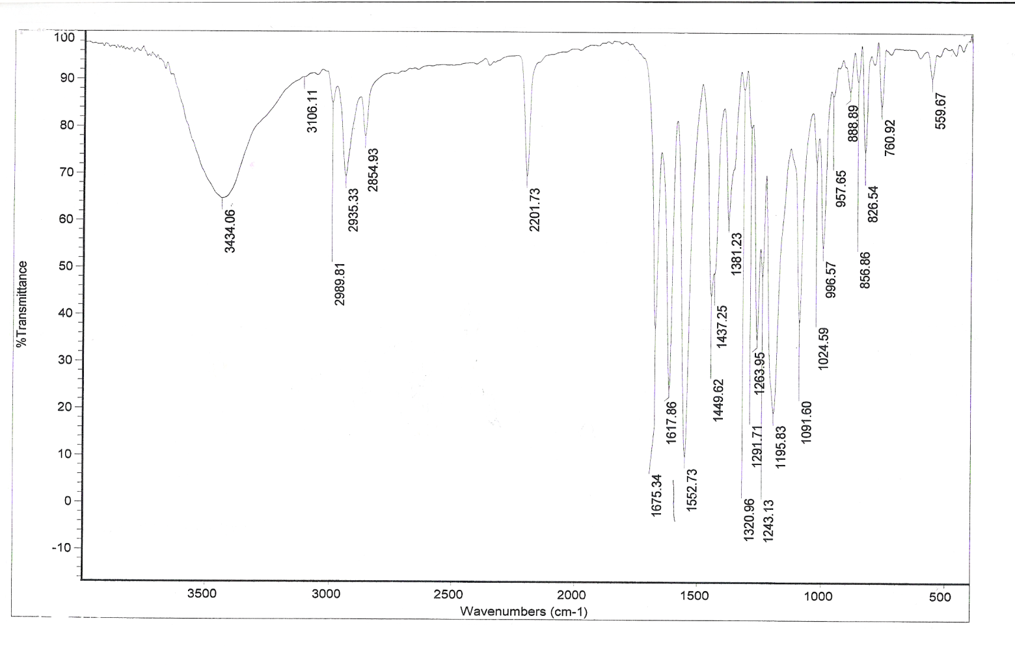
Fig ( 12 ): IR Spectrum of Compound (9)

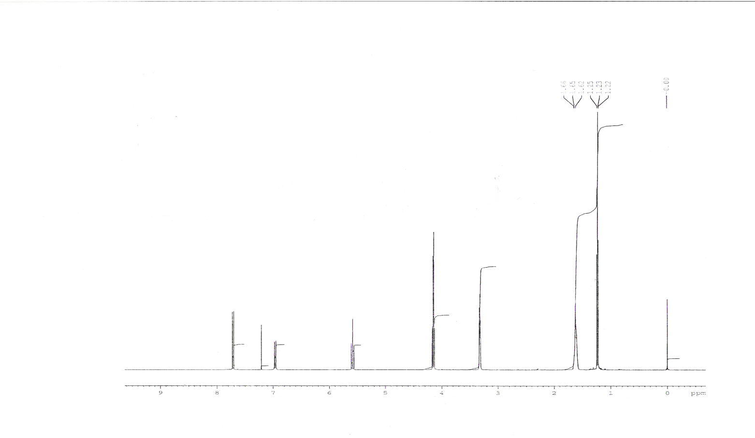
Fig ( 13 ): ¹H NMR Spectrum of Compound (9) ….Solvent CDCl₃

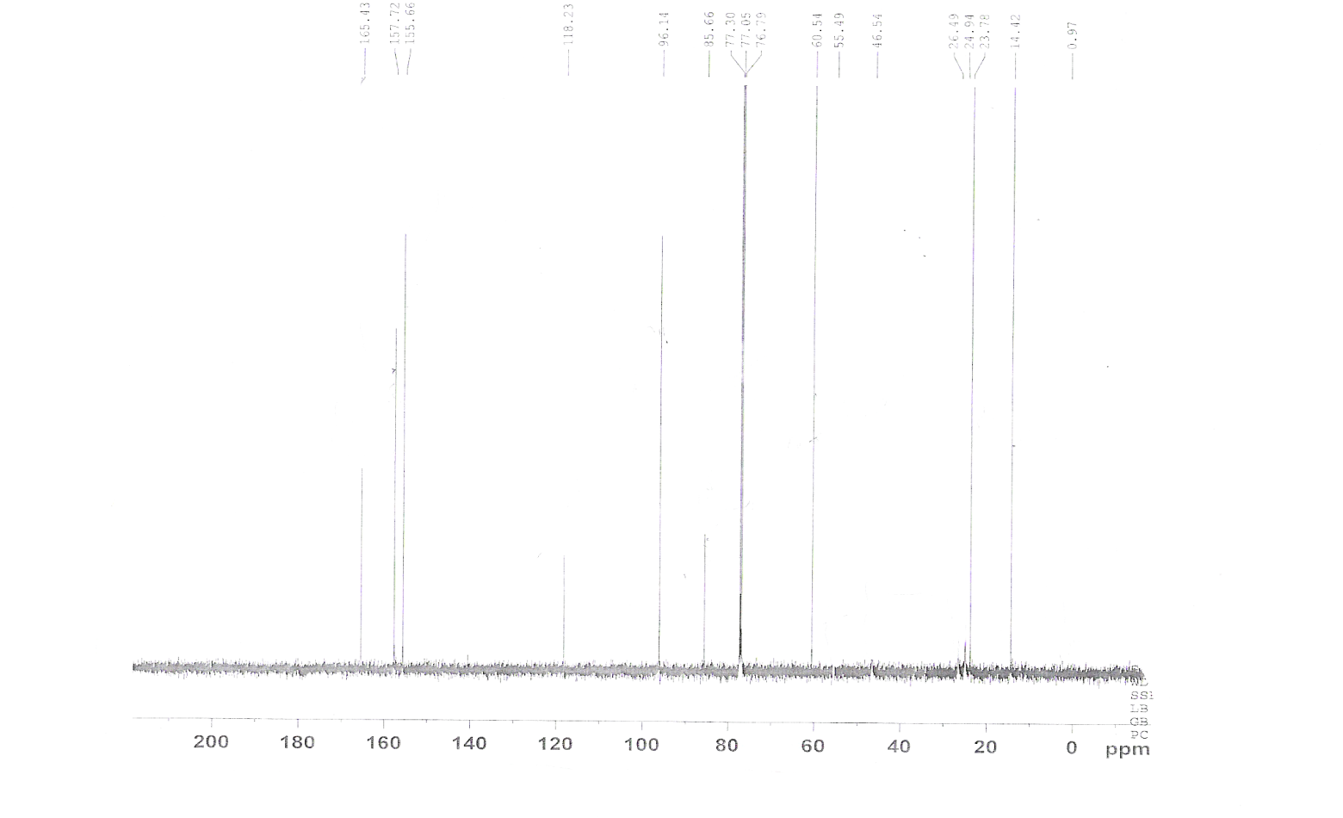
Fig ( 14 ): ¹³C NMR Spectrum of Compound (9)…….Solvent CDCl₃

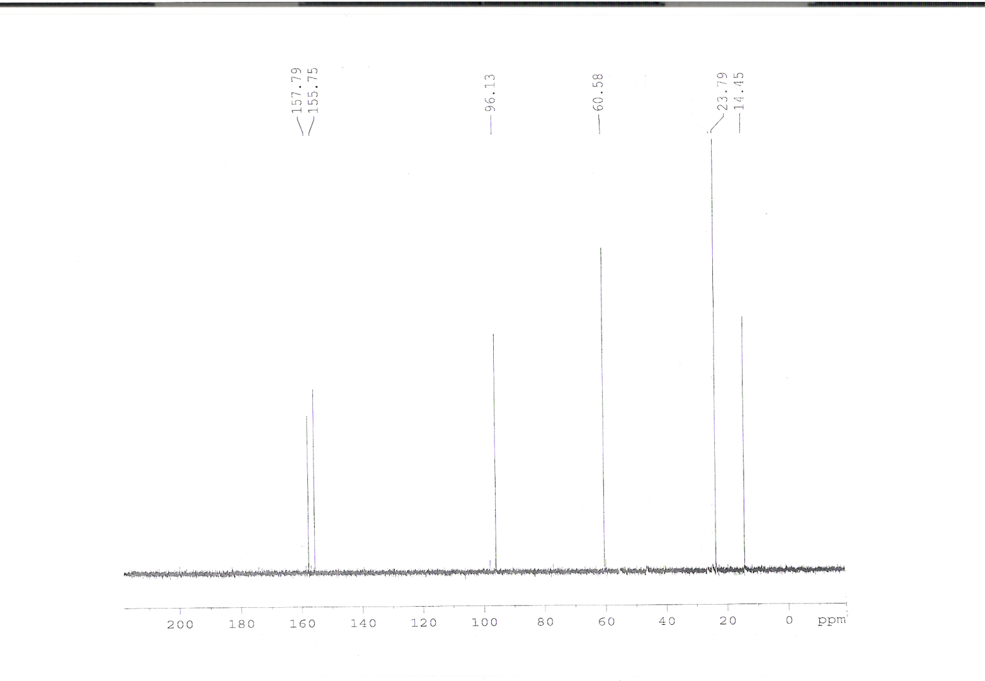
Fig ( 15 ): Dept. 45 ¹³C NMR Spectrum of Compound (9)…….Solvent CDCl₃

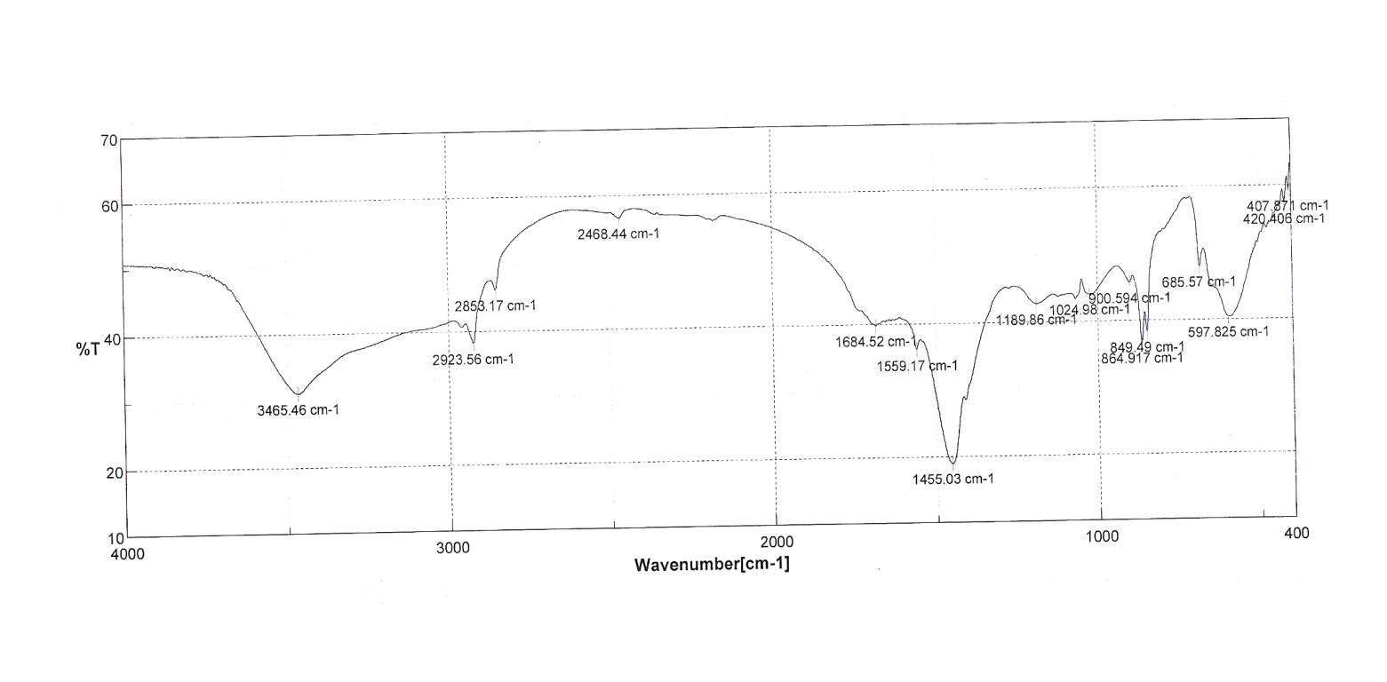
Fig ( 16 ): IR Spectrum of Compound (10)

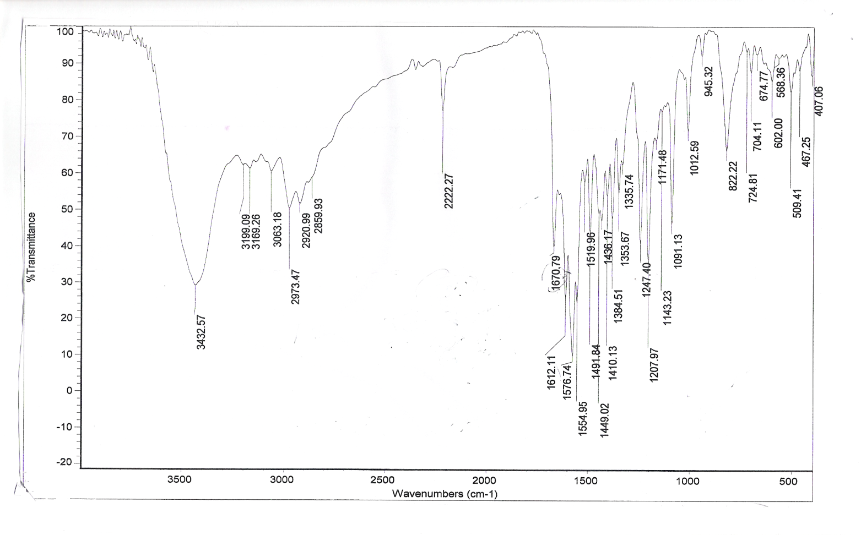
Fig ( 17 ):IR Spectrum of Compound 15

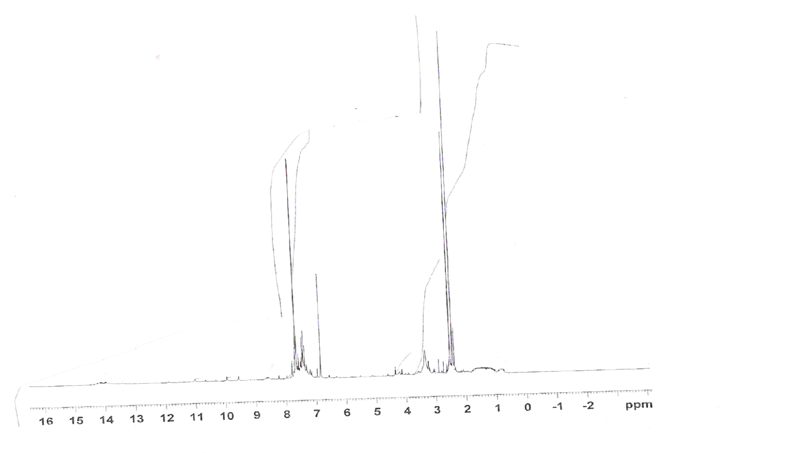
Fig ( 18 ): ¹H NMR Spectrum of Compound 15…….Solvent DMSO

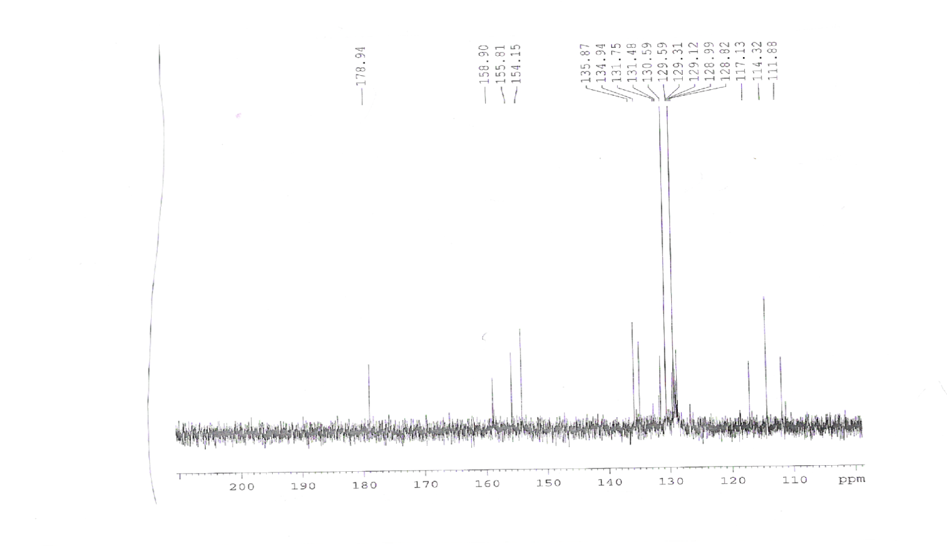
Fig ( 19):¹³C NMR Spectrum of Compound 15…….Solvent DMSO

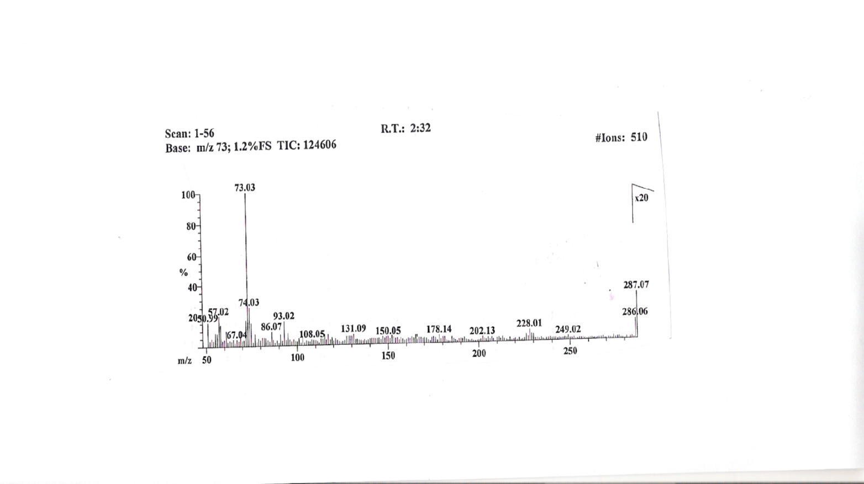
Fig ( 20 ): Mass Spectrum of Compound 17
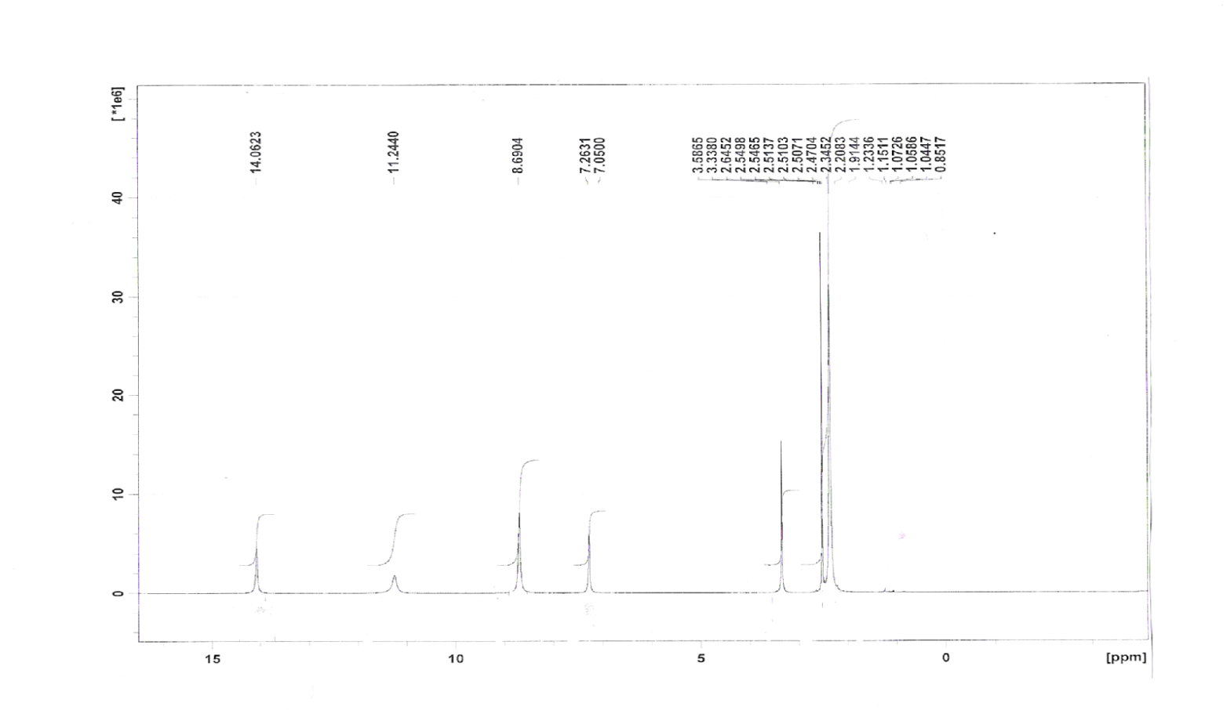
Fig ( 21 ): ¹H NMR Spectrum of Compound 17…….Solvent DMSO
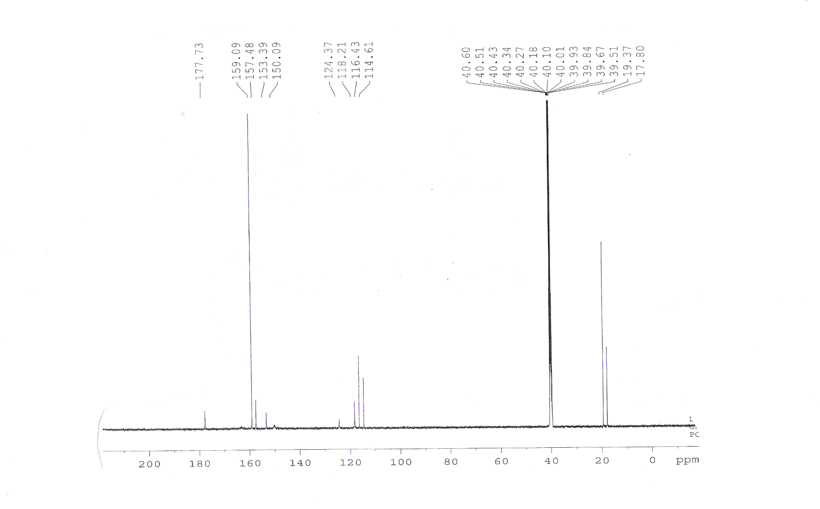
Fig ( 22 ):¹³C NMR Spectrum of Compound 17…….Solvent DMSO

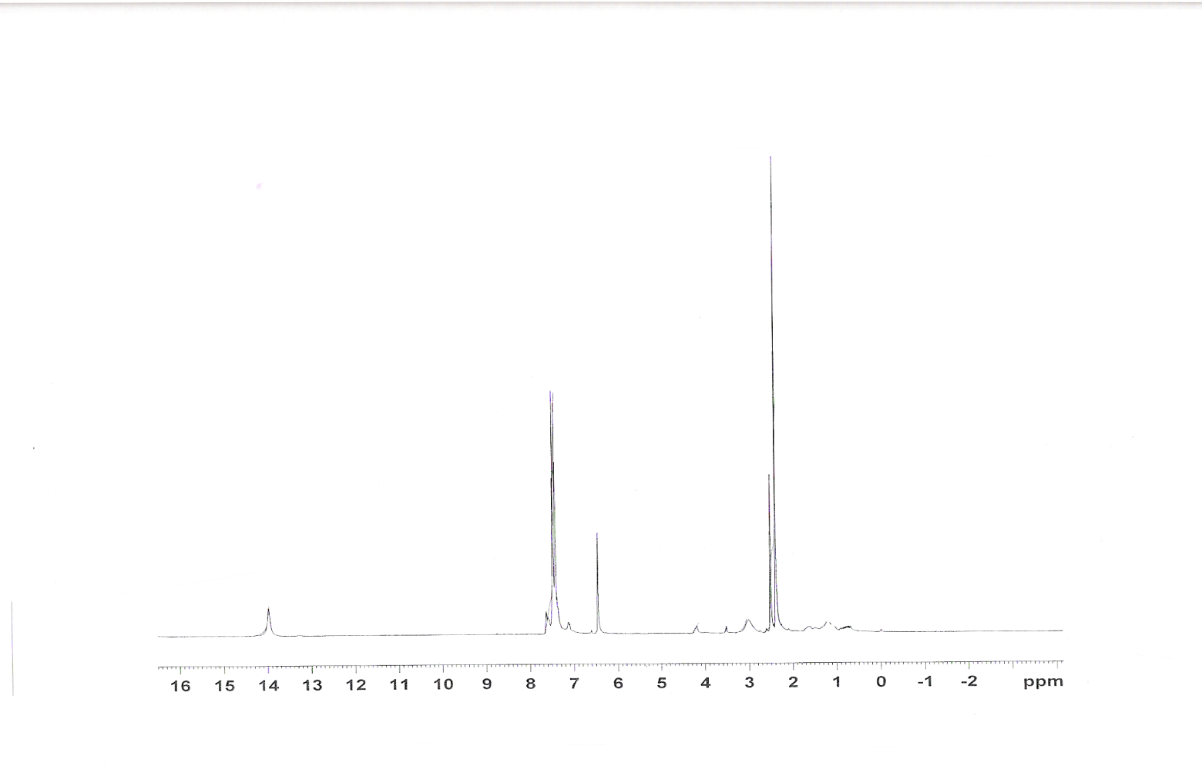
Fig ( 23 ): ¹H NMR Spectrum of Compound 18…….Solvent DMSO

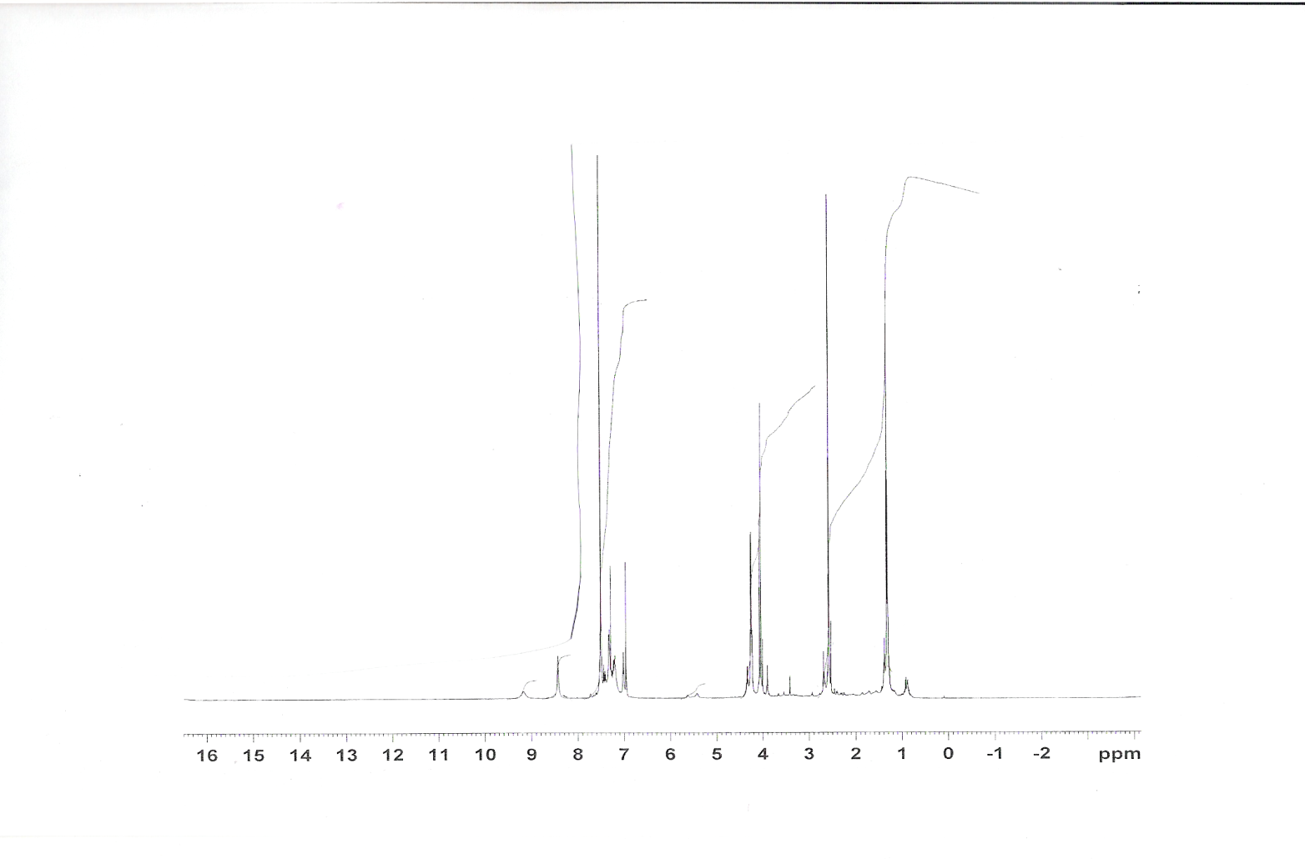
Fig ( 24 ): ¹H NMR Spectrum of Compound (19)…….Solvent CDCl₃

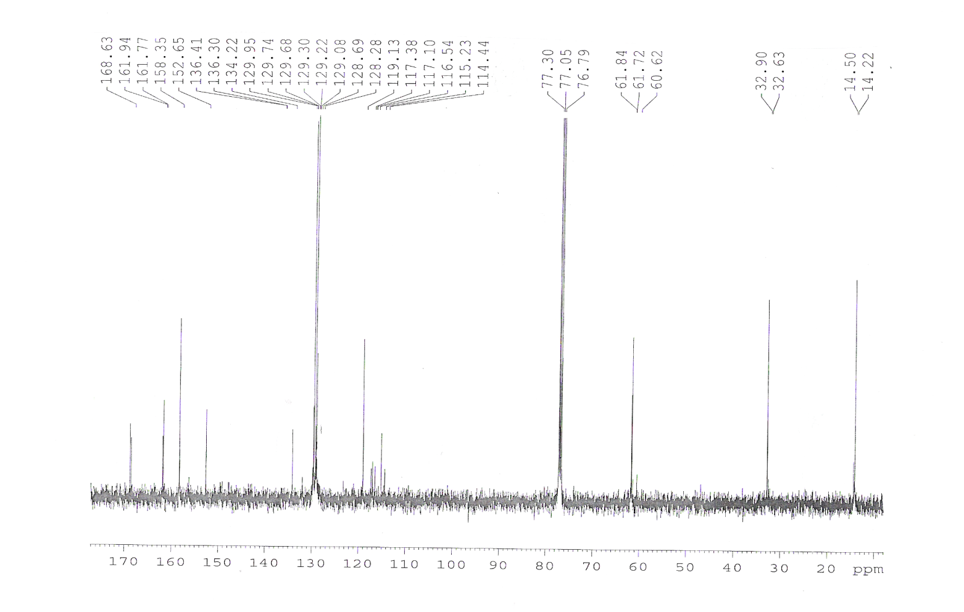
Fig ( 25 ):¹³C NMR Spectrum of Compound (19)…….Solvent CDCL₃

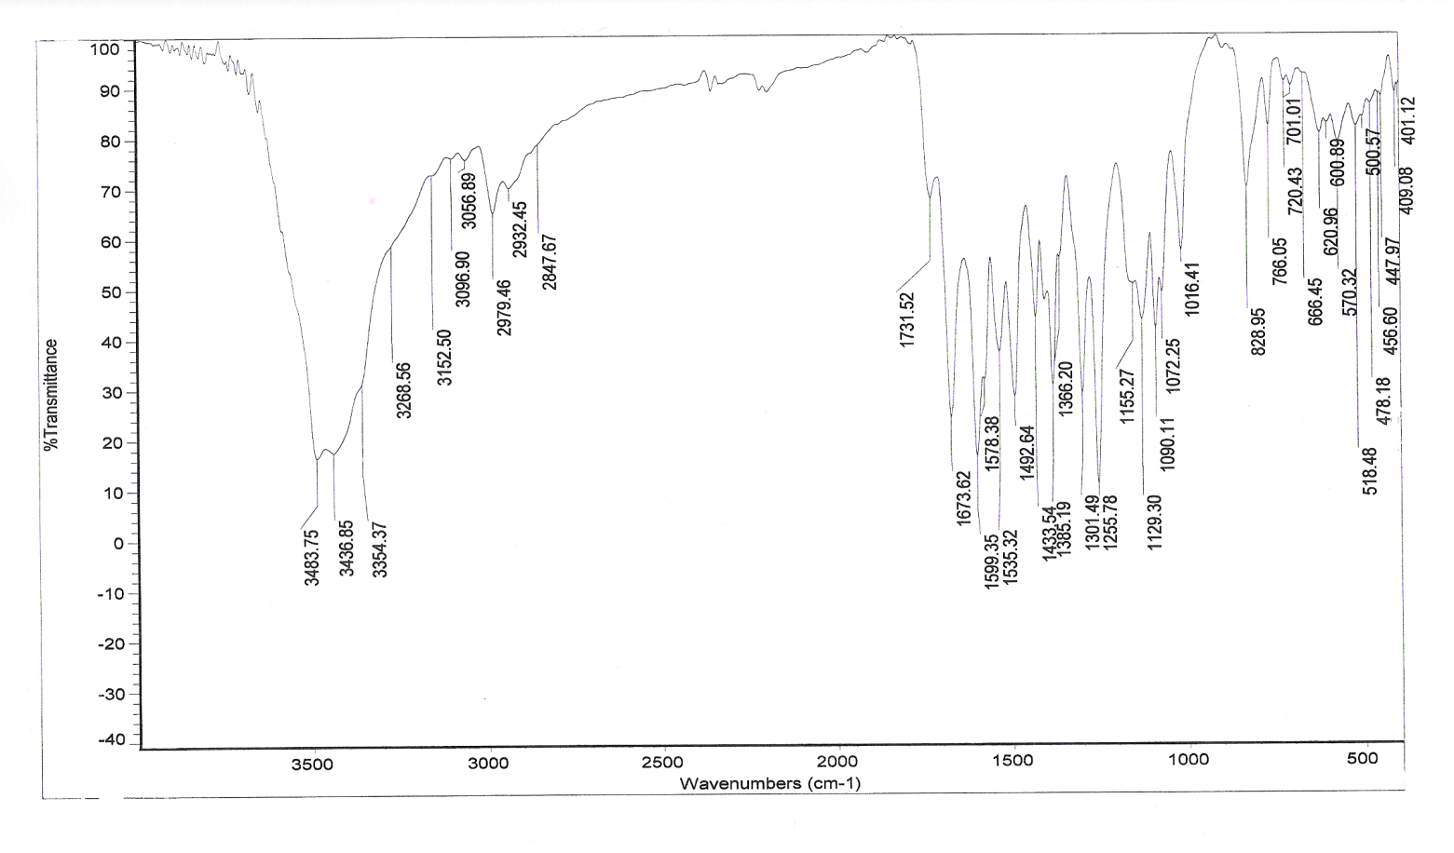
Fig ( 26 ):IR Spectrum of Compound (20)
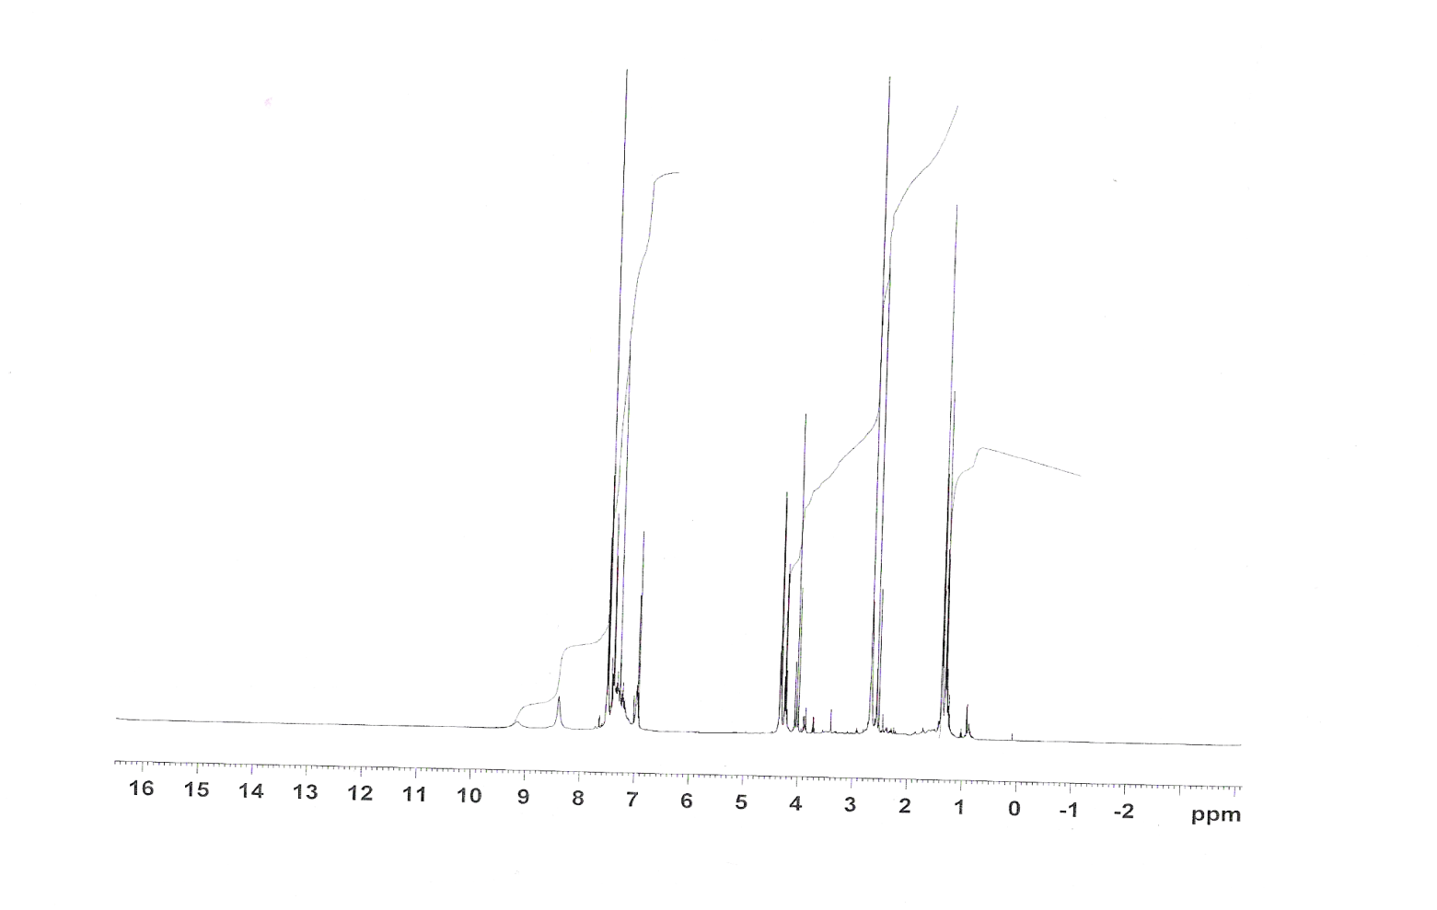
Fig ( 27): ¹H NMR Spectrum of Compound (20)…….Solvent CDCl₃

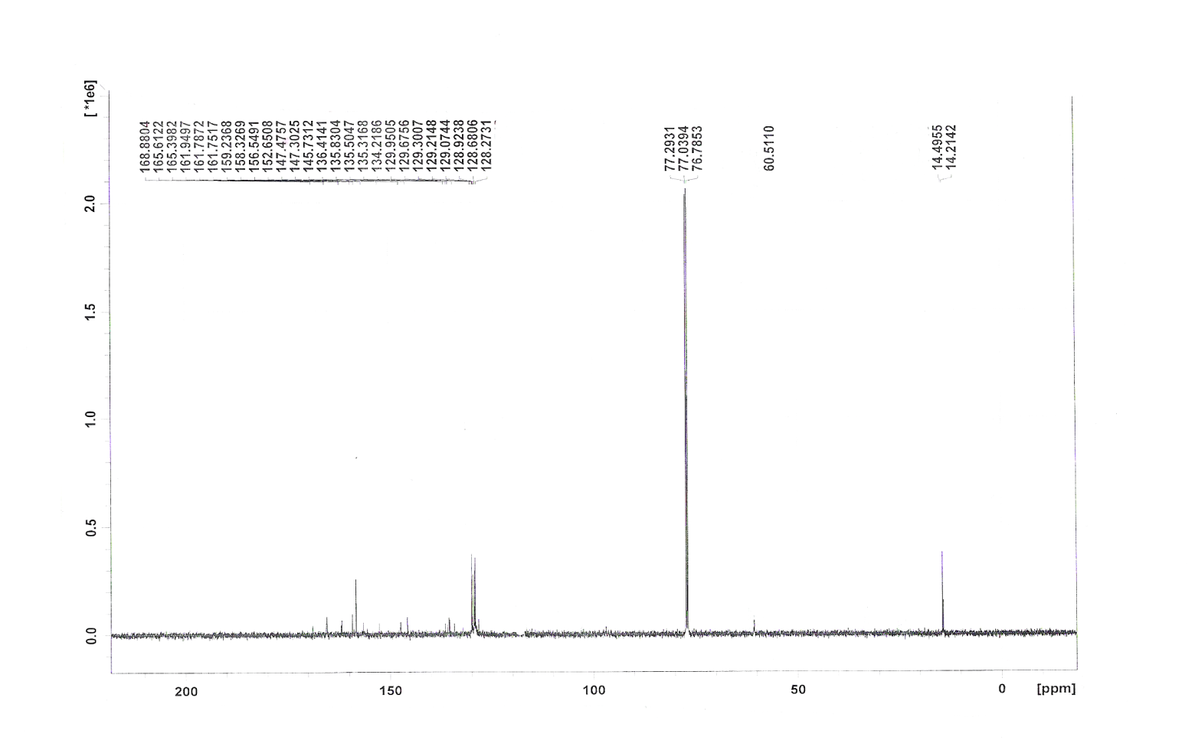
Fig ( 28 ):¹³C NMR Spectrum of Compound (20)…….Solvent CDCl₃
21
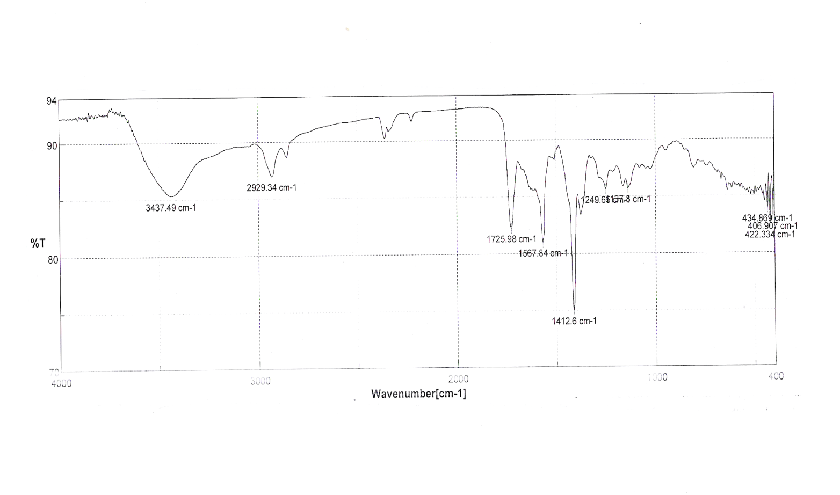
Fig ( 29 ): IR Spectrum of Compound (21)

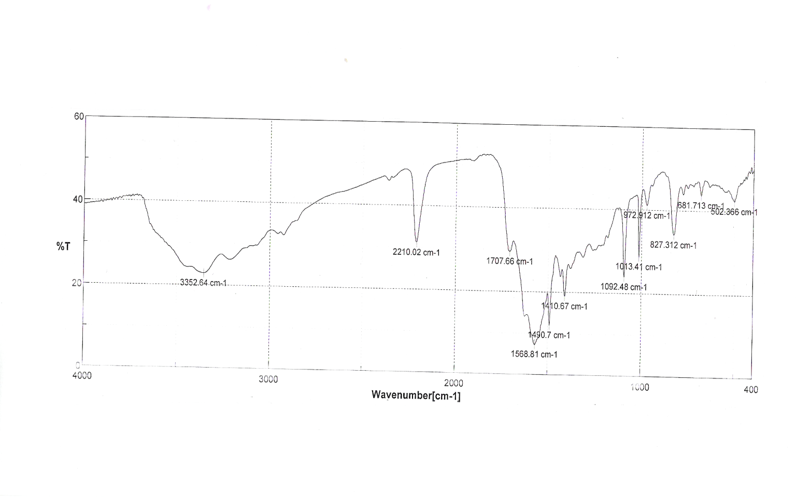
Fig ( 30 ):IR Spectrum of Compound (22a)

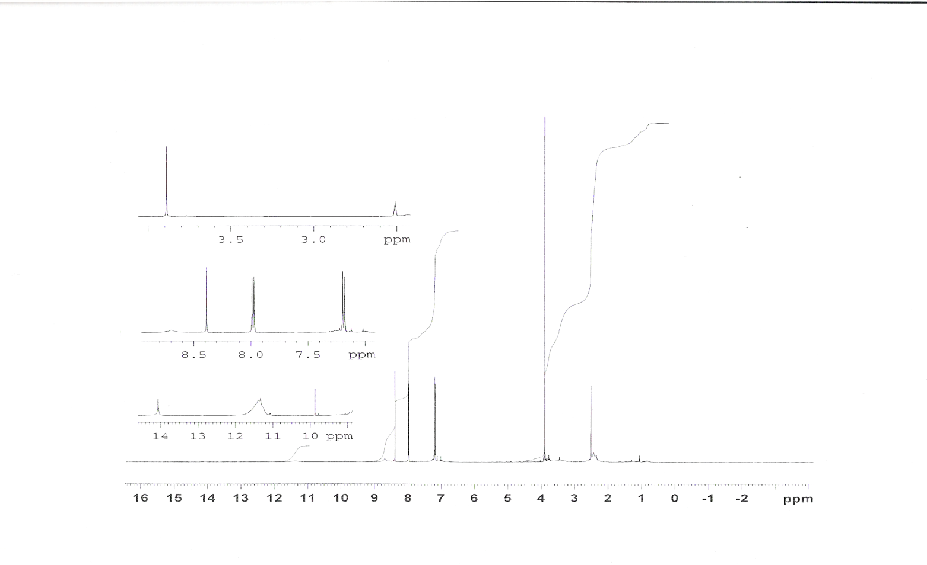
Fig ( 31 ): ¹H NMR Spectrum of Compound (22b)…….Solvent DMSO

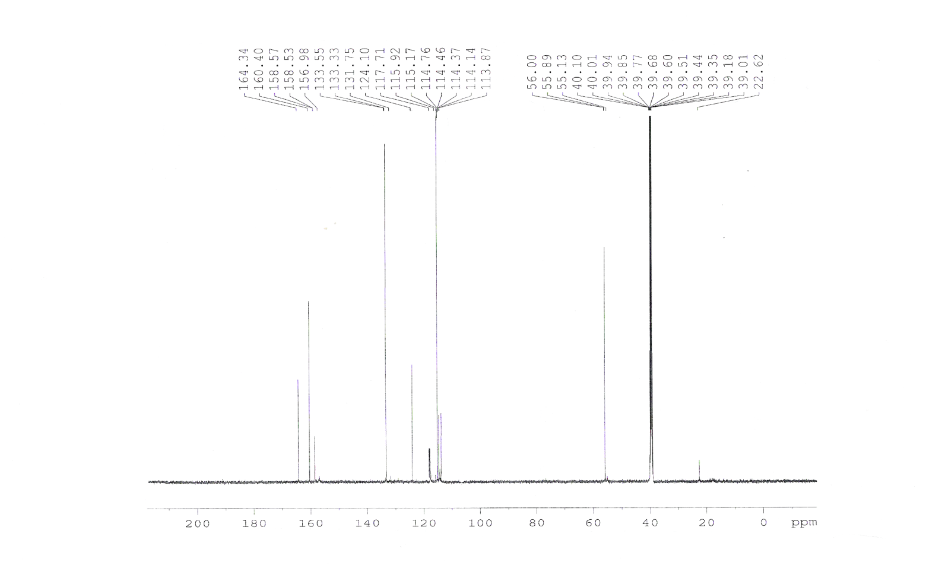
Fig ( 32 ):¹³C NMR Spectrum of Compound (22b)…….Solvent DMSO

