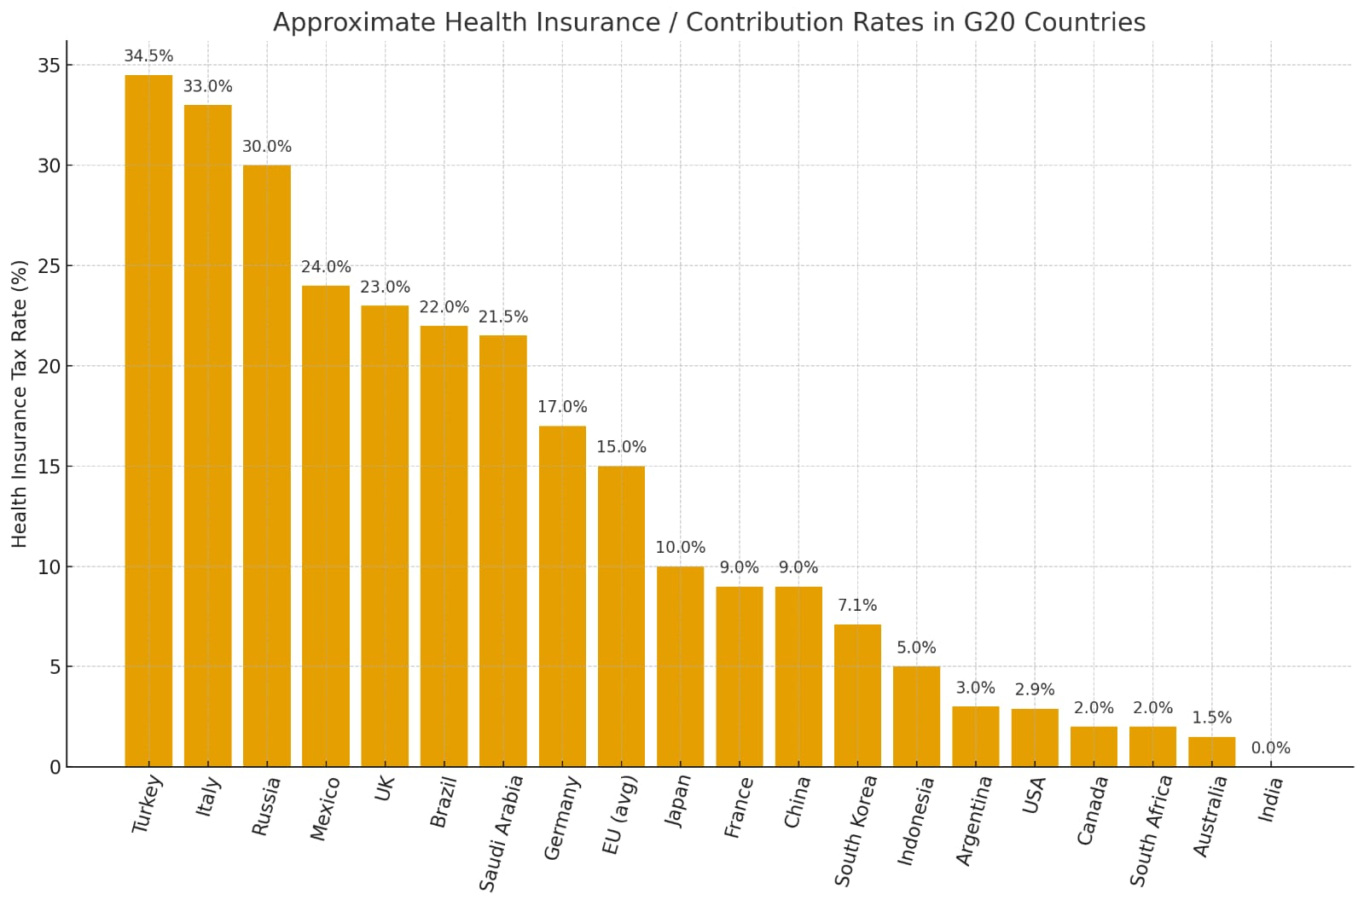
Figure 2: Comparative health insurance contribution rates across the G20 Countries

Figure 2 shows India is positioned at the extreme lower end of the G20 distribution, registering a zero percent statutory contribution rate following the 2025 elimination of Goods and Services Tax (GST) on individual health-insurance premiums.

Benefits of India’s zero-tax position compared with high-contribution G20 countries

1. Lower employment costs.
In countries with high mandatory contributions, such as Turkey, the combined payroll burden can exceed one-third of wages, increasing the cost of formal employment. India’s absence of a health-insurance tax avoids this distortion, keeping labour costs comparatively lower and potentially encouraging firms to expand within the formal sector.

2. Greater affordability for households.
With the removal of GST on health-insurance premiums, Indian families face a reduced financial barrier when purchasing private cover. This makes health insurance more accessible to the middle class and may encourage broader uptake without the need for compulsory deductions.

3. Flexibility in government spending.
Unlike systems where payroll levies are tied exclusively to health, India can allocate general tax revenues across competing priorities such as infrastructure, education, or social protection. This provides greater room to adjust spending in response to emerging national needs.

4. Competitive advantage for investment.
High payroll taxes raise labour costs and can make economies less attractive to investors. India’s zero-tax stance lowers non-wage costs for employers, strengthening its appeal as a base for global manufacturing and service industries.

5. Immediate relief for households.
At a time when costs of living are rising, the elimination of GST reduces the out-of-pocket spending of households on insurance. This leaves families with more disposable income, which may support domestic consumption and provide indirect stimulus to the wider economy.

