Supplementary information for Sea anemone genomes reveal ancestral metazoan chromosomal macrosynteny

- Supplementary Figures
  - Divergence time estimates of cnidarians
  - Size estimates
  - Assembly quality
  - Assembly gene completeness
  - Alignments of candidate N. vectensis pseudo-chromosome assemblies
  - Summary of N. vectensis gene models
  - Locations of ANTP class homoebox complements on the E. muelleri and N. vectensis genome
  - Contact maps of two largest chromosomes of the N. vectensis assembly
  - Cnidarian ancestral linkage groups
  - Bilaterian ancestral linkage groups
  - Metazoan ancestral linkage groups
  - Summary of orthologous groups used in macrosynteny detection and ALG inference
- Supplementary Text
  - Assembly of Nematostella vectensis and Scolanthus callimorphus genomes
  - Chromosomal repeat dynamics in the Edwardsiidae
  - Evolution the homeobox gene clusters in early branching metazoans
  - Ultraconserved Non-coding Elements
  - The SIMRBase Genome Browser
  - Inference of ancestral linkage groups
- Supplementary Tables
  - Summary of repetitive sequence content in the N. vectensis and S. callimorphus genomes reported by RepeatMasker
  - Chromosome-wise abundance and enrichment of repeat families in N. vectensis
  - Chromosome-wise abundance and enrichment of repeat classes in N. vectensis
  - Chromosome-wise abundance and enrichment of repeat families in S. callimorphus
  - Chromosome-wise abundance and enrichment of repeat classes in S. callimorphus
  - Genomic locations of a subset of the ANTP, PRD, SINE, TALE and HNF class homeobox genes in the N. vectensis genome
  - Table of correspondence between N. vectensis cloned complete CDS sequences in the NCBI database and NV2 models
  - Ultraconserved Noncoding Elements in the N. vectensis genome

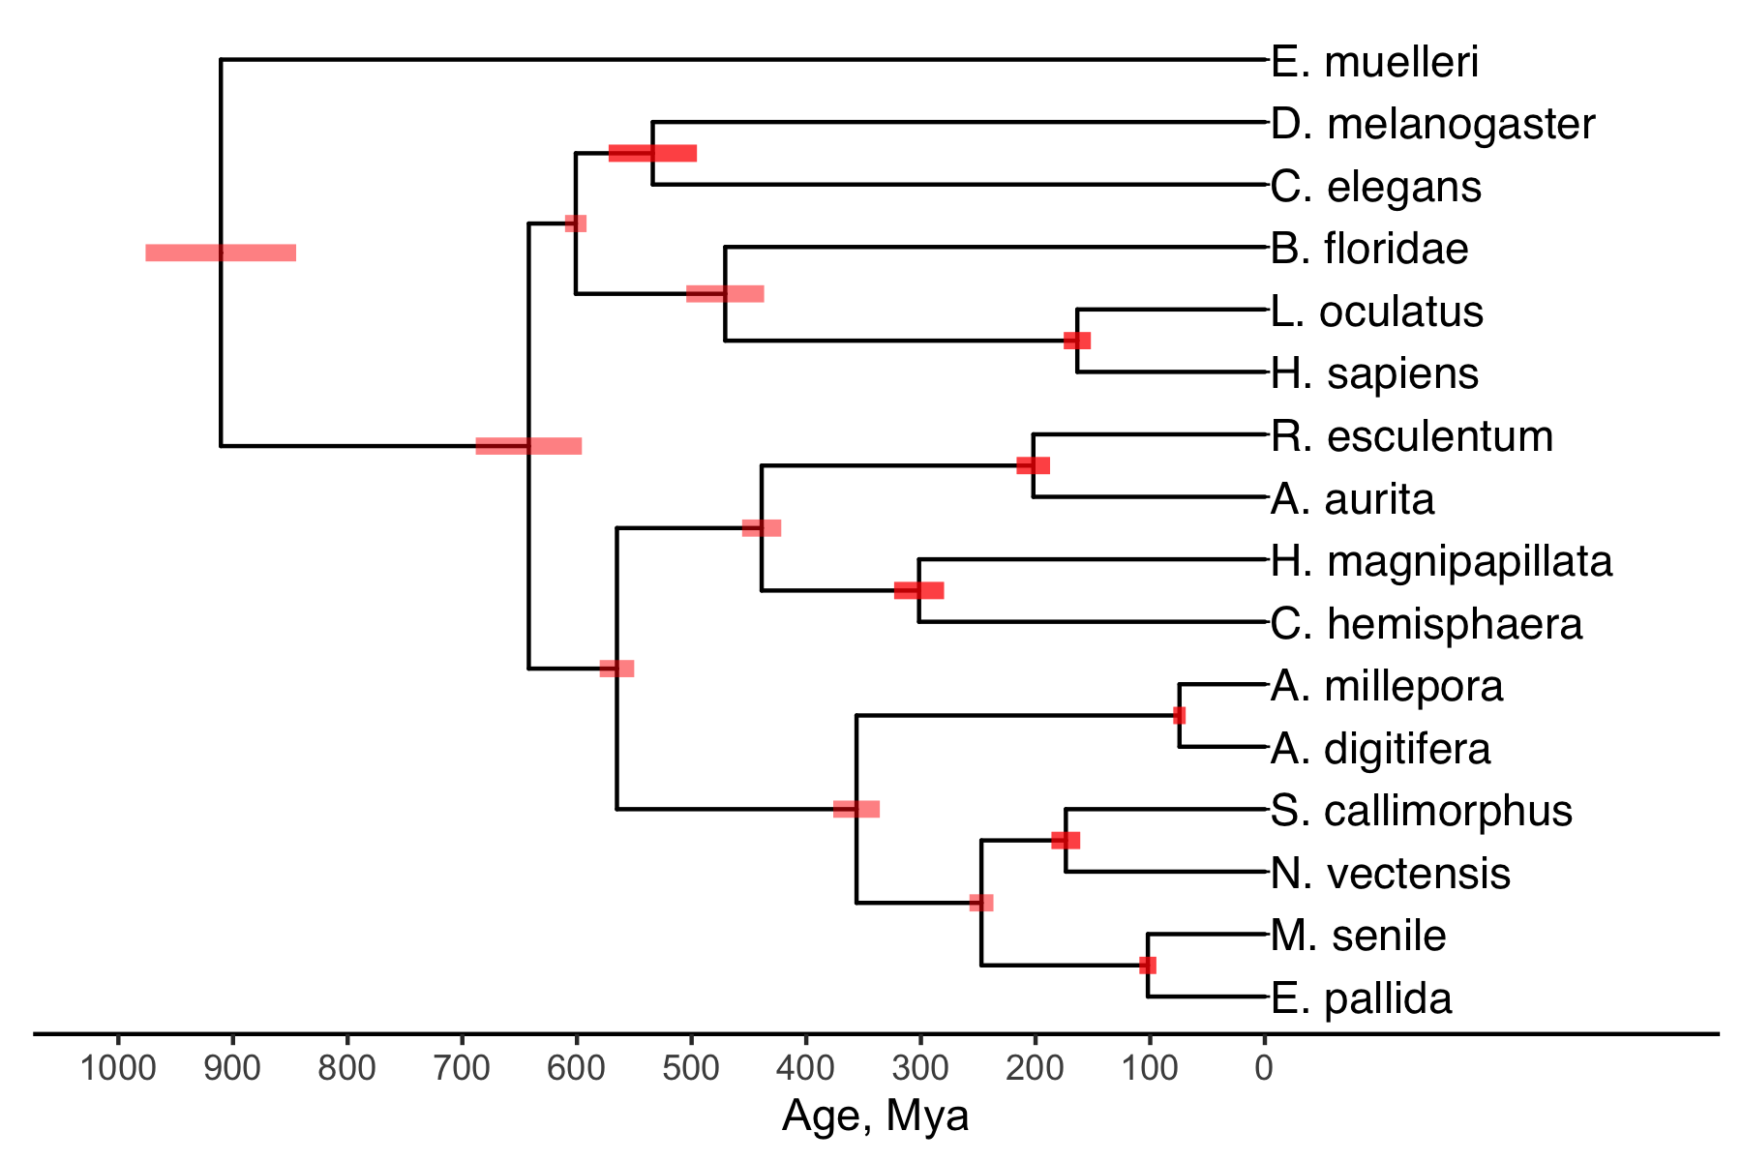
Extended Data Figure 1. Divergence time estimates of cnidarians, calibrated by an estimate of the cnidarian-bilaterian split between 595.7 and 688.3 Mya¹.

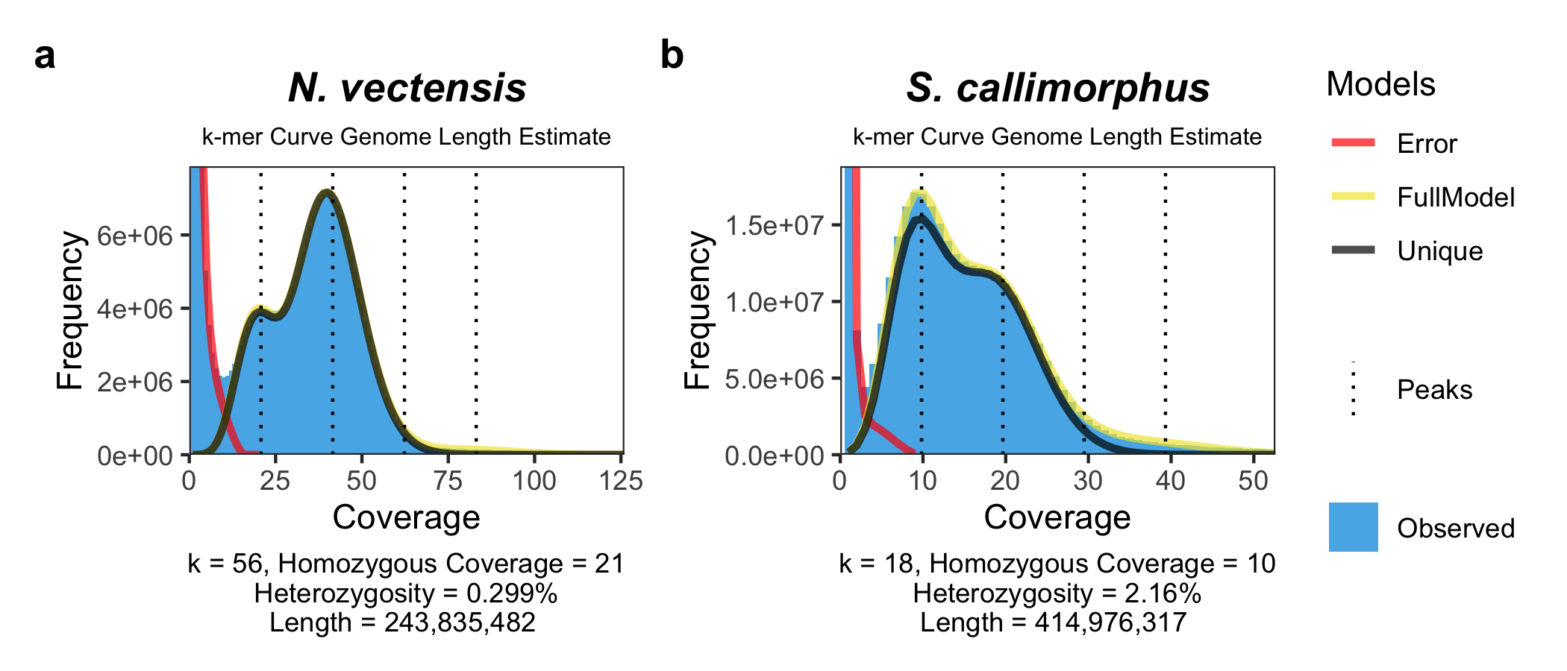
Extended Data Figure 2. k-mer curve genome size and heterozygosity estimates of short read data from N. vectensis and S. callimorphus.
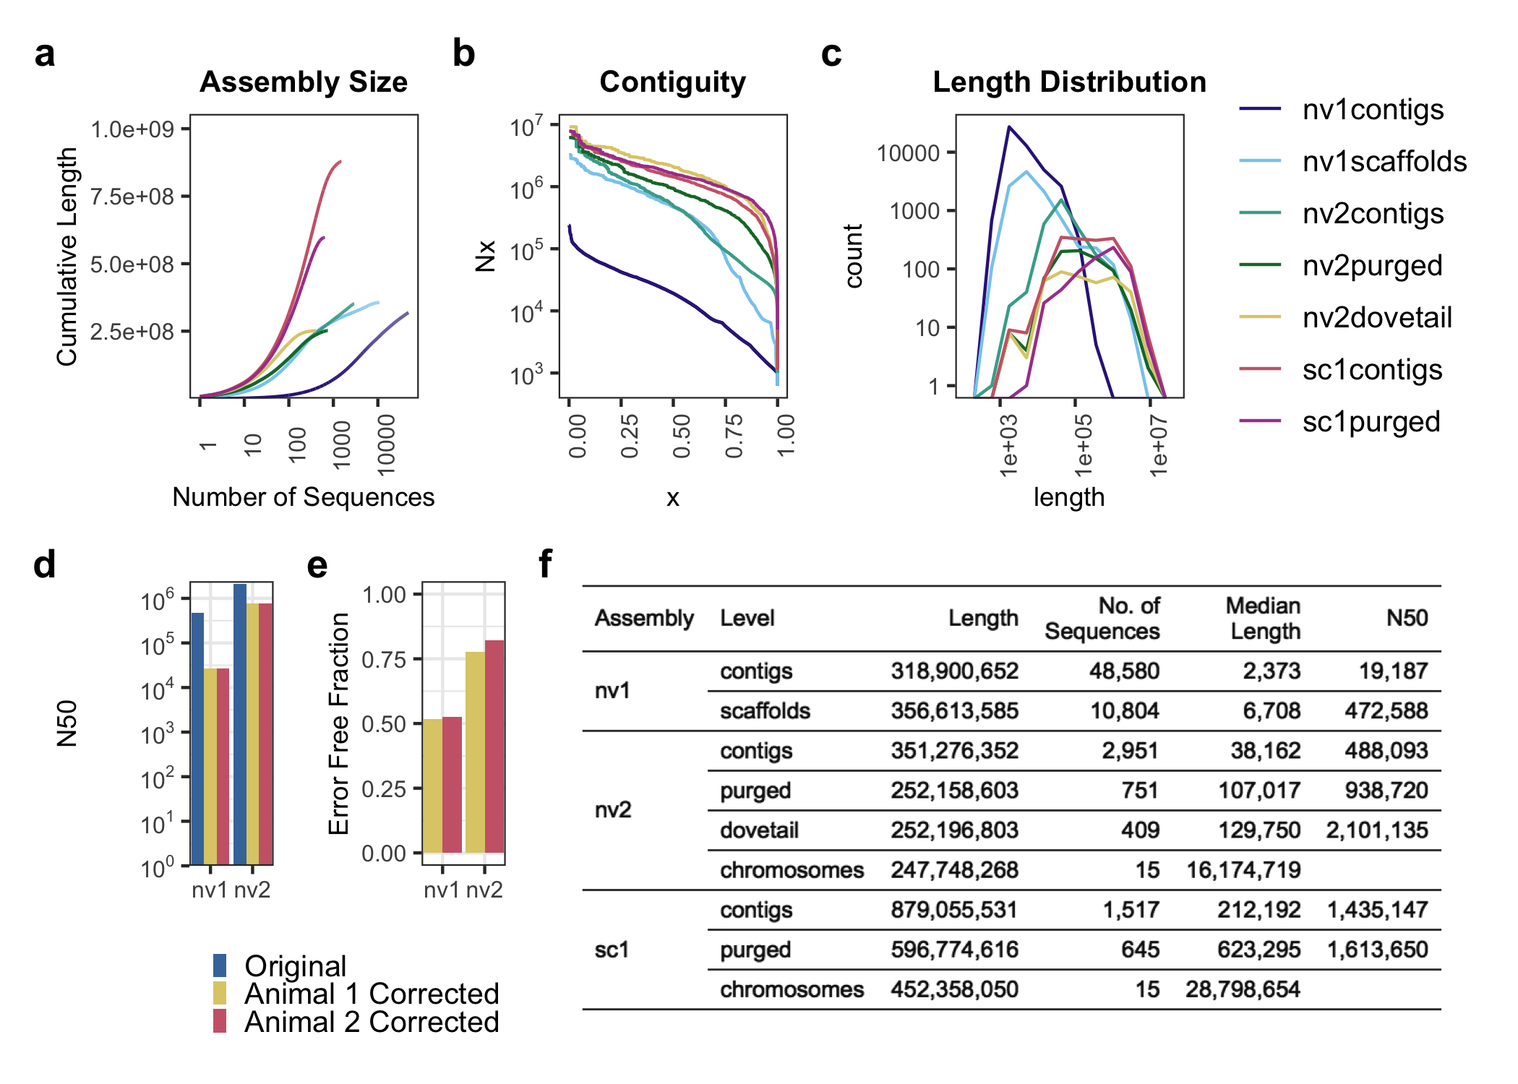
Extended data figure 3. Quality assessment of the previous Nematostella vectensis assembly (nv1) ², the assembly presented in this paper (nv2) and Scolanthus callimorphus (sc1) genomes at different assembly levels. Contigs refer to sequences which have been contiguously assembled by read overlap. “Purged” assemblies have been filtered against redundant contigs appearing due to heterozygosity (see Materials and Methods). Scaffolds and “dovetail” are collections of contigs which have been ordered by evidence from BAC ends (scaffolds) or in vitro proximity ligation (“dovetail”) and “chromosomes” are collections of contigs (sc) or dovetail scaffolds (nv) ordered by in vivo proximity ligation. a) Assembly size characterized by the cumulative length as a function of number of sequences b) Nx contiguity c) sequence unit (contig, scaffold or dovetail scaffold) length distribution. d,e) Assembly fidelity of the nv1 and nv2 assemblies with respect to intra-scaffold and intra-contig assembly correctness, assessed by the sequenced paired-end reads of 2 individuals and analyzed using the REAPR pipeline. d) N. vectensis assembly N50 after stringent breaking of dovetail scaffolds. A smaller reduction from the “original” N50 indicates a better assembly. e) The estimated error-free fraction, in terms of sequence fidelity and contiguity, of the original nv1 and nv2 genomes. f) Summary statistics of the nv1, nv2 and sc1 genomes at all levels. Lengths at the “chromosome” level indicate the total length of the 15 pseudo-chromosomes including a 100 base gap at each of the scaffold junctions.
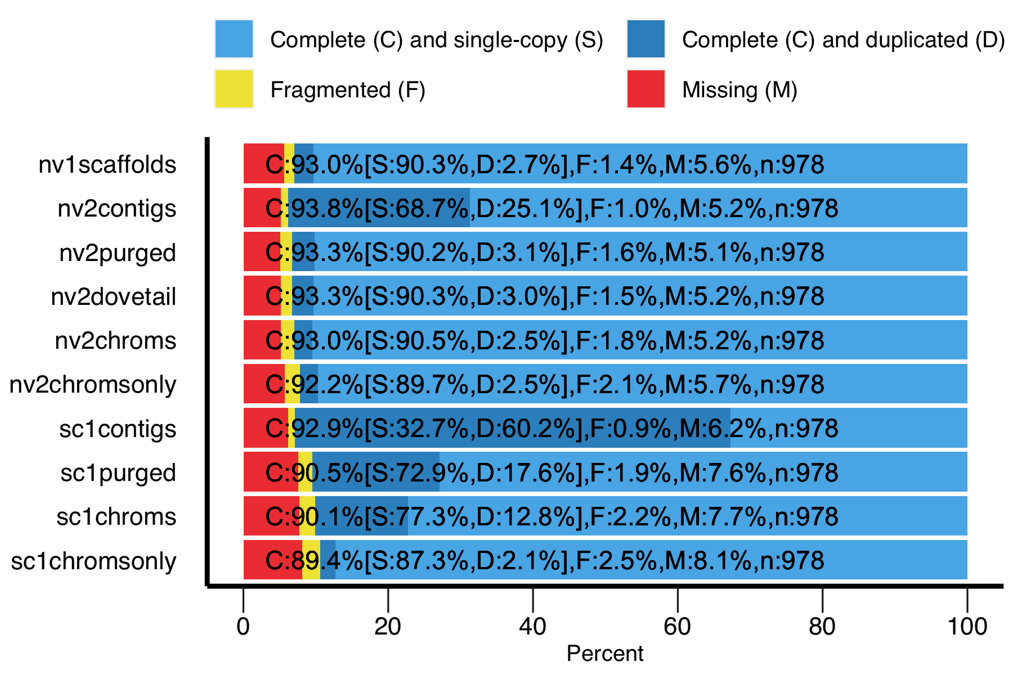
Extended data figure 4. Estimates of assembly completeness and redundancy by proxy of conserved pan-metazoan single-copy genes (“BUSCOs”). “chromsonly” assemblies exclude unplaced dovetail scaffolds (nv) or contigs (sc) and only include the respective 15 chromosomes.

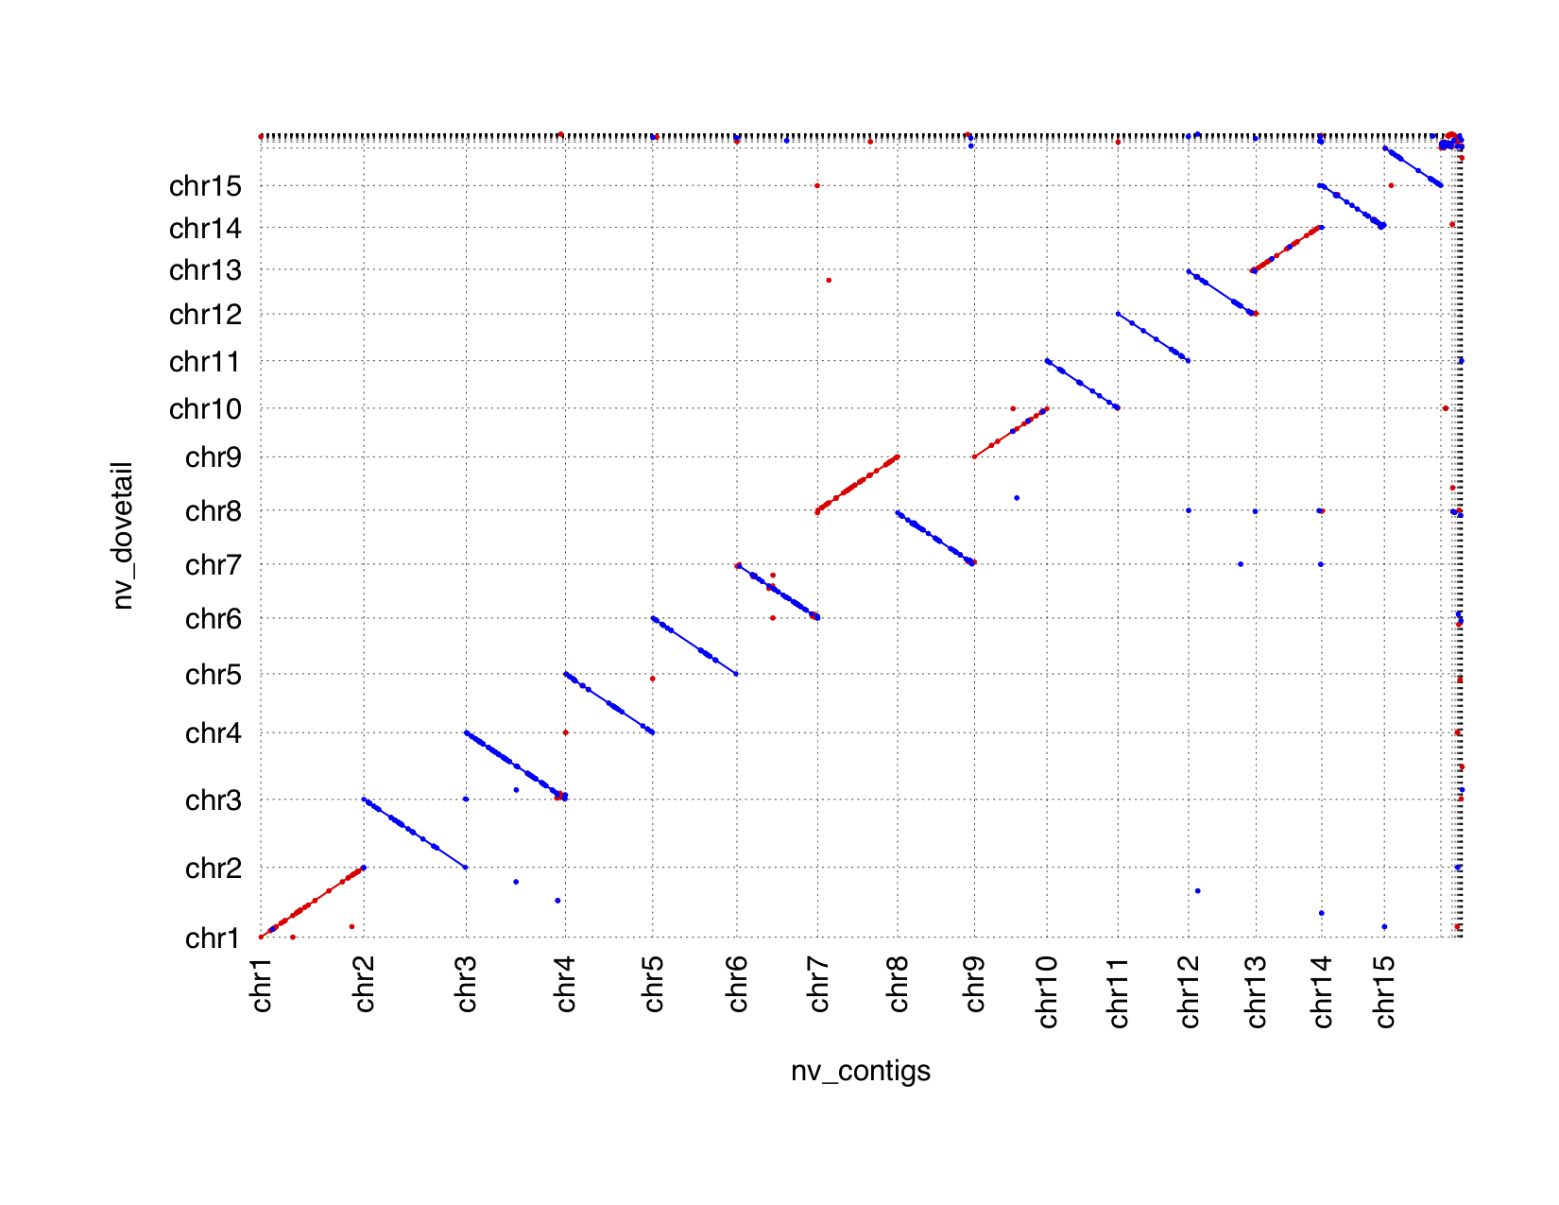Extended Data Figure 5. Genome-genome alignment of two N. vectensis chromosome level assemblies. Red represents forward alignments and blue represents reverse alignments. The assembly on the x-axis was generated using the contigs after purging haplotigs as a starting point, and the assembly on the y-axis using the Dovetail-scaffolded contigs as a starting point. Chromosomes are labeled and unplaced contigs or scaffolds are placed after chr15. Both were independently and blindly subjected to manual review.
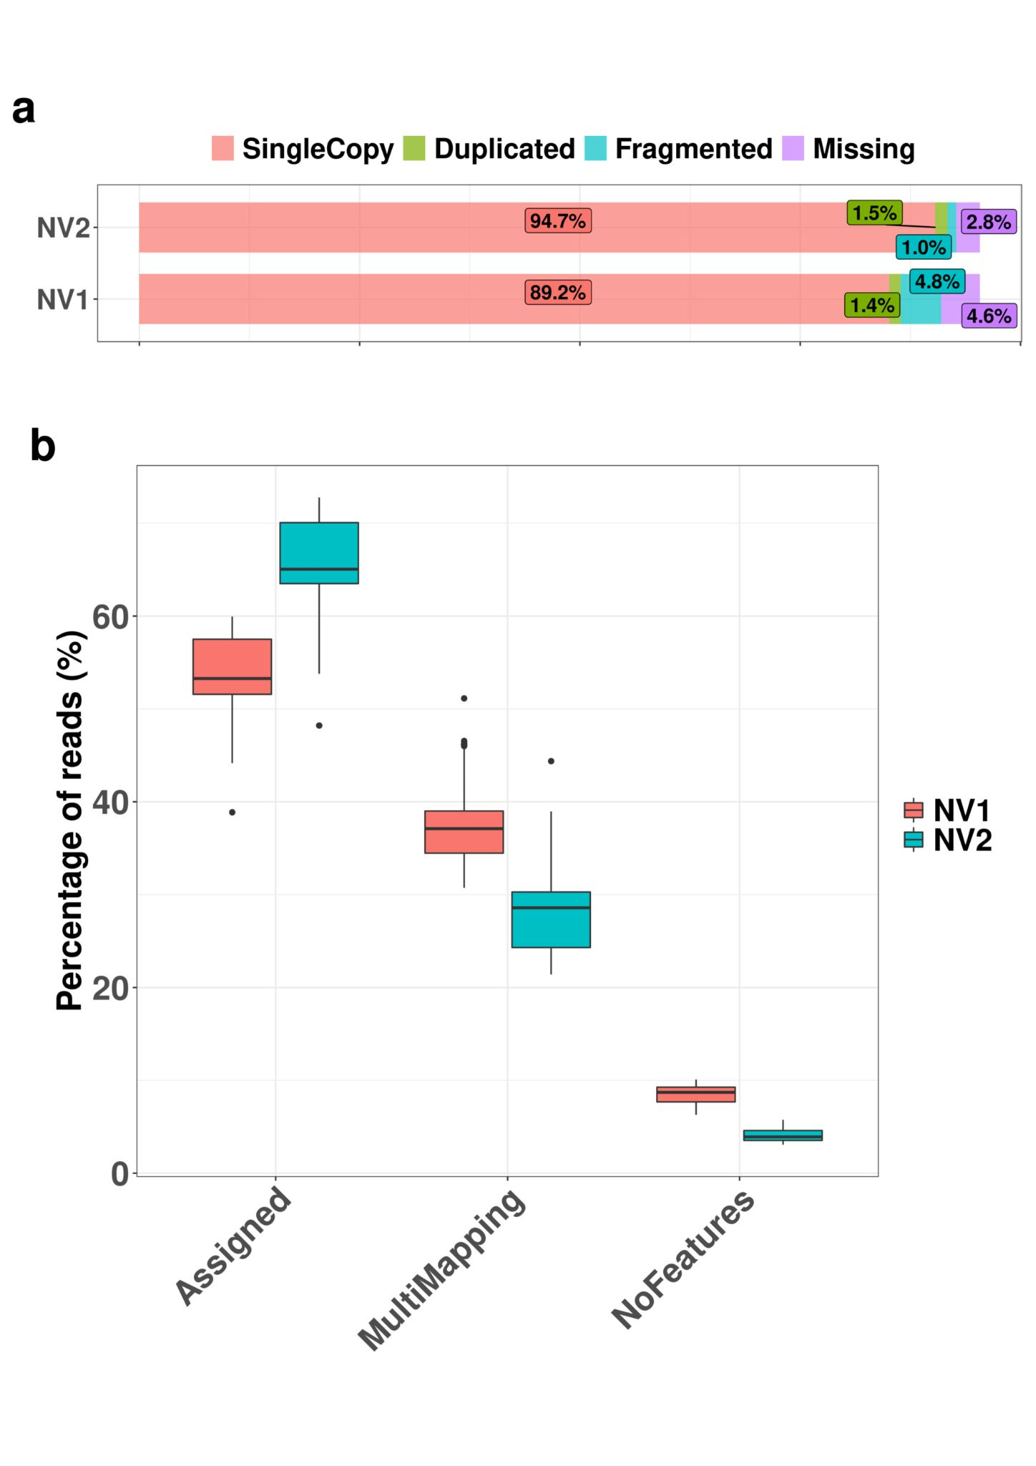
Extended Data Figure 6. Comparison of NVE and NV2 gene models; a) Busco completeness using the Metazoan ODB10 database shows an increase of 5% in full single copy orthologs and a reduction of missing a fragmented orthologs in the NV2 annotation; b) Percentage of RNA-seq reads unequivocally assigned to a single gene model (Assigned), to multiple gene models (MultiMapping) and to intergenic regions (NoFeatures) in NVE and NV2 models. On average, 10% more reads are made available for downstream analysis in NV2 compared to NVE annotation (Assigned), mostly from a drop in the number of duplicated genes in the older NVE models.

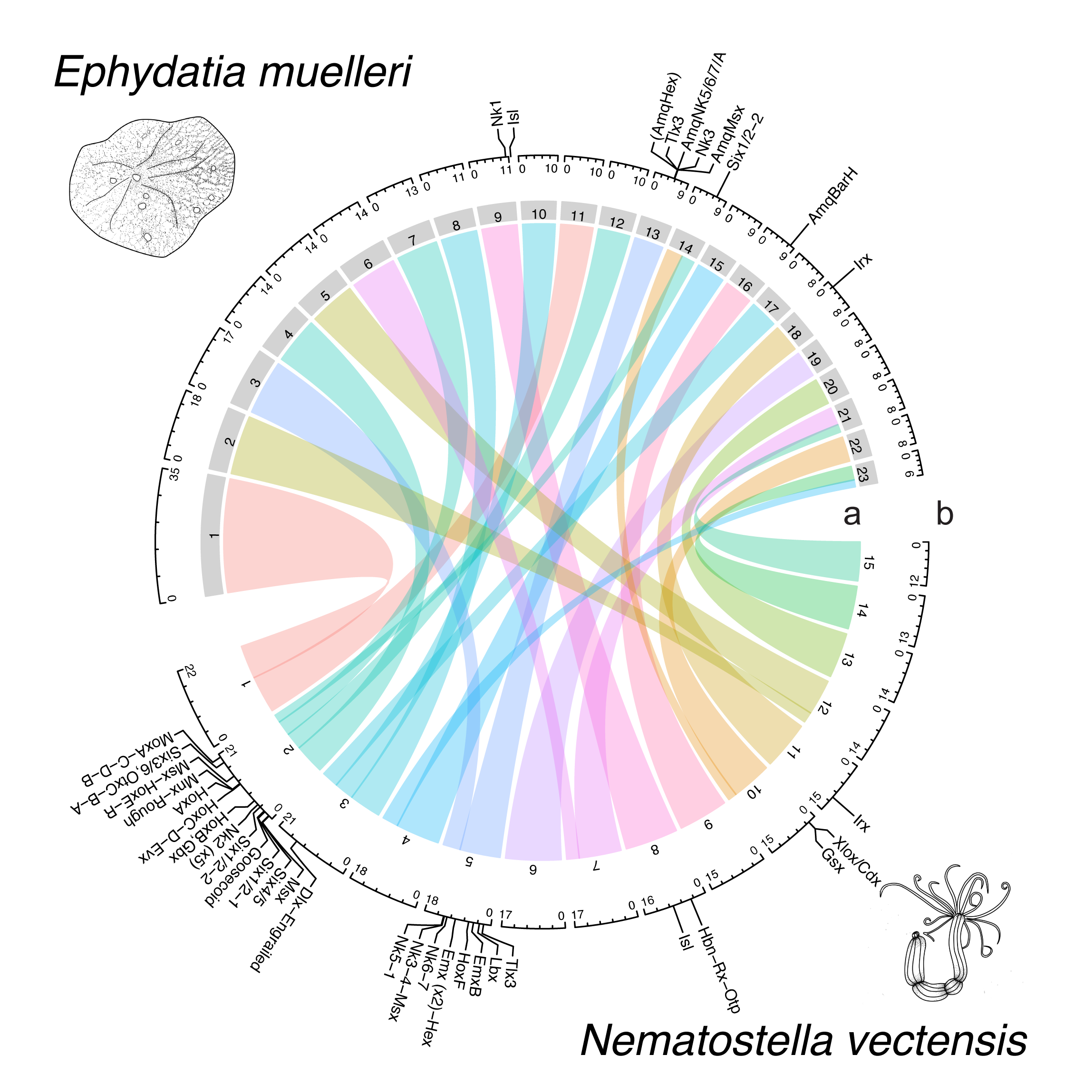
Extended data figure 7. Locations of Hox genes and relationships of N. vectensis, and Ephydatia muelleri chromosomes. a) Chord diagram of macrosyntenic relationships of chromosomes. b) Locations of NK and extended Hox cluster genes on the genomes.

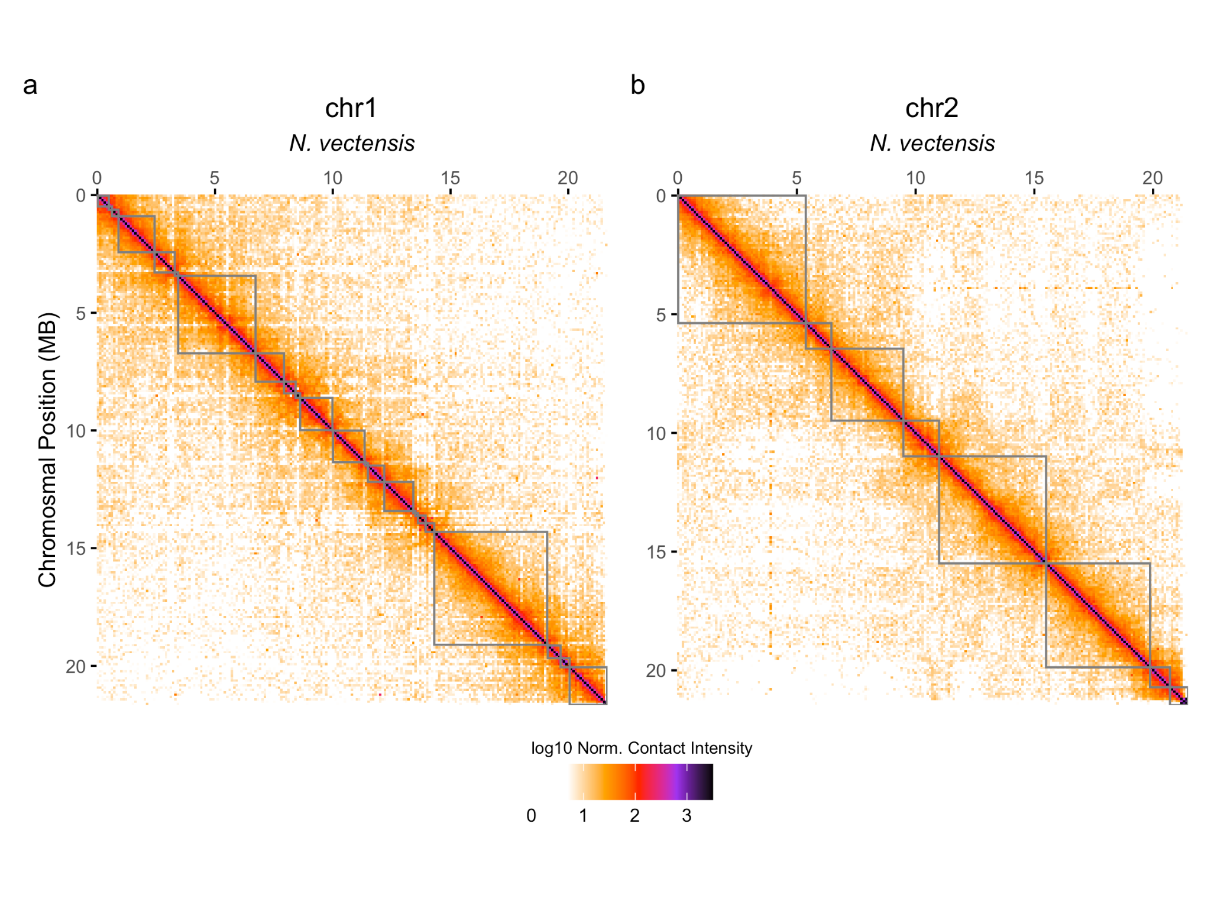
Extended Data Figure 8. Chromosome-level Hi-C contact maps. Contact maps for the two largest chromosomes of the Nematostella assembly. Each point represents a binned, normalized intensity of chromosomal contact as measured by the number of ligated fragments sequenced. Grey boxes represent dovetail scaffolds.
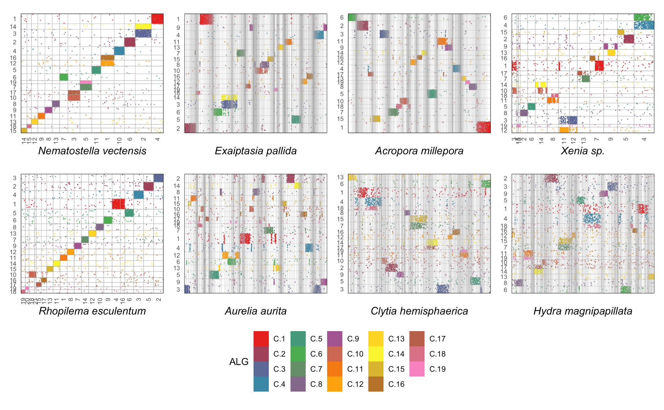
Extended data figure 9. Dot plots representing positions of genes from ancestral cnidarian linkage groups (ALGs) in extant chromosomes. The y-axis represents the 19 ALGs from the cnidarian lineage and dots are redundantly colored for clarity. The x-axis represents the extant genome. In the case of the genomes assembled only at the scaffold level, no chromosomes are represented on the x-axis. Scaffold order in the dot plots is determined using hierarchical clustering of the ALG-wise scaled matrix of genes shared between the extant genome and the ALG.

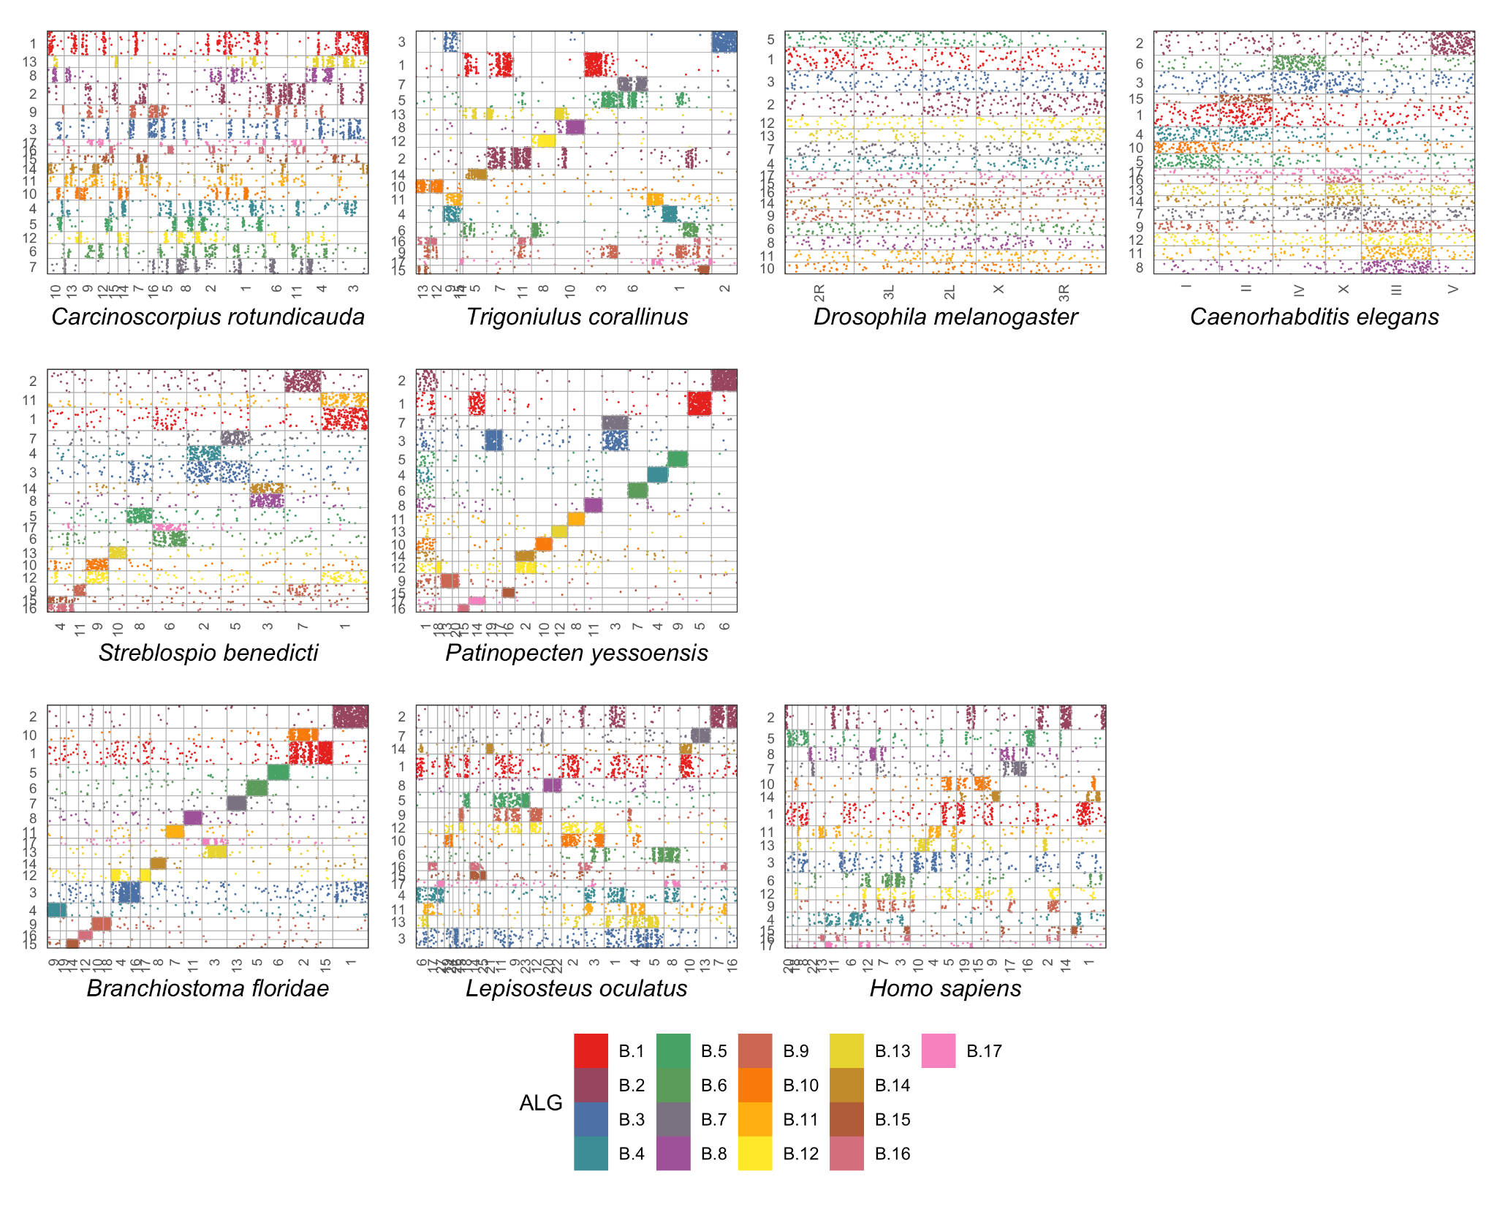
Extended data figure 10. Same analysis as EDF 9 using the bilaterian ancestral linkage groups.
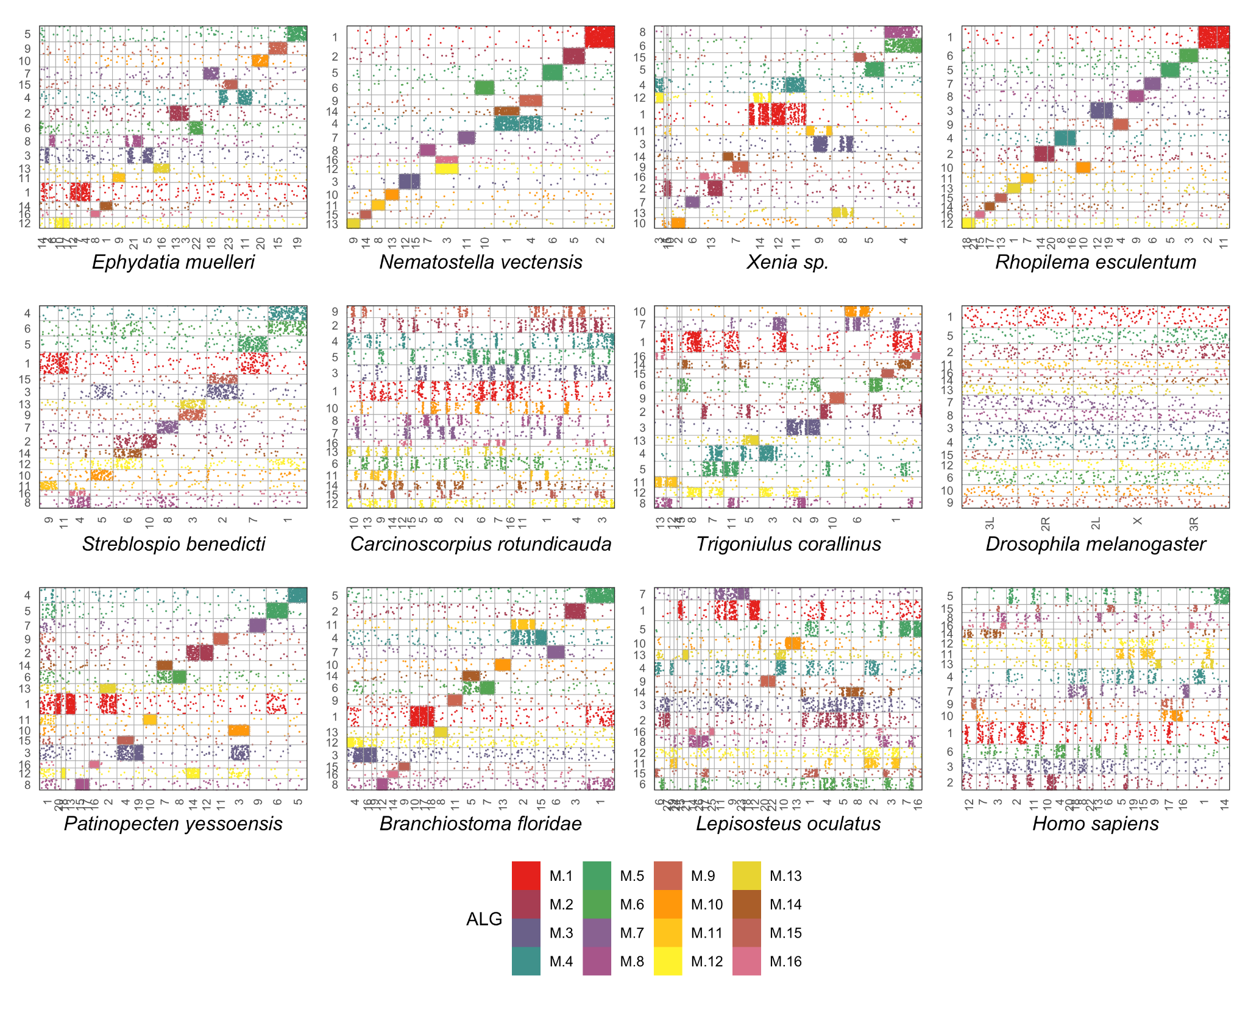

Extended data figure 11. Same analysis as EDF 9 using the metazoan ancestral linkage groups.

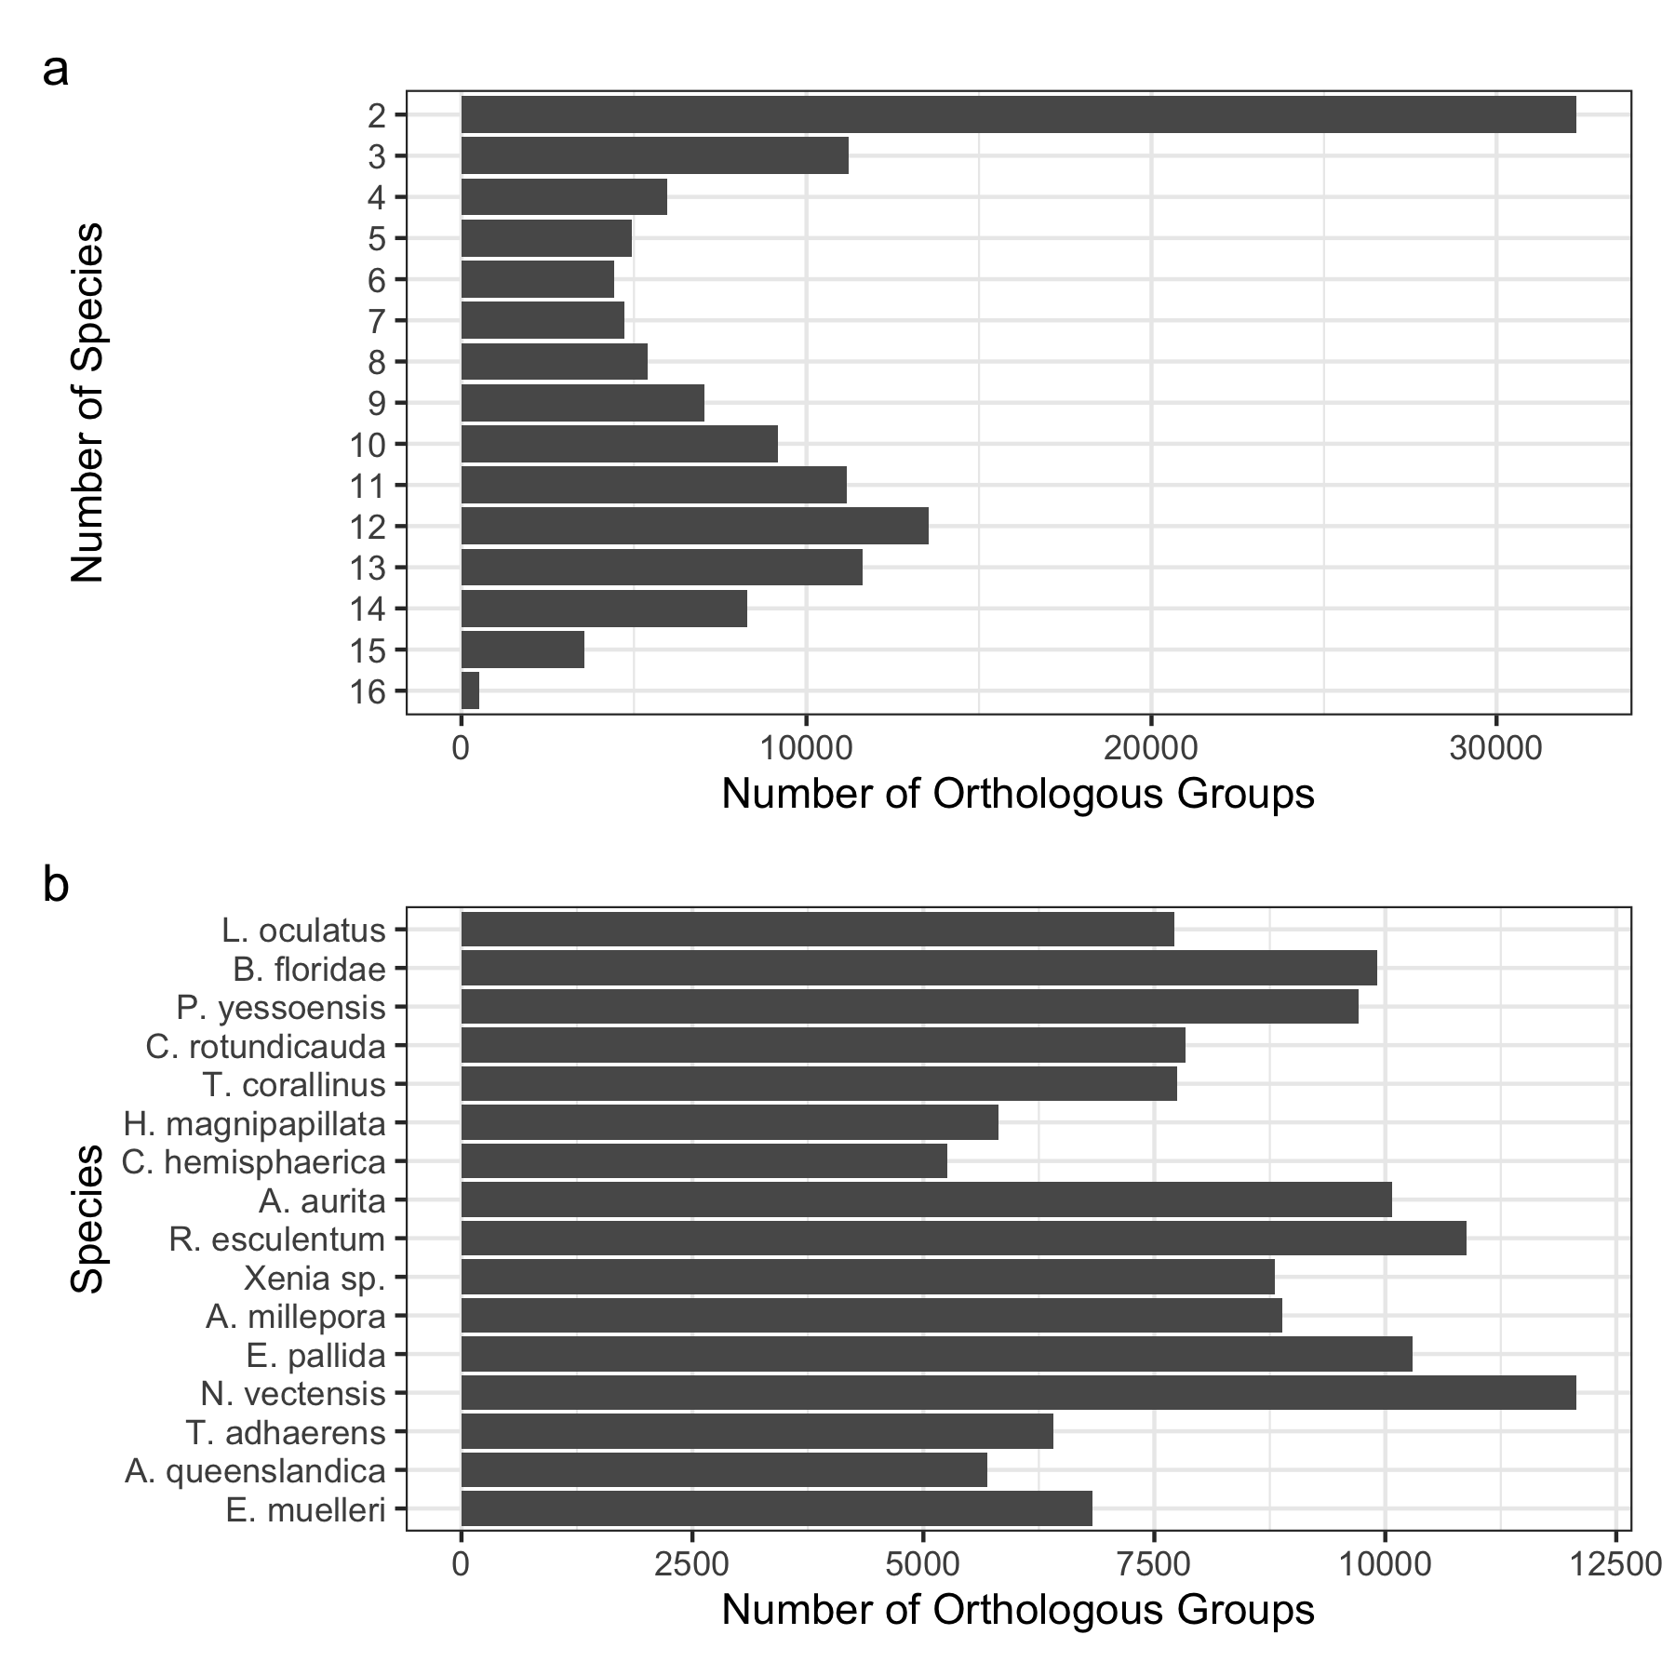
Extended Data Figure 12. Summary of orthologous groups used in macrosynteny detection and ALG inference. Multi-way reciprocal best blast hits were inferred as described in the supplementary text. a) Histogram of the number of orthology groups of differing sizes. Only one gene per species was allowed, so the number of species implies the number of genes in the group. b) Total number of genes included in orthologous groups in each genome.

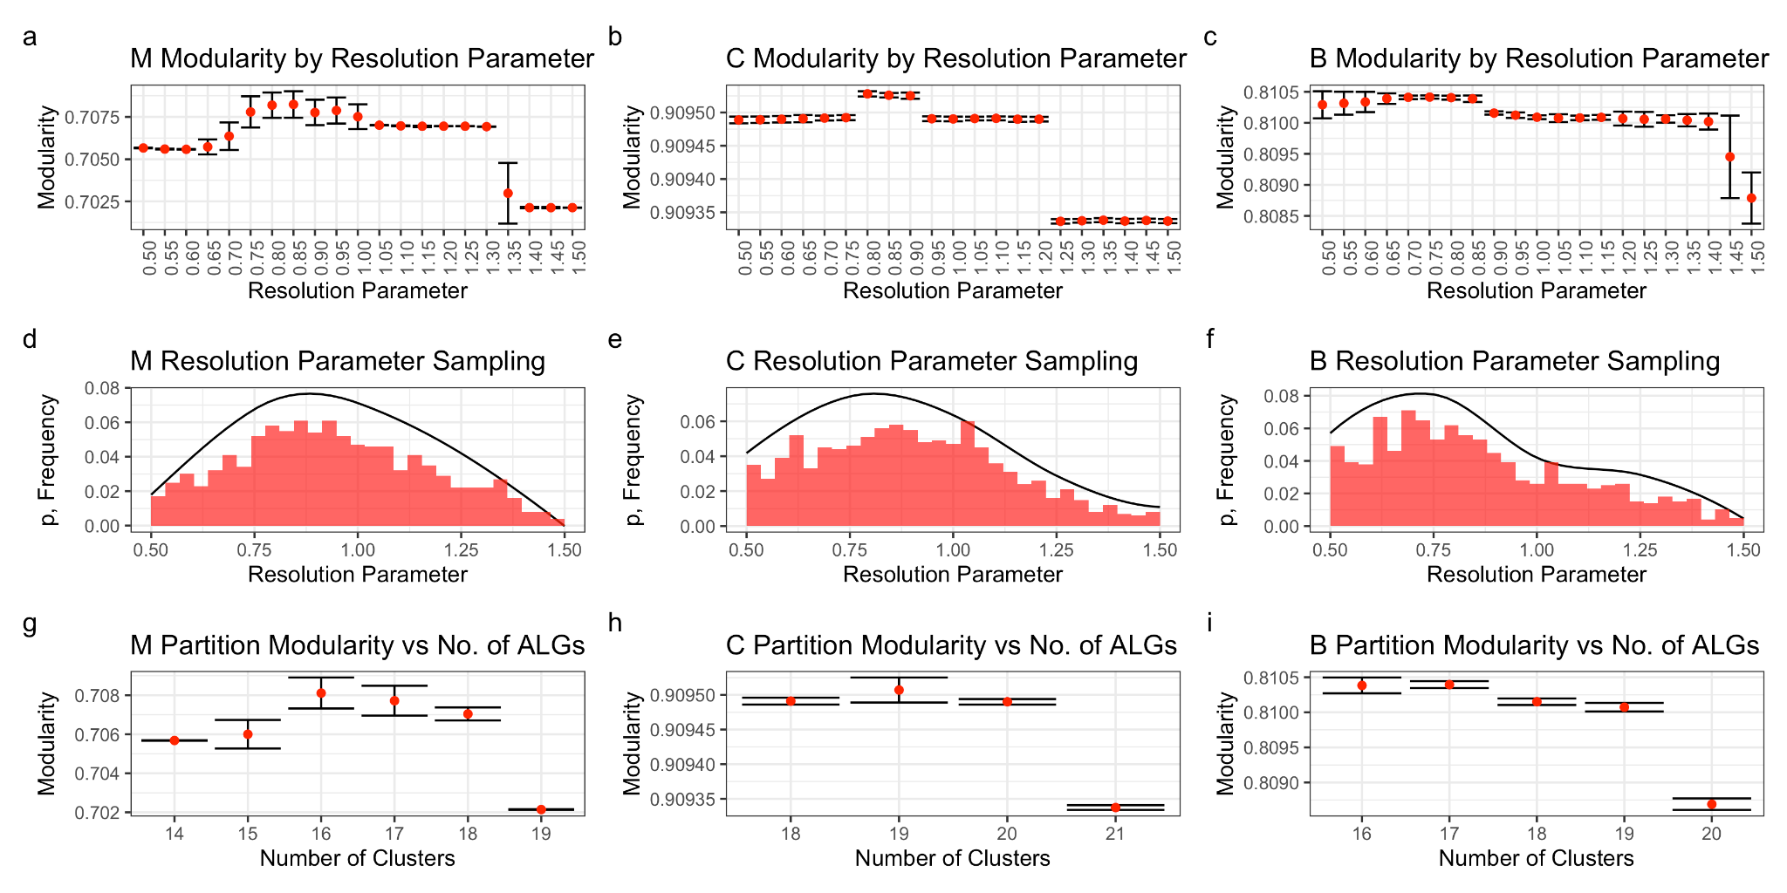
Extended Data Figure 13. Inference of ancestral linkage groups for Metazoa (M), Cnidaria (C) and Bilateria (B). a-c) Each setting of the resolution parameter was run with the given setting 100 times and the resulting distributions of modularity values for the partitions are represented here. The dot represents the mean modularity and the error bars +/- 1 standard deviation. d-f) A distribution of the resolution parameter was generated using the ranks of all modularity values (see supplementary text for details). The line represents the distribution from which 1000 resolution parameters were sampled. The bars are a frequency histogram of the samples taken from the distribution. g-i) 1000 partitions were generated using the Leiden algorithm using the sampled resolution parameters. Results were grouped by the number of ALGs (Clusters) inferred, and the distributions of modularity are again represented as a dot for the mean and the error bars +/- 1 standard deviation.

Supplementary Text
- Assembly of Nematostella vectensis and Scolanthus callimorphus genomes
Nematostella and Scolanthus PacBio long-read libraries were constructed from the same DNA used to estimate the genome size (Scolanthus) or individuals from the same clonal population (Nematostella). Self-corrected PacBio sequences were assembled into initial contigs which were already highly contiguous after an initial pass (nv2contigs, sc1contigs, EDF 3a-c). The initial assembly showed indications of redundancy as indicated by Benchmarking of Universal Single Copy Orthologs (BUSCO) scores (EDF 4), likely caused by heterozygous alleles assembling into separate contigs. The greater number of duplicate BUSCOs in Scolanthus corresponds to its higher heterozygosity as indicated by the k-mer model (EDF 2). After removal of these redundant contigs, the duplicate BUSCOs were reduced 3.4-fold in Scolanthus and 8-fold in Nematostella (EDF 4).
Compared to the published Nematostella assembly, the contiguity of both genomes in terms of contig-level N50 was over 25 fold higher (EDF 3a-c,f). The Nematostella assembly was further scaffolded by generating libraries using the Dovetail Chicago in vitro proximity ligation platform (see Materials and Methods for details). The Dovetail-scaffolded genome further increased the N50 contiguity by 2-fold (EDF 3f). In addition, one BUSCO gene match which was previously fragmented due to an assembly break in the contig-level assembly was united on a single scaffold in the new Dovetail assembly.
We were additionally able to validate the order and correctness of the Nematostella intra-scaffold sequence using the REAPR pipeline³. We extracted DNA fragments from two individuals, measured the insert size distribution and sequenced paired ends. REAPR was used to break the genome where a substantial portion of paired read mappings on the contigs conflicted with the expected distance. The contiguity of the broken assemblies, as compared to the initial scaffolded assemblies, was much higher than that of the original Nematostella assembly, and also relatively higher as a fraction of the raw N50 (EDF 3d). Additionally, the fraction of the scaffolded genome considered to be error-free (in terms of both sequence and contiguity) was 150% and 157% of the previous Nematostella scaffolds based on the data from each of the individuals (EDF 3e). Taken together, not only were the nv2 scaffolds substantially more contiguous than the previous nv1 scaffolds, the sequences within these scaffolds exhibited fewer misassemblies and errors (EDF3).
In order to obtain a chromosome-level assembly of Nematostella and Scolanthus, we performed high throughput chromosomal conformation capture (Hi-C) on a single individual from each species. After automated assembly followed by assembly review (see Materials and Methods for details). The HiC contact maps showed evidence for 15 chromosomes for both Nematostella and Scolanthus (Figure 2a,b). This is in line with the previous estimates based on the analyses of Nematostella chromosome spreads^{2,4}. We were also able to validate the Dovetail scaffolding by performing a second, independent assembly of the purged contigs using our Hi-C data. As shown in EDF 5, the assemblies were nearly identical, confirming the robustness of both the scaffolding and the assembly method. The minor differences in these assemblies were inspected in further manual review and ties were broken according to the Hi-C contact signal in the Dovetail assembly.
To showcase the quality of the new gene annotation we aligned and assigned RNAseq libraries from the Nematostella developmental time series (0-19h)⁵ and compared it to the previous transcriptome. Overall we see a decrease of 2% in the fraction of unmapped reads, an increase of 10% in the fraction of reads unambiguously assigned to a gene model, a drop of 10% in the fraction of reads not assigned to any gene model and a drop of 5% in the fraction of multi mapping reads which cannot be reliably assigned to a specific gene model. Notably, the capture of the 3’ UTRs in the new gene models will significantly improve the mapping of the single cell transcriptome libraries from 10X Genomics platforms.

- Chromosomal repeat dynamics in the Edwardsiidae
Remarkably, the longest two pseudo-chromosomes in Scolanthus correspond to the 7th shortest and the shortest pseudo-chromosome in Nematostella, respectively. Both pseudo-chromosomes were rich in repetitive sequences in both species (Figure 3a-3). Based on this observation, we wondered whether any repeat classes were enriched in these chromosomes. We calculated z-scores based on the individual repeat families’ fractional enrichment per chromosome relative to the distribution of chromosomal repeat enrichment. We found that in particular the LTR/Pao repeat class, a pan-metazoan repeat class abundant in Drosophila genomes, but absent from mammalian genomes⁶, was enriched in both pseudo-chromosomes relative to others (z-scores 1.3 and 1.4, respectively, EDT 2-5) as well as their counterparts in Nematostella (z-scores 1.8 and 1.5).

- Evolution the homeobox gene clusters in early branching metazoans
The chromosome-level assembly of the Nematostella genome allows us not only to follow the evolution of gene linkages by comparing macrosyntenies at the genome-wide scale, but also to re-address the evolution of specific gene clusters. Some of the best-known examples of clusters of regulatory genes in Bilateria include the homeobox genes of the Antennapedia class (ANTP), the paired class (PRD), the TALE-class (Irx genes) and the SINE-class (SIX genes). For the ANTP genes, a single ancestral Megacluster containing the ProtoHox cluster linked to Evx, Mox and Dlx, the NK/NK-like homeobox genes, as well as the EHGbox genes (Engrailed, HB9/Mnx, Gbx), has been hypothesized. Upon duplication of the ProtoHox cluster, the Hox and the ParaHox clusters arose, and the Megacluster broke up into several fragments⁷. The later continuation of the work of Pollard and Holland added several genes to the “extended Hox” or “SuperHox” cluster of the Urbilaterian, which was postulated to have contained the Hox, Evx, Dlx, Nedx, Engrailed, Mnx, Rough, Hex, Mox⁸ and Gbx⁹. Comparison of the genomic linkages in the early-branching chordate Branchiostoma floridae (Deuterostomia) and the annelid Platynereis dumerilii (Protostomia) then allowed to postulate that the last common ancestor of the protostomes and deuterostomes had the following four clusters of ANTP genes: the SuperHox cluster, the ParaHox cluster, the NK/NK-like cluster, and the NK2 family cluster⁸. In contrast to the earlier branching sponges, which only contain the NK/NK-like cluster of the ANTP class genes¹⁰, Nematostella vectensis has the four clusters similar to that postulated for the hypothetical urbilaterian by Hui et al¹¹.
The Nematostella extended Hox cluster is located on the chromosome 2 (Figure 3) and consists of the immediately linked three Hox genes (HoxC/Anthox7, HoxDa/Anthox8a and HoxDb/Anthox8b, the latter two likely being alternative splice variants of the single HoxD/Anthox8), Evx, HoxA (Anthox6) followed by eight bystander genes, and then by Mnx and Rough. Two more Hox genes, (HoxE/Anthox1a and HoxR/Anthox9) are located ~2.5Mb downstream of Rough, and one further Hox gene, HoxB/Anthox6a, is located ~5Mb upstream of HoxC. The last remaining Nematostella Hox gene, HoxF/Anthox1, a paralog of HoxE/Anthox1a, is found on chromosome 5. Gbx and a cluster of four Mox paralogs can also be found on the chromosome 2: Gbx is located ~0.4Mb downstream of HoxB, and Mox genes are positioned at the end of the same chromosome some 5.6Mb downstream of HoxE. A possible Engrailed ortholog Engrailed-like and Dlx are linked, but located on a different chromosome (Figure 3), and Nedx is not present in the Nematostella genome. This unusual “interrupted” structure of the SuperHox cluster with Evx in the middle and parts of the cluster far away of the Hox-Evx-Mnx-Rough core indicate some secondary rearrangement (Figure 3 and 4). The existence of clear Hox and ParaHox genes in Cnidaria and in Bilateria suggests that the duplication of the ProtoHox cluster took place prior to the cnidarian-bilaterian split. Phylogenetic analyses^{12–15} show very low support for the orthology of the cnidarian Hox genes with distinct groups of bilaterian Hox paralogs, which resulted in an attempt to use non-tree-based methods to establish the phylogenetic relationships between them¹⁶. Given that the Nematostella ParaHox cluster (N. vectensis chromosome 10; Figure 3) consists of two linked genes – an “anterior” Gsx and a mixed identity “non-anterior” Xlox/Cdx¹³, it seems likely that Hox genes in Cnidaria and Bilateria are a result of the independent diversification of the descendants of a single “anterior” and a single “non-anterior” Hox gene of the cnidarian-bilaterian ancestor (Figure 4A), although the presence of the complete cnidarian ParaHox cluster containing Gsx, Xlox and Cdx cannot be excluded based on the evidence from a scyphozoan Rhopilema¹⁷. The putative ancestral two-gene Hox cluster was linked to Eve, Mnx, Rough and, possibly, Mox. Since the SuperHox cluster of the scyphozoan jellyfish also appears to be at least partially atomized¹⁷, it remains unclear whether the remaining members of the bilaterian SuperHox cluster (Gbx, Dlx, Engrailed-like, if the latter is a true Engrailed ortholog) were also linked to it or got “trapped” by it in the bilaterian lineage.
Similar to the situation in Bilateria, the Nematostella NK/NK-like homeobox genes are concentrated in two locations: the five NK2.2 genes form a cluster on the chromosome 2, and there is an NK cluster on the chromosome 5 (Figure 3). Within a space of less than 1Mb, there is a group of NK6, NK7, NK3, NK4, Msx, NK5 and NK1. These are seven out of nine members of the ProtoNK cluster postulated for the protostome-deuterostome ancestor¹⁸. The missing two genes, Tlx-like (its orthology with bilaterian Tlx is not fully certain) and Ladybird (Lbx), are found on the same chromosome respectively 8.2Mb and 9.3Mb upstream of NK6. Since in the sponge Amphimedon a suggested Tlx ortholog is part of the NK cluster¹⁰, it is possible that Tlx-like outside of the NK cluster in Nematostella represents a derived rather than an ancestral trait. Alternatively, it may be that true Tlx genes first evolved in Bilateria. More orthologs of the bilaterian NK-like genes and possible members of the ancestral eumetazoan NK cluster^{9–11,18} are found on the same chromosome at varying distances to the cluster: Emx (5 Emx genes in different locations on the chromosome), Hlx, Not, and, intriguingly, Hex. Multiple additional NK-class genes are located on different chromosomes, including one Msx copy approximately 0.34Mb upstream of the HoxE/Anthox1a.
Hex was proposed to be a member of the SuperHox rather than the NK cluster of the bilaterian ancestor⁸. At the same time, in the sea anemone, Hex is found on chromosome 5 carrying the NK cluster as well as many other NK-like genes and, notably, HoxF/Anthox1. The presence of the HoxF gene, sometimes in several copies, on the chromosome carrying the NK cluster appears to be a conserved cnidarian feature, since this is also the case in another edwardsiid sea anemone Scolanthus, the octocoral Xenia and the scyphozoan Rhopilema. Hex appears to be the single potential SuperHox cluster gene present in the ctenophore and sponge genomes^{19–23} Like the sea anemone Hex, the proposed Hex orthologue in the sponge Amphimedon queenslandica is part of the NK cluster¹⁰. Thus, the position of Hex on the “NK-cluster chromosome” in Nematostella may represent the ancestral condition. It is also possible that Hex linked to the NK cluster may be a remnant of the SuperHox-NK Megacluster, which independently split into SuperHox and NK clusters in Cnidaria and Bilateria. In this scenario, cnidarian SuperHox cluster must have translocated onto what is now Nematostella chromosome 2 leaving HoxF/Anthox1 and Hex behind; and bilaterian SuperHox cluster must have translocated into its current position taking all the SuperHox cluster genes (including Hex) with it. However, it is also possible that Hex became translocated into the SuperHox cluster from the NK cluster early in the bilaterian evolution, and the placement of the sea anemone HoxF/Anthox1 on the chromosome carrying the NK cluster does not represent its ancestral position but is a result of its translocation out of the SuperHox cluster at the base of Cnidaria. This second option seems to be a much better fit to the results of our comparison of the chromosomal arrangement of the extended Hox cluster and the NK-like genes, as well as with the macrosynteny analysis. The latter shows that syntenic blocks from the SuperHox-containing Nematostella chromosome 2 can be found on the Branchiostoma chromosomes 1, 10 and 17 (where the amphioxus SuperHox cluster resides). In contrast, syntenic blocks from the NK cluster containing Nematostella chromosome 5 are all found on the Branchiostoma chromosome 3 (where the disarranged amphioxus NK genes are located). Moreover, clear Hex orthologs are members of the NK cluster not only in the sea anemone, but also in deuterostome bilaterians such as the cephalochordate Branchiostoma and the ambulacrarian Saccoglossus²⁴. Thus, currently we do not find support for the SuperHox-NK Megacluster hypothesis. Taken together, we propose that the last common ancestor of Cnidaria and Bilateria possessed an NK-cluster on a chromosome different from the one carrying the SuperHox cluster, and a separate NK2.2-like cluster, which might have been on the same chromosome as the SuperHox cluster (Figure 4A). The later notion is supported by the localization of Branchiostoma NK2.1 and NK2.2 on the same chromosome as the Six gene cluster, Goosecoid and Otx in Branchiostoma – similar to the situation in Nematostella (Figure 3 and see also text below).
In addition to the previously established clustering of the PRD-class Homeobrain-Rx-Orthopedia conserved between cnidarians, bilaterians and placozoans^{25,26}, we find several other more distant linkages, which might be nonetheless meaningful. For example, similar to the deuterostome situation^{24,27}, LIM class gene Isl is linked to the Rx-Orthopedia, however, at a distance of approximately 4.7Mb. SINE-class genes Six3/6, Six1/2 and Six4/5 are clustered in deuterostomes either closely like in hemichordates²⁴ and cephalochordates or with several Mb in between, like in vertebrates. The order of the genes in this cluster appears to be highly conserved: Six3/6 > Six1/2 > Six4/5. The same order of the Six genes we find on the Nematostella chromosome 2. Another notable cluster is the so-called “pharyngeal cluster”, which was considered deuterostome-specific²⁴. In deuterostomes, it is composed of the NK2.1 and NK2.2 genes closely linked with the non-homeobox transcription factor FoxA and Pax1/9 and two non-transcription factor genes Mipol1 and Slc25A21. In Nematostella, the five NK2.2 genes, Mipol1 and FoxA are all located on chromosome 2. Mipol1 is located between the immediately linked NK2.2E, NK2.2D, NK2.2C and NK2.2A, and the more distant NK2.2B, while FoxA is approximately 1.6Mb further downstream. We found no orthologs of Pax1/9 and Slc25A21 in Nematostella. Notably, similar to deuterostomes, among the five Nematostella NK2.2 genes, only NK2.2A is not expressed in the pharynx²⁸, and FoxA is one of the most traditional pharyngeal markers in Nematostella^{29,30}. The location of a selection of other homeobox proteins including the aforementioned PRD, TALE and LIM classes is provided in the EDT 6.

- Ultraconserved Non-coding Elements
We were interested to find out how many, and to what extent, Ultraconserved Non-Coding Elements (UCNEs) are present in Edwardsiidae. We adopted criteria previously used to detect UCNEs between chicken and humans³¹ and found 145 regions in the Nematostella genome that were highly conserved with Scolanthus (EDT 7). 116 of these regions fell into 37 syntenic clusters of at most 500 kb intervening gaps, and the remaining 29 were singletons. Several such clusters were close to NK paralogs, such as one containing 12 UCNEs and spanning 70 kb surrounding the NK3-4 cluster on chromosome 5 and three UCNEs upstream of the NK2.2 cluster on chromosome 2, a pattern previously reported in vertebrates³². Additionally, we detected a single UCNE neighboring the PaxC gene. While Pax-associated UCNEs have been previously reported in vertebrates^{32–34}, this neural developmental gene appears to have arisen from a cnidarian-specific duplication³⁵, implying that the accompanying UCNE also arose independently. On the other hand, no UCNEs are found near the edwardsiid Irx gene, despite their ubiquity among Bilateria^{36–38}. Likewise, our stringent criteria did not detect the previously reported UCNE at the 3’ end of the SoxB2 gene, as previously reported³⁹, suggesting that more relaxed parameters might reveal additional conserved elements shared between more distantly related species.

- SIMRBase Genome Browser
We are providing a comprehensive, maintained and community-oriented genomic resource for the N. vectensis genome. Genome browsers, gene pages, gene searches, and BLAST interfaces for each species are available at https://simrbase.stowers.org. Users may query genes by name, ID, and genome location and gene ontology (GO) to view data aligned to the genomes, such as transcriptomes, RNAseq and protein homologs in the genome browsers. Outside the browsers, more detailed searches can be performed using keywords from a collection of precomputed sequence similarity searches and protein domain predictions.

- Inference of ancestral linkage groups
We compared the chromosomal content and order of Nematostella vectensis to metazoan genomes including Porifera, other Cnidaria, Ecdysozoa, Spiralia and Chordata. We were able to observe differential rearrangement and conservation of genes among chromosomal pairs, and we hypothesized that some of these chromosomes shared among Nematostella and many other genomes in fact derived from the same ancestral linkage group. In order to directly determine the extent to which these ancestral linkage groups are shared, we took a graph-based approach for the inference of both orthologous groups and macrosyntenic links.
In order to determine orthology groups, we chose a reciprocal best approach. We chose this in order to avoid the misidentification of genes which are either paralogous and would not be expected to have retained their chromosomal linkage or are partial matches to loci originating from duplicated regions arising from misassemblies. Best BLAST hits were determined using NCBI+ blastp version 2.10.0⁴⁰, filtering against hits with an e-value above 1e-5. A graph was constructed of vertices containing all genes of all genomes and edges representing reciprocal best BLAST hits. We then searched for multi-way reciprocal best BLAST hits among multiple genomes. The optimal solution is a special case of the maximum clique problem, which is NP-complete, so in order to approximate this we took a greedy approach. We identified all cliques in the graph and iterated through them in descending order of size. Cliques containing one gene per species are accumulated to a list of orthology groups, as long as no genes in the clique are already contained in any of the genes in the list. This resulted in several large orthology groups, summarized in EDF 12.
The orthology groups from the previous step were used to construct a macrosynteny graph whose nodes were the orthology groups. We added edges to the graph for each pair of groups that occur on the same chromosome or scaffold in two different species. We then endeavored to determine ancestral linkage groups (ALGs) among critical internal nodes of the metazoan tree and the root, using subgraphs of the macrosynteny graph of species contained in each clade. Specifically, we used the genomes of N. vectensis, E. pallida, A. millepora, Xenia sp., A. aurita, R. esculentum, C. hemisphaerica and H. magnipapillata to determine the cnidarian ancestral linkage groups, the genomes of C. rotundicauda, T. corallinus, D. melanogaster, P. yessoensis and L. oculatus to determine the bilaterian ancestral linkage groups and both of the above groups combined with T. adhaerens, E. muelleri and A. queenslandica to determine the metazoan ancestral linkage groups.
Our approach to determining the groups from the graph is centered around the Leiden algorithm⁴¹ as implemented in igraph version 1.2.5⁴², which finds well-connected communities. The output of the algorithm is a “partition” of the input vertices into a number of groups. In our case, this translates to groups of genes which are frequently detected on the same chromosomes in corresponding genomes. We based our approach around the modularity optimization function, which maximizes the number of edges within communities as compared to the expected number of edges⁴³. In the case of the Leiden algorithm, a “resolution” parameter defines the granularity of community detection, in other words, the number of communities detected.
As the number of ancestral linkage groups is critical to the interpretation of the result, we chose to optimize the number of clusters detected based on the reported modularity of various values of the resolution parameter $γ$. Instead of fixing the value, we initially ran the Leiden algorithm 100 times for each $γ_{}$ value between 0.5-1.5, by steps of 0.05. The ranks were then used to generate a stepwise function $f(γ) = \frac{Σ_{γ_{i}=γ}r_{i}}{N}$ where $r_{i}$is the rank of partition $i$ with respect to modularity and $γ_{i}$is the gamma value used for partition $i$, and $N$ is the total number of partitions. This was transformed into a smooth local regression function generated using the locfit algorithm⁴⁴ (EDF 13).
Optimizing modularity is an NP-hard problem⁴⁵, and therefore the Leiden algorithm is an approximation to the optimal. In order to find high-confidence communities, we chose to use a consensus approach. We sampled the distribution of $γ_{}$parameters 1000 times to generate a pool of partitions by running the Leiden algorithm with the sampled $γ_{}$values. The pool of 1000 partitions was then used to determine the consensus among the many runs of the Leiden algorithm. The consensus number of clusters $k$ was determined as the maximum of $f(k) = \frac{Σ_{k_{i}=k}m_{i}}{N_{k}}$where $m_{i}$ is the modularity of partition $i$ and $N_{k}$ is the number of partitions with $k$ groups. We synthesized the results of all 1000 partitions to a consensus using the algorithm implied by the first model of Gordon and Vichi⁴⁶.

1. dos Reis, M. et al. Uncertainty in the Timing of Origin of Animals and the Limits of Precision in Molecular Timescales. Current Biology 25, 2939–2950 (2015).
2. Putnam, N. H. et al. Sea Anemone Genome Reveals Ancestral Eumetazoan Gene Repertoire and Genomic Organization. Science 317, 86–94 (2007).
3. Hunt, M. et al. REAPR: a universal tool for genome assembly evaluation. Genome Biology 14, R47 (2013).
4. Guo, L. et al. An adaptable chromosome preparation methodology for use in invertebrate research organisms. BMC Biology 16, 25 (2018).
5. Fischer, A. H. L. & Smith, J. Nematostella High-density RNAseq time-course. (2013) doi:10.1575/1912/5981.
6. de la Chaux, N. & Wagner, A. BEL/Pao retrotransposons in metazoan genomes. BMC Evolutionary Biology 11, 154 (2011).
7. Pollard, S. L. & Holland, P. W. H. Evidence for 14 homeobox gene clusters in human genome ancestry. Current Biology 10, 1059–1062 (2000).
8. Butts, T., Holland, P. W. H. & Ferrier, D. E. K. The Urbilaterian Super-Hox cluster. Trends in Genetics 24, 259–262 (2008).
9. Ferrier, D. E. K. Evolution of Homeobox Gene Clusters in Animals: The Giga-Cluster and Primary vs. Secondary Clustering. Frontiers in Ecology and Evolution 4, (2016).
10. Larroux, C. et al. The NK Homeobox Gene Cluster Predates the Origin of Hox Genes. Current Biology 17, 706–710 (2007).
11. Hui, J. H. L. et al. Extensive Chordate and Annelid Macrosynteny Reveals Ancestral Homeobox Gene Organization. Mol Biol Evol 29, 157–165 (2012).
12. Finnerty, J. R., Pang, K., Burton, P., Paulson, D. & Martindale, M. Q. Origins of Bilateral Symmetry: Hox and Dpp Expression in a Sea Anemone. Science 304, 1335–1337 (2004).
13. Chourrout, D. et al. Minimal ProtoHox cluster inferred from bilaterian and cnidarian Hox complements. Nature 442, 684–687 (2006).
14. Ryan, J. F. et al. Pre-Bilaterian Origins of the Hox Cluster and the Hox Code: Evidence from the Sea Anemone, Nematostella vectensis. PLoS ONE 2, e153 (2007).
15. DuBuc, T. Q., Ryan, J. F., Shinzato, C., Satoh, N. & Martindale, M. Q. Coral Comparative Genomics Reveal Expanded Hox Cluster in the Cnidarian–Bilaterian Ancestor. Integr Comp Biol 52, 835–841 (2012).
16. Thomas-Chollier, M., Ledent, V., Leyns, L. & Vervoort, M. A non-tree-based comprehensive study of metazoan Hox and ParaHox genes prompts new insights into their origin and evolution. BMC Evolutionary Biology 10, 73 (2010).
17. Nong, W. et al. Jellyfish genomes reveal distinct homeobox gene clusters and conservation of small RNA processing. Nature Communications 11, 3051 (2020).
18. Chan, C. et al. Remodelling of a homeobox gene cluster by multiple independent gene reunions in Drosophila. Nature Communications 6, 6509 (2015).
19. Srivastava, M. et al. The Amphimedon queenslandica genome and the evolution of animal complexity. Nature 466, 720–726 (2010).
20. Ryan, J. F. et al. The Genome of the Ctenophore Mnemiopsis leidyi and Its Implications for Cell Type Evolution. Science 342, 1242592–1242592 (2013).
21. Moroz, L. L. et al. The ctenophore genome and the evolutionary origins of neural systems. Nature 510, 109–114 (2014).
22. Pastrana, C. C., DeBiasse, M. B. & Ryan, J. F. Sponges Lack ParaHox Genes. Genome Biol Evol 11, 1250–1257 (2019).
23. Kenny, N. J. et al. Tracing animal genomic evolution with the chromosomal-level assembly of the freshwater sponge Ephydatia muelleri. Nature Communications 11, 3676 (2020).
24. Simakov, O. et al. Hemichordate genomes and deuterostome origins. Nature 527, 459–465 (2015).
25. Mazza, M. E., Pang, K., Reitzel, A. M., Martindale, M. Q. & Finnerty, J. R. A conserved cluster of three PRD-class homeobox genes (homeobrain, rx and orthopedia) in the Cnidaria and Protostomia. EvoDevo 1, 3 (2010).
26. Schierwater, B. et al. The early ANTP gene repertoire: insights from the placozoan genome. PLoS ONE 3, e2457 (2008).
27. Marlétaz, F. et al. Amphioxus functional genomics and the origins of vertebrate gene regulation. Nature 564, 64–70 (2018).
28. Steinmetz, P. R. H., Aman, A., Kraus, J. E. M. & Technau, U. Gut-like ectodermal tissue in a sea anemone challenges germ layer homology. Nat Ecol Evol 1, 1535–1542 (2017).
29. Fritzenwanker, J. H., Saina, M. & Technau, U. Analysis of forkhead and snail expression reveals epithelial–mesenchymal transitions during embryonic and larval development of Nematostella vectensis. Developmental Biology 275, 389–402 (2004).
30. Martindale, M. Q., Pang, K. & Finnerty, J. R. Investigating the origins of triploblasty: `mesodermal’ gene expression in a diploblastic animal, the sea anemone Nematostella vectensis (phylum, Cnidaria; class, Anthozoa). Development 131, 2463–2474 (2004).
31. Dimitrieva, S. & Bucher, P. UCNEbase—a database of ultraconserved non-coding elements and genomic regulatory blocks. Nucleic Acids Res 41, D101–D109 (2013).
32. Woolfe, A. et al. Highly conserved non-coding sequences are associated with vertebrate development. PLoS Biol. 3, e7 (2005).
33. Miles, C. et al. Complete sequencing of the Fugu WAGR region from WT1 to PAX6: Dramatic compaction and conservation of synteny with human chromosome 11p13. PNAS 95, 13068–13072 (1998).
34. Santagati, F. et al. Identification of Cis-regulatory elements in the mouse Pax9/Nkx2-9 genomic region: implication for evolutionary conserved synteny. Genetics 165, 235–242 (2003).
35. Matus, D. Q., Pang, K., Daly, M. & Martindale, M. Q. Expression of Pax gene family members in the anthozoan cnidarian, Nematostella vectensis: Pax gene expression in Nematostella vectensis. Evolution & Development 9, 25–38 (2007).
36. Calle-Mustienes, E. de la et al. A functional survey of the enhancer activity of conserved non-coding sequences from vertebrate Iroquois cluster gene deserts. Genome Res. 15, 1061–1072 (2005).
37. Irimia, M., Maeso, I. & Garcia-Fernàndez, J. Convergent Evolution of Clustering of Iroquois Homeobox Genes across Metazoans. Mol Biol Evol 25, 1521–1525 (2008).
38. Tena, J. J. et al. An evolutionarily conserved three-dimensional structure in the vertebrate Irx clusters facilitates enhancer sharing and coregulation. Nature Communications 2, 310 (2011).
39. Royo, J. L. et al. Transphyletic conservation of developmental regulatory state in animal evolution. PNAS 108, 14186–14191 (2011).
40. Camacho, C. et al. BLAST+: architecture and applications. BMC Bioinformatics 10, 421 (2009).
41. Traag, V. A., Waltman, L. & Eck, N. J. van. From Louvain to Leiden: guaranteeing well-connected communities. Scientific Reports 9, 5233 (2019).
42. Csardi, G. & Nepusz, T. The igraph software package for complex network research. InterJournal Complex Systems, 1695 (2006).
43. Newman, M. E. J. & Girvan, M. Finding and evaluating community structure in networks. Phys. Rev. E 69, 026113 (2004).
44. Loader, C. Local Regression and Likelihood. (Springer, 1999).
45. Brandes, U. et al. On Modularity Clustering. IEEE Transactions on Knowledge and Data Engineering 20, 172–188 (2008).
46. Gordon, A. D. & Vichi, M. Fuzzy partition models for fitting a set of partitions. Psychometrika 66, 229–247 (2001).

