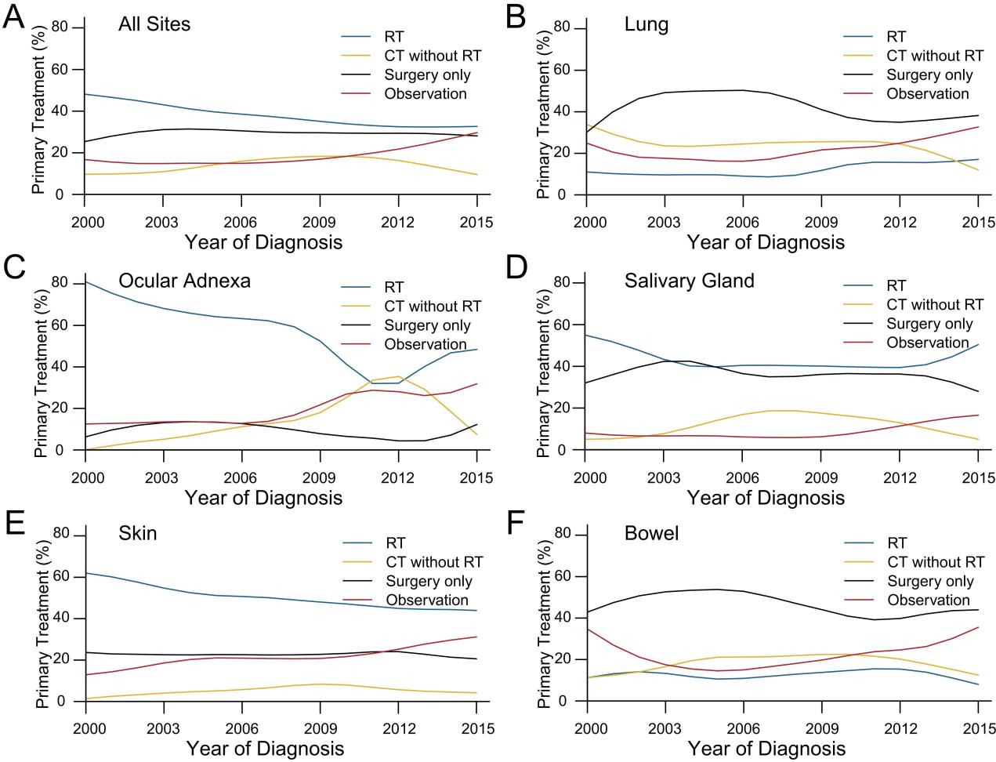
Supplementary Figure 1. Primary treatment decision trend over time according to primary sites. Treatment strategies were divided into radiotherapy (RT), chemotherapy (CT) without RT, surgery only, and observation. Abbreviations: RT, radiotherapy; CT, chemotherapy.

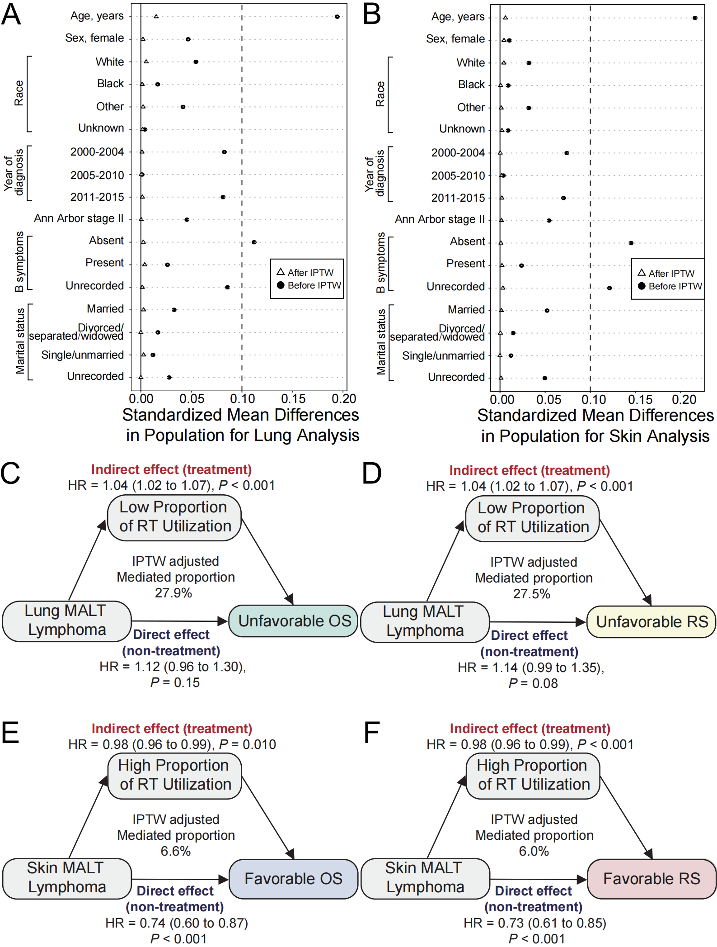

Supplementary Figure 2. Mediation analysis of radiotherapy’s role in the association between primary site and survival outcomes after IPTW adjustment. (A-B) Clinical characteristics with absolute standardized mean differences between treatment arms before and after IPTW in population for lung and skin mediation analysis, respectively. Mediation analysis of the role of radiotherapy in the association between primary site and OS. (C) Mediation analysis evaluating the direct and indirect effects of lung primary involvement on overall survival (OS) and relative survival (RS) through RT utilization. The proportion of the survival disparity mediated by RT is quantified as the indirect-to-total effect ratio. (E-F) Corresponding mediation analysis for skin primary involvement. Boxes labeled “Direct effect” represent the hazard ratio (HR) quantifying the primary site’s impact on survival independent of RT use, whereas the “Indirect effect” and “Mediated proportion” show how much of that impact is transmitted through RT utilization. A significant indirect effect indicates that treatment disparities (i.e., lower or higher RT use) partially explain the association between primary site and survival.
Abbreviations: IPTW, inverse probability of treatment weighting; OS, overall survival;RS, relative survival; MALT, mucosa-associated lymphoid tissue; HR, hazard ratio; RT, radiotherapy

