Supplementary data

Table S1 Sequences of primers used in this study [8]
Name | Direction | Sequences |  | Positionª
PCR primers

GBA-f | Forward | 5′-TCCTAAAGTTGTCACCCATACATG-3′ |  | chr1:155,211,182-155,211,206
MTX1P-r | Reverse | 5′-CCAACCTTTCTTCCTTCTTCTCAA-3′ |  | chr1:155,202,291-155,202,315
GBA-r | Reverse | 5′-TAGTCACAGACAGCGTGTGAGC-3′ |  | chr1:155,204,705-155,204,727
Sequencing primers
GBA-F1 | Forward | 5'-GGAAGCCAATTGCCCTTTAG-3' |  | chr1:155,211,119-155,211,139
GBA-F2 | Forward | 5'-CTGTGGGCCTTGTCCTAATG-3' |  | chr1:155,210,619-155,210,639
GBA-F3 | Forward | 5'-CCAAGGGGTGAGGAATTTTG-3' |  | chr1:155,209,954-155,209,974
GBA-F4 | Forward | 5'-CCCATCCAGGCTAATCACAC-3' |  | chr1:155,209,684-155,209,704
GBA-F5 | Forward | 5'-ACAGGTTCCAACCCAGGAG-3' |  | chr1:155,208,194-155,208,214
GBA-F6 | Forward | 5'-GGAGGCTAATGGCTGAACC-3' |  | chr1:155,207,856-155,208,876
GBA-F7 | Forward | 5'-AGGCTGTTCTCGAACTCCTG-3' |  | chr1:155,207,011-155,207,031
GBA-F8 | Forward | 5'-GTCACCCAACTCCAGGATTC-3' |  | chr1:155,206,329-155,206,349
GBA-F9 | Forward | 5'-CCTCACAGGGCTGACCTACC-3' |  | chr1:155,205,728-155,205,748
GBA-F10 | Forward | 5'-GAGCCTCTGCAGGAGTTATGG-3' |  | chr1:155,205,188-155,205,209
GBA-F11 | Forward | 5'-GGGCTTCCTGGAGACAATC-3' |  | chr1:155,204,288-155,204,307

ª GBA gene (NCBI: NM_000157.4; GRCh37)

Table S2 GBA variants and its frequency in Thai GD (n = 68 alleles)

Mutation change | Protein variant |  |  | Number of allele |  |  |  |  | %
 | 3 letter code | 1 letter code (traditional name) | present study |  | other reference |  | total
 | IVS2+1G>A |  |  | 4 |  |  |  | 4 | 5.8
  c.115+1G>A
c.475C>T | p.Arg159Trp | p.R159W (R120W) | 1 |  |  |  | 1 |  | 1.5
 | p.Asn227Lys | p.N227K (N188K) | 0 |  | 1ª |  | 1 |  | 1.5
  c.681T>C
c.754T>A | p.Phe252Ile | p.F252I (F213I) | 0 |  | 2^{b} |  | 2 |  | 2.9
c.762-1G>C | IVS6-1G>C |  |  | 2 |  | 2^{b} |  | 4 | 5.8
c.913C>G | p.Pro305Ala | p.P305A (P266A) | 1 |  |  |  | 1 |  | 1.5
c.999+1G>A | IVS7+1G>A |  |  | 1 |  |  |  | 1 | 1.5
c.1204T>C | p.Tyr402His | p.Y402H |  |  | 1ª |  | 1 |  | 1.5
c.1216A>G | p.Asn409Ser | p.N409S (N370S) | 1 |  |  |  | 1 |  | 1.5
c.1240G>C | p.Val414Leu | p.V414L (V375L) | 1 |  |  |  | 1 |  | 1.5
c.1389-3C>G | IVS9-3C>G |  |  | 1 |  | 2^{b} |  | 3 | 4.4
c.1342G>C | p.Asp448His | p.D448H (D409H) | 1 |  |  |  | 1 |  | 1.5
c.1448T>C | p.Leu483Pro | p.L483P (L444P) | 33 |  | 8^{a,c} |  | 41 |  | 60.3
c.1609T>C | p.Ter537Ala | p.X537A | 0 |  | 1ª |  | 1 |  | 1.5
c.151C>T+ c.1599G>A (cis) | p.Ser384Phe +p.Trp533Ter | p.S384F+ p.W533*  (S345F+W484*) | 1 |  |  |  | 1 |  | 1.5
p.1448T>C+c.1483G>C+ c.1497G>C (cis) or Rec1a | Rec1a or [p.Leu483Pro+ p.Ala495Pro+ p.Val499Val] | Rec1a or [L444P+ A456P+ V460V] | 2 |  |  |  | 2 |  | 2.9
unidentified allele |  |  | 1 |  | 1ª |  | 2 |  | 2.9
total |  |  | 50 |  | 18 |  | 68 |  | 100
ª Tammachote R et al., 2013 [18]; ^{b} Suwannarat P et al., 2007 [17]; ^{c} Chavananon S, et al, 2021 [16]

Fig. S1 Nested PCR and locations of primers. A. Graphical methods of nested PCR and locations of primer used. B. Products of nested PCR and location of primers for sequencing.

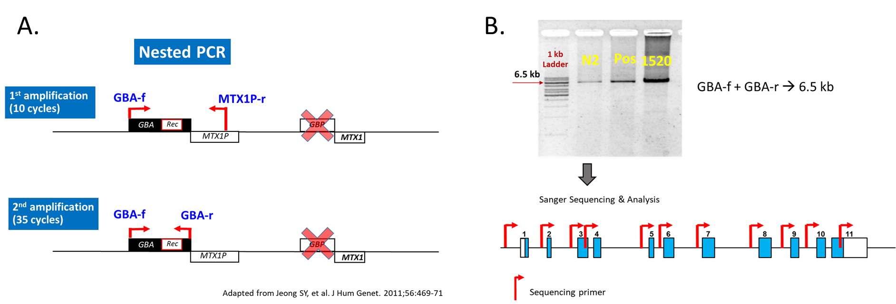

Fig. S2 Genomic organization of GBA and GBAP and sites of various recombination (gene conversion) alleles. Noted distinct sequences of GBAP.

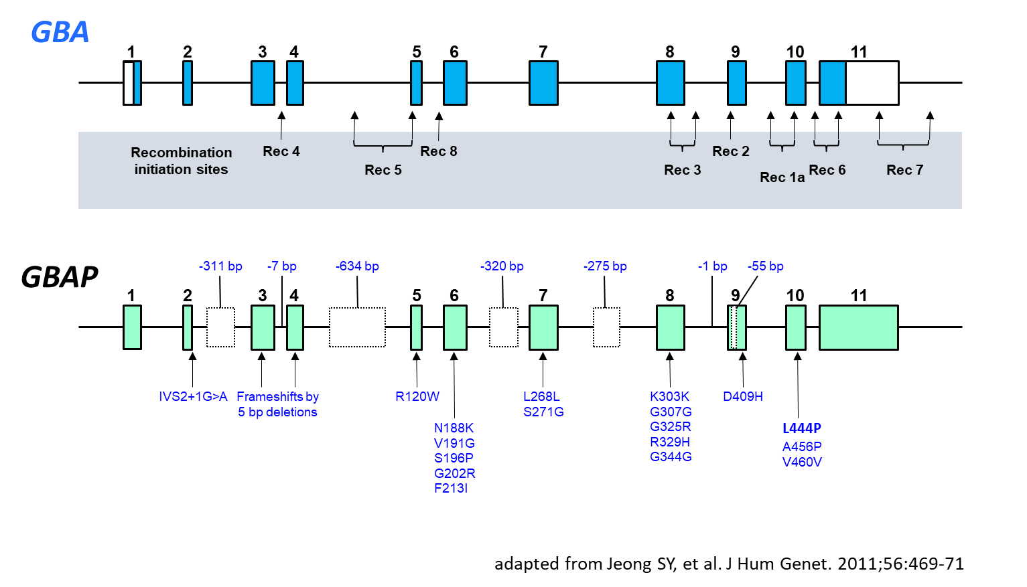
Fig. S3 Heterozygous gene conversion, Rec1a, allele. Noted 3 missense variants, p.L483L, p.A495P, p.V499V, on the same allele (in cis) indicating the Rec1a.

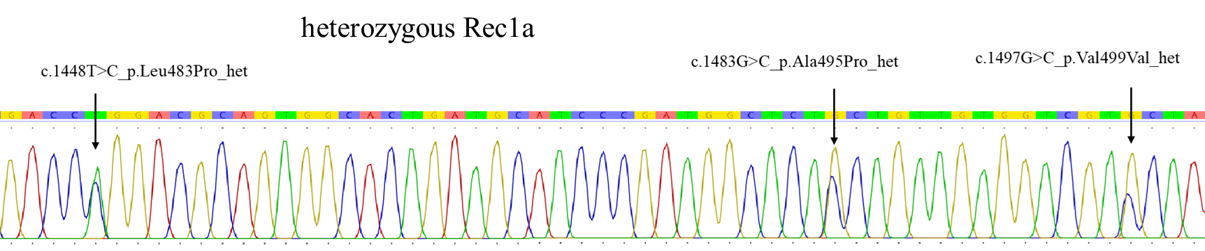

Fig. S4 Prevalence of Gaucher disease phenotypes and GBA mutant alleles in total Thai patients. Data for the present study combined with three previous reports (total n = 36 for phenotype analysis, and 68 alleles for genotype analysis).
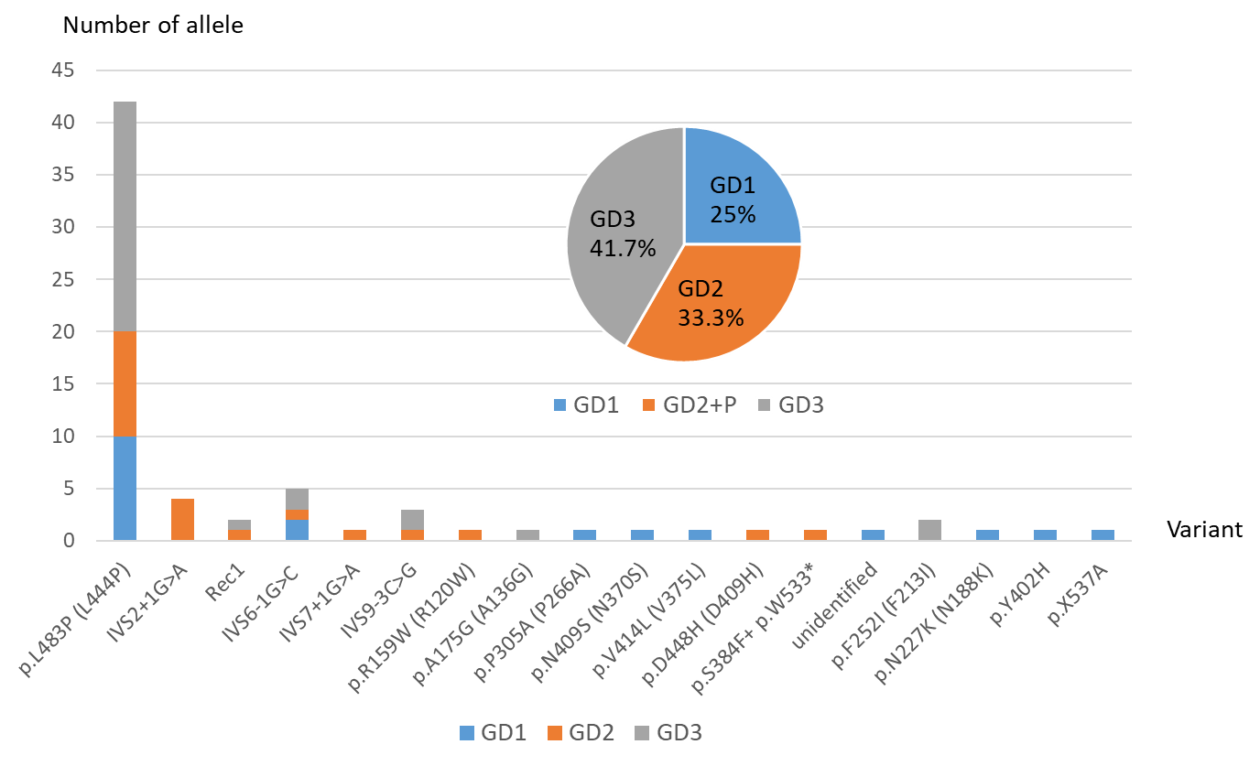
List of References (using the same running number as shown in the main text manuscript)
8. Jeong SY, Kim SJ, Yang JA, Hong JH, Lee SJ, Kim HJ. Identification of a novel recombinant mutation in Korean patients with Gaucher disease using a long-range PCR approach. J Hum Genet. 2011;56:469-71.
16. Chavananon S, Sripornsawan P, Songthawee N, Chotsampancharoen T. Successful Treatment of Gaucher Disease With Matched Sibling Hematopoietic Stem Cell Transplantation: A Case Report and Literature Review. J Pediatr Hematol Oncol. 2021.
17. Suwannarat P, Keeratichamroen S, Wattanasirichaigoon D, Ngiwsara L, Cairns JR, Svasti J, et al. Molecular characterization of type 3 (neuronopathic) Gaucher disease in Thai patients. Blood Cells Mol Dis. 2007;39:348-52.
18. Tammachote R, Tongkobpetch S, Srichomthong C, Phipatthanananti K, Pungkanon S, Wattanasirichaigoon D, et al. A common and two novel GBA mutations in Thai patients with Gaucher disease. J Hum Genet. 2013;58:594-9.

