Supplementary material
Content:
SM1.1. Search strategy
GRADE assessment
SM2.1. GRADE (Primary outcomes)
SM2.2. GRADE (Secondary outcomes)

Outcomes: meta-analyses
SM3.1. Total blood loss by the quantification method
SM3.2. Total blood loss by time of tranexamic acid administration
SM3.3. Meta-analysis of hemoglobin 48 hours after a C-section
SM3.4. Meta-analysis of hematocrit 48 hours after a C-section
SM3.5. Meta-analysis of hospital stay
SM3.6. Meta-analysis of additional uterotonics
SM3.7. Meta-analysis of additional surgical intervention
SM3.8. Meta-analysis of blood transfusion need
SM3.9. Meta-analysis of side effects
SM3.10. Meta-analysis of serious events

SM4.1.PRISMA 2020 Checklist

SM1.1. Search strategy
Search strategy on each database
SEARCH ENGINE | STRATEGY | RESULTS
PUBMED | ("Cesarean Section" OR "Cesarean Sections" OR "Abdominal Delivery" OR "C-Section (OB)" OR "C Section (OB)" OR "C-Sections (OB)" OR "Caesarean Section" OR "Caesarean Sections" OR "Delivery, Abdominal" OR "Abdominal Deliveries" OR "Deliveries, Abdominal" OR "Postcesarean Section") AND ("Tranexamic Acid" OR "AMCA" OR "AMCHA" OR "t-AMCHA" OR "trans-4-(Aminomethyl)cyclohexanecarboxylic Acid" OR "Cyklokapron" OR "Ugurol" OR "Transamin" OR "KABI 2161" OR "Amchafibrin" OR "Anvitoff" OR "Spotof" OR "Exacyl") AND ("Postpartum Hemorrhage" OR "Hemorrhage, Postpartum" OR "Delayed Postpartum Hemorrhage" OR "Hemorrhage, Delayed Postpartum" OR "Postpartum Hemorrhage, Delayed" OR "Immediate Postpartum Hemorrhage" OR "Hemorrhage, Immediate Postpartum" OR "Postpartum Hemorrhage, Immediate") | 128
SCOPUS | ( TITLE-ABS-KEY ( "Cesarean Section" OR "Cesarean Sections" OR "Abdominal Delivery" OR "C-Section (OB)" OR "C Section (OB)" OR "C-Sections (OB)" OR "Caesarean Section" OR "Caesarean Sections" OR "Delivery, Abdominal" OR "Abdominal Deliveries" OR "Deliveries, Abdominal" OR "Postcesarean Section" ) ) AND ( TITLE-ABS-KEY ( "Tranexamic Acid" OR "AMCA" OR "AMCHA" OR "t-AMCHA" OR "trans-4-(Aminomethyl)cyclohexanecarboxylic Acid" OR "Cyklokapron" OR "Ugurol" OR "Transamin" OR "KABI 2161" OR "Amchafibrin" OR "Anvitoff" OR "Spotof" OR "Exacyl" ) ) AND ( TITLE-ABS-KEY ( "Postpartum Hemorrhage" OR "Hemorrhage, Postpartum" OR "Delayed Postpartum Hemorrhage" OR "Hemorrhage, Delayed Postpartum" OR "Postpartum Hemorrhage, Delayed" OR "Immediate Postpartum Hemorrhage" OR "Hemorrhage, Immediate Postpartum" OR "Postpartum Hemorrhage, Immediate" ) ) | 538
WEB OF SCIENCE | TS=("cesarean section*" OR "caesarean section*" OR "c-section" OR "abdominal delivery*")  AND  TS=("tranexamic acid" OR "cyklokapron" OR "transamin" OR "exacyl")  AND  TS=("postpartum hemorrhag*" OR "postpartum bleeding" OR "postpartum blood loss" OR "postpartum haemorrhag*") | 282
Embase | ("Cesarean Section" OR "Cesarean Sections" OR "Abdominal Delivery" OR "C-Section (OB)" OR "C Section (OB)" OR "C-Sections (OB)" OR "Caesarean Section" OR "Caesarean Sections" OR "Delivery, Abdominal" OR "Abdominal Deliveries" OR "Deliveries, Abdominal" OR "Postcesarean Section"):ti,ab,kw,de  AND  ("Tranexamic Acid" OR "AMCA" OR "AMCHA" OR "t-AMCHA" OR "trans-4-(Aminomethyl)cyclohexanecarboxylic Acid" OR "Cyklokapron" OR "Ugurol" OR "Transamin" OR "KABI 2161" OR "Amchafibrin" OR "Anvitoff" OR "Spotof" OR "Exacyl"):ti,ab,kw,de  AND  ("Postpartum Hemorrhage" OR "Hemorrhage, Postpartum" OR "Delayed Postpartum Hemorrhage" OR "Hemorrhage, Delayed Postpartum" OR "Postpartum Hemorrhage, Delayed" OR "Immediate Postpartum Hemorrhage" OR "Hemorrhage, Immediate Postpartum" OR "Postpartum Hemorrhage, Immediate"):ti,ab,kw,de | 701
Cochrane Library  Embase: 85  Pubmed: 49  ClinicalTrials.gov: 28  ICTRP (International Clinical Trials Registry Platform): 26  CINAHL: 2 | ("cesarean section" OR "cesarean sections" OR "abdominal delivery" OR "c-section" OR "caesarean section" OR "caesarean sections" OR "delivery, abdominal" OR "postcesarean section")  AND  ("tranexamic acid" OR "amca" OR "amcha" OR "t-amcha" OR "trans-4-(aminomethyl)cyclohexanecarboxylic acid" OR "cyklokapron" OR "ugurol" OR "transamin" OR "kabi 2161" OR "amchafibrin" OR "anvitoff" OR "spotof" OR "exacyl")  AND  ("postpartum hemorrhage" OR "hemorrhage, postpartum" OR "delayed postpartum hemorrhage" OR "hemorrhage, delayed postpartum" OR "immediate postpartum hemorrhage" OR "hemorrhage, immediate postpartum") | 162

SM2.1. GRADE (Primary outcomes)

Tranexamic acid compared to Placebo for To Prevent Postpartum Hemorrhage in High-risk Cesarean Deliveries (Primary outcomes)
Patient or population: To Prevent Postpartum Hemorrhage in High-risk Cesarean Deliveries
Setting:
Intervention: Tranexamic acid
Comparison: Placebo
Outcomes | № of participants  (studies)  Follow-up | Certainty of the evidence  (GRADE) | Relative effect  (95% CI) | Anticipated absolute effects
 |  |  |  | Risk with Placebo | Risk difference with Tranexamic acid
Total blood loss (ml) (TBL)  assessed with: ml | 866  (6 RCTs) | ⨁⨁◯◯  Low^{a,b} | - | - | SMD 1.74 SD lower  (3.09 lower to 0.39 lower)
Total blood loss - Time grouped 10 min (TBL)  assessed with: ml | 506  (4 RCTs) | ⨁⨁◯◯  Low^{a,b} | - | - | SMD 2.31 SD lower  (3.5 lower to 1.13 lower)
Total blood loss - Time grouped 15-20 min (TBL)  assessed with: ml | 360  (2 RCTs) | ⨁⨁⨁◯  Moderate^{c} | - | - | SMD 0.61 SD lower  (0.82 lower to 0.39 lower)
Intraoperative blood loss (IBL)  assessed with: ml | 988  (4 RCTs) | ⨁⨁⨁⨁  Highª | - | - | SMD 0.99 SD lower  (1.15 lower to 0.82 lower)
Blood loss 2 hours (BL 2 hr)  assessed with: ml | 1000  (2 RCTs) | ⨁⨁⨁◯  Moderate^{b,c} | - | - | SMD 0.78 SD lower  (1.21 lower to 0.35 lower)
Blood loss > 1000 ml (BL>1000)  assessed with: ml | 1338  (6 RCTs) | ⨁⨁⨁⨁  High^{d} | RR 0.24  (0.14 to 0.41) | 161 per 1,000 | 123 fewer per 1,000  (139 fewer to 95 fewer)
*The risk in the intervention group (and its 95% confidence interval) is based on the assumed risk in the comparison group and the relative effect of the intervention (and its 95% CI).
CI: confidence interval; RR: risk ratio; SMD: standardised mean difference
GRADE Working Group grades of evidence
High certainty: we are very confident that the true effect lies close to that of the estimate of the effect.
Moderate certainty: we are moderately confident in the effect estimate: the true effect is likely to be close to the estimate of the effect, but there is a possibility that it is substantially different.
Low certainty: our confidence in the effect estimate is limited: the true effect may be substantially different from the estimate of the effect.
Very low certainty: we have very little confidence in the effect estimate: the true effect is likely to be substantially different from the estimate of effect.

Explanations
a. Downgraded one level due to some concerns in the deviations from the intended interventions, measurement of the outcome and selection of the reported results.
b. Downgraded one level due to high heterogeneity.
c. Downgraded one level due to some concerns in the selection of the reported results.
d. Downgraded one level due to crosses the clinical decision threshold.

SM2.2. GRADE (Secondary outcomes)

Tranexamic acid compared to Placebo for To Prevent Postpartum Hemorrhage in High-risk Cesarean Deliveries (Secondary outcomes)
Patient or population: To Prevent Postpartum Hemorrhage in High-risk Cesarean Deliveries
Setting:
Intervention: Tranexamic acid
Comparison: Placebo
Outcomes | № of participants  (studies)  Follow-up | Certainty of the evidence  (GRADE) | Relative effect  (95% CI) | Anticipated absolute effects
 |  |  |  | Risk with Placebo | Risk difference with Tranexamic acid
Hemoglobin pos (HGB)  assessed with: g/dL | 1668  (7 RCTs) | ⨁⨁⨁◯  Moderate^{a,b} | - | - | SMD 1.39 SD higher  (0.58 higher to 2.2 higher)
Hematocrit post (HCT)  assessed with: % | 498  (4 RCTs) | ⨁⨁⨁◯  Moderate^{a,c} | - | - | SMD 0.67 SD higher  (0.48 higher to 0.85 higher)
Hospital stay  assessed with: days | 910  (3 RCTs) | ⨁◯◯◯  Very low^{c} | - | - | SMD 0.03 SD higher  (0.2 lower to 0.25 higher)
Additional uterotonics (AU) | 1498  (7 RCTs) | ⨁⨁⨁◯  Moderate^{c,d} | RR 0.37  (0.24 to 0.58) | 296 per 1,000 | 187 fewer per 1,000  (225 fewer to 124 fewer)
Surgical intervention (SI) | 260  (2 RCTs) | ⨁⨁⨁◯  Moderate^{c} | RR 0.35  (0.16 to 0.78) | 154 per 1,000 | 100 fewer per 1,000  (129 fewer to 34 fewer)
Blood transfusion need (BTN) | 1698  (8 RCTs) | ⨁⨁◯◯  Low^{c,e} | RR 0.30  (0.22 to 0.40) | 106 per 1,000 | 74 fewer per 1,000  (83 fewer to 64 fewer)
Side effects (SE) | 1050  (3 RCTs) | ⨁◯◯◯  Very low^{b,c} | RR 3.47  (0.65 to 18.41) | 38 per 1,000 | 94 more per 1,000  (13 fewer to 663 more)
Serious events (SE) | 1060  (3 RCTs) | ⨁◯◯◯  Very low^{c} | RR 1.00  (0.29 to 3.43) | 8 per 1,000 | 0 fewer per 1,000  (5 fewer to 18 more)
*The risk in the intervention group (and its 95% confidence interval) is based on the assumed risk in the comparison group and the relative effect of the intervention (and its 95% CI).
CI: confidence interval; RR: risk ratio; SMD: standardised mean difference
GRADE Working Group grades of evidence
High certainty: we are very confident that the true effect lies close to that of the estimate of the effect.
Moderate certainty: we are moderately confident in the effect estimate: the true effect is likely to be close to the estimate of the effect, but there is a possibility that it is substantially different.
Low certainty: our confidence in the effect estimate is limited: the true effect may be substantially different from the estimate of the effect.
Very low certainty: we have very little confidence in the effect estimate: the true effect is likely to be substantially different from the estimate of effect.

Explanations
a. Downgraded one level due to some concerns in the deviations from the intended interventions, measurement of the outcome and selection of the reported results.
b. Downgraded one level due to high heterogeneity.
c. Downgraded one level due to crosses the clinical decision threshold.
d. Downgraded one level due to moderate heterogeneity.
e. Downgraded one level due to some concerns in the selection of the reported results.

SM3.1. Total blood loss by the quantification method
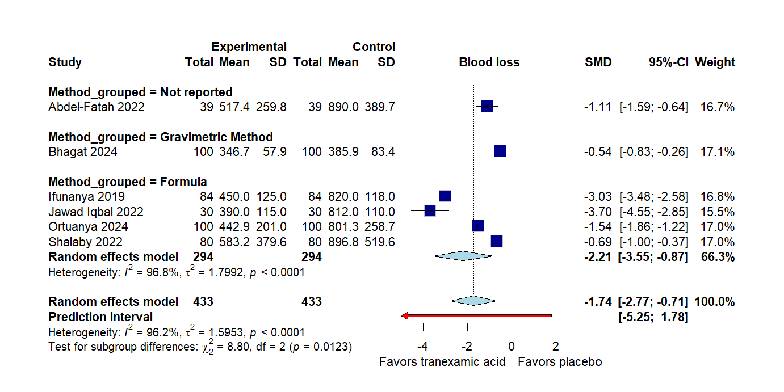
SM3.2. Total blood loss by time of tranexamic acid administration

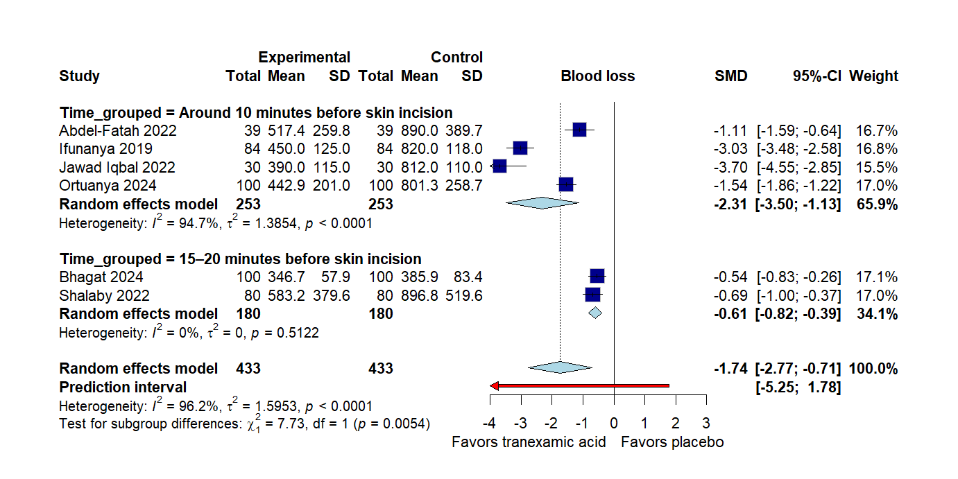

SM3.3. Meta-analysis of hemoglobin 48 hours after a C-section
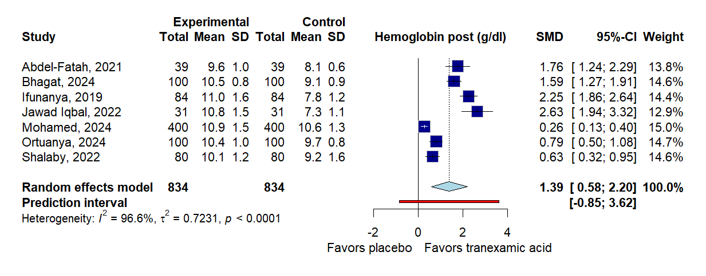

SM3.4. Meta-analysis of hematocrit 48 hours after a C-section
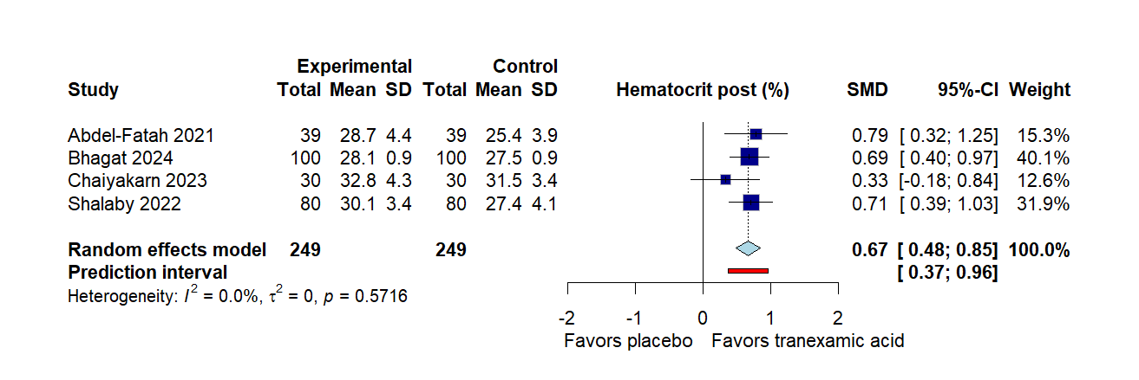

SM3.5. Meta-analysis of hospital stay
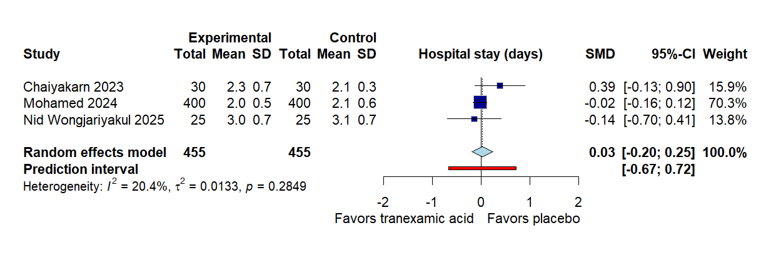

SM3.6. Meta-analysis of additional uterotonics

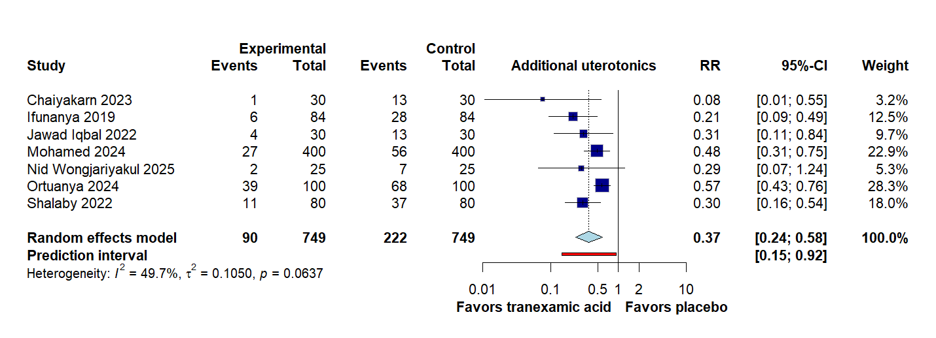
SM3.7. Meta-analysis of additional surgical intervention
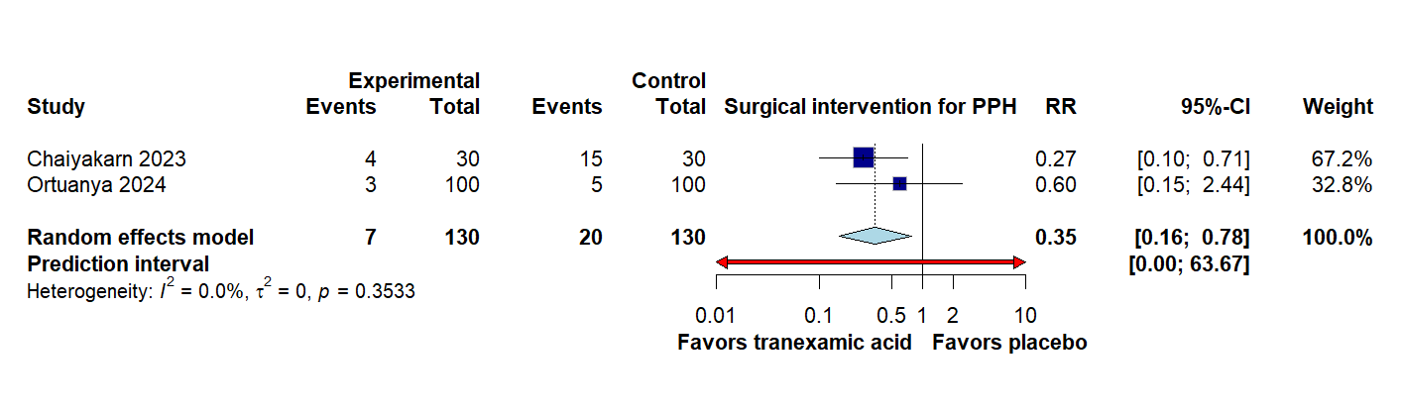

SM3.8. Meta-analysis of blood transfusion need
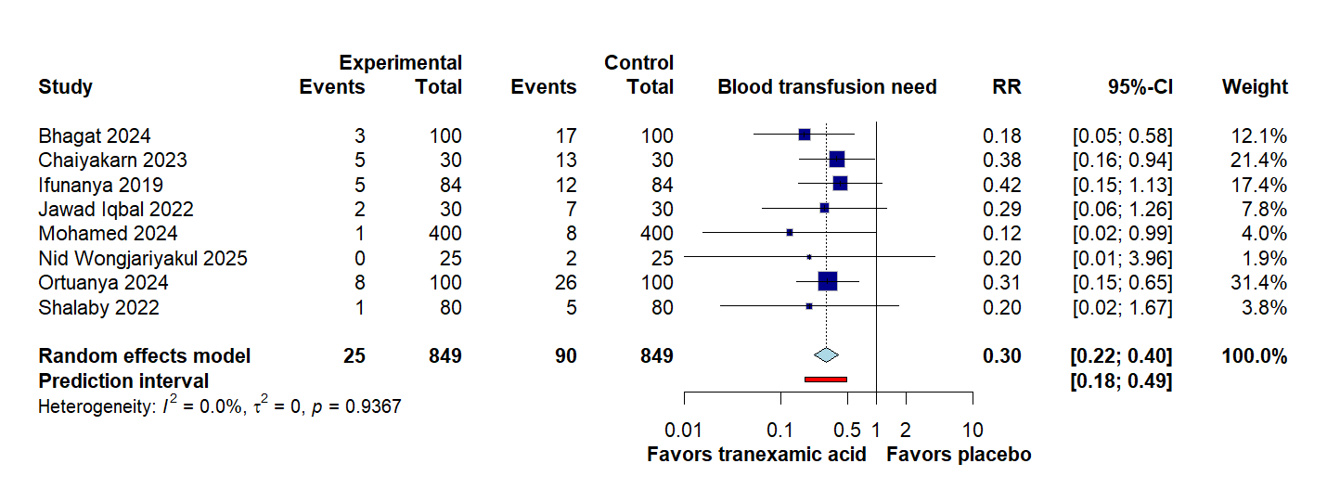

SM3.9. Meta-analysis of side effects

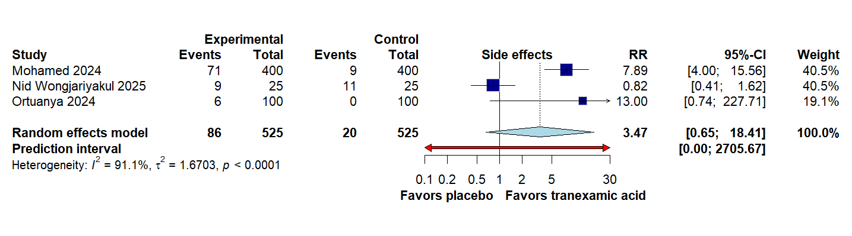

SM3.10. Meta-analysis of serious events

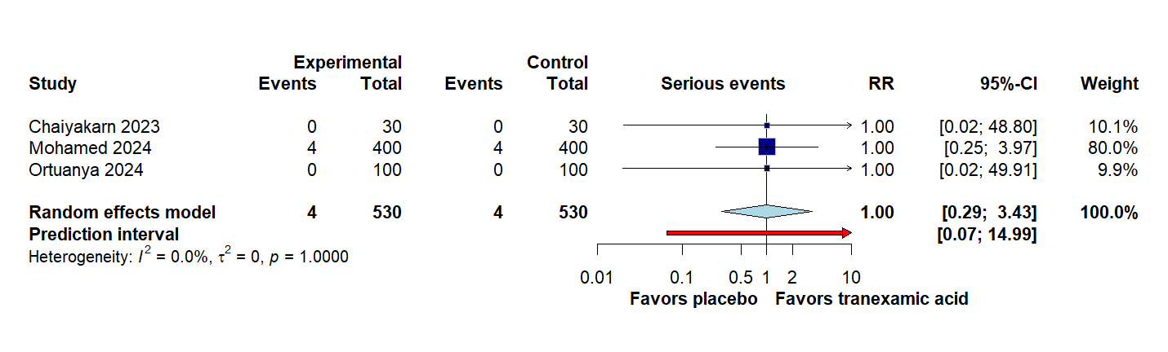

SM4.1.PRISMA 2020 Checklist
Section and Topic | Item # | Checklist item | Location where item is reported
TITLE
Title | 1 | Identify the report as a systematic review. | 1
ABSTRACT
Abstract | 2 | See the PRISMA 2020 for Abstracts checklist. | 1
INTRODUCTION
Rationale | 3 | Describe the rationale for the review in the context of existing knowledge. | 2
Objectives | 4 | Provide an explicit statement of the objective(s) or question(s) the review addresses. | 3
METHODS
Eligibility criteria | 5 | Specify the inclusion and exclusion criteria for the review and how studies were grouped for the syntheses. | 4
Information sources | 6 | Specify all databases, registers, websites, organisations, reference lists and other sources searched or consulted to identify studies. Specify the date when each source was last searched or consulted. | 4
Search strategy | 7 | Present the full search strategies for all databases, registers and websites, including any filters and limits used. | Supplementary material
Selection process | 8 | Specify the methods used to decide whether a study met the inclusion criteria of the review, including how many reviewers screened each record and each report retrieved, whether they worked independently, and if applicable, details of automation tools used in the process. | 4
Data collection process | 9 | Specify the methods used to collect data from reports, including how many reviewers collected data from each report, whether they worked independently, any processes for obtaining or confirming data from study investigators, and if applicable, details of automation tools used in the process. | 5
Data items | 10a | List and define all outcomes for which data were sought. Specify whether all results that were compatible with each outcome domain in each study were sought (e.g. for all measures, time points, analyses), and if not, the methods used to decide which results to collect. | 4
Data items | 10b | List and define all other variables for which data were sought (e.g. participant and intervention characteristics, funding sources). Describe any assumptions made about any missing or unclear information. | 4-5
Study risk of bias assessment | 11 | Specify the methods used to assess risk of bias in the included studies, including details of the tool(s) used, how many reviewers assessed each study and whether they worked independently, and if applicable, details of automation tools used in the process. | 5
Effect measures | 12 | Specify for each outcome the effect measure(s) (e.g. risk ratio, mean difference) used in the synthesis or presentation of results. | 6
Synthesis methods | 13a | Describe the processes used to decide which studies were eligible for each synthesis (e.g. tabulating the study intervention characteristics and comparing against the planned groups for each synthesis (item #5)). | 4-5
Synthesis methods | 13b | Describe any methods required to prepare the data for presentation or synthesis, such as handling of missing summary statistics, or data conversions. | 6
Synthesis methods | 13c | Describe any methods used to tabulate or visually display results of individual studies and syntheses. | 6
Synthesis methods | 13d | Describe any methods used to synthesize results and provide a rationale for the choice(s). If meta-analysis was performed, describe the model(s), method(s) to identify the presence and extent of statistical heterogeneity, and software package(s) used. | 6
Synthesis methods | 13e | Describe any methods used to explore possible causes of heterogeneity among study results (e.g. subgroup analysis, meta-regression). | 6
Synthesis methods | 13f | Describe any sensitivity analyses conducted to assess robustness of the synthesized results. | 6
Reporting bias assessment | 14 | Describe any methods used to assess risk of bias due to missing results in a synthesis (arising from reporting biases). | 5
Certainty assessment | 15 | Describe any methods used to assess certainty (or confidence) in the body of evidence for an outcome. | 6
RESULTS
Study selection | 16a | Describe the results of the search and selection process, from the number of records identified in the search to the number of studies included in the review, ideally using a flow diagram. | 7
Study selection | 16b | Cite studies that might appear to meet the inclusion criteria, but which were excluded, and explain why they were excluded. | 7
Study characteristics | 17 | Cite each included study and present its characteristics. | Table 1
Risk of bias in studies | 18 | Present assessments of risk of bias for each included study. | 8
Results of individual studies | 19 | For all outcomes, present, for each study: (a) summary statistics for each group (where appropriate) and (b) an effect estimate and its precision (e.g. confidence/credible interval), ideally using structured tables or plots. | 8-10
Results of syntheses | 20a | For each synthesis, briefly summarise the characteristics and risk of bias among contributing studies. | 8-10
Results of syntheses | 20b | Present results of all statistical syntheses conducted. If meta-analysis was done, present for each the summary estimate and its precision (e.g. confidence/credible interval) and measures of statistical heterogeneity. If comparing groups, describe the direction of the effect. | 8-10
Results of syntheses | 20c | Present results of all investigations of possible causes of heterogeneity among study results. | 8-9
Results of syntheses | 20d | Present results of all sensitivity analyses conducted to assess the robustness of the synthesized results. | 9
Reporting biases | 21 | Present assessments of risk of bias due to missing results (arising from reporting biases) for each synthesis assessed. | It was not evaluated because the outcomes had fewer than 10 studies
Certainty of evidence | 22 | Present assessments of certainty (or confidence) in the body of evidence for each outcome assessed. | 8-10
DISCUSSION
Discussion | 23a | Provide a general interpretation of the results in the context of other evidence. | 11
Discussion | 23b | Discuss any limitations of the evidence included in the review. | 14
Discussion | 23c | Discuss any limitations of the review processes used. | 14
Discussion | 23d | Discuss implications of the results for practice, policy, and future research. | 14
OTHER INFORMATION
Registration and protocol | 24a | Provide registration information for the review, including register name and registration number, or state that the review was not registered. | 3
Registration and protocol | 24b | Indicate where the review protocol can be accessed, or state that a protocol was not prepared. | 3
Registration and protocol | 24c | Describe and explain any amendments to information provided at registration or in the protocol. | -
Support | 25 | Describe sources of financial or non-financial support for the review, and the role of the funders or sponsors in the review. | 16
Competing interests | 26 | Declare any competing interests of review authors. | 16
Availability of data, code and other materials | 27 | Report which of the following are publicly available and where they can be found: template data collection forms; data extracted from included studies; data used for all analyses; analytic code; any other materials used in the review. | 16

From: Page MJ, McKenzie JE, Bossuyt PM, Boutron I, Hoffmann TC, Mulrow CD, et al. The PRISMA 2020 statement: an updated guideline for reporting systematic reviews. BMJ 2021;372:n71. doi: 10.1136/bmj.n71. This work is licensed under CC BY 4.0. To view a copy of this license, visit https://creativecommons.org/licenses/by/4.0/

